W. E. P.

Würzburg Economic Papers

Nr. 12

Reflections on the optimal size of government

Hans G. Monissen

1999

Universität Würzburg
Lehrstuhl für Volkswirtschaftslehre,
insbesondere allgemeine Wirtschaftspolitik
Sanderring 2, D-97070 Würzburg
hans_g.monissen@mail.uni-wuerzburg.de
Tel.: +49/931/31-2951

REFLECTIONS ON THE OPTIMAL
SIZE OF GOVERNMENT

Hans G. Monissen
University of Würzburg*⁾
Sanderring 2
97070 Würzburg
Germany

0. ON GORDON TULLOCK

“It is not always easy to see a common thread in Tullock’s work: he is almost too fertile and throws off so many ideas in all directions that the connecting links between them threaten to disappear from view. Any simple summary of his ‘system’, therefore, must wait on some future effort of his own. However, a common thread in his work, as in that of all public choice theorists, is the view that human behaviour must be viewed in all circumstances as a ‘rational’ response to the twin constraints of the physical environment and the prevailing social institutions; people will always strive to maximize their satisfactions in the face of these constraints, taking due account of the costs of alternative choices” (Blaug, [1985] 252-53).
Gordon Tullock is the 1998 Distinguished Fellow of the American Economic Association. In the enclosed short appreciation of his work we read: “Tullock’s scholarship and entrepreneurship have left an indelible imprint on economics. He is a pioneer who has worked almost exclusively at the frontiers of the discipline” (American Economic Review, [1998]).
Inspecting Gordon Tullock’s curriculum vitae which contains 37 pages compiling his published work will indeed confirm the assertion that his scientific work is concentrated at the frontiers of our discipline. However, Tullock has not only extended the domain of economic inquiry, but also strengthened the core of our discipline. As opposed to Blaug’s remark we should note that there exists a simple summary of his “system”. It was in 1975 when Gordon Tullock with his co-author Richard McKenzie published one of the most fascinating introductory textbooks in economics which exposes the authors’ view of the workings of the socio-economic process. In their standard model the basic unit of analysis used is homo oeconomicus as characterized above. The authors apply this role model consistently and successfully to a wide range of both market and non-market phenomena.
The paper “Reflections on the Optimal Size of Government” should, at least subjectively, reflect Gordon Tullock’s influence on our perspective. However, we have to admit our analytical shortcomings of not being able to simultaneously include such Tullockian topics as rent-seeking, demand-revealing, bureaucratic behavior (to name only some of his important insights) into an envisaged general-equilibrium model.

1. INTRODUCTION

Most economists in the classical liberal tradition associate with Adam Smith (1976, 208-9) by assigning only three duties to the government: “first, the duty of protecting the society from the violence and invasion of other independent societies; secondly, the duty of protecting, as far as possible, every member of the society from the injustice or oppression of every other member of it, or the duty of establishing an exact administration of justice; and thirdly, the duty of erecting and maintaining certain public works and certain public institutions, which it can never be for the interest of any individual, or small number of individuals, to erect and maintain; because the profit could never repay the expense to any individual or small number of individuals, though it may frequently do much more than repay it to a great society.” To provide the necessary financial funds for implementing these duties, Adam Smith’s system of natural liberty has to be completed by a set of fiscal rules or a fiscal constitution. Since the publication of the seminal book by Brennan and Buchanan The Power to Tax with the programmatic subtitle Analytical Foundations of a Fiscal Constitution ([1980]; see also Brennan and Buchanan, [1977]), the general conceptional ingredients for such a completion seem to be available. However, as known from the literature, applying operational criteria to limit government activities in a dynamic setting is not an easy task (see Inman, [1982 and 1987]).
The fundamental constitutional approach by Brennan and Buchanan advocating several constraining principles for Leviathan remains somewhat controversial. Some economists subscribing to the theory of optimal taxation argue that an implicit trade-off between overall efficiency and a smaller government sector size may be biased. Avoiding a general discussion of this issue, we take a more pragmatic stance and consider the theory of optimal taxation at least as a useful starting point describing a “what-could-be” position.
The paper is organized as follows: In Section 2, a simple choice-theoretic general equilibrium model describing government productive activity is presented. The government supplies a public good which becomes effective as an infrastructure investment enhancing the productivity of the private sector. This type of government productive activity should be distinguished from the Keynesian view of the typical macroeconomic model in which the government activity remains not only unproductive but also welfare reducing if potential multiplier effects of government activity on employment are ignored. However, a government above a critical size will bring forth Leviathan who might appear in two quite different roles: he might materialize as a selfish dictator maximizing a surplus to be appropriated for personal uses or an anonymous bureaucracy trying to maximize the size of the budget. In supplementing the standard public-choice perspective, the model could rationalize efforts of “organized labor” to redistribute income in the functional sense from capital to labor by fixing the real wage rate at too high a level for overall efficiency. These efforts may lead to an excessive size of government over time.
Section 3 discusses the economic problem for a benevolent dictator under the perspective of the modern theory of optimal taxation. In addition to the infrastructure effect of the public good the model includes two private goods and a pure public good for our representative consumer. For this extended model the second-best tax structure is derived. These more technical aspects should complete the discussion in Section 2 and 4. In particular, Section 3 allows the formal computation of the Lindahl equilibrium included in Table 1.
In Section 4, relying on a numerical example, the pattern of production and employment under competing objectives is evaluated for a benevolent dictator. This “first-best” solution provides the reference situation against which other objectives such as maximizing aggregate consumer surplus, national product or national income (private production) are evaluated. Section 5 deals with the effects of a budget- or revenue-maximizing bureaucracy with some interesting results for efficiency. The simple model of Section 2 summarized in equations I and the one underlying the discussion in Section 4 and 5 regard a basic problem from two different angles. The first emphasizes more the productivity aspects and the second focuses mainly on welfare issues. Section 6 briefly summarizes the main results. Two supplementary appendices to Section 2 and 3 are included at the end of the paper.

2. A SIMPLE CHOICE-THEORETIC MODEL DESCRIBING GOVERNMENT PRODUCTIVE ACTIVITIES

The point of departure is a simple choice-theoretic model incorporating a representative private consumer and a complementary private firm. The role of government derives from the fact that a public good is included. This public good operates as an efficiency parameter in the production function for private output but, for the present, remains excluded from the utility function. In Section 3, the model will be extended to cover such a utility effect. The wage bill of the public sector has to be financed by taxes. The funds will be raised by imposing a proportional income tax. In deriving the structure of the model, special care is necessary to demarcate the functional role of the representative agent. As in all market systems the private agents are characterized by partial ignorance which allows to treat specific prices as parameters. In socio-political models the representative agent frequently plays the dual role of a typical consumer in the market arena and a median voter driving the political process and controlling government activities. It should be noted that a representative agent in a comprehensive sense does not need a government because he controls all resources and all instruments to maximize his private utility or, for that matter, the welfare of the economy with identical individuals.
We postulate a simple utility function with standard properties:
$U=u(x^{p},R−y^{w})$, u₁ and u₂ > 0. (2.1)
$x^{p}$denotes the output disposable for the private consumption, R identifies the total time endowment available for work time,$y^{w},$and leisure, y.
The private budget constraint is defined as follows:
$x^{p}=(1−t){\text{wy}}^{w}+(1−t)p$. (2.2)
Gross wages, ${\text{wy}}^{w}$, plus gross profits,$p,$minus the tax burden define the disposable income for the economy which is large enough to buy the whole product if the government abstains from engaging in transactions which reduce this consumption potential. The first-order conditions are familiar:
$\frac{¶u/¶y}{¶u/¶x^{p}}=(1−t)w=(−\frac{{\text{dx}}^{p}}{\text{dy}})$. (2.3)
The consumer treats the real wage rate,$w,$and real profits,$p,$as parameters, thereby ignoring the fact that both magnitudes depend on his employment decision.
Because working hours supplied both to the private and the public sector, $y^{p}$ and $y^{g}$, command the same real net wage rate, the allocation of the working time is, to begin with, indeterminate. Output produced in the private sector is not only a function of the employment level and the capital stock in the private sector, $y^{p}$ and $\bar{K^{p}}$but also of the employment level in the public sector, $y^{g}$. The later variable determines a public good or an infrastructure component, z, which multiplies a private output component f:
$x=z(y^{g})f^{}(y^{p};{\bar{K}}^{p})ºz(y^{g})f(y^{p})$,
$z^{'}>0,z^{''}<0,f^{'}>0,f^{''}<0\text{.}$ (2.4)
The right side of the equation suppresses the term for the capital stock in the private sector which will be kept constant. The signs of the stated derivatives follow a priori-reasoning where the signs of the public component could be switched to allow for a more pessimistic view of the economic role of government. Different from the procedure in Section 4, the effect of z on x is simply proportional.
Overall efficiency requires that a marginal shift of employment between the two sectors should produce the same effect on the private production level:
$z^{'}(y^{g})f(y^{p})=z(y^{g})f^{'}(y^{p})$. (2.5)
How is the efficiency requirement brought about? Without evoking a benevolent social planner the actions of the government have to be constrained by appropriate budgetary rules. Sufficient rules, as will be seen in a moment, are the imposition of an optimal tax rate and the requirement of a balanced budget to be defined below. Before the attention is directed to the government budget constraint the model has to be solved for w and$p$. These solutions are derived from the private business sector:
$w=z(y^{g})f^{'}(y^{p})$, (2.6)
$p=z(y^{g})f(y^{p})−{\text{wy}}^{p}$. (2.7)
The government uses the tax receipts for paying off the government employees and financing a possible extra absorption of the private output, x. This discretionary expenditure component will be referred to as Keynesian government expenditures,$x^{g}$. As in most macroeconomic models these expenditures constitute economic waste or a welfare loss.
$\text{tx}º\text{tz}(y^{g})f(y^{p})=(1−t){\text{wy}}^{g}+x^{g}$. (2.8)
If we set$x^{g}$equal to zero, all requirements are fulfilled to solve for the optimal tax rate, $t^{0}:$
$t^{0}=\frac{{\text{wy}}^{g}}{x+{\text{wy}}^{g}}$. (2.9)
The denominator,$x+{\text{wy}}^{g},$identifies national product as conventionally measured by national income and product accounting and the numerator indicates the output of the public sector,${\text{wy}}^{g}\text{.}$If all leisure effects are ignored, it should be private production, x, rather than national product defining the appropriate welfare indicator (cf. Section 4).
In order to derive solutions for $y^{g},y^{p}$ and $x^{p}$ which could be easily incorporated into the government budget constraint, it is necessary to work with specific functional forms of the representative actor’s utility function. A frequently implicit assumption followed in standard macroeconomics is to rely on a so-called no-wealth effects utility function or, more concrete, on a utility function which is quasi-linear in consumption.
$U=x^{p}+\frac{(R−y^{w})^{1−q}}{1−q},0<q<1\text{.}$ (2.1a)
The strictly concave term in leisure specifies constant relative risk aversion, a property which might be useful under an extended analysis covering uncertainty. The specific functional form has no essential bearing on our results, except that the profit term remains excluded from the labor market, which simplifies the analysis. Because the main objective of this section is to analyze a regime with an institutionally fixed real wage rate, the utility function remains incidental. Of course, the profit or wealth term could be removed from the model by restricting the private production function. This would, however, destroy the thread of the basic hypothesis of this section: It is “organized labor” which gains from a wage rate fixed at an excessively high level, thereby redistributing income from capital to labor.
The implied solutions for the central variables are:
$y^{w}({ºy}^{g}+y^{p})=R−[(1−t)w]^{−\frac{1}{q}}$, (2.10)
$x^{p}=(1−t)w$. (2.11)
Equation 2.10 reflects our no-wealth effects labor supply function.
The decomposition of $y^{w}$ from the demand side is brought about by the government employment decision given profit maximization by the private firms. However, the labor market reflects the trade-off between real consumption and leisure. If this relation remains excluded, the government budget constraint becomes
$t^{0}z(y^{g})f(y^{p})=(1−t^{0})z(y^{g})f^{'}(y^{p})y^{g}$ (2.12)
and the employment level is restricted by
$R=y^{g}+y^{p}$. (2.13a)
The following implicit relation specifies the more general case:
$\frac{(R−y^{g}−y^{p})^{−q}}{1−t^{0}}=z(y^{g})f^{'}(y^{p})$. (2.13b)
This leads to an interesting paper published by Ronald Findlay and John D. Wilson (1987) some years ago on “The Political Economy of Leviathan”, to which we owe some important insights. Findlay and Wilson exclude a leisure-income trade-off in their simple model which amounts to maximizing the production of private output.
If the employment level is exogenously fixed, $y^{w}={\bar{y}}^{w}$, a slightly more general form of the Findlay-Wilson model could start from
$U=u(x^{p},R−{\bar{y}}^{w})$.
Overall efficiency requires maximizing$x^{p}\text{.}$ Relying on the efficient allocation of the given working hours, the government budget constraint simplifies to
$\text{tx}=(1−t){\text{wy}}^{g}$. (2.8a)
Equation 2.6 shows that the wage rate is equal to the marginal product of labor in the private sector. Because the labor supply, $y^{w}$, is fixed, equation 2.8a can be rewritten as follows:
$t^{0}z(y^{g})f({\bar{y}}^{w}−y^{g})=(1−t^{0})z(y^{w})f^{'}({\bar{y}}^{w}−y^{g})y^{g}$. (2.8b)
In equation 2.8b the tax rate is introduced as a parameter and, as a matter of expediency, $t^{0}$ identifies the welfare maximizing rate. The left-hand side of equation 2.8a has a definite maximum which may be intuitively evident from the fact that the size of the government may be either too small or too large for maximizing private production. This maximum will be reached, if equation 2.5 is met. The public component, z, may be restricted in such a way that a minimum private production is forthcoming even if the employment level in the public sector is nil. The right-hand side of equation 2.8b has a positive slope throughout. We assume that this slope is increasing over the positive domain of $y^{g}$. A difference between the left- and the right-hand side terms identifies government discretionary expenditures or the budget surplus. A negative difference, denoting a deficit, remains excluded under the structure of the model. A government materializing in a selfish dictator will maximize the surplus $x^{g}$ to be appropriated for personal uses.

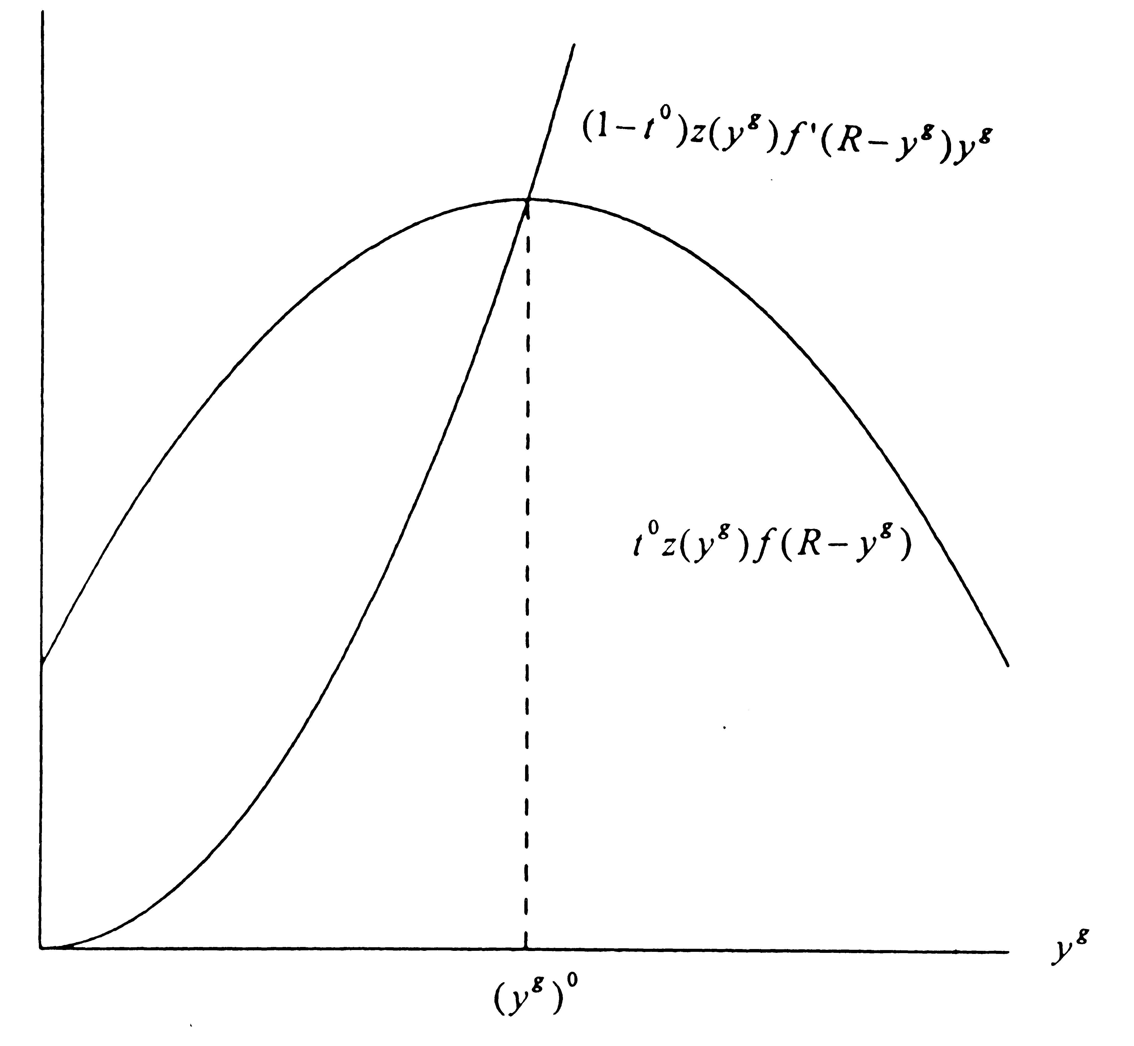

Figure 1. The Government Budget Constraint in General Equilibrium

As compared to a budget maximizing bureaucracy, the selfish dictator creates serious, uncontrollable welfare problems. At least in principle, Leviathan in the form of a budget maximizing bureaucracy could be tamed by appropriate fiscal rules (i.e. assigning the optimal tax rate). In this case the self-interested bureaucracy is guided by an invisible hand to support the welfare of society. This information is compiled in Figure 1.
There is an important difference between our more general model and the special one discussed by Findlay and Wilson. If a consumption-leisure effect remains excluded, the government could set $t=1$and confiscate the whole of the private production. In the general case, there is a well defined tax rate $0<t<1$which maximizes government appropriation, i.e. Keynesian government expenditures or the budget surplus. We refer to our numerical illustrations in Section 4 and state without proof that the general case can be pictured in a qualitative similar way as in their model, which is condensed in Figure 1.
Some interesting results can be derived from a partial structure of our model. These results have immediate bearing on the interpretation of macroeconomic processes and provide possible interpretations both on the size and the growth of the public sector. The assumption is that the real wage rate is fixed at a level too high to support a welfare-maximizing equilibrium. There is no need to work with specific production functions. For the results to be derived only the usual assumption about the signs of the first and second derivatives are sufficient. Essential for the analysis is the fact that the profit share in the functional income distribution is a variable.
$z(y^{g})f^{'}(y^{p})=w$,
$y^{g}+y^{p}=R$, (I)
$x−z(y^{g})f(y^{p})=0$,
$\text{tx}−(1−t){\text{wy}}^{g}=x^{g}$.
A linear approximation of the system yields:
$$\begin{aligned}\begin{aligned}\left(z^{'}(y^{g})f^{'}(y^{p})z(y^{g})f^{''}(y^{p})00 | \right)\left(1100 | \right)\left(−z^{'}(y^{g})f(y^{p})−z(y^{g})f^{'}(y^{p})10 | \right) \\ \end{aligned} \\ \end{aligned}$$
Let us assume that the changes in the time endowment, $\text{dR}$, and in discretionary expenditure, ${\text{dx}}^{g}$, are zero. The resulting response pattern for a change in the wage rate, w, reads as:
$\frac{{\text{dy}}^{g}}{\text{dw}}=\frac{(x+{\text{wy}}^{g})}{D}>0$. (2.14)
$\frac{{\text{dy}}^{p}}{\text{dw}}=\frac{−(x+{\text{wy}}^{g})}{D}<0$. (2.15)
$\frac{\text{dx}}{\text{dw}}=\frac{(x+{\text{wy}}^{g})}{D}[z^{'}(y^{g})f(y^{p})−z(y^{g})f^{'}(y^{p})]<0$. (2.16)
$D=(x+{\text{wy}}^{g})[z^{'}(y^{g})f^{'}(y^{p})−z(y^{g})f^{''}(y^{p})]>0$. (2.17)
If the wage rate is set above the efficiency level, the marginal product of labor in the private sector is higher than the corresponding marginal product in the public sector:
$zf^{'}>z^{'}f$.
In this range an increase in w will reduce private production, x. Because the model prevents the government from running a deficit and $x^{g}$ remains constant, the marginal tax rate, t , will adjust. Equation 2.18 shows that this rate will increase:
$\begin{aligned}\frac{\text{dt}}{\text{dw}}=\frac{1}{D}\left\{\right.1−t)y^{g}[z^{'}(y^{g})f^{'}(y^{p})−z(y^{g})f^{''}(y^{p})]+ \\ t[z(y^{g})f^{'}(y^{p})−z^{'}(y^{g})f(y^{p})]+\left.(1−t)w\right\}>0\text{.}\end{aligned}$ (2.18)
The change in disposable labor income can be calculated from a change in the net wage rate, $w^{n}$, because the government guarantees “full” employment by hiring any excess supply of labor at the prevailing wage rate.
$w^{n}=(1−t)w$. (2.19)
Using equation 2.18 we may write
$\frac{{\text{dw}}^{n}}{\text{dw}}=(1−t)\frac{\text{dw}}{\text{dw}}−w\frac{\text{dt}}{\text{dw}}$ (2.20)
Equation 2.20 yields a rather complex expression. We follow our intuition and state without proof that for a range of wage rates above the efficiency level an increase in the gross wage rate will lead to a corresponding increase in the net wage rate, too. This is indeed an elaborate argument for collective wage bargaining. A weaker argument, however, may be sufficient: Similar to the familiar wage-push theory of inflation, organized labor might initiate a wage-tax spiral over time. The argument will be reinforced if the government is allowed to run deficits and to shift the relative tax rate from labor to capital. These results and the thrust of the general discussion could provide evidence for the hypothesis that even if the median voter or an anonymous group of bureaucrats does not exercise power to affect the budget, organized labor, possibly in tacit or implicit agreement with the incumbent bureaucracy, may be the decisive group, determining the size of the budget over time.
Let us conclude this section by adding some remarks on the effects of changes in the other parameters of the model. An increase in R will produce higher employment levels in both sectors. These effects are neither equal nor proportional. The increase in private employment will produce an increase in private production. To finance the increased public employment level taxes must be increased. The qualitative information provided by the production functions, however, is not sufficient to decide in what direction the tax rate will change, given the endogenous increase of tax revenues provided by the higher tax base, x.
Changes in discretionary government expenditures constitute pure economic waste because the level of private production, x, remains unaffected. Inspection of our system demonstrates that a change of $x^{g}$ has no effect on the employment levels $y^{g}$ and $y^{p}$. The crowding-out of private expenditures by public expenditures will be brought about by an increase in taxes induced by a higher marginal tax rate.
The above stated results are the main implications of our simple model. An appendix included at the end of the paper describes alternative socio-economic arrangements derived from the basic model and focuses on Leviathan’s activities introduced in two variants.

3. THE ECONOMIC POLICY PROBLEM FOR A BENEVOLENT DICTATOR

$U=u(x_{1},x_{2},z)+(R−y^{w})\text{.}$ (3.1)
Utility is a function of two goods produced by the private sector,$x_{1}$and $x_{2}$, and a pure public good, z, produced by the government. The component u is a strictly concave function. Leisure,$y,$as in the above model is the difference between the total time endowment and the time supplied for work. The budget constraint for the consumer reads as
${\text{wy}}^{w}+p=p_{1}x_{1}+p_{2}x_{2}\text{.}$ (3.2)
The private goods are produced by a representative firm and are available at competitive gross prices,$p_{1}$and$p_{2}\text{.}$Nominal profits,$p,$plus nominal wages,${\text{wy}}^{w},$define the income of the representative consumer. In our first model a proportional income tax specified the second-best tax arrangement. Given the fact that it is not possible to tax the time endowment, charging commodity taxes is the efficient second-best solution here.
The consumptive optimum is described by two equations:
$\frac{p_{1}}{w}=\frac{¶u}{¶x_{1}},$ $\frac{p_{2}}{w}=\frac{¶u}{¶x_{2}}\text{.}$ (3.3), (3.4)
Equation (3.5) specifies the productive possibilities open to the private firm. The variable$y^{p}$indicates the labor input used to produce the private goods. To keep the model as general as possible, we continue to include$z$as an efficiency parameter in the private production function. To facilitate the reconstruction of the model, the supply quantities are identified by asterisks:
$y^{p}=y^{p}(x_{1}^{},x_{2}^{},z)\text{.}$ (3.5)
Equation 3.6 defines profits whereby the net sales revenue is the product of the net prices and the quantities sold. The specific tax rates $t_{1}$ and $t_{2}$ are stated in terms of the number of numéraire units per unit of product sold.
$p=(p_{1}−t_{1})x_{1}^{}+(p_{2}−t_{2})x_{2}^{}−{\text{wy}}^{p}(x_{1}^{},x_{2}^{},z)\text{.}$ (3.6)
The productive optimum is described by two equations:
$\frac{p_{1}}{w}=\frac{t_{1}}{w}+\frac{¶y^{p}}{¶x_{1}^{}},$ $\frac{p_{2}}{w}=\frac{t_{2}}{w}+\frac{¶y^{p}}{¶x_{2}^{}}\text{.}$ (3.7), (3.8)
The input requirement for the production of the public good which is under the control of the government is stated in equation 3.9:
$y^{g}=y^{g}(z)\text{.}$ (3.9)
The tax revenues are used to finance the production of the public good. The government budget has to be balanced, a fact which prevents the government from generating a surplus:
$t_{1}x_{1}^{}+t_{2}x_{2}^{}={\text{wy}}^{g}(z)ºC(z)\text{.}$ (3.10)
Market equilibrium is described by three equations, although by referring to Walras’ law, only two are independent:
$x_{1}=x_{1}^{},$ $x_{2}=x_{2}^{},$ $y^{w}=y^{p}+y^{g}$. (3.11) - (3.13)
The model specifies twelve independent equations to determine twelve independent variables, if the nominal wage rate, w, is set equal to one and the tax rates are treated as policy parameters.
Given the utility function, the solutions for $x_{1}$ and $x_{2}$ have a simple form:
$x_{1}=x_{1}(\frac{t_{1}}{w},\frac{t_{2}}{w},z),$ $x_{2}=x_{2}(\frac{t_{1}}{w},\frac{t_{2}}{w},z)\text{.}$ (3.14), (3.15)
A benevolent dictator or an enlightened social planner will maximize social welfare subject to the government budget constraint:
$\text{Max}U=u\left[x_{1}(\text{.}),x_{2}(\text{.}),z\right]+$$\left\{R−\frac{t_{1}}{w}x_{1}(\text{.})−\frac{t_{2}}{w}x_{2}(\text{.})−y^{p}\left[x_{1}(\text{.}),x_{2}(\text{.}),z\right]\right\}$ (3.16)
subject to $t_{1}x_{1}(\text{.})+t_{2}x_{2}(\text{.})=C(z)$.
We recall that $x_{1}$ and $x_{2}$ are determined by a first stage maximization process which allows to interpret the utility function in 3.16 as an indirect utility function. We also notice that the quantities in the budget restraint are replaced by using equations 3.14 and 3.15.
If $λ$ is introduced as an undetermined multiplier, the necessary conditions for the solution of the policy problem can be derived. Needless to say, the solution describes only a second-best optimum:
$\frac{¶u}{¶z}−\frac{t_{1}}{w}\frac{¶x_{1}}{¶z}−\frac{t_{2}}{w}\frac{¶x_{2}}{¶z}−\frac{¶y^{p}}{¶z}=λ(\frac{¶C}{¶z}−t_{1}\frac{¶x_{1}}{¶z}−t_{2}\frac{¶x_{2}}{¶z}),$ (3.17)
$t_{1}\frac{¶x_{1}}{¶t_{1}}+t_{2}\frac{¶x_{2}}{¶t_{1}}=\frac{1−wλ}{wλ}x_{1},$ (3.18)
$t_{1}\frac{¶x_{1}}{¶t_{2}}+t_{2}\frac{¶x_{2}}{¶t_{2}}=\frac{1−wλ}{wλ}x_{2}\text{.}$ (3.19)
Equation 3.17 reads as a modified variant of the familiar Samuelson condition for the optimal supply of public goods. Including z in 3.14 and 3.15 will effect the tax bases, which carry over to the last two terms in brackets. The multiplier$λ$identifies the shadow price of the costs of producing the public good reduced by the above mentioned revenue effects. As illustrated by the numerical example in Section 4, this shadow price is greater than one. The net marginal willingness to pay is measured by the expression on the left side of the equation. The term in brackets on the right side adjusts the cost of producing the public good by the marginal net revenue induced by the increase in the quantities of the private goods caused by the larger quantity of the public good. The two other equations, 3.18 and 3.19, depict the so-called Ramsey-Boiteux conditions. Because an income effect is not operating in the standard demand functions for x₁ and x₂, the cross effects are symmetrical. This yields the following formulation:
$t_{1}\frac{¶x_{1}}{¶t_{1}}+t_{2}\frac{¶x_{1}}{¶t_{2}}=\frac{1−wλ}{wλ}x_{1},$ (3.18a)
$t_{1}\frac{¶x_{2}}{¶t_{1}}+\frac{¶x_{2}}{¶t_{2}}=\frac{1−wλ}{wλ}x_{2}$. (3.19a)
Only if the two goods are unrelated, both in demand and supply, the simpler form of the inverse elasticity rule can be derived.
To relate the analysis directly to Section 2 and illustrate the argument by a concrete numerical example, some simplifications are appropriate. Because working with two private goods does not provide further insights, the analysis can be simplified here, too.

4. THE SIZE OF GOVERNMENT UNDER COMPETING POLICY OBJECTIVES: SOME NUMERICAL ILLUSTRATIONS

By restricting the structure of the model to only one private good which remains earmarked for taxation, the Ramsey-Boiteux conditions are reduced to the following equation:
$t\frac{¶x}{¶t}=\frac{1−λw}{λw}x$.
The simplified functional forms allow us to illustrate the qualitative analysis by working with a concrete numerical example. Given the structure of the model, the proportional (or flat rate) income-tax regime is equivalent to a value-added tax regime. The latter in turn can be derived from our commodity tax on x.
Our model will now be adjusted in such a way to allow for a direct computation of the reduced forms without starting in a possibly nonstractable way from the first-order conditions and transform the problem to a second-stage maximization problem. Because the functional form of the utility function is maintained, the profit variable materializes as an additive term in an otherwise log-linear system. In the following equation 3.5a $β_{1}$will be set equal to one to keep marginal costs constant. In extension of the previous model the effect of$z$on the employment level in the private sector,$y^{p},$is subject to decreasing returns, i.e.$β_{2}$is larger than$−1$. It should be noted that the loss of generality caused by the following specification is acceptable because the qualitative characteristics are maintained:
$U=\text{ln}x+\text{ln}z+(R−y^{w}),\text{with}R=3$, (3.1a)
${\text{wy}}^{w}+0=\text{px},$ (3.2a)
$\frac{p}{w}=\frac{1}{x}$, (3.3a)
$y^{p}={\text{Ax}}^{β_{1}}z^{β_{2}},$ with $A=0\text{.}\text{08}$,$β_{1}=1,$and $β_{2}\text{=-}0\text{.}\text{25}$, (3.5a)
$[p=0]$, (3.6a)
$\frac{p}{w}=\frac{{\text{Az}}^{β_{2}}}{1−t}$, (3.7a)
$y^{g}={\text{Bz}}^{g},$ with $B=0\text{.}2,$and $g=5$, (3.9a)
$\text{ptx}=\text{wB}z^{g}$. (3.10a)
$p_{1}$, the price of x, will be set equal to one. The wage rate, w, will be endogenously determined. As mentioned above, t denotes a marginal commodity tax rate (resp. a value-added tax rate). The equations 3.2a to 3.10a, excluding equation 3.6a, can be written as a log-linear system and then solved in a routine way. The endogenous variables are $y^{w}$ (resp. $R−y^{w}$), $y^{p},y^{g},x,z,\text{and}w$. The tax rate, t, operates as a parameter (policy instrument) to be determined by assigning alternative roles to the government. The following equations denote the solutions for the variables entering the private agent’s utility function:
$x=(\frac{1−t}{A})(\frac{B}{t})^{\frac{β_{2}}{g}}=(\frac{1−t}{0\text{.}\text{08}})(\frac{0\text{.}2}{t})^{−0\text{.}\text{05}}$, (4.1)
$z=(\frac{t}{B})^{\frac{1}{g}}=(\frac{t}{0\text{.}2})^{0\text{.}2}$, (4.2)
$y^{w}=\frac{p}{w}x=1$. (4.3)
The remaining solutions can be derived by direct substitution into the equations of the system. Information and transaction costs may impose restrictions on the benevolent dictator, thus preventing him from pursuing a first-best optimum. Similar cost barriers will prevent the arrangement of a Lindahl-tax system. Financing the production of the public good by levying value-added taxes restrict the optimum to a second-best utility level,$U^{\text{sb}}\text{.}$It might be the case that the benevolent dictator must content himself with more conventional goals such as national product (NP), defined as $x+{\text{wy}}^{g}$, or national income (NI), recorded here as x.
The above stated reduced-form equations apply only to cases of so-called non-first-best solutions, where the representative consumer and producer are not charged the correct “price” for the public goods. A first-best solution or a utility maximum can be derived by maximizing utility subject to the resource constraints. The formal computation of a Lindahl equilibrium could follow the rules derived in the Appendix to Section 3. However, given the specification of the model, this equilibrium creates problems of interpretation: Introducing a competitive market for the public good will turn the private production function into one with increasing returns. This implies losses for the private firms. The public sector will earn profits. The sum of these two items which is positive should be included in the private sector’s budget constraint.
To derive the second-best solutions, we proceed as follows: Given the definition of the policy goal under discussion, the reduced-form solutions in terms of the tax rate are substituted for the respective variables. Setting the first derivative equal to 0 allows solving for the respective tax rate and the policy variables involved.
The first three second-best policy alternatives should be evaluated against the ideal norm of the first-best solution or the Lindahl equilibrium. The solution values for these competing arrangements are stated in Table 1. The numbers in brackets describe the case in which the productive effect of the public good remains excluded and only the utility effect is operating. The results of the simulations confirm what should be expected from a priori-reasoning: Social welfare or utility, U, is highest under the first-best or Lindahl solution. Maximizing NI instead of focussing on NP will reduce welfare. It may be surprising and may run counter to intuition that the level of employment distributed over the two sectors remains constant under all three second-best solutions. This result is the consequence of the specific form of the utility function and the fact that a profit term in the private sector budget constraint does not become operative. The employment level will be higher in the Lindahl equilibrium, which is equivalent to the first-best utility solution, because the privatization of the market for public goods generates profits as described above. Under the first-best utility solution the scarcity prices of the public good both for the consumers and the firms are implicitly included. Given the constant level of employment under second-best solutions, the interesting aspect of the numbers in Table 1 is the distribution of employment and production over the two sectors. The higher welfare under the NP-goal as compared to the NI-goal is associated with a larger public sector, measured either by tax revenues, public good production or public sector employment. Maximizing national income directs production from the public good to the private good. Maximizing second-best utility, $U^{\text{sb}}$, will reinforce this mechanism if compared to the NP-goal. Finally, a very important result should be noted: If the policies of the benevolent dictator approach the first best solution, the optimal and efficient size of the government will increase. However, to assess the consequences of the model appropriately, it should be made clear that the government materializes here in the role of a benevolent dictator and not in a Leviathan who will be analyzed in Section 5.

Goal | U | $$R−y^{w}$$ | $$y^{p}$$ | $$y^{g}$$ | $$x=w$$ | z | t
$$U^{\text{sb}}$$ | 4.302 | 2 | 0.8 | 0.2 | 10.0 | 1.0 | 0.2
 | (4.296) | (2) | (0.84) | (0.16) | (10.35) | (0.96) | (0.16)
NP | 4.292 | 2 | 0.84 | 0.16 | 10.42 | 0.95 | 0.16
 | (4.015) | (2) | (0.5) | (0.5) | (6.25) | 1.2 | 0.5
NI | 4.114 | 2 | 0.95 | 0.05 | 11.04 | 0.75 | 0.05
 | not def. | (2) | (1.0) | (0) | (12.5) | (0) | (0)
U | 4.340 | 1.75 | 1.0 | 0.25 |  | 1.05
Lindahl | 4.340 | 1.75 | 1.0 | 0.21 | 12.7 | 1.05 | $$\begin{aligned}t_{z}^{f}=3\text{.}\text{34} \\ t_{z}^{c}=\text{12}\text{.}\text{10}\end{aligned}$$

Table 1. Efficient Size of Government under Competing Goals

Once more, our model incorporates a productive government should be contrasted with the standard macroeconomic model in which the government has no useful role to play. At least under full employment, the welfare-maximizing size of the government is simply zero.
The reduced-form equation 4.1 specifies a Laffer-type curve for x. As shown in Table 1, this curve has a regular maximum at the tax rate $t=0\text{.}\text{05}$ (see row for NI in Table 1). A government maximizing tax revenues will operate on the Laffer curve—in the usual denotation—and thereby, as a typical monopolist, fix a tax rate in the falling range of the reduced-form equation for x. Under the specified parameter constellation, tax revenues are:
$\text{ln}(\text{tx})=\text{ln}t+\text{ln}(1−t)−\text{ln}A−\frac{β_{2}}{g}\text{ln}t+\frac{β_{2}}{g}1nB\text{.}$ (4.4)
The first-order condition,
$$\frac{d\text{ln}(\text{tx})}{\text{dt}}=\frac{1}{t}−\frac{1}{1−t}−\frac{β_{2}}{g}\frac{1}{t}=0$$
yields a tax rate $t»0\text{.}\text{51}\text{for}\frac{d^{2}\text{/ln}(\text{tx})}{{\text{dt}}^{2}}<0\text{.}$

5. GOVERNMENT AS LEVIATHAN

The benevolent (and efficient) dictator is the implicit role model of the more orthodox public finance literature. The results derived from such a model are not different from an extreme variant of a public choice model where an enlightened median voter is able to fully constrain the political process from the demand side. As in Section 2, it makes sense to contrast this case with a Leviathan government. Leviathan may either materialize as a surplus-maximizing dictator or a budget-maximizing anonymous bureaucracy. In this final section we concentrate only on this second variant.
It should be noted that the typical model of the literature, incorporating a revenue-maximizing politician-bureaucrat with standard reference to Niskanen (1968 and 1971), remains incomplete as long as it ignores the productive activities provided by the government. In order to prevent a so-called worst case scenario leading to a complete confiscation of private production, the familiar consumption-leisure trade-off will be retained. Including a production function for the public good in connection with the revenue-maximizing hypothesis reveals some surprising results for efficiency. The politician-bureaucrat, at least in a technical sense, is forced to be efficient in order to maximize tax revenues.
To illustrate the results, the standard microeconomic technique contrasting indifference relations with underlying restrictions can be used. A graphic analysis allows us to separate the behavior of a Leviathan bureaucracy from that of the benevolent dictator.
For the consumer-voter both the tax rate and the quantity of the public good are given parameters. A benevolent dictator will strive to maximize the private agent’s utility function:
$U={\text{xze}}^{(R−y^{w})}$ (5.1), [(3.1a)]
Substituting from equation 4.1 and 4.2 and applying equation 4.3 to simplify the expressions yields
$U=\frac{1−t}{A}z^{(1−β_{2})}e^{(R−1)}=\frac{1−t}{0\text{.}\text{08}}z^{1\text{.}\text{25}}e^{2}$.
The marginal rate of substitution in t-z-space has a positive slope because the tax rate operates as an economic bad. The rate of change of the slope of an indifference curve is negative:
$\frac{\text{dt}}{\text{dz}}|_{U}>0$, $\frac{d^{2}t}{{\text{dz}}^{z}}<0$.
Both in Figures 2 and 3 three typical indifference curves are presented. For the moment the set of indifference curves, $U_{0}^{g},U_{1}^{g}\text{and}U_{2}^{g}$, which will be discussed in a moment, should be ignored.
The efficiency line or restriction depicting the maximum level of the public good for any given tax rate is identical with the reduced form equation 4.2 for z. The efficiency line has a positive slope throughout, due to the fact that the demand function for x has unitary elasticity:
$t=0\text{.}2z^{5}$, $\frac{\text{dt}}{\text{dz}}|_{E}>0,\frac{d^{2}t}{{\text{dz}}^{z}}>0$. (5.2), [(4.2)]

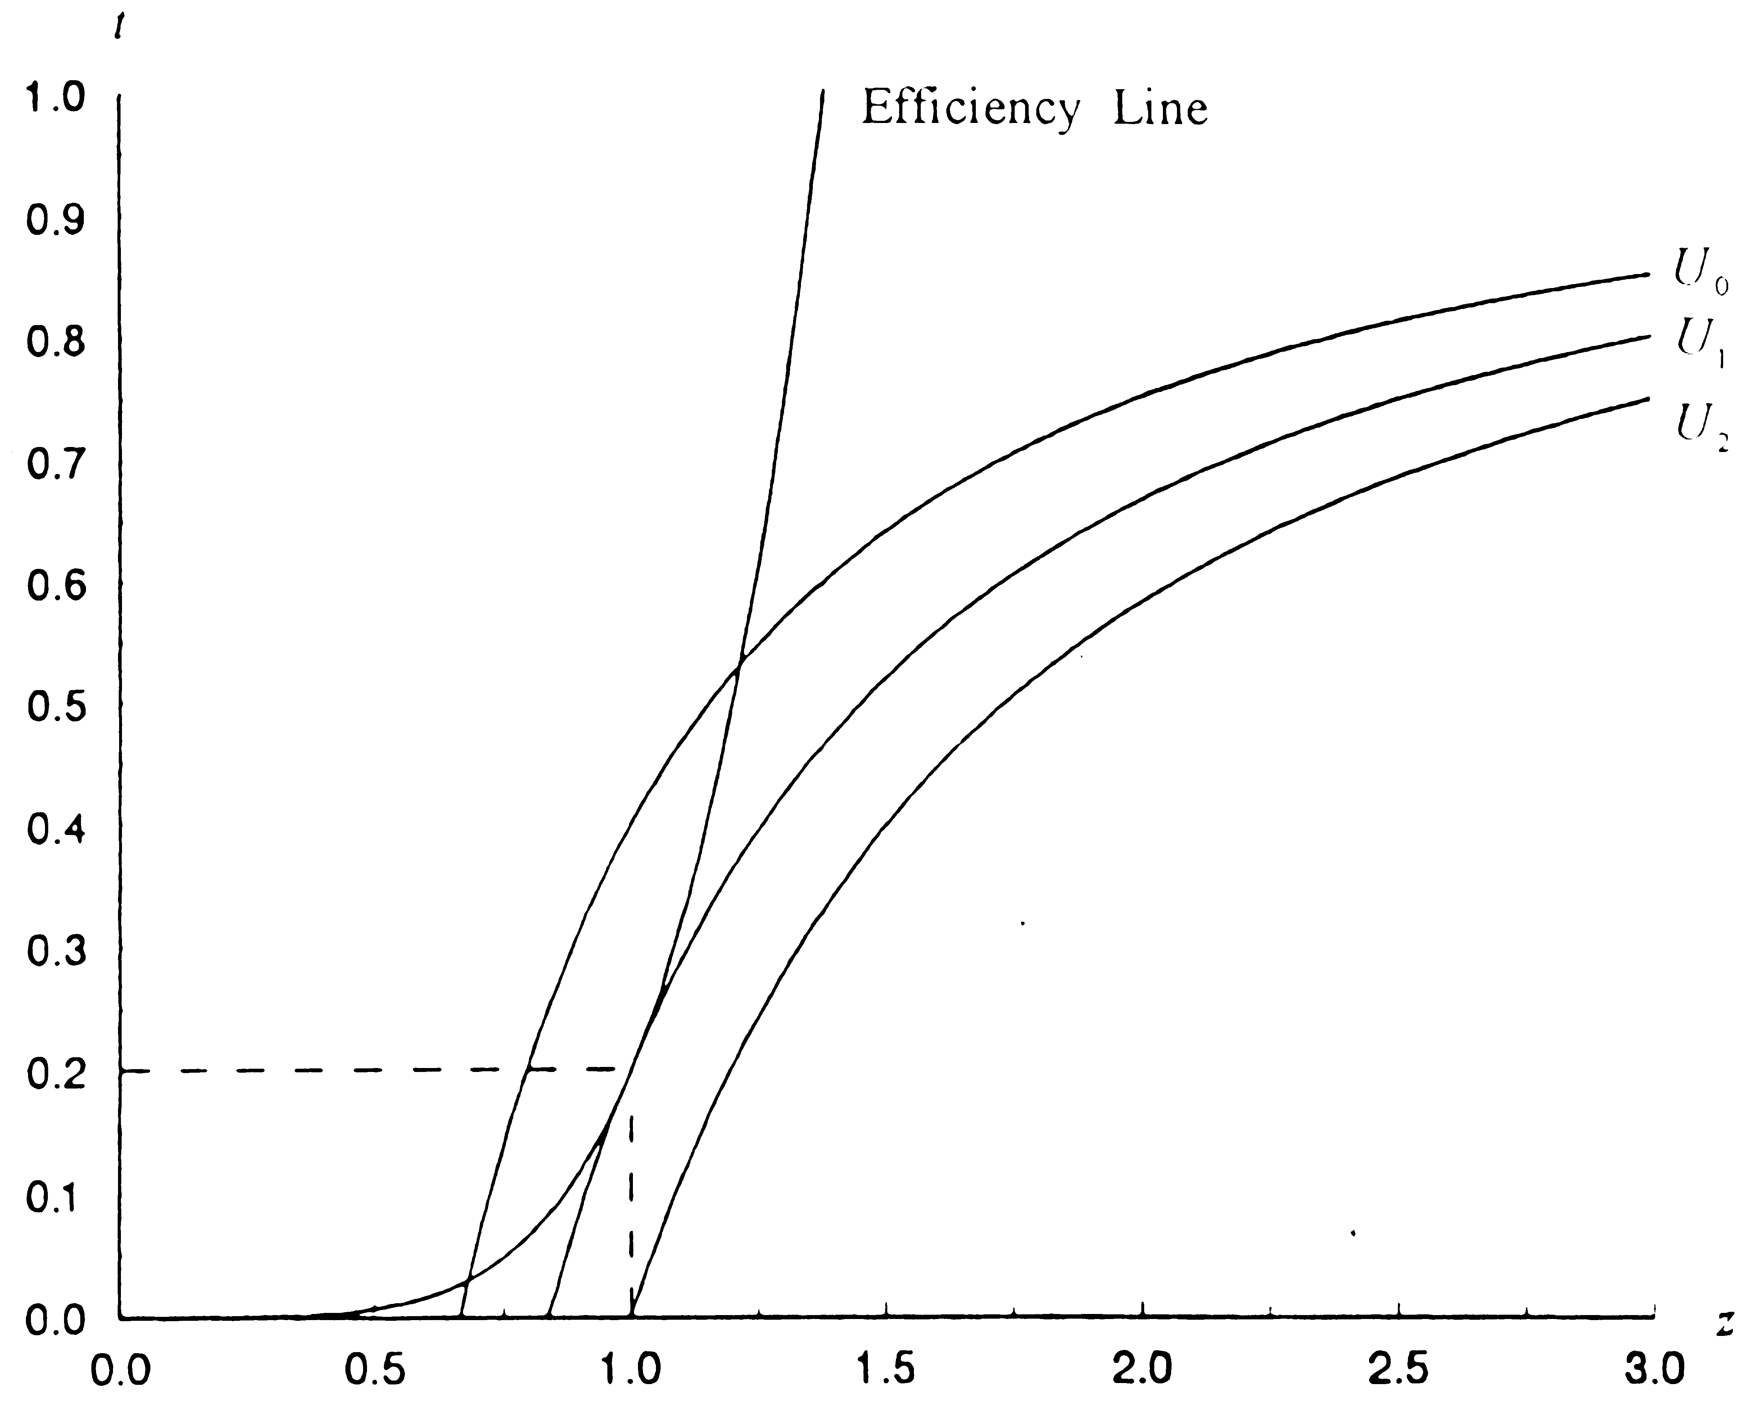
Figure 2. The Second-Best Optimum

The efficiency line is depicted both in Figures 2 and 3. The standard microeconomic problem can be solved in a routine way. Figure 2 illustrates the optimization problem for a benevolent dictator with the implicit second-best solution for utility. The solution values, $z=1$ and $t=0\text{.}2$, reproduce the second-best solution for utility, $U^{\text{sb}}$, shown in Table 1.
Our simple hypothesis for the politician-bureaucrat is that he strives to maximize tax revenues:
$U^{g}=\text{tx}$. (5.3)
Substituting the reduced form for z yields
$$U^{g}=t(\frac{1−t}{0\text{.}\text{08}})(\frac{t}{0\text{.}2})^{0\text{.}\text{05}}\text{.}$$
As shown in the last section—see equation 4.4—maximizing tax revenues results in a tax rate that is much higher than the one maximizing the Laffer curve for x. The quantity of the public good, z, associated with the revenue-maximizing tax rate $t=0\text{.}\text{51}$ is 1.21.
This solution could, of course, be derived by using standard indifference curves to be derived from the following utility function:
$$U^{g}=t\frac{1−t}{0\text{.}\text{08}}z^{0\text{.}\text{25}}\text{.}$$
The substitution procedure parallels the one described above. Without further discussion we graph the government’s indifference curves shown in Figure 3. It certainly does not come as a surprise that the size of government under this hypothesis will be more excessive, thereby reducing utility or welfare.

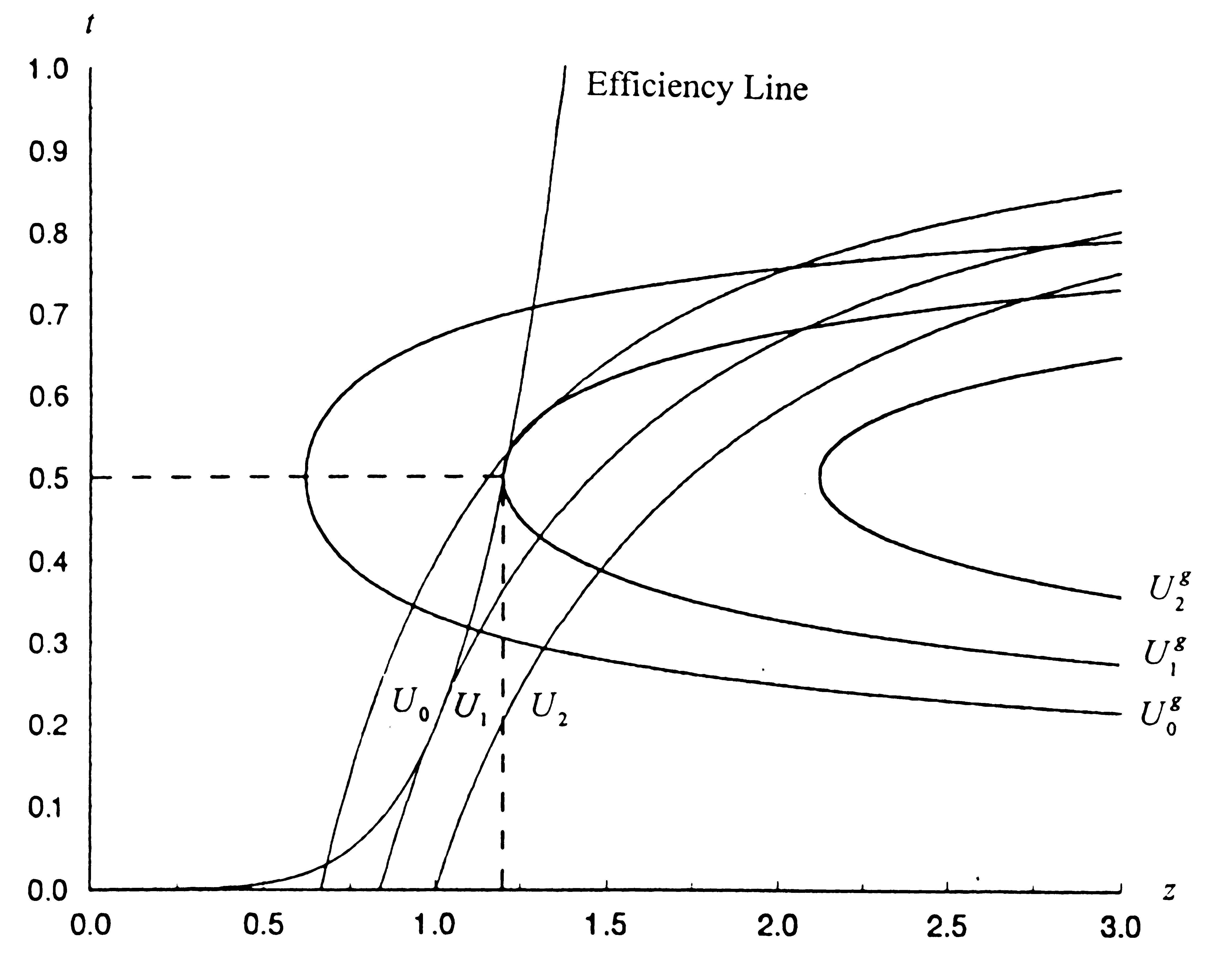
Figure 3. The Budget-Maximizing Bureaucrat

6. SUMMARY

In the preceding discussion we have tried to reconcile the neoclassical approach of optimal tax theory with a simple public choice model. The analytical basis for this attempt was provided by a general equilibrium model with a public good produced by the government which enhances utility and increases the productivity of the private sector. The public good is financed by levying optimal second-best taxes given the fact that the prevailing institutional arrangement prevents a first-best solution.
In Section 2, a simple choice-theoretical model was presented in which the public good operates only as a productive factor via the infrastructure thereby enhancing the productivity of the private sector. The income tax system operates as a flat income tax. Given the optimal tax rate, the appropriate rule for a welfare maximizing dictator is to balance the budget. The same unintended social consequences are brought about by a budget-maximizing bureaucracy constrained by the same optimal income tax rate. The basic model proved especially useful in the modeling of alternative social arrangements: e.g., if organized labor succeeds in fixing the real wage rate over the efficiency level, the marginal productivity in the private sector will increase both because the level of private employment will decrease and the level of public employment will increase. As the government is forced to pay competitive wages, this collective action leads to a redistribution of income from capital to labor, thereby increasing the size of the government. It should be emphasized that the model of a productive government could be reformulated without analytical difficulties to extend or to replace the typical Keynesian perspective of the standard macroeconomic models. Leviathan played either the role of a budget-maximizing bureaucrat or a surplus-maximizing selfish dictator.
In Section 3 the economic problem for a benevolent dictator was discussed from the perspective of the theory of optimal taxation. Because several private goods were included, the second-best tax system is one of distinct commodity taxes. If only one private good is available, a commodity-tax system can be easily transformed into a value-added tax system which under the structure of the model is equivalent to a proportional income tax system. This more technical discussion was used to derive some useful first-best conditions which are important for the institutionalization of a demand-revealing process or possible Lindahl-tax prices.
The main part of Section 3 was the analysis of alternative government arrangements based on a concrete numerical example where the public good operated both through the utility function of the representative agent and the production function of the private sector. The pattern of production and employment under alternative governmental goals was derived for a benevolent dictator. The “first-best” or Lindahl solution thereby supplied the reference situation against which competing goals such as aggregate consumer surplus, national product or national income could be evaluated. Rather surprisingly, the size of the government increased with government efforts to maximize welfare by establishing a more efficient tax rate. Subsequently, the behavior of an optimizing politician-bureaucrat was modeled according to a Leviathan perspective, whereby the relevant structural restrictions were consistently derived and not postulated in an ad hoc fashion. The excessive size of government in this case did not come as a surprise. A graphic illustration helped to elucidate the analysis and summarize the major results.
The deplorable fact of excessive (inefficient measured against optimal “social welfare”) government size along an explosive growth path for almost all Western countries would certainly suggest the need for fiscal reforms on a constitutional level. Constitutional limitations upon government taxing activities as proposed by Buchanan and Brennan are without doubt a most effective recipe for taming Leviathan. A serious objection, of course, remains because pulling away the government from the Leviathan equilibrium is no guarantee that the new equilibrium is preferable from an overall welfare point of view. Further understanding of the welfare reducing effects of a Leviathan government presupposes opening the “black box” called government and analyzing its internal structure and organization. This procedure, however, remains basically a partial one with the difficulties holding the strings together under a general equilibrium perspective. The main theoretical avenue seems to be clear: Fiscal reforms should start from an economic model of the behavior of the politician-bureaucrat, whereby modern microeconomics could provide the technical details for an efficiently designed contract mechanism. Such a mechanism, together with the specification of the proper role of the government in a market economy, could provide efficient incentives for the political actor to redirect his behavior toward a “first-best” solution.

Appendix to Section 2: Some Variations of the Basic Model

Model II restates a second-best utility solution excluding the consumption-leisure trade-off of the general model:
$z(y^{g})f^{'}(y^{p})−w=0$,
$y^{g}+y^{p}=R$, (II)
$z(y^{g})f^{'}(y^{p})+z^{'}(y^{g})f(y^{p})=0$,
$x−z(y^{g})f(y^{p})=0$,
$\text{tx}−(1−t){\text{wy}}^{g}=x^{g}$.
The endogenous variables are $y^{g},y^{p},x,w,$ and $t\text{.}$
If a consumption-leisure trade-off is included, the economic process is described by model III:
$z(y^{g})f^{'}(y^{p})−w=0$,
$y^{g}+y^{p}+[(1−t)w]^{−\frac{1}{q}}=R$, (III)
$x−z(y^{g})f(y^{p})=0$,
$\text{tx}−(1−t){\text{wy}}^{g}=x^{g}$.
The endogenous variables are $y^{g},y^{p},x$, and$w\text{.}$ Including our efficiency condition will endogenize t. It is possible to include the utility function as a second-best welfare function, too. This procedure constitutes the subject matter of Section 4 and 5.
Model IV and model V could be used to analyze Leviathan in either of two roles: A specific dictator will maximize $x^{g}$, and an anonymous group of bureaucrats aims at maximizing the size of the budget. If the Leviathan of model V uses the tax rate as an instrument the government, as a monopolist, will operate in the declining range of a curve relating x to t (see Section 4). Model IV reads as:
$z(y^{g})f^{'}(y^{p})−w=0$,
$y^{g}+y^{p}+[(1−t)w]^{−\frac{1}{q}}=R$, (IV)
$x−z(y^{g})f(y^{p})=0$,
$\text{tx}−(1−t){\text{wy}}^{g}−x^{g}=0$.
The endogenous variables are $y^{p},x,w$, and$x^{p}\text{.}$Including the efficiency condition from equation 2.5, once more, will endogenize t.
$z(y^{g})f^{'}(y^{p})−w=0$,
$y^{g}+y^{p}=R$, (V)
$x−z(y^{g})f(y^{p})=0$,
$\text{tx}−(1−t){\text{wy}}^{g}=0$,
$T−\text{tx}=0$.
The endogenous variables are $y^{g},y^{p},x,w$, and T.

Appendix to Section 3: Some General Welfare Remarks

Given the case of one private good, x, and one public good, z, an omniscient benevolent dictator would maximize social welfare or aggregate consumer surplus which is much simplified by the fact that only one representative consumer is included:
$$\text{Max}U=u(x,z)+\left[R−y^{p}(x,z)−y^{g}(z)\right]\text{.}$$
The first order conditions are as follows:
$\frac{¶U}{¶x}=\frac{¶y^{p}}{¶x}\text{and}$$\frac{¶U}{¶z}−\frac{¶y^{p}}{¶z}=\frac{¶y^{g}}{¶z}\text{.}$
From these equations the conditions for an equivalent Lindahl equilibrium may be reconstructed:
$\frac{¶U}{¶x}=\frac{¶y^{p}}{¶x},$$p_{z}^{c}=w\frac{¶u}{¶z},$ and $p_{z}^{f}\text{=-}w\frac{¶y^{p}}{¶z}\text{.}$
The personalized prices $p_{z}^{c}$ and $p_{z}^{f}$ denote the marginal willingness to pay of consumers and firms respectively. These equations can be rearranged to yield the familiar Lindahl conditions which are nothing more than another expression for the general Samuelson conditions:
$p_{z}^{c}+p_{z}^{f}=w\frac{¶y^{g}}{¶z}º\frac{¶C}{¶z}=(t_{z}^{c}+t_{z}^{f})$.
The Lindahl equilibrium thus selects the first-best optimum.
Our abstract analysis has direct bearing on a number of interesting policy applications among which the demand-revealing scheme seems to be the most important. Demand-revelation could overcome the incentive problem inherent in the Lindahl-tax scheme. Tullock (together with Nicolas Tidemann) not only coined the term “rent-seeking” but he himself contributed to the theoretical development of this theory (e.g. Tidemann and Tullock, [1976]).

NOTES

* The author gratefully acknowledges helpful comments and suggestions by Price Fishback, Günter Krause, Stephan Monissen and the participants of the conference. Of course, any remaining errors and omissions are those of the author.
The 5th Edition from 1989 was revised 1994 and retitled. The 5th Edition was reissued 1994 as The New World of Economics. Gordon Tullock’s public choice perspective is included in a later book which unfortunately did not receive the commercial influence it deserved: Gordon Tullock and Richard B. McKenzie (1978). “On the Trail of Homo Economicus” is the apt title of a collection of Gordon Tullock’s unpublished papers edited by Gordon L. Brady and Robert D. Tollison (1994).
In a recent paper James Gwartney, Randall Holcombe and Robert Lawson present an empirical assessment of Adam Smith’s core functions of government (1998).
As a general reference to the modern theory of optimal taxation see Alan J. Auerbach, (1985).
This analytical variant is a useful extension of the standard positive-normative spectrum, cf. here James M. Buchanan, (1998).
The structure of the model builds on Hans G. Monissen, (1985). His model incorporates a monetary sector, an extension which has no consequence for the problems under discussion here.
See John S. Chipman for a detailed discussion of this point (1965).
The specific circumstances under which a voting process with heterogeneous actors will generate a Pareto-optimal provision of a public good are no more restrictive than those under which the representative actor operates in modern economic theory. A standard reference in this context is an early paper by Howard R. Bowen from 1943.
The model is set up in such a way that it allows approximately a sequential solution.
For a lucid discussion in the context of macroeconomic theory see Stephen McCafferty (1990).
A more general treatment is given by Hans G. Monissen (1996).
Theories trying to explain the size of government and its development over time are mushrooming. A recent popular thesis is that the openness of an economy is a critical factor. An open economy is exposed to external risk necessitating the insurance role of the government; cf. here Dani Rodrik (1998) or Alberto Alesina and Romain Wacziarg (1997).
Our figure corresponds to their Figure 8.2 on page 294.
The marginal product in the private sector which determines gross compensation of labor in the public sector is higher than the marginal product of z. If the efficiency condition is fulfilled, the change in x is zero depicting the maximum value for x.
The general argument presented here is based on the technical analysis in Claude Henry (1989).
Value-added taxes are levied ad valorem which changes the Ramsey-Boiteux condition. Tax revenues are now tpx, where t is the value-added tax rate. The Ramsey-Boiteux condition has now to be extracted from the following equation: $$\frac{¶p}{¶t}\frac{\text{tx}}{w}+\frac{\text{px}}{w}=λ(\frac{¶p}{¶t}\text{tx}+\text{px}+\text{pt}\frac{¶x}{¶t})\text{.}$$
This interesting observation should be related to the empirical findings published in a recent paper by Gary S. Becker and Casey B. Mulligan (1998). But we should note that Becker and Mulligan start from a somewhat different perspective.
It should be noted that Niskanen explicitly acknowledges here the “powerful insight” provided by Gordon Tullock (1968, p. 294).
In this context it is impossible to summarize Tullock’s guiding contributions to this problem over several decades. A representative reference is here Gordon Tullock (1992). The same problems are at present on the agenda of modern contract theorists, see for instance Jean Tirole (1982). 19 It is here where Tullock’s work on rent-seeking could be usefully integrated. The seminal contribution is Tullock’s paper from 1967. For an effort to integrate rent-seeking into a general equilibrium frame see Hans G. Monissen (1991). REFERENCES Alesina, Alberto, and Romain R. Wacziarg (1997). “Country Size and the Government.” NBER, Working Paper 6024. American Economic Review, September 1998. 88(4). Auerbach, Alan J. (1985).“The Theory of Excess Burden and Optimal Taxation.” In Alan J. Auerbach and Martin Feldstein, eds., Handbook of Public Economics. Vol. I, pp. 61-127. North Holland: Elsevier Science Publishers. Becker, Garry S. and Casey B. Mulligan (1998). “Deadweight Costs and the Size of the Government.” NBER, Working Paper 6789. Blaug, Mark (1985). Great Economists since Keynes, An Introduction to the Lives and Works of One Hundred Modern Economists. Cambridge: Cambridge University Press, pp. 252-53. Bowen, Howard R. (1943). “The Interpretation of Voting in the Allocation of Economic Resources.” Quarterly Journal of Economics 58(1) pp. 27-48. Brady, Gordon L., and Robert D. Tollison, eds. (1994). On the Trail of Homo Economicus: Essays by Gordon Tullock. Fairfax, VA: George Mason University Press. Brennan, Geoffrey, and James M. Buchanan (1977). “Towards a Tax Constitution for Leviathan.” Journal of Public Economics 8(3) pp. 255-73. Brennan, Geoffrey, and James M. Buchanan (1980). The Power to Tax: Analytical Foundations of a Fiscal Constitution. Cambridge: Cambridge University Press. Buchanan, James M. (1998). “Has Economics Lost Its Way? Reflections on the Economists’ Enterprise at Century’s End.” In James M. Buchanan and Bettina Monissen, eds., The Economists’ Vision - Essays in Modern Economic Perspectives, Frankfurt: Campus Verlag, pp. 17-29. Chipman, John S. (1965). “The Nature and Meaning of Equilibrium in Economic Theory.” In Don Martindale, ed. Functionalism in the Social Sciences: The Strength and Limits of Functionalism in Anthropology, Economics, Political Sciences and Sociology., Philadelphia: American Economic Academy of Political and Social Science, pp. 35-65; reprinted in Harry Townsend, ed., (1971) Price Theory, Selected Readings, Harmondsworth, Middlesex, England: Penguin Books Ltd., pp. 341-71. Findlay, Ronald, and John D. Wilson. (1987). “The Political Economy of Leviathan.” In Assaf Razin and Efraim Sadka, eds., Economic Policy in Theory and Practice. Houndsmill, Basingstroke, Hampshire and London: The McMillan Press Ltd., pp. 289-304. Gwartney James, Randall Holcombe, and Robert Lawson (1998). “The Scope of Government and the Wealth of Nations.” Cato Journal 18(2) pp. 163-90. Henry, Claude (1989). Microeconomics for Public Policy - Helping the Invisible Hand. Oxford: Clarendon Press,. Inman Robert P. (1982). The Economic Case for Limits to Government. American Economic Review, 72(2) pp. 176-83. Inman, Robert P. (1987). “Markets, Governments, and the ‘New’ Political Economy.” In Alan J. Auerbach and Martin Feldstein, eds., Handbook of Public Economics. Vol. 2, pp. 647-777. North Holland: Elsevier Science Publishers. McCafferty, Stephen (1990). Macroeconomics. New York: Harper & Row. Monissen, Hans G. (1985). “Optimale Staatsgröße in einem Einkommensteuerregime.” In Hellmuth Milde und Hans G. Monissen, eds., Rationale Wirtschaftspolitik in komplexen Gesellschaften pp.195-205. Stuttgart: Verlag W. Kohlhammer. Monissen, Hans G. (1991). “Rent-Seeking in General Equilibrium: A Didactic Illustration.” Public Choice 72, pp. 111-29. Monissen Hans G. (1996). “Verallgemeinerungen einfacher quasi-linearer Nutzenfunktionen.” Jahrbücher for Nationalökonomie und Statistik 15 (1) pp. 1-13. Niskanen , William A. (1968). “The Peculiar Economics of Bureaucracy.” American Economic Review 58 (2) pp. 293-305. Niskanen, William A. (1971) Bureaucracy and Representative Government. Chicago: Aldine-Atterton. Rodrik, Dani (1998). “Why Do More Open Economics Have Bigger Governments?” Journal of Political Economy 106(5) pp. 997-1032. Smith, Adam (1976). An Inquiry into the Nature and Causes of the Wealth of Nations. Edited by Edwin Cannan. Chicago: The University of Chicago Press, Volume Two, Book IV, Chap. IX. Tidemann, Nicolas T., and Gordon G. Tullock (1976). “A New and Superior Process for Making Social Choices.” Journal of Political Economy, 84(6) pp. 1145-59. Tirole, Jean (1982). “The Internal Organization of Government.” Oxford Economic Papers 46, pp. 1-29. Tullock, Gordon (1967). “The Welfare Costs of Tariffs, Monopolies and Theft.” Western Economic Journal 5, pp. 224-32. Tullock, Gordon (1992). Economic Hierarchies, Organization and the Structure of Production. Studies in Public Choice. Norwell, MA/Dordrecht: Kluwer Academic Publishers. Tullock, Gordon, and Richard B. McKenzie (1975). The New World of Economics: Explorations into the Human Experience. Homewood, IL: Richard D. Irwin. Tullock, Gordon, and Richard B. McKenzie (1978). Modern Political Economy: An Introduction to Economics. New York: McGraw-Hill.

