Supplementary Material

Supplementary Material 1: Working Groups and Expert Profiles
Expert ID | Countries of Expertise | Disciplines | Gender | Years working in the country | Expert Working Group Number
6 | Iran | Conservation science, practitioner | M | 20 | Expert Working Group 1
8 | Iran | Practitioner | F | 20 | Expert Working Group 1
9 | Iran | Zoology, Ecology, Conservation science and practice, Human-wildlife conflicts | M | 20 | Expert Working Group 1 and 3
16 | Iran | Ecologist; Conservation Scientist | M | 33 | Expert Working Group 1
5 | Iran, Kyrgystan | Conservation Science | M | 20 | Expert Working Group 1 and 3
13 | Iran, Kyrgyzstan | Practitioner; Ecologist; Conservation Scientist | F | 30 | Expert Working Group 1 and 3
2 | Bolivia | Veterinary Medicine, Animal Husbandry, Zoology, Socio-environmental conflicts | M | 23 | Expert Working Group 2
3 | Bolivia | Practitioner; Conservation social science; Indigenous communities | F | 25 | Expert Working Group 2
7 | Bolivia | Ecology, Zoology, Conservation Science | M | 21 | Expert Working Group 2
10 | Bolivia | Ecology, Zoology, Land-use science, Remote sensing, Conservation science | M | 26 | Expert Working Group 2
12 | Bolivia | Ecologist; Conservation Science | M | 22 | Expert Working Group 2
14 | Bolivia | Land-use; Conservation Scientist | M | 33 | Expert Working Group 2
1 | Kyrgyzstan | Conservation scientist, practitioner, remote sensing | F | 11 | Expert Working Group 3
15 | Kyrgyzstan | History, Russian Studies, Conservation Practice | M | 5 | Expert Working Group 3
17 | Bolivia, Iran, Kyrgyzstan | Land-use science, conservation science | M |  | Expert Working Group 2 and 3
18 | Kyrgyzstan | Social science, socio-ecological systems, conservation science, conservation practice | F | 15 | Expert Working Group 1,2, and 3

Supplementary Material 2: Discussion Guide for the expert workshops
The expert workshops were open ended discussions guided by the conceptual framework. The discussions did not necessarily follow the format or the guide provided below, but it provides an indication of the kind of questions asked.
- Who were the main actors in the system before the shock?
- Who were the main actors in the system after the shock?
- What were their mandates? What did they influence in the system?
- What were the main institutions in the system?
- What were the rules related to protected areas?
- What were the rules related to grazing?
- What were the rules/norms related to agriculture? Water?
- What were the rules related to deforestation?
- Were there any tradtional community systems? If yes, what were they?
- Who owned agricultural land/grazing land/forest land? What were the rules around ownership/leasing/using/extraction of resources?
- What were the rules related to hunting/trade?
- What were the other kinds of institutions that impacted habitat, prey, carnivores in the system? How did they influence them?
- What happened in case on conservation conflicts? How were they resolved?
- How was information shared in this system? How did this change after the shock?
- What were the systems for monitoring and evaluation? How did they continue after the shock?
- How did behaviour change with relation to illegal hunting/trade/ harvesting/deforestation/monitoring/evaluation/conservation/migration? Why?
- What was the habitat that the carnivore occupied? How did it get impacted?
- What are the main prey species of the carnivore? How do you think they were impacted? Why?
- How was the carnivore impacted? Why?

Supplementary Material 3: The list of keywords and the time periods used for the narrative literature reviews. The keywords were used in different combinations with each other.
Case study | Keywords | Time Period
Economic sanctions on the Asiatic cheetah in Iran | "Economic Sanctions"; "Iran"; "environment"; "cheetah"; "Asiatic cheetah"; “Acinonyx jubatus venaticus”; "socio-ecological system"; "institutions"; "actors"; "grazing"; "livestock"; "management"; "governance" | 2010 - 2024
Global commodity price shock on jaguar in Bolivia | "jaguar"; “Panthera onca”; "Bolivia"; "deforestation"; "agricultural summit"; "sowing Bolivia"; "economy"; "environment"; "fires"; "illegal wildlife trade"; "poaching"; "agricultur*"; "corporation"; "actors" | 2014 - 2024
Dissolution on the Soviet Union on snow leopard in Kyrgyzstan | "Soviet Union"; "Kyrgyzstan"; "pastures"; "livestock"; "degradation"; "management"; "transition"; "snow leopard"; “Panthera uncia”; "wildlife"; "biodiversity"; "govern*"; "break-down"; "dissolution"; "environment"; "actors" | 1990 - 2024
Supplementary Material 4: The most important linkages from the case studies, indicating a casual diagram
Impacts of Economic Sanctions on the Asiatic Cheetah
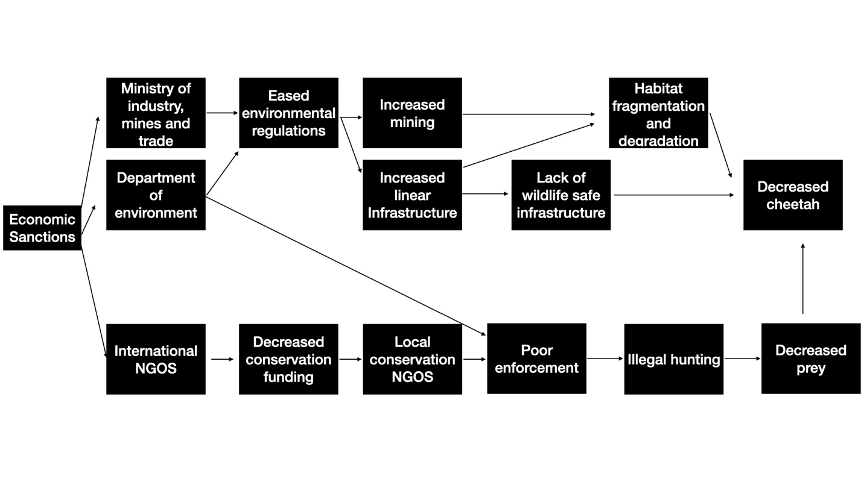

Impacts of the Global Commodity Price Crash on Jaguars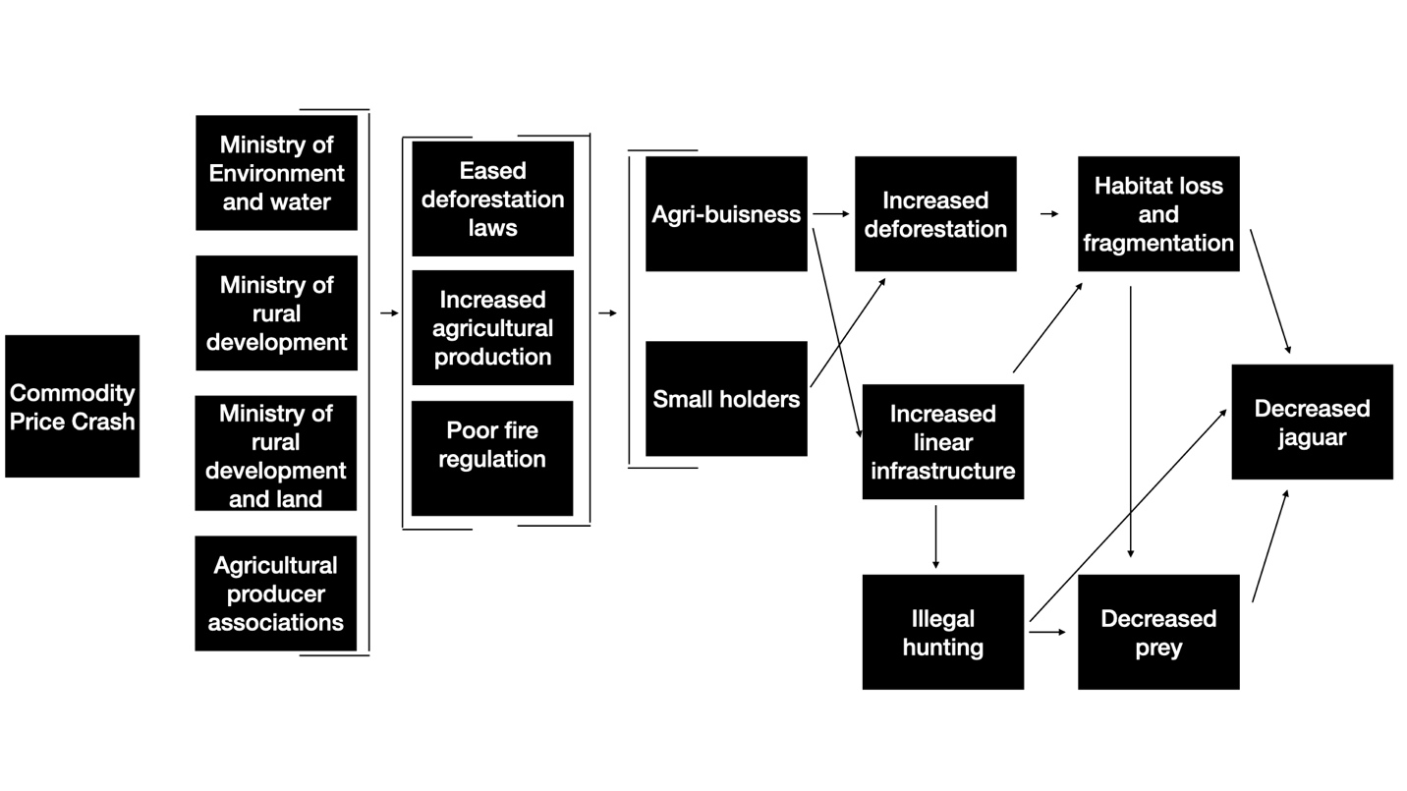

Impacts of the collapse of the Soviet Union on Snow Leopards
