Supplementary information

Appendix A
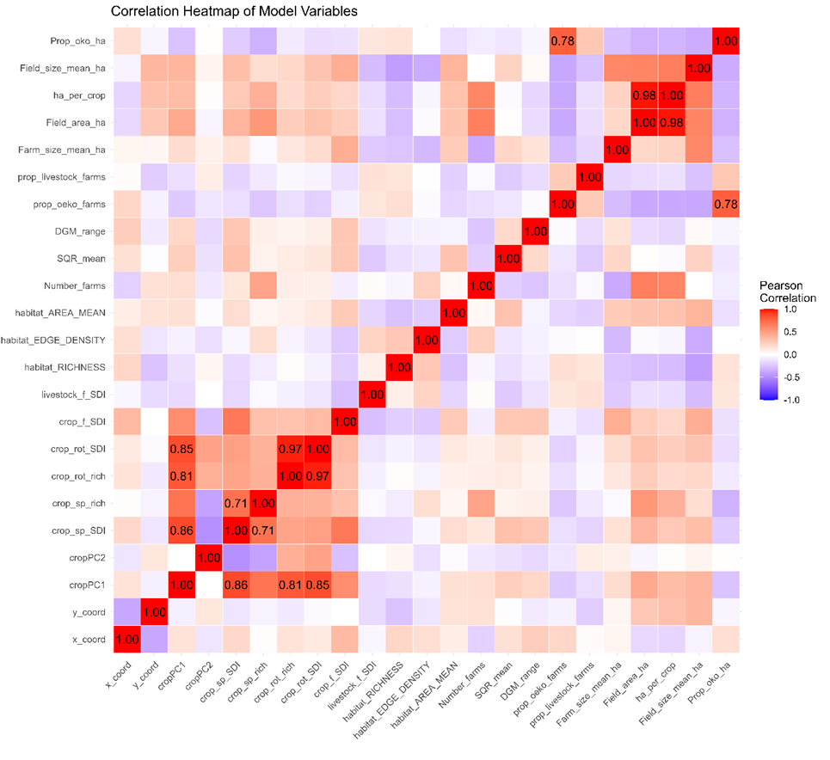
Figure A.1. Heatmap showing Pearson’s correlation between variables¹; colors range from dark red (strong positive correlation) to dark blue (strong negative correlation) with white (no correlation); labeled coefficients show absolute values of ≥ 0.7

¹Variable abbreviations: Prop_oko_ha = proportion of organic farming area; Field_size_mean_ha = field size mean in ha; ha_per_crop = theoretical area per crop in ha; Field_area_ha = area under agricultural land use; Farm_size_mean_ha = farm size mean in ha; prop_livestock_farms = proportion of livestock farms; prop_oeko_farms = proportion of farms that practice organic farming; DGM_range = slope; SQR_mean = soil quality rating mean; Number_farms = number of farms; habitat_AREA_MEAN = mean size of habitat patches; habitat_EDGE_DENSITY = edge density of habitat patches; habitat_RICHNESS = habitat richness; livestock_f = livestock diversity per farm; crop_f = crop diversity per farm; crop_rot = temporal crop diversity; crop_sp = spatial crop diversity; SDI = Shannon's diversity index; SEI = Shannon's evenness index; cropPC = principal component of crop diversity; y_coord = y coordinate; x_coord = x coordinate
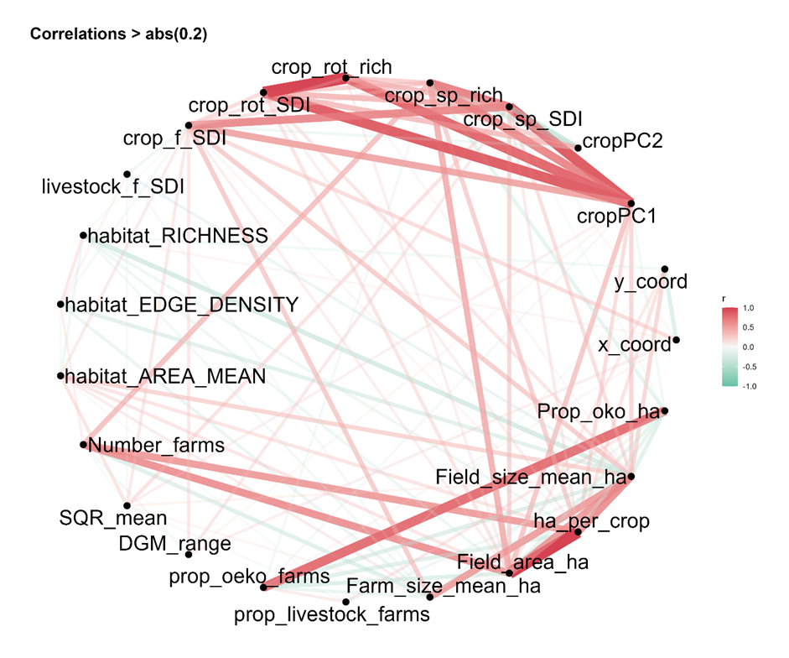
Figure A.2. Pearson’s correlation network plot; nodes indicate individual variables¹; edges represent pairwise correlations with absolute values > 0.2; edge color represents the direction of variable relationship, and thickness the strength of the correlation measured as Pearson’s correlation coefficient.

Table A.1. Annual crop distribution in hectares derived from the Integrated Administration and Control System (IACS) data
Crops | Area 2011 | Area 2012 | Area 2013 | Area 2014 | Area 2015 | Area 2016 | Area 2017 | Area 2018 | Area 2019 | Area 2020
Arable grass | 59,119.58 | 56,634.52 | 50,383.58 | 48,559.49 | 32,879.62 | 35,860.85 | 35,451.26 | 37,199.42 | 35,857.39 | 33,664.88
Legumes, extensive | 44,147.05 | 46,735.32 | 47,877.82 | 47,988.45 | 28,901.37 | 29,932.05 | 33,047.29 | 35,174.50 | 36,895.24 | 40,608.61
Legumes, intensive | 21,188.71 | 18,274.50 | 15,185.93 | 19,079.34 | 26,231.37 | 25,023.85 | 25,240.94 | 23,592.06 | 21,877.77 | 21,773.61
Maize | 189,859.94 | 192,009.95 | 185,851.29 | 194,206.77 | 194,002.70 | 197,266.48 | 207,061.10 | 212,473.22 | 229,439.13 | 234,465.57
Multi-  annual use | 336,785.81 | 329,308.75 | 324,521.03 | 319,430.46 | 343,027.89 | 346,025.97 | 350,444.76 | 362,638.01 | 362,971.98 | 362,294.70
Potato | 9,417.08 | 8,548.13 | 8,894.58 | 9,549.18 | 9,117.78 | 9,354.89 | 9,863.73 | 10,731.84 | 11,148.23 | 12,083.12
Spring cereals | 40,788.60 | 54,034.00 | 27,981.98 | 28,416.57 | 37,596.45 | 30,212.84 | 31,269.98 | 39,573.90 | 29,813.50 | 35,451.36
Sugar beet | 8,435.45 | 9,525.21 | 8,364.94 | 9,041.53 | 7,685.39 | 8,504.36 | 6,973.10 | 8,322.15 | 8,802.01 | 7,936.81
Triticale | 42,056.38 | 38,440.60 | 36,688.40 | 43,605.60 | 42,437.70 | 42,139.88 | 38,143.44 | 35,685.86 | 36,492.70 | 33,407.25
Unknown | 2,243.72 | 2,766.38 | 3,679.76 | 3,017.57 | 2,411.28 | 2.17 | 233.52 | 734.7 | 979.48 | 886.53
Others (including vegetables, herbs, oilseed, specialty crops) | 29,040.05 | 24,709.39 | 18,387.15 | 18,427.01 | 17,788.02 | 16,754.53 | 16,846.49 | 16,974.13 | 17,810.89 | 18,454.58
Winter barley | 65,545.11 | 66,231.94 | 73,240.93 | 81,405.00 | 84,669.22 | 90,874.95 | 90,434.82 | 93,936.03 | 103,802.17 | 97,791.22
Winter rapeseed | 116,751.03 | 124,341.17 | 129,973.37 | 133,055.86 | 128,634.52 | 132,637.57 | 127,075.57 | 123,151.99 | 66,547.06 | 78,267.60
Winter rye | 195,968.33 | 211,489.75 | 237,064.79 | 189,390.47 | 189,522.94 | 180,107.75 | 165,899.41 | 164,124.72 | 192,747.74 | 187,544.49
Winter wheat | 148,241.19 | 122,910.07 | 135,082.94 | 152,826.42 | 161,026.71 | 164,176.86 | 172,296.78 | 165,361.42 | 173,607.52 | 153,264.77

Table A.2. Overview of habitat and land cover classes derived from CIR2009 (Landesamt für Umwelt (LfU), 2013)
Habitat and land cover classes
Running waters
Standing waters
Anthropogenic bare soil sites and ruderal areas
Moors and swamps
Grass and herbaceous vegetation
Heath and coniferous shrubs
Deciduous shrubs, field woodlands, avenues, rows of trees
Forests
Arable land
Green and open spaces
Special habitats
Built-up areas, transport infrastructure and special areas

Table A.3. Summary statistics of variables per 10 x 10 km grid cell. PC = principal component; SDI = Shannon's diversity index; SEI = Shannon's evenness index; SQR = soil quality rating
Variable | Minimum | 1. Quantil | Median | Mean | 3. Quantil | Maximum
PC1 | -9.67 | -1.03 | 0.13 | 0.00 | 1.34 | 4.40
PC2 | -3.24 | -0.74 | -0.02 | 0.00 | 0.67 | 4.93
Spatial crop SDI | 0.21 | 1.59 | 1.78 | 1.72 | 1.90 | 2.33
Spatial crop richness | 2.00 | 12.10 | 12.80 | 12.43 | 13.30 | 14.00
Temporal crop SDI | 0.69 | 1.10 | 1.16 | 1.17 | 1.24 | 1.44
Temporal crop richness | 2.00 | 3.74 | 3.97 | 3.99 | 4.22 | 5.01
Area under agricultural land use (ha) | 429.9 | 2669.1 | 4037.0 | 4212.0 | 5678.9 | 8554.6
Field mean size (ha) | 2.59 | 6.37 | 8.14 | 8.74 | 10.335 | 22.433
Theoretical area per crop | 62.3 | 222.6 | 317.8 | 331.6 | 436.6 | 708.1
Farm mean size (ha) | 121.1 | 311.2 | 374.1 | 388.5 | 440.2 | 890.6
% organic farms | 0.00 | 0.078 | 0.12 | 0.15 | 0.19 | 0.59
% livestock farms | 0.27 | 0.47 | 0.56 | 0.56 | 0.66 | 0.81
Farm-level livestock SDI | 0.01 | 0.44 | 0.50 | 0.5 | 0.58 | 0.82
Farm-level livestock SEI | 0.01 | 0.54 | 0.61 | 0.61 | 0.69 | 0.90
Farm-level livestock richness | 1.07 | 1.27 | 1.38 | 1.40 | 1.50 | 2.22
Farm-level crop SDI | 0.58 | 0.95 | 1.06 | 1.05 | 1.17 | 1.45
Farm-level crop richness | 2.83 | 4.48 | 4.89 | 4.86 | 5.31 | 6.53
Farm-level crop SEI | 0.64 | 0.75 | 0.78 | 0.78 | 0.81 | 0.90
Number farms | 5.40 | 29.90 | 37.90 | 38.92 | 48.40 | 115.00
Habitat SDI | 0.63 | 1.18 | 1.31 | 1.32 | 1.48 | 2.02
Habitat SEI | 0.27 | 0.50 | 0.55 | 0.56 | 0.62 | 0.83
Habitat mean size | 8.79 | 19.13 | 24.57 | 35.29 | 35.42 | 749.35
Habitat edge density | 14.10 | 35.68 | 40.90 | 41.92 | 47.15 | 77.57
Habitat richness | 8.00 | 10.00 | 11.00 | 10.71 | 11.00 | 12.00
SQR mean | 40.87 | 47.67 | 50.17 | 51.13 | 53.24 | 74.71
x coordinate | 262217 | 352217 | 402217 | 391466 | 432217 | 482217
y coordinate | 5691608 | 5771608 | 5821608 | 5814817 | 5871608 | 5921608
Slope (m) | 4.68 | 28.79 | 44.24 | 47.90 | 63.78 | 141.89

Appendix B
Table B.1. Overview of the variables used for predicting crop diversity
Response variable | Predictor variables
General crop diversity (PC1) | x coordinate; y coordinate; farm-level crop SDI; farm-level livestock SDI; habitat richness; habitat edge density; habitat size mean; number of farms; SQR; slope; % organic farms; % livestock farms; farm size mean; ha per crop; field size mean
Relatively higher spatial or temporal crop (PC2) | x coordinate; y coordinate; farm-level crop SDI; farm-level livestock SDI; habitat richness; habitat edge density; habitat size mean; number of farms; SQR; slope; % organic farms; % livestock farms; farm size mean; ha per crop; field size mean
Temporal crop richness | x coordinate; y coordinate; spatial crop SDI; farm-level crop SDI; farm-level livestock SDI; habitat richness; habitat edge density; habitat size mean; number of farms; SQR; slope; % organic farms; % livestock farms; farm size mean; ha per crop; field size mean
Temporal crop SDI | x coordinate; y coordinate; spatial crop SDI; farm-level crop SDI; farm-level livestock SDI; habitat richness; habitat edge density; habitat size mean; number of farms; SQR; slope; % organic farms; % livestock farms; farm size mean; ha per crop; field size mean
Spatial crop richness | x coordinate; y coordinate; temporal crop SDI; farm-level crop SDI; farm-level livestock SDI; habitat richness; habitat edge density; habitat size mean; number of farms; SQR; slope; % organic farms; % livestock farms; farm size mean; ha per crop; field size mean
Spatial crop SDI | x coordinate; y coordinate; temporal crop SDI; farm-level crop SDI; farm-level livestock SDI; habitat richness; habitat edge density; habitat size mean; number of farms; SQR; slope; % organic farms; % livestock farms; farm size mean; ha per crop; field size mean

Table B.2. Model performance indicated as the mean R² for the training and test phases with standard deviation (n = 10) comparing linear models (LM), decision trees (DT), random forest (RF), and gradient boosting (GB); PC = principal component
Response variable | LM training | LM test | DT training | DT test | RF training | RF test | GB training | GB test
PC1 | 0.4 ± 0.03 | 0.41 ± 0.08 | 0.27 ± 0.05 | 0.3 ± 0.06 | 0.43 ± 0.04 | 0.44 ± 0.06 | 0.38 ± 0.04 | 0.37 ± 0.08
PC2 | 0.12 ± 0.05 | 0.1 ± 0.05 | Na ± NA | NA ± NA | 0.11 ± 0.05 | 0.08 ± 0.04 | 0.11 ± 0.06 | 0.08 ± 0.04
Temporal crop richness | 0.18 ± 0.05 | 0.18 ± 0.11 | 0.19 ± 0.03 | 0.15 ± 0.05 | 0.19 ± 0.04 | 0.18 ± 0.06 | 0.16 ± 0.07 | 0.13 ± 0.08
Temporal crop SDI | 0.21 ± 0.06 | 0.21 ± 0.08 | 0.19 ± 0.05 | 0.16 ± 0.05 | 0.22 ± 0.04 | 0.23 ± 0.06 | 0.17 ± 0.05 | 0.14 ± 0.06
Spatial crop richness | 0.41 ± 0.03 | 0.36 ± 0.09 | 0.36 ± 0.04 | 0.25 ± 0.08 | 0.46 ± 0.05 | 0.46 ± 0.07 | 0.4 ± 0.06 | 0.43 ± 0.06
Spatial crop SDI | 0.62 ± 0.04 | 0.59 ± 0.09 | 0.4 ± 0.06 | 0.32 ± 0.08 | 0.55 ± 0.05 | 0.52 ± 0.09 | 0.54 ± 0.06 | 0.49 ± 0.1

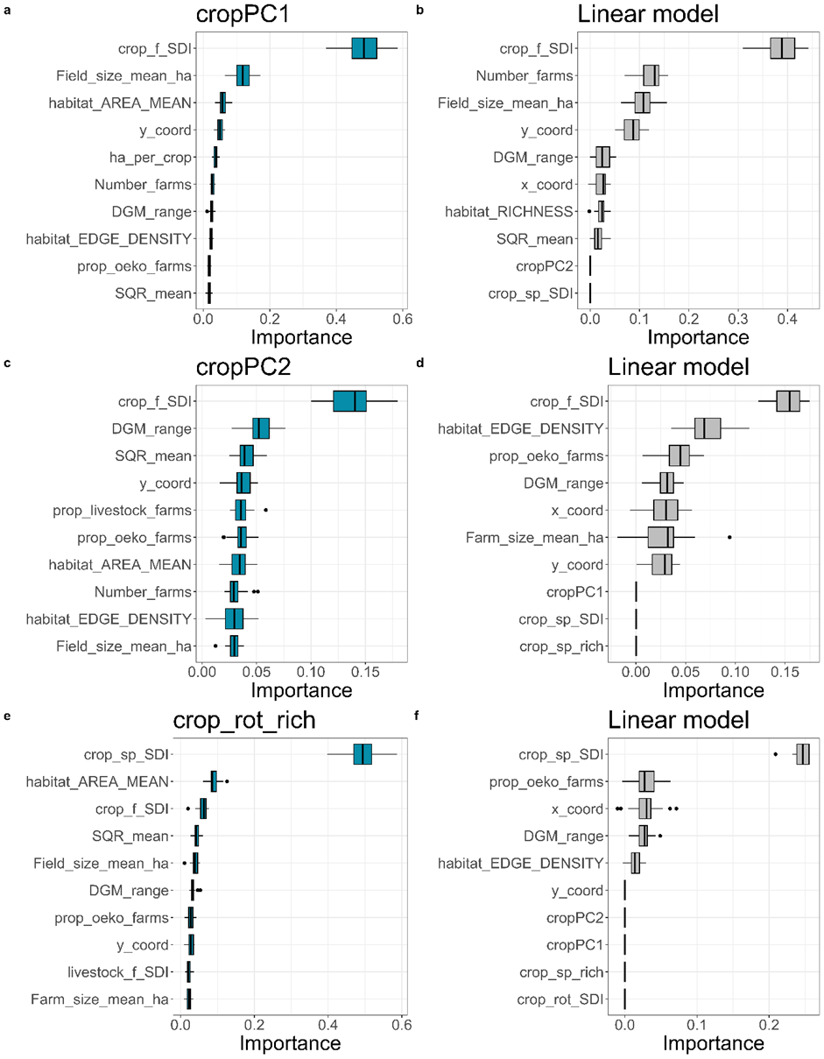
Figure B.1. Variable importance plots comparing random forest (left panels, blue boxplots) and linear regression (right panels, gray boxplots); response variables are a-b) cropPC1 = principal component 1; c-d) cropPC2 = principal component 2; e-f) crop_rot_rich = temporal crop richness
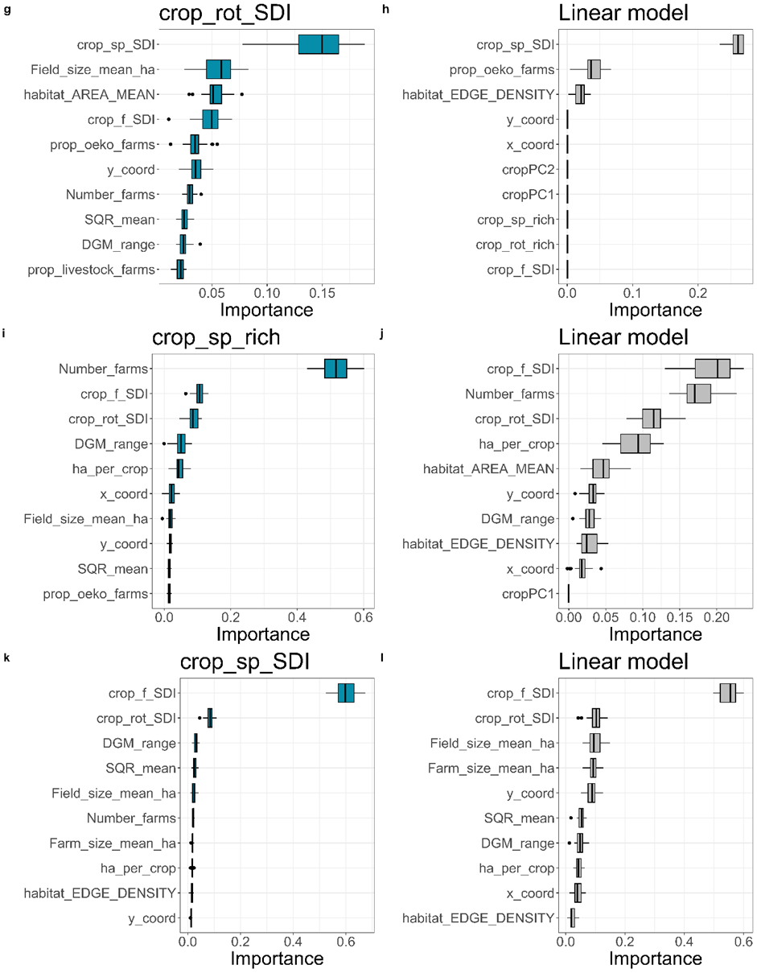
Figure B.2. Variable importance plots comparing random forest (left panels, blue boxplots) and linear regression (right panels, gray boxplots); response variables are g–h) crop_rot_SDI = Shannon’s evenness index of temporal crop diversity, i–j) crop_sp_rich = spatial crop richness, k–l) crop_sp_SDI = Shannon’s diversity index of spatial crop diversity)
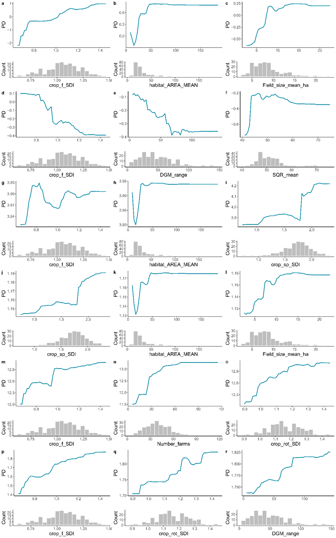Figure B.3. Partial dependence (PD) plots (blue) with histograms (gray) showing modeled associations between predictor variables and prediction; a–c) cropPC1 = principal component 1; d–f) cropPC2 = principal component 2; g–i) temporal crop richness, j–l) temporal crop diversity (SDI); m–o) spatial crop richness; p–r) spatial crop diversity (SDI)
Abbreviations:SDI = Shannon’s diversity index; crop_rot = temporal crop diversity;crop_sp = spatial crop diversity;crop_f = crop diversity per farm; Field_size_mean_ha = mean field size in hectares; DGM_range = slope (elevation range); SQR_mean = mean soil quality rating;
Number_farms = number of farms; habitat_AREA_MEAN = mean size of habitat patches.

