Online Supplementary Material (SM)
Section S1: Farm Resilience Measurement Framework
It is essential to distinguish the farm resilience framework from the context of general and specific resilience. Meuwissen, Feindt et al. (2019) offered a framework to assess farm resilience, distinguishing specific resilience and general resilience. The framework outlines five essential steps to determine whether farm resilience is generic or specific (Table S1). In characterizing the farming system (resilience of what?), the core of the system in the manuscript is a farm household. Although there are different farming systems and non-farm actors, the manuscript measures pillars and farm resilience capacity from only farm household operations. Another criterion is to identify the key challenges (resilience to what?) because resilience is specific to shocks and stresses (d’Errico, Garbero et al. 2016). Although robustness or R in our estimation mostly characterizes how farm households are robust to shocks, we distinguished two specific shock groups: shocks over the last year (short-term shock) and shocks over the last 10 years (long-term shocks) as covariate variables. The framework proposes considering the provision of private and public goods to understand what the functions are attached to the farm system (Resilience for what purpose?). Farm operations in the manuscript are mostly for private goods (crop production and livestock). Three resilience capacities (adaptability, robustness, and transformability) gained prominence as farm resilience (what resilience capacity?). The measurement includes all the pillars to construct farm resilience. The last dimension is related to resilience-enhancing attributes (what enhances resilience?). Since farm resilience depends on individual and collective competencies, Meuwissen, Feindt et al. (2019) proposed to apply five generic attributes established by Resilience Alliance (2010). The principles are diversity, modularity, openness, tightness of feedback, and system reserves. In our measurement, resilience pillars are based on diverse observed variables (e.g., crops and livestock), and household internal farm operations within these pillars relate to each other (modularity). Moreover, non-farm investment or safety nets, referring to modularity, represent the internal subdivision of the farm. A connection with other systems or openness refers to connectivity with the external environment. In our measurement, the extension service in adaptiveness or AC implies connection with the government. The measurement characterizes the reflection of farm operations on non-farm activities through the transformation capacity for tightness of feedback and the combination of different capital stocks within the reserve system.
Table S1. Resilience Framework
Questions | Dimensions | Components | Study
Resilience of what? | Define farm system characteristics | Farms and other actors | Farm household
Resilience to what? | Shocks and stresses | Environmental, economic, social, institutional, and others | Shocks over the last year (short-term shock) and shocks over the last 10 years (long-term shocks)  Robustness capacity
Resilience for what purpose? | Functions | Private and/or public goods | Private goods
What resilience capacities? | Capacities | Robustness, Adaptability, and Transformability | Robustness, Adaptive Capacity, and Transformation Capacity
What enhances resilience? | Attributes | Diversity  Openness  Tightness of feedback  System of reserves  Modularity | Diversity: TLU, crop diversity, greenhouse, and safety nets  Openness: Extension service  Tightness: Non-farm investment, ratio past non-farm investment  System of reserves: Total land, cultivated land, and agricultural assets  Modularity: Cropping system, livestock system, and non-farm activities

Table S2. Farm Resilience Capacity
Pillars (Determinants) | Definition | Implication | References
Adaptive Capacity | Farm level capacity to adapt or adjust to a changing environment. | Less intense changes in input-output operations  Temporary changes in the structure of the farm operations | (Mosnier, Agabriel et al. 2009, Béné, Wood et al. 2012, de Goede, Gremmen et al. 2013, Panda, Sharma et al. 2013, Eakin, York et al. 2016, Jones and d'Errico 2019, Meuwissen, Feindt et al. 2019, Tessema, Joerin et al. 2019, Williams, Crespo et al. 2019, Antwi-Agyei and Stringer 2021, Nicholas-Davies, Fowler et al. 2021, Poelma, Bayrak et al. 2021, Witinok-Huber and Radil 2021, Daniele, Barbara et al. 2022, Slijper, de Mey et al. 2022, van der Lee, Kangogo et al. 2022)
Transformative Capacity | Farm level capacity to provide significant changes in the farming operations in response to shocks and stresses. | Changes in farming internal structures  Changes in farming input-output combinations  Changes in farming feedback mechanisms  Changes in risk management or mitigation strategies  Changes in sales and marketing operations | (Béné, Wood et al. 2012, de Goede, Gremmen et al. 2013, Eakin, York et al. 2016, Jones and d'Errico 2019, Meuwissen, Feindt et al. 2019, Nicholas-Davies, Fowler et al. 2021, Poelma, Bayrak et al. 2021, Daniele, Barbara et al. 2022, Slijper, de Mey et al. 2022, van der Lee, Kangogo et al. 2022)
Robustness | Farm level capacity to maintain desired levels of agricultural operations in the presence of shocks and stresses | Inherent resistance in farm operations  Recovery from the changes  Improvement in the system  Efficiency in the function | (de Goede, Gremmen et al. 2013, Urruty, Tailliez-Lefebvre et al. 2016, Meuwissen, Feindt et al. 2019, Nicholas-Davies, Fowler et al. 2021, Poelma, Bayrak et al. 2021, Daniele, Barbara et al. 2022, Slijper, de Mey et al. 2022, van der Lee, Kangogo et al. 2022)

Table S3. Variables for Adaptive Capacity
 | Mean | Std. | Min | Max
TLU per capita*  (The variable is obtained by measuring Tropical Livestock Unit, divided by household size. A conversational factor is applied to measure TLU: horse-0.8, cow-0.8, donkey-0.5, pig-0.2, sheep-0.1, rabbit-0.02 and chicken-0.01). | 0.222 | 0.215 | 0 | 1
Crop diversity per capita*  (The variable is obtained by Simpson index, divided by household size). | 0.098 | 0.082 | 0 | 0.691
Agricultural asset per capita*  (The variable is constructed using PCA of agricultural assets, divided by household size). | 0.010 | 0.013 | 0 | 0.125
Total land per capita*  (The variable represents a total available land for farm plots, divided by household size). | 0.019 | 0.052 | 0 | 1
Cultivated land per capita*  (The variable represents a total cultivated land in hectare, including all available farm plots). | 0.001 | 0.001 | 0 | 0.025
Extension service  (A binary variable represents whether the household received agricultural extension services over the last 10 years). | 0.028 | 0.166 | 0 | 1
Greenhouse  (A binary variable represents whether the household has a greenhouse on the plot). | 0.036 | 0.186 | 0 | 1
Note: * min-max scaling approach is applied

Table S4. Variables for Transformation Capacity
 | Mean | Std. | Min | Max
Nonfarm investment  (A binary variable represents whether the household has a nonfarm investment for motorized vehicles, house, flat, electronics, non-electronics, and others over the last 12 months). | 0.162 | 0.369 | 0 | 1
Ratio past nonfarm investment  (The variable is obtained through the ratio of past nonfarm investment against total investment over the last 10 years). | 0.131 | 0.325 | 0 | 1
Ratio nonfarm investment  (The variable is obtained through the ratio of past nonfarm investment against total investment over the last 12 months). | 0.142 | 0.331 | 0 | 1
Nonfarm income  (The variable is obtained using from PCA through using 18 types of non-farm income activities) | 0.277 | 0.256 | 0 | 1
Safety Nets  (Income diversity is obtained from PCA through using non-agricultural income sources). | 0.303 | 0.075 | 0 | 1

Table S5. Variables for Robustness
 | Mean | Std. | Min | Max
Income Shock Ratio  (The variable represent the number of income sources per shock) | 1.174 | 1.099 | 0 | 8
Loss in TLU (reversed)  (The variable represents the reversed binary for the loss in TLU between 2015 and 2023). | 0.609 | 0.487 | 0 | 1
Loss in Agricultural Assets (reversed)  (The variable represents the reversed binary for the loss in Agricultural Assets between 2015 and 2023). | 0.486 | 0.499 | 0 | 1
Harvest Lost (reversed)  (The variable represents the reversed binary for the loss in harvesting due to the shock between 2015 and 2023). | 0.990 | 0.051 | 0 | 1
Crop Affected (reversed)  (The variable represents the reversed binary for the crops affected by the shock). | 0.689 | 0.462 | 0 | 1

Table S6. Summary Statistics
Indicators | Measurement | Mean | Std. | Min | Max
Dependent Variables
Dietary Diversity | Simpson Index | 0.929 | 0.029 | 0.666 | 0.972
The Adequacy of Fruit and Vegetable Consumption | Total weight (in grams) of fruits and vegetables consumed by the household member in day (grams/capita/day) | 288.243 | 168.039 | 0 | 1857.143
Household Hunger Score | 0-1: little or no hunger  2-3: moderate hunger  4-6: severe hunger | 0.604 | 1.183 | 0 | 6
Pillars and Farm Resilience
Adaptive Capacity (AC) | Measured with PCA and min-max scaling through TLU per capita, crop diversity per capita, agricultural asset per capita, total land per capita, cultivated land per capita, extension service, and greenhouse | 0.036 | 0.055 | 0 | 1
Transition Capacity (TC) | Measured with PCA and min-max scaling through nonfarm investment, ratio past nonfarm investment, ratio nonfarm investment, nonfarm income, and safety nets | 0.155 | 0.323 | 0 | 1
Robustness (R) | Measured PCA and min-max scaling through income shock ratio, loss in TLU (reversed), loss in agricultural assets (reversed), harvest loss (reversed), and crop affected (reversed) | 0.649 | 0.354 | 0 | 1
Farm Resilience Capacity | Measured with LPA through AC, TC, and R (Low Resilience, Medium Resilience, and High Resilience Profiles) | 2.146 | 0.662 | 1 | 3
Controlling Variables
Head female | Dummy | 0.251 | 0.433 | 0 | 1
Higher education | Dummy | 0.185 | 0.388 | 0 | 1
Elderly people | Dummy | 0.338 | 0.598 | 0 | 1
Household size | Continuous | 6.740 | 3.051 | 0 | 23
Migration over the last decade | Dummy | 0.030 | 0.172 | 0 | 1
Shocks over the last year | Continuous | 0.553 | 0.795 | 0 | 6
Shocks over the last decade | Continuous | 1.970 | 1.836 | 0 | 10
Bokhtar | Dummy | 0.124 | 0.330 | 0 | 1
Jilikul | Dummy | 0.049 | 0.217 | 0 | 1
Jomi | Dummy | 0.083 | 0.276 | 0 | 1
Khuroson | Dummy | 0.049 | 0.127 | 0 | 1
Kolkhozobod | Dummy | 0.083 | 0.276 | 0 | 1
Nosir Khusrav | Dummy | 0.016 | 0.127 | 0 | 1
Qabodiyon | Dummy | 0.083 | 0.276 | 0 | 1
Qumsangir | Dummy | 0.066 | 0.249 | 0 | 1
Sarband | Dummy | 0.024 | 0.156 | 0 | 1
Shahrituz | Dummy | 0.058 | 0.234 | 0 | 1
Vakhsh | Dummy | 0.091 | 0.288 | 0 | 1
Yovon | Dummy | 0.099 | 0.299 | 0 | 1

Table S7. Factorability Analysis
Index | Component | Cumulative Variance
Adaptive Capacity
 | 1 | 0.247
 | 2 | 0.440
 | 3 | 0.609
Bartlett Test |  |  | 1925.967***
KMO |  |  | 0.529
determinant of R-matrix |  |  | 0.381
Communality |  |  | Satisfied
Transition Capacity
 | 1  2 | 0.242  0.567
Bartlett Test
KMO |  |  | 142.134***
determinant of R-matrix |  |  | 0.931
Bartlett Test |  |  | 0.549
Communality |  |  | Satisfied
Robustness
 | 2 | 0.277
 | 1 | 0.420
 | 3 | 0.555
Bartlett Test |  |  | 1732.810***
KMO |  |  | 0.731
determinant of R-matrix |  |  | 0.420
Communality |  |  | Satisfied

Table S8. Model Fit for Latent Analysis
No. | LL | df | AIC | BIC | Entropy
Model-1 | 1601.537 | 6 | -3191.073 | -3157.468
Model-2 | 2029.231 | 10 | -4038.463 | -3982.454 | 0.561
Model-3 | 4178.602 | 14 | -8329.204 | -8250.791 | 0.675
Model-4 | 5729.472 | 18 | -11422.94 | -11322.13 | 0.636

Section S2: Multiple Indicators and Multiple Causes (MIMIC) for Resilience and Food Security Relationship
In Fig. S1, a Multiple Indicator Multiple Causes (MIMIC) model explains the relationship between observable and unobservable variables. MIMIC, belonging to the Structural Equation Modelling family, has two important model components: formative and reflective. A reflective model operationalizes latent variable as the cause of observed (resilience capacity is the cause of food security). At the same time, the formative model operationalizes the observed variables as the cause of the latent variable (resilience pillars are the cause of resilience capacity index)(FAO 2016).
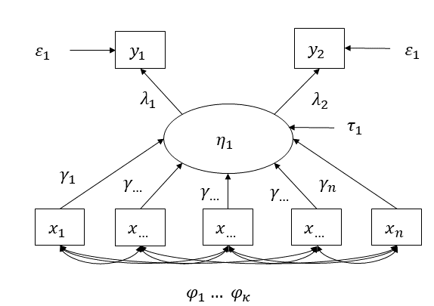
Fig.S1 MIMIC Approach
Source: (FAO 2016, d’Errico and Smith 2019)
Therefore, there are two types of observable variables ($y_{1}…y_{n}$) and $(x_{1}…x_{n})$ in the diagram. In this case, the resilience pillars (Adaptive Capacity, Transformation Capacity, and Robustness) are considered as observed endogenous variables of Farm Resilience Capacity (FRM). Another group of observable variables, defined by $y$, is related to food security indicators (Dietary Diversity, Adequacy of Fruit and Vegetable Consumption, and Household Hunger Score). According to d’Errico and Smith (2019), it can be represented in the following equations:
$$y=λη+ε$$ | 1

$$η=γx+τ$$ | 2

where $η$ is latent resilience or FRM. While $λ$ and $γ$ are coefficients, $ε$ and $τ$ represent error terms.

Section S3: Causal Inferences in Latent Analysis
Studies use inverse propensity score weighting with the latent analysis to obtain causal inferences. For example, the authors constructed multifaceted variables for investigating the causal links between the treatment and latent class membership (Lanza, Coffman et al. 2013, Lanza, Moore et al. 2013, Butera, Lanza et al. 2014, Jakubowski 2015, Kim and Steiner 2015, Clouth, Pauws et al. 2023). Recently, Bray, Dziak et al. (2019) integrated the latent class membership with distal outcomes based on the methodology proposed by Schuler, Leoutsakos et al. (2014). The authors concluded the three-step approach is the most appropriate to implement latent modelling with the propensity scores. Similarly, Yamaguchi (2015) applied latent analysis with a set of observed indicators to construct the treatment variable. The author claimed that the application for combining inverse-probability weighting (IPW) and the latent-class variable is particularly important for the cross-sectional observed data. Another simulation study applying one-step and three-step approaches confirmed that the estimation strategy under three-step latent analysis with IPW provides robust results for the causal claim (Clouth, Pauws et al. 2022).
In the integration, the first step was used to obtain the posterior probability of membership and model fit. Based on the class membership, we created a latent profile variable or Farm Resilience Capacity with Adaptive Capacity, Transformation Capacity, and Robustness by using a pseudoclass assignment in this stage. Fig.S2 illustrates that a predicted latent profile of FRC is regressed on potential confounder ($X_{1}$…$X_{n}$) to estimate the propensity score model in the next stage. After assessing overlap and balance assumptions, we finally regressed the model for the distal food security outcomes (dietary diversity, the adequacy of fruit and vegetable consumption, household hunger score) on the predicted latent class membership (categorical latent variable).
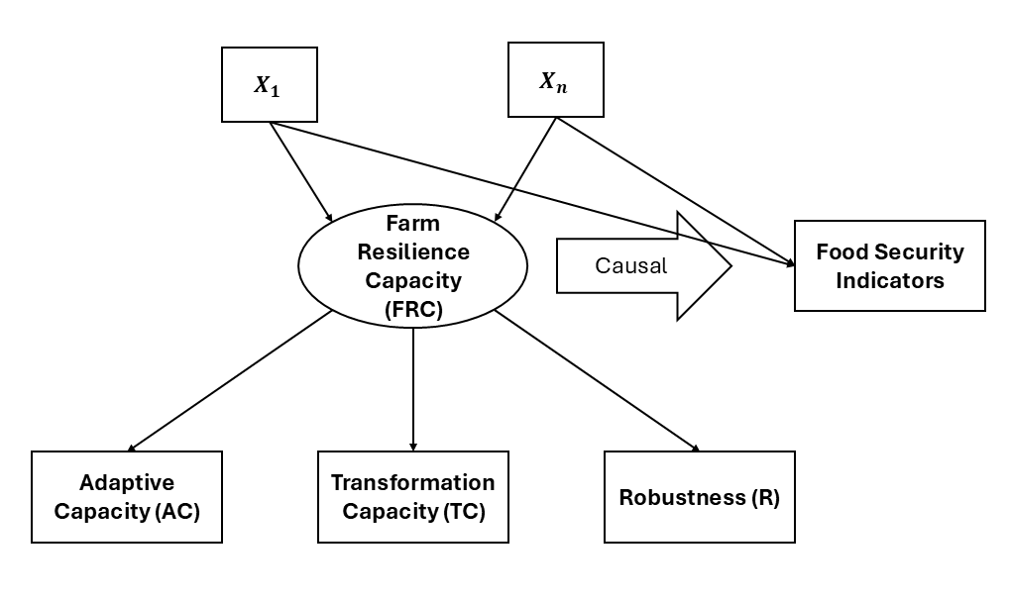
Fig.S2 LPA and PSM (LPA-PSM) Integration for Causal Claim (Schematic illustration)
Source: Adapted from Schuler, Leoutsakos et al. (2014)
Note: Farm Resilience Capacity-latent variable; Adaptive Capacity, Transformation Capacity, and Robustness are latent determinants (pillars); $X_{1}$…$X_{n}$ are the potential confounders; and Food Security Indicators denote the distal outcome (Dietary diversity, the Adequacy of Fruit and Vegetable Consumption, or Household Hunger Score).
According to Bray, Dziak et al. (2019), the estimation of Average Treatment Effects (ATEs) through latent profile was the difference between the values of the potential outcomes from the membership of one class compared to the expected values of outcomes from the membership of another class: ${ATE}_{c1}=E\left[Y\left(C=c\right)\right]-E[Y\left(C=1\right)]$. In this manuscript, we define ATE of membership in one resilience profile compared to the membership in another profile. Letting $Y_{h}[t]$ as the value of distal outcome or food security indicator, we can observe the change value of $Y$ if the household $h$ belongs to one of actual latent profile $t$. Therefore, the ATE from the membership in profile $t$ compared to profile $\grave{t}$ is defined by the following expectation $E(Y\left[t\right]-Y[\grave{t}$]) over the households. From this perspective, the approach we propose is to estimate ATEs of latent class membership (nominal household resilience profile) on distal outcomes (dietary diversity index and household hunger score).

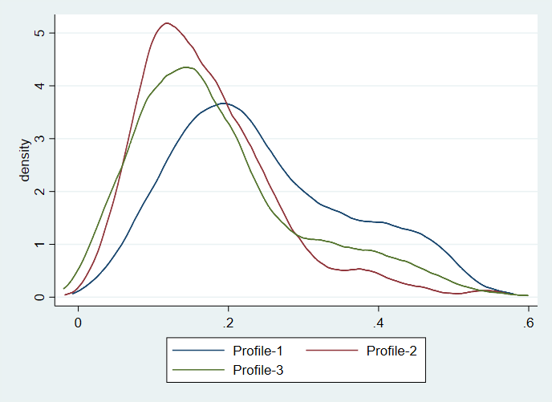
Fig. S3 Kernel density function
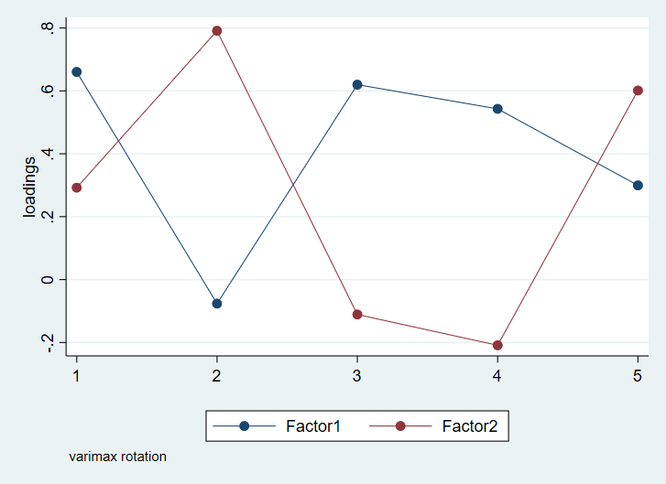
Fig. S4 Transformation Capacity
Note: 1 – Nonfarm Investment; 2 – Safety Nets; 3 – Ratio Past Nonfarm Investment; 4 – Ratio Nonfarm Investment; and 5-Nonfarm income
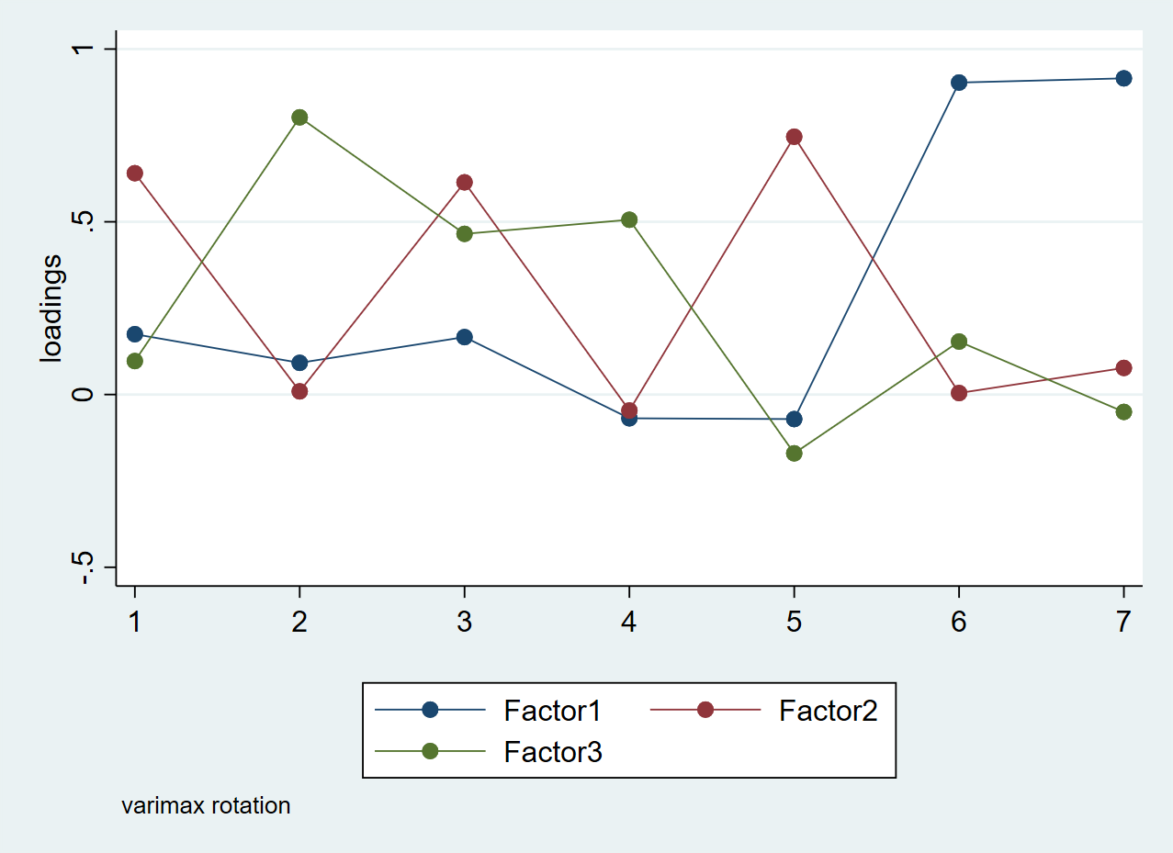
Fig. S5 Adaptive Capacity
Note: 1 – Tropical Livestock Unit (TLU) per capita; 2 – Crop Diversity Index (Simpson) per capita; 3 – Agricultural Assets per capita; 4 – Total Land per capita; 5 – Extension Service; 6 – Greenhouse; 7 – Cultivated Land
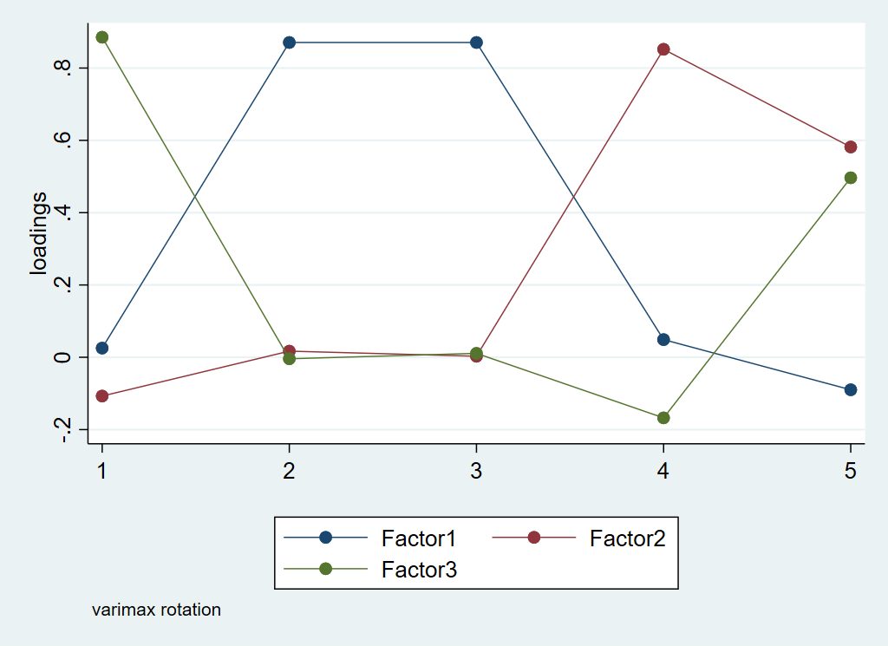
Fig. S6 Robustness
Note: 1 – Shock Ratio; 2 – TLU Loss; 3 – Agricultural Asset Decline; 4 – Harvest Lost; 5 – Crop Affected

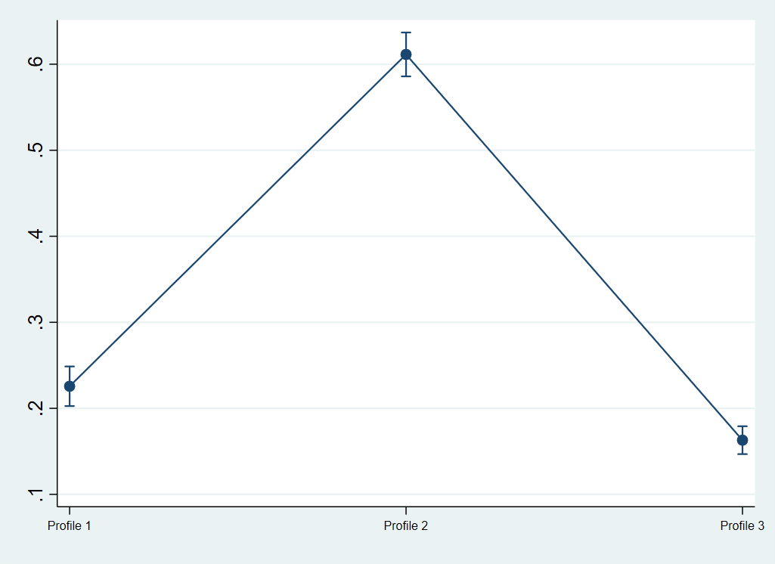
Fig. S7 Class Membership

Table S9. Instrumental variable statistics
 | Mean | Std. | Min | Max
Good quality of soil  (A binary variable represents whether the household has a good quality of soil) | 0.316 | 0.465 | 0 | 1
Cooperation and associations  (The variable represents the number of collective dehkan farms, production cooperative, service cooperatives, water user association, and mobile milk collecting organizations) | 1.202 | 0.979 | 0 | 4
Land certificate  (A binary variable represents whether the household received a legal document or ownership right between 2015 and 2023) | 0.112 | 0.319 | 0 | 1

Table S10. Instrumental variables and resilience (first stage)
 | Medium Resilient Profile | High Resilient Profile
Good quality of soil | 0.293*  (0.165) | 0.624***  (0.197)
Cooperation and associations | 0.094  (0.088) | 0.274**  (0.112)
Land certificate | 3.515***  (0.601) | 3.169***  (0.624)
Higher education | 0.328  (0.201) | 0.440*  (0.244)
Head female | -0.222  (0.162) | -0.528**  (0.208)
Household size | 0.120***  (0.027) | 0.103***  (0.033)
Elderly people | 0.148  (0.128) | -0.009  (0.157)
Migration over the last decade | -0.026  (0.399) | 0.225  (0.492)
Shock over the last12 months | -0.279**  (0.109) | 0.045  (0.126)
Shock over the last decade | 0.080  (0.050) | 0.215***  (0.060)
Bokhtar | 1.354***  (0.488) | -1.124*  (0.660)
Jilikul | 0.937*  (0.514) | -0.495  (0.679)
Jomi | 1.182**  (0.531) | 0.616  (0.647)
Khuroson | -0.326  (0.481) | -0.065  (0.587)
Kolkhozobod | 1.068**  (0.493) | 0.023  (0.621)
Nosir Khusrav | 0.880*  (0.478) | 0.726  (0.589)
Qabodiyon | 1.542***  (0.518) | 0.349  (0.646)
Qumsangir | 1.393***  (0.518) | 1.135*  (0.627)
Sarband | 0.912  (0.606) | 0.755  (0.722)
Shahrituz | 0.335  (0.500) | 0.422  (0.609)
Vakhsh | 1.781***  (0.508) | 1.092*  (0.624)
Observation | 1998 | 1998
*** ρ<0.01, ** ρ<0.05, * ρ<0.1. A base class for farm resilience is “Low Resilient” Profile. Standard errors in parentheses. The excluded regional dummy is Yovon

Table S11. Farm Resilience Effect on Food Security (second stage)
 | Dietary Diversity | Adequacy of Fruit and Vegetable Consumption | Household Hunger Score
Medium Resilience | 0.004  (0.002) | -0.639  (6.857) | -0.282  (0.266)
High Resilience | 0.018***  (0.003) | 19.240**  (8.707) | -0.987***  (0.260)
Higher education | 0.004***  (0.001) | 22.276***  (8.349) | -0.533***  (0.123)
Head female | -0.001  (0.001) | 3.381  (7.376) | 0.167*  (0.086)
Household size | 0.001***  (0.001) | -27.134***  (1.086) | -0.020  (0.015)
Elderly people | -0.001  (0.001) | -5.954  (5.411) | -0.041  (0.071)
Migration over the last decade | -0.002  (0.004) | -19.749  (18.448) | -0.335  (0.248)
Shock over the last 12 months | 0.001  (0.001) | -1.382  (2.048) | 0.154***  (0.021)
Shock over the last decade | 0.001***  (0.001) | 3.409*  (2.048) | 0.216***  (0.021)
Bokhtar | -0.013**  (0.005) | 13.659  (20.675) | -0.185  (0.316)
Jilikul | -0.011**  (0.005) | -4.918  (22.380) | 0.150  (0.322)
Jomi | -0.004  (0.005) | 16.173  (22.442) | -0.260  (0.323)
Khuroson | -0.001  (0.005) | 9.323  (20.837) | 0.348  (0.297)
Kolkhozobod | 0.004  (0.005) | 24.452  (20.848) | -0.619*  (0.330)
Nosir Khusrav | -0.001  (0.005) | 20.932  (20.030) | -0.182  (0.306)
Qabodiyon | -0.024***  (0.005) | -9.551  (20.873) | 0.151  (0.314)
Qumsangir | -0.012**  (0.005) | -18.431  (21.403) | -0.457  (0.336)
Sarband | -0.003  (0.006) | 18.584  (21.855) | 0.497  (0.342)
Shahrituz | 0.001  (0.005) | -0.903  (20.441) | 0.256  (0.309)
Vakhsh | -0.008  (0.005) | -16.130  (28.800) | -0.071  (0.321)
Observation | 1988 |  | 1988
*** ρ<0.01, ** ρ<0.05, * ρ<0.1. A base class for farm resilience is “Low Resilient” Profile. Standard errors in parentheses. The excluded regional dummy is Yovon

Table S12. Shocks
 | Shock over the last12 months |  |  |  | Shock over the last decade
Shock | Mean | Std. | Min | Max | Mean | Std. | Min | Max
Drought/too little rain | 0.109 | 0.312 | 0 | 1 | 0.150 | 0.357 | 0 | 1
Too much rain/ extreme rainfall | 0.177 | 0.383 | 0 | 1 | 0.140 | 0.347 | 0 | 1
Flooding | 0.043 | 0.204 | 0 | 1 | 0.057 | 0.232 | 0 | 1
Extreme heat | 0.068 | 0.253 | 0 | 1 | 0.124 | 0.329 | 0 | 1
Extreme cold/ frost | 0.734 | 0.442 | 0 | 1 | 0.177 | 0.381 | 0 | 1
Land erosion | 0.381 | 0.488 | 0 | 1 | 0.048 | 0.218 | 0 | 1
Loss of land (e.g., confiscation of land) | 0.214 | 0.417 | 0 | 1 | 0.014 | 0.117 | 0 | 1
Disease or pest affecting crops | 0.091 | 0.288 | 0 | 1 | 0.153 | 0.360 | 0 | 1
Disease affecting livestock or fish | 0.186 | 0.391 | 0 | 1 | 0.059 | 0.235 | 0 | 1
Sharp increase in food price | 0.553 | 0.497 | 0 | 1 | 0.542 | 0.498 | 0 | 1
Someone stealing or destroying belonging | 0.125 | 0.333 | 0 | 1 | 0.028 | 0.165 | 0 | 1
COVID-19 disease of household member | 0.009 | 0.095 | 0 | 1 | 0.163 | 0.369 | 0 | 1
Serious illness/ accident of household member(s) (not COVID-19) | 0.098 | 0.299 | 0 | 1 | 0.086 | 0.280 | 0 | 1
Death of family member | 0.046 | 0.210 | 0 | 1 | 0.226 | 0.418 | 0 | 1

References
Antwi-Agyei, P. and L. C. Stringer (2021). "Improving the effectiveness of agricultural extension services in supporting farmers to adapt to climate change: Insights from northeastern Ghana." Climate Risk Management 32: 100304.
Béné, C., R. G. Wood, A. Newsham and M. Davies (2012). "Resilience: New Utopia or New Tyranny? Reflection about the Potentials and Limits of the Concept of Resilience in Relation to Vulnerability Reduction Programmes." IDS Working Papers 2012(405): 1-61.
Bray, B. C., J. J. Dziak, M. E. Patrick and S. T. Lanza (2019). "Inverse Propensity Score Weighting with a Latent Class Exposure: Estimating the Causal Effect of Reported Reasons for Alcohol Use on Problem Alcohol Use 16 Years Later." Prevention Science 20(3): 394-406.
Butera, N. M., S. T. Lanza and D. L. Coffman (2014). "A Framework for Estimating Causal Effects in Latent Class Analysis: Is There a Causal Link Between Early Sex and Subsequent Profiles of Delinquency?" Prevention Science 15(3): 397-407.
Clouth, F. J., S. Pauws, F. Mols and J. K. Vermunt (2022). "A new three-step method for using inverse propensity weighting with latent class analysis." Advances in Data Analysis and Classification 16(2): 351-371.
Clouth, F. J., S. Pauws and J. K. Vermunt (2023). "Three-Step Latent Class Analysis with Inverse Propensity Weighting in the Presence of Differential Item Functioning." Structural Equation Modeling: A Multidisciplinary Journal 30(5): 737-748.
d’Errico, M., A. Garbero and M. Constas (2016). Quantitative analyses for resilience measurement. Food Security Information Network, Resilience Measurement Technical Working Group.
d’Errico, M. and L. Smith (2019). Comparison of FAO and TANGO measures of household resilience and resilience capacity, Working paper.
Daniele, B.-C., S. Barbara, B. Isabel and G. Alberto (2022). "Analysis of perceived robustness, adaptability and transformability of Spanish extensive livestock farms under alternative challenging scenarios." Agricultural Systems 202: 103487.
de Goede, D. M., B. Gremmen and M. Blom-Zandstra (2013). "Robust agriculture: Balancing between vulnerability and stability." NJAS: Wageningen Journal of Life Sciences 64-65(1): 1-7.
Eakin, H., A. York, R. Aggarwal, S. Waters, J. Welch, C. Rubiños, S. Smith-Heisters, C. Bausch and J. M. Anderies (2016). "Cognitive and institutional influences on farmers’ adaptive capacity: insights into barriers and opportunities for transformative change in central Arizona." Regional Environmental Change 16(3): 801-814.
FAO (2016). Resilience Index Measurement Analysis (RIMA). Rome, Food and Agriculture Organization.
Jakubowski, M. (2015). "Latent variables and propensity score matching: a simulation study with application to data from the Programme for International Student Assessment in Poland." Empirical Economics 48(3): 1287-1325.
Jones, L. and M. d'Errico (2019). "Whose resilience matters? Like-for-like comparison of objective and subjective evaluations of resilience." World Development 124: 104632.
Kim, J.-S. and P. M. Steiner (2015). Multilevel Propensity Score Methods for Estimating Causal Effects: A Latent Class Modeling Strategy. Quantitative Psychology Research, Cham, Springer International Publishing.
Lanza, S. T., D. L. Coffman and S. Xu (2013). "Causal Inference in Latent Class Analysis." Structural Equation Modeling: A Multidisciplinary Journal 20(3): 361-383.
Lanza, S. T., J. E. Moore and N. M. Butera (2013). "Drawing Causal Inferences Using Propensity Scores: A Practical Guide for Community Psychologists." American Journal of Community Psychology 52(3): 380-392.
Meuwissen, M. P. M., P. H. Feindt, A. Spiegel, C. J. A. M. Termeer, E. Mathijs, Y. d. Mey, R. Finger, A. Balmann, E. Wauters, J. Urquhart, M. Vigani, K. Zawalińska, H. Herrera, P. Nicholas-Davies, H. Hansson, W. Paas, T. Slijper, I. Coopmans, W. Vroege, A. Ciechomska, F. Accatino, B. Kopainsky, P. M. Poortvliet, J. J. L. Candel, D. Maye, S. Severini, S. Senni, B. Soriano, C.-J. Lagerkvist, M. Peneva, C. Gavrilescu and P. Reidsma (2019). "A framework to assess the resilience of farming systems." Agricultural Systems 176: 102656.
Mosnier, C., J. Agabriel, M. Lherm and A. Reynaud (2009). "A dynamic bio-economic model to simulate optimal adjustments of suckler cow farm management to production and market shocks in France." Agricultural Systems 102(1): 77-88.
Nicholas-Davies, P., S. Fowler, P. Midmore, I. Coopmans, M. Draganova, A. Petitt and S. Senni (2021). "Evidence of resilience capacity in farmers’ narratives: Accounts of robustness, adaptability and transformability across five different European farming systems." Journal of Rural Studies 88: 388-399.
Panda, A., U. Sharma, K. N. Ninan and A. Patt (2013). "Adaptive capacity contributing to improved agricultural productivity at the household level: Empirical findings highlighting the importance of crop insurance." Global Environmental Change 23(4): 782-790.
Poelma, T., M. M. Bayrak, D. Van Nha and T. A. Tran (2021). "Climate change and livelihood resilience capacities in the Mekong Delta: a case study on the transition to rice–shrimp farming in Vietnam’s Kien Giang Province." Climatic Change 164(1): 9.
Resilience Alliance. (2010). "Resilience Assessment." Retrieved 11.06.2025, from https://www.resalliance.org/resilience-assessment.
Schuler, M. S., J.-M. S. Leoutsakos and E. A. Stuart (2014). "Addressing confounding when estimating the effects of latent classes on a distal outcome." Health Services and Outcomes Research Methodology 14(4): 232-254.
Slijper, T., Y. de Mey, P. M. Poortvliet and M. P. M. Meuwissen (2022). "Quantifying the resilience of European farms using FADN." European Review of Agricultural Economics 49(1): 121-150.
Tessema, Y. A., J. Joerin and A. Patt (2019). "Climate change as a motivating factor for farm-adjustments: Rethinking the link." Climate Risk Management 23: 136-145.
Urruty, N., D. Tailliez-Lefebvre and C. Huyghe (2016). "Stability, robustness, vulnerability and resilience of agricultural systems. A review." Agronomy for Sustainable Development 36(1): 15.
van der Lee, J., D. Kangogo, Ş. Ö. Gülzari, D. Dentoni, S. Oosting, J. Bijman and L. Klerkx (2022). "Theoretical positions and approaches to resilience assessment in farming systems. A review." Agronomy for Sustainable Development 42(2): 27.
Williams, P. A., O. Crespo and M. Abu (2019). "Adapting to changing climate through improving adaptive capacity at the local level – The case of smallholder horticultural producers in Ghana." Climate Risk Management 23: 124-135.
Witinok-Huber, R. and S. M. Radil (2021). "Introducing the Local Agricultural Potential Index: An approach to understand local agricultural extension impact for farmer adaptive capacity and gender equity." World Development Perspectives 23: 100345.
Yamaguchi, K. (2015). Extensions of Rubin's Causal Model for a Latent-Class Treatment Variable: An analysis of the effects of employers' work-life balance policies on women's income attainment in Japan, Research Institute of Economy, Trade and Industry (RIETI).

Dehkan farms are family-based and small scaled farm enterprises in Central Asia.

