SUPPLEMENTARY MATERIAL

The full title: An accuracy assessment of satellite-based cotton yield estimation using panel data regression: A case study of Uzbekistan
Journal name: Environment, Development and Sustainability

Supplementary Material
Supplementary Table S1. Reviewing existing literature for crop yield estimation
# | Title of the article | Authors | Crop type | Research scale (farmer, district, province, country) | Satellite type | Satellite resolution | Analysis period | Regression type | Publication year
1 | A scalable satellite-based crop yield mapper | David B. Lobell, David Thau, Christopher Seifert, Eric Engle, Bertis Little | Maize and Soybean | USA district scale | Landsat | 30x30m | 2008-2012 | linear regression (time series) | 2015
2 | Application note: Crop-loss assessment monitor – A multi-model and multistage decision support system | Pramod Aggarwal, Paresh Shirsath, Shalika Vyas, Ponraj Arumugam, Sheshakumar Goroshi,  S. Aravind, Mansi Nagpal, Madhur Chanana | Soybean | India country scale | MODIS | 250x250m | 2010-2016 | linear regression (time series) | 2020
3 | Improving the accuracy of satellite-based high-resolution yield estimation: A test of multiple scalable approaches | Zhenong Jin, George Azzari, David B. Lobell | Maize | USA state scale | Landsat | 30x30m | 2001-2015 | linear regression (time series) | 2017
4 | Assessment of the effectiveness of spatiotemporal fusion of multi-source satellite images for cotton yield estimation | Linghua Menga, Huanjun Liua, Xinle Zhangb, Chunying Rena, Susan Ustinc, Zhengchao Qiub, Mengyuan Xub, Dong Guoa | Cotton | USA district scale | MODIS, Landsat | 250x250m, 30x30m | 2002 | linear regression (cross sectional) | 2019
5 | Satellite-based vegetation health indices as a criteria for insuringagainst drought-related yield losses | R. Bokushevaa, F. Koganb, I. Vitkovskayac, S. Conradta, M. Batyrbayeva | Wheat | Kazakhstan district scale | NOAA | 1.1x 1.1km | 1982-2010 | linear regression (time series) | 2016
6 | Machine learning approaches for rice crop yield predictions using time-series satellite data in Taiwan | Nguyen-Thanh Son, Chi-Farn Chen, Cheng-Ru Chen, Horng-Yuh Guo, YougSing Cheng, Shu-Ling Chen, Huan-Sheng Lin & Shih-Hsiang Chen | Rice | Taiwan country scale | MODIS | 250x250m | 2000-2018 | linear regression (time series) | 2020
7 | Assessing the applicability of NDVI data for the design of index-based agricultural insurance in Bihar, India | Irene Winklera, Mamta Mehrab, Sarah Favrichonb, Vaibhav Sharmab, Nihar Jangle | Rice, Maize and Wheat | India district scale | MODIS | 250x250m | 2001-2009 | linear regression analysis (time series) | 2015
8 | Wheat Yield Estimation from NDVI and Regional Climate Models in Latvia | Astrid Vannoppen, Anne Gobin, Lola Kotova, Sara Top, Lesley De Cruz, Andris Viksna, Svetlana Aniskevich, Leonid Bobylev, Lars Buntemeyer, Steven Caluwaerts, Rozemien De Troch, Natalia Gnatiuk, Rafiq Hamdi, Armelle Reca Remedio, Abdulla Sakalli, Hans Van De Vyver, Bert Van Schaeybroeck | Wheat | Latvia country scale | PROBA | 300x300m | 2014-2018 | linear regression analysis (time series) | 2020
9 | Integrated Application of Remote Sensing and GIS in Crop Information System—A Case Study on Aman Rice Production Forecasting Using MODIS-NDVI in Bangladesh | B. M. Refat Faisal, Hafizur Rahman, Nur Hossain Sharifee, Nasrin Sultana, | Rice | Bangladesh and Aman country scale | MODIS | 250x250m | 2011-2017 | linear regression analysis (time series) | 2020
10 | Predicting the Normalized Difference Vegetation Index (NDVI) by training a crop growth model with historical data | Mohammad Imrul Islam, S. M. Ahsan Habib and Tofayel Ahammad | Soybean | Uruguay province scale | MODIS | 250x250m | 2009-2015 | linear regression analysis (time series) | 2019
11 | Modeling of Cotton Yields in the Amu Darya River Floodplains of Uzbekistan Integrating Multitemporal Remote Sensing and Minimum Field Data | Zhou Shi, Gerd R. Ruecker, Marc Mueller, Christopher Conrad, Nazar Ibragimov, John P. A. Lamers, Christopher Martius, Guenter Strunz, Stefan Dech, and Paul L. G. Vlek | Cotton | Uzbekistan district scale | MODIS, Landsat | 500x500m, 30x30m | 1998-2001 | linear regression analysis (time series) | 2007
12 | Incorporating environmental variables into a MODIS-based crop yield estimation method for United States corn and soybeans through the use of a random forest regression algorithm | Toshihiro Sakamoto | Corn and Soybean | USA state scale | MODIS | 250x250m | 2000-2018 | linear regression analysis (time series) | 2020
13 | Eyes in the Sky, Boots on the Ground: Assessing Satellite‐ and Ground‐Based Approaches to Crop Yield Measurement and Analysis | David B. Lobell, George Azzari, Marshall Burke, Sydney Gourlay, Zhenong Jin, Talip Kilic, And Siobhan Murray | Maize | Eastern Uganda farmer scale | Sentinel | 10x10m | 2016 | linear regression analysis (cross-sectional) | 2020
14 | Satellite-based assessment of yield variation and its determinants in smallholder African systems | Marshall Burkea and David B. Lobella | Maize | Kenya farmer scale | SkySat | 1x1m | 2015 | linear regression analysis (cross-sectional) | 2017
15 | Regional yield estimation for winter wheat with MODIS-NDVI data in Shandong, China | Jianqiang Ren, Zhongxin Chen, Qingbo Zhou, Huajun Tang | Wheat | China province scale | MODIS | 250x250m | 2005-2006 | linear regression analysis (cross-sectional) | 2008
16 | Comparison of winter wheat NDVI data derived from Landsat 8 and active optical sensor at field scale | Dariusz Gozdowski, Michał Stępien, Ewa Panek, James Varghese, Elzbieta Bodecka, Jan Rozbicki, Stanisław Samborski | Wheat | Poland farmer scale | Landsat | 30x30m | 2013-2014 | linear regression analysis (cross-sectional) | 2020
17 | Wheat and maize yield forecasting for the Tisza river catchment using MODIS NDVI time series and reported crop statistics | Attila Nagy, János Fehér, János Tamás | Wheat and Maize | Central Eastern Europe county scale | MODIS | 250x250m | 2000-2015 | linear regression analysis (time series) | 2018
18 | An empirical model for prediction of wheat yield, using time-integrated Landsat NDVI | Y.R. Laia, M.J. Pringleb, P.M. Kopittkea, N.W. Menziesa, T.G. Ortona, Y.P. Dang | Wheat | Australia farmer scale | Landsat | 30x30m | 2001-2016 | linear regression analysis (time series) | 2018
19 | A study on trade-offs between spatial resolution and temporal sampling density for wheat yield estimation using both thermal and calendar time | Yetkin Özüm Durguna, Anne Gobinb, Grégory Duveillerd, Bernard Tychon | Wheat | France province scale | PROBA-V | 300x300m | 2015 | linear regression analysis (cross-sectional) | 2019
20 | Relationship between MODIS-NDVI data and wheat yield: a case study in Northern Buenos Aires province, Argentina | Mariano F. Lopresti, Carlos M. Di Bella, Américo J. Degioanni | Wheat | Argentina province scale | MODIS | 250x250m | 2003-2011 | linear regression analysis (time series) | 2015
21 | Estimation of harvest index in wheat crops using a remote sensing-based approach | Jaime Campoya, Isidro Camposa, Carmen Plazab, María Calerab, Vicente Bodasb, Alfonso Calera | Wheat | Spain province scale | Landsat 8 | 30x30m | 2015-2018 | linear regression analysis (time series) | 2020
22 | A simple model of regional wheat yield based on NDVI data | M. Moriondo, F. Maselli, M. Bindi | Wheat | Italy province scale | AVHRR | 1.1x1.1km | 1986-2003 | linear regression analysis (time series) | 2007
23 | Empirical regression models using NDVI, rainfall and temperature data for the early prediction of wheat grain yields in Morocco | Riad Balaghi, Bernard Tychon, Herman Eerens, Mohammed Jlibene | Wheat | Morocco province scale | AVHRR | 1.1x1.1km | 1990-2004 | linear regression analysis (time series) | 2008
24 | Estimating regional winter wheat yield by assimilation of time series of HJ-1 CCD NDVI into WOFOST–ACRM model with Ensemble Kalman Filter | Hongyuan Ma, Jianxi Huang, Dehai Zhua, Junming Liua, Wei Sua, Chao Zhang, Jinlong Fan | Wheat | China district scale | China Environment Satellite HJ-1A and B | 30x30m | 2009 | linear regression analysis (cross-sectional) | 2013
25 | Rapid mapping of winter wheat yield, protein, and nitrogen uptake using remote and proximal sensing | Ku Wanga, David R. Hugginsb, Haiying Tao | Wheat | USA farmer scale | RapidEye radiometry | 5x5m | 2017 | linear regression analysis (cross-sectional) | 2019
26 | Evaluation of MODIS and Landsat multiband vegetation indices used for wheat yield estimation in irrigated Indus Basin | Muhammad Usman Liaqat, Muhammad Jehanzeb Masud Cheema, Wenjiang Huang, Talha Mahmood, Muhammad Zaman, Muhammad Mohsin Khan | Wheat | Pakistan province scale | MODIS, Landsat | 250x250m, 30x30m | 2013-2014 | linear regression analysis (cross-sectional) | 2017
27 | Estimating wheat yields in Australia using climate records, satellite image time series and machine learning methods | Elisa Kamira, François Waldnera, Zvi Hochman | Wheat | Australia province scale | MODIS | 250x250m | 2009-2015 | linear regression analysis (time series) | 2020
28 | Characterizing major agricultural land change trends in the Western Corn Belt | Yang Shao, Gregory N. Taff, Jie Ren, James B. Campbell | Corn | USA state scale | MODIS | 250x250m | 2001-2015 | linear regression analysis (time series) | 2016
29 | National-scale soybean mapping and area estimation in the United States using medium resolution satellite imagery and field survey | Xiao-Peng Song, Peter V. Potapov, Alexander Krylov, LeeAnn King, Carlos M. Di Bella, Amy Hudson, Ahmad Khan, Bernard Adusei, Stephen V. Stehman, Matthew C. Hansen | Soybean | USA country scale | Landsat | 30x30m | 2015 | linear regression analysis (cross-sectional) | 2017
30 | Maize yield estimation in West Africa from crop process-induced combinations of multi-domain remote sensing indices | Louise Lerouxa, Mathieu Castets, Christian Baron, Maria-Jose Escorihuela, Agnès Bégué, Danny Lo Seen | Maize | Burkina-Faso province scale | MODIS | 250x250m | 2011-2016 | linear regression analysis (time series) | 2019
31 | Remote sensing-based framework to predict and assess the interannual variability of maize yields in Pakistan using Landsat imagery | Ishfaq Ahmad, Aditya Singh, Muhammad Fahad, Muhammad Mohsin Waqas | Maize | Pakistan district scale | Landsat | 30x30m | 2006-2017 | linear regression analysis (time series) | 2020
32 | Modelling paddy rice yield using MODIS data | Dailiang Peng, Jingfeng Huang, Cunjun Li, Liangyun Liu, Wenjiang Huang, Fuming Wang, Xiaohua Yang | Rice | China district scale | MODIS | 250x250m | 2005-2006 | linear regression analysis (cross-sectional) | 2014
33 | Cotton Yield Estimation Based on NOAA/AVHRR Produced NDVI | N.R.Dalezios, C.Domenikiotis, A.Loukas, S.T.Tzortzios, C.Kalaitzidis | Cotton | Greece district scale | AVHRR | 1.1x1.1km | 1994-1996 | linear regression analysis (time series) | 2001
34 | A comparative analysis of multitemporal MODIS EVI and NDVI data for large-scale rice yield estimation | N.T. Sona,∗, C.F. Chena,b, C.R. Chenb, V.Q. Minhc, N.H. Trung | Rice | Vietnam province scale | MODIS | 250x250m | 2002-2011 | linear regression analysis (time series) | 2014
35 | Application of phenology-based algorithm and linear regression model for estimating rice cultivated areas and yield using remote sensing data in Bansloi River Basin, Eastern India | Gopal Chandra Paul, Sunil Saha, Tusar Kanti Hembram | Rice | India province scale | Landsat | 30x30m | 2017 | linear regression analysis (cross-sectional) | 2020
36 | Recognition of different yield potentials among rain-fed wheat fields before harvest using the remote sensing | Hamed Sabzchi-Dehkharghani, Amir Hossein Nazemi, Ali Ashraf Sadraddini, Abolfazl Majnooni-Heris, Asim Biswas | Wheat | Iran province scale | MODIS, Landsat | 250x250m, 30x30m | 2015 | linear regression analysis (cross-sectional) | 2020
37 | Estimating winter wheat yield based on a light use efficiency model and wheat variety data | Jie Donga, Haibo Lub, Yawen Wang, Tao Yea, Wenping Yuan | Wheat | USA state scale | Landsat | 30x30m | 2008-2017 | linear regression analysis (cross-sectional) | 2020
38 | A comparison of harvest index estimation methods of winter wheat based on field measurements of biophysical and spectral data | Heli Li, Yi Luo, Xiaoping Xue, Yujin Zhao, Hong Zhao, Feng Li | Wheat | China province scale | MODIS | 250x250m | 2008-2010 | linear regression analysis (cross-sectional) | 2011
39 | Winter wheat biomass estimation based on spectral indices, band depth analysis and partial least squares regression using hyperspectral measurements | Yuanyuan Fu, Guijun Yang b, Jihua Wang, Xiaoyu Song, Haikuan Feng | Wheat | China district scale | MODIS | 250x250m | 2008-2009 | linear regression analysis (cross-sectional) | 2014
40 | High resolution wheat yield mapping using Sentinel-2 | Merryn L. Hunta, George Alan Blackburnb, Luis Carrascod, John W. Redhead, Clare S. Rowland | Wheat | United Kingdom farmer scale | Sentinel | 10x10m | 2016 | linear regression analysis (cross-sectional) | 2019
41 | Image masking for crop yield forecasting using AVHRR NDVI time series imagery | Jude H. Kastens, Terry L. Kastens, Dietrich L.A. Kastens, Kevin P. Price, Edward A. Martinko, Re-Yang Lee | Corn and Soybean | USA state scale | AVHRR | 1.1x1.1km | 1989 to 2000 | linear regression analysis (time series) | 2005
42 | Regression model to estimate flood impact on corn yield using MODIS NDVI and USDA cropland data layer | Ranjay Shrestha, Liping Di, Eugene G. Yu, Lingjun Kang, SHAO Yuan-zheng, BAI Yu-qi | Corn | USA state scale | MODIS | 250x250m | 2000–2014 | linear regression analysis (time series) | 2017
43 | The early explanatory power of NDVI in crop yield modelling | Lenny Wall , Denis Larocque & Pierre‐Majorique Léger | Wheat | Canada province scale | AVHRR | 1.1x1.1km | 1987-2002 | linear regression analysis (time series) | 1998
44 | Winter wheat yield forecasting in Ukraine based on Earth observation, meteorological data and biophysical models | Felix Kogana, Nataliia Kussul, Tatiana Adamenkoc, Sergii Skakun, Oleksii Kravchenko, Oleksii Kryvobok, Andrii Shelestov, Andrii Kolotii, Olga Kussul, Alla Lavrenyuk | Wheat | Ukrain district scale | MODIS | 250x250m | 2000–2010 | linear regression analysis (time series) | 2013
45 | Improved mapping and change detection of the start of the crop growing season in the US Corn Belt from long-term AVHRR NDV | Hyeon-Ju Gima, Chang-Hoi Ho, Sujong Jeong, Jinwon Kimc, Song Feng, Michael J. Hayes | Corn | USA state scale | AVHRR MODIS | 1.1x1.1km 250x250m | 1982–2015 | linear regression analysis (time series) | 2020
46 | Improving remotely-sensed crop monitoring by NDVI-based crop phenology estimators for corn and soybeans in Iowa and Illinois, USA | Bumsuk Seoa, Jihye Leeb, Kyung-Do Leed, Sukyoung Honge, Sinkyu Kang | Corn and Soybean | USA state scale | MODIS | 250x250m | 2003–2015 | linear regression analysis (time series) | 2019
47 | Potential of using spectral vegetation indices for corn green biomass estimation based on their relationship with the photosynthetic vegetation sub-pixel fraction | Luan Peroni Venancioa, Everardo Chartuni Mantovania, Cibele Hummel do Amaralb, Christopher Michael Usher Nealec, Ivo Zution Gonçalvesc, Roberto Filgueirasa, Fernando Coelho Eugenio | Corn | Brazil farmer scale | Landsat | 30x30m | 2015-2018 | linear regression analysis (time series) | 2019
48 | Using spatio-temporal fusion of Landsat-8 and MODIS data to derive phenology, biomass and yield estimates for corn and soybean | Chunhua Liao, Jinfei Wang, Taifeng Dong, Jiali Shang, Jiangui Liu\, Yang Song | Corn and Soybean | Canada farmer scale | Landsat | 30x30m | 2015 | linear regression analysis (cross-sectional) | 2019
49 | An assessment of pre- and within-season remotely sensed variables for forecasting corn and soybean yields in the United States | David M. Johnson | Corn and Soybean | USA state scale | MODIS | 250x250m | 2006–2011 | linear regression analysis (time series) | 2014
50 | Regression based Corn Yield Assessment using MODIS Based Daily NDVI in Iowa State | Ranjay Shrestha; Liping Di; Eugene G. Yu; Lingjun Kang; Lin Li; Md. Shahinoor Rahman; Meixia Deng; Zhengwei Yang | Corn | USA state scale | MODIS | 250x250m | 2000 - 2014 | linear regression analysis (time series) | 2016
51 | Drought Monitoring and Corn Yield Estimation in Southern Africa from AVHRR Data | Leonard S. Unganai and Felix N. Kogan | Corn | Southern Africa country scale | AVHRR | 1.1x1.1km | 1985-1994 | linear regression analysis (time series) | 1998
52 | Monitoring maize growth on the North China Plain using a hybrid genetic algorithm-based back-propagation neural network model | Lei Wang, Pengxin Wang, Shunlin Liang, Yongchao Zhu, Jahangir Khan, Shibo Fang | Maize | China province scale | MODIS | 250x250m | 2010-2018 | linear regression analysis (time series) | 2020
53 | Detection and estimation of mixed paddy rice cropping patterns with MODIS data | Dailiang Peng, Alfredo R. Huete, Jingfeng Huang, Fuming Wang, Huasheng Sun | Rice | China province scale | MODIS | 250x250m | 2000-2007 | linear regression analysis (time series) | 2011
54 | An analysis of cropland mask choice and ancillary data for annual corn yield forecasting using MODIS data | Yang Shao, James B. Campbell, Gregory N. Taff, Baojuan Zheng | Corn | USA state scale | MODIS | 250x250m | 2001-2012 | linear regression analysis (time series) | 2015
55 | Remote sensing phenological monitoring framework to characterize corn and soybean physiological growing stages | Chunyuan Diao | Corn and Soybean | USA province scale | MODIS | 250x250m | 2002-2017 | linear regression analysis (time series) | 2020
56 | A new space-borne perspective of crop productivity variations over the US Corn Belt | Peter Somkuti, Hartmut Bösch, Liang Feng, Paul I. Palmer, Robert J. Parker, Tristan Quaife | Corn | USA state scale | GOSAT | 1x1km | 2010–2016 | linear regression analysis (time series) | 2020
57 | Multi-year monitoring of rice crop phenology through time series analysis of MODIS images | M. Boschetti, D. Stroppiana, P. A. Brivio & S. Bocchi | Rice | Italian district scale | MODIS | 250x250m | 2001-2005 | linear regression analysis (time series) | 2009
58 | Wheat yield estimates using multi-temporal NDVI satellite imagery | M. P. Labus, G. A. Nielsen, R. L. Lawrence, R. Engel & D. S. Long | Wheat | USA province scale | AVHRR | 1.1x1.1km | 1989–1997 | linear regression analysis (time series) | 2002
59 | Spring Wheat Yield Estimation for Western Canada Using NOAA NDVI Data | K.P. Hochheim & D.G. Barber | Wheat | Canada province scale | AVHRR | 1.1x1.1km | 1987-1991 | linear regression analysis (time series) | 2014
60 | ON CORRELATION OF MAIZE AND WHEAT YIELD WITH NDVI: EXAMPLE OF HUNGARY | J. Mika, J. Kerenyi, A. Rimoczi-Paal, A. Merza, C. Szinell and I. Csiszar | Maize | Hungary province scale | AVHRR | 1.1x1.1km | 1985-1998 | linear regression analysis (time series) | 2002
61 | Assessment of the effectiveness of spatiotemporal fusion of multi-source satellite images for cotton yield estimation | Linghua Meng, Huanjun Liua, Xinle Zhang, Chunying Ren, Susan Ustin, Zhengchao Qiu, Mengyuan Xu, Dong Guo | Cotton | USA province scale | MODIS | 250x250m | 2002 | linear regression analysis (cross-sectional) | 2019
62 | MODIS-based corn grain yield estimation model incorporating crop phenology information | Toshihiro Sakamoto, Anatoly A. Gitelson, Timothy J. Arkebauer | Corn | USA state scale | MODIS | 250x250m | 2000-2011 | linear regression analysis (time series) | 2013
63 | Monitoring crop water content for corn and soybean fields through data fusion of MODIS and Landsat measurements in Iowa | Chenyang Xu, John J. Qu, Xianjun Hao, Michael H. Cosh, Zhiliang Zhu, Laurel Gutenberg | Corn | USA scale | Landsat | 30x30m | 2016 | linear regression analysis (cross-sectional) | 2020
64 | Spatiotemporal changes of surface solar radiation: Implication for air pollution and rice yield in East China | Yanyu Wang, Ze Meng, Rui Lyu, Guan Huang, Qianshan He, Tiantao Cheng | Rice | China province scale | MODIS | 250x250m | 2000-2016 | linear regression analysis (time series) | 2020

Supplementary Table S2. Skewness and kurtosis test result
 | Observed | Bootstrap |  |  | Normal-based
 | coefficient | std. err. | z | P>z | [95% conf. interval]
Skewness_e | 0.000 | 0.073 | 0.000 | 0.999 | -0.143 | 0.143
Kurtosis_e | -0.504 | 0.204 | -2.470 | 0.014 | -0.904 | -0.103
Skewness_u | -0.086 | 0.142 | -0.600 | 0.545 | -0.364 | 0.192
Kurtosis_u | -0.090 | 0.216 | -0.420 | 0.676 | -0.513 | 0.333
Note: One or more parameters could not be estimated in 11 bootstrap replicates;
standard-error estimates include only complete replications.
Joint test for Normality on e: chi2(2) = 6.08 Prob > chi2 = 0.0477
Joint test for Normality on u: chi2(2) = 0.54 Prob > chi2 = 0.7630

Supplementary Figure S1. Hausman test result NDVI, MSAVI2, CIred-edge and NDRE indices (p<0.05)
NDVI index
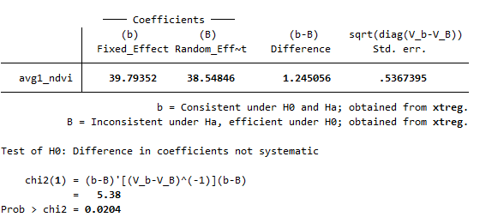 | 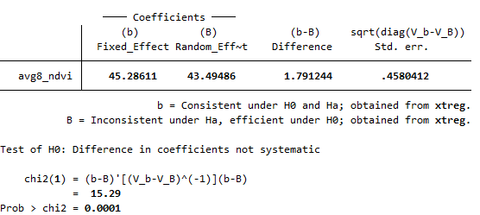
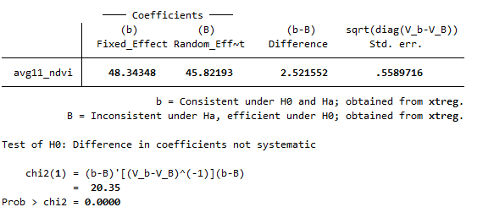 | 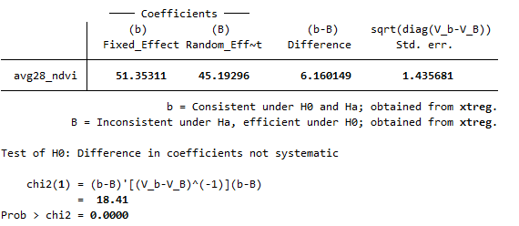
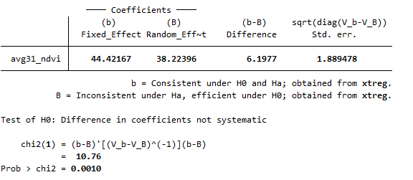 | 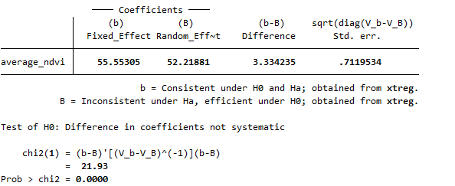
CIred-edge Index
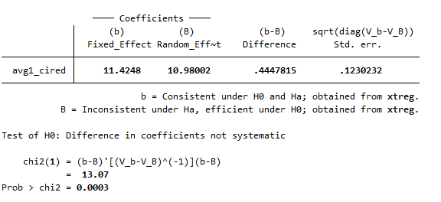 | 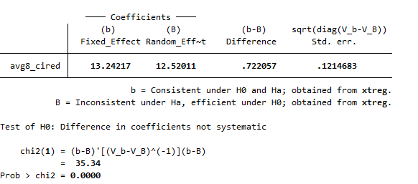
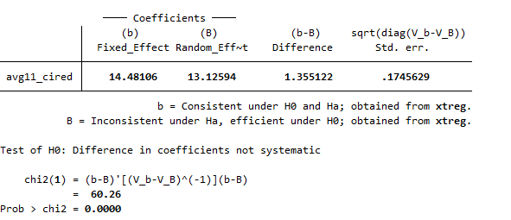 | 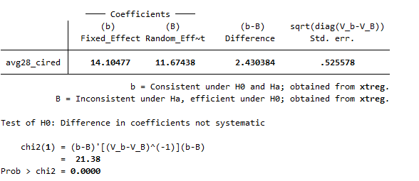
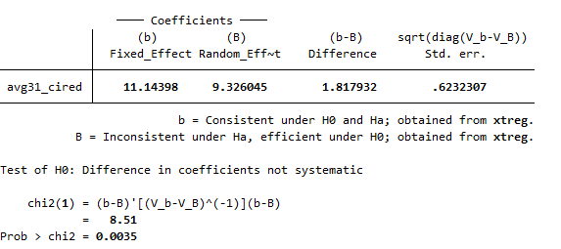 | 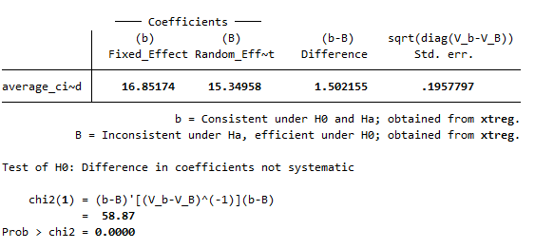
MSAVI2
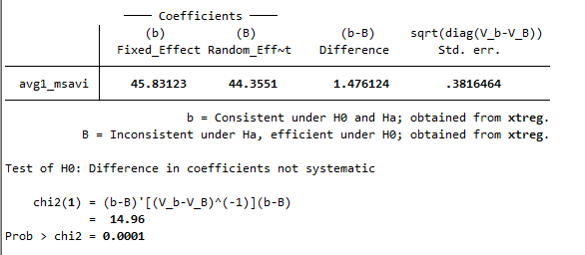 | 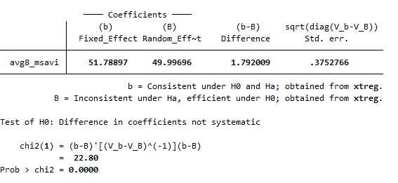
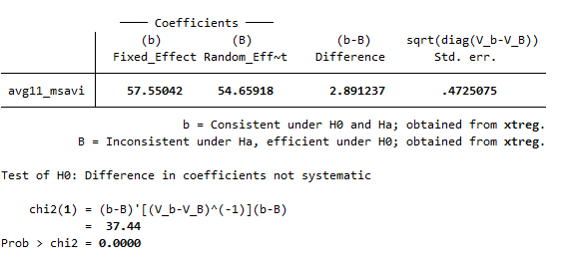 | 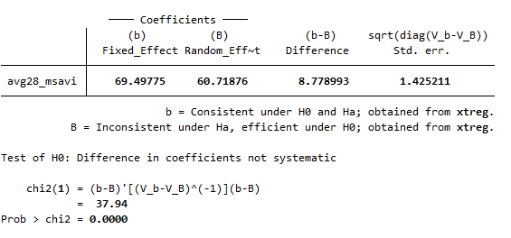
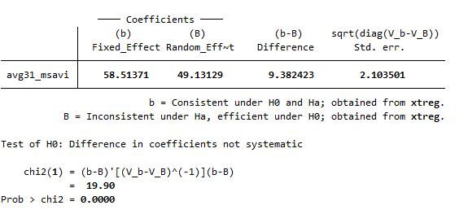 | 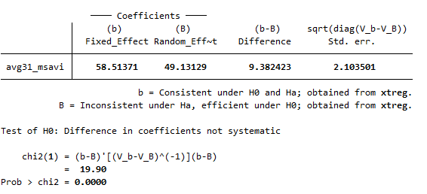
NDRE index
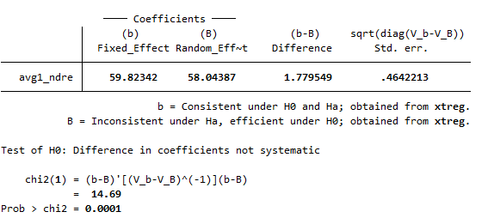 | 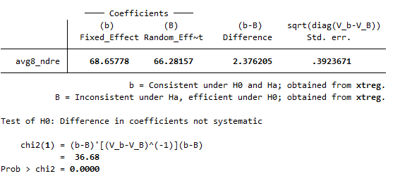
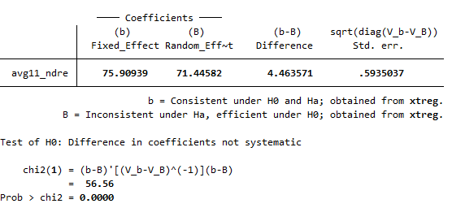 | 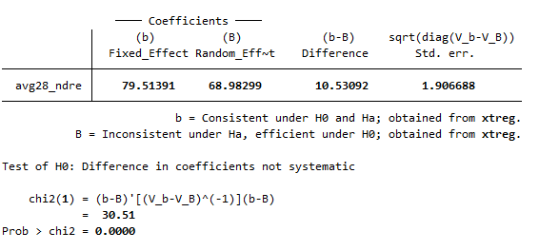
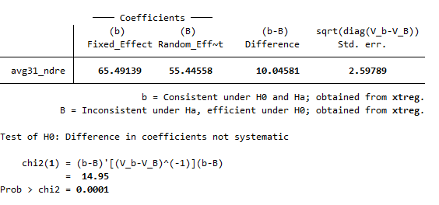 | 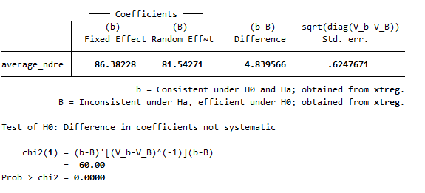

Supplementary Table S3. Wooldridge test result for autocorrelation in panel data
Linear regression Number of obs. = 464
F (20, 231) = 33.60
Prob > F = 0.00
R-squared = 0.747
Root MSE = 0.209
(Std. err. adjusted for 232 clusters in fid)
D.log_yield | Coefficient | Robust  std. err. |  | t | P>t | [95% conf. interval]
avg1_ndre
D1. | -0.715 | 0.617 |  | -1.160 | 0.248 | -1.932 | 0.501
avg8_ndre
D1. | 2.748 | 0.645 |  | 4.260 | 0.000 | 1.478 | 4.018
avg11_ndre
D1. | -0.026 | 0.900 |  | -0.030 | 0.977 | -1.799 | 1.747
avg28_ndre
D1. | 1.082 | 0.734 |  | 1.470 | 0.142 | -0.364 | 2.529
avg31_ndre
D1. | -1.019 | 0.812 |  | -1.260 | 0.211 | -2.619 | 0.580
avg1_msavi
D1. | 0.445 | 0.439 |  | 1.010 | 0.311 | -0.419 | 1.309
avg8_msavi
D1. | 0.197 | 0.586 |  | 0.340 | 0.737 | -0.958 | 1.351
avg11_msavi
D1. | 0.418 | 0.664 |  | 0.630 | 0.529 | -0.889 | 1.726
avg28_msavi
D1. | -0.556 | 0.513 |  | -1.080 | 0.280 | -1.566 | 0.455
avg31_msavi
D1. | 0.585 | 0.452 |  | 1.290 | 0.197 | -0.305 | 1.476
avg1_cired
D1. | 0.139 | 0.099 |  | 1.410 | 0.159 | -0.055 | 0.333
avg8_cired
D1. | 0.079 | 0.109 |  | 0.730 | 0.466 | -0.135 | 0.293
avg11_cired
D1. | -0.264 | 0.137 |  | -1.930 | 0.055 | -0.534 | 0.006
avg28_cired
D1. | 0.112 | 0.128 |  | 0.870 | 0.383 | -0.141 | 0.365
avg31_cired
D1. | 0.098 | 0.120 |  | 0.820 | 0.415 | -0.138 | 0.333
avg1_ndvi
D1. | -0.090 | 0.263 |  | -0.340 | 0.733 | -0.608 | 0.428
avg8_ndvi
D1. | 0.214 | 0.566 |  | 0.380 | 0.705 | -0.901 | 1.329
avg11_ndvi
D1. | 0.087 | 0.617 |  | 0.140 | 0.889 | -1.129 | 1.302
avg28_ndvi
D1. | -0.359 | 0.549 |  | -0.650 | 0.513 | -1.440 | 0.722
avg31_ndvi
D1. | -0.218 | 0.591 |  | -0.370 | 0.712 | -1.383 | 0.947
Wooldridge test for autocorrelation in panel data
H0: no first-order autocorrelation
F (1, 231) = 3.017
Prob > F = 0.0083

Supplementary Table S4. Panel fixed effect model results of R², Adj R² and RMSE between vegetation indices and ground yield data
NDRE index
  log_yield | Coef. |  | St.Err. | t-value |  | p-value | [95% Conf |  | Interval] | Sig
  avg1_ndre | 3.048 |  | 0.138 | 22.04 |  | 0.000 | 2.776 |  | 3.321 | ***
  Constant | 1.979 |  | 0.05 | 39.41 |  | 0.000 | 1.880 |  | 2.078 | ***
  Mean depend var |  | 3.087 |  |  | SD dependent var |  |  | 0.351
  R-squared |  | 0.677 |  |  | Number of obs |  |  | 696.000
  Adj R-squared |  | 0.66 |  |  | Root MSE |  |  | 0.14
  F-test |  | 485.936 |  |  | Prob > F |  |  | 0.000
  Akaike crit. (AIC) |  | -798.509 |  |  | Bayesian crit. (BIC) |  |  | -793.964
  *** p<0.01, ** p<0.05, * p<0.1
  log_yield | Coef. |  | St.Err. | t-value |  | p-value | [95% Conf |  | Interval] |  | Sig
  avg8_ndre | 3.514 |  | .151 | 23.30 |  | 0 | 3.217 |  | 3.811 |  | ***
  Constant | 1.793 |  | .056 | 32.28 |  | 0 | 1.683 |  | 1.902 |  | ***
  Mean depend var |  | 3.087 |  |  | SD dependent var |  |  | 0.351
  R-squared |  | 0.730 |  |  | Number of obs |  |  | 696.000
  Adj R-squared |  | 0.72 |  |  | Root MSE |  |  | 0.12
  F-test |  | 542.859 |  |  | Prob > F |  |  | .
  Akaike crit. (AIC) |  |  | -920.34 |  | Bayesian crit. (BIC) |  |  | -915.802
  *** p<.01, ** p<.05, * p<.1
  log_yield | Coef. |  | St.Err. | t-value |  | p-value | [95% Conf |  | Interval] |  | Sig
  avg11_ndre | 3.876 |  | .181 | 21.38 |  | 0 | 3.518 |  | 4.233 |  | ***
  Constant | 1.612 |  | .069 | 23.37 |  | 0 | 1.476 |  | 1.748 |  | ***
  Mean depend var |  | 3.087 |  |  | SD dependent var |  |  | 0.351
  R-squared |  | 0.680 |  |  | Number of obs |  |  | 696.000
  Adj R-squared |  | 0.67 |  |  | Root MSE |  |  | 0.13
  F-test |  | 457.022 |  |  | Prob > F |  |  | .
  Akaike crit. (AIC) |  | -802.096 |  |  | Bayesian crit. (BIC) |  |  | -797.550
  *** p<.01, ** p<.05, * p<.1
  log_yield | Coef. |  | St.Err. | t-value |  | p-value | [95% Conf |  | Interval] |  | Sig
  avg28_ndre | 4.012 |  | .255 | 15.76 |  | 0 | 3.511 |  | 4.514 |  | ***
  Constant | 1.573 |  | .096 | 16.38 |  | 0 | 1.384 |  | 1.762 |  | ***
  Mean depend var |  | 3.087 |  |  | SD dependent var |  |  | 0.351
  R-squared |  | 0.404 |  |  | Number of obs |  |  | 696.000
  Adj R-squared |  | 0.39 |  |  | Root MSE |  |  | 0.19
  F-test |  | 248.257 |  |  | Prob > F |  |  | .
  Akaike crit. (AIC) |  | -368.398 |  |  | Bayesian crit. (BIC) |  |  | -363.853
  *** p<.01, ** p<.05, * p<.1
  log_yield | Coef. |  | St.Err. | t-value |  | p-value | [95% Conf |  | Interval] |  | Sig
  avg31_ndre | 3.258 |  | .285 | 11.45 |  | 0 | 2.697 |  | 3.819 |  | ***
  Constant | 1.874 |  | .106 | 17.68 |  | 0 | 1.665 |  | 2.082 |  | ***
  Mean dependent var |  | 3.087 |  |  | SD dependent var |  |  | 0.351
  R-squared |  | 0.245 |  |  | Number of obs |  |  | 696.000
  Adj R-squared |  | 0.23 |  |  | Root MSE |  |  | 0.21
  F-test |  | 131.036 |  |  | Prob > F |  |  | .
  Akaike crit. (AIC) |  | -203.595 |  |  | Bayesian crit. (BIC) |  |  | -199.050
  *** p<.01, ** p<.05, * p<.1
  log_yield | Coef. |  | St.Err. | t-value |  | p-value | [95% Conf |  | Interval] |  | Sig
  average_ndre | 4.393 |  | .211 | 20.78 |  | 0 | 3.977 |  | 4.81 |  | ***
  Constant | 1.451 |  | .079 | 18.44 |  | 0 | 1.296 |  | 1.606 |  | ***
  Mean dependent var |  | 3.087 |  |  | SD dependent var |  |  | 0.351
  R-squared |  | 0.687 |  |  | Number of obs |  |  | 696.000
  Adj R-squared |  | 0.67 |  |  | Root MSE |  |  | 0.13
  F-test |  | 431.994 |  |  | Prob > F |  |  | .
  Akaike crit. (AIC) |  | -816.754 |  |  | Bayesian crit. (BIC) |  |  | -812.209
  *** p<.01, ** p<.05, * p<.1
NDVI index
  log_yield | Coef. |  | St.Err. | t-value |  | p-value | [95% Conf |  | Interval] |  | Sig
  avg1_ndvi | 2.06 |  | .115 | 17.88 |  | 0 | 1.833 |  | 2.287 |  | ***
  Constant | 2.056 |  | .058 | 35.68 |  | 0 | 1.943 |  | 2.17 |  | ***
  Mean dependent var |  | 3.087 |  |  | SD dependent var |  |  | 0.351
  R-squared |  | 0.542 |  |  | Number of obs |  |  | 696.000
  Adj R-squared |  | 053 |  |  | Root MSE |  |  | 0.16
  F-test |  | 319.517 |  |  | Prob > F |  |  | .
  Akaike crit. (AIC) |  | -552.205 |  |  | Bayesian crit. (BIC) |  |  | -547.660
  *** p<.01, ** p<.05, * p<.1
  log_yield | Coef. |  | St.Err. | t-value |  | p-value | [95% Conf |  | Interval] |  | Sig
  avg8_ndvi | 2.337 |  | .119 | 19.64 |  | 0 | 2.103 |  | 2.572 |  | ***
  Constant | 1.913 |  | .06 | 32.02 |  | 0 | 1.796 |  | 2.031 |  | ***
  Mean dependent var |  | 3.087 |  |  | SD dependent var |  |  | 0.351
  R-squared |  | 0.610 |  |  | Number of obs |  |  | 696.000
  Adj R-squared |  | 0.60 |  |  | Root MSE |  |  | 0.15
  F-test |  | 385.590 |  |  | Prob > F |  |  | .
  Akaike crit. (AIC) |  | -663.242 |  |  | Bayesian crit. (BIC) |  |  | -658.696
  *** p<.01, ** p<.05, * p<.1
  log_yield | Coef. |  | St.Err. | t-value |  | p-value | [95% Conf |  | Interval] |  | Sig
  avg11_ndvi | 2.48 |  | .136 | 18.23 |  | 0 | 2.212 |  | 2.748 |  | ***
  Constant | 1.805 |  | .07 | 25.69 |  | 0 | 1.667 |  | 1.944 |  | ***
  Mean dependent var |  | 3.087 |  |  | SD dependent var |  |  | 0.351
  R-squared |  | 0.578 |  |  | Number of obs |  |  | 696.000
  Adj R-squared |  | 0.56 |  |  | Root MSE |  |  | 0.16
  F-test |  | 332.227 |  |  | Prob > F |  |  | .
  Akaike crit. (AIC) |  | -608.446 |  |  | Bayesian crit. (BIC) |  |  | -603.900
  *** p<.01, ** p<.05, * p<.1
  log_yield | Coef. |  | St.Err. | t-value |  | p-value | [95% Conf |  | Interval] |  | Sig
  avg28_ndvi | 2.613 |  | .245 | 10.66 |  | 0 | 2.13 |  | 3.096 |  | ***
  Constant | 1.714 |  | .129 | 13.31 |  | 0 | 1.461 |  | 1.968 |  | ***
  Mean dependent var |  | 3.087 |  |  | SD dependent var |  |  | 0.351
  R-squared |  | 0.343 |  |  | Number of obs |  |  | 696.000
  Adj R-squared |  | 0.33 |  |  | Root MSE |  |  | 0.19
  F-test |  | 113.575 |  |  | Prob > F |  |  | .
  Akaike crit. (AIC) |  | -300.679 |  |  | Bayesian crit. (BIC) |  |  | -296.133
  *** p<.01, ** p<.05, * p<.1
  log_yield | Coef. |  | St.Err. | t-value |  | p-value | [95% Conf |  | Interval] |  | Sig
  avg31_ndvi | 2.222 |  | .264 | 8.43 |  | 0 | 1.703 |  | 2.742 |  | ***
  Constant | 1.943 |  | .136 | 14.33 |  | 0 | 1.676 |  | 2.21 |  | ***
  Mean dependent var |  | 3.087 |  |  | SD dependent var |  |  | 0.351
  R-squared |  | 0.213 |  |  | Number of obs |  |  | 696.000
  Adj R-squared |  | 0.20 |  |  | Root MSE |  |  | 0.21
  F-test |  | 71.097 |  |  | Prob > F |  |  | .
  Akaike crit. (AIC) |  | -174.391 |  |  | Bayesian crit. (BIC) |  |  | -169.845
  *** p<.01, ** p<.05, * p<.1
  log_yield | Coef. |  | St.Err. | t-value |  | p-value | [95% Conf |  | Interval] |  | Sig
  average_ndvi | 2.851 |  | .175 | 16.25 |  | 0 | 2.505 |  | 3.197 |  | ***
  Constant | 1.628 |  | .09 | 18.13 |  | 0 | 1.451 |  | 1.805 |  | ***
  Mean dependent var |  | 3.087 |  |  | SD dependent var |  |  | 0.351
  R-squared |  | 0.561 |  |  | Number of obs |  |  | 696.000
  Adj R-squared |  | 0.55 |  |  | Root MSE |  |  | 0.16
  F-test |  | 264.062 |  |  | Prob > F |  |  | .
  Akaike crit. (AIC) |  | -581.531 |  |  | Bayesian crit. (BIC) |  |  | -576.986
  *** p<.01, ** p<.05, * p<.1
MSAVI2
  log_yield | Coef. |  | St.Err. | t-value |  | p-value | [95% Conf |  | Interval] |  | Sig
  avg1_msavi | 2.372 |  | .115 | 20.70 |  | 0 | 2.147 |  | 2.598 |  | ***
  Constant | 1.569 |  | .073 | 21.39 |  | 0 | 1.424 |  | 1.713 |  | ***
  Mean dependent var |  | 3.087 |  |  | SD dependent var |  |  | 0.351
  R-squared |  | 0.665 |  |  | Number of obs |  |  | 696.000
  Adj R-squared |  | 0.65 |  |  | Root MSE |  |  | 0.14
  F-test |  | 428.628 |  |  | Prob > F |  |  | .
  Akaike crit. (AIC) |  | -770.148 |  |  | Bayesian crit. (BIC) |  |  | -765.603
  *** p<.01, ** p<.05, * p<.1
  log_yield | Coef. |  | St.Err. | t-value |  | p-value | [95% Conf |  | Interval] |  | Sig
  avg8_msavi | 2.682 |  | .12 | 22.31 |  | 0 | 2.445 |  | 2.918 |  | ***
  Constant | 1.349 |  | .078 | 17.33 |  | 0 | 1.196 |  | 1.503 |  | ***
  Mean dependent var |  | 3.087 |  |  | SD dependent var |  |  | 0.351
  R-squared |  | 0.693 |  |  | Number of obs |  |  | 696.000
  Adj R-squared |  | 0.68 |  |  | Root MSE |  |  | 0.13
  F-test |  | 497.520 |  |  | Prob > F |  |  | .
  Akaike crit. (AIC) |  | -830.663 |  |  | Bayesian crit. (BIC) |  |  | -826.117
  *** p<.01, ** p<.05, * p<.1
  log_yield | Coef. |  | St.Err. | t-value |  | p-value | [95% Conf |  | Interval] |  | Sig
  avg11_msavi | 2.968 |  | .139 | 21.35 |  | 0 | 2.694 |  | 3.242 |  | ***
  Constant | 1.118 |  | .092 | 12.13 |  | 0 | .937 |  | 1.3 |  | ***
  Mean dependent var |  | 3.087 |  |  | SD dependent var |  |  | 0.351
  R-squared |  | 0.668 |  |  | Number of obs |  |  | 696.000
  Adj R-squared |  | 0.65 |  |  | Root MSE |  |  | 0.14
  F-test |  | 455.924 |  |  | Prob > F |  |  | .
  Akaike crit. (AIC) |  | -775.584 |  |  | Bayesian crit. (BIC) |  |  | -771.038
  *** p<.01, ** p<.05, * p<.1
  log_yield | Coef. |  | St.Err. | t-value |  | p-value | [95% Conf |  | Interval] |  | Sig
  avg28_msavi | 3.557 |  | .217 | 16.42 |  | 0 | 3.131 |  | 3.984 |  | ***
  Constant | .685 |  | .146 | 4.68 |  | 0 | .396 |  | .973 |  | ***
  Mean dependent var |  | 3.087 |  |  | SD dependent var |  |  | 0.351
  R-squared |  | 0.464 |  |  | Number of obs |  |  | 696.000
  Adj R-squared |  | 0.45 |  |  | Root MSE |  |  | 0.18
  F-test |  | 269.493 |  |  | Prob > F |  |  | .
  Akaike crit. (AIC) |  | -441.854 |  |  | Bayesian crit. (BIC) |  |  | -437.308
  *** p<.01, ** p<.05, * p<.1
  log_yield | Coef. |  | St.Err. | t-value |  | p-value | [95% Conf |  | Interval] |  | Sig
  avg31_msavi | 2.963 |  | .248 | 11.93 |  | 0 | 2.474 |  | 3.453 |  | ***
  Constant | 1.113 |  | .165 | 6.73 |  | 0 | .787 |  | 1.439 |  | ***
  Mean dependent var |  | 3.087 |  |  | SD dependent var |  |  | 0.351
  R-squared |  | 0.285 |  |  | Number of obs |  |  | 696.000
  Adj R-squared |  | 0.27 |  |  | Root MSE |  |  | 0.20
  F-test |  | 142.232 |  |  | Prob > F |  |  | .
  Akaike crit. (AIC) |  | -241.73 |  |  | Bayesian crit. (BIC) |  |  | -237.192
  *** p<.01, ** p<.05, * p<.1
  log_yield | Coef. |  | St.Err. | t-value |  | p-value | [95% Conf | Interval] |  | Sig
  average_msavi | 3.445 |  | .16 | 21.56 |  | 0 | 3.13 | 3.76 |  | ***
  Constant | .818 |  | .105 | 7.77 |  | 0 | .611 | 1.026 |  | ***
  Mean dependent var |  | 3.087 |  |  | SD dependent var |  |  | 0.351
  R-squared |  | 0.683 |  |  | Number of obs |  |  | 696.000
  Adj R-squared |  | 0.67 |  |  | Root MSE |  |  | 0.14
  F-test |  | 464.657 |  |  | Prob > F |  |  | .
  Akaike crit. (AIC) |  | -807.018 |  |  | Bayesian crit. (BIC) |  |  | -802.47
  *** p<.01, ** p<.05, * p<.1
CIred-edge Index
  log_yield | Coef. |  | St.Err. | t-value |  | p-value | [95% Conf |  | Interval] |  | Sig
  avg1_cired | .576 |  | .033 | 17.48 |  | 0 | .511 |  | .64 |  | ***
  Constant | 2.305 |  | .045 | 51.50 |  | 0 | 2.217 |  | 2.393 |  | ***
  Mean dependent var |  | 3.087 |  |  | SD dependent var |  |  | 0.351
  R-squared |  | 0.609 |  |  | Number of obs |  |  | 696.000
  Adj R-squared |  | 0.59 |  |  | Root MSE |  |  | 0.15
  F-test |  | 305.391 |  |  | Prob > F |  |  | .
  Akaike crit. (AIC) |  | -660.992 |  |  | Bayesian crit. (BIC) |  |  | -656.446
  *** p<.01, ** p<.05, * p<.1
  log_yield | Coef. |  | St.Err. | t-value |  | p-value | [95% Conf |  | Interval] |  | Sig
  avg8_cired | .672 |  | .037 | 18.01 |  | 0 | .599 |  | .746 |  | ***
  Constant | 2.163 |  | .051 | 42.17 |  | 0 | 2.062 |  | 2.264 |  | ***
  Mean dependent var |  | 3.087 |  |  | SD dependent var |  |  | 0.351
  R-squared |  | 0.650 |  |  | Number of obs |  |  | 696.000
  Adj R-squared |  | 0.64 |  |  | Root MSE |  |  | 0.14
  F-test |  | 324.511 |  |  | Prob > F |  |  | .
  Akaike crit. (AIC) |  | -739.572 |  |  | Bayesian crit. (BIC) |  |  | -735.026
  *** p<.01, ** p<.05, * p<.1
  log_yield | Coef. |  | St.Err. | t-value |  | p-value | [95% Conf |  | Interval] |  | Sig
  avg11_cired | .735 |  | .042 | 17.64 |  | 0 | .653 |  | .817 |  | ***
  Constant | 2.026 |  | .06 | 33.70 |  | 0 | 1.908 |  | 2.145 |  | ***
  Mean dependent var |  | 3.087 |  |  | SD dependent var |  |  | 0.351
  R-squared |  | 0.613 |  |  | Number of obs |  |  | 696.000
  Adj R-squared |  | 0.60 |  |  | Root MSE |  |  | 0.15
  F-test |  | 311.281 |  |  | Prob > F |  |  | .
  Akaike crit. (AIC) |  | -667.893 |  |  | Bayesian crit. (BIC) |  |  | -663.348
  *** p<.01, ** p<.05, * p<.1
  log_yield | Coef. |  | St.Err. | t-value |  | p-value | [95% Conf |  | Interval] |  | Sig
  avg28_cired | .726 |  | .06 | 12.14 |  | 0 | .608 |  | .844 |  | ***
  Constant | 2.107 |  | .081 | 26.11 |  | 0 | 1.948 |  | 2.266 |  | ***
  Mean dependent var |  | 3.087 |  |  | SD dependent var |  |  | 0.351
  R-squared |  | 0.309 |  |  | Number of obs |  |  | 696.000
  Adj R-squared |  | 0.29 |  |  | Root MSE |  |  | 0.20
  F-test |  | 147.486 |  |  | Prob > F |  |  | .
  Akaike crit. (AIC) |  | -265.030 |  |  | Bayesian crit. (BIC) |  |  | -260.485
  *** p<.01, ** p<.05, * p<.1
  log_yield | Coef. |  | St.Err. | t-value |  | p-value | [95% Conf |  | Interval] |  | Sig
  avg31_cired | .564 |  | .064 | 8.81 |  | 0 | .437 |  | .69 |  | ***
  Constant | 2.348 |  | .084 | 27.98 |  | 0 | 2.182 |  | 2.513 |  | ***
  Mean dependent var |  | 3.087 |  |  | SD dependent var |  |  | 0.351
  R-squared |  | 0.177 |  |  | Number of obs |  |  | 696.000
  Adj R-squared |  | 0.16 |  |  | Root MSE |  |  | 0.22
  F-test |  | 77.598 |  |  | Prob > F |  |  | .
  Akaike crit. (AIC) |  | -143.841 |  |  | Bayesian crit. (BIC) |  |  | -139.295
  *** p<.01, ** p<.05, * p<.1
  log_yield | Coef. |  | St.Err. | t-value |  | p-value | [95% Conf |  | Interval] |  | Sig
  average_cired | .855 |  | .052 | 16.32 |  | 0 | .751 |  | .958 |  | ***
  Constant | 1.918 |  | .072 | 26.78 |  | 0 | 1.777 |  | 2.059 |  | ***
  Mean dependent var |  | 3.087 |  |  | SD dependent var |  |  | 0.351
  R-squared |  | 0.615 |  |  | Number of obs |  |  | 696.000
  Adj R-squared |  | 0.60 |  |  | Root MSE |  |  | 0.15
  F-test |  | 266.336 |  |  | Prob > F |  |  | .
  Akaike crit. (AIC) |  | -672.449 |  |  | Bayesian crit. (BIC) |  |  | -667.903
  *** p<.01, ** p<.05, * p<.1
Supplementary Table S5. Prais–Winsten model results of R2, Adj R2 and RMSE between vegetation indices and ground yield data
NDRE index
  log_yield | Coef. |  | St.Err. | t-value |  | p-value | [95% Conf |  | Interval] |  | Sig
  avg1_ndre | 2.637 |  | .256 | 10.30 |  | 0 | 2.135 |  | 3.139 |  | ***
  Constant | 2.105 |  | .107 | 19.62 |  | 0 | 1.894 |  | 2.315 |  | ***
  Mean dependent var |  | 3.087 |  |  | SD dependent var |  |  | 0.351
  R-squared |  | 0.95 |  |  | Number of obs |  |  | 696.000
  Adj R-squared |  | 0.94 |  |  | Root MSE |  |  | 0.22
  Chi-square |  | 106.050 |  |  | Prob > chi2 |  |  | 0.000
  *** p<.01, ** p<.05, * p<.1
  log_yield | Coef. |  | St.Err. | t-value |  | p-value | [95% Conf |  | Interval] |  | Sig
  avg8_ndre | 2.969 |  | .279 | 10.63 |  | 0 | 2.421 |  | 3.516 |  | ***
  Constant | 1.969 |  | .114 | 17.32 |  | 0 | 1.746 |  | 2.191 |  | ***
  Mean dependent var |  | 3.087 |  |  | SD dependent var |  |  | 0.351
  R-squared |  | 0.96 |  |  | Number of obs |  |  | 696.000
  Adj R-squared |  | 0.95 |  |  | Root MSE |  |  | 0.21
  Chi-square |  | 112.977 |  |  | Prob > chi2 |  |  | 0.000
  *** p<.01, ** p<.05, * p<.1
  log_yield | Coef. |  | St.Err. | t-value |  | p-value | [95% Conf |  | Interval] |  | Sig
  avg11_ndre | 3.033 |  | .382 | 7.93 |  | 0 | 2.284 |  | 3.782 |  | ***
  Constant | 1.901 |  | .156 | 12.17 |  | 0 | 1.595 |  | 2.208 |  | ***
  Mean dependent var |  | 3.087 |  |  | SD dependent var |  |  | 0.351
  R-squared |  | 0.95 |  |  | Number of obs |  |  | 696.000
  Adj R-squared |  | 0.94 |  |  | Root MSE |  |  | 0.23
  Chi-square |  | 62.953 |  |  | Prob > chi2 |  |  | 0.000
  *** p<.01, ** p<.05, * p<.1
  log_yield | Coef. |  | St.Err. | t-value |  | p-value | [95% Conf |  | Interval] |  | Sig
  avg28_ndre | 2.816 |  | .545 | 5.17 |  | 0 | 1.748 |  | 3.884 |  | ***
  Constant | 1.98 |  | .214 | 9.25 |  | 0 | 1.56 |  | 2.4 |  | ***
  Mean dependent var |  | 3.087 |  |  | SD dependent var |  |  | 0.351
  R-squared |  | 0.93 |  |  | Number of obs |  |  | 696.000
  Adj R-squared |  | 0.92 |  |  | Root MSE |  |  | 0.26
  Chi-square |  | 26.723 |  |  | Prob > chi2 |  |  | 0.000
  *** p<.01, ** p<.05, * p<.1
  log_yield | Coef. |  | St.Err. | t-value |  | p-value | [95% Conf |  | Interval] |  | Sig
  avg31_ndre | 2.242 |  | .557 | 4.03 |  | 0 | 1.151 |  | 3.333 |  | ***
  Constant | 2.206 |  | .209 | 10.55 |  | 0 | 1.796 |  | 2.615 |  | ***
  Mean dependent var |  | 3.087 |  |  | SD dependent var |  |  | 0.351
  R-squared |  | 0.92 |  |  | Number of obs |  |  | 696.000
  Adj R-squared |  | 0.91 |  |  | Root MSE |  |  | 0.28
  Chi-square |  | 16.220 |  |  | Prob > chi2 |  |  | 0.000
  *** p<.01, ** p<.05, * p<.1
  log_yield | Coef. |  | St.Err. | t-value |  | p-value | [95% Conf |  | Interval] |  | Sig
  average_ndre | 3.47 |  | .421 | 8.24 |  | 0 | 2.644 |  | 4.296 |  | ***
  Constant | 1.767 |  | .167 | 10.58 |  | 0 | 1.439 |  | 2.094 |  | ***
  Mean dependent var |  | 3.087 |  |  | SD dependent var |  |  | 0.351
  R-squared |  | 0.94 |  |  | Number of obs |  |  | 696.000
  Adj R-squared |  |  |  |  | Root MSE |  |  | 0.23
  Chi-square |  | 67.845 |  |  | Prob > chi2 |  |  | 0.000
  *** p<.01, ** p<.05, * p<.1
NDVI index
  log_yield | Coef. |  | St.Err. | t-value |  | p-value | [95% Conf |  | Interval] |  | Sig
  avg1_ndvi | 1.799 |  | .251 | 7.16 |  | 0 | 1.306 |  | 2.291 |  | ***
  Constant | 2.157 |  | .133 | 16.23 |  | 0 | 1.896 |  | 2.417 |  | ***
  Mean dependent var |  | 3.087 |  |  | SD dependent var |  |  | 0.351
  R-squared |  | 0.95 |  |  | Number of obs |  |  | 696.000
  Adj R-squared |  | 0.94 |  |  | Root MSE |  |  | 0.24
  Chi-square |  | 51.197 |  |  | Prob > chi2 |  |  | 0.000
  *** p<.01, ** p<.05, * p<.1
  log_yield | Coef. |  | St.Err. | t-value |  | p-value | [95% Conf |  | Interval] |  | Sig
  avg8_ndvi | 1.965 |  | .303 | 6.48 |  | 0 | 1.371 |  | 2.559 |  | ***
  Constant | 2.068 |  | .157 | 13.20 |  | 0 | 1.761 |  | 2.375 |  | ***
  Mean dependent var |  | 3.087 |  |  | SD dependent var |  |  | 0.351
  R-squared |  | 0.95 |  |  | Number of obs |  |  | 696.000
  Adj R-squared |  |  |  |  | Root MSE |  |  | 0.23
  Chi-square |  | 42.040 |  |  | Prob > chi2 |  |  | 0.000
  *** p<.01, ** p<.05, * p<.1
  log_yield | Coef. |  | St.Err. | t-value |  | p-value | [95% Conf |  | Interval] |  | Sig
  avg11_ndvi | 2.011 |  | .345 | 5.82 |  | 0 | 1.334 |  | 2.688 |  | ***
  Constant | 2.016 |  | .184 | 10.94 |  | 0 | 1.654 |  | 2.377 |  | ***
  Mean dependent var |  | 3.087 |  |  | SD dependent var |  |  | 0.351
  R-squared |  | 0.94 |  |  | Number of obs |  |  | 696.000
  Adj R-squared |  | 0.93 |  |  | Root MSE |  |  | 0.24
  Chi-square |  | 33.887 |  |  | Prob > chi2 |  |  | 0.000
  *** p<.01, ** p<.05, * p<.1
  log_yield | Coef. |  | St.Err. | t-value |  | p-value | [95% Conf |  | Interval] |  | Sig
  avg28_ndvi | 1.892 |  | .479 | 3.95 |  | 0 | .954 |  | 2.83 |  | ***
  Constant | 2.051 |  | .262 | 7.83 |  | 0 | 1.537 |  | 2.564 |  | ***
  Mean dependent var |  | 3.087 |  |  | SD dependent var |  |  | 0.351
  R-squared |  | 0.93 |  |  | Number of obs |  |  | 696.000
  Adj R-squared |  | 0.92 |  |  | Root MSE |  |  | 0.27
  Chi-square |  | 15.620 |  |  | Prob > chi2 |  |  | 0.000
  *** p<.01, ** p<.05, * p<.1
  log_yield | Coef. |  | St.Err. | t-value |  | p-value | [95% Conf |  | Interval] |  | Sig
  avg31_ndvi | 1.587 |  | .479 | 3.31 |  | .001 | .648 |  | 2.526 |  | ***
  Constant | 2.226 |  | .257 | 8.66 |  | 0 | 1.722 |  | 2.73 |  | ***
  Mean dependent var |  | 3.087 |  |  | SD dependent var |  |  | 0.351
  R-squared |  | 0.92 |  |  | Number of obs |  |  | 696.000
  Adj R-squared |  | 0.91 |  |  | Root MSE |  |  | 0.28
  Chi-square |  | 10.981 |  |  | Prob > chi2 |  |  | 0.001
  *** p<.01, ** p<.05, * p<.1
  log_yield | Coef. |  | St.Err. | t-value |  | p-value | [95% Conf |  | Interval] |  | Sig
  average_ndvi | 2.258 |  | .407 | 5.55 |  | 0 | 1.461 |  | 3.055 |  | ***
  Constant | 1.898 |  | .213 | 8.91 |  | 0 | 1.481 |  | 2.316 |  | ***
  Mean dependent var |  | 3.087 |  |  | SD dependent var |  |  | 0.351
  R-squared |  | 0.94 |  |  | Number of obs |  |  | 696.000
  Adj R-squared |  |  |  |  | Root MSE |  |  | 0.24
  Chi-square |  | 30.822 |  |  | Prob > chi2 |  |  | 0.000
  *** p<.01, ** p<.05, * p<.1
MSAVI2
  log_yield | Coef. |  | St.Err. | t-value |  | p-value | [95% Conf |  | Interval] |  | Sig
  avg1_msavi | 2.037 |  | .239 | 8.54 |  | 0 | 1.569 |  | 2.504 |  | ***
  Constant | 1.752 |  | .157 | 11.15 |  | 0 | 1.444 |  | 2.06 |  | ***
  Mean dependent var |  | 3.087 |  |  | SD dependent var |  |  | 0.351
  R-squared |  | 0.95 |  |  | Number of obs |  |  | 696.000
  Adj R-squared |  | 0.94 |  |  | Root MSE |  |  | 0.23
  Chi-square |  | 72.907 |  |  | Prob > chi2 |  |  | 0.000
  *** p<.01, ** p<.05, * p<.1
  log_yield | Coef. |  | St.Err. | t-value |  | p-value | [95% Conf |  | Interval] |  | Sig
  avg8_msavi | 2.275 |  | .262 | 8.67 |  | 0 | 1.76 |  | 2.789 |  | ***
  Constant | 1.582 |  | .172 | 9.20 |  | 0 | 1.245 |  | 1.919 |  | ***
  Mean dependent var |  | 3.087 |  |  | SD dependent var |  |  | 0.351
  R-squared |  | 0.95 |  |  | Number of obs |  |  | 696.000
  Adj R-squared |  | 0.94 |  |  | Root MSE |  |  | 0.22
  Chi-square |  | 75.131 |  |  | Prob > chi2 |  |  | 0.000
  *** p<.01, ** p<.05, * p<.1
  log_yield | Coef. |  | St.Err. | t-value |  | p-value | [95% Conf |  | Interval] |  | Sig
  avg11_msavi | 2.384 |  | .32 | 7.44 |  | 0 | 1.756 |  | 3.011 |  | ***
  Constant | 1.472 |  | .216 | 6.80 |  | 0 | 1.048 |  | 1.896 |  | ***
  Mean dependent var |  | 3.087 |  |  | SD dependent var |  |  | 0.351
  R-squared |  | 0.95 |  |  | Number of obs |  |  | 696.000
  Adj R-squared |  | 0.94 |  |  | Root MSE |  |  | 0.23
  Chi-square |  | 55.427 |  |  | Prob > chi2 |  |  | 0.000
  *** p<.01, ** p<.05, * p<.1
  log_yield | Coef. |  | St.Err. | t-value |  | p-value | [95% Conf |  | Interval] |  | Sig
  avg28_msavi | 2.494 |  | .448 | 5.57 |  | 0 | 1.615 |  | 3.372 |  | ***
  Constant | 1.36 |  | .303 | 4.49 |  | 0 | .766 |  | 1.954 |  | ***
  Mean dependent var |  | 3.087 |  |  | SD dependent var |  |  | 0.351
  R-squared |  | 0.93 |  |  | Number of obs |  |  | 696.000
  Adj R-squared |  | 0.92 |  |  | Root MSE |  |  | 0.27
  Chi-square |  | 30.973 |  |  | Prob > chi2 |  |  | 0.000
  *** p<.01, ** p<.05, * p<.1
  log_yield | Coef. |  | St.Err. | t-value |  | p-value | [95% Conf |  | Interval] |  | Sig
  avg31_msavi | 1.986 |  | .475 | 4.19 |  | 0 | 1.056 |  | 2.916 |  | ***
  Constant | 1.719 |  | .314 | 5.47 |  | 0 | 1.103 |  | 2.335 |  | ***
  Mean dependent var |  | 3.087 |  |  | SD dependent var |  |  | 0.351
  R-squared |  | 0.92 |  |  | Number of obs |  |  | 696.000
  Adj R-squared |  | 0.91 |  |  | Root MSE |  |  | 0.27
  Chi-square |  | 17.519 |  |  | Prob > chi2 |  |  | 0.000
  *** p<.01, ** p<.05, * p<.1
  log_yield | Coef. |  | St.Err. | t-value |  | p-value | [95% Conf |  | Interval] |  | Sig
  average_msavi | 2.709 |  | .373 | 7.26 |  | 0 | 1.978 |  | 3.441 |  | ***
  Constant | 1.268 |  | .248 | 5.12 |  | 0 | .783 |  | 1.754 |  | ***
  Mean dependent var |  | 3.087 |  |  | SD dependent var |  |  | 0.351
  R-squared |  | 0.95 |  |  | Number of obs |  |  | 696.000
  Adj R-squared |  | 0.94 |  |  | Root MSE |  |  | 0.23
  Chi-square |  | 52.662 |  |  | Prob > chi2 |  |  | 0.000
  *** p<.01, ** p<.05, * p<.1
CIred-edge Index
  log_yield | Coef. |  | St.Err. | t-value |  | p-value | [95% Conf |  | Interval] |  | Sig
  avg1_cired | .499 |  | .062 | 8.07 |  | 0 | .378 |  | .621 |  | ***
  Constant | 2.384 |  | .108 | 22.08 |  | 0 | 2.172 |  | 2.596 |  | ***
  Mean dependent var |  | 3.087 |  |  | SD dependent var |  |  | 0.351
  R-squared |  | 0.95 |  |  | Number of obs |  |  | 696.000
  Adj R-squared |  | 0.94 |  |  | Root MSE |  |  | 0.23
  Chi-square |  | 65.170 |  |  | Prob > chi2 |  |  | 0.000
  *** p<.01, ** p<.05, * p<.1
  log_yield | Coef. |  | St.Err. | t-value |  | p-value | [95% Conf |  | Interval] |  | Sig
  avg8_cired | .553 |  | .069 | 8.01 |  | 0 | .417 |  | .688 |  | ***
  Constant | 2.301 |  | .115 | 20.06 |  | 0 | 2.076 |  | 2.526 |  | ***
  Mean dependent var |  | 3.087 |  |  | SD dependent var |  |  | 0.351
  R-squared |  | 0.95 |  |  | Number of obs |  |  | 696.000
  Adj R-squared |  | 0.94 |  |  | Root MSE |  |  | 0.22
  Chi-square |  | 64.176 |  |  | Prob > chi2 |  |  | 0.000
  *** p<.01, ** p<.05, * p<.1
  log_yield | Coef. |  | St.Err. | t-value |  | p-value | [95% Conf |  | Interval] |  | Sig
  avg11_cired | .543 |  | .087 | 6.23 |  | 0 | .372 |  | .714 |  | ***
  Constant | 2.272 |  | .148 | 15.32 |  | 0 | 1.981 |  | 2.563 |  | ***
  Mean dependent var |  | 3.087 |  |  | SD dependent var |  |  | 0.351
  R-squared |  | 0.94 |  |  | Number of obs |  |  | 696.000
  Adj R-squared |  | 0.93 |  |  | Root MSE |  |  | 0.23
  Chi-square |  | 38.850 |  |  | Prob > chi2 |  |  | 0.000
  *** p<.01, ** p<.05, * p<.1
  log_yield | Coef. |  | St.Err. | t-value |  | p-value | [95% Conf |  | Interval] |  | Sig
  avg28_cired | .5 |  | .094 | 5.34 |  | 0 | .317 |  | .684 |  | ***
  Constant | 2.371 |  | .161 | 14.74 |  | 0 | 2.056 |  | 2.686 |  | ***
  Mean dependent var |  | 3.087 |  |  | SD dependent var |  |  | 0.351
  R-squared |  | 0.93 |  |  | Number of obs |  |  | 696.000
  Adj R-squared |  | 0.92 |  |  | Root MSE |  |  | 0.27
  Chi-square |  | 28.545 |  |  | Prob > chi2 |  |  | 0.000
  *** p<.01, ** p<.05, * p<.1
  log_yield | Coef. |  | St.Err. | t-value |  | p-value | [95% Conf |  | Interval] |  | Sig
  avg31_cired | .394 |  | .089 | 4.41 |  | 0 | .219 |  | .569 |  | ***
  Constant | 2.527 |  | .145 | 17.44 |  | 0 | 2.243 |  | 2.811 |  | ***
  Mean dependent var |  | 3.087 |  |  | SD dependent var |  |  | 0.351
  R-squared |  | 0.92 |  |  | Number of obs |  |  | 696.000
  Adj R-squared |  | 0.91 |  |  | Root MSE |  |  | 0.28
  Chi-square |  | 19.468 |  |  | Prob > chi2 |  |  | 0.000
  *** p<.01, ** p<.05, * p<.1
  log_yield | Coef. |  | St.Err. | t-value |  | p-value | 95% Conf |  | Interval] |  | Sig
  average_cired | .64 |  | .097 | 6.60 |  | 0 | .45 |  | .831 |  | ***
  Constant | 2.183 |  | .155 | 14.10 |  | 0 | 1.879 |  | 2.486 |  | ***
  Mean dependent var |  | 3.087 |  |  | SD dependent var |  |  | 0.351
  R-squared |  | 0.94 |  |  | Number of obs |  |  | 696.000
  Adj R-squared |  | 0.93 |  |  | Root MSE |  |  | 0.23
  Chi-square |  | 43.518 |  |  | Prob > chi2 |  |  | 0.000
  *** p<.01, ** p<.05, * p<.1

Supplementary Figure S3. Hausman test result NDRE indices for 25% testing set
NDRE index
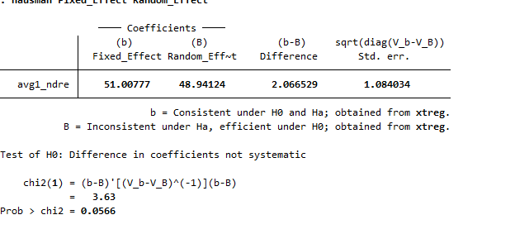 | 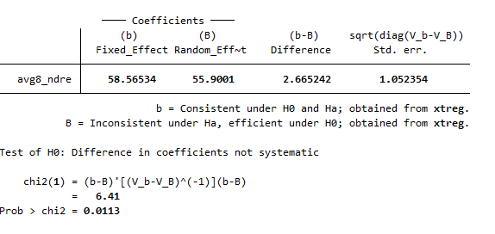
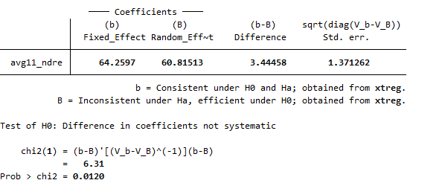 | 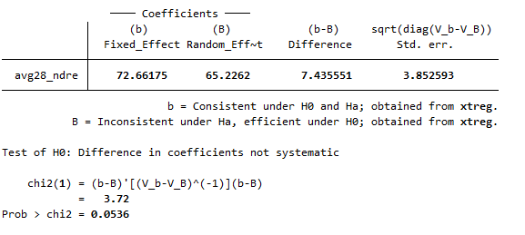
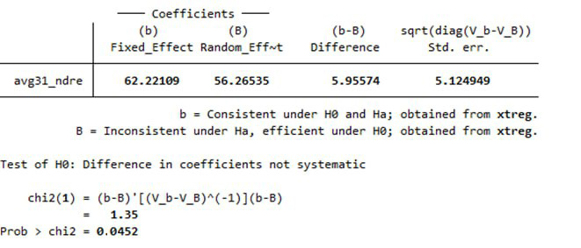 | 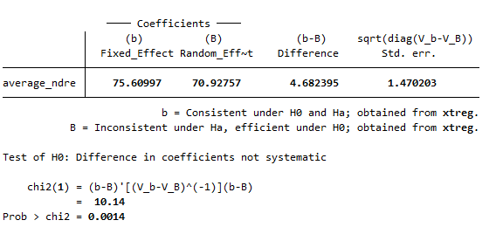

Supplementary Figure S4 Hausman test result NDRE indices for 75% training set
NDVI index
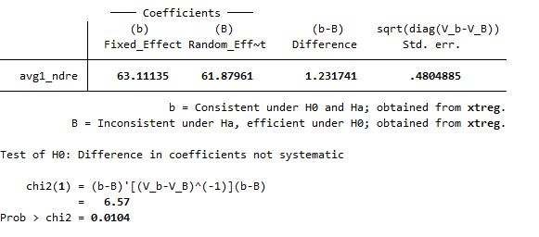 | 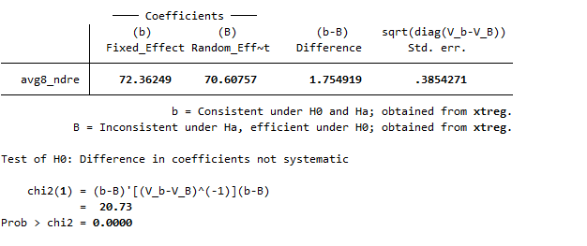
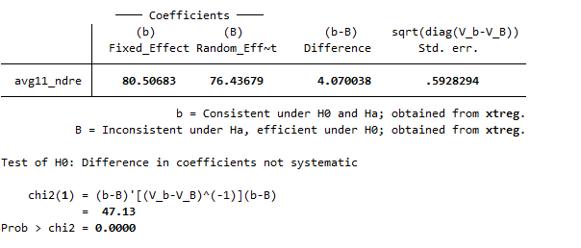 | 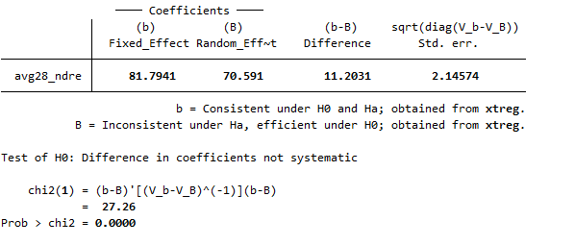
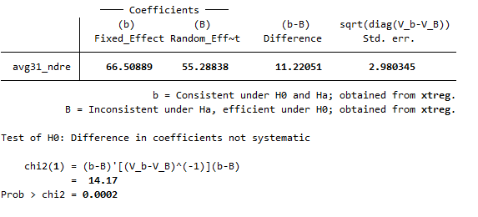 | 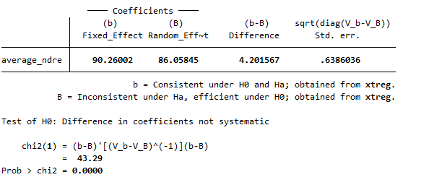
Supplementary Table S6. Panel fixed effect model for 25% testing set
NDRE index
  log_yield | Coef. |  | St.Err. | t-value |  | p-value | [95% Conf |  | Interval] |  | Sig
  avg1_ndre | 2.592 |  | .181 | 14.34 |  | 0 | 2.23 |  | 2.954 |  | ***
  Constant | 2.206 |  | .06 | 36.75 |  | 0 | 2.086 |  | 2.327 |  | ***
  Mean depend. var |  | 3.067 |  |  | SD dependent var |  |  | 0.293
  R-squared |  | 0.693 |  |  | Number of obs |  |  | 174.000
  Adj R-squared |  | 0.68 |  |  | Root MSE |  |  | 0.17
  F-test |  | 205.504 |  |  | Prob > F |  |  | .
  Akaike crit. (AIC) |  | -251.924 |  |  | Bayesian crit. (BIC) |  |  | -248.765
  *** p<.01, ** p<.05, * p<.1
  log_yield | Coef. |  | St.Err. | t-value |  | p-value | [95% Conf |  | Interval] |  | Sig
  avg8_ndre | 2.99 |  | .186 | 16.06 |  | 0 | 2.617 |  | 3.363 |  | ***
  Constant | 2.058 |  | .063 | 32.74 |  | 0 | 1.932 |  | 2.183 |  | ***
  Mean depend. var |  | 3.067 |  |  | SD dependent var |  |  | 0.293
  R-squared |  | 0.74 |  |  | Number of obs |  |  | 174.000
  Adj R-squared |  | 0.73 |  |  | Root MSE |  |  | 0.11
  F-test |  | 257.973 |  |  | Prob > F |  |  | .
  Akaike crit. (AIC) |  | -279.777 |  |  | Bayesian crit. (BIC) |  |  | -276.618
  *** p<.01, ** p<.05, * p<.1
  log_yield | Coef. |  | St.Err. | t-value |  | p-value | [95% Conf |  | Interval] |  | Sig
  avg11_ndre | 3.283 |  | .205 | 16.05 |  | 0 | 2.874 |  | 3.693 |  | ***
  Constant | 1.911 |  | .072 | 26.54 |  | 0 | 1.767 |  | 2.055 |  | ***
  Mean depend. var |  | 3.067 |  |  | SD dependent var |  |  | 0.293
  R-squared |  | 0.72 |  |  | Number of obs |  |  | 174.000
  Adj R-squared |  | 0.71 |  |  | Root MSE |  |  | 0.11
  F-test |  | 257.733 |  |  | Prob > F |  |  | .
  Akaike crit. (AIC) |  | -267.077 |  |  | Bayesian crit. (BIC) |  |  | -263.918
  *** p<.01, ** p<.05, * p<.1
  log_yield | Coef. |  | St.Err. | t-value |  | p-value | [95% Conf |  | Interval] |  | Sig
  avg28_ndre | 3.623 |  | .348 | 10.42 |  | 0 | 2.927 |  | 4.32 |  | ***
  Constant | 1.759 |  | .126 | 14.01 |  | 0 | 1.507 |  | 2.01 |  | ***
  Mean depend. var |  | 3.067 |  |  | SD dependent var |  |  | 0.293
  R-squared |  | 0.428 |  |  | Number of obs |  |  | 174.000
  Adj R-squared |  | 0.42 |  |  | Root MSE |  |  | 0.16
  F-test |  | 108.614 |  |  | Prob > F |  |  | .
  Akaike crit. (AIC) |  | -143.464 |  |  | Bayesian crit. (BIC) |  |  | -140.305
  *** p<.01, ** p<.05, * p<.1
  log_yield | Coef. |  | St.Err. | t-value |  | p-value | [95% Conf |  | Interval] |  | Sig
  avg31_ndre | 2.997 |  | .371 | 8.09 |  | 0 | 2.255 |  | 3.739 |  | ***
  Constant | 1.992 |  | .133 | 14.97 |  | 0 | 1.725 |  | 2.258 |  | ***
  Mean depend. var |  | 3.067 |  |  | SD dependent var |  |  | 0.293
  R-squared |  | 0.256 |  |  | Number of obs |  |  | 174.000
  Adj R-squared |  | 0.25 |  |  | Root MSE |  |  | 0.18
  F-test |  | 65.376 |  |  | Prob > F |  |  | .
  Akaike crit. (AIC) |  | -97.664 |  |  | Bayesian crit. (BIC) |  |  | -94.505
  *** p<.01, ** p<.05, * p<.1
  log_yield | Coef. |  | St.Err. | t-value |  | p-value | [95% Conf |  | Interval] |  | Sig
  average_ndre | 3.823 |  | .265 | 14.43 |  | 0 | 3.293 |  | 4.354 |  | ***
  Constant | 1.735 |  | .092 | 18.81 |  | 0 | 1.551 |  | 1.92 |  | ***
  Mean depend. var |  | 3.067 |  |  | SD dependent var |  |  | 0.293
  R-squared |  | 0.717 |  |  | Number of obs |  |  | 174.000
  Adj R-squared |  | 0.71 |  |  | Root MSE |  |  | 0.11
  F-test |  | 208.334 |  |  | Prob > F |  |  | .
  Akaike crit. (AIC) |  | -265.620 |  |  | Bayesian crit. (BIC) |  |  | -262.461
  *** p<.01, ** p<.05, * p<.1

Supplementary Table S7. Panel fixed effect model for 75% training set
NDRE index
  log_yield | Coef. |  | St.Err. | t-value |  | p-value | [95% Conf |  | Interval] |  | Sig
  avg1_ndre | 3.219 |  | .176 | 18.27 |  | 0 | 2.871 |  | 3.567 |  | ***
  Constant | 1.891 |  | .066 | 28.73 |  | 0 | 1.761 |  | 2.021 |  | ***
  Mean dependent var |  | 3.093 |  |  | SD dependent var |  |  | 0.369
  R-squared |  | 0.682 |  |  | Number of obs |  |  | 522.000
  Adj R-squared |  | 0.67 |  |  | Root MSE |  |  | 0.14
  F-test |  | 333.847 |  |  | Prob > F |  |  | .
  Akaike crit. (AIC) |  | -565.482 |  |  | Bayesian crit. (BIC) |  |  | -561.224
  *** p<.01, ** p<.05, * p<.1
  log_yield | Coef. |  | St.Err. | t-value |  | p-value | [95% Conf |  | Interval] |  | Sig
  avg8_ndre | 3.706 |  | .193 | 19.18 |  | 0 | 3.325 |  | 4.088 |  | ***
  Constant | 1.691 |  | .073 | 23.12 |  | 0 | 1.546 |  | 1.835 |  | ***
  Mean dependent var |  | 3.093 |  |  | SD dependent var |  |  | 0.369
  R-squared |  | 0.736 |  |  | Number of obs |  |  | 522.000
  Adj R-squared |  | 0.72 |  |  | Root MSE |  |  | 0.12
  F-test |  | 368.013 |  |  | Prob > F |  |  | .
  Akaike crit. (AIC) |  | -661.573 |  |  | Bayesian crit. (BIC) |  |  | -657.315
  *** p<.01, ** p<.05, * p<.1
  log_yield | Coef. |  | St.Err. | t-value |  | p-value | [95% Conf |  | Interval] |  | Sig
  avg11_ndre | 4.109 |  | .241 | 17.08 |  | 0 | 3.635 |  | 4.584 |  | ***
  Constant | 1.491 |  | .094 | 15.89 |  | 0 | 1.305 |  | 1.676 |  | ***
  Mean dependent var |  | 3.093 |  |  | SD dependent var |  |  | 0.369
  R-squared |  | 0.68 |  |  | Number of obs |  |  | 522.000
  Adj R-squared |  | 0.67 |  |  | Root MSE |  |  | 0.14
  F-test |  | 291.880 |  |  | Prob > F |  |  | .
  Akaike crit. (AIC) |  | -560.063 |  |  | Bayesian crit. (BIC) |  |  | -555.805
  *** p<.01, ** p<.05, * p<.1
  log_yield | Coef. |  | St.Err. | t-value |  | p-value | [95% Conf |  | Interval] |  | Sig
  avg28_ndre | 4.142 |  | .32 | 12.94 |  | 0 | 3.51 |  | 4.774 |  | ***
  Constant | 1.509 |  | .123 | 12.31 |  | 0 | 1.267 |  | 1.75 |  | ***
  Mean dependent var |  | 3.093 |  |  | SD dependent var |  |  | 0.369
  R-squared |  | 0.400 |  |  | Number of obs |  |  | 522.000
  Adj R-squared |  | 0.39 |  |  | Root MSE |  |  | 0.19
  F-test |  | 167.357 |  |  | Prob > F |  |  | .
  Akaike crit. (AIC) |  | -233.452 |  |  | Bayesian crit. (BIC) |  |  | -229.194
  *** p<.01, ** p<.05, * p<.1
  log_yield | Coef. |  | St.Err. | t-value |  | p-value | [95% Conf |  | Interval] |  | Sig
  avg31_ndre | 3.339 |  | .357 | 9.36 |  | 0 | 2.635 |  | 4.043 |  | ***
  Constant | 1.835 |  | .134 | 13.65 |  | 0 | 1.57 |  | 2.1 |  | ***
  Mean dependent var |  | 3.093 |  |  | SD dependent var |  |  | 0.369
  R-squared |  | 0.243 |  |  | Number of obs |  |  | 522.000
  Adj R-squared |  | 0.23 |  |  | Root MSE |  |  | 0.21
  F-test |  | 87.602 |  |  | Prob > F |  |  | .
  Akaike crit. (AIC) |  | -112.080 |  |  | Bayesian crit. (BIC) |  |  | -107.822
  *** p<.01, ** p<.05, * p<.1
  log_yield | Coef. |  | St.Err. | t-value |  | p-value | [95% Conf |  | Interval] |  | Sig
  average_ndre | 4.599 |  | .273 | 16.87 |  | 0 | 4.061 |  | 5.137 |  | ***
  Constant | 1.344 |  | .104 | 12.97 |  | 0 | 1.14 |  | 1.549 |  | ***
  Mean dependent var |  | 3.093 |  |  | SD dependent var |  |  | 0.369
  R-squared |  | 0.685 |  |  | Number of obs |  |  | 522.000
  Adj R-squared |  | 0.67 |  |  | Root MSE |  |  | 0.14
  F-test |  | 284.695 |  |  | Prob > F |  |  | .
  Akaike crit. (AIC) |  | -570.242 |  |  | Bayesian crit. (BIC) |  |  | -565.984
  *** p<.01, ** p<.05, * p<.1
Supplementary Table S8. Prais-Winsten model for 25% testing set
NDRE index
  log_yield | Coef. |  | St.Err. | t-value |  | p-value | [95% Conf |  | Interval] |  | Sig
  avg1_ndre | 2.178 |  | .222 | 9.82 |  | 0 | 1.743 |  | 2.613 |  | ***
  Constant | 2.345 |  | .08 | 29.42 |  | 0 | 2.189 |  | 2.501 |  | ***
  Mean dependent var |  | 3.067 |  |  | SD dependent var |  |  | 0.293
  R-squared |  | 0.96 |  |  | Number of obs |  |  | 174.000
  Adj R-squared |  | 0.95 |  |  | Root MSE |  |  | 0.18
  Chi-square |  | 96.427 |  |  | Prob > chi2 |  |  | 0.000
  *** p<.01, ** p<.05, * p<.1
  log_yield | Coef. |  | St.Err. | t-value |  | p-value | [95% Conf |  | Interval] |  | Sig
  avg8_ndre | 2.478 |  | .242 | 10.23 |  | 0 | 2.003 |  | 2.952 |  | ***
  Constant | 2.231 |  | .088 | 25.36 |  | 0 | 2.058 |  | 2.403 |  | ***
  Mean dependent var |  | 3.067 |  |  | SD dependent var |  |  | 0.293
  R-squared |  | 0.97 |  |  | Number of obs |  |  | 174.000
  Adj R-squared |  | 0.96 |  |  | Root MSE |  |  | 0.17
  Chi-square |  | 104.708 |  |  | Prob > chi2 |  |  | 0.000
  *** p<.01, ** p<.05, * p<.1
  log_yield | Coef. |  | St.Err. | t-value |  | p-value | [95% Conf |  | Interval] |  | Sig
  avg11_ndre | 2.748 |  | .269 | 10.22 |  | 0 | 2.221 |  | 3.275 |  | ***
  Constant | 2.098 |  | .105 | 20.03 |  | 0 | 1.893 |  | 2.304 |  | ***
  Mean dependent var |  | 3.067 |  |  | SD dependent var |  |  | 0.293
  R-squared |  | 0.96 |  |  | Number of obs |  |  | 174.000
  Adj R-squared |  | 0.95 |  |  | Root MSE |  |  | 0.17
  Chi-square |  | 104.529 |  |  | Prob > chi2 |  |  | 0.000
  *** p<.01, ** p<.05, * p<.1
  log_yield | Coef. |  | St.Err. | t-value |  | p-value | [95% Conf |  | Interval] |  | Sig
  avg28_ndre | 2.871 |  | .425 | 6.75 |  | 0 | 2.038 |  | 3.704 |  | ***
  Constant | 2.011 |  | .172 | 11.71 |  | 0 | 1.675 |  | 2.348 |  | ***
  Mean dependent var |  | 3.067 |  |  | SD dependent var |  |  | 0.293
  R-squared |  | 0.94 |  |  | Number of obs |  |  | 174.000
  Adj R-squared |  | 0.93 |  |  | Root MSE |  |  | 0.20
  Chi-square |  | 45.620 |  |  | Prob > chi2 |  |  | 0.000
  *** p<.01, ** p<.05, * p<.1
  log_yield | Coef. |  | St.Err. | t-value |  | p-value | [95% Conf |  | Interval] |  | Sig
  avg31_ndre | 2.469 |  | .475 | 5.20 |  | 0 | 1.538 |  | 3.4 |  | ***
  Constant | 2.153 |  | .179 | 12.06 |  | 0 | 1.803 |  | 2.503 |  | ***
  Mean dependent var |  | 3.067 |  |  | SD dependent var |  |  | 0.293
  R-squared |  | 0.94 |  |  | Number of obs |  |  | 174.000
  Adj R-squared |  | 0.93 |  |  | Root MSE |  |  | 0.22
  Chi-square |  | 27.007 |  |  | Prob > chi2 |  |  | 0.000
  *** p<.01, ** p<.05, * p<.1
  log_yield | Coef. |  | St.Err. | t-value |  | p-value | [95% Conf |  | Interval] |  | Sig
  average_ndre | 3.057 |  | .34 | 9.00 |  | 0 | 2.391 |  | 3.722 |  | ***
  Constant | 2.001 |  | .13 | 15.36 |  | 0 | 1.746 |  | 2.257 |  | ***
  Mean dependent var |  | 3.067 |  |  | SD dependent var |  |  | 0.293
  R-squared |  | 0.96 |  |  | Number of obs |  |  | 174.000
  Adj R-squared |  | 0.95 |  |  | Root MSE |  |  | 0.17
  Chi-square |  | 80.979 |  |  | Prob > chi2 |  |  | 0.000
  *** p<.01, ** p<.05, * p<.1

Supplementary Table S9. Prais-Winsten model for 75% training set
NDRE index
  log_yield | Coef. |  | St.Err. | t-value |  | p-value | [95% Conf |  | Interval] |  | Sig
  avg1_ndre | 2.944 |  | .246 | 11.96 |  | 0 | 2.462 |  | 3.427 |  | ***
  Constant | 1.967 |  | .109 | 18.13 |  | 0 | 1.755 |  | 2.18 |  | ***
  Mean dependent var |  | 3.093 |  |  | SD dependent var |  |  | 0.369
  R-squared |  | 0.95 |  |  | Number of obs |  |  | 522.000
  Adj R-squared |  | 0.94 |  |  | Root MSE |  |  | 0.23
  Chi-square |  | 143.088 |  |  | Prob > chi2 |  |  | 0.000
  *** p<.01, ** p<.05, * p<.1
  log_yield | Coef. |  | St.Err. | t-value |  | p-value | [95% Conf |  | Interval] |  | Sig
  avg8_ndre | 3.302 |  | .24 | 13.77 |  | 0 | 2.832 |  | 3.772 |  | ***
  Constant | 1.819 |  | .105 | 17.31 |  | 0 | 1.613 |  | 2.025 |  | ***
  Mean dependent var |  | 3.093 |  |  | SD dependent var |  |  | 0.369
  R-squared |  | 0.96 |  |  | Number of obs |  |  | 522.000
  Adj R-squared |  | 0.95 |  |  | Root MSE |  |  | 0.22
  Chi-square |  | 189.557 |  |  | Prob > chi2 |  |  | 0.000
  *** p<.01, ** p<.05, * p<.1
  log_yield | Coef. |  | St.Err. | t-value |  | p-value | [95% Conf |  | Interval] |  | Sig
  avg11_ndre | 3.311 |  | .384 | 8.63 |  | 0 | 2.559 |  | 4.063 |  | ***
  Constant | 1.768 |  | .164 | 10.80 |  | 0 | 1.447 |  | 2.089 |  | ***
  Mean dependent var |  | 3.093 |  |  | SD dependent var |  |  | 0.369
  R-squared |  | 0.94 |  |  | Number of obs |  |  | 522.000
  Adj R-squared |  | 0.93 |  |  | Root MSE |  |  | 0.24
  Chi-square |  | 74.510 |  |  | Prob > chi2 |  |  | 0.000
  *** p<.01, ** p<.05, * p<.1
  log_yield | Coef. |  | St.Err. | t-value |  | p-value | [95% Conf |  | Interval] |  | Sig
  avg28_ndre | 2.894 |  | .588 | 4.92 |  | 0 | 1.741 |  | 4.046 |  | ***
  Constant | 1.935 |  | .235 | 8.24 |  | 0 | 1.474 |  | 2.395 |  | ***
  Mean dependent var |  | 3.093 |  |  | SD dependent var |  |  | 0.369
  R-squared |  | 0.92 |  |  | Number of obs |  |  | 522.000
  Adj R-squared |  | 0.91 |  |  | Root MSE |  |  | 0.28
  Chi-square |  | 24.219 |  |  | Prob > chi2 |  |  | 0.000
  *** p<.01, ** p<.05, * p<.1
  log_yield | Coef. |  | St.Err. | t-value |  | p-value | [95% Conf |  | Interval] |  | Sig
  avg31_ndre | 2.225 |  | .596 | 3.73 |  | 0 | 1.057 |  | 3.394 |  | ***
  Constant | 2.203 |  | .233 | 9.47 |  | 0 | 1.747 |  | 2.659 |  | ***
  Mean dependent var |  | 3.093 |  |  | SD dependent var |  |  | 0.369
  R-squared |  | 0.91 |  |  | Number of obs |  |  | 522.000
  Adj R-squared |  | 0.90 |  |  | Root MSE |  |  | 0.29
  Chi-square |  | 13.928 |  |  | Prob > chi2 |  |  | 0.000
  *** p<.01, ** p<.05, * p<.1
  log_yield | Coef. |  | St.Err. | t-value |  | p-value | [95% Conf |  | Interval] |  | Sig
  average_ndre | 3.796 |  | .405 | 9.38 |  | 0 | 3.002 |  | 4.589 |  | ***
  Constant | 1.618 |  | .167 | 9.71 |  | 0 | 1.292 |  | 1.945 |  | ***
  Mean dependent var |  | 3.093 |  |  | SD dependent var |  |  | 0.369
  R-squared |  | 0.94 |  |  | Number of obs |  |  | 522.000
  Adj R-squared |  | 0.93 |  |  | Root MSE |  |  | 0.24
  Chi-square |  | 87.909 |  |  | Prob > chi2 |  |  | 0.000
  *** p<.01, ** p<.05, * p<.1

