Supplementary tables

Table 1: Indian insurance firms offering technology-based products
Insurer | Category | Example
Aditya Birla | Health Insurance | Discounts for policyholders who use an activity tracker to track their steps, go to the gym or have a health exam.
Max Bupa | Health Insurance | Discounts on premium on achieving health scores and personalized health coaching.
ICICI Lombard | Health Insurance | Rewards for healthy routines like gym sessions, participation in marathons, etc.
Source: Authors’ work

Table 2: Demographic characteristics
Characteristics | Categories | Percentages
Gender | Male | 51.6%
Gender | Female | 48.4%
Age group | Less than 25 years | 25.3%
Age group | 25-34 years | 47.3%
Age group | 35-44 years | 7.7%
Age group | 45 and above | 19.3%
Suffering from chronic disease? | Yes | 11%
Suffering from chronic disease? | No | 89%
Purchase health insurance before? | Yes | 47.3%
Purchase health insurance before? | No | 52.7%
Source: Authors’ work

Table 3: Convergent validity results for constructs
Construct | Items | Factor Loading | Cronbach’s Alpha | Average Variance
Perceived Usefulness | PU1 | 0.917 | 0.901 | 0.772
Perceived Usefulness | PU2 | 0.843 | 0.901 | 0.772
Perceived Usefulness | PU3 | 0.842 | 0.901 | 0.772
Perceived Usefulness | PU4 | 0.909 | 0.901 | 0.772
Perceived Ease of Use | PEOU1 | 0.945 | 0.916 | 0.857
Perceived Ease of Use | PEOU2 | 0.915 | 0.916 | 0.857
Perceived Ease of Use | PEOU3 | 0.916 | 0.916 | 0.857
Trust | PDT1 | 0.939 | 0.901 | 0.835
Trust | PDT2 | 0.883 | 0.901 | 0.835
Trust | PDT3 | 0.918 | 0.901 | 0.835
Privacy Concerns | PC1 | 0.937 | 0.868 | 0.723
Privacy Concerns | PC2 | 0.707 | 0.868 | 0.723
Privacy Concerns | PC3 | 0.960 | 0.868 | 0.723
Willingness To Pay | WTP1 | 0.895 | 0.901 | 0.834
Willingness To Pay | WTP2 | 0.916 | 0.901 | 0.834
Willingness To Pay | WTP3 | 0.929 | 0.901 | 0.834
Attitude | ATT1 | 0.921 | 0.904 | 0.839
Attitude | ATT2 | 0.946 | 0.904 | 0.839
Attitude | ATT3 | 0.879 | 0.904 | 0.839
Purchase Intention | PI1 | 0.907 | 0.923 | 0.813
Purchase Intention | PI2 | 0.894 | 0.923 | 0.813
Purchase Intention | PI3 | 0.904 | 0.923 | 0.813
Purchase Intention | PI4 | 0.901 | 0.923 | 0.813
Source: Authors’ work

Table 4: Discriminant validity results for constructs (HTMT)
 | ATT | PC | PEOU | PI | PU | T | WTP
ATT | 0.816
PC | 0.151 | 0.750
PEOU | 0.583 | 0.223 | 0.826
PI | 0.797 | 0.210 | 0.572 | 0.802
PU | 0.733 | 0.155 | 0.615 | 0.623 | 0.779
T | 0.731 | 0.110 | 0.529 | 0.675 | 0.697 | 0.814
WTP | 0.714 | 0.154 | 0.555 | 0.710 | 0.618 | 0.675 | 0.813
Source: Authors’ work

Table 5: Mediation results
Hypothesis | Effect | Path | t statistics | p-value | Remarks
H8 | Direct | PEOU -> ATT | 2.228 | 0.026 | Partial mediation (Complementary)
H8 | Indirect | PEOU-> PU-> ATT | 4.579 | 0.000 | Partial mediation (Complementary)
Source: Authors’ work

Questionnaire
Email (optional): | Location:
Age:  - Less than 25 years  - 25-34 years  - 35-44 years  - 45-54 years  - 55 years and above | Gender:  - Male  - Female  - Prefer not to say
Educational Qualification:  - Primary  - Matriculation (10th Pass)  - Higher Secondary (12th Pass)  - Graduate  - Post-Graduate  - Professional Degree | Monthly Family Income:  - Less than Rs. 30,000  - Rs 30,000-60,000  - Rs 60,001- 1,00,000  - Rs 1,00,001- 2,50,000  - Rs 2,50,001- 5,00,000  - Rs 5,00,000 & above
Mobile phone experience:
- Less than a year
- 1-3 years
- 3-5 years
- More than 5 years

Have you ever purchased health insurance?
- Yes
- No
Did you know that now by working out and sharing your daily health data, like steps count or gym activity, one can reduce their premium amount and also gain price concessions? So, nowadays many big insurance companies like Aditya Birla are offering rewards for being active. Basically, if you are working out on a daily basis then you can eventually bring down your monthly premium amount and also gain some rewards by keeping your health and wealth intact. We have attached a screenshot of an insurance company offering rewards for staying healthy. Based on this, please fill in the survey questions below.
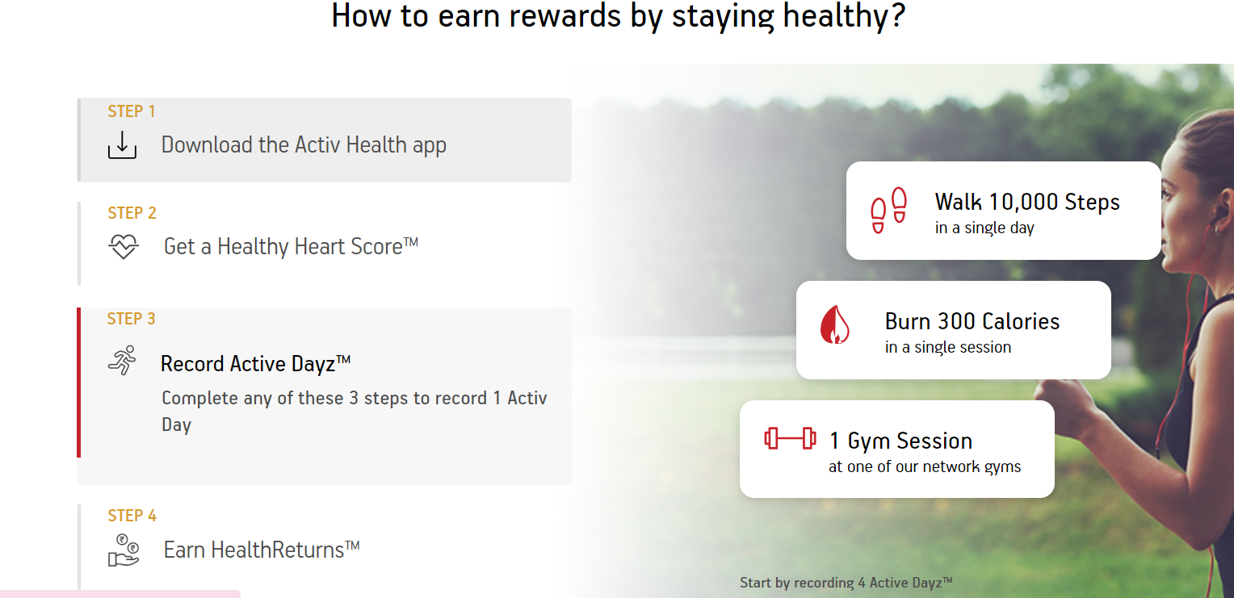

Please tick the appropriate option in the right-hand column
(1=Strongly Disagree, 2=Disagree, 3= Neither Agree/Neither disagree, 4=Agree, 5=Strongly Agree):
Construct | Items | References
Perceived Usefulness | PU 1 I find that technology-based health insurance products are helpful in managing health.  PU 2 I find that managing health through technology-based health insurance products make me safer in my daily life.  PU 3 Technology-based health insurance products can enhance my level of convenience in accessing medical care service.  PU 4 Technology-based health insurance products can enhance the quality of my health.  PU 5 Overall, I find that Technology-based health insurance products are highly useful. | (Davis, 1989), (Davis et. al., 1989)
Perceived Ease of Use | PEOU 1 I find that using technology-based health insurance products are simple.  PEOU 2 I find that technology-based health insurance products are easy to learn.  PEOU 3 I find that technology-based health insurance products are easily understandable and clear.  PEOU 4 Overall, I find that technology-based health insurance products are convenient. | (Davis, 1989), (Davis et. al., 1989), (Huang, 2010)
Trust | T 1 Based on my experience with the technology-based health insurance products in the past, I know it is trustworthy.  T 2 Based on my experience with the technology-based health insurance products in the past, I know that it is not exploitative.  T3 Based on my experience with technology-based health insurance products in the past, I know that it provides information as promised to patient. | (Khan et. al., 2019)
Privacy Concerns | PC 1 I am concerned about the security of my personal information when using technology-based health insurance products.  PC2 I am uncomfortable providing personal information to the technology-based health insurance products.  PC3 I am concerned that the agent could share my data with third parties without my consent.  PC4 I worry that my personal information could be used for targeted advertising or other marketing purposes.  PC5 I worry that my personal data could be used for purposes that I am not aware of or do not approve of. | (Zhang, Wang & Jin, 2014)
Willingness to pay | WTP 1 I will pay for accessing technology-based health insurance products.  WTP 2 I am willing to pay more money to purchase technology-based health insurance products instead of the regular ones.  WTP 3 I will continue to use this type of service via the mobile device even if the prices increase. | Adapted from Bloemer, Odekerken-Schröder and Kestens  2003; Fullerton 2003; Zeithaml and Berry 1996
Attitude | ATT 1 I like using technology-based health insurance products  ATT 2 Overall, I consider technology-based health insurance products to be just right.  ATT 3 In my old age, using technology-based health insurance products would be ideal. | (Taylor and Todd, 1995), (Huang, 2010)
Purchase Intention | PI 1 Overall, i am highly willing to use technology-based health insurance products.  PI 2 If necessary, I would use technology-based health insurance products often.  PI 3 In my old age, I am willing to use technology-based health insurance products.  PI 4 In my old age, I would use technology-based health insurance products often. | (Taylor and Todd, 1995), (Huang, 2010)

