Building certain knowledge based on the intention to consequence gap in uncertain surroundings

Tadeusz GOSPODAREK
WSB University in Wroclaw, Poland
Received: 25.03.2021, Revised: 17.06.2021, Revised: 27.07.2021, Revised: 30.08.2021, Accepted: 24.09.2021
doi: http://dx.doi.org/10.29015/cerem.916

Aim: Develop a methodological approach to reduce uncertainty of knowledge necessary for decision making in quick changing surroundings.

Research methods: The research method is heuristic supported by the research programme in Lakatos’ sense, specially designed for these purposes based on the good paradigm of minimization the intentional consequential gap (ICG).

Findings: The ICG is an interesting object related to the “is-ought problem” in Hume’s sense, representing the difference of resulting consequences and achievements of the intention after its realization. Any kind of minimization of the ICG may be recognized as a good paradigm in Kuhn’s sense suitable to build certain knowledge in the uncertain surroundings. So, it is the base of research programme in Lakatos’ sense which is a kind of filter for certain judgements about facts. It is crucial for decision making processes based on uncertain information and knowledge. In this paper a methodology of introduction the research programme based on the minimum ICG is presented.. Currently this method of inferring may be used for building the certain knowledge about rationality of decisions regarding dealing with COVID-19.

Value of the paper: The paper presents an original method of setting the criterion of rationality of any social projects and some axiological evaluations of, among other things, prognoses and strategies.

Keywords: intention to consequence gap, knowledge, uncertainty, system approach, economic state, paradigm, research programme, game theory approach.
JEL: D81; P40

1. Introduction

Epistemological models of human economic activity, axiological evaluations related to these activities and building effective prognostic models for business purposes are joined together by the issue of Hume’s guillotine (Black 1964) and the system approach (Gospodarek 2009). The question is: whether from the issue how is here and now, one can derive how it should be regarding the economic state of the forecast subject. It is the base aspect of uncertainty in decision making processes. For that reason, the problem of intention to consequence gap (ICG), which determines the uncertainty and is directly related to the issue of bounded rationality of decision making (Simon 1957) is important. The gap between ‘is’ and ‘ought’ always appears at the time of making decisions, regardless of the amount of information available to the decision maker. Uncertain surroundings raise the gap adding some unexpected factors to be taken into account. In COVID-19 case there are a lot of different problems derived that were impossible to handle and describe at the beginning of pandemic. It is an example of the “black swan” event (Taleb 2007) regarding the economic consequences of induced decisions of freezing national economies and introducing societal isolations. Taleb explained that a pandemic like COVID-19 is not a black swan and called it as Will’s (2020) black elephant. But nobody could imagine at the very beginning of the pandemic, how COVID-19 would influence the rearrangement of macro-micro equilibrium in world’s economics. Therefore, it should not be erroneous to call those effects “black swan” type phenomenon.
The following issue arises: is it possible to state judgments about facts close to the truth in such uncertain conditions? Usually, managers making decision have highly probable knowledge about the past and the present. This allows them to approximate economic conditions related to the subject which they decide about at an acceptable level of current knowledge. Perception of the state of reality takes place at a moment when they took an intention to change the state of the managed entity in any way. However, at the same time, it is necessary to make a forecast of the description of this state for the moment after materialization of the intentions. Thus, the Hume’s problem manifests itself in the form of an ICG. In addition, some extra complexity is introduced to the managed system due to uncertainty increasing from the black swan or black elephant issue. It makes non reducible extension of the ICG. But even such bad conditions of predictions do not eliminate correct descriptions of facts. An implication may be true even if its assumptions are false. The most important results of inferring under uncertainty should be correct forecasting of possible consequences of actions performed for the materialization of the intentions.
The ICG is independent on epistemological position of the researcher because it depends on the scope and quality of available information about the economic state of the managed objective. It may be correctly described depending on the existing knowledge, theories, and models of the analysed entity. But it is impossible to reduce the uncertainty to null. There always remains uncertainty, as large as some unexpected phenomena, which would influence the described object.
Because transition of the state of the object from the moment the intention is taken to the consequences after the time of its realization takes place in uncertain surroundings, it is also necessary to predict the most probable scenario of development of these surroundings. Such approach is suggested by the ISO 31000 norm of risk management. It is the base of contingency theory of management (Burns, Stalker 1961) and the model of self-adaptation of the firm using the feedback responses from the surroundings (Gospodarek 2012).
Let’s have a look at some decisions about lockdown in any country. There is not sufficient knowledge about the effectiveness of such acting regarding a stop to the virus transmission. But the vicinity of some countries using the lockdown as the tool of fighting the COVID-19 pandemic induces one to keep similar procedures hoping that set of countries are right. The intention is OK, but the consequences are difficult to predict due to a dramatic lack of certain information. This is an example of the ICG: we know something about the past and about the present and based on this knowledge and some experience derived from the surroundings, we form the prediction of the future behaviour of the virus. COVID-19 has painfully verified this kind of inferring and shown how wide is the gap between prediction and future behaviour. This what we know today about the future is highly uncertain.
For building ordered knowledge about any entity acting with the surroundings it is convenient to divide the question about its state on seven logical layers of modelling: context, ontological, epistemological, methodical, semantic, syntactic and blueprint (Gospodarek 2009b, 2012). These represent the most important aspects of descriptive theories about the subject and a formal approach to explain its interactions with the surroundings. This way allows the researcher to consider possible perturbations in the surroundings and their influences on the final model of the state of the object. The described logical division of the scope helps to narrowing the ICG due to decreasing number of aspects within any single logical layer compared to the full complex structure.
Among the set of logical layers, there is the epistemological one, where the issue is defined and its scope is fixed. Therefore, this is a crucial element for the entire process of formal modelling of any problem. Lacking a good definition, any further inferring may result in erroneous conclusions. Lack of precise description of the scope may interfere with the use of the right theories and methods for scientific verification of the hypotheses pointed out and it introduces uncertainty to predictions of the consequences of potential acting. At the end, the existing in the epistemological layer demarcation criteria for the concerned problem allow to filter true judgements about fact from the scope of the model against those falsifiable or not verifiable. It is important to describe the different states of any entity in time during a process of transition, especially for the holistic approach.
At the epistemological level of modelling, the system approach to the transition of the entity from the state A (taking intent) to the state B (occurrence of consequences) is well supported by a model of two-persons game against the environment (Gospodarek 2018). Then the ICG can be determined as a payoff of this game regardless the methods of acting used in the transition processes. Since the consequential aspects of any transition are the overriding criteria of axiological evaluations of economic decisions it may be regarded as the “golden rule of operation” (whatever you do, do it cautiously and see the end consequences). In highly uncertain surroundings the player must often take some ad hoc strategies because the game is not possible to stop. This being so good strategies may be chosen even if the ICG is not determined well enough. But it is stochastic choice. More probable is, that those ad hoc choices will be not adequate, as shown by the example of the COVID-19 pandemic fighting. This is a game where there are a lot of strategies applied ad hoc, because the ICG is still not defined sufficiently.
The ICG is an interesting entity. Based on T. Kuhn’s concept of a good paradigm (Kuhn 1970) the following sentence may be recognized as the paradigm: The categorical imperative of making decisions under uncertainty is minimization of the intention to consequence gap. It is possible to build valuable knowledge about the ICG and methods of its minimization. This may be the base of the scientific programme in I. Lakatos’ sense (Lakatos 1978; Gospodarek 2009a), leading to consistent knowledge about measurements of the gap of the present time description of two states of an entity during transition. It is also possible to build axiological judgements about facts regarding given intentions and observed consequences.
The aim of this paper is the methodological introduction to the research programme in I. Lakatos’ sense named “Intention to consequence Gap in Decision Making Optimization”. It is the epistemological approach to questions crosslinking the scopes of economics and philosophy that may be used for the purpose to organize knowledge, eliminating inconsistent basic statements of the theory. It may be a good tool for building fundamental knowledge for macro-decisions of lockdown type. It seems to be rational to verify the lockdown paradigm as a panacea for the transmission of the virus. It may help to avoid using a treatment which is worse than the disease.

2. Understanding the system approach to managing changes

In many cases of description of human acting for any reason one can find problems including complexity of interactions between the acting entity and the surroundings. These problems are caused by the impossibility to describe the reality with a finite set of equations. What is more, a human being often reacts behaviourally according to contrariness principle against different ‘silly’ regulations. Because all economic actions take place in an environment that is continuously changing, it is impossible to repeat any economic experiment on the same initial conditions. The reason is obvious, it is impossible to go back to the past, because the environment does not stop during the experiment. Trying to describe a state of any entity using common language, the researcher automatically introduces semantic complexity to the description, because one can use similar meaning words, cognitive metaphors, different linguistic styles, etc. So, it is necessary to simplify the case, introducing any ceteris paribus and trying to achieve formal semantic descriptions based on models, like a black or grey box.
One of successful methods of simplifying descriptions of economic acting is the system approach. It bases on some assumptions.
- A detailed structure of acting entity is not necessary to know (black or grey box model).
- Any acting entity may be treated as an open complex adaptative system interacting economically with its surroundings.
- The system is a complex structure acting accordingly to a defined objective function, where its state may be described with a set of fixed parameters.
The structure called the system should meet some axiomatic rules (Gospodarek 2012). Acting should be understood as a conscious activity of the system changing any of its parameters of the state in a given period. It is not directly dependent on any changes derived in the surroundings, even black swan type. The methodology is well defined as a general system theory (Bertalanffy 1968).
In this paper the following definition of the system will be applied. “The system is a structure interacting with the surroundings, contains of organized elements able to achieve assumed goals on the optimum way, for which the following principles are valid:
- The principle of subsystem synergy – Each system in a holistic sense exhibits the synergy of the operation of its components.
- The principle of inseparability from the context – Each system interacts with the surroundings and should not be analysed as an isolated object.
- Principle of isomorphism – Differently defined systems can lead to the same goal regardless the way of its realization.
- Principle of requisite variety (Ashby’s Law): The system is the more stable the more various control solutions it contains.
- The principle of limited functionality of the system: The functionality of the system in relation to the η criterion depends on the efficiency of its weakest element in relation to this criterion.
- Principle of optimum operation ability. The most general, most common, profound and expressive cause of everything is optimality.”
In some cases, the action of the system may be recognized as resolving a conflict situation using available interactions with the surroundings. For such issues, the game theory offers good methodological solutions. From the theory it follows that if the game may be defined in a finite matrix form, then there does exist an optimum solution (saddle point of the game). It means, that for such cases, there exists optimum management method for a given issue, and/or minimum knowledge gap of the defined ICG, etc. Of course, existing means not equal to be found automatically, but it is possible to find the optimum in some. The suitable model is presented in Figure 1.
At the moment t₁ an inventor (intention maker) makes an intention of doing something in the surroundings, regardless its type. This intention may be materialized after a decision making to start a realization of a project with participation of stakeholders of that intention. The surroundings mean: the society with its ontic properties and the set of resources with defined usability and characteristics. So, it is possible to define the state of the stakeholders’ organization related to the intention and some potential recipients of consequences related to the results of actions joined with the materialization of the intention at a starting moment t₁ and any other time. This is derived from the system properties and the assumed black box simplification. The measure remains the same in the entire time of the experiment. Only results of measurements are different for different moments.
It is also possible to determine the state of the entities involved in processing the idea taken. There is a moment t₂ > t₁ when the consequences will occur (on the Figure 1 it is marked as “New state”). Therefore, the intention makers try to predict in the moment t₁ the state description for the moment t₂.
Because the surroundings not always are able to change something inside, not all external intentions influencing the existing dynamic balance of micro-macro are acceptable at once. The intention stakeholders must convince the society about the correctness of the intention proposed, and about some benefits derived from its adaptation. This is the base of a game setting because there is a typical conflict situation. On the one hand, the intention stakeholders try to implement new idea, but on the other hand some entities, responsible for the economic and social equilibrium in the surroundings, try to stop any changes. Regardless the details of the strategies structure and rules of the game, each one is starting in a moment t1. From the initial state description one can yield new, final state description in t2 after the game is finished.
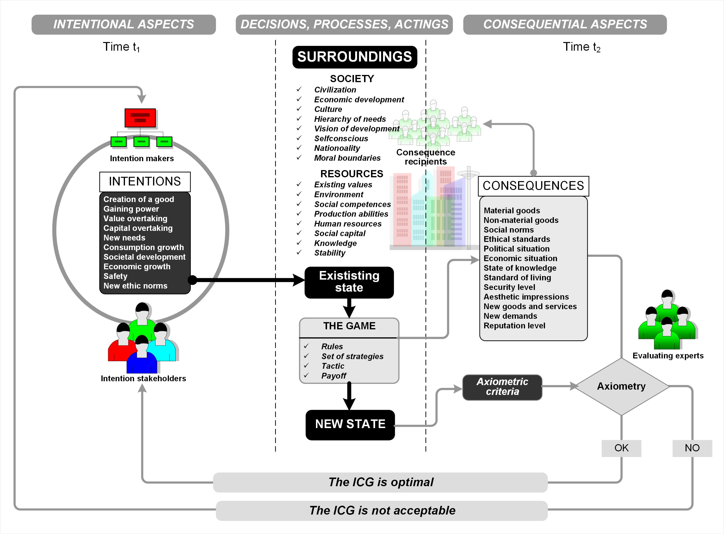
Figure 1. System approach to determine the intention to consequence gap
Source: author’s own elaboration.
Then some consequences of physical acting by intention stakeholders are derived in the surrounding during gaming. These consequences may influence the final state description, and their recipients can evaluate the consequential state observed at a moment t₂. It may be quite different result from that predicted at the moment t₁ by the intention makers. This is the classic example of ICG in the system approach.
Using some axiometric criteria to compare the states at the initial and the final time of handling the intention, the evaluating experts may judge the ICG. If the ICG is optimal, then the intention was rational, if not, then intention must be replaced by another one. The same model may be used for the detailed analysis of decision making under uncertainty. Even rationally bounded decisions are based on optimized ICG because the construction of the game described above offers solutions not far from the optimum. If prediction of consequences will be good, then the decision about the implementation of the related intention will be optimal.
Let’s have a look how this may work in the case of a lockdown decision relating to the fight against the COVID-19. The authorities make an intention to defend against the SARS-COV-19 virus transmission inside a defined area by applying a lockdown. At the moment of the intention taken there is huge uncertainty about the nature of the virus, the ranges of its transmission, the possible protection instruments, etc. But some knowledge from the past is collected, and some experience derived from other countries at the present is available. Therefore, some consequences of applying the lockdown may be predicted. The ICG in this case is as wide as the uncertainty during a decision making. Multi-aspect analysis and comparisons of lockdown results between different regions made from the perspective of a year experience have shown that the ICG had been still existing. One can observe different evaluations of the lockdown in action, from very positive (mainly made by the authorities) to narrow critical (from the business point of view). Costs of the lockdowns are huge in relation to effectiveness of the method. The game against the surroundings is not resolved. There is no break point, so the intention was not right. But the negative payoffs in all national economies where the intention was implemented, had been dramatically exhibited. Where is the point? In the uncertainty caused by lack of knowledge about a set of consequences in a moment when the intention had taken. This knowledge gap was derived from erroneous base judgements about facts believed as true.

3. Intention to consequence gap as a tool for uncertainty reduction

The definition of the ICG is based on the system approach supported by the game theory concept.

Definition 1: The Intention to consequence gap (ICG) is a measure of uncertainty of judgements about consequences of acting related to the idea materialization predicted at a moment when the intention was being made, against the real changes observed after the consequences of implementation of that intention in the surroundings have arisen.

As an example of defining ICG, as a cognitive, conceptual model, the bounded rationality approach to managing an issue may be useful. We make decisions suitable for our comfort and wellbeing as it was presented by (Kahneman et al. 1982) and earlier by Simon (Barnard, Simon 1947) regardless the precise determination of all possible options. It is continuously observed during SARS-COV-19 pandemic handling. Due to the big knowledge gap about the nature of the virus and its transmission, a lot of inconsistent economic and organizational decision were made worldwide by the authorities. Today we can evaluate the lockdown decisions as very problematic (Book, Bjørnskov 2021). Also, a lot of false information, hypotheses and knowledge have been spread widely around the World, regarding such opinion making institution like WHO. These made the ICG greater and possible consequences of the intentions rolled out more uncertain. But the definition of the ICG is still valid, and the methodology of the system approach supporting by the game theory concept too.
It seems valuable to provide a tool that is helpful in building true knowledge for the systems interacting with the surroundings. This way these systems receive, and may adapt to, more diversity for correct acting. The research programme in Lakatos’ sense will offer a rational reduction of ICG and build a demarcation criterion for uncertain judgements about facts. The proposed method may be useful for building healthcare decision systems based on certain knowledge rather than on political and corporate interests.

4. The paradigm based on minimum of the ICG

The main objective of building ordered knowledge is a good paradigm in Kuhn’s (1970) sense. It is a kind of paradigmatic sentence characterized by the following properties:
- Logical consistency (fixed logical value: true or false).
- Cognitive simplicity (lack of semantic complexity).
- Creativity (it is possible to derive from this sentence several hypotheses, theorems, lemmas, and true judgements about facts).
- Transferability (the paradigm may be replaced by a better one).
- Scientific judgement (the paradigm may be falsified in Popper’s sense [Popper 1934] or verified according to Carnap’s concept [Carnap 1995]).
Based on a paradigm, it should be possible to build falsifiable or verifiable theories explaining some empirical facts. It should be possible to filter scientific problems based on the inclusion relation to this paradigm. It is very convenient method of inheriting paradigmatic properties to all entities included in it (theories, judgements, lemmas). If one can prove, that a given problem belongs to the defined paradigm, it automatically inherits characteristics from this paradigm. So, instead of proving something based on induction or deduction, it may be sufficient to prove its belonging to the suitable paradigm. This option is very convenient in describing something in uncertain surroundings.
The following statement related to the ICG may be considered as good paradigm (the paradigm of minimum the ICG):
The categorical imperative of the rational economic actor is minimization the ICG related to consequences of the objective function of the intention taken. Let us justify that all requirements according to Kuhn’s concept are met.
- Logical consistency. The sentence is presented in an explicit, declarative form. The value “true” may be assigned to it.
- Cognitive simplicity. There is no semantic complexity, but definition of the ICG must be understood by readers.
- Creativity. It is possible to formulate the following hypotheses and theorems.
- Theorem of rational decisions. Any decision may be considered rational if it was taken with the minimum ICG defined at a given moment.
- Praxeological lemma. Each praxeological action tends to minimization of its ICG.
- Hypothesis of rationality bounding influence on ICG. Bounded rationality of decisions does not eliminate the problem of minimizing the ICG.
- Strategic lemma. This strategy is better, for which the ICG of its results is smaller.
- Transferability. It is possible to extend the introduced paradigm on wider spectrum of actions or find other approaches than system one, which description may be included in the paradigm. This way, the original paradigm is replaceable by better one.
- Scientific judgement. This paradigm is confirmed by a lot of cases of economic actions (verified in Carnap’s sense).
Based on the above there is no rational objections to accept the proposed imperative of minimization ICG as the good paradigm. This is the sentence fulfilling all requirements pointed out by Kuhn (1970).

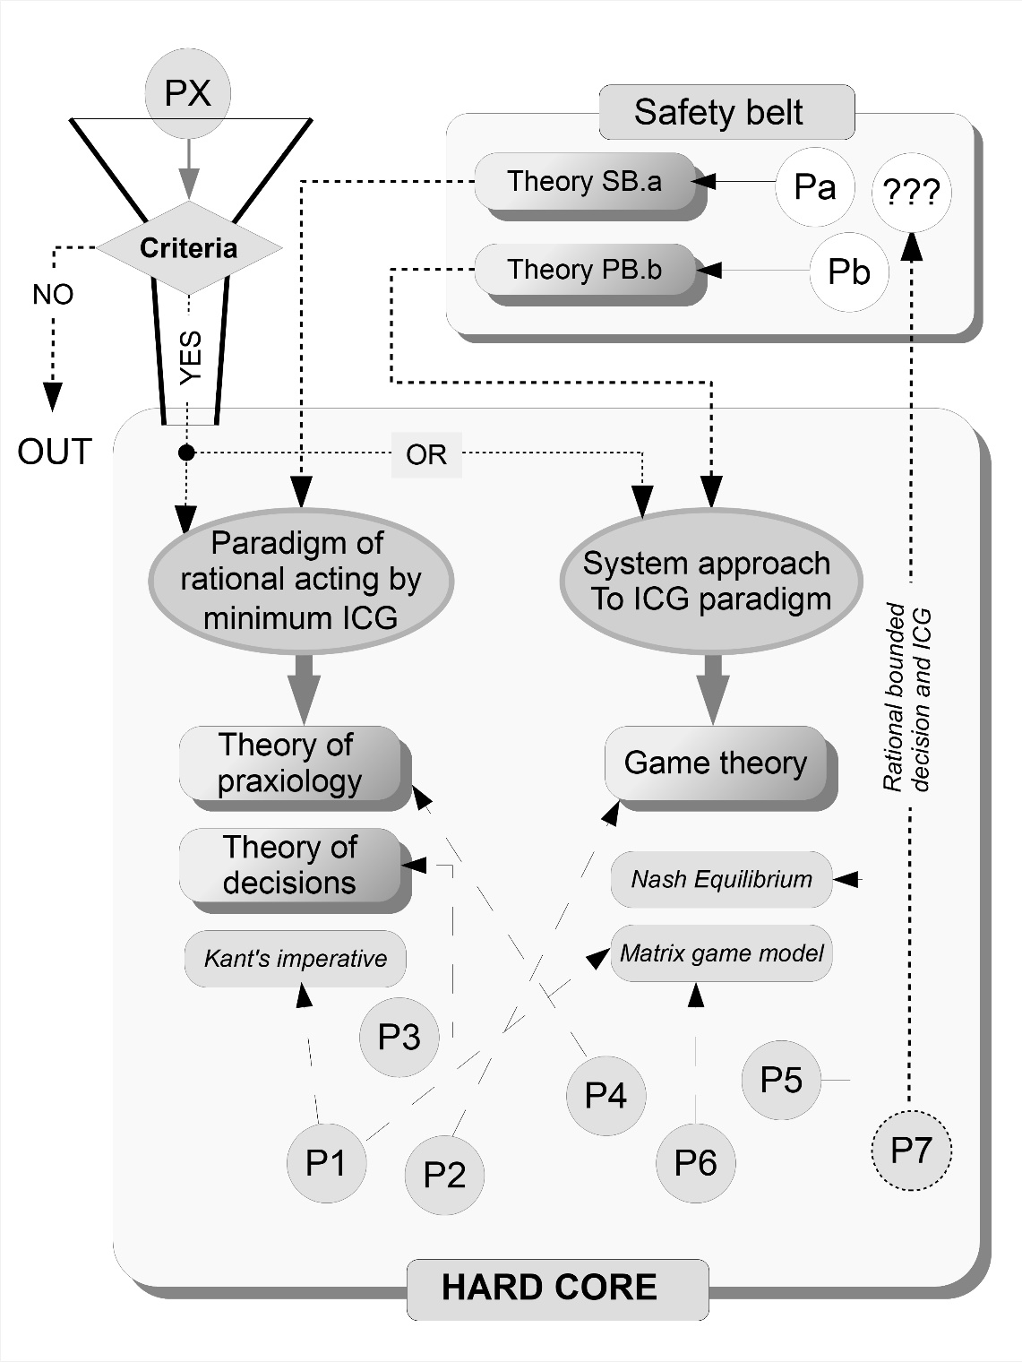
Figure 2. Structure of the research programme based on two joined paradigms

Source: author’s own elaboration.

5. Building the truth under uncertainty

Based on the paradigm of minimum ICG, it is possible to build the research programme in I. Lakatos’ sense derived from it but joined with another one related to the system approach.
This function of state paradigm may be expressed as follows: Description of development of an economic entity based on differences between the values of its function of state in different moments is a rational approach. Rather than proving the requirements for paradigm statement of the above sentence, it may be noticed that all bookkeeping and controlling in organizations is based on it. All project management systems are based on the incremental comparisons of partial results of acting according to schedules. The one problem arises – what is the meaning of “rational”. In this paper “rational” would be understood as “maintain minimal ICG”. If so, then both paradigms are joined together and may be used in one research programme successfully.
The structure of the research programme “minimum ICG” is presented on the Figure 2. It consists of three main parts: filtering mechanism, hard core, and safety belt. The filtering mechanism is responsible for qualifying a problem PX to one or to both paradigms. If the PX met the requirements of selection criteria, it may be attached to the hard core of the programme. If not, it is qualified as out of the programme. Some criteria of acceptance an issue to the structure of ICG were described earlier in this paper.
The first question for introducing the research programme “minimum ICG” is selecting criteria for issues belonging to it. There are four crucial aspects necessary to meet the requirements of the paradigm.
- The case is related to conscious acting of an agent in the surroundings.
- The case must be described by an objective function.
- It is possible to describe the economic state of acting entity for any moment using finite number of descriptors, parameters, or quantifiable characteristics.
- It is possible to express explicit intentions of acting and predict consequences of it materialization as precise as possible.
The example of correct issue may be a project of social aid for a group of beneficiaries. It is a conscious acting of the authorities (acting economic entity). There is a defined objective function (e.g. reduction of poverty on 10% during two years on a given area). The economic state may be estimated by the disposable income or consumption rising indicator. These are possible to predict at any moment based on initial data. The set of intention and the derived consequences may be determined at the beginning of the project. So, all requirements for joining this issue to the research programme ICG are met. Then one can evaluate the minimum ICG, because this minimum exists, based on the research programme construction.
The hard core of the programme contains paradigms and belonging to them theories, models, theorems, and problems that have inherited characteristics from the paradigm. Therefore it is true, ordered knowledge from the scope of the programme. All problems denoted P1, …P6 on the Figure 2 are assigned to any theory, theorem, or model of the hard core. The problem P7 is not belonging to any substructure of the hard core. Therefore, it may falsify one of the paradigms or both. For such cases, the research programme is supported with a safety belt substructure. It is the set of problems deviated from the restrictions defined by the hard core. For the reason, not to falsifying the whole programme for a few exclusions (attacks on paradigms), some theories ad hoc explaining temporarily these deviations are used in safety belts. Then the paradigms may be supported until better ones will develop.
In case of P7 problem (rationally bounded decision making and minimization of ICG) it is necessary to transfer it to the safety belt substructure and find strong theoretical explanation for some deviations from general observations. Then it may be joined back with the hard core of the programme or remains in the safety belt assigned with suitable ad hoc theory. If there will be no suitable explanation for the P7 deviations and it will arise some new falsifying the hypothesis issues after some time, the research programme will have to be revised. It is sufficient if the P7 case will belong to the safety belt with partial verification and the programme contains far much more positive cases than negative ones to safe paradigms.
Concluding, the development of knowledge related to the programme takes place in its safety belt and is subjected to some changes in the surroundings. In the hard core the existing true knowledge is mainly ordered. But if a new issue arises based on inferring by deduction or induction using the existing judgements about facts, models, and theories included in the hard core, then knowledge development may be assigned to this part of the programme. Uncertainty does not influence the truth included in the hard core of the programme. All rational acting decreasing the ICG allow to move the uncertain problems from the safety belts to the hard core.

6. Conclusions

The ICG is a good base for creating research programme in I. Lakatos’ sense ordering and developing knowledge related to economic and management issues even in uncertain behaviours in the surroundings. It was shown that ICG may be the base of good paradigm relating to minimization the gap during rational decision making. It is joined with the paradigm of rationality of the system approach (Figure 2).
Based on the above the research programme ICG was creating and described. Some aspects of its functioning were presented (Figure 2). It was concluded that this programme had included important economic issues as praxiological acting, optimal decision making, quality of prediction evaluations. It was described by the example of an issue which had needed ad hoc theoretical explanation related to making rationally bounded decisions under uncertainty. The programme orders knowledge from the scope and allows to build new, true judgements about facts. It defines the demarcation border for uncertain judgements about facts and give the interacting system more diversity of reacting.
It is not easy to find good paradigms, but it is possible. There is a lot of erroneously uses of the category “paradigm” in a scientific literature. It is necessary to prove that the sentence may be classified to paradigms, what was done in this paper. Paradigms filter issues which may be attached to them. If this filtration is successful, then proving that the issue belongs to a paradigm allows it to inherit properties of this paradigm without further verifications. It is a good opportunity for building true knowledge, eliminating inconsistency. It is not possible to infer both true and false judgements using the same base sentences from the structure of research programme. It is epistemologically independent on a subjective researcher position. There are no paradoxes in the built knowledge if the paradigms belonging to the programme are correct and the ICG reaches the minimum value.
The ICG programme is prospective for the theory of economics because it fixes a set of base sentences for the issues related to optimization of rational acting. It is the model of correct scientific acting related to the existing facts, ordering theories and problems to the ordered resource of knowledge. The following examples may confirm the above hypothesis.
- Criterion of rationality of any social projects may be based on the sentence: this social aid is rational, where the minimum ICG is achieved.
- Optimum for a strategy of development may be based on the judgement: this strategy is the best for which the ICG reaches the minimum value.
- Evaluations of the rationality of decisions may be defined using the following judgement: rationality of decision derives from minimization of the ICG related to it.
- Axiological evaluation of managing may be supported by the judgement: this method of managing is good where the ICG will reach its minimum.
- Rational prognosis may be formulated based on the rule: this prognosis will be more accurate for which the related ICG will be smaller.
The above judgements about ICG are useful for economic development, management, and rational acting. Because the research programme ICG is free from subjective knowledge (epistemological position of the researcher has no influence on the results) it may by assumed as the scientific approach to problems possible to be joined with the hard core of the programme. It is the rational answer on questions of decision making under uncertainty temporarily derived in the surroundings.

Bibliography

Barnard C., Simon H.A. (1947), Administrative behavior. A study of decision-making processes in administrative organization, Macmillan, New York.

Bertalanffy L. von (1968), General system theory. Foundations, development, applications, Braziller, New York.

Black M. (1964), The gap between ‘is’ and ‘should’, “The Philosophical Review”, no. 73, pp. 165-181.

Book J., Bjørnskov C. (2021), Lockdowns don’t prevent coronavirus spread, AIER, Jan 12, https://www.aier.org/article/lockdowns-dont-prevent-coronavirus-spread/ [11.06.2021].

Burns T., Stalker G.M. (1961), The management of innovation, Tavistock, London.

Carnap R. (1995), An introduction to the philosophy of science”, Gardner M. (ed.), Dover Publications Inc., New York.

Gospodarek T. (2009a), Representative management as a rational research program in Kuhn-Lakatos-Laudan sense, “International Journal of Economics and Business Research”, vol. 1 no. 4, pp. 409-421.

Gospodarek T. (2009b), Modelowanie w naukach o zarządzaniu oparte na metodzie programów badawczych i formalizmie reprezentatywnym, Wydawnictwo Uniwersytetu Ekonomicznego we Wrocławiu, Wrocław.

Gospodarek T. (2012), Aspekty złożoności i filozofii nauki w teorii i praktyce zarządzania, Wydawnictwo WWSZiP, Wałbrzych.

Gospodarek T. (2015), Systemy ERP. Modelowanie, projektowanie, wdrażanie, Helion, Gliwice.

Gospodarek T. (2018), Biała księga zarządzania, Difin, Warszawa.

Kahneman D., Slovic P., Tversky A. (1982), Judgment under uncertainty. Heuristics and biases, Cambridge University Press, New York.

Kuhn T.S. (1970), The structure of scientific revolutions, 2nd ed., The University of Chicago Press, Chicago, London.

Lakatos I. (1978), The methodology of scientific research programmes, in: Philosophical papers, vol. 1, Worall J., Curie G. (eds.), Cambridge University Press, Cambridge, London.

Laudan L. (1983), The demise of the demarcation problem, in: Cohen R.S., Laudan L., Physics, philosophy and psychoanalysis. Essays in honor of Adolf Grünbaum, “Boston Studies in the Philosophy of Science”, vol. 76, pp. 111-127.

Popper K.R. (1934/1959), The logic of scientific discovery, Routlege, London, New York, https://books.google.pl/books?id=Yq6xeupNStMC&printsec=frontcover&redir_esc=y#v=onepage&q&f=false [11.06.2021].

Simon H.A. (1957), Administrative behavior, Free Press, New York.

Taleb N.N. (2007), The Black Swan. The impact of the highly improbable, Penguin, London.

Will M. (2020), The CoViD-19 pandemic and the end of corporate risk management as we know it, “Central European Review of Economics and Management”, vol. 4 no. 3, pp. 89-115.

Hume’s guillotine may be understood as the is-ought problem. It is a criticism of writings by ethicists who make normative claims (about what ought to be) based on positive premises (about what is now). Hume argued that one cannot make a normative claim based on facts about the world, implying that normative claims cannot be the conclusions of reason (see Black 1964).
ICG is an exogenous variable, not dependent on human behaviour. The dimension of the ICG depends on the assumed criteria. These criteria may be arbitrary, and evaluation is subjective, not epistemic. The game approach allows to reduce the subjective aspects of the assumed measure of rationality. This explains the reduction of rationally bounded behaviour during decision-making processes based minimizing the ICG.

