SUPPLEMENTARY MATERIAL

The full title: Identifying an optimal machine learning algorithm for wheat yield estimation using multilevel UAV datasets

Journal name: Modeling Earth Systems and Environment

Supplementary Material
Supplementary Figure S1. Machine learning model results
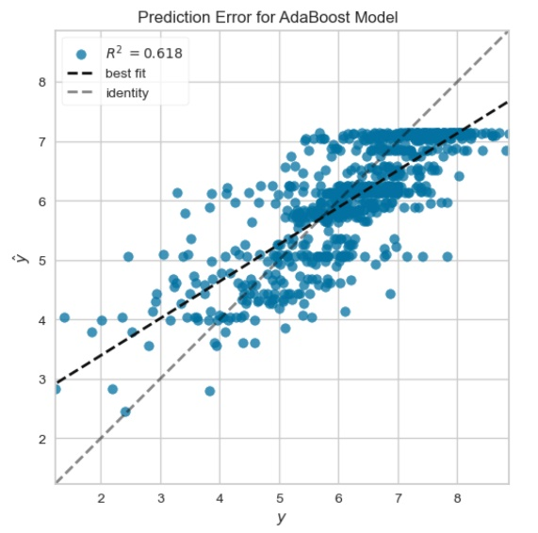 | 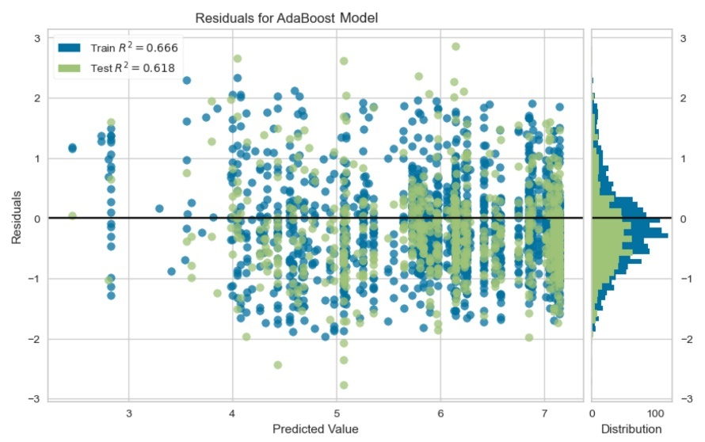
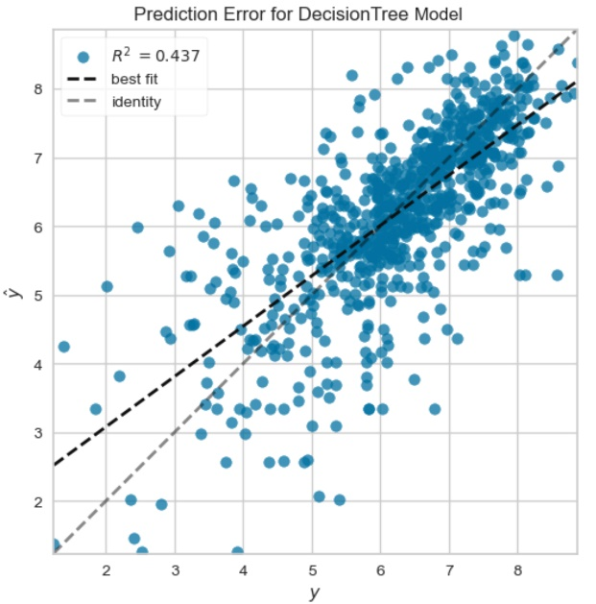 | 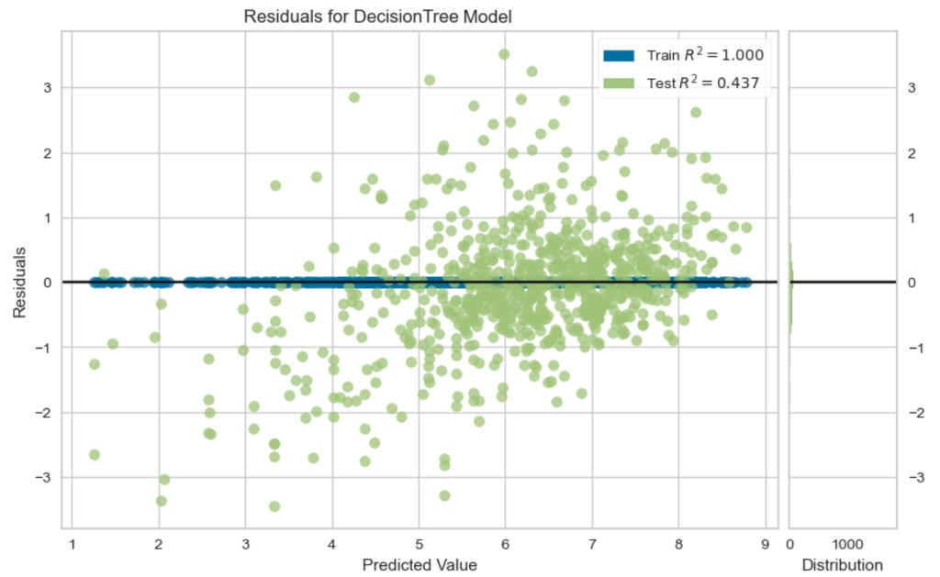
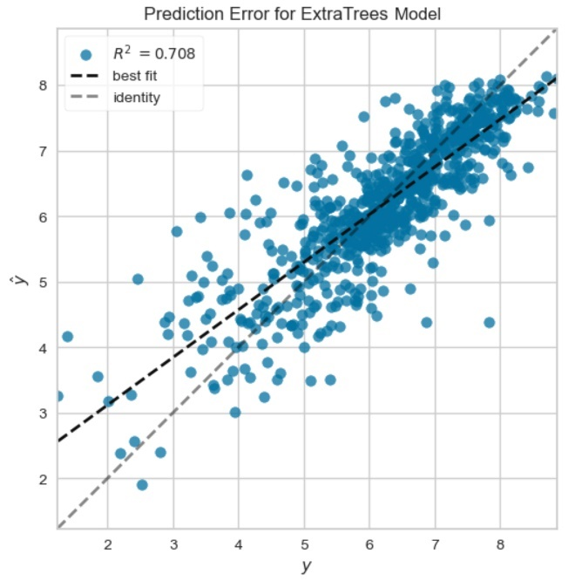 | 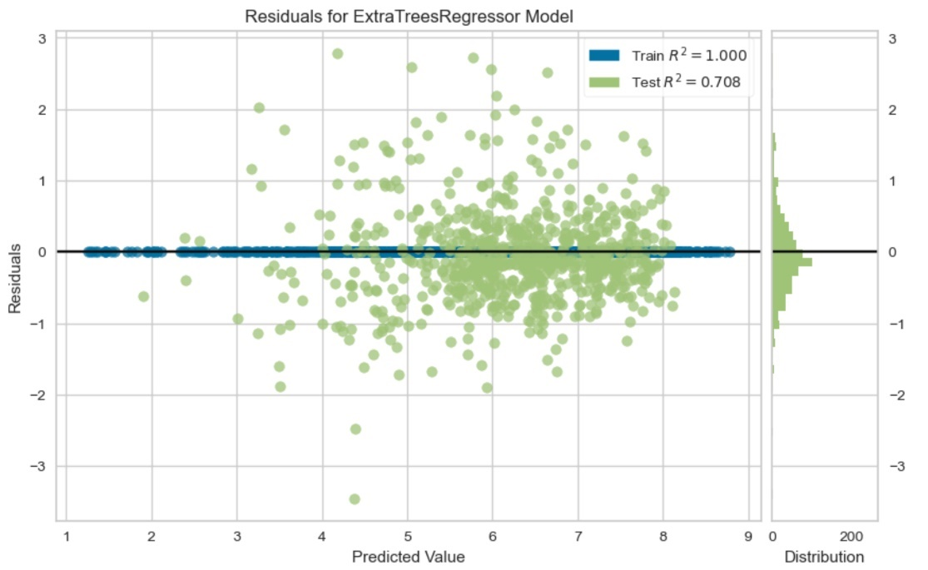
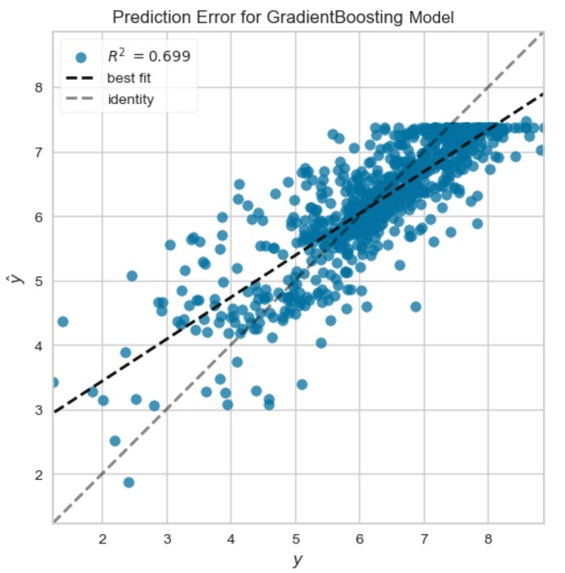 | 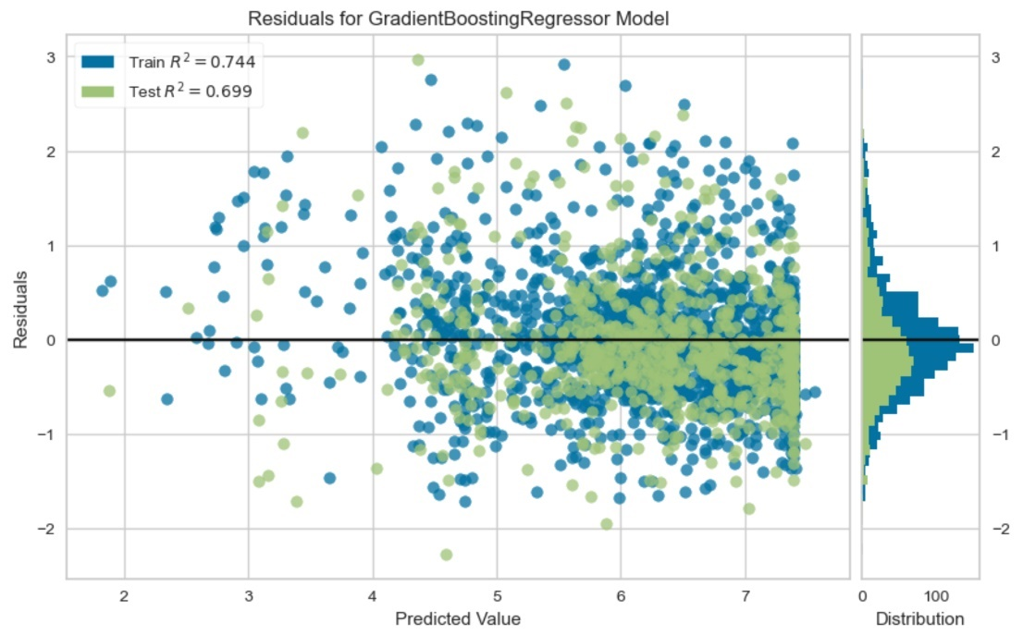
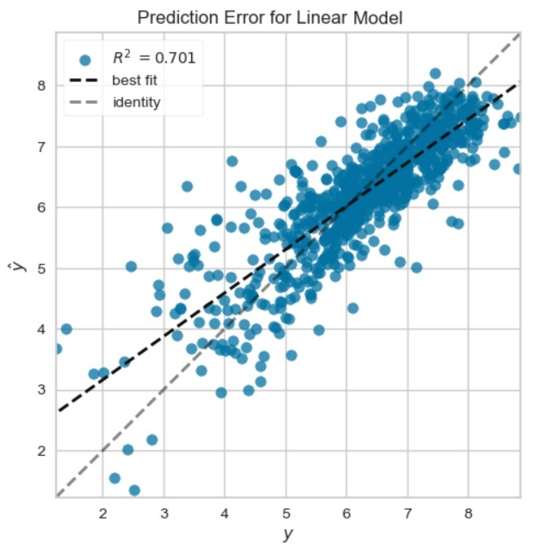 | 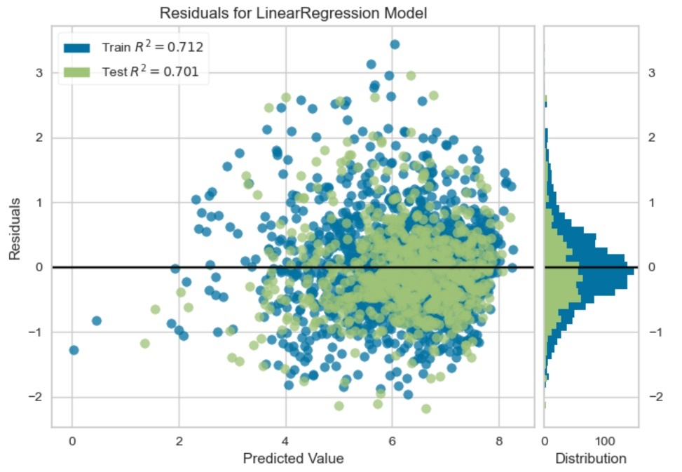
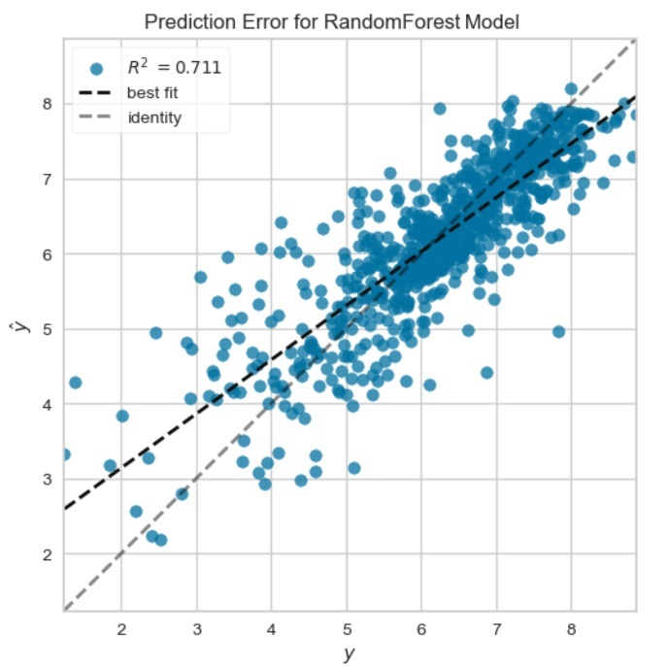 | 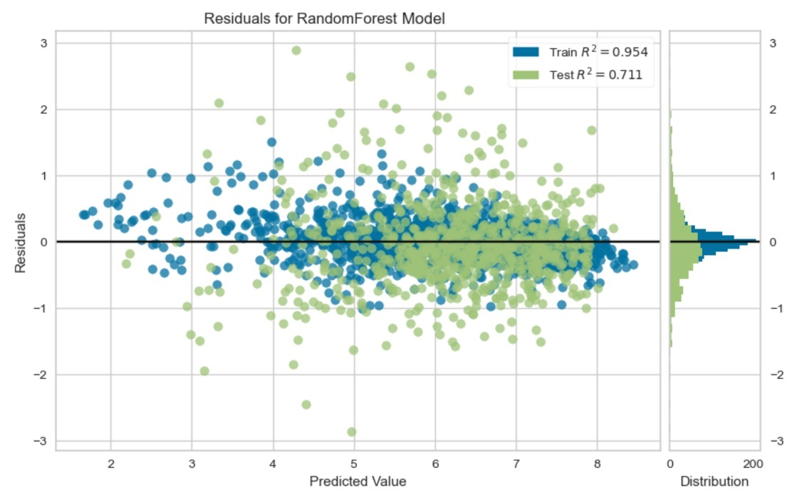
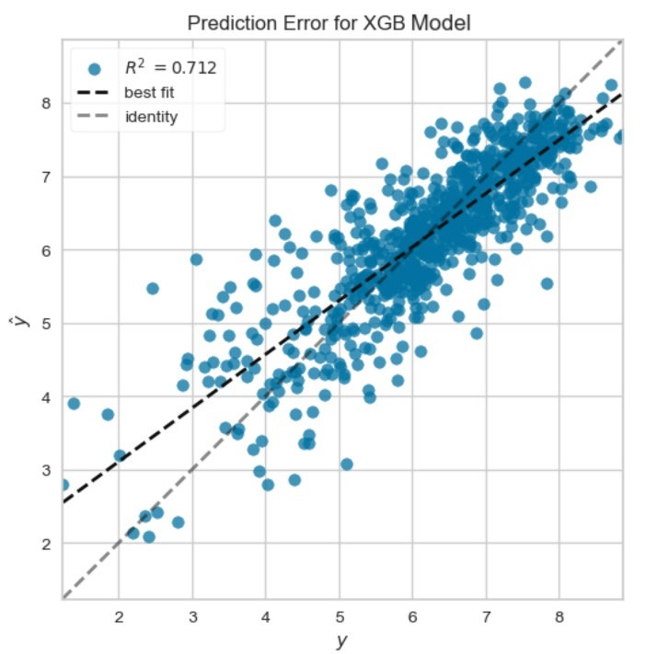 | 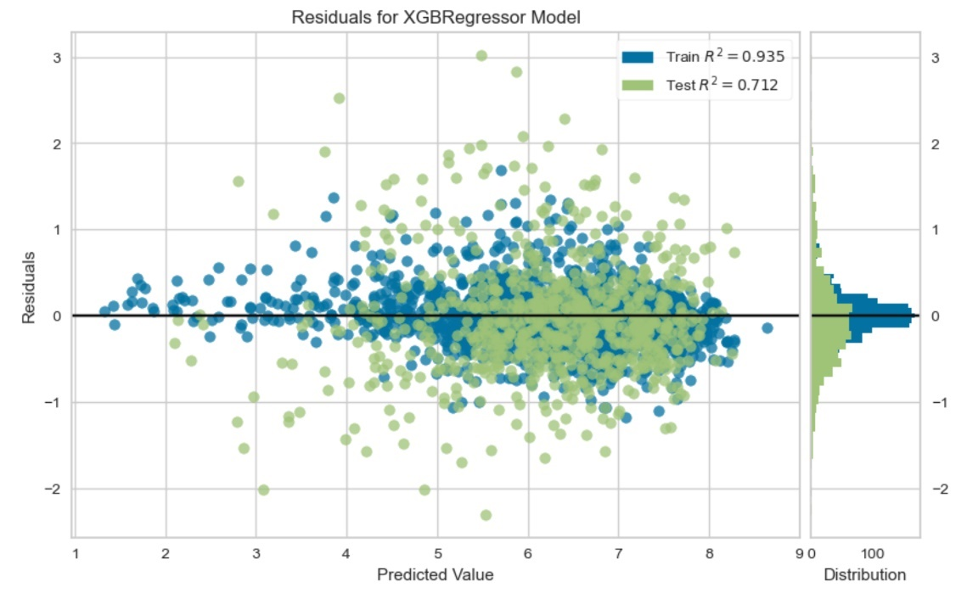

Supplementary Table S1. Machine learning model results with and without adjustment for multicollinearity

Model name | R2  Testing | R2  Training | R2  Full | R2  Testing | R2  Training | R2  Full
 | With |  |  | Without
Linear  (LM) Model | 0.70 | 0.71 | 0.70 | 0.65 | 0.64 | 0.64
Extreme Gradient Boosting (XGBoost) | 0.71 | 0.93 | 0.87 | 0.66 | 0.89 | 0.83
Random Forest  (RF)Model | 0.71 | 0.95 | 0.88 | 0.67 | 0.94 | 0.87
Decision Tree  (DT) Model | 0.44 | 1.00 | 0.83 | 0.39 | 1.00 | 0.82
AdaBoost  Model | 0.62 | 0.67 | 0.65 | 0.59 | 0.64 | 0.63
Extra Trees  (ET) Model | 0.70 | 1.00 | 0.91 | 0.66 | 1.00 | 0.90
Gradient Boosting (GB) Model | 0.69 | 0.74 | 0.73 | 0.68 | 0.71 | 0.70

Supplementary Figure S2. SHAP plot results
XGBoost Model | Random Forest Model
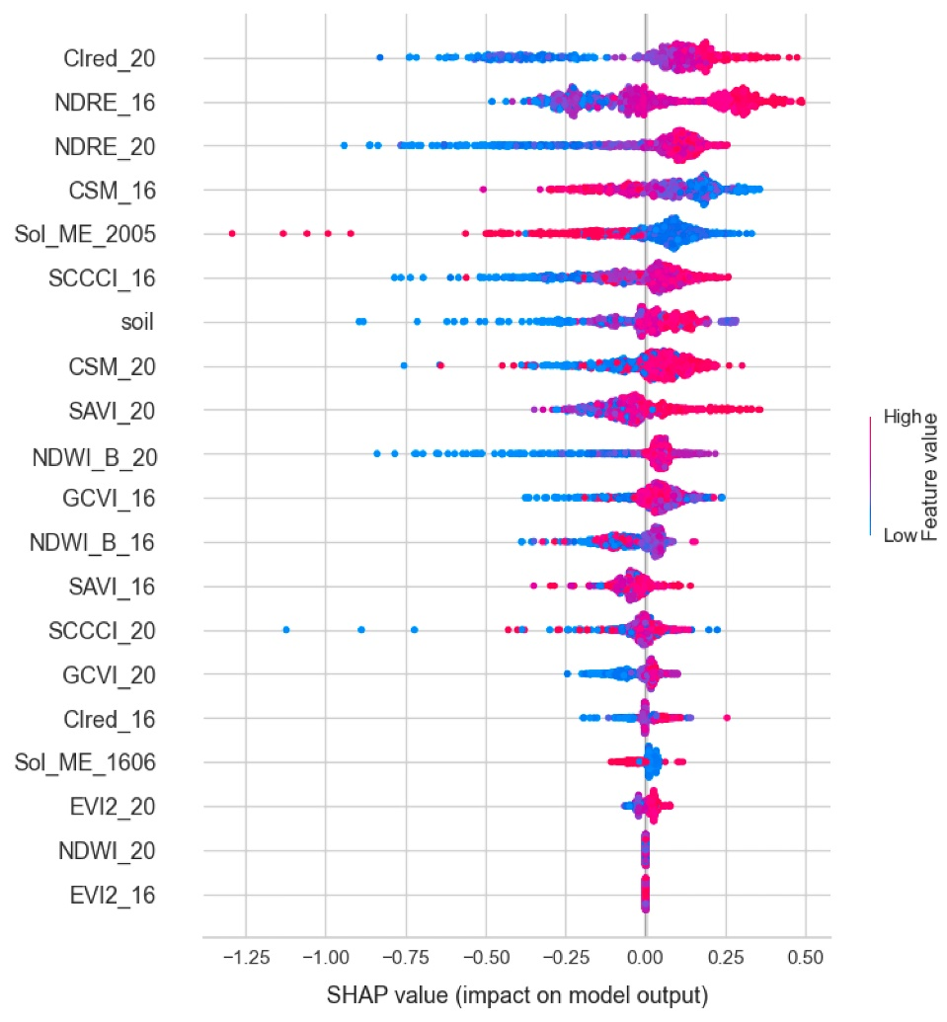 | 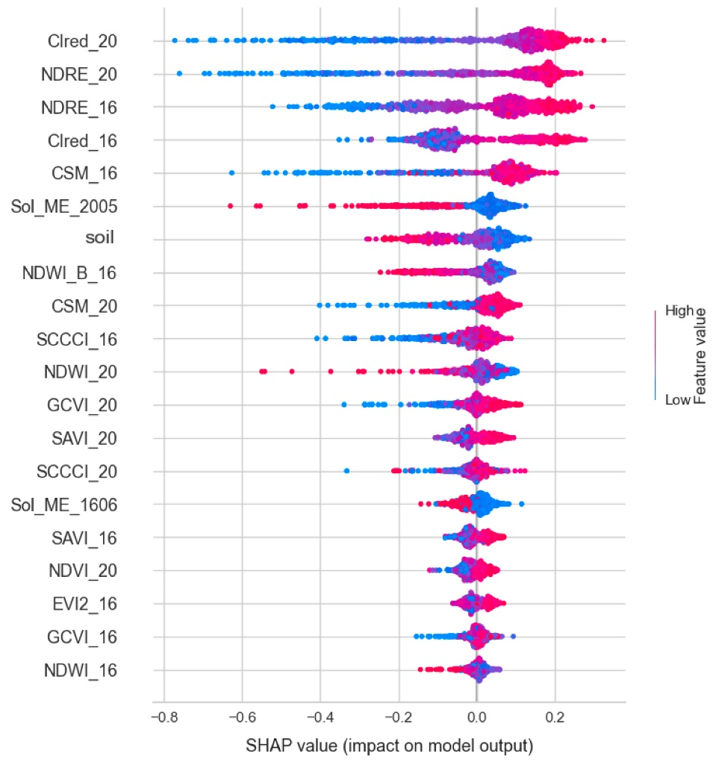
Decision Tree Model | Extra Trees Model
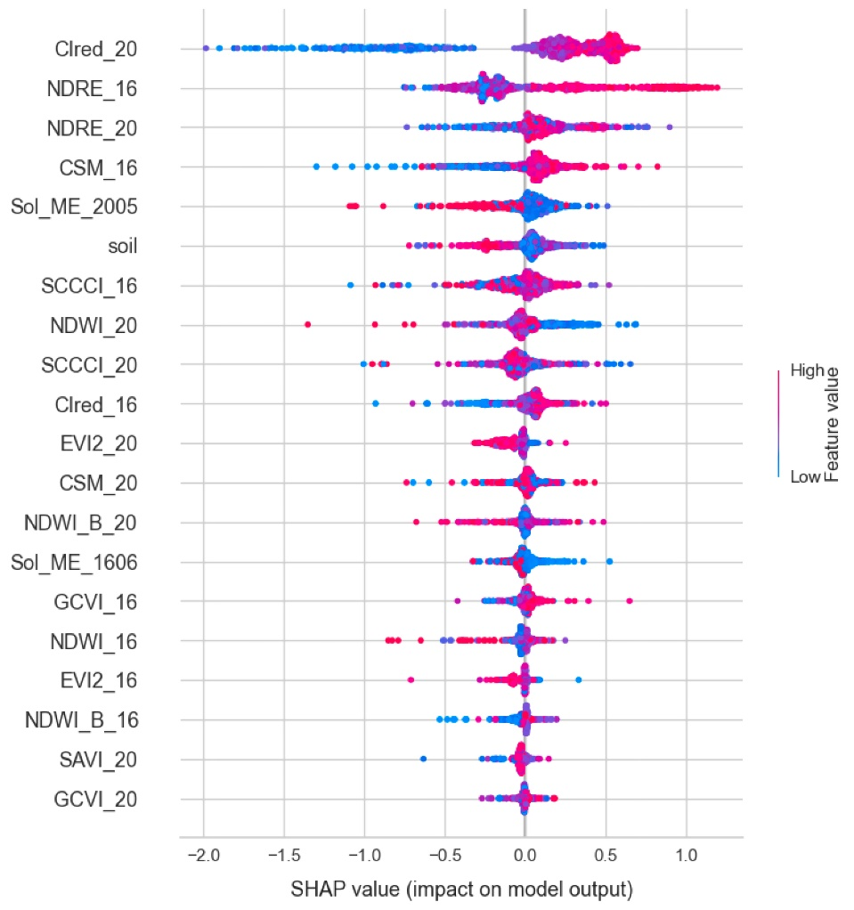 | 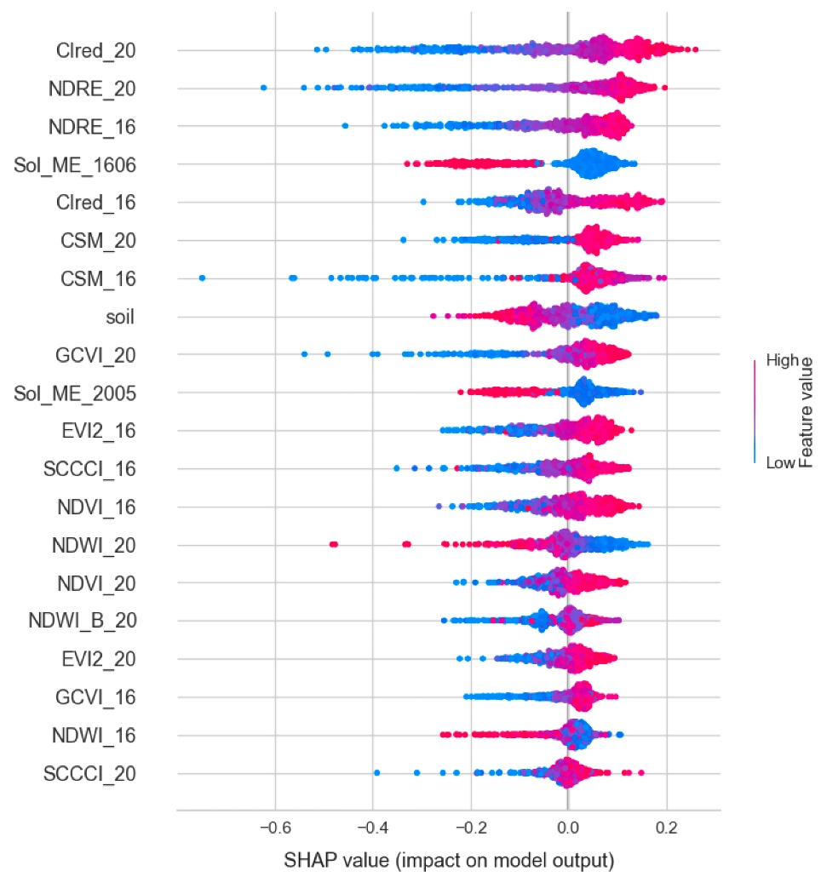
Gradient Boosting Model | AdaBoost Model
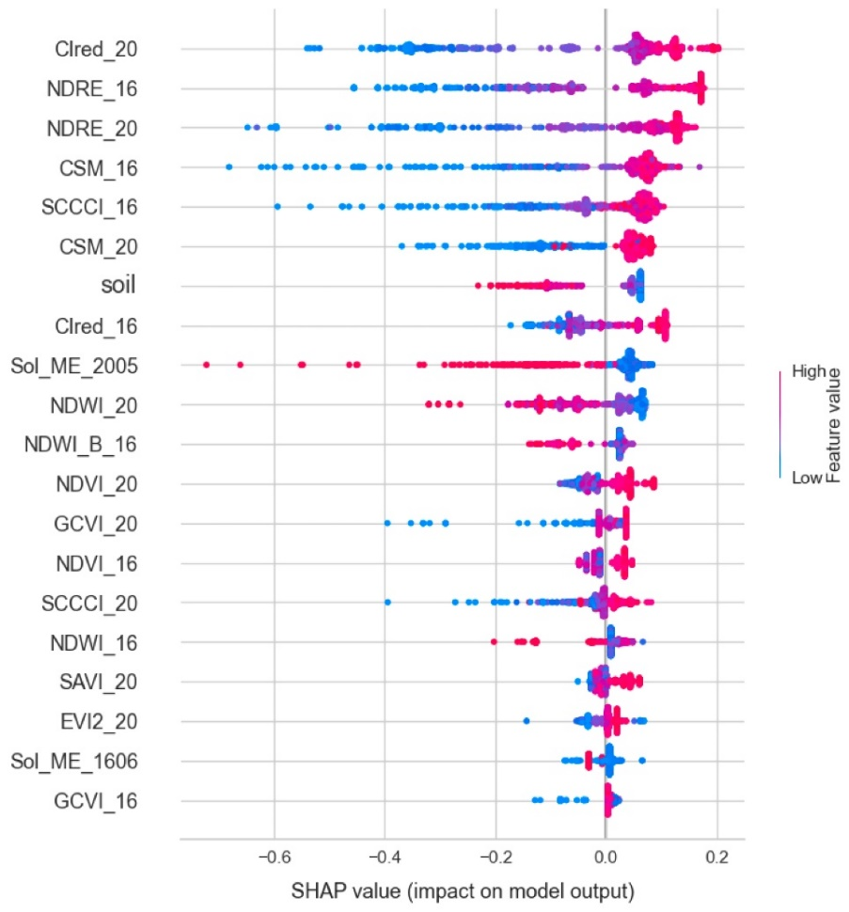 | 