**Appendix**

**Household Resilience and Coping Strategies to Food Insecurity: An Empirical Analysis from Tajikistan**

This appendix includes:

**Table A1. Descriptive Statistics of RCI Pillars**

**Appendix A. Factorability and validity analysis for pillars and RCI**

**Figure A1. Structural Equation Modelling (SEM) for Resilience Capacity Index (RCI)**

**Table A2. Factor Post Estimation of Pillars and RCI**

**Appendix B. Multiple Indicators Multiple Causes (MIMIC) in Resilience Index Measurement Analysis (RIMA)**

**Figure A2. Two-step approach for Resilience Capacity Index (RCI)**

**Appendix C. Latent Coping Strategy**

**Table A3. Descriptive statistics of subjective coping strategies**

**Table A4. Model Fit**

**Figure A3. Identified Classes and Predicted Scales**

**Table A5. Descriptive Statistics of Controlling and Dependent Variables**

**Appendix D. Validation of Instrumental Variable Approach**

**Table A6. Instrumenting regression results for RCI and RCI*Shock (First stage)**

**Appendix E. MIMIC Outcomes**

**Figure A4. Factor components and loadings of ABS**

**Figure A5. Factor components and loadings of AST**

**Figure A6. Factor components and loadings of SSN**

**Figure A7. Factor components and loadings of AC**

**Figure A8: Factor components and loadings of S**

**Appendix F. Latent Class Comparing**

**Table A7. Class Comparison**

**Table A8. Resilience and Food Security Outcomes**

**Table A9. Resilience and Food Security Loss**

**Table A1. Descriptive Statistics of RCI Pillars**

|  |  |  |  |  |  |
| --- | --- | --- | --- | --- | --- |
| **Pillar** | **Variable** | **Mean** | **St.Dev** | **Min** | **Max** |
| **Access to Basic Services (ABS)** |  |  |  |  |  |
|  | Central heating | 0.122 | 0.327 | 0 | 1 |
|  | Electricity heating | 0.314 | 0.464 | 0 | 1 |
|  | Gas | 0.324 | 0.468 | 0 | 1 |
|  | Improved water source | 0.538 | 0.498 | 0 | 1 |
| **Assets (AST)** |
|  | Wealth Index per capita from non-productive assets (based on factor analysis) | 0.233 | 0.161 | 0 | 1 |
|  | Monthly per capita non-food consumption in nominal value | 59.919 | 119.129 | 0 | 1958.5 |
|  | Monthly per capita expenditures on utilities in nominal value | 20.948 | 22.125 | 0 | 265 |
| **Adaptive Capacity (AC)** |  |  |  |  |  |
|  | Income diversification (based on factor analysis) | 0.019 | 0.043 | 0 | 1 |
|  | Income earner share | 0.616 | 0.230 | 0 | 1 |
|  | Secondary education | 0.964 | 0.184 | 0 | 1 |
|  | Migration | 0.330 | 0.470 | 0 | 1 |
|  | Number of elderly people (65+) | 0.290 | 0.564 | 0 | 2 |
| **Social Safety Nets (SSN)** |  |  |  |  |  |
|  | Old age pension | 0.326 | 0.469 | 0 | 1 |
|  | Disability pension | 0.103 | 0.305 | 0 | 1 |
|  | Survivor pension | 0.031 | 0.174 | 0 | 1 |
|  | Special merit pension | 0.003 | 0.057 | 0 | 1 |
|  | Social pension | 0.001 | 0.044 | 0 | 1 |
|  | Compensation | 0.020 | 0.142 | 0 | 1 |
|  | Compensation cash | 0.029 | 0.168 | 0 | 1 |
|  | Compensation bulbs | 0.133 | 0.340 | 0 | 1 |
| **Sensitivity (S)** |  |  |  |  |  |
|  | Life unsatisfaction | 0.384 | 0.486 | 0 | 1 |
|  | Financial unsatisfaction | 0.563 | 0.491 | 0 | 1 |
|  | Hospitalization (reversed) | 0.712 | 9,451 | 0 | 1 |
|  | Hospitalization times (reversed) | 17.292 | 1.750 | 0 | 18 |

**Appendix A. Factorability and validity analysis for pillars and RCI**

First of all, the *Bartlett Test of Sphericity* is applied by testing the null hypothesis, indicating variables are orthogonal (Bartlett 1951). In order to check the proportion of variance among variables, we apply a *Kaiser-Meyer-Olkin* test (KMO) (Kaiser 1974). For the threshold of acceptance of KMO, we use values bigger than 0.5 (Hair et al. 2014). Multicollinearity is checked by using a *correlation coefficient matrix,* which should be greater than 0.00001 for a good model (Field 2013). In order to determine the number of components in factor analysis, results are based on *Kaiser’s rule* (Kaiser 1960). Factorability results are provided in Table A2. In order to facilitate factor interpretations, we use a factor rotation technique. In this case, all pillar and RCI factors are based on the *varimax rotation* technique (as the default option for orthogonal rotation), where efforts are made to maximize the dispersion of loadings to get a small number of variables with relatively higher loadings (Kaiser 1958).

To test whether our designed measurement aimed to construct pillars and RCI is truly measuring them, we followed the instruction to demonstrate construct validity. For simplicity and given the paucity of evidence, initial studies have not provided sufficient evidence on the construct validity. This study demonstrates construct validity through establishing the *convergent*, *discriminant* and *external validity* (Høgheim, Jenssen, and Federici 2023, Rönkkö and Cho 2020).

Since convergent validity indicates whether items truly measure the latent phenomena being constructed (Bagozzi, Yi, and Phillips 1991), we use the *communality* as equivalent to the Average Variance Extracted (AVE) (Venturini and Mehmetoglu 2019). In this case, 1-Uniqueness is referred to *communality*; therefore, it should not be less than 50 percent (Hair 2010). *Communality* information is available in Table A2. Convergent validity further requires that measurement model fits data adequately (Hair 2010) and loading coefficients are statistically significant (Dunn, Seaker, and Waller 1994). For inspecting discriminant validity, it is based on the comparison of AVE and squared correlations (SC) (Fornell and Larcker 1981). The main purpose of this test is to demonstrate whether $AVE ≥SC$. In other words, each latent construct should share more variance with the associated indictors compared to other latent variables (Cheung et al. 2023). To generalize the findings from factor analysis, we further apply Structural Equations Modelling (SEM) to construct RCI through ABS, AST, SSN, AC and S pillars obtained from the same observable variables (Figure A1).

External construct validity demonstrates whether the constructed instrument is consistent with other derived hypothesis or generalized to other contexts (Lucas 2003). A rigorous way to provide external construct validity is through hypotheses testing (Bataineh and Attlee 2021); therefore, we inspect mean-scores of pillars and RCI according to the level of coping strategies. In this case, T-test was used to evaluate whether mean differences across the variables are statistically significant (see Appendix F and Table A7 for further details).

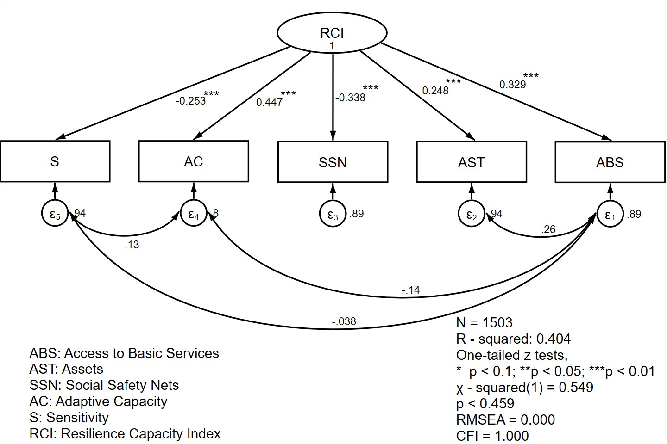

**Figure A1. Structural Equation Modelling (SEM) for Resilience Capacity Index (RCI)**

For the SEM approach in Figure A1, we apply a *Likelihood Ratio (LR)* test by testing whether selected factors are able to reproduce the entire covariance matrix (Acock 2013). We also consider a *Root Mean Square Error of Approximation (RMSEA)* to measure the discrepancy or error for each degree of freedom (Steiger 1990). It is generally recommended to have less than 0.06 for a good fit (Hu and Bentler 1999). In addition to this, we include a *Comparative Fit Index* *(CFI)* to measure the relative improvement in a fit (Acock 2013), which should be bigger than 0.8 in the covariance structure analysis (Hu and Bentler 1999).

**Table A2. Factor Post Estimation of Pillars and RCI**

|  |  |  |  |
| --- | --- | --- | --- |
| **Index** | **Component** | **Cumulative Variance** |  |
| **Access to Basic Services (ABS)** |  |  |  |
|  | 1 | 0.435 |  |
|  | 2 | 0.686 |  |
| Bartlett Test |  |  | 650.671*** |
| KMO |  |  | 0.648 |
| determinant of R-matrix |  |  | 0.599 |
| Average communality |  |  | 0.686 |
| **Assets (AST)** |  |  |  |
|  | 1 | 0.530 |  |
| Bartlett Test |  |  | 370.596*** |
| KMO |  |  | 0.608 |
| determinant of R-matrix |  |  | 0.781 |
| Average communality |  |  | 0.529 |
| **Adaptive Capacity (AC)** |  |  |  |
|  | 1 | 0.366 |  |
|  | 2 | 0.618 |  |
| Bartlett Test |  |  | 331.073*** |
| KMO |  |  | 0.509 |
| determinant of R-matrix |  |  | 0.802 |
| Average communality |  |  | 0.617 |
| **Social Safety Nets (SSN)** |  |  |  |
|  | 1 | 0.179 |  |
|  | 2 | 0.320 |  |
|  | 3 | 0.449 |  |
|  | 4 | 0.575 |  |
| Bartlett Test |  |  | 253.089*** |
| KMO |  |  | 0.536 |
| determinant of R-matrix |  |  | 0.845 |
| Average communality |  |  | 0.575 |
| **Sensitivity (S)** |  |  |  |
|  | 1 | 0.410 |  |
|  | 2 | 0.754 |  |
| Bartlett Test |  |  | 1022.380*** |
| KMO |  |  | 0.500 |
| determinant of R-matrix |  |  | 0.506 |
| Average communality |  |  | 0.755 |
| **Resilience Capacity Index (RCI)** |  |  |  |
|  | 1 | 0.292 |  |
|  | 2 | 0.502 |  |
| Bartlett Test |  |  | 247.235*** |
| KMO |  |  | 0.553 |
| determinant of R-matrix |  |  | 0.848 |
| Average communality |  |  | 0.506 |

**Appendix B. Multiple Indicators Multiple Causes (MIMIC) in Resilience Index Measurement Analysis (RIMA)**

The first part of the relationship in Figure A2 indicates the relationship between the pillars of resilience and $ε_{R}$, which is the disturbance term of the estimation. The path arrows in the second part of the diagram show the relationship between Resilience Capacity Index (RCI) and food security outcomes with their corresponding error terms.

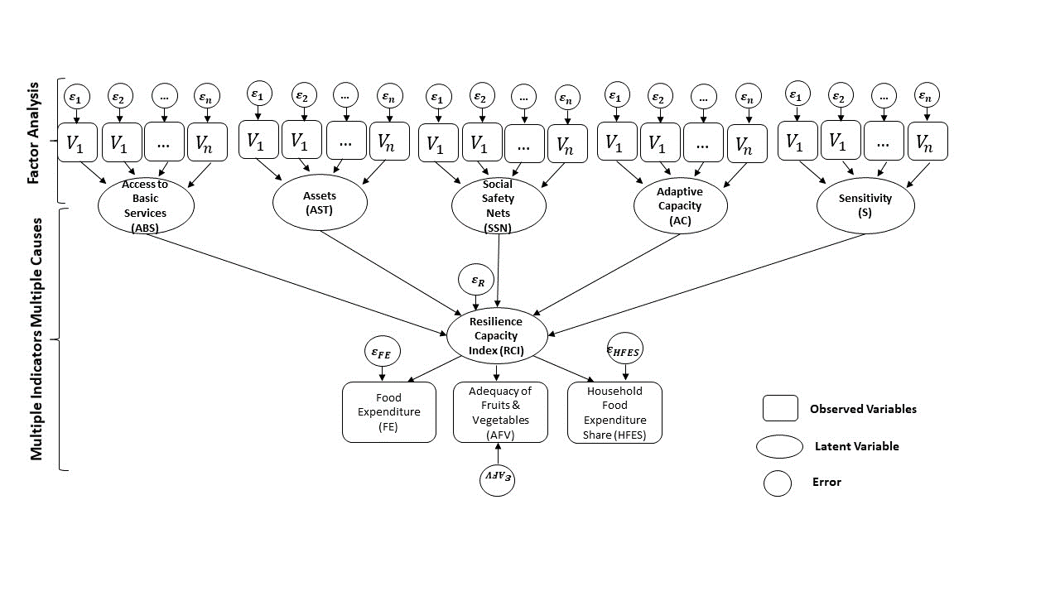

**Figure A2. Two-step approach for Resilience Capacity Index (RCI)**

We use Access to Basic Services (ABS), Assets (AST), Social Safety Nets (SSN), Adaptive Capacity (AC), and Sensitivity (S) as observed endogenous variables correlating with RCI. In the formative part, a model represented in Equation (1) shows that resilience is influenced by five pillars:

|  |  |  |
| --- | --- | --- |
|  | $$\left[RCI\right]= \left[β_{1}, β_{2}, β_{3}\right] × \left[\begin{aligned}ABS \\ AST \\ SSN \\ AC \\ S\end{aligned}\right] + \left[ε_{R}\right]$$ | (1) |

According to the measurement or reflective model in Equation (2), it is specified by the weekly food expenditure (FE), adequacy of fruit and vegetable consumption (AFV) and household food expenditure share (HFES).

|  |  |  |
| --- | --- | --- |
|  | $$\left[\begin{aligned}FE \\ AFV \\ HFES\end{aligned}\right]= \left[⋀_{1}, ⋀_{2},⋀_{3} \right] × \left[η\right] + \left[ε_{FE}, ε_{AFC},ε_{HFES}\right]$$ | (2) |

As RIMA-II adopts a *min-max rescaling method* (FAO 2016), we applied this technique based on:

|  |  |  |
| --- | --- | --- |
|  | ${RCI}^{*}$ = (RCI - ${RCI}_{min}$) / ( ${RCI}_{max}$- ${RCI}_{min}$) $×100$ | (3) |

This approach allows us to interpret changes in RCI as well as the relationship between RCI and food security outcomes.

**Appendix C. Latent Coping Strategy**

We utilized a notation from Collins and Lanza (2009) expressed by Equation (4). Accordingly, it shows that the probability of observing any vector response is explained by the function of the probability of membership class ($γ$) and observing the response conditional on a latent class membership ().

|  |  |  |
| --- | --- | --- |
|  |  | (4) |

The element of $j$ of a response pattern $y$ is represented by $y_{j}$. The item response probability which is $ρ_{j, r_{j | c}}$ shows the probability of response $r_{j}$ to the elements of $j$, conditional on the membership in latent class $c.$ The indicator function expressed by $I$ ($y_{j}=r_{j}$) is equal to 1 if $j$ $=$ $r_{j}$; otherwise, it equals 0. In this case, the values of observed variables within latent classes are independent, referred to as *“local independence”* or *“uncorrelated uniqueness”* in factor analysis.

By defining a latent categorical variable it is further possible to use it as a predictor variable in the regression (Collier and Leite 2017).

The optimal number of classes is determined by following *Akaike’s Information Criterion* (AIC) (Akaike 1987), *Bayesian Information Criterion* (BIC) (Schwarz 1978) and *Entropy Criterion* (Celeux and Soromenho 1996). The reason behind including the entropy-based conclusion is that it sometimes outperforms AIC and BIC selection criterion (Larose et al. 2016). In this case, lower AIC and BIC or higher than 0.6 in the Entropy value is recommended to obtain the most parsimonious and correct model (Tein, Coxe, and Cham 2013, Weller, Bowen, and Faubert 2020).

**Table A3. Descriptive statistics of subjective coping strategies**

|  |  |  |  |  |  |  |
| --- | --- | --- | --- | --- | --- | --- |
| **N.O** | **Variable** | **Observation** | **Mean** | **St.Dev** | **Min** | **Max** |
| 1. | Aid from friends or family for money | 1503 | 0.355 | 0.478 | 0 | 1 |
| 2. | Borrowed money from a moneylender | 1503 | 0.051 | 0.220 | 0 | 1 |
| 3. | Sent a member of the household to work elsewhere as a seasonal worker | 1503 | 0.396 | 0.489 | 0 | 1 |
| 4. | Increased the production of food products for own consumption | 1503 | 0.390 | 0.488 | 0 | 1 |
| 5. | Cancelled health insurance | 1503 | 0.153 | 0.360 | 0 | 1 |
| 6. | Cancelled house or car insurance | 1503 | 0.142 | 0.349 | 0 | 1 |
| 7. | Spent savings or investments | 1503 | 0.193 | 0.395 | 0 | 1 |
| 8. | Worked more than normally | 1503 | 0.399 | 0.490 | 0 | 1 |
| 9. | Sold the harvest in advance | 1503 | 0.181 | 0.385 | 0 | 1 |
| 10. | Household members sent to work who normally do not work | 1503 | 0.330 | 0.470 | 0 | 1 |

According to model fit criteria, a two-class model (AIC = 15031.50, BIC = 15143.12 and Entropy = 0.690) is compared to other models as described in Table A3. It is chosen for its robust interpretability of classes representing homogenous coping strategies.

**Table A4. Model Fit**

|  |  |  |  |  |  |  |
| --- | --- | --- | --- | --- | --- | --- |
| **Model** | **N** | **LL (model)** | **df** | **AIC** | **BIC** | **Entropy** |
| One class | 1,503 | -7971.081 | 10 | 15962.16 | 16015.31 | 0 |
| **Two class** | **1,503** | **-7494.751** | **21** | **15031.50** | **15143.12** | **0.690** |
| Three class | 1,503 | -7294.332 | 32 | 14652.66 | 14822.75 | 0.604 |

## *Latent Class Identification*

Figure 2 depicts the identified classes and corresponding predicted scales for the 10 selected types of coping strategies. The first class, which accounts for 47% of the sample, is labelled as *“Low Coping Strategy”* with its below-median probability of all selected observed strategies. The second class showing the remaining 53% of the sample is labeled as *“High Coping Strategy”* class due to the presence of higher probability or almost above-median probability of half the selected strategies. See Appendix F and Table A7 for latent class comparison discussion.

C:\Users\Egamberdiev\OneDrive\RESILIENCE STUDY\LAMDA\Paper\Final\New folder\PLOS\Graphs\Fig2.tiff

**Figure A3. Identified Classes and Predicted Scales**

*Notes: 1: Aid from friends or family for money; 2: Borrowed money from a moneylender; 3: Sent a member of the household to work elsewhere as a seasonal worker; 4: Increased the production of food products for own consumption; 5: Cancelled health insurance; 6: Cancelled house or car insurance; 7: Spent savings or investments; 8: Worked more than normally; 9: Sold the harvest in advance; 10: Household members sent to work who normally do not work*

**Table A5. Descriptive Statistics of Controlling and Dependent Variables**

|  |  |  |  |  |
| --- | --- | --- | --- | --- |
| **Variables** | **Mean** | **St.Dev** | **Min** | **Max** |
| RCI | 23.868 | 11.143 | 0 | 100 |
| RCI (obtained from Structural Equation Modelling or SEM) | 51.170 | 13.332 | 0 | 100 |
| RCI*Shock | 56.323 | 52.469 | 0 | 400 |
| RCI*Shock (through SEM) | 119.063 | 86.050 | 0 | 400 |
|  |  |  |  |  |
| Coping strategy | 1.522 | 0.499 | 1 | 2 |
| Head age | 54.392 | 12.982 | 19 | 94 |
| Head female | 0.252 | 0.434 | 0 | 1 |
| Household size | 6.392 | 3.104 | 1 | 26 |
| Rural | 0.652 | 0.476 | 0 | 1 |
| Number of moderate and severe drought | 0.790 | 1.364 | 0 | 5 |
|  |  |  |  |  |
| Food expenditure (FE) | 306.666 | 452.288 | 0 | 15441.3 |
| Adequacy of fruits and vegetables (AFV) | 369.517 | 245.721 | 17.857 | 3714.286 |
| Household food expenditure share (HFES) | 0.173 | 0.150 | 0 | 0.942 |
| FE loss | 0.255 | 0.436 | 0 | 1 |
| AFV loss | 0.335 | 0.472 | 0 | 1 |
| HFES loss | 0.578 | 0.494 | 0 | 1 |

**Appendix D. Validation of Instrumental Variable Approach**

We use *Cragg-Donal F statistics* by having the “rule-of-thumb” with F>10 (Baum 2006). We also include an *Anderson-Rubin (AR)* significance level as a weak instrument robust test (Riquelme, Berkowitz, and Caner 2013). The results for the first stage estimation show that instrumental variables are significantly correlated with RCI (Table A6). Moreover, we apply the *Wald test* of exogeneity by checking the null hypothesis of no endogeneity (Wooldridge 2010).

**Table A6. Instrumenting regression results for RCI and RCI*Shock (First stage)**

|  |  |  |  |  |
| --- | --- | --- | --- | --- |
|  | **RCI** | **RCI*Shock** | **RCI-SEM** | **RCE-SEM* Shock** |
| Distance | -0.147***  (0.014) | -0.611***  (0.051) | -0.078***  (0.020) | -0.351***  (0.059) |
| High Coping Strategy | 0.161  (0.444) | 1.143  (1.557) | 0.490  (0.615) | 2.467  (1.816) |
| Head female | -0.135  (0.516) | 0.498  (1.805) | -1.057**  (0.715) | -3.064*  (2.106) |
| Head age | -0.007  (0.017) | -0.084  (0.060) | -0.348***  (0.024) | -0.963***  (0.071) |
| Household size | -1.172***  (0.223) | -5.262***  (0.781) | -1.434***  (0.309) | -3.760***  (0.911) |
| Sq. Household size | 0.052***  (0.012) | 0.150***  (0.043) | 0.047***  (0.017) | 0.123***  (0.051) |
| Rural | -9.104***  (0.519) | -31.171*** (1.814) | -6.826***  (0.719) | -23.285***  (2.116) |
| Drought Shock Events | 1.010***  (0.192) | 25.433***  (0.672) | 1.195***  (0.265) | 53.533***  (0.784) |
| Constant | 38.130***  (1.415) | 59.911***  (4.952) | 79.683***  (1.959) | 88.417***  (5.778) |
| Observations | 1333 | 1327 | 1333 | 1327 |

*\*\*\* p<0.01, **p<0.05, *p<0.1. The reference class is “Low Coping Strategy”. Standard errors in parentheses*

**Appendix E. MIMIC Outcomes**

In the estimation of pillars, ABS is based on heating, electricity and water sources of the household in Factor 1 and gas in Factor 2 (Figure A4). Similarly, a high dependency on heating in Tajikistan causes regular winter energy crises leaving many households more vulnerable (Worldbank 2015).

As for AST (Figure A5), both wealth index per capita and other consumptions have high explanatory weight (loading) in Factor 1. This result implies that households might be able to activate resilience by selling more assets to protect consumption (Zimmerman and Carter 2003). Therefore, the wealth index representing different types of assets in the RIMA approach is likely to be transferable to the consumption smoothing strategies (FAO 2016). The coefficient of SSN is also positive and significant. It should be also considered that the present study only covers formal types of transfer (Figure A6) showing the significance of social-security support from the state.



**Figure A4. Factor components and loadings of ABS**

(Note: 1 - Central heating; 2 - Electricity heating; 3 - Gas; and 4 - Improved water source)

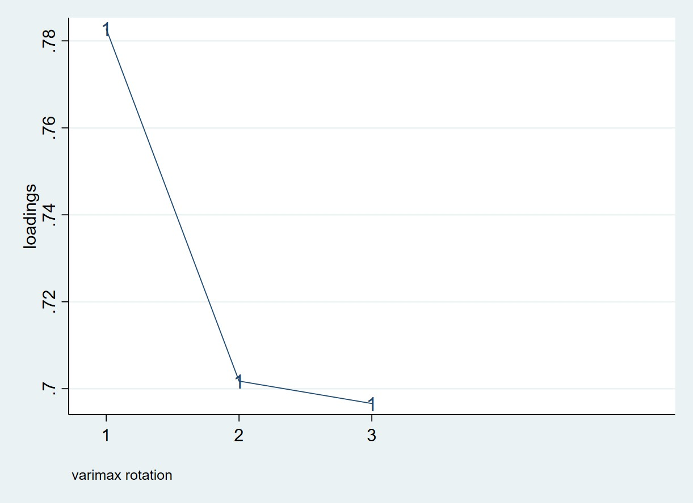

**Figure A5. Factor components and loadings of AST**

(Note: 1 - Wealth Index in per capita; 2 - Non-food consumption in per capita; and 3 -Expenditure of utility consumption in per capita)



**Figure A6. Factor components and loadings of SSN**

(Note: 1 - Old age pension; 2 - Disability pension; 3 - Survivor pension; 4 - Special merit pension; 5 - Social pension; 6 - Compensation; 7 - Compensation cash; and 8 - Compensation bulbs)

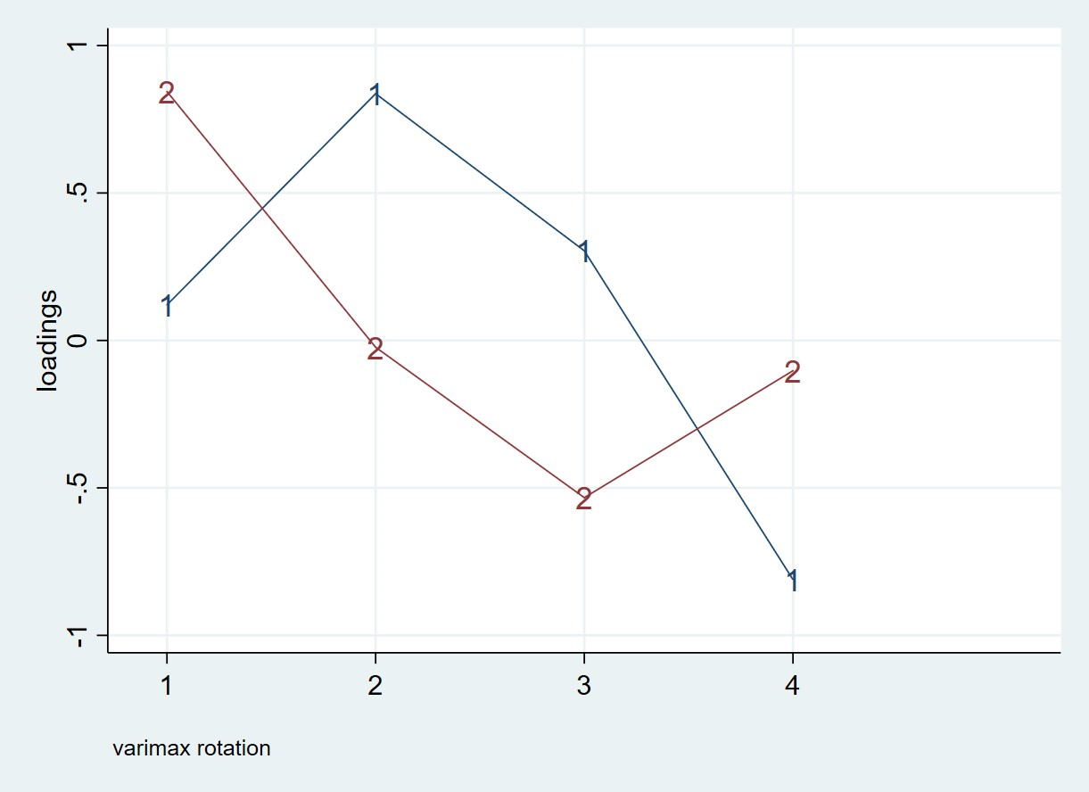

**Figure A7. Factor components and loadings of AC**

(Note: 1 - Income diversification; 2 - Income earner share; 3 - Migration ratio; and 4 - Number of elderly people)

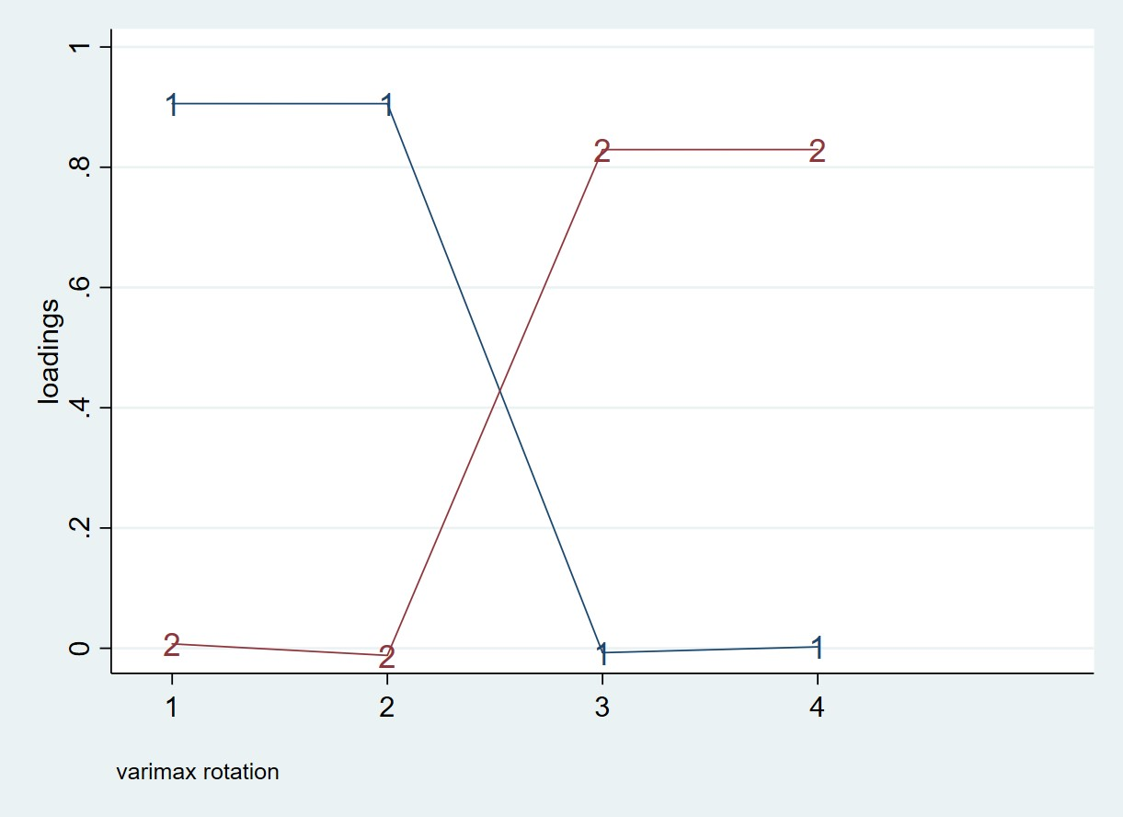

**Figure A8: Factor components and loadings of S**

(Note: 1 - Life unsatisfaction; 2 - Financial unsatisfaction; 3 - Hospitalization (reversed); and 4 - Times of hospitalization (reversed))

**Appendix F. Latent Class Comparing**

Looking at RCI, households with a higher RCI in 2009 are associated with a lower coping strategy in 2011 (Table A7). A negative relationship between coping strategies and resilience has already been mentioned (Nahid et al. 2021). In this case, less resilient households might be highly sensitive to shocks, encouraging them to activate short-term coping strategies. Looking at class comparisons for food security outcomes, FE is higher in the *“High Coping Strategy”* class, but the relationship with AFV is not statistically significant. As it is expected, HFES is lower in the *“High Coping Strategy”* class. The result could suggest that households experiencing better food security outcomes are those who strongly activate coping strategies to deal with the shocks. A similar comment given by Ansah, Gardebroek, and Ihle (2019) or Lascano Galarza (2020) accentuated the significance of different types of *ex ante* or *ex post* shock strategies linked with food security outcomes.

**Table A7. Class Comparison**

|  |  |  |  |
| --- | --- | --- | --- |
|  | **Low Coping Strategy** | **High Coping Strategy** | **p value** |
| RCI | 24.342 (47.93) | 22.208 (52.07) | 0.000 |
| RCI (obtained from the SEM approach) | 51.709 (47.93) | 50.188 (52.07) | 0.035 |
| FE | 264.345 (47.70) | 345.272 (52.30) | 0.000 |
| AFV | 375.647 (47.49) | 363.961 (52.51) | 0.358 |
| HFES | 0.196 (47.70) | 0.151 (52.30) | 0.000 |

*Sample size percentage in parentheses*

*RCI: Resilience Capacity Index; FE: Food Expenditure; AFV: Adequacy of Fruit and Vegetable Consumption; HFES: Household Food Expenditure Share*

**Table A8. Resilience and Food Security Outcomes**

|  |  |  |  |  |  |  |
| --- | --- | --- | --- | --- | --- | --- |
|  | **AFV** | | **FE** | | **HFES** | |
|  | **(1)** | **(2)** | **(3)** | **(4)** | **(5)** | **(6)** |
| RCI | 12.940**  (5.849) |  | 45.470***  (15.390) |  | 0.011**  (0.004) |  |
| RCI*Shock |  | 2.901**  (1.171) |  | 10.200***  (2.879) |  | 0.002***  (0.001) |
| High Coping Strategy | 7.287  (14.162) | 6.775  (12.681) | 59.149  (37.439) | 57.308*  (31.313) | -0.033***  (0.011) | -0.034***  (0.009) |
| Head female | -16.638  (16.950) | -21.714  (14.644) | 16.338  (44.735) | -1.429  (36.168) | 0.011  (0.013) | 0.006  (0.011) |
| Head age | 5.295**  (2.155) | 3.557***  (1.258) | 15.521***  (5.647) | 9.441***  (3.082) | 0.005*** (0.001) | 0.003***  (0.001) |
| Household size | -51.580***  (10.108) | -59.107***  (7.128) | 104.102***  (26.833) | 77.637***  (17.692) | -0.006  (0.008) | -0.013***  (0.005) |
| Sq. Household size | 2.033***  (0.463) | 2.275***  (0.371) | -3.178**  (1.231) | -2.321**  (0.920) | 0.001  (0.001) | 0.001**  (0.001) |
| Rural | 73.244  (46.225) | 52.635  (33.583) | 184.685  (122.17) | 112.187  (82.969) | 0.018  (0.036) | 0.002  (0.025) |
| Drought Shock Events | -6.036  (10.100) | -146.039**  (64.032) | -54.729**  (26.691) | -546.874***  (157.489) | -0.025***  (0.008) | -0.152***  (0.048) |
| Constant | -385.457  (456.535) | 389.934***  (100.451) | -3379.486***  (1200.57) | -656.407***  (157.489) | -0.619*  (0.360) | 0.084  (0.075) |
| Observations | 1327 | 1327 | 1333 | 1333 | 1333 | 1333 |
| Cragg-Donald F Stat. | 14.961 | 34.377 | 15.215 | 34.904 | 15.215 | 34.904 |

*\*\*\* p<0.01, **p<0.05, *p<0.1. The reference class is “Low Coping Strategy”. Standard errors in parentheses. RCI: Resilience Capacity Index; FE: Food Expenditure; AFV: Adequacy of Fruit and Vegetable Consumption; HFES: Household Food Expenditure Share*

**Table A9. Resilience and Food Security Loss**

|  |  |  |  |  |  |  |
| --- | --- | --- | --- | --- | --- | --- |
|  | **AFV** | | **FE** | | **HFES** | |
|  | **(1)** | **(2)** | **(3)** | **(4)** | **(5)** | **(6)** |
| RCI | 0.049***  (0.017) |  | -0.083***  (0.023) |  | -0.047***  (0.016) |  |
| RCI*Shock |  | 0.011***  (0.003) |  | -0.018***  (0.003) |  | -0105***  (0.003) |
| High Coping Strategy | -0.028  (0.041) | -0.030  (0.035) | -0.051  (0.056) | -0.047  (0.041) | 0.014  (0.039) | 0.016  (0.033) |
| Head female | 0.039  (0.049) | 0.020  (0.040) | -0.085  (0.067) | -0.053  (0.048) | 0.062  (0.047) | 0.080**  (0.038) |
| Head age | 0.016***  (0.006) | 0.010***  (0.003) | -0.028***  (0.008) | -0.016***  (0.004) | -0.015***  (0.005) | -0.009***  (0.003) |
| Household size | 0.075**  (0.029) | 0.046**  (0.019) | -0.150***  (0.040) | -0.102***  (0.023) | -0.053*  (0.028) | -0.025  (0.018) |
| Sq. Household size | -0.002  (0.001) | -0.001  (0.001) | 0.005***  (0.001) | 0.003***  (0.001) | 0.001  (0.001) | 0.001  (0.001) |
| Rural | 0.352**  (0.135) | 0.272***  (0.093) | -0.482*** (0.185) | -0.348***  (0.111) | -0.304**  (0.129) | -0.229**  (0.088) |
| Drought Shock Events | -0.086***  (0.029) | -0.626***  (0.178) | 0.147***  (0.040) | 1.053***  (0.210) | 0.069**  (0.028) | 0.579***  (0.167) |
| Constant | -3.333**  (1.342) | -0.345  (0.280) | 6.729***  (1.824) | 1.718***  (0.330) | 4.095***  (1.272) | 1.277***  (0.262) |
| Observations | 1327 | 1327 | 1333 | 1333 | 1333 | 1333 |
| Cragg-Donald F Stat. | 14.961 | 34.377 | 15.215 | 34.904 | 15.215 | 34.904 |
| Wald test of exogeneity p-value | 0.000 | 0.000 | 0.000 | 0.000 | 0.000 | 0.000 |
| AR Stat. p-value | 0.000 | 0.000 | 0.000 | 0.000 | 0.000 | 0.000 |

*\*\*\* p<0.01, **p<0.05, *p<0.1. The reference class is “Low Coping Strategy”. Standard errors in parentheses. RCI: Resilience Capacity Index; FE: Food Expenditure; AFV: Adequacy of Fruit and Vegetable Consumption; HFES: Household Food Expenditure Share*

**References**

Acock, A.C. 2013. *Discovering structural equation modeling using Stata*: Stata Press Books.

Akaike, H. 1987. "Factor analysis and AIC." *Psychometrika* no. 52 (3):317-332. doi: 10.1007/BF02294359.

Ansah, I.G.K., C. Gardebroek, and R. Ihle. 2019. "Resilience and household food security: a review of concepts, methodological approaches and empirical evidence." *Food Security* no. 11 (6):1187-1203. doi: 10.1007/s12571-019-00968-1.

Bagozzi, R.P., Y. Yi, and L.W.J.A.s.q. Phillips. 1991. "Assessing construct validity in organizational research."421-458.

Bartlett, M.S. 1951. "The effect of standardization on a Chi-square approximation in factor analysis." *Biometrika* no. 38 (3-4):337-344. doi: 10.1093/biomet/38.3-4.337.

Bataineh, M.a.F., and A. Attlee. 2021. "Reliability and validity of Arabic version of revised general nutrition knowledge questionnaire on university students." *Public Health Nutrition* no. 24 (5):851-860. doi: 10.1017/S1368980020002724.

Baum, C.F. 2006. *An Introduction to Modern Econometrics Using Stata*: Stata press.

Celeux, G., and G. Soromenho. 1996. "An entropy criterion for assessing the number of clusters in a mixture model." *Journal of Classification* no. 13 (2):195-212. doi: 10.1007/BF01246098.

Cheung, G.W., H.D. Cooper-Thomas, R.S. Lau, and L.C. Wang. 2023. "Reporting reliability, convergent and discriminant validity with structural equation modeling: A review and best-practice recommendations." *Asia Pacific Journal of Management*. doi: 10.1007/s10490-023-09871-y.

Collier, Z.K., and W.L. Leite. 2017. "A Comparison of Three-Step Approaches for Auxiliary Variables in Latent Class and Latent Profile Analysis." *Structural Equation Modeling: A Multidisciplinary Journal* no. 24 (6):819-830. doi: 10.1080/10705511.2017.1365304.

Collins, L.M., and S.T. Lanza. 2009. *Latent class and latent transition analysis: With applications in the social, behavioral, and health sciences*. Vol. 718: John Wiley & Sons.

Dunn, S.C., R.F. Seaker, and M.A.J.J.o.B.l. Waller. 1994. "Latent variables in business logistics research: scale development and validation." no. 15 (2):145.

FAO. 2016. Resilience Index Measurement and Analysis—II. Rome: FAO.

Field, A. 2013. *Discovering statistics using IBM SPSS statistics*: SAGE Publications.

Fornell, C., and D.F. Larcker. 1981. "Evaluating Structural Equation Models with Unobservable Variables and Measurement Error." *Journal of Marketing Research* no. 18 (1):39-50. doi: 10.1177/002224378101800104.

Hair, J., W. Black, B. Babin, R. Anderson, and R. Tatham. 2014. *Multivariate Data Analysis New Jersey: Pearson Prentice Hall*. Vol. 2: Pearson Education Limited.

Hair, J.F., Jr, Black, J. W, Babin, B. J, Anderson, E. R. 2010. *Multivariate data analysis*. 7 ed. Edinburgh, UK: Pearson Education Limited.

Høgheim, S., E.S. Jenssen, and R.A. Federici. 2023. "Do lectures matter? Exploring students’ situational interest in two learning arenas in teacher education." *Scandinavian Journal of Educational Research* no. 67 (7):1027-1040. doi: 10.1080/00313831.2022.2115131.

Hu, L.t., and P.M. Bentler. 1999. "Cutoff criteria for fit indexes in covariance structure analysis: Conventional criteria versus new alternatives." *Structural Equation Modeling: A Multidisciplinary Journal* no. 6 (1):1-55. doi: 10.1080/10705519909540118.

Kaiser, H.F. 1958. "The varimax criterion for analytic rotation in factor analysis." *Psychometrika* no. 23 (3):187-200.

Kaiser, H.F. 1960. "The Application of Electronic Computers to Factor Analysis." *Educational and Psychological Measurement* no. 20 (1):141-151. doi: 10.1177/001316446002000116.

Kaiser, H.F. 1974. "An index of factorial simplicity." *Psychometrika* no. 39 (1):31-36. doi: 10.1007/BF02291575.

Larose, C., O. Harel, K. Kordas, and D.K. Dey. 2016. "Latent class analysis of incomplete data via an entropy-based criterion." *Statistical Methodology* no. 32:107-121. doi: <https://doi.org/10.1016/j.stamet.2016.04.004>.

Lascano Galarza, M.X. 2020. "Resilience to Food Insecurity: Theory and Empirical Evidence from International Food Assistance in Malawi." *Journal of Agricultural Economics* no. 71 (3):936-961. doi: 10.1111/1477-9552.12397.

Lucas, J.W. 2003. "Theory-Testing, Generalization, and the Problem of External Validity." *Sociological Theory* no. 21 (3):236-253. doi: <https://doi.org/10.1111/1467-9558.00187>.

Nahid, N., F. Lashgarara, S.J. Farajolah Hosseini, S.M. Mirdamadi, and K. Rezaei-Moghaddam. 2021. "Determining the Resilience of Rural Households to Food Insecurity during Drought Conditions in Fars Province, Iran." *Sustainability* no. 13 (15):8384. doi: 10.3390/su13158384.

Riquelme, A., D. Berkowitz, and M. Caner. 2013. "Valid tests when instrumental variables do not perfectly satisfy the exclusion restriction." *The Stata Journal* no. 13 (3):528-546.

Rönkkö, M., and E. Cho. 2020. "An Updated Guideline for Assessing Discriminant Validity." *Organizational Research Methods* no. 25 (1):6-14. doi: 10.1177/1094428120968614.

Schwarz, G. 1978. "Estimating the dimension of a model." *The annals of statistics* no. 6 (2):461-464.

Steiger, J.H. 1990. "Structural model evaluation and modification: An interval estimation approach." *Multivariate behavioral research* no. 25 (2):173-180.

Tein, J.-Y., S. Coxe, and H. Cham. 2013. "Statistical Power to Detect the Correct Number of Classes in Latent Profile Analysis." *Structural Equation Modeling: A Multidisciplinary Journal* no. 20 (4):640-657. doi: 10.1080/10705511.2013.824781.

Venturini, S., and M. Mehmetoglu. 2019. "plssem: A Stata Package for Structural Equation Modeling with Partial Least Squares." *Journal of Statistical Software* no. 88 (8):1 - 35. doi: 10.18637/jss.v088.i08.

Weller, B.E., N.K. Bowen, and S.J. Faubert. 2020. "Latent Class Analysis: A Guide to Best Practice." *Journal of Black Psychology* no. 46 (4):287-311. doi: 10.1177/0095798420930932.

Wooldridge, J.M. 2010. *Econometric analysis of cross section and panel data*: MIT press.

Worldbank. *Reliable and Affordable Heating is Essential to Everyday Life in Tajikistan* 2015. Available from <https://www.worldbank.org/en/news/feature/2015/07/23/reliable-and-affordable-heating-is-essential-to-everyday-life-in-tajikistan>.

Zimmerman, F.J., and M.R. Carter. 2003. "Asset smoothing, consumption smoothing and the reproduction of inequality under risk and subsistence constraints." *Journal of Development Economics* no. 71 (2):233-260. doi: 10.1016/S0304-3878(03)00028-2.