# **Supplementary material**

## S1. Supplementary tables

Table S1 Variance Inflation Factor per indicator. Variance Inflation Factor (VIF) is a measure used to detect multicollinearity in regression analysis. It quantifies how much the variance of an estimated regression coefficient is inflated due to multicollinearity. A VIF value of 5 or higher can be a sign of moderate multicollinearity (James et al., 2013).

|  |  |
| --- | --- |
| **Indicator** | **Variance Inflation Factor (VIF)** |
| GNI per cap | 2.33 |
| Inequality (GINI) | 1.48 |
| Education | 4.22 |
| Fluvial flood volume | 1.08 |
| Built-up land | 1.17 |
| Conflict | 1.01 |
| Dry spell | 1.87 |
| Precipitation | 1.46 |
| Yields | 1.53 |
| Temperature | 1.93 |

Table S2: Minimum, maximum, average and standard deviation of the yearly varying sample data per administrative unit for all countries (Bangladesh, Bhutan, India, Pakistan, Nepal, Sri Lanka) over all years (2000-2019).

|  |  |  |  |  |
| --- | --- | --- | --- | --- |
| **Indicators** | **min** | **max** | **Average** | **std** |
| GNI per capita (US$2017) | 1225.11 | 17866.00 | 4656.12 | 2530.73 |
| Inequality (GINI) | 0.15 | 0.54 | 0.42 | 0.05 |
| Education (number of years) | 2.04 | 10.70 | 6.29 | 2.46 |
| Fluvial flood volume (M3) | 0.00 | 3.7 x 108 | 7.1x106 | 2.1x107 |
| Built-up land (km2/cell) | 0.00 | 39.59 | 1.26 | 2.89 |
| Conflict (events) | 0.00 | 145.00 | 0.11 | 2.24 |
| Dry spell (maximum number of dry days per year) | 2.00 | 293.33 | 62.78 | 45.70 |
| Precipitation (millimetre) | 12.53 | 5527.80 | 1428.35 | 727.79 |
| Yields (ton/km2) | 0.00 | 1252.01 | 289.57 | 180.71 |
| Temperature (Degree C°) | -1.82 | 29.29 | 24.66 | 4.41 |

Table S3 Scenario details per variable. Spatial resolution is the same as the reference data.

|  |  |
| --- | --- |
| **Variable** | **Scenario details** |
| Built-up area | SSP1, SSP2, SSP3 scenario projections per cell developed by Wolff et al. (2018). |
| Conflict prevelance | Since no conflict projections are available, no conflict events were included in projections. |
| Education | The SSP1, SSP2, and SSP3 education scenarios follow the SSP country trends as presented in Lutz et al. (2018) downloaded from Wittgenstein Centre for Demography and Global Human Capital (2018). These trends are applied upon the individual values of the last reference year (2019) per administrative area up to 2050 the administrative areas. |
| GNI per cap | The SSP1, SSP2 and SSP3 GNI per capita scenarios follow the linearly interpolated % change GDP per cap PPP $2017 as developed by Koch and Leimbach (2023). These trends are applied upon the individual values of the last reference year (2019) per administrative area up to 2050 the administrative areas. |
| Inequality (GINI) | The SSP1, SSP2 and SSP3 GINI are based on the SSP trends for India as developed by Rao et al. (2019). For South Asia, SSP trends are solely available for India. These trends are applied upon the individual values of the last reference year (2019) per administrative area up to 2050 the administrative areas. |
| Dry spells (number of dry days) | Multi-model ensembles RCP2.6, RCP4.5, RCP7.0 by World Bank Group (2023) |
| Fluvial flood Volume (M3) | RCP 2.6, RCP 4.5 and RCP 6.0 developed by the PCR-GLOB model (Sutanudjaja et al., 2018). |
| Precipitation | Multi-model ensembles RCP2.6, RCP4.5, RCP7.0 by World Bank Group (2023) |
| Temperature | RCP2.6, RCP4.5, RCP7.0 developed by the IMAGE model (Doelman et al., 2018; Stehfest et al., 2014) |
| Actual yield | SSP1-RCP2.6, SSP2 – RCP4.5, SSP3 – RCP7.0 developed by the IMAGE model (Doelman et al., 2018; Stehfest et al., 2014) |

## S1. Supplementary figures

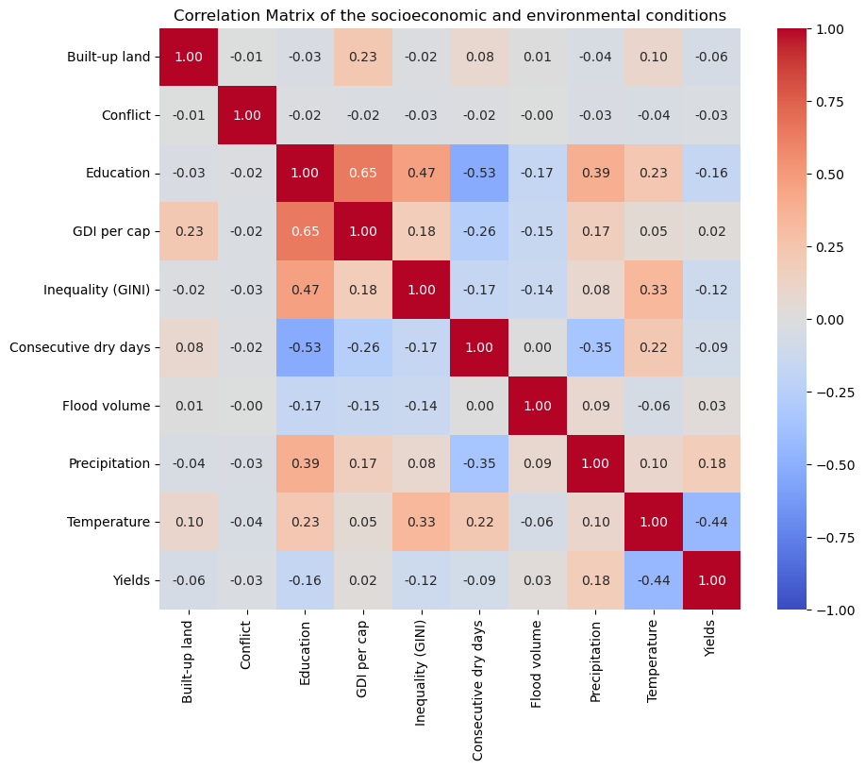

Figure S1: Correlation matrix of the sample data. For correlation between individual predictors, we used a value of 0.8 as threshold value, based on other studies (Chan et al., 2022). For the indicators used in this study, the highest value is 0.66, representing the correlation between GNI per capita and education.

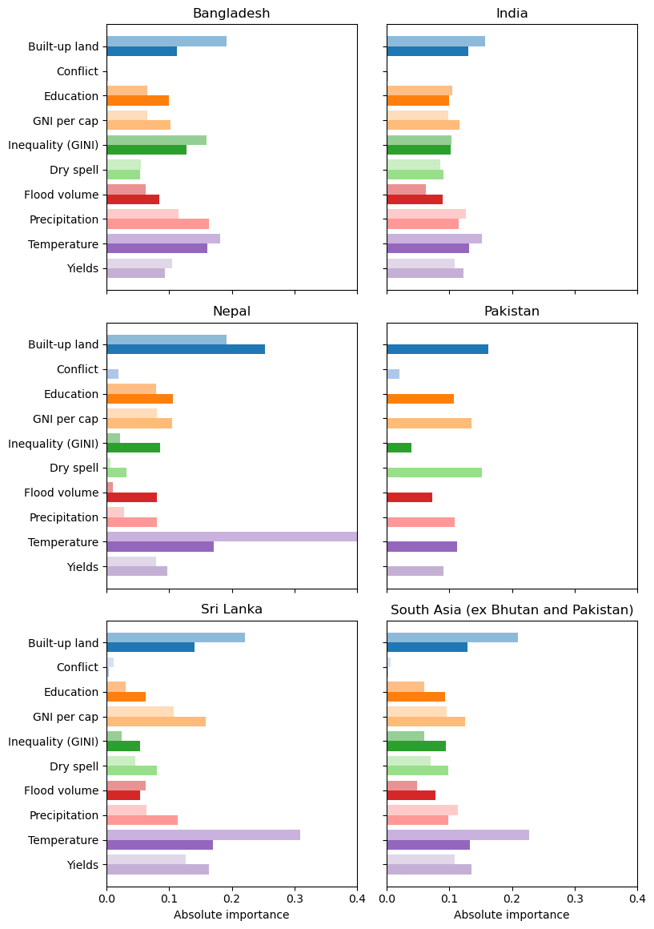

Figure S2 Feature importance per country and the combined South Asian region. Per variable, the lighter shaded upper bar represents the RFR run and the darker shaded lower bar represents the RFC run.

**References**

Chan, J. Y.-L., Leow, S. M. H., Bea, K. T., Cheng, W. K., Phoong, S. W., Hong, Z.-W., & Chen, Y.-L. (2022). Mitigating the Multicollinearity Problem and Its Machine Learning Approach: A Review. *Mathematics*, *10*(8), 1283. <https://www.mdpi.com/2227-7390/10/8/1283>

Doelman, J. C., Stehfest, E., Tabeau, A., van Meijl, H., Lassaletta, L., Gernaat, D. E., Hermans, K., Harmsen, M., Daioglou, V., & Biemans, H. (2018). Exploring SSP land-use dynamics using the IMAGE model: Regional and gridded scenarios of land-use change and land-based climate change mitigation. *Global Environmental Change*, *48*, 119-135. <https://doi.org/10.1016/j.gloenvcha.2017.11.014>

James, G., Witten, D., Hastie, T., & Tibshirani, R. e. (2013). *An introduction to statistical learning: with applications in R.* Springer.

Koch, J., & Leimbach, M. (2023). SSP economic growth projections: Major changes of key drivers in integrated assessment modelling. *Ecological Economics*, *206*, 107751. <https://doi.org/10.1016/j.ecolecon.2023.107751>

Lutz, W., Goujon, A., Kc, S., Stonawski, M., & Stilianakis, N. (2018). *Demographic and human capital scenarios for the 21st century: 2018 assessment for 201 countries*. Publications Office of the European Union.

Rao, N., Sauer, P., Gidden, M., & Riahi, K. (2019). Income inequality projections for the Shared Socioeconomic Pathways (SSPs). *Futures*, *105*, 27-39. <https://doi.org/10.1016/j.futures.2018.07.001>

Stehfest, E., Vuuren, D. v., Kram, T., Bouwman, L., Alkemade, R., Bakkenes, M., Biemans, H., Bouwman, A., Elzen, M. d., Janse, J., Lucas, P., Minnen, J. v., Müller, C., & Prins, A. G. (2014). *Integrated Assessment of Global Environmental Change with IMAGE 3.0. Model description and policy applications*. PBL Netherlands Environmental Assessment Agency.

Sutanudjaja, E. H., Van Beek, R., Wanders, N., Wada, Y., Bosmans, J. H., Drost, N., Van Der Ent, R. J., De Graaf, I. E., Hoch, J. M., & De Jong, K. (2018). PCR-GLOBWB 2: a 5 arcmin global hydrological and water resources model. *Geoscientific Model Development*, *11*(6), 2429-2453. <https://doi.org/10.5194/gmd-11-2429-2018>

Wittgenstein Centre for Demography and Global Human Capital. (2018). *Wittgenstein Centre Data Explorer Version 2.0*. Available at: <http://www.wittgensteincentre.org/dataexplorer>

World Bank Group. (2023). *Climate Change Knowledge Portal*. <https://climateknowledgeportal.worldbank.org/download-data>