Supplement
Figure S 1: Crop yields in the main cultivation area in 2011

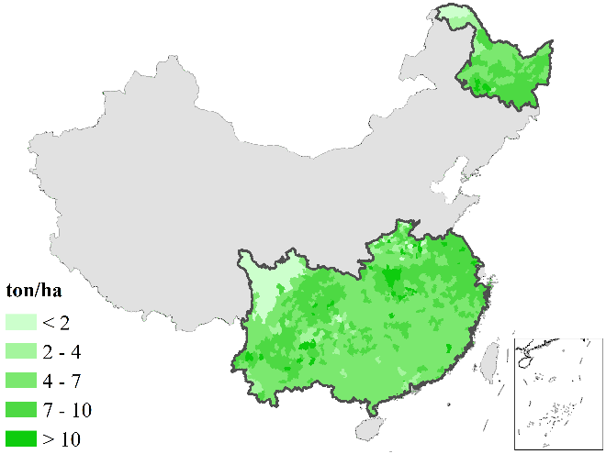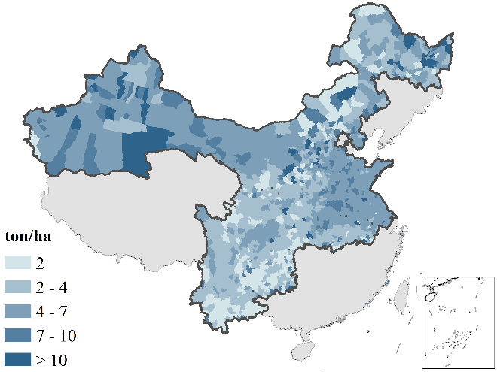
Rice
Wheat
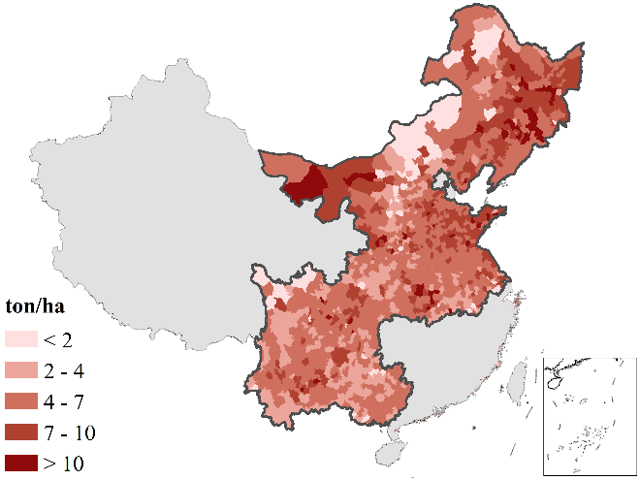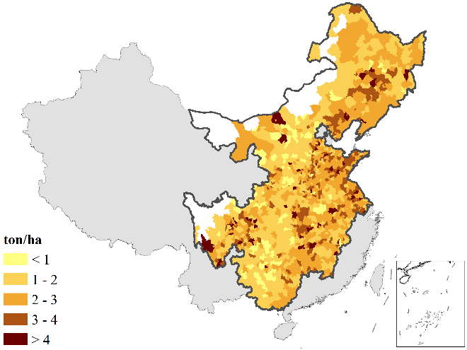
Soybean
Maize

Figure S 2: Changes in harvested areas in 10-year intervals

a) Rice:
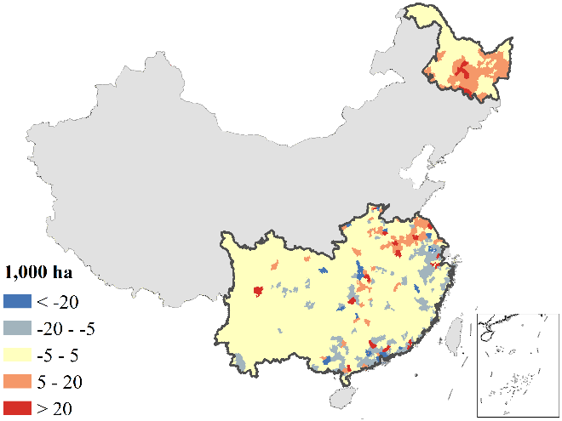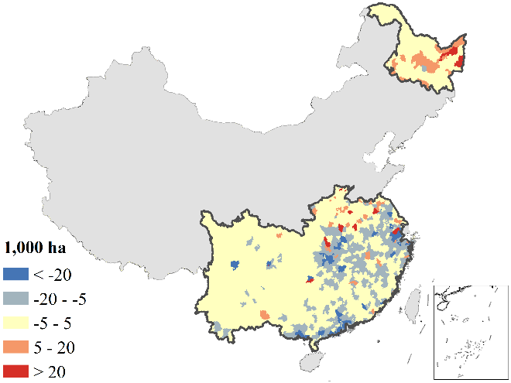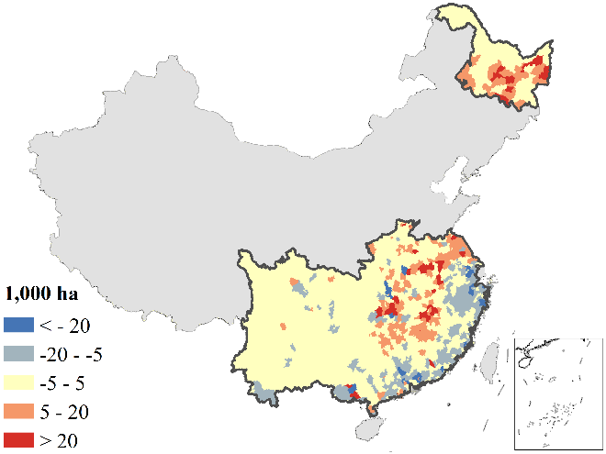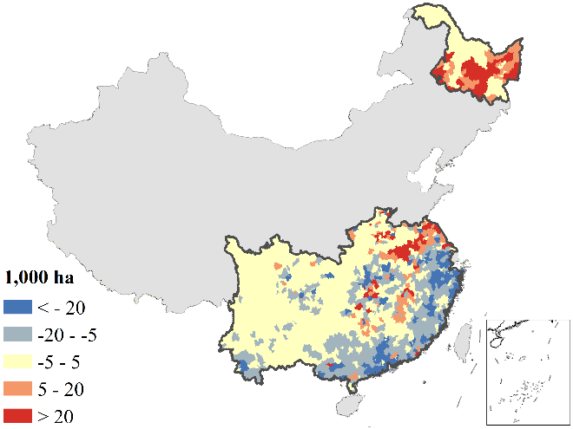
1980-1990
1990-2000
1980-2011
2000-2010

b) Wheat:
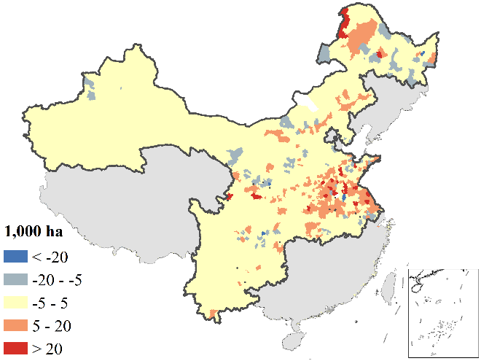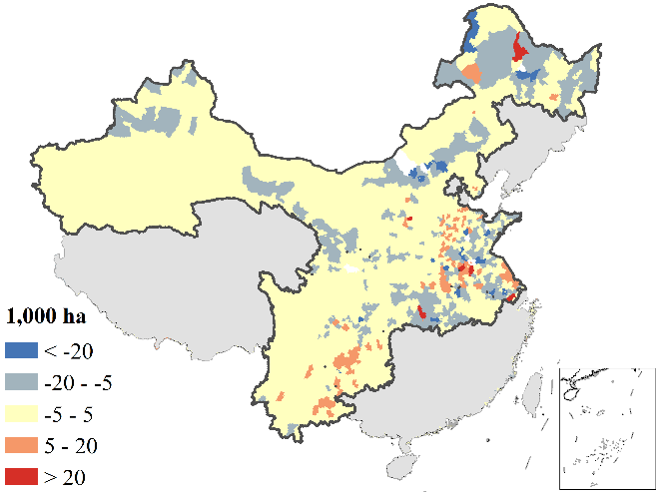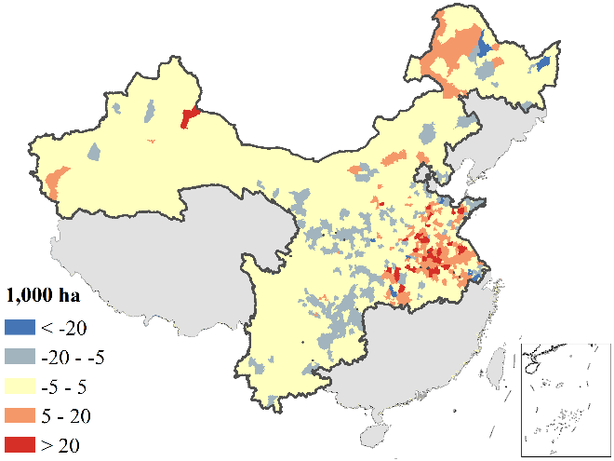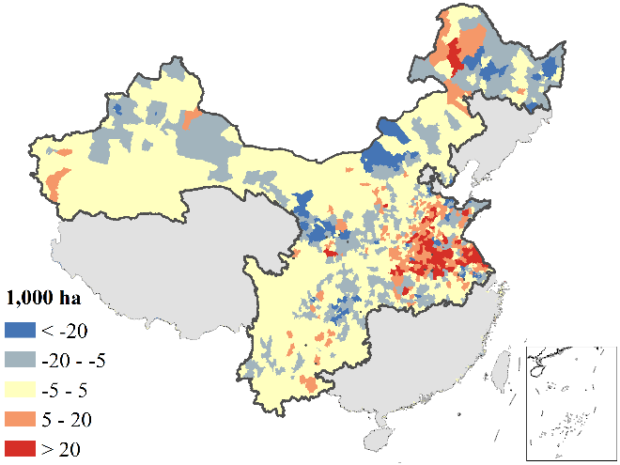
2000-2010
1980-2011
1990-2000
1980-1990

c) Maise:
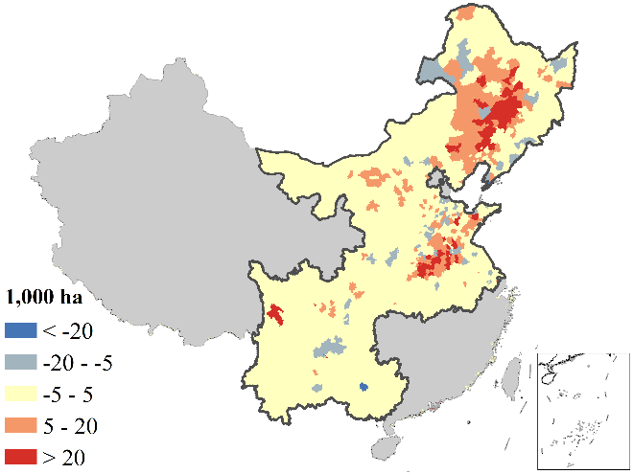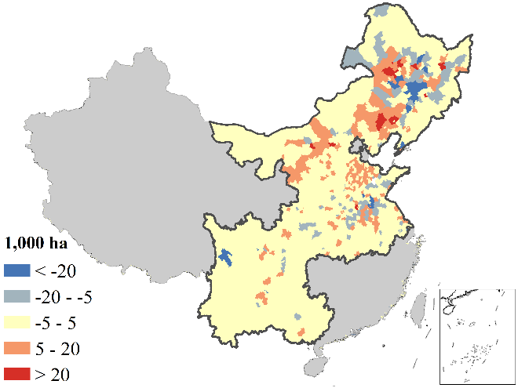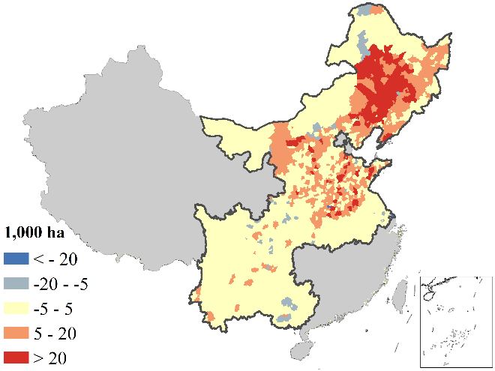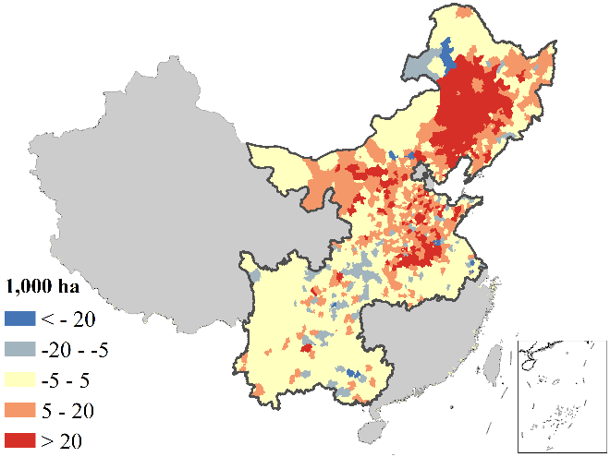
1990-2000
2000-2010
1980-2011
1980-1990

d) Soybean:
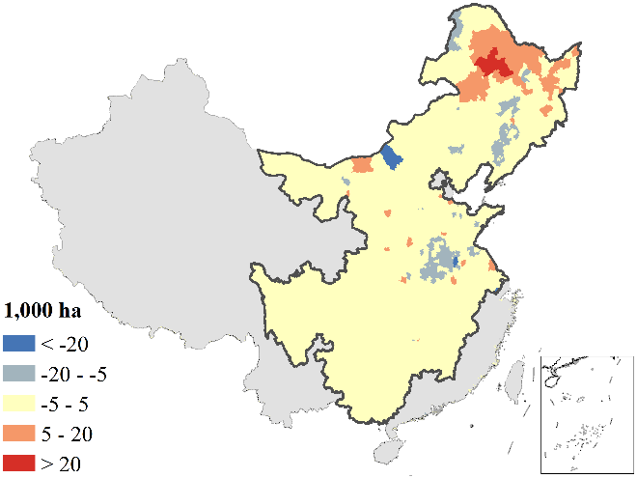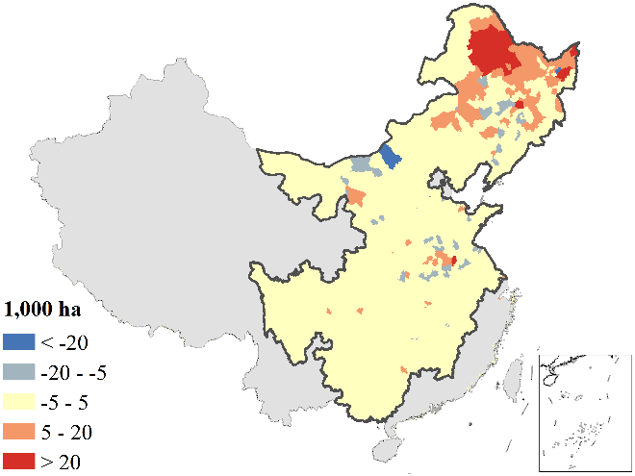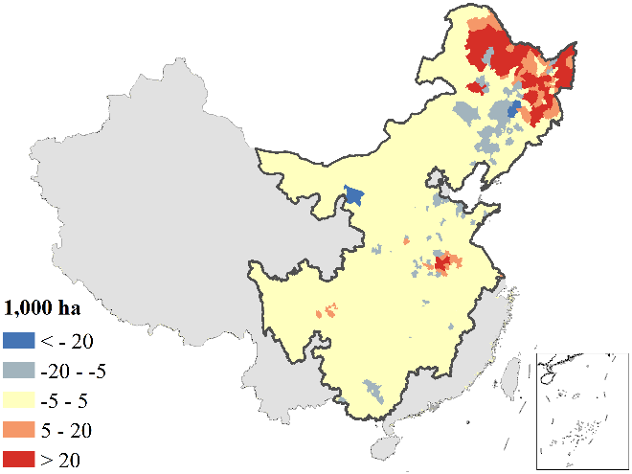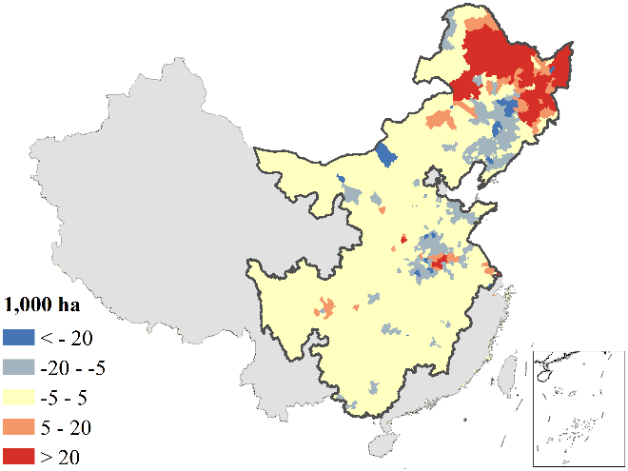
1990-2000
2000-2010
1980-2011
1980-1990

Figure S 3: Changes in yield of the four major crops in 10-year intervals

a) Rice
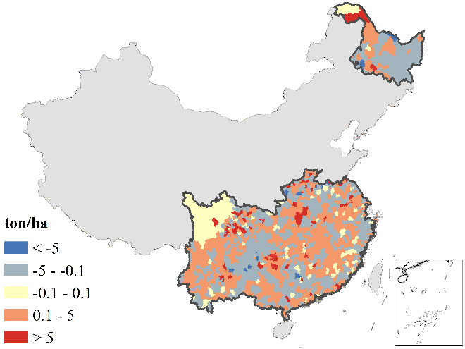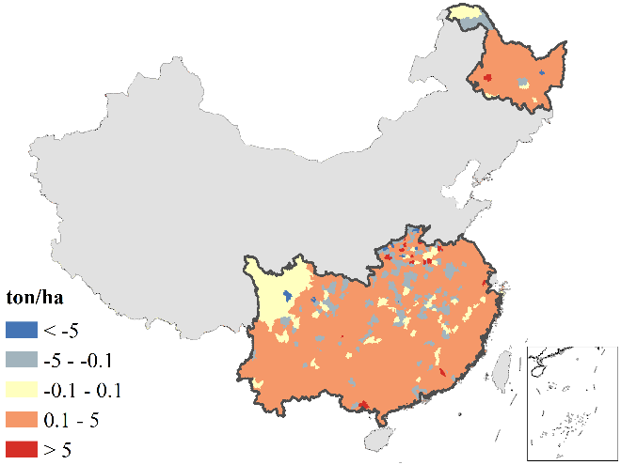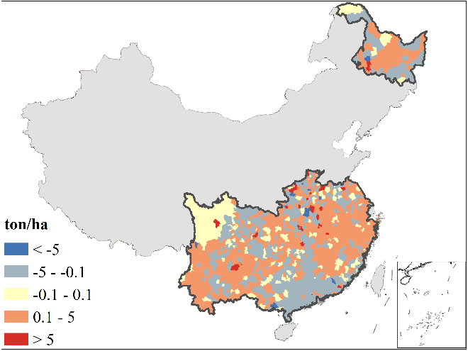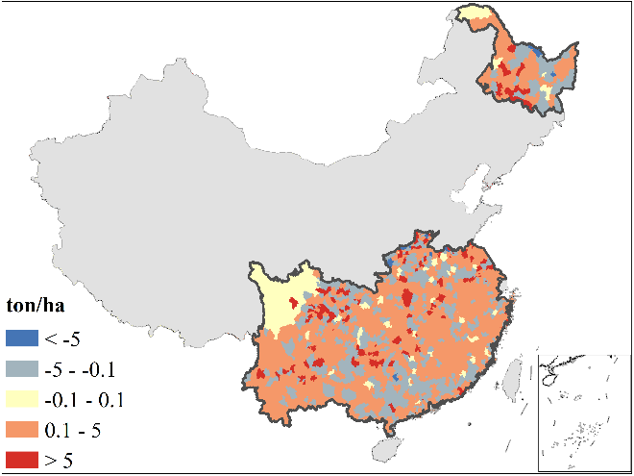
1980-1990
1980-2011
1990-2000
2000-2010

b) Wheat
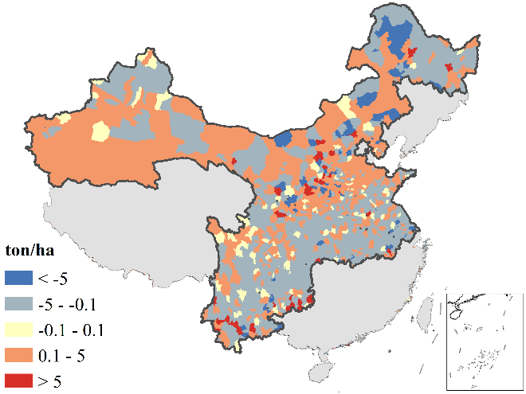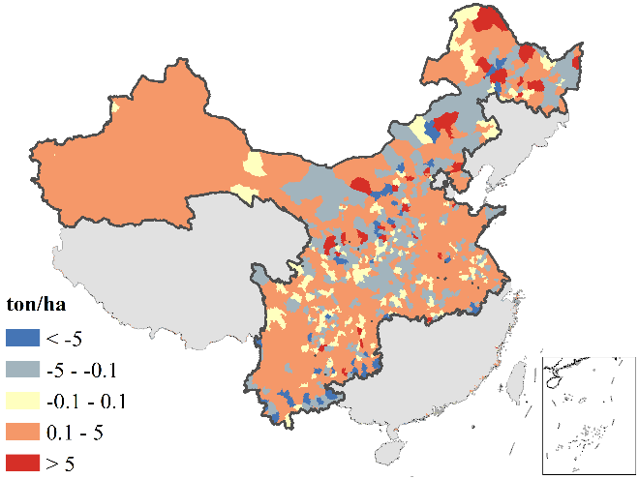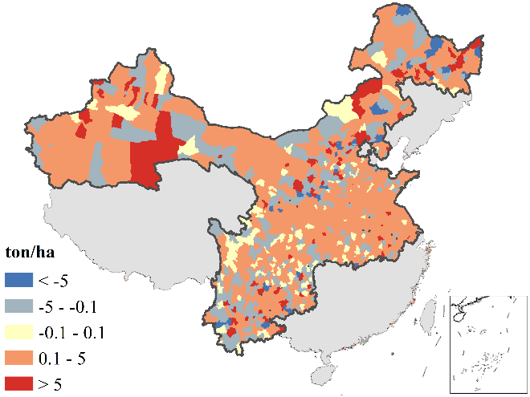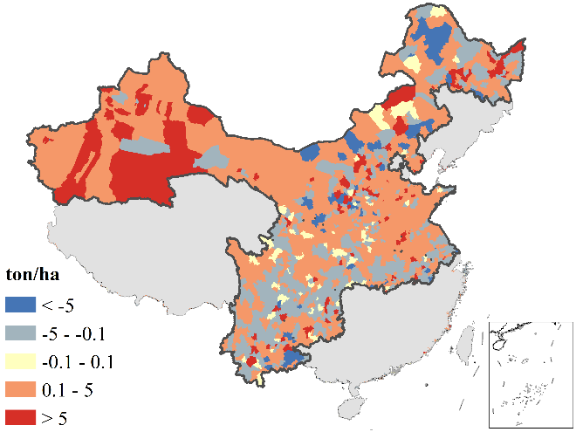
1980-1990
1980-2011
1990-2000
2000-2010

c) Maise
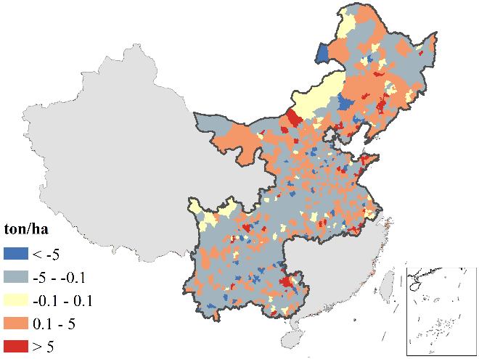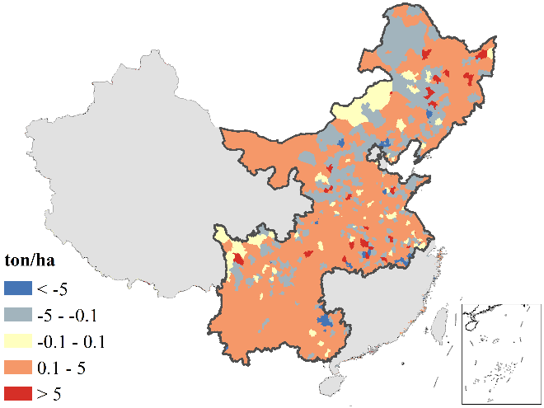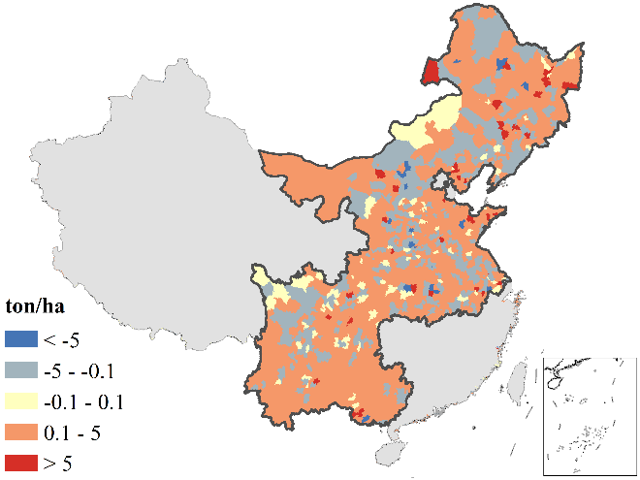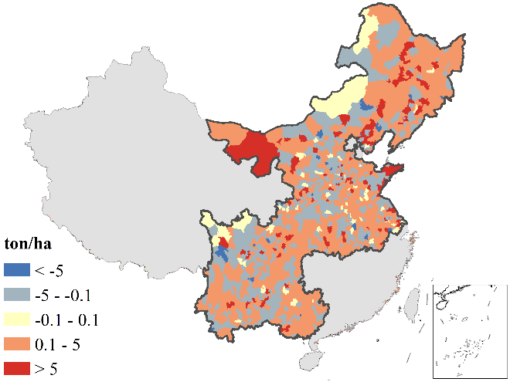
1980-1990
1980-2011
1990-2000
2000-2010

d) Soybean
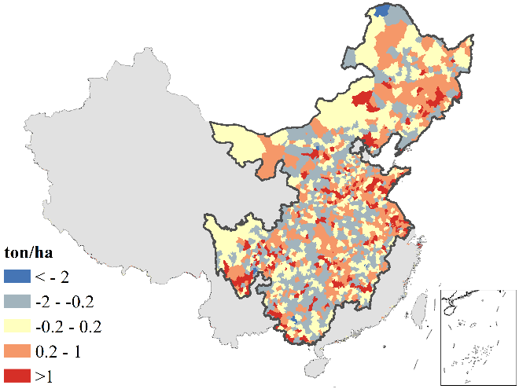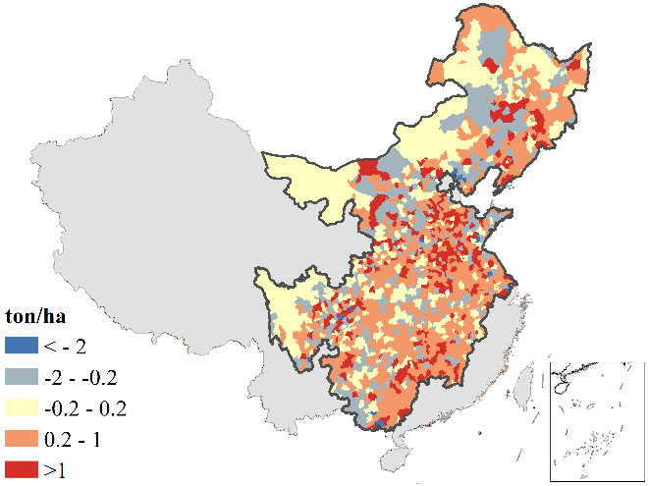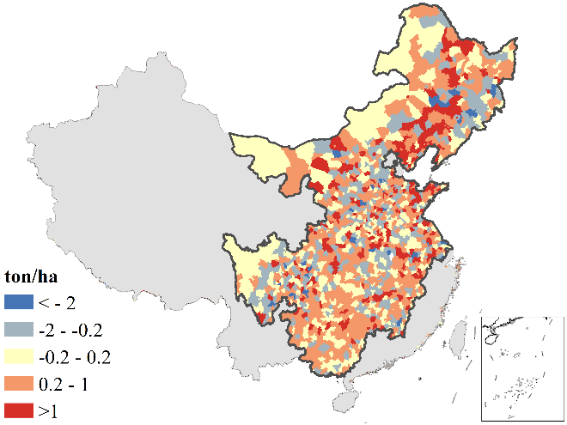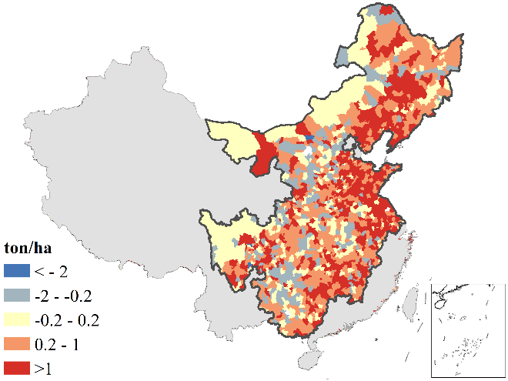
1980-1990
1980-2011
1990-2000
2000-2010

Table S 4: Estimations from log-log regression with its 95% standard errors

a) Harvested areas
 | Rice area | Wheat area | Maise area | Soybean area
GDP | -0.032 | -0.012 | -0.0017 | 0.0034
 | [-0.063,0] | [-0.048,0.025] | [-0.039,0.035] | [-0.023,0.030]
Population | 0.16 | 0.33 | 0.27 | 0.13
 | [0.034,0.29] | [0.20,0.45] | [0.16,0.38] | [0.0054,0.25]
Labour | 0.29 | -0.027 | 0.049 | 0.1
 | [0.20,0.38] | [-0.11,0.051] | [-0.021,0.12] | [0.033,0.17]
Machinery | 0.037 | 0.071 | 0.047 | 0.026
 | [0.0099,0.063] | [0.038,0.10] | [0.018,0.077] | [-0.0062,0.058]
Road | -0.36 | 0.3 | 0.11 | -0.28
 | [-0.45,-0.28] | [0.17,0.43] | [0.022,0.21] | [-0.42,-0.15]
Rainfall | 0.0025 | 0.03 | 0.047 | -0.046
 | [-0.027,0.032] | [0.0056,0.054] | [0.022,0.073] | [-0.071,-0.022]
GDD | 0.18 | -0.25 | 0.095 | 0.13
 | [-0.35,0.70] | [-0.49,-0.011] | [-0.12,0.32] | [-0.077,0.33]
WTO | -0.099 | -0.21 | -0.072 | -0.14
 | [-0.13,-0.067] | [-0.25,-0.18] | [-0.11,-0.039] | [-0.17,-0.12]
Year | 0.0077 | -0.017 | 0.0063 | 0.0051
 | [0.0032,0.012] | [-0.022,-0.012] | [0.0014,0.011] | [0.00068,0.0095]
Spatial lag | 0.29 | 0.56 | 0.43 | 0.49
 | [0.22,0.36] | [0.52,0.60] | [0.38,0.47] | [0.45,0.52]
Variance | 0.23 | 0.33 | 0.31 | 0.32
sigma2_e | [0.19,0.28] | [0.29,0.37] | [0.26,0.36] | [0.29,0.35]
R² | 0.03 | 0.256 | 0.078 | 0.003
AIC | 59951.2 | 90569.4 | 86622.4 | 91328
Log likelihood | -29964.6 | -45273.7 | -43300.2 | -45653
N | 43136 | 50272 | 50624 | 52640

b) Yields
 | Rice yield | Wheat yield | Maise yield | Soybean yield
GDP | 0.01 | 0.016 | 0.027 | 0.019
 | [-0.0018,0.022] | [0.0026,0.029] | [0.016,0.038] | [0.010,0.028]
Fertiliser | 0.02 | 0.0071 | 0.0065 | 0.0065
 | [0.0039,0.037] | [-0.0070,0.021] | [-0.0080,0.021] | [-0.0043,0.017]
Labour | -0.0028 | 0.013 | -0.00014 | -0.025
 | [-0.027,0.021] | [-0.015,0.040] | [-0.022,0.022] | [-0.040,-0.0092]
Machinery | 0.0078 | 0.02 | 0.017 | 0.012
 | [-0.0030,0.018] | [0.0079,0.031] | [0.0063,0.027] | [0.0036,0.020]
Road | -0.039 | 0.012 | -0.09 | 0.031
 | [-0.077,-0.001] | [-0.039,0.062] | [-0.13,-0.049] | [-0.011,0.072]
Rainfall | -0.0098 | 0.047 | 0.068 | 0.063
 | [-0.027,0.0076] | [0.030,0.065] | [0.051,0.086] | [0.046,0.081]
GDD | 0.086 | 0.15 | 0.038 | -0.097
 | [0.010,0.16] | [0.033,0.26] | [-0.043,0.12] | [-0.19,-0.0044]
WTO | -0.067 | 0.048 | 0.022 | -0.008
 | [-0.083,-0.052] | [0.032,0.065] | [0.0083,0.037] | [-0.023,0.0066]
Year | 0.011 | 0.0011 | 0.007 | 0.0066
 | [0.0088,0.013] | [-0.0011,0.003] | [0.0049,0.009] | [0.0049,0.0082]
Spatial lag | 0.3 | 0.35 | 0.41 | 0.32
 | [0.27,0.32] | [0.33,0.37] | [0.39,0.43] | [0.31,0.34]
Variance | 0.085 | 0.15 | 0.12 | 0.12
sigma2_e | [0.079,0.091] | [0.14,0.16] | [0.11,0.12] | [0.12,0.12]
R² | 0.112 | 0.027 | 0.052 | 0.112
AIC | 16874.3 | 48657.7 | 37212.8 | 38536.2
Log likelihood | -8426.1 | -24317.9 | -18595.4 | -19257.1
N | 43136 | 50272 | 50624 | 52640

Table S 5: Estimations from standard regression with its 95% standard error

a) Harvested areas
 | Rice area | Wheat area | Maise area | Soybean area
GDP | -0.02 | -0.008 | -0.0014 | 0.0031
 | [-0.041,0] | [-0.033,0.017] | [-0.030,0.028] | [-0.022,0.028]
Population | 0.07 | 0.15 | 0.14 | 0.073
 | [0.014,0.13] | [0.089,0.21] | [0.082,0.20] | [0.0030,0.14]
Labour | 0.13 | -0.013 | 0.028 | 0.069
 | [0.091,0.18] | [-0.051,0.025] | [-0.012,0.067] | [0.022,0.12]
Machinery | 0.022 | 0.045 | 0.034 | 0.022
 | [0.0058,0.037] | [0.024,0.065] | [0.013,0.055] | [-0.0052,0.048]
Road | -0.11 | 0.093 | 0.041 | -0.12
 | [-0.13,-0.081] | [0.054,0.13] | [0.0079,0.074] | [-0.18,-0.067]
Rainfall | 0.00078 | 0.0096 | 0.018 | -0.017
 | [-0.0081,0.0097] | [0.0018,0.017] | [0.0082,0.027] | [-0.026,-0.0080]
GDD | 0.033 | -0.05 | 0.022 | 0.026
 | [-0.065,0.13] | [-0.098,-0.0021] | [-0.029,0.072] | [-0.016,0.069]
WTO | -0.042 | -0.095 | -0.038 | -0.099
 | [-0.055,-0.029] | [-0.11,-0.080] | [-0.055,-0.02] | [-0.12,-0.080]
Year | 0.0033 | -0.0077 | 0.0033 | 0.0035
 | [0.001,0.005] | [-0.01,-0.005] | [0.0007,0.006] | [0.00047,0.0065]
Spatial lag | 0.29 | 0.56 | 0.43 | 0.49
 | [0.22,0.36] | [0.52,0.60] | [0.38,0.47] | [0.45,0.52]
Variance | 0.042 | 0.067 | 0.084 | 0.15
sigma2_e | [0.034,0.050] | [0.060,0.075] | [0.071,0.097] | [0.14,0.16]
R² | 0.025 | 0.254 | 0.076 | 0.002
AIC | -13648.2 | 10553.3 | 20316.7 | 51812.3
Log likelihood | 6835.1 | -5265.7 | -10147.3 | -25895.2
N | 43136 | 50272 | 50624 | 52640

b. Yields
 | Rice yield | Wheat yield | Maise yield | Soybean yield
GDP | 0.035 | 0.043 | 0.078 | 0.058
 | [-0.0065,0.077] | [0.0071,0.078] | [0.046,0.11] | [0.030,0.085]
Fertilizer | 0.081 | 0.021 | 0.021 | 0.022
 | [0.015,0.15] | [-0.021,0.064] | [-0.026,0.069] | [-0.015,0.059]
Labour | -0.0072 | 0.025 | -0.00029 | -0.054
 | [-0.069,0.054] | [-0.029,0.078] | [-0.046,0.046] | [-0.087,-0.020]
Machinery | 0.025 | 0.049 | 0.045 | 0.032
 | [-0.0097,0.060] | [0.020,0.079] | [0.017,0.073] | [0.0098,0.054]
Road | -0.063 | 0.015 | -0.12 | 0.043
 | [-0.12,-0.0022] | [-0.047,0.077] | [-0.17,-0.065] | [-0.015,0.10]
Rainfall | -0.017 | 0.061 | 0.095 | 0.075
 | [-0.046,0.013] | [0.039,0.083] | [0.071,0.12] | [0.054,0.096]
GDD | 0.09 | 0.12 | 0.033 | -0.066
 | [0.011,0.17] | [0.026,0.21] | [-0.037,0.10] | [-0.13,-0.0030]
WTO | -0.16 | 0.087 | 0.044 | -0.018
 | [-0.19,-0.12] | [0.057,0.12] | [0.016,0.071] | [-0.050,0.015]
Year | 0.026 | 0.0019 | 0.014 | 0.015
 | [0.021,0.031] | [-0.0019,0.0057] | [0.0096,0.017] | [0.011,0.018]
Spatial lag | 0.3 | 0.35 | 0.41 | 0.32
 | [0.27,0.32] | [0.33,0.37] | [0.39,0.43] | [0.31,0.34]
Variance | 0.47 | 0.49 | 0.44 | 0.59
sigma2_e | [0.44,0.51] | [0.46,0.52] | [0.42,0.46] | [0.57,0.61]
R² | 0.113 | 0.028 | 0.053 | 0.112
AIC | 90864.1 | 107747.3 | 104398 | 122516.9
Log likelihood | -45421.1 | -53862.7 | -52188 | -61247.4
N | 43136 | 50272 | 50624 | 52640

