# Appendix 1

Table A1. Descriptive statistics of spring wheat yield data

|  |  |  |  |  |  |  |  |  |
| --- | --- | --- | --- | --- | --- | --- | --- | --- |
| № | Country | Province | County | Period of yield observation | MAX | MEAN | MIN | STD |
| 1 | Kazakhstan | Akmola | Akkol | 1991-2015 | 1.47 | 0.77 | 0.33 | 0.33 |
| 2 | Kazakhstan | Akmola | Arshaly | 1991-2015 | 1.43 | 0.90 | 0.48 | 2.33 |
| 3 | Kazakhstan | Akmola | Astrakhan | 1991-2015 | 1.45 | 0.80 | 0.36 | 2.89 |
| 4 | Kazakhstan | Akmola | Atbasar | 1991-2015 | 1.50 | 0.85 | 0.27 | 3.18 |
| 5 | Kazakhstan | Akmola | Bulandy | 1991-2015 | 1.72 | 0.93 | 0.44 | 3.21 |
| 6 | Kazakhstan | Akmola | Burabay | 1991-2015 | 1.79 | 1.12 | 0.49 | 3.18 |
| 7 | Kazakhstan | Akmola | Egindykol | 1991-2015 | 1.72 | 0.76 | 0.32 | 3.17 |
| 8 | Kazakhstan | Akmola | Enbekshilder | 1991-2015 | 1.58 | 0.91 | 0.17 | 4.46 |
| 9 | Kazakhstan | Akmola | Ereymentau | 1991-2015 | 1.56 | 0.68 | 0.32 | 2.89 |
| 10 | Kazakhstan | Akmola | Esil | 1991-2015 | 1.94 | 0.77 | 0.29 | 3.45 |
| 11 | Kazakhstan | Akmola | Korganzhyn | 1991-2015 | 1.60 | 0.62 | 0.27 | 2.97 |
| 12 | Kazakhstan | Akmola | Sandyktau | 1991-2015 | 1.81 | 1.08 | 0.59 | 3.41 |
| 13 | Kazakhstan | Akmola | Shortandy | 1991-2015 | 1.95 | 0.96 | 0.41 | 3.40 |
| 14 | Kazakhstan | Akmola | Tselinograd | 1991-2015 | 1.75 | 0.85 | 0.42 | 2.80 |
| 15 | Kazakhstan | Akmola | Zerendi | 1991-2015 | 2.22 | 1.12 | 0.48 | 3.95 |
| 16 | Kazakhstan | Akmola | Zhaksy | 1991-2015 | 2.04 | 0.94 | 0.31 | 4.10 |
| 17 | Kazakhstan | Akmola | Zharkayyk | 1991-2015 | 1.69 | 0.81 | 0.22 | 3.80 |
| 18 | Kazakhstan | Kostanay | Altynsarin | 1985-2015 | 1.91 | 1.02 | 0.37 | 4.02 |
| 19 | Kazakhstan | Kostanay | Amangeldi | 1997-2015 | 1.39 | 0.74 | 0.18 | 3.08 |
| 20 | Kazakhstan | Kostanay | Auliekal | 1982-2015 | 1.64 | 0.84 | 0.16 | 3.63 |
| 21 | Kazakhstan | Kostanay | Denisov | 1982-2015 | 1.92 | 0.96 | 0.13 | 4.21 |
| 22 | Kazakhstan | Kostanay | Fedorov | 1982-2015 | 2.29 | 1.32 | 0.50 | 4.30 |
| 23 | Kazakhstan | Kostanay | Kamysty | 1982-2015 | 1.65 | 0.85 | 0.10 | 3.70 |
| 24 | Kazakhstan | Kostanay | Karabalyk | 1982-2015 | 2.01 | 1.22 | 0.29 | 4.13 |
| 25 | Kazakhstan | Kostanay | Karasu | 1982-2015 | 1.97 | 0.97 | 0.26 | 3.96 |
| 26 | Kazakhstan | Kostanay | Kostanay | 1982-2015 | 2.21 | 1.23 | 0.46 | 4.60 |
| 27 | Kazakhstan | Kostanay | Mendykara | 1982-2015 | 1.98 | 1.16 | 0.35 | 4.20 |
| 28 | Kazakhstan | Kostanay | Nauryzym | 1982-2015 | 1.36 | 0.74 | 0.15 | 3.06 |
| 29 | Kazakhstan | Kostanay | Sarykol | 1982-2015 | 2.16 | 1.16 | 0.45 | 4.17 |
| 30 | Kazakhstan | Kostanay | Taran | 1982-2015 | 1.90 | 0.90 | 0.18 | 4.00 |
| 31 | Kazakhstan | Kostanay | Uzynkol | 1982-2015 | 2.06 | 1.09 | 0.48 | 3.74 |
| 32 | Kazakhstan | Kostanay | Zhangeldin | 1982-2015 | 1.25 | 0.62 | 0.11 | 2.49 |
| 33 | Kazakhstan | Kostanay | Zhitikarin | 1982-2015 | 1.55 | 0.75 | 0.06 | 3.32 |
| 34 | Kazakhstan | Kostanay | city.Arkalyk | 1982-2015 | 1.60 | 0.85 | 0.33 | 3.37 |
| 35 | Mongolia | Bulgan | Bayan.Agt | 2000-2018 | 3.07 | 1.14 | 0.08 | 7.05 |
| 36 | Mongolia | Bulgan | Bugat | 2000-2018 | 2.00 | 1.25 | 0.75 | 4.12 |
| 37 | Mongolia | Bulgan | Bureghangai | 2000-2018 | 1.84 | 0.94 | 0.18 | 4.90 |
| 38 | Mongolia | Bulgan | Dashinchilen | 2006-2018 | 2.72 | 1.44 | 0.11 | 8.19 |
| 39 | Mongolia | Bulgan | Hangal | 2000-2018 | 2.57 | 1.51 | 0.72 | 4.57 |
| 40 | Mongolia | Bulgan | Hishig.Undur | 2000-2018 | 2.67 | 1.14 | 0.14 | 6.80 |
| 41 | Mongolia | Bulgan | Hutag.Undur | 2000-2018 | 1.83 | 1.16 | 0.61 | 3.91 |
| 42 | Mongolia | Bulgan | Orhon | 2000-2018 | 1.91 | 1.09 | 0.45 | 3.73 |
| 43 | Mongolia | Bulgan | Selenge | 2000-2018 | 1.88 | 1.15 | 0.80 | 2.86 |
| 44 | Mongolia | Bulgan | Teshig | 2000-2018 | 1.85 | 1.26 | 0.57 | 4.29 |
| 45 | Mongolia | Huvsgul | Erdenebulgan | 2000-2018 | 1.52 | 0.99 | 0.29 | 3.68 |
| 46 | Mongolia | Huvsgul | Rashaant | 2000-2018 | 2.39 | 1.30 | 0.31 | 6.11 |
| 47 | Mongolia | Huvsgul | Tarialan | 2000-2018 | 1.98 | 1.24 | 0.52 | 4.46 |
| 48 | Mongolia | Tuv | Argalant | 2000-2017 | 2.05 | 0.91 | 0.01 | 7.13 |
| 49 | Mongolia | Tuv | Bayantsogt | 2000-2017 | 1.60 | 0.76 | 0.10 | 5.03 |
| 50 | Mongolia | Tuv | Bornuur | 2000-2017 | 1.70 | 0.95 | 0.01 | 4.52 |
| 51 | Mongolia | Tuv | Erdenesant | 2000-2018 | 2.12 | 0.95 | 0.03 | 6.11 |
| 52 | Mongolia | Tuv | Jargalant | 2000-2017 | 1.96 | 0.94 | 0.20 | 4.81 |
| 53 | Mongolia | Tuv | Sumber | 2000-2017 | 1.78 | 1.01 | 0.09 | 5.34 |
| 54 | Mongolia | Tuv | Tseel | 2000-2017 | 2.67 | 1.27 | 0.08 | 7.04 |
| 55 | Mongolia | Tuv | Ugtaal | 2000-2017 | 2.16 | 1.07 | 0.06 | 7.55 |
| 56 | Mongolia | Tuv | Zaamar | 2000-2017 | 1.46 | 0.64 | 0.07 | 4.45 |

**Table A2.** Cross validation of RF estimated climate data for each month for study site in Kazakhstan

|  |  |  |  |  |  |  |  |  |  |  |  |
| --- | --- | --- | --- | --- | --- | --- | --- | --- | --- | --- | --- |
| **Date** | **Precipitation** | | |  | **Temperature** | | |  | **Soil moisture** | | |
| **cor** | **rmse** | **pbias** |  | **cor** | **rmse** | **pbias** |  | **cor** | **rmse** | **pbias** |
| **June, 1982** | 0.99 | 0.58 | 1.40 |  | 0.99 | 0.058 | 0.20 |  | 0.99 | 0.000569 | 0.30 |
| **July, 1982** | 0.99 | 0.58 | 1.10 |  | 0.99 | 0.057 | 0.20 |  | 0.99 | 0.000582 | 0.30 |
| **June, 1983** | 0.99 | 0.58 | 1.20 |  | 0.99 | 0.059 | 0.30 |  | 0.99 | 0.000575 | 0.30 |
| **July, 1983** | 0.99 | 0.57 | 1.30 |  | 0.99 | 0.057 | 0.20 |  | 0.99 | 0.000577 | 0.30 |
| **June, 1984** | 0.99 | 0.59 | 1.10 |  | 0.99 | 0.057 | 0.30 |  | 0.99 | 0.000575 | 0.30 |
| **July, 1984** | 0.99 | 0.57 | 1.60 |  | 0.99 | 0.057 | 0.20 |  | 0.99 | 0.000583 | 0.30 |
| **June, 1985** | 0.99 | 0.58 | 1.50 |  | 0.99 | 0.058 | 0.30 |  | 0.99 | 0.000577 | 0.30 |
| **July, 1985** | 0.99 | 0.58 | 0.70 |  | 0.99 | 0.058 | 0.20 |  | 0.99 | 0.000577 | 0.30 |
| **June, 1986** | 0.99 | 0.58 | 1.20 |  | 0.99 | 0.058 | 0.30 |  | 0.99 | 0.000571 | 0.20 |
| **July, 1986** | 0.99 | 0.58 | 1.00 |  | 0.99 | 0.058 | 0.20 |  | 0.99 | 0.000587 | 0.30 |
| **June, 1987** | 0.99 | 0.58 | 1.90 |  | 0.99 | 0.058 | 0.30 |  | 0.99 | 0.000579 | 0.30 |
| **July, 1987** | 0.99 | 0.57 | 0.80 |  | 0.99 | 0.057 | 0.20 |  | 0.99 | 0.000577 | 0.30 |
| **June, 1988** | 0.99 | 0.57 | 2.50 |  | 0.99 | 0.057 | 0.20 |  | 0.99 | 0.000586 | 0.30 |
| **July, 1988** | 0.99 | 0.60 | 0.70 |  | 0.99 | 0.057 | 0.20 |  | 0.99 | 0.000583 | 0.30 |
| **June, 1989** | 0.99 | 0.58 | 1.60 |  | 0.99 | 0.057 | 0.30 |  | 0.99 | 0.000582 | 0.30 |
| **July, 1989** | 0.99 | 0.58 | 2.30 |  | 0.99 | 0.058 | 0.20 |  | 0.99 | 0.000574 | 0.30 |
| **June, 1990** | 0.99 | 0.58 | 1.30 |  | 0.99 | 0.058 | 0.20 |  | 0.99 | 0.000583 | 0.30 |
| **July, 1990** | 0.99 | 0.58 | 0.50 |  | 0.99 | 0.059 | 0.30 |  | 0.99 | 0.000573 | 0.20 |
| **June, 1991** | 0.99 | 0.57 | 2.40 |  | 0.99 | 0.058 | 0.20 |  | 0.99 | 0.000577 | 0.30 |
| **July, 1991** | 0.99 | 0.57 | 1.00 |  | 0.99 | 0.058 | 0.20 |  | 0.99 | 0.000573 | 0.30 |
| **June, 1992** | 0.99 | 0.58 | 0.90 |  | 0.99 | 0.058 | 0.30 |  | 0.99 | 0.000581 | 0.20 |
| **July, 1992** | 0.99 | 0.58 | 0.70 |  | 0.99 | 0.059 | 0.30 |  | 0.99 | 0.000572 | 0.20 |
| **June, 1993** | 0.99 | 0.59 | 0.80 |  | 0.99 | 0.058 | 0.30 |  | 0.99 | 0.000573 | 0.20 |
| **July, 1993** | 0.99 | 0.58 | 0.60 |  | 0.99 | 0.059 | 0.30 |  | 0.99 | 0.000582 | 0.20 |
| **June, 1994** | 0.99 | 0.58 | 1.70 |  | 0.99 | 0.057 | 0.20 |  | 0.99 | 0.000576 | 0.30 |
| **July, 1994** | 0.99 | 0.57 | 0.60 |  | 0.99 | 0.059 | 0.30 |  | 0.99 | 0.000586 | 0.20 |
| **June, 1995** | 0.99 | 0.58 | 1.80 |  | 0.99 | 0.058 | 0.30 |  | 0.99 | 0.000582 | 0.30 |
| **July, 1995** | 0.99 | 0.57 | 0.80 |  | 0.99 | 0.058 | 0.20 |  | 0.99 | 0.000567 | 0.30 |
| **June, 1996** | 0.99 | 0.58 | 1.40 |  | 0.99 | 0.058 | 0.20 |  | 0.99 | 0.000581 | 0.30 |
| **July, 1996** | 0.99 | 0.58 | 0.80 |  | 0.99 | 0.060 | 0.20 |  | 0.99 | 0.000587 | 0.30 |
| **June, 1997** | 0.99 | 0.57 | 2.00 |  | 0.99 | 0.057 | 0.30 |  | 0.99 | 0.000583 | 0.30 |
| **July, 1997** | 0.99 | 0.58 | 1.20 |  | 0.99 | 0.062 | 0.30 |  | 0.99 | 0.000583 | 0.30 |
| **June, 1998** | 0.99 | 0.58 | 1.50 |  | 0.99 | 0.058 | 0.20 |  | 0.99 | 0.000576 | 0.30 |
| **July, 1998** | 0.99 | 0.57 | 1.30 |  | 0.99 | 0.057 | 0.20 |  | 0.99 | 0.000583 | 0.30 |
| **June, 1999** | 0.99 | 0.58 | 0.80 |  | 0.99 | 0.058 | 0.30 |  | 0.99 | 0.000568 | 0.20 |
| **July, 1999** | 0.99 | 0.60 | 0.80 |  | 0.99 | 0.058 | 0.20 |  | 0.99 | 0.000568 | 0.30 |
| **June, 2000** | 0.99 | 0.57 | 0.90 |  | 0.99 | 0.057 | 0.30 |  | 0.99 | 0.000585 | 0.30 |
| **July, 2000** | 0.99 | 0.58 | 1.40 |  | 0.99 | 0.058 | 0.20 |  | 0.99 | 0.000569 | 0.30 |
| **June, 2001** | 0.99 | 0.58 | 0.80 |  | 0.99 | 0.059 | 0.30 |  | 0.99 | 0.000582 | 0.30 |
| **July, 2001** | 0.99 | 0.58 | 0.80 |  | 0.99 | 0.059 | 0.30 |  | 0.99 | 0.000573 | 0.30 |
| **June, 2002** | 0.99 | 0.58 | 0.70 |  | 0.99 | 0.059 | 0.30 |  | 0.99 | 0.000584 | 0.20 |
| **July, 2002** | 0.99 | 0.59 | 1.20 |  | 0.99 | 0.058 | 0.30 |  | 0.99 | 0.000581 | 0.20 |
| **June, 2003** | 0.99 | 0.65 | 0.90 |  | 0.99 | 0.058 | 0.30 |  | 0.99 | 0.000577 | 0.20 |
| **July, 2003** | 0.99 | 0.58 | 0.80 |  | 0.99 | 0.058 | 0.30 |  | 0.99 | 0.000589 | 0.20 |
| **June, 2004** | 0.99 | 0.59 | 1.30 |  | 0.99 | 0.060 | 0.20 |  | 0.99 | 0.000566 | 0.30 |
| **July, 2004** | 0.99 | 0.58 | 1.10 |  | 0.99 | 0.058 | 0.20 |  | 0.99 | 0.000570 | 0.30 |
| **June, 2005** | 0.99 | 0.61 | 1.10 |  | 0.99 | 0.057 | 0.20 |  | 0.99 | 0.000579 | 0.30 |
| **July, 2005** | 0.99 | 0.58 | 1.00 |  | 0.99 | 0.057 | 0.20 |  | 0.99 | 0.000583 | 0.30 |
| **June, 2006** | 0.99 | 0.58 | 0.90 |  | 0.99 | 0.058 | 0.20 |  | 0.99 | 0.000574 | 0.30 |
| **July, 2006** | 0.99 | 0.59 | 1.00 |  | 0.99 | 0.057 | 0.30 |  | 0.99 | 0.000577 | 0.30 |
| **June, 2007** | 0.99 | 0.57 | 1.20 |  | 0.99 | 0.058 | 0.30 |  | 0.99 | 0.000578 | 0.20 |
| **July, 2007** | 0.99 | 0.58 | 0.70 |  | 0.99 | 0.059 | 0.20 |  | 0.99 | 0.000582 | 0.20 |
| **June, 2008** | 0.99 | 0.88 | 1.30 |  | 0.99 | 0.057 | 0.30 |  | 0.99 | 0.000578 | 0.30 |
| **July, 2008** | 0.99 | 0.58 | 1.00 |  | 0.99 | 0.057 | 0.20 |  | 0.99 | 0.000575 | 0.30 |
| **June, 2009** | 0.99 | 0.59 | 1.50 |  | 0.99 | 0.058 | 0.30 |  | 0.99 | 0.000580 | 0.30 |
| **July, 2009** | 0.99 | 0.57 | 0.80 |  | 0.99 | 0.058 | 0.30 |  | 0.99 | 0.000569 | 0.30 |
| **June, 2010** | 0.99 | 0.58 | 2.30 |  | 0.99 | 0.058 | 0.20 |  | 0.99 | 0.000580 | 0.30 |
| **July, 2010** | 0.99 | 0.58 | 1.20 |  | 0.99 | 0.057 | 0.20 |  | 0.99 | 0.000576 | 0.30 |
| **June, 2011** | 0.99 | 0.58 | 0.80 |  | 0.99 | 0.060 | 0.30 |  | 0.99 | 0.001443 | 0.20 |
| **July, 2011** | 0.99 | 0.63 | 0.80 |  | 0.99 | 0.058 | 0.20 |  | 0.99 | 0.000618 | 0.30 |
| **June, 2012** | 0.99 | 0.58 | 1.10 |  | 0.99 | 0.058 | 0.20 |  | 0.99 | 0.000575 | 0.30 |
| **July, 2012** | 0.99 | 0.57 | 1.10 |  | 0.99 | 0.057 | 0.20 |  | 0.99 | 0.000573 | 0.30 |
| **June, 2013** | 0.99 | 0.57 | 2.40 |  | 0.99 | 0.058 | 0.30 |  | 0.99 | 0.000577 | 0.30 |
| **July, 2013** | 0.99 | 0.58 | 0.60 |  | 0.99 | 0.060 | 0.30 |  | 0.99 | 0.000584 | 0.20 |
| **June, 2014** | 0.99 | 0.58 | 2.10 |  | 0.99 | 0.057 | 0.20 |  | 0.99 | 0.000581 | 0.30 |
| **July, 2014** | 0.99 | 0.58 | 0.70 |  | 0.99 | 0.058 | 0.30 |  | 0.99 | 0.000581 | 0.20 |
| **June, 2015** | 0.99 | 0.58 | 1.50 |  | 0.99 | 0.057 | 0.20 |  | 0.99 | 0.000567 | 0.20 |
| **July, 2015** | 0.99 | 0.57 | 1.00 |  | 0.99 | 0.057 | 0.20 |  | 0.99 | 0.000572 | 0.30 |
| **average** | 0.99 | 0.59 | 1.19 |  | 0.99 | 0.058 | 0.25 |  | 0.99 | 0.000591 | 0.27 |

**Table A3.** Cross validation of RF estimated climate data for each month for study site in Mongolia

|  |  |  |  |  |  |  |  |  |  |  |  |
| --- | --- | --- | --- | --- | --- | --- | --- | --- | --- | --- | --- |
| **Date** | **Precipitation** | | |  | **Temperature** | | |  | **Soil moisture** | | |
| **cor** | **rmse** | **pbias** |  | **cor** | **rmse** | **pbias** |  | **cor** | **rmse** | **pbias** |
| **June, 2000** | 0.99 | 0.72 | 0.80 |  | 0.99 | 0.056 | 0.30 |  | 0.99 | 0.000587 | 0.30 |
| **July, 2000** | 0.99 | 0.70 | 0.50 |  | 0.99 | 0.057 | 0.30 |  | 0.99 | 0.000557 | 0.20 |
| **June, 2001** | 0.99 | 0.70 | 0.70 |  | 0.99 | 0.059 | 0.30 |  | 0.99 | 0.000575 | 0.30 |
| **July, 2001** | 0.99 | 0.72 | 0.70 |  | 0.99 | 0.057 | 0.30 |  | 0.99 | 0.000597 | 0.30 |
| **June, 2002** | 0.99 | 0.71 | 0.90 |  | 0.99 | 0.058 | 0.30 |  | 0.99 | 0.00058 | 0.30 |
| **July, 2002** | 0.99 | 0.72 | 0.70 |  | 0.99 | 0.058 | 0.30 |  | 0.99 | 0.000578 | 0.30 |
| **June, 2003** | 0.99 | 0.69 | 1.00 |  | 0.99 | 0.057 | 0.30 |  | 0.99 | 0.000579 | 0.30 |
| **July, 2003** | 0.99 | 0.69 | 0.40 |  | 0.99 | 0.059 | 0.30 |  | 0.99 | 0.00059 | 0.30 |
| **June, 2004** | 0.99 | 0.71 | 0.70 |  | 0.99 | 0.059 | 0.30 |  | 0.99 | 0.000571 | 0.30 |
| **July, 2004** | 0.99 | 0.70 | 0.50 |  | 0.99 | 0.058 | 0.30 |  | 0.99 | 0.000586 | 0.30 |
| **June, 2005** | 0.99 | 1.29 | 0.70 |  | 0.99 | 0.057 | 0.30 |  | 0.99 | 0.000568 | 0.30 |
| **July, 2005** | 0.99 | 0.69 | 0.70 |  | 0.99 | 0.056 | 0.30 |  | 0.99 | 0.00059 | 0.30 |
| **June, 2006** | 0.99 | 0.71 | 0.90 |  | 0.99 | 0.058 | 0.30 |  | 0.99 | 0.000596 | 0.30 |
| **July, 2006** | 0.99 | 0.68 | 0.40 |  | 0.99 | 0.058 | 0.30 |  | 0.99 | 0.000572 | 0.20 |
| **June, 2007** | 0.99 | 0.71 | 0.70 |  | 0.99 | 0.057 | 0.30 |  | 0.99 | 0.000585 | 0.30 |
| **July, 2007** | 0.99 | 0.70 | 0.70 |  | 0.99 | 0.057 | 0.30 |  | 0.99 | 0.000562 | 0.30 |
| **June, 2008** | 0.99 | 0.69 | 0.40 |  | 0.99 | 0.057 | 0.30 |  | 0.99 | 0.000577 | 0.30 |
| **July, 2008** | 0.99 | 0.72 | 0.60 |  | 0.99 | 0.116 | 0.30 |  | 0.99 | 0.000575 | 0.20 |
| **June, 2009** | 0.99 | 0.71 | 0.60 |  | 0.99 | 0.059 | 0.40 |  | 0.99 | 0.00057 | 0.30 |
| **July, 2009** | 0.99 | 0.71 | 0.60 |  | 0.99 | 0.058 | 0.30 |  | 0.99 | 0.000594 | 0.30 |
| **June, 2010** | 0.99 | 0.70 | 0.80 |  | 0.99 | 0.058 | 0.30 |  | 0.99 | 0.000581 | 0.30 |
| **July, 2010** | 0.99 | 0.71 | 0.70 |  | 0.99 | 0.058 | 0.30 |  | 0.99 | 0.000592 | 0.30 |
| **June, 2011** | 0.99 | 0.71 | 0.70 |  | 0.99 | 0.057 | 0.30 |  | 0.99 | 0.000577 | 0.30 |
| **July, 2011** | 0.99 | 0.69 | 0.60 |  | 0.99 | 0.058 | 0.30 |  | 0.99 | 0.000571 | 0.20 |
| **June, 2012** | 0.99 | 0.69 | 0.60 |  | 0.99 | 0.057 | 0.30 |  | 0.99 | 0.000577 | 0.20 |
| **July, 2012** | 0.99 | 0.69 | 0.40 |  | 0.99 | 0.057 | 0.30 |  | 0.99 | 0.000589 | 0.20 |
| **June, 2013** | 0.99 | 0.71 | 0.80 |  | 0.99 | 0.058 | 0.40 |  | 0.99 | 0.000577 | 0.30 |
| **July, 2013** | 0.99 | 0.71 | 0.60 |  | 0.99 | 0.059 | 0.30 |  | 0.99 | 0.000572 | 0.20 |
| **June, 2014** | 0.99 | 0.73 | 0.80 |  | 0.99 | 0.057 | 0.40 |  | 0.99 | 0.000581 | 0.30 |
| **July, 2014** | 0.99 | 0.70 | 0.80 |  | 0.99 | 0.058 | 0.30 |  | 0.99 | 0.000584 | 0.20 |
| **June, 2015** | 0.99 | 0.71 | 1.50 |  | 0.99 | 0.055 | 0.30 |  | 0.99 | 0.000592 | 0.30 |
| **July, 2015** | 0.99 | 0.72 | 0.60 |  | 0.99 | 0.058 | 0.30 |  | 0.99 | 0.000595 | 0.30 |
| **June, 2016** | 0.99 | 0.68 | 0.60 |  | 0.99 | 0.057 | 0.30 |  | 0.99 | 0.000588 | 0.20 |
| **July, 2016** | 0.99 | 0.71 | 0.60 |  | 0.99 | 0.057 | 0.30 |  | 0.99 | 0.00057 | 0.20 |
| **June, 2017** | 0.99 | 0.70 | 1.40 |  | 0.99 | 0.057 | 0.30 |  | 0.99 | 0.000589 | 0.30 |
| **July, 2017** | 0.99 | 0.71 | 0.90 |  | 0.99 | 0.057 | 0.30 |  | 0.99 | 0.000588 | 0.30 |
| **June, 2018** | 0.99 | 0.70 | 0.80 |  | 0.99 | 0.057 | 0.30 |  | 0.99 | 0.000576 | 0.30 |
| **July, 2018** | 0.99 | 0.73 | 0.40 |  | 0.99 | 0.059 | 0.30 |  | 0.99 | 0.000571 | 0.20 |
| **average** | 0.99 | 0.72 | 0.71 |  | 0.99 | 0.059 | 0.308 |  | 0.99 | 0.000581 | 0.27 |



**Figure A4.** Hedging effectiveness of index insurance products for each county based on original and downscaled climate parameters, counties in (a) Kazakhstan and (b) Mongolia.

Table A5. Results of Local Moran’s I statistic for original climate data

|  |  |  |  |  |  |  |
| --- | --- | --- | --- | --- | --- | --- |
| **Year** | **PCP (June)** | **PCP (July)** | **TEMP (June)** | **TEMP (July)** | **SM (June)** | **SM (July)** |
| **1982** | 0.41 | 0.70 | 0.60 | 0.61 | 0.55 | 0.66 |
| **1983** | 0.30 | 0.64 | 0.53 | 0.67 | 0.25 | 0.13 |
| **1984** | 0.46 | 0.80 | 0.52 | 0.63 | 0.73 | 0.14 |
| **1985** | 0.67 | 0.68 | 0.68 | 0.67 | 0.10 | 0.16 |
| **1986** | 0.30 | 0.39 | 0.60 | 0.48 | 0.07 | 0.49 |
| **1987** | 0.11 | 0.76 | 0.60 | 0.46 | 0.59 | 0.57 |
| **1988** | 0.79 | 0.63 | 0.71 | 0.72 | - | - |
| **1989** | 0.74 | 0.73 | 0.65 | 0.69 | - | - |
| **1990** | 0.75 | 0.72 | 0.57 | 0.62 | - | - |
| **1991** | 0.54 | 0.68 | 0.67 | 0.70 | - | - |
| **1992** | 0.37 | 0.62 | 0.68 | 0.60 | 0.78 | 0.13 |
| **1993** | 0.51 | 0.25 | 0.58 | 0.47 | 0.15 | 0.05 |
| **1994** | 0.61 | 0.60 | 0.64 | 0.56 | 0.15 | 0.10 |
| **1995** | 0.69 | 0.22 | 0.54 | 0.51 | 0.24 | 0.29 |
| **1996** | 0.70 | 0.75 | 0.67 | 0.70 | 0.48 | 0.25 |
| **1997** | 0.79 | 0.71 | 0.63 | 0.74 | 0.52 | 0.38 |
| **1998** | 0.64 | 0.43 | 0.72 | 0.63 | 0.20 | 0.23 |
| **1999** | 0.16 | 0.77 | 0.67 | 0.70 | 0.18 | 0.24 |
| **2000** | 0.60 | 0.67 | 0.68 | 0.74 | 0.66 | 0.22 |
| **2001** | 0.53 | 0.75 | 0.64 | 0.72 | 0.35 | 0.27 |
| **2002** | 0.73 | 0.39 | 0.73 | 0.69 | 0.72 | 0.76 |
| **2003** | 0.57 | 0.67 | 0.70 | 0.69 | -0.04 | 0.03 |
| **2004** | 0.67 | 0.70 | 0.68 | 0.71 | -0.04 | 0.06 |
| **2005** | 0.65 | 0.71 | 0.64 | 0.63 | 0.77 | 0.54 |
| **2006** | 0.72 | 0.73 | 0.65 | 0.72 | 0.64 | 0.01 |
| **2007** | 0.70 | 0.34 | 0.74 | 0.72 | 0.72 | 0.70 |
| **2008** | 0.38 | 0.57 | 0.64 | 0.71 | 0.69 | 0.56 |
| **2009** | 0.28 | 0.76 | 0.61 | 0.70 | 0.60 | 0.59 |
| **2010** | 0.06 | 0.02 | 0.63 | 0.68 | 0.68 | 0.56 |
| **2011** | 0.68 | 0.63 | 0.70 | 0.73 | 0.63 | 0.65 |
| **2012** | 0.26 | 0.33 | 0.64 | 0.61 | 0.52 | 0.12 |
| **2013** | 0.73 | 0.70 | 0.72 | 0.69 | 0.01 | 0.11 |
| **2014** | 0.53 | 0.66 | 0.62 | 0.69 | 0.20 | 0.28 |
| **2015** | 0.80 | 0.59 | 0.64 | 0.65 | 0.19 | 0.08 |
| **2016** | 0.49 | 0.75 | 0.61 | 0.72 | 0.01 | 0.33 |
| **2017** | 0.60 | 0.57 | 0.68 | 0.72 | 0.37 | 0.45 |
| **2018** | 0.17 | 0.35 | 0.66 | 0.65 | 0.19 | 0.02 |
| **2019** | 0.67 | 0.66 | 0.68 | 0.71 | 0.33 | 0.25 |
| **average** | 0.54 | 0.60 | 0.65 | 0.66 | 0.39 | 0.31 |

Table A6. Results of Local Moran’s I statistic for downscaled climate data

|  |  |  |  |  |  |  |
| --- | --- | --- | --- | --- | --- | --- |
| **Year** | **PCP (June)** | **PCP (July)** | **TEMP (June)** | **TEMP (July)** | **SM (June)** | **SM (July)** |
| **1982** | 0.60 | -0.03 | 0.37 | 0.17 | 0.03 | 0.53 |
| **1983** | 0.11 | 0.64 | 0.52 | 0.68 | 0.50 | 0.74 |
| **1984** | 0.09 | 0.17 | 0.47 | 0.24 | 0.51 | 0.41 |
| **1985** | 0.19 | 0.32 | 0.43 | 0.04 | 0.19 | 0.34 |
| **1986** | 0.39 | 0.37 | 0.11 | 0.37 | 0.01 | -0.10 |
| **1987** | 0.66 | 0.44 | 0.30 | 0.22 | 0.28 | 0.35 |
| **1988** | 0.62 | 0.64 | 0.66 | 0.67 | 0.72 | 0.73 |
| **1989** | -0.05 | 0.62 | 0.43 | 0.42 | 0.04 | 0.48 |
| **1990** | 0.23 | 0.45 | 0.48 | 0.21 | 0.10 | 0.50 |
| **1991** | 0.66 | 0.28 | 0.53 | 0.36 | 0.43 | 0.06 |
| **1992** | 0.41 | 0.08 | 0.33 | 0.41 | 0.61 | 0.06 |
| **1993** | -0.06 | 0.15 | 0.14 | 0.50 | -0.02 | 0.42 |
| **1994** | 0.64 | 0.22 | 0.43 | 0.18 | 0.49 | 0.36 |
| **1995** | 0.35 | 0.31 | 0.32 | 0.56 | 0.52 | 0.53 |
| **1996** | 0.17 | 0.05 | 0.36 | 0.35 | 0.51 | 0.33 |
| **1997** | 0.56 | 0.12 | 0.29 | 0.48 | 0.35 | 0.36 |
| **1998** | 0.59 | 0.27 | 0.42 | 0.55 | 0.39 | 0.49 |
| **1999** | 0.47 | 0.28 | 0.38 | 0.44 | 0.25 | 0.22 |
| **2000** | 0.07 | 0.20 | 0.43 | 0.18 | 0.36 | 0.43 |
| **2001** | -0.04 | 0.24 | 0.42 | 0.12 | 0.30 | 0.50 |
| **2002** | 0.56 | 0.55 | 0.70 | 0.35 | 0.35 | 0.74 |
| **2003** | 0.21 | 0.08 | 0.29 | 0.33 | 0.32 | 0.39 |
| **2004** | 0.59 | -0.01 | 0.31 | 0.17 | 0.48 | 0.17 |
| **2005** | 0.39 | 0.36 | 0.45 | 0.40 | 0.60 | 0.63 |
| **2006** | 0.19 | 0.25 | 0.54 | -0.01 | 0.18 | 0.19 |
| **2007** | 0.68 | 0.31 | 0.23 | 0.43 | 0.66 | 0.58 |
| **2008** | 0.09 | 0.70 | 0.11 | 0.31 | 0.30 | 0.47 |
| **2009** | 0.46 | 0.48 | 0.48 | 0.32 | 0.79 | 0.67 |
| **2010** | 0.09 | 0.46 | 0.31 | 0.29 | 0.51 | 0.47 |
| **2011** | 0.09 | 0.24 | 0.11 | 0.32 | 0.18 | 0.61 |
| **2012** | 0.13 | 0.31 | 0.57 | 0.22 | 0.40 | 0.16 |
| **2013** | 0.57 | 0.32 | 0.27 | 0.41 | 0.22 | 0.13 |
| **2014** | 0.49 | 0.46 | 0.55 | 0.34 | 0.43 | 0.64 |
| **2015** | 0.52 | -0.01 | 0.43 | 0.07 | 0.31 | 0.69 |
| **2016** | 0.37 | 0.33 | 0.54 | 0.00 | 0.44 | 0.51 |
| **2017** | 0.69 | 0.55 | 0.43 | 0.65 | 0.55 | 0.70 |
| **2018** | 0.57 | 0.18 | 0.63 | 0.14 | 0.43 | -0.02 |
| **2019** | -0.08 | 0.23 | 0.61 | -0.07 | 0.43 | -0.01 |
| **average** | 0.35 | 0.31 | 0.40 | 0.31 | 0.37 | 0.41 |

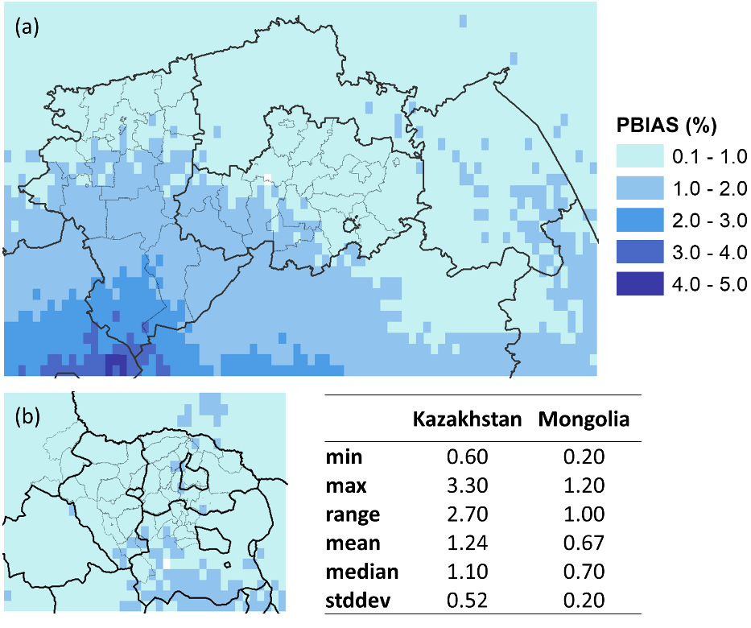

**Figure A7.** Time-series cross validation (PBIAS) of RF models to estimate the precipitation in coarse resolution. June-July months of 1985-2015 and 2000-2019 for (a) Kazakhstan and (b) Mongolia, respectively.

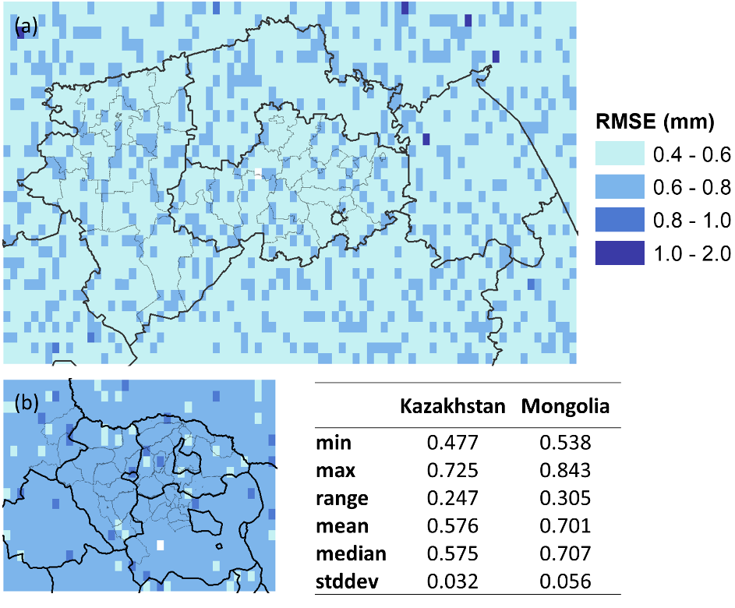

**Figure A8.** Time-series cross validation (RMSE) of RF models to estimate the precipitation in coarse resolution. June-July months of 1985-2015 and 2000-2018 for (a) Kazakhstan and (b) Mongolia, respectively.

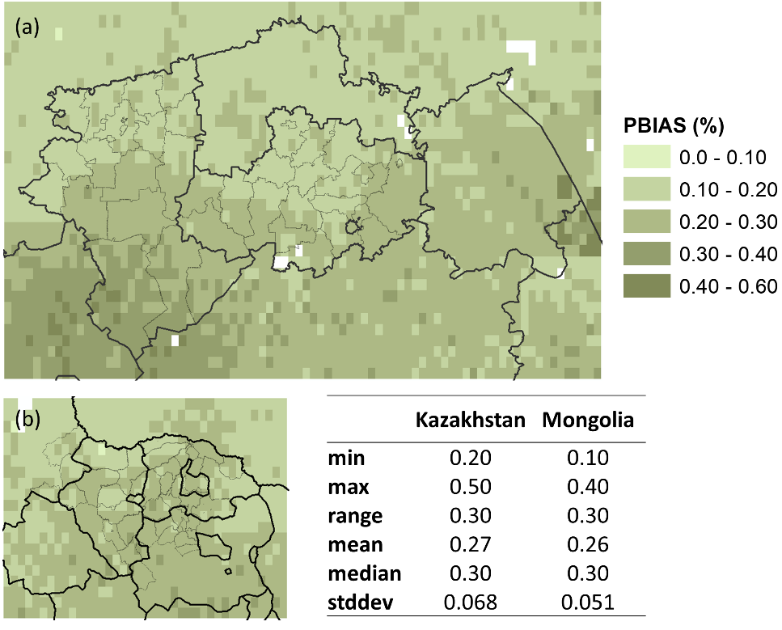

**Figure A9.** Time-series cross validation (PBIAS) of RF models to estimate the soil moisture in coarse resolution. June-July months of 1985-2015 and 2000-2018 for (a) Kazakhstan and (b) Mongolia, respectively.

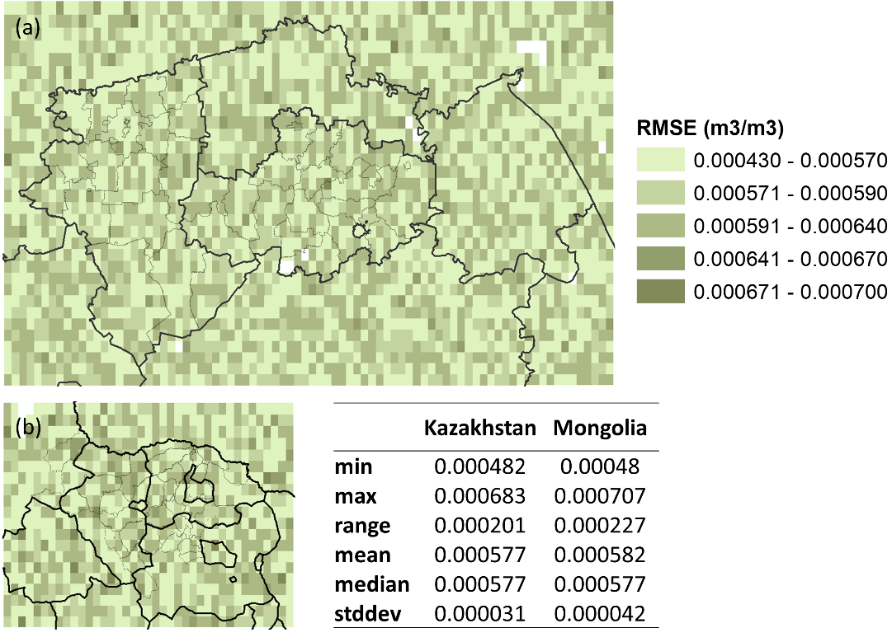

**Figure A10.** Time-series cross validation (RMSE) of RF models to estimate the soil moisture in coarse resolution. June-July months of 1985-2015 and 2000-2018 for (a) Kazakhstan and (b) Mongolia, respectively.

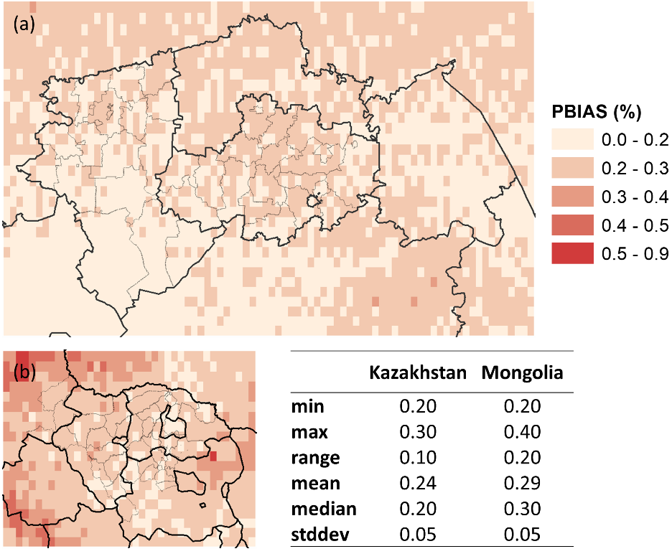

**Figure A11.** Time-series cross validation (PBIAS) of RF models to estimate the temperature in coarse resolution. June-July months of 1985-2015 and 2000-2018 for (a) Kazakhstan and (b) Mongolia, respectively.

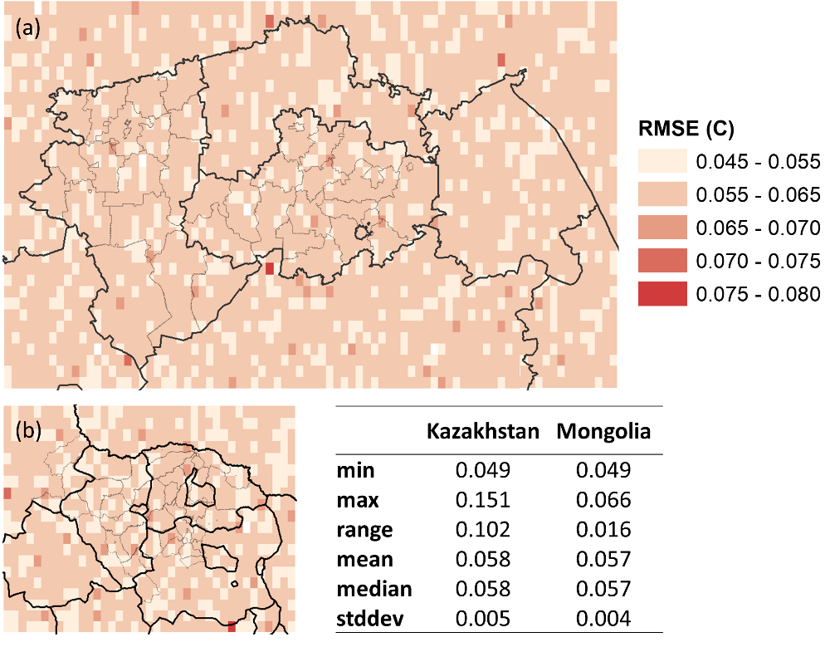

**Figure A12.** Time-series cross validation (RMSE) of RF models to estimate the temperature in coarse resolution. June-July months of 1985-2015 and 2000-2018 for (a) Kazakhstan and (b) Mongolia, respectively.

**Table A13.** Wilcoxon test between county-wise RMSE of improved and not improved cases in Kazakhstan

|  |  |  |  |  |
| --- | --- | --- | --- | --- |
|  | Climate variable | Improved HE | Number of cases | p-value |
| 1 | Precipitation | No | 10 | 0.5895 |
| Yes | 24 |
| 2 | Temperature | No | 10 | 0.8091 |
| Yes | 24 |
| 3 | Soil moisture | No | 13 | 0.8871 |
| Yes | 21 |

**Table A14.** Wilcoxon test between county-wise PBIAS of improved and not improved cases in Kazakhstan

|  |  |  |  |  |
| --- | --- | --- | --- | --- |
|  | Climate variable | Improved HE | Number of cases | p-value |
| 1 | Precipitation | No | 10 | 0.2866 |
| Yes | 24 |
| 2 | Temperature | No | 10 | 0.650 |
| Yes | 24 |
| 3 | Soil moisture | No | 13 | 0.06007 |
| Yes | 21 |

**Table A15.** Wilcoxon test between county-wise RMSE of improved and not improved cases in Mongolia

|  |  |  |  |  |
| --- | --- | --- | --- | --- |
|  | Climate variable | Improved HE | Number of cases | p-value |
| 1 | Precipitation | No | 1 | 0.6364 |
| Yes | 21 |
| 2 | Temperature | No | 14 | 0.1653 |
| Yes | 8 |
| 3 | Soil moisture | No | 4 | 0.6094 |
| Yes | 18 |

**Table A16.** Wilcoxon test between county-wise PBIAS of improved and not improved cases in Mongolia

|  |  |  |  |  |
| --- | --- | --- | --- | --- |
|  | Climate variable | Improved HE | Number of cases | p-value |
| 1 | Precipitation | No | 1 | 0.5278 |
| Yes | 21 |
| 2 | Temperature | No | 14 | 0.863 |
| Yes | 8 |
| 3 | Soil moisture | No | 4 | 0.0738 |
| Yes | 18 |