Supplement materials

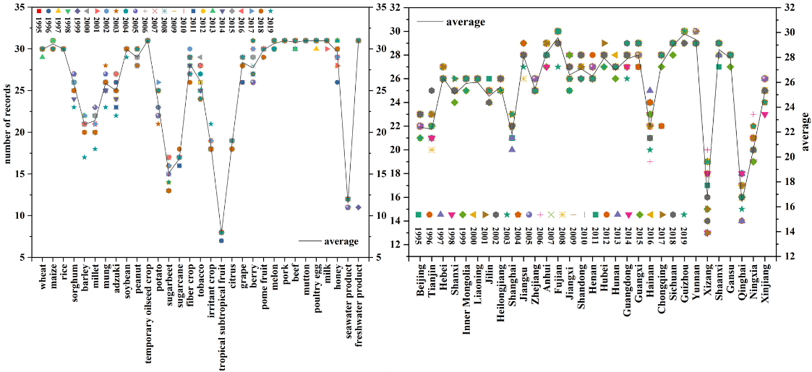
Fig. S1. Number of records of each agricultural products and province from 1995 to 2019.
Data sources: National Bureau of Statistics (https://data.stats.gov.cn/easyquery.htm?cn=E0103)

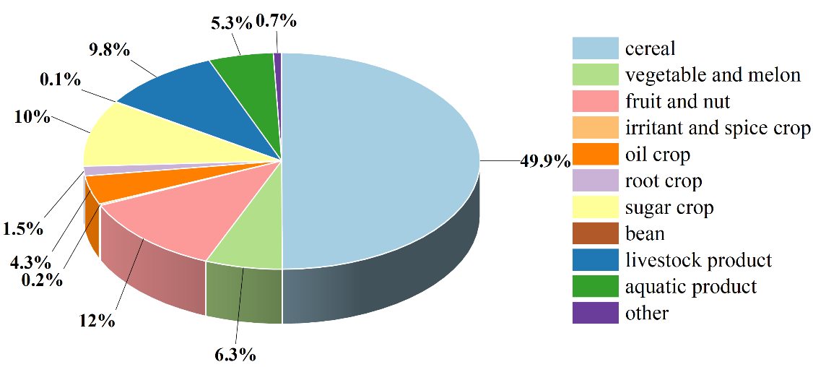
Fig. S2. Percentage of each agricultural products in Level 1.
Data sources: National Bureau of Statistics (https://data.stats.gov.cn/easyquery.htm?cn=E0103)

Table S1
Indexes and characteristics of China’s agricultural natural zones and subzones.
province | Main products
Shanxi | Maize, pome fruit, wheat, poultry egg, milk, pork, potato, melon, millet, grape, sorghum, soybean, temporary oilseed crop
Jilin | Maize, rice, melon, poultry egg, pork, peanut, soybean, sorghum, beef, milk, potato, freshwater product, millet, pome fruit
Hebei | Maize, wheat, pome fruit, milk, poultry egg, melon, pork, grape, potato, peanut, seawater product, sugarbeet, beef, rice, millet, mutton, freshwater product, berry, soybean, temporary oilseed crop, fiber crop
Inner Mongolia | Maize, sugarbeet, milk, soybean, melon, temporary oilseed crop, wheat, potato, rice, mutton, sorghum, millet, beef, pork, poultry egg, pome fruit, mung, freshwater product, peanut
Liaoning | Maize, rice, pome fruit, seawater product, poultry egg, pork, melon, milk, peanut, freshwater product, grape, berry, beef, sorghum, millet, potato, soybean, sugarbeet
Heilongjiang | Maize, rice, soybean, milk, pork, melon, poultry egg, freshwater product, potato, beef, sugarbeet, sorghum, wheat, pome fruit, mutton, fiber crop
Henan | Wheat, maize, melon, pome fruit, peanut, rice, poultry egg, pork, milk, freshwater product, soybean, grape, temporary oilseed crop, beef, mutton, tobacco, berry, millet, sugarcane
Shandong | Wheat, maize, pome fruit, melon, seawater product, poultry egg, peanut, pork, milk, freshwater product, grape, rice, beef, berry, soybean, mutton, fiber crop, millet

Fig. S3. Rice, wheat, maize distribution and their proportion of grain sowing area
Data sources: National ecosystem Science Data Center (http://www.nesdc.org.cn/) and National Bureau of Statistics (https://data.stats.gov.cn/easyquery.htm?cn=E0103)

Table S2
Indexes and characteristics of China’s agricultural natural zones and subzones.
Natural region | Natural zone and subzone | Temperature index (℃) |  |  | Main vegetation and soil | Agricultural characteristics
Eastern region |  | ≥10℃ accumulated temperature | Coldest month temperature | Annual mean extreme minimum temperature
 | Temperate zone | <4500 | <0 | <-10
 | Cold temperate zone | <1700 | <-30 | <-45 | Coniferous forest, fuller ash soil | A very early season crop
 | Middle temperate zone | 1700-3500 | -30 - -10 | -45 - -25 | Coniferous and broad-leaved mixed forest, dark brown soil | One crop a year, mainly spring wheat
 | Warm temperate zone | 3500-4500 | -10-0 | -25 - -10 | deciduous broad-leaved forest, brown soil | Two years for three crops, mainly winter wheat, apples and pears
 | Sub-tropical zone | 4500-8000 | 0-15 | -10 - -5 |  | Growing cooler crops in winter and warmer crops in the hot season
 | North subtropical zone | 4500-5300 | 0-5 | -10 - -5 | Evergreen deciduous broad-leaved forest, yellow-brown soil | Rice and wheat, tea, bamboo
 | Mid-subtropical zone | 5300-6500 | 5-10 | -5 -0 | Evergreen broad-leaved forest, yellow and red soil | Double cropping rice for two years and three crops, citrus, camellia
 | South subtropical zone | 6500-8000 | 10-15 | 0-5 | Monsoon evergreen broad-leaved forest, red soil | Double-cropping rice crops three times a year, longan and lychee
 | Tropical zone | >8000 | >15 | >5 |  | Temperature-loving crops grow all year round
 | Borderline tropical zone | 8000-8500 | 15-18 | 5-8 | Semi-evergreen monsoon forest, brick red loam soil | Temperature-loving crops are cropped three times a year, coffee
 | Mid-tropical zone | >8500 | >18 | >8 | Monsoon forest, brick red soil | Mainly woody plants, rubber
 | Equatorial Tropical zone | >9000 | >25 | >20 | Coral island evergreen forest, red soil | Tropical crops
Inner Mongolia and Xinjiang region | Arid temperate zone | <4000 | <-10 | >-20 | Grassland and desert, brown calcium soil | One crop a year, winter wheat and cotton
 | Arid warm temperate zone | >4000 | >-10 | >-20 | Thicket and desert, brown desert soil | Three crops in two years or two crops in one year
Qinghai- Xizang Region |  | >0 ℃ | Warmest monthly temperature
 | Plateau temperate zone | 1500-3000 | 10-18 |  | Mountain coniferous forest, mountain forest soil | Farming and forestry
 | Plateau subarctic zone | 500-1500 | 6-10 |  | Alpine grassland, alpine steppe soil | Only animal husbandry
 | Plateau cold zone | <500 | <6 |  | Plateau desert, alpine desert soil | No-man's land
Sources: Resource and environment science and data center (https://www.resdc.cn/data)

