Supplementary material
Table S1. Implementation costs and monetary value of each land use type by soil type.
Land use type | Implementation costs/ha | Soil type | Production | Temporality | Monetary value
Traditional agriculture | 1 Labor | Black soils | 3 tons of maize | Annually | USD300
 |  |  | 2 units of firewood | Once | USD200
 |  | Stony soils | 2 tons of maize | Annually | USD200
 |  |  | 1 unit of firewood | Once | USD100
 |  | Flood-prone soils | Waterlogged production | Annually | USD0
 |  |  | 1 unit of firewood | Once | USD100
 |  | Red soils | 2 tons of maize | Annually | USD200
 |  |  | 1 unit of firewood | Once | USD100
Mechanized agriculture | 1 Labor + USD250 | Black soils | 5 tons of maize | Annually | USD500
 |  | Stony soils | Non-machinable soil | Annually | USD0
 |  | Flood-prone soils | 5 tons of maize | Annually | USD500
 |  | Red soils | 6 tons of maize | Annually | USD600
Cattle raising | 1 Labor + USD450 | Black soils | 1 calf | Adult cow (1 year), every year | USD550
 |  | Stony soils | 1 calf | Adult cow (1 year), every year | USD550
 |  | Flood-prone soils | 1 calf | Adult cow (1 year), every year | USD550
 |  | Red soils | 1 calf | Adult cow (1 year), every year | USD550
Agroforestry | 1 Labor + USD350 | Black soils | 2 units of timber | After 7 years | USD500
 |  |  | 1 ton of maize | Annually | USD100
 |  | Stony soils | 2 units of timber | After 7 years | USD500
 |  |  | 1 ton of maize | Annually | USD100
 |  | Flood-prone soils | 2 units of timber | After 7 years | USD500
 |  |  | 1 ton of maize | Annually | USD100
 |  | Red soils | 2 units of timber | After 7 years | USD500
 |  |  | 1 ton of maize | Annually | USD100
Forest management | Labor +  collective agreement | Black soils | 2 units of firewood | Annually | USD200
 |  | Stony soils | 1 unit of firewood | Annually | USD100
 |  | Flood-prone soils | 1 unit of firewood | Annually | USD100
 |  | Red soils | 1 unit of firewood | Annually | USD100
Conservation | Collective agreement | Same across all soil types | Intangible services | N/A | N/A
Forestry | Labor + collective agreement | Same across all soil types | 1 unit of hardwood | Once + awaiting time 10 years | USD250

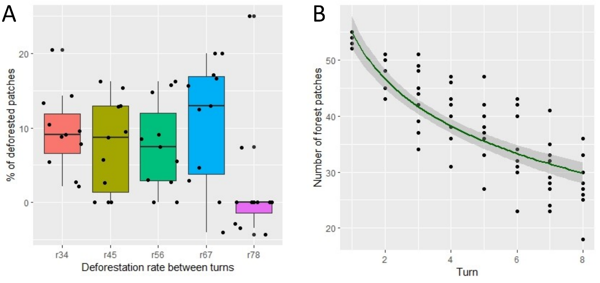
Fig. S1. A) Comparison of deforestation rates across years, B) Decreasing tendency of forest cover across years. N= 11 game sessions.

Table S2. Number of players who implement each land use type per year. NP: non-policy; AGP: agricultural policy; COP: conservation policy; AFP: agroforestry policy. Total number of players: 44. Soil type – Land use association were calculated as number of cells per land use across the 8 turns of the 11 games / Total number of cells across the 8 turn and the 11 games (5632 cells).
 |  | NP |  | AGP |  | AGP & COP |  | AGP & AFP |  | Soil types
Variable | Metric | Year 1 | Year 2 | Year 3 | Year 4 | Year 5 | Year 6 | Year 7 | Year 8 | Black  soils | Flood-prone  soils | Red  soils | Stony  soils
Land uses /player | Average | 1 | 1.4 | 1.8 | 2 | 3 | 3.3 | 3 | 3.1 | N/A | N/A | N/A | N/A
Land uses /player | Standard Error | 0 | 0.1 | 0.1 | 0.1 | 0.1 | 0.1 | 0.1 | 0.1 | N/A | N/A | N/A | N/A
Total ha / player | Average | 2.8 | 4.4 | 5.7 | 6.8 | 10.7 | 11.4 | 9.4 | 10 | N/A | N/A | N/A | N/A
Total ha/ player | Standard Error | 0.1 | 0.2 | 0.3 | 0.4 | 0.4 | 0.4 | 0.5 | 0.6 | N/A | N/A | N/A | N/A
Traditional agriculture ha/player | Average | 2.8 | 2.6 | 2.4 | 2.3 | 2.2 | 2.5 | 2.3 | 2.2 | 5.9% | 0.1% | 3.7% | 2.2%
Traditional agriculture ha/player | Standard Error | 0.1 | 0.1 | 0.2 | 0.2 | 0.2 | 0.2 | 0.2 | 0.2
Traditional agriculture ha/player | Players | 42 | 44 | 37 | 34 | 32 | 32 | 28 | 28
Firewood gathering ha/player | Average | 1.5 | 1.6 | 1.5 | 1.6 | 1.8 | 1.7 | 1.9 | 2.5 | 1.0% | 0.4% | 1.8% | 0.5%
Firewood gathering ha/player | Standard Error | 0.3 | 0.4 | 0.2 | 0.3 | 0.3 | 0.3 | 0.3 | 0.3
Firewood gathering ha/player | Players | 4 | 7 | 13 | 15 | 16 | 18 | 18 | 23
Mechanized agriculture ha/player | Average | N/A | 1.4 | 2.1 | 2.5 | 2.6 | 2.7 | 2.9 | 3.3 | 2.8% | 0.0% | 4.4% | 0.1%
Mechanized agriculture ha/player | Standard Error | N/A | 0.2 | 0.2 | 0.3 | 0.3 | 0.3 | 0.3 | 0.3
Mechanized agriculture ha/player | Players | 0 | 7 | 21 | 27 | 27 | 26 | 25 | 24
Cattle raising ha/player | Average | N/A | 1 | 1.2 | 1.1 | 1.4 | 1.4 | 1.5 | 1.5 | 0.9% | 0.7% | 0.9% | 0.4%
Cattle raising ha/player | Standard Error | N/A | 0 | 0.1 | 0.1 | 0.2 | 0.1 | 0.2 | 0.2
Cattle raising ha/player | Players | 0 | 5 | 10 | 13 | 19 | 27 | 24 | 22
Agroforestry ha/player | Average | N/A | N/A | N/A | N/A | N/A | 2 | 2.2 | 2.4 | 1.2% | 0.6% | 0.5% | 0.9%
Agroforestry ha/player | Standard Error | N/A | N/A | N/A | N/A | N/A | N/A | 0.1 | 0.2
Agroforestry ha/player | Players | 0 | 0 | 0 | 0 | 0 | 1 | 39 | 38
Conservation ha/player | Average | N/A | N/A | N/A | N/A | 3.3 | 3.3 | N/A | N/A | 0.7% | 1.8% | 0.5% | 1.8%
Conservation ha/player | Standard Error | N/A | N/A | N/A | N/A | 0.2 | 0.2 | N/A | N/A
Conservation ha/player | Players | 0 | 0 | 0 | 0 | 40 | 40 | 0 | 0
Unmanaged forest | Total per turn | 581 | 511 | 454 | 404 | 235 | 204 | 290 | 263 | 6.1% | 20.7% | 7.9% | 17.5%
Fallow | Total per turn | 0 | 52 | 86 | 116 | 141 | 148 | 121 | 121 | 6.4% | 0.7% | 5.2% | 1.5%

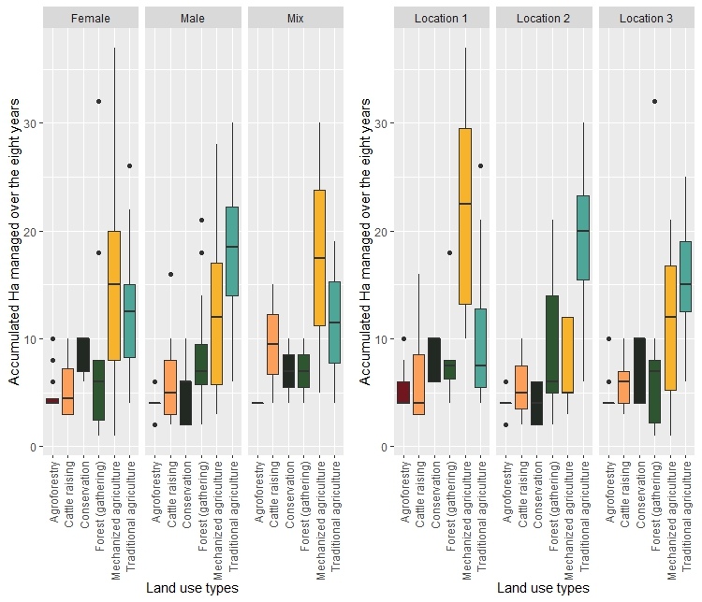
Fig. S2. Land use area managed per player (team of players) grouped by location and gender.

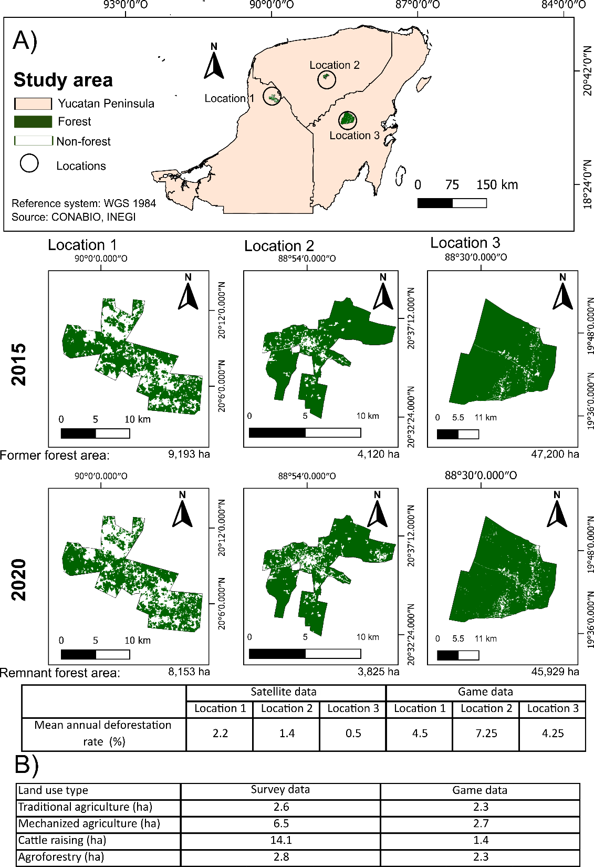
Fig. S3. Game results validation comparing a) mean annual deforestation in % between 2015-2020 across the three study locations (CONABIO 2020a, CONABIO 2020b) versus the mean deforestation observed in the games played across the three locations (only for turns 3 to 6), and b) mean area managed for different land use types in 2021 by the participants of the workshops versus the mean number of ha managed par land use types in the games (only for turns 3 to 8).
Table S3. Land use combinations from A) the 1st to the 4th year, B) the 5th to the 6th year, and C) the 7th to the 8th year
A | Color code: Presence  Absence
 | Traditional  agriculture | Firewood  gathering | Mechanized  agriculture | Cattle  raising | Conservation | Agroforestry | Players | Total number of strategies
1st year | 0 | 1 | 0 | 0 | 0 | 0 | 2 | 3
 | 1 | 0 | 0 | 0 | 0 | 0 | 40
 | 1 | 1 | 0 | 0 | 0 | 0 | 2
Number of  strategies | 2 | 2 | 0 | 0 | 0 | 0
2nd year | 1 | 1 | 0 | 1 | 0 | 0 | 1 | 6
 | 1 | 1 | 1 | 0 | 0 | 0 | 2
 | 1 | 0 | 0 | 1 | 0 | 0 | 4
 | 1 | 1 | 0 | 0 | 0 | 0 | 4
 | 1 | 0 | 1 | 0 | 0 | 0 | 5
 | 1 | 0 | 0 | 0 | 0 | 0 | 28
Number of  strategies | 6 | 3 | 2 | 2 | 0 | 0
3rd year | 0 | 1 | 1 | 1 | 0 | 0 | 1 | 10
 | 1 | 1 | 0 | 1 | 0 | 0 | 1
 | 0 | 0 | 1 | 1 | 0 | 0 | 1
 | 1 | 0 | 1 | 1 | 0 | 0 | 2
 | 1 | 1 | 1 | 0 | 0 | 0 | 3
 | 0 | 0 | 1 | 0 | 0 | 0 | 5
 | 1 | 0 | 0 | 1 | 0 | 0 | 5
 | 1 | 1 | 0 | 0 | 0 | 0 | 8
 | 1 | 0 | 1 | 0 | 0 | 0 | 9
 | 1 | 0 | 0 | 0 | 0 | 0 | 9
Number of  strategies | 7 | 4 | 6 | 5 | 0 | 0
4th year | 0 | 1 | 1 | 1 | 0 | 0 | 1 | 10
 | 1 | 1 | 0 | 1 | 0 | 0 | 2
 | 0 | 0 | 1 | 1 | 0 | 0 | 2
 | 1 | 0 | 0 | 1 | 0 | 0 | 3
 | 1 | 0 | 0 | 0 | 0 | 0 | 5
 | 1 | 0 | 1 | 1 | 0 | 0 | 5
 | 1 | 1 | 1 | 0 | 0 | 0 | 5
 | 0 | 0 | 1 | 0 | 0 | 0 | 7
 | 1 | 0 | 1 | 0 | 0 | 0 | 7
 | 1 | 1 | 0 | 0 | 0 | 0 | 7

B | Color code: Presence  Absence
 | Traditional  agriculture | Firewood  gathering | Mechanized  agriculture | Cattle  raising | Conservation | Agroforestry | landholders | Total number of strategies
Number of  strategies | 7 | 4 | 6 | 5 | 0 | 0
5th year | 0 | 1 | 0 | 0 | 1 | 0 | 1 | 16
 | 1 | 0 | 0 | 0 | 0 | 0 | 1
 | 1 | 0 | 0 | 1 | 0 | 0 | 1
 | 1 | 0 | 1 | 0 | 0 | 0 | 1
 | 1 | 1 | 0 | 0 | 0 | 0 | 1
 | 0 | 1 | 1 | 1 | 1 | 0 | 1
 | 1 | 0 | 0 | 1 | 1 | 0 | 2
 | 1 | 1 | 0 | 1 | 1 | 0 | 2
 | 1 | 1 | 1 | 1 | 1 | 0 | 2
 | 1 | 0 | 0 | 0 | 1 | 0 | 3
 | 1 | 1 | 1 | 0 | 1 | 0 | 3
 | 0 | 0 | 1 | 0 | 1 | 0 | 4
 | 1 | 0 | 1 | 0 | 1 | 0 | 5
 | 1 | 0 | 1 | 1 | 1 | 0 | 5
 | 0 | 0 | 1 | 1 | 1 | 0 | 6
 | 1 | 1 | 0 | 0 | 1 | 0 | 6
Number of  strategies | 12 | 7 | 8 | 7 | 12 | 0
6th year | 0 | 1 | 0 | 1 | 1 | 0 | 1 | 15
 | 1 | 0 | 0 | 0 | 1 | 0 | 1
 | 1 | 0 | 0 | 1 | 0 | 0 | 1
 | 1 | 0 | 1 | 0 | 1 | 1 | 1
 | 1 | 1 | 0 | 1 | 0 | 0 | 1
 | 0 | 1 | 1 | 1 | 1 | 0 | 1
 | 1 | 1 | 0 | 0 | 0 | 0 | 2
 | 1 | 1 | 0 | 1 | 1 | 0 | 2
 | 1 | 1 | 1 | 0 | 1 | 0 | 2
 | 1 | 1 | 1 | 1 | 1 | 0 | 3
 | 1 | 0 | 0 | 1 | 1 | 0 | 4
 | 1 | 0 | 1 | 1 | 1 | 0 | 4
 | 1 | 0 | 1 | 0 | 1 | 0 | 5
 | 1 | 1 | 0 | 0 | 1 | 0 | 6
 | 0 | 0 | 1 | 1 | 1 | 0 | 10
Number of  strategies | 12 | 8 | 7 | 9 | 12 | 1

C | Color code: Presence  Absence
 | Traditional  agriculture | Firewood  gathering | Mechanized  agriculture | Cattle  raising | Conservation | Agroforestry | landholders | Total number of strategies
7th year | 0 | 0 | 0 | 0 | 0 | 1 | 1 | 17
 | 0 | 1 | 0 | 0 | 0 | 1 | 1
 | 0 | 1 | 1 | 1 | 0 | 0 | 1
 | 1 | 0 | 1 | 0 | 0 | 0 | 1
 | 1 | 1 | 1 | 0 | 0 | 0 | 1
 | 1 | 1 | 1 | 0 | 0 | 1 | 1
 | 0 | 0 | 1 | 1 | 0 | 0 | 2
 | 1 | 0 | 0 | 0 | 0 | 1 | 2
 | 1 | 1 | 0 | 1 | 0 | 1 | 2
 | 1 | 1 | 1 | 1 | 0 | 1 | 2
 | 0 | 0 | 1 | 0 | 0 | 1 | 3
 | 1 | 0 | 1 | 0 | 0 | 1 | 3
 | 1 | 0 | 1 | 1 | 0 | 1 | 3
 | 0 | 1 | 1 | 1 | 0 | 1 | 3
 | 0 | 0 | 1 | 1 | 0 | 1 | 5
 | 1 | 0 | 0 | 1 | 0 | 1 | 6
 | 1 | 1 | 0 | 0 | 0 | 1 | 7
Number of  strategies | 10 | 8 | 11 | 8 | 0 | 13
8th year | 0 | 1 | 0 | 1 | 0 | 1 | 1 | 18
 | 0 | 1 | 1 | 1 | 0 | 0 | 1
 | 1 | 0 | 1 | 0 | 0 | 0 | 1
 | 1 | 0 | 1 | 1 | 0 | 0 | 1
 | 1 | 1 | 1 | 0 | 0 | 0 | 1
 | 1 | 1 | 1 | 0 | 0 | 1 | 1
 | 0 | 0 | 1 | 1 | 0 | 0 | 2
 | 0 | 1 | 0 | 0 | 0 | 1 | 2
 | 1 | 0 | 0 | 0 | 0 | 1 | 2
 | 1 | 0 | 1 | 1 | 0 | 1 | 2
 | 1 | 1 | 1 | 1 | 0 | 1 | 2
 | 0 | 0 | 1 | 1 | 0 | 1 | 3
 | 1 | 0 | 0 | 1 | 0 | 1 | 3
 | 1 | 0 | 1 | 0 | 0 | 1 | 3
 | 0 | 1 | 1 | 1 | 0 | 1 | 3
 | 0 | 0 | 1 | 0 | 0 | 1 | 4
 | 1 | 1 | 0 | 1 | 0 | 1 | 4
 | 1 | 1 | 0 | 0 | 0 | 1 | 8
Number of  strategies | 11 | 9 | 12 | 10 | 0 | 13

