SUPPLEMENTARY MATERIAL

The full title: Combining Multiple UAV-Based Indicators for Wheat Yield Estimation, a Case Study from Germany
Journal name: European Journal of Remote Sensing

Table S1. Linear regression
NDRE index
yield Coef. St.Err. t-value p-value [95% Conf Interval] Sig  ndre_20 20.597 0.614 33.57 0.000 19.392 21.802 ***  Constant -4.017 0.291 -13.81 0.000 -4.588 -3.446 ***  Mean dependent var 5.712 SD dependent var 1.101  R-squared 0.608 Number of obs 729.000  Adj R-squared 0.607 Root MSE 0.68  F-test 1126.809 Prob > F 0.000  Akaike crit. (AIC) 1529.667 Bayesian crit. (BIC) 1538.851  *** p<0.01, ** p<0.05, * p<0.1 | yield Coef. St.Err. t-value p-value [95% Conf Interval] Sig  ndre_16 21.740 0.821 26.49 0.000 20.129 23.351 ***  Constant -4.740 0.396 -11.98 0.000 -5.516 -3.963 ***  Mean dependent var 5.712 SD dependent var 1.101  R-squared 0.491 Number of obs 729.000  Adj R-squared 0.490 Root MSE 0.78  F-test 701.791 Prob > F 0.000  Akaike crit. (AIC) 1719.509 Bayesian crit. (BIC) 1728.692  *** p<0.01, ** p<0.05, * p<0.1
EVI2
yield Coef. St.Err. t-value p-value [95% Conf Interval] Sig  evi2_20 7.048 0.264 26.71 0.000 6.530 7.566 ***  Constant -7.462 0.494 -15.10 0.000 -8.432 -6.492 ***  Mean dependent var 5.712 SD dependent var 1.101  R-squared 0.495 Number of obs 729.000  Adj R-squared 0.494 Root MSE 0.78  F-test 713.260 Prob > F 0.000  Akaike crit. (AIC) 1713.681 Bayesian crit. (BIC) 1722.864  *** p<0.01, ** p<0.05, * p<0.1 | yield Coef. St.Err. t-value p-value [95% Conf Interval] Sig  evi2_16 8.856 0.362 24.45 0.000 8.145 9.568 ***  Constant -11.262 0.695 -16.20 0.000 -12.626 -9.898 ***  Mean dependent var 5.712 SD dependent var 1.101  R-squared 0.451 Number of obs 729.000  Adj R-squared 0.450 Root MSE 0.81  F-test 597.590 Prob > F 0.000  Akaike crit. (AIC) 1774.713 Bayesian crit. (BIC) 1783.896  *** p<0.01, ** p<0.05, * p<0.1
GCVI
yield Coef. St.Err. t-value p-value [95% Conf Interval] Sig  gcvi_20 23.905 0.762 31.36 0.000 22.408 25.401 ***  Constant -11.284 0.543 -20.80 0.000 -12.350 -10.219 ***  Mean dependent var 5.712 SD dependent var 1.101  R-squared 0.575 Number of obs 729.000  Adj R-squared 0.574 Root MSE 0.71  F-test 983.547 Prob > F 0.000  Akaike crit. (AIC) 1588.300 Bayesian crit. (BIC) 1597.483  *** p<0.01, ** p<0.05, * p<0.1 | yield Coef. St.Err. t-value p-value [95% Conf Interval] Sig  gcvi_16 27.462 1.003 27.38 0.000 25.493 29.431 ***  Constant -14.288 0.731 -19.55 0.000 -15.723 -12.853 ***  Mean dependent var 5.712 SD dependent var 1.101  R-squared 0.508 Number of obs 729.000  Adj R-squared 0.507 Root MSE 0.77  F-test 749.763 Prob > F 0.000  Akaike crit. (AIC) 1695.434 Bayesian crit. (BIC) 1704.618  *** p<0.01, ** p<0.05, * p<0.1
CIred
yield Coef. St.Err. t-value p-value [95% Conf Interval] Sig  cired_20 2.852 0.091 31.50 0.000 2.674 3.030 ***  Constant 0.417 0.170 2.45 0.014 0.083 0.751 **  Mean dependent var 5.712 SD dependent var 1.101  R-squared 0.577 Number of obs 729.000  Adj R- squared 0.576 Root MSE 0.71  F-test 992.587 Prob > F 0.000  Akaike crit. (AIC) 1584.458 Bayesian crit. (BIC) 1593.641  *** p<0.01, ** p<0.05, * p<0.1 | yield Coef. St.Err. t-value p-value [95% Conf Interval] Sig  cired_16 2.848 0.116 24.59 0.000 2.621 3.076 ***  Constant 0.305 0.222 1.38 0.169 -0.130 0.741  Mean dependent var 5.712 SD dependent var 1.101  R-squared 0.454 Number of obs 729.000  Adj R-squared 0.453 Root MSE 0.81  F-test 604.690 Prob > F 0.000  Akaike crit. (AIC) 1770.816 Bayesian crit. (BIC) 1779.999  *** p<0.01, ** p<0.05, * p<0.1
SCCCI
yield Coef. St.Err. t-value p-value [95% Conf Interval] Sig  sccci_20 32.984 1.156 28.52 0.000 30.714 35.254 ***  Constant -14.297 0.702 -20.37 0.000 -15.675 -12.919 ***  Mean dependent var 5.712 SD dependent var 1.101  R-squared 0.528 Number of obs 729.000  Adj R-squared 0.527 Root MSE 0.75  F-test 813.671 Prob > F 0.000  Akaike crit. (AIC) 1664.550 Bayesian crit. (BIC) 1673.733  *** p<0.01, ** p<0.05, * p<0.1 | yield Coef. St.Err. t-value p-value [95% Conf Interval] Sig  sccci_16 35.000 1.420 24.65 0.000 32.212 37.787 ***  Constant -15.323 0.854 -17.95 0.000 -16.999 -13.646 ***  Mean dependent var 5.712 SD dependent var 1.101  R-squared 0.455 Number of obs 729.000  Adj R-squared 0.454 Root MSE 0.81  F-test 607.738 Prob > F 0.000  Akaike crit. (AIC) 1769.149 Bayesian crit. (BIC) 1778.332  *** p<0.01, ** p<0.05, * p<0.1
NDVI
yield Coef. St.Err. t-value p-value [95% Conf Interval] Sig  ndvi_20 16.914 0.633 26.71 0.000 15.670 18.157 ***  Constant -7.462 0.494 -15.10 0.000 -8.432 -6.491 ***  Mean dependent var 5.712 SD dependent var 1.101  R-squared 0.495 Number of obs 729.000  Adj R-squared 0.494 Root MSE 0.78  F-test 713.185 Prob > F 0.000  Akaike crit. (AIC) 1713.718 Bayesian crit. (BIC) 1722.902  *** p<0.01, ** p<0.05, * p<0.1 | yield Coef. St.Err. t-value p-value [95% Conf Interval] Sig  ndvi_16 21.254 0.869 24.45 0.000 19.547 22.961 ***  Constant -11.263 0.695 -16.20 0.000 -12.627 -9.898 ***  Mean dependent var 5.712 SD dependent var 1.101  R-squared 0.451 Number of obs 729.000  Adj R-squared 0.450 Root MSE 0.81  F-test 597.539 Prob > F 0.000  Akaike crit. (AIC) 1774.741 Bayesian crit. (BIC) 1783.924  *** p<0.01, ** p<0.05, * p<0.1
Solar Radiation
yield_1 Coef. St.Err. t-value p-value [95% Conf Interval] Sig  sol_me_1606 8.231 1.129 7.29 0 6.013 10.448 ***  Constant -38.838 6.113 -6.35 0 -50.838 -26.837 ***  Mean dependent var 5.712 SD dependent var 1.101  R-squared 0.068 Number of obs 729.000  Adj R-squared 0.066 Root MSE 1.06  F-test 53.119 Prob > F 0.000  Akaike crit. (AIC) 2160.654 Bayesian crit. (BIC) 2169.837  *** p<.01, ** p<.05, * p<.1 | yield_1 Coef. St.Err. t-value p-value [95% Conf Interval] Sig  sol_me_2005 -18.013 1.553 -11.6 0 -21.061 -14.964 ***  Constant 95.195 7.715 12.34 0 80.049 110.341 ***  Mean dependent var 5.712 SD dependent var 1.101  R-squared 0.156 Number of obs 729.000  Adj R-squared 0.155 Root MSE 1.01  F-test 134.534 Prob > F 0.000  Akaike crit. (AIC) 2088.288 Bayesian crit. (BIC) 2097.471  *** p<.01, ** p<.05, * p<.1
Crop surface model
yield_1 Coef. St.Err. t-value p-value [95% Conf Interval] Sig  csm_20 2.595 .287 9.04 0 2.032 3.159 ***  Constant -.461 .684 -0.67 .501 -1.803 .882  Mean dependent var 5.712 SD dependent var 1.101  R-squared 0.101 Number of obs 729.000  Adj R-squared 0.09 Root MSE 1.04  F-test 81.729 Prob > F 0.000  Akaike crit. (AIC) 2134.398 Bayesian crit. (BIC) 2143.581  *** p<.01, ** p<.05, * p<.1 | yield_1 Coef. St.Err. t-value p-value [95% Conf Interval] Sig  csm_16 2.027 .102 19.81 0 1.826 2.228 ***  Constant -1.611 .371 -4.34 0 -2.34 -.883 ***  Mean dependent var 5.712 SD dependent var 1.101  R-squared 0.351 Number of obs 729.000  Adj R-squared 0.349 Root MSE 0.88  F-test 392.532 Prob > F 0.000  Akaike crit. (AIC) 1897.325 Bayesian crit. (BIC) 1906.508  *** p<.01, ** p<.05, * p<.1

Table S2. Multiple linear regression
NDRE index
yield_1 Coef. St.Err. t-value p-value [95% Conf Interval] Sig  ndre_16 17.69 .72 24.59 0 16.277 19.103 ***  csm_16 1.244 .08 15.48 0 1.086 1.402 ***  sol_me_1606 1.301 .706 1.84 .066 -.084 2.686 *  Constant -14.31 3.727 -3.84 0 -21.627 -6.993 ***  Mean dependent var 5.736 SD dependent var 1.069  R-squared 0.653 Number of obs 1722.000  Adj R-squared 0.65 Root MSE 0.63  F-test 451.260 Prob > F 0.000  Akaike crit. (AIC) 1386.847 Bayesian crit. (BIC) 1405.175  *** p<.01, ** p<.05, * p<.1 | yield_1 Coef. St.Err. t-value p-value [95% Conf Interval] Sig  ndre_20 18.977 .68 27.93 0 17.643 20.311 ***  csm_20 2.109 .18 11.69 0 1.755 2.464 ***  sol_me_2005 -2.414 1.215 -1.99 .047 -4.8 -.028 **  Constant 3.744 6.075 0.62 .538 -8.182 15.67  Mean dependent var 5.736 SD dependent var 1.069  R-squared 0.693 Number of obs 1722.000  Adj R-squared 0.69 Root MSE 0.59  F-test 540.949 Prob > F 0.000  Akaike crit. (AIC) 1298.688 Bayesian crit. (BIC) 1317.016  *** p<.01, ** p<.05, * p<.1
yield_1 Coef. St.Err. t-value p-value [95% Conf Interval] Sig  ndre_20 17.914 .538 33.32 0 16.858 18.969 ***  csm_16 1.242 .068 18.39 0 1.109 1.374 ***  sol_me_1606 -1.994 .618 -3.22 .001 -3.208 -.78 ***  Constant 6.389 3.269 1.95 .051 -.028 12.806 *  Mean dependent var 5.736 SD dependent var 1.069  R-squared 0.75 Number of obs 1722.000  Adj R-squared 0.74 Root MSE 0.53  F-test 715.492 Prob > F 0.000  Akaike crit. (AIC) 1152.935 Bayesian crit. (BIC) 1171.264  *** p<.01, ** p<.05, * p<.1 | yield_1 Coef. St.Err. t-value p-value [95% Conf Interval] Sig  ndre_20 17.764 .627 28.33 0 16.533 18.995 ***  csm_16 1.181 .068 17.41 0 1.047 1.314 ***  sol_me_2005 1.605 1.018 1.58 .115 -.394 3.603  Constant -14.899 5.205 -2.86 .004 -25.117 -4.68 ***  Mean dependent var 5.736 SD dependent var 1.069  R-squared 0.743 Number of obs 1722.000  Adj R-squared 0.74 Root MSE 0.54  F-test 693.111 Prob > F 0.000  Akaike crit. (AIC) 1170.061 Bayesian crit. (BIC) 1188.389  *** p<.01, ** p<.05, * p<.1
EVI2 index
yield_1 Coef. St.Err. t-value p-value [95% Conf Interval] Sig  evi2_16 7.074 .335 21.09 0 6.416 7.733 ***  csm_16 1.252 .086 14.50 0 1.083 1.422 ***  sol_me_1606 .428 .761 0.56 .574 -1.067 1.922  Constant -14.664 3.975 -3.69 0 -22.469 -6.86 ***  Mean dependent var 5.736 SD dependent var 1.069  R-squared 0.606 Number of obs 1722.000  Adj R-squared 0.60 Root MSE 0.67  F-test 367.894 Prob > F 0.000  Akaike crit. (AIC) 1479.730 Bayesian crit. (BIC) 1498.058  *** p<.01, ** p<.05, * p<.1 | yield_1 Coef. St.Err. t-value p-value [95% Conf Interval] Sig  evi2_20 6.421 .247 26.04 0 5.937 6.905 ***  csm_16 1.353 .077 17.62 0 1.202 1.504 ***  sol_me_1606 -4.762 .753 -6.32 0 -6.242 -3.283 ***  Constant 14.617 3.867 3.78 0 7.025 22.208 ***  Mean dependent var 5.736 SD dependent var 1.069  R-squared 0.672 Number of obs 1722.000  Adj R-squared 0.67 Root MSE 0.61  F-test 489.670 Prob > F 0.000  Akaike crit. (AIC) 1347.768 Bayesian crit. (BIC) 1366.096  *** p<.01, ** p<.05, * p<.1
yield_1 Coef. St.Err. t-value p-value [95% Conf Interval] Sig  evi2_16 6.977 .359 19.41 0 6.271 7.683 ***  csm_20 2.461 .21 11.70 0 2.048 2.874 ***  sol_me_2005 -11.79 1.267 -9.31 0 -14.277 -9.302 ***  Constant 45.077 6.465 6.97 0 32.385 57.769 ***  Mean dependent var 5.736 SD dependent var 1.069  R-squared 0.580 Number of obs 1722.000  Adj R-squared 0.57 Root MSE 0.69  F-test 330.901 Prob > F 0.000  Akaike crit. (AIC) 1525.113 Bayesian crit. (BIC) 1543.441  *** p<.01, ** p<.05, * p<.1 | yield_1 Coef. St.Err. t-value p-value [95% Conf Interval] Sig  evi2_20 5.289 .254 20.81 0 4.79 5.788 ***  csm_16 1.308 .078 16.87 0 1.156 1.46 ***  sol_me_1606 -4.329 1.086 -3.99 0 -6.461 -2.197 ***  Constant 12.624 5.613 2.25 .025 1.605 23.643 **  Mean dependent var 5.736 SD dependent var 1.069  R-squared 0.661 Number of obs 1722.000  Adj R-squared 0.65 Root MSE 0.62  F-test 466.527 Prob > F 0.000  Akaike crit. (AIC) 1371.059 Bayesian crit. (BIC) 1389.387  *** p<.01, ** p<.05, * p<.1
GCVI index
yield_1 Coef. St.Err. t-value p-value [95% Conf Interval] Sig  gcvi_16 22.519 .918 24.53 0 20.716 24.321 ***  csm_16 1.213 .081 15.01 0 1.055 1.372 ***  sol_me_1606 -.104 .716 -0.15 .885 -1.51 1.303  Constant -14.49 3.73 -3.88 0 -21.814 -7.166 ***  Mean dependent var 5.736 SD dependent var 1.069  R-squared 0.653 Number of obs 1722.000  Adj R-squared 0.65 Root MSE 0.63  F-test 449.810 Prob > F 0.000  Akaike crit. (AIC) 1388.364 Bayesian crit. (BIC) 1406.692  *** p<.01, ** p<.05, * p<.1 | yield_1 Coef. St.Err. t-value p-value [95% Conf Interval] Sig  gcvi_20 21.135 .698 30.27 0 19.765 22.506 ***  csm_16 1.226 .072 17.08 0 1.085 1.367 ***  sol_me_1606 -3.535 .672 -5.26 0 -4.855 -2.215 ***  Constant 5.408 3.455 1.57 .118 -1.375 12.191  Mean dependent var 5.736 SD dependent var 1.069  R-squared 0.720 Number of obs 1722.000  Adj R-squared 0.71 Root MSE 0.56  F-test 614.178 Prob > F 0.000  Akaike crit. (AIC) 1233.922 Bayesian crit. (BIC) 1252.250  *** p<.01, ** p<.05, * p<.1
yield_1 Coef. St.Err. t-value p-value [95% Conf Interval] Sig  gcvi_16 22.362 1.004 22.28 0 20.391 24.333 ***  csm_20 2.338 .2 11.70 0 1.946 2.731 ***  sol_me_2005 -10.195 1.215 -8.39 0 -12.58 -7.81 ***  Constant 34.532 6.248 5.53 0 22.266 46.798 ***  Mean dependent var 5.736 SD dependent var 1.069  R-squared 0.622 Number of obs 1722.000  Adj R-squared 0.62 Root MSE 0.65  F-test 393.235 Prob > F 0.000  Akaike crit. (AIC) 1450.212 Bayesian crit. (BIC) 1468.540  *** p<.01, ** p<.05, * p<.1 | yield_1 Coef. St.Err. t-value p-value [95% Conf Interval] Sig  gcvi_20 19.165 .765 25.06 0 17.664 20.667 ***  csm_20 1.185 .073 16.33 0 1.042 1.327 ***  sol_me_2005 -1.814 1.03 -1.76 .079 -3.836 .208 *  Constant -3.164 5.382 -0.59 .557 -13.731 7.403  Mean dependent var 5.736 SD dependent var 1.069  R-squared 0.710 Number of obs 1722.000  Adj R-squared 0.70 Root MSE 0.57  F-test 586.075 Prob > F 0.000  Akaike crit. (AIC) 1258.095 Bayesian crit. (BIC) 1276.423  *** p<.01, ** p<.05, * p<.1
CIred index
yield_1 Coef. St.Err. t-value p-value [95% Conf Interval] Sig  cired_16 2.306 .101 22.91 0 2.109 2.504 ***  csm_16 1.275 .083 15.41 0 1.113 1.438 ***  sol_me_1606 1.972 .725 2.72 .007 .549 3.395 ***  Constant -13.928 3.847 -3.62 0 -21.48 -6.376 ***  Mean dependent var 5.736 SD dependent var 1.069  R-squared 0.631 Number of obs 1722.000  Adj R-squared 0.62 Root MSE 0.65  F-test 409.718 Prob > F 0.000  Akaike crit. (AIC) 1431.639 Bayesian crit. (BIC) 1449.967  *** p<.01, ** p<.05, * p<.1 | yield_1 Coef. St.Err. t-value p-value [95% Conf Interval] Sig  cired_20 2.388 .078 30.59 0 2.234 2.541 ***  csm_16 1.27 .071 17.91 0 1.131 1.409 ***  sol_me_1606 -.781 .642 -1.22 .224 -2.041 .479  Constant .933 3.4 0.27 .784 -5.742 7.609  Mean dependent var 5.736 SD dependent var 1.069  R-squared 0.723 Number of obs 1722.000  Adj R-squared 0.72 Root MSE 0.56  F-test 624.193 Prob > F 0.000  Akaike crit. (AIC) 1225.500 Bayesian crit. (BIC) 1243.828  *** p<.01, ** p<.05, * p<.1
yield_1 Coef. St.Err. t-value p-value [95% Conf Interval] Sig  cired_16 2.253 .119 18.87 0 2.019 2.488 ***  csm_20 2.379 .214 11.11 0 1.959 2.8 ***  sol_me_2005 -10.829 1.31 -8.27 0 -13.401 -8.258 ***  Constant 49.596 6.433 7.71 0 36.965 62.226 ***  Mean dependent var 5.736 SD dependent var 1.069  R-squared 0.572 Number of obs 1722.000  Adj R-squared 0.57 Root MSE 0.70  F-test 320.243 Prob > F 0.000  Akaike crit. (AIC) 1538.735 Bayesian crit. (BIC) 1557.063  *** p<.01, ** p<.05, * p<.1 | yield_1 Coef. St.Err. t-value p-value [95% Conf Interval] Sig  cired_20 2.562 .096 26.62 0 2.373 2.751 ***  csm_20 1.226 .07 17.59 0 1.089 1.363 ***  sol_me_2005 3.644 1.107 3.29 .001 1.47 5.817 ***  Constant -21.558 5.585 -3.86 0 -32.523 -10.593 ***  Mean dependent var 5.736 SD dependent var 1.069  R-squared 0.726 Number of obs 1722.000  Adj R-squared 0.72 Root MSE 0.56  F-test 635.419 Prob > F 0.000  Akaike crit. (AIC) 1216.174 Bayesian crit. (BIC) 1234.502  *** p<.01, ** p<.05, * p<.1
SCCCI index
yield_1 Coef. St.Err. t-value p-value [95% Conf Interval] Sig  sccci_16 28.574 1.155 24.74 0 26.306 30.842 ***  csm_16 1.354 .079 17.18 0 1.2 1.509 ***  sol_me_1606 2.676 .698 3.83 0 1.306 4.047 ***  Constant -30.821 3.729 -8.27 0 -38.141 -23.501 ***  Mean dependent var 5.736 SD dependent var 1.069  R-squared 0.655 Number of obs 1722.000  Adj R-squared 0.65 Root MSE 0.62  F-test 455.137 Prob > F 0.000  Akaike crit. (AIC) 1382.805 Bayesian crit. (BIC) 1401.133  *** p<.01, ** p<.05, * p<.1 | yield_1 Coef. St.Err. t-value p-value [95% Conf Interval] Sig  sccci_20 27.501 .906 30.37 0 25.723 29.279 ***  csm_16 1.254 .071 17.57 0 1.114 1.395 ***  sol_me_1606 4.576 .628 7.28 0 3.343 5.81 ***  Constant -40.258 3.398 -11.8 0 -46.93 -33.586 ***  Mean dependent var 5.736 SD dependent var 1.069  R-squared 0.721 Number of obs 1722.000  Adj R-squared 0.71 Root MSE 0.56  F-test 617.161 Prob > F 0.000  Akaike crit. (AIC) 1231.403 Bayesian crit. (BIC) 1249.731  *** p<.01, ** p<.05, * p<.1
yield_1 Coef. St.Err. t-value p-value [95% Conf Interval] Sig  sccci_16 26.847 1.4 19.18 0 24.099 29.595 ***  csm_20 2.412 .212 11.37 0 1.995 2.828 ***  sol_me_2005 -12.418 1.259 -9.86 0 -14.89 -9.946 ***  Constant 45.551 6.492 7.02 0 32.806 58.297 ***  Mean dependent var 5.736 SD dependent var 1.069  R-squared 0.577 Number of obs 1722.000  Adj R-squared 0.57 Root MSE 0.69  F-test 326.363 Prob > F 0.000  Akaike crit. (AIC) 1530.881 Bayesian crit. (BIC) 1549.210  *** p<.01, ** p<.05, * p<.1 | yield_1 Coef. St.Err. t-value p-value [95% Conf Interval] Sig  sccci_20 27.069 1.121 24.14 0 24.867 29.27 ***  csm_20 1.398 .071 19.62 0 1.258 1.537 ***  sol_me_2005 -.214 1.088 -0.20 .844 -2.35 1.922  Constant -14.678 5.792 -2.53 .011 -26.05 -3.306 **  Mean dependent var 5.736 SD dependent var 1.069  R-squared 0.700 Number of obs 1722.000  Adj R-squared 0.69 Root MSE 0.58  F-test 558.264 Prob > F 0.000  Akaike crit. (AIC) 1282.841 Bayesian crit. (BIC) 1301.169  *** p<.01, ** p<.05, * p<.1
NDVI index
yield_1 Coef. St.Err. t-value p-value [95% Conf Interval] Sig  ndvi_16 16.977 .805 21.09 0 15.397 18.558 ***  csm_16 1.252 .086 14.50 0 1.083 1.422 ***  sol_me_1606 .427 .761 0.56 .575 -1.067 1.922  Constant -14.664 3.975 -3.69 0 -22.469 -6.86 ***  Mean dependent var 5.736 SD dependent var 1.069  R-squared 0.606 Number of obs 1722.000  Adj R-squared 0.60 Root MSE 0.67  F-test 367.884 Prob > F 0.000  Akaike crit. (AIC) 1479.743 Bayesian crit. (BIC) 1498.071  *** p<.01, ** p<.05, * p<.1 | yield_1 Coef. St.Err. t-value p-value [95% Conf Interval] Sig  ndvi_20 15.41 .592 26.04 0 14.248 16.571 ***  csm_16 1.353 .077 17.62 0 1.203 1.504 ***  sol_me_1606 -4.762 .754 -6.32 0 -6.241 -3.283 ***  Constant 14.615 3.867 3.78 0 7.024 22.207 ***  Mean dependent var 5.736 SD dependent var 1.069  R-squared 0.672 Number of obs 1722.000  Adj R-squared 0.67 Root MSE 0.61  F-test 489.646 Prob > F 0.000  Akaike crit. (AIC) 1347.791 Bayesian crit. (BIC) 1366.119  *** p<.01, ** p<.05, * p<.1
yield_1 Coef. St.Err. t-value p-value [95% Conf Interval] Sig  ndvi_16 16.744 .863 19.41 0 15.05 18.438 ***  csm_20 2.462 .21 11.70 0 2.049 2.875 ***  sol_me_2005 -11.79 1.267 -9.31 0 -14.278 -9.302 ***  Constant 45.077 6.465 6.97 0 32.385 57.769 ***  Mean dependent var 5.736 SD dependent var 1.069  R-squared 0.580 Number of obs 1722.000  Adj R-squared 0.57 Root MSE 0.69  F-test 330.890 Prob > F 0.000  Akaike crit. (AIC) 1525.127 Bayesian crit. (BIC) 1543.455  *** p<.01, ** p<.05, * p<.1 | yield_1 Coef. St.Err. t-value p-value [95% Conf Interval] Sig  ndvi_20 12.693 .61 20.81 0 11.495 13.89 ***  csm_16 1.308 .078 16.87 0 1.156 1.46 ***  sol_me_2005 -4.329 1.086 -3.99 0 -6.462 -2.197 ***  Constant 12.625 5.613 2.25 .025 1.606 23.644 **  Mean dependent var 5.736 SD dependent var 1.069  R-squared 0.661 Number of obs 1722.000  Adj R-squared 0.65 Root MSE 0.62  F-test 466.510 Prob > F 0.000  Akaike crit. (AIC) 1371.077 Bayesian crit. (BIC) 1389.405  *** p<.01, ** p<.05, * p<.1

Table S3. Quantiale regression 0.25, 0.50 and 0.75
NDRE index
yield Coef. St.Err. t-value p-value [95% Conf Interval] Sig  ndre_20 18.754 .782 23.99 0 17.22 20.289 ***  csm_16 1.131 .086 13.21 0 .963 1.3 ***  sol_me_1606 -1.009 .602 -1.68 .094 -2.19 .173 *  Constant -2.023 3.079 -0.66 .511 -8.068 4.022  ndre_20 17.515 .4 43.82 0 16.73 18.3 ***  csm_16 1.075 .099 10.89 0 .881 1.269 ***  sol_me_1606 -2.822 .784 -3.60 0 -4.361 -1.283 ***  Constant 8.93 4.346 2.05 .04 .398 17.463 **  ndre_20 16.393 .512 32.02 0 15.388 17.398 ***  csm_16 1.056 .065 16.18 0 .928 1.184 ***  sol_me_1606 -2.638 .636 -4.14 0 -3.887 -1.388 ***  Constant 8.804 3.461 2.54 .011 2.009 15.599 **  Mean dependent var 5.736 SD dependent var 1.069  Pseudo r-squared 0.25 0.578 Number of obs 1722.000  Pseudo r-squared 0.50 0.544 Number of obs 1722.000  Pseudo r-squared 0.75 0.556 Number of obs 1722.000  *** p<.01, ** p<.05, * p<.1 | yield Coef. St.Err. t-value p-value [95% Conf Interval] Sig  ndre_16 20.59 1.348 15.28 0 17.944 23.236 ***  csm_16 1.199 .184 6.53 0 .839 1.56 ***  sol_me_1606 2.121 .882 2.41 .016 .39 3.852 **  Constant -20.227 5.165 -3.92 0 -30.367 -10.086 ***  ndre_16 17.877 .623 28.68 0 16.653 19.1 ***  csm_16 1.049 .119 8.82 0 .816 1.283 ***  sol_me_1606 1.368 .626 2.19 .029 .139 2.597 **  Constant -13.934 3.233 -4.31 0 -20.281 -7.586 ***  ndre_16 16.778 .913 18.38 0 14.986 18.57 ***  csm_16 1 .092 10.89 0 .82 1.18 ***  sol_me_1606 1.048 .573 1.83 .068 -.077 2.173 *  Constant -11.231 2.931 -3.83 0 -16.984 -5.477 ***  Mean dependent var 5.736 SD dependent var 1.069  Pseudo r-squared 0.25 0.382 Number of obs 1722.000  Pseudo r-squared 0.50 0.390 Number of obs 1722.000  Pseudo r-squared 0.75 0.413 Number of obs 1722.000  *** p<.01, ** p<.05, * p<.1
yield Coef. St.Err. t-value p-value [95% Conf Interval] Sig  ndre_20 20.269 .883 22.96 0 18.536 22.002 ***  csm_20 2.075 .289 7.17 0 1.507 2.643 ***  sol_me_2005 -1.59 1.984 -0.80 .423 -5.486 2.306  Constant -1.178 9.966 -0.12 .906 -20.743 18.387  ndre_20 17.524 .706 24.81 0 16.137 18.911 ***  csm_20 1.906 .185 10.30 0 1.543 2.269 ***  sol_me_2005 -4.325 1.096 -3.94 0 -6.478 -2.173 ***  Constant 14.483 5.441 2.66 .008 3.8 25.166 ***  ndre_20 14.808 .912 16.24 0 13.017 16.598 ***  csm_20 1.74 .341 5.10 0 1.069 2.41 ***  sol_me_2005 -6.078 1.645 -3.69 0 -9.308 -2.848 ***  Constant 25.177 7.897 3.19 .001 9.674 40.68 ***  Mean dependent var 5.736 SD dependent var 1.069  Pseudo r-squared 0.25 0.437 Number of obs 1722.000  Pseudo r-squared 0.50 0.400 Number of obs 1722.000  Pseudo r-squared 0.75 0.392 Number of obs 1722.000  *** p<.01, ** p<.05, * p<.1 | yield Coef. St.Err. t-value p-value [95% Conf Interval] Sig  ndre_20 18.677 1.012 18.46 0 16.69 20.663 ***  csm_16 1.08 .109 9.91 0 .866 1.293 ***  sol_me_2005 1.475 2.32 0.64 .525 -3.08 6.03  Constant -14.573 11.827 -1.23 .218 -37.793 8.647  ndre_20 17.011 1.242 13.70 0 14.572 19.45 ***  csm_16 1.025 .111 9.25 0 .807 1.242 ***  sol_me_2005 -.099 1.897 -0.05 .958 -3.822 3.625  Constant -5.431 9.826 -0.55 .581 -24.721 13.86  ndre_20 15.118 1.097 13.78 0 12.964 17.273 ***  csm_16 1.039 .065 16.07 0 .912 1.166 ***  sol_me_2005 -1.552 1.467 -1.06 .29 -4.431 1.327  Constant 2.904 7.556 0.38 .701 -11.93 17.737  Mean dependent var 5.736 SD dependent var 1.069  Pseudo r-squared 0.25 0.324 Number of obs 1722.000  Pseudo r-squared 0.50 0.336 Number of obs 1722.000  Pseudo r-squared 0.75 0.364 Number of obs 1722.000  *** p<.01, ** p<.05, * p<.1
EVI2 index
yield Coef. St.Err. t-value p-value [95% Conf Interval] Sig  evi2_16 8.672 .56 15.49 0 7.573 9.771 ***  csm_16 1.225 .192 6.38 0 .848 1.601 ***  sol_me_1606 .572 1.267 0.45 .652 -1.916 3.06  Constant -18.719 7.527 -2.49 .013 -33.497 -3.941 **  evi2_16 7.273 .316 23.05 0 6.654 7.893 ***  csm_16 .998 .12 8.29 0 .761 1.234 ***  sol_me_1606 .185 .632 0.29 .77 -1.056 1.426  Constant -12.686 3.383 -3.75 0 -19.328 -6.044 ***  evi2_16 7.078 .485 14.61 0 6.127 8.03 ***  csm_16 .868 .136 6.37 0 .6 1.136 ***  sol_me_1606 -.173 .608 -0.28 .776 -1.366 1.02  Constant -9.596 3.065 -3.13 .002 -15.613 -3.58 ***  Mean dependent var 5.736 SD dependent var 1.069  Pseudo r-squared 0.25 0.347 Number of obs 1722.000  Pseudo r-squared 0.50 0.346 Number of obs 1722.000  Pseudo r-squared 0.75 0.369 Number of obs 1722.000  *** p<.01, ** p<.05, * p<.1 | yield Coef. St.Err. t-value p-value [95% Conf Interval] Sig  evi2_20 7.381 .355 20.82 0 6.685 8.077 ***  csm_16 1.283 .162 7.90 0 .964 1.601 ***  sol_me_1606 -4.171 1.225 -3.40 .001 -6.577 -1.765 ***  Constant 9.564 6.556 1.46 .145 -3.308 22.436  evi2_20 6.317 .371 17.01 0 5.587 7.046 ***  csm_16 1.237 .124 9.98 0 .994 1.48 ***  sol_me_1606 -5.235 .619 -8.46 0 -6.449 -4.02 ***  Constant 17.882 3.126 5.72 0 11.745 24.018 ***  evi2_20 5.957 .359 16.61 0 5.253 6.661 ***  csm_16 1.172 .105 11.16 0 .966 1.378 ***  sol_me_1606 -5.832 .684 -8.53 0 -7.174 -4.489 ***  Constant 22.331 3.723 6.00 0 15.022 29.639 ***  Mean dependent var 5.736 SD dependent var 1.069  Pseudo r-squared 0.25 0.406 Number of obs 1722.000  Pseudo r-squared 0.50 0.352 Number of obs 1722.000  Pseudo r-squared 0.75 0.354 Number of obs 1722.000  *** p<.01, ** p<.05, * p<.1
yield Coef. St.Err. t-value p-value [95% Conf Interval] Sig  evi2_16 7.939 .577 13.76 0 6.806 9.072 ***  csm_20 2.328 .394 5.91 0 1.554 3.102 ***  sol_me_2005 -9.845 2.556 -3.85 0 -14.862 -4.827 ***  Constant 33.587 12.539 2.68 .008 8.969 58.205 ***  evi2_16 7.426 .675 11.00 0 6.1 8.752 ***  csm_20 1.939 .27 7.18 0 1.409 2.469 ***  sol_me_2005 -8.326 1.514 -5.50 0 -11.299 -5.354 ***  Constant 28.402 8.193 3.47 .001 12.317 44.487 ***  evi2_16 7.173 .479 14.97 0 6.232 8.114 ***  csm_20 1.48 .194 7.64 0 1.1 1.861 ***  sol_me_2005 -7.297 1.335 -5.47 0 -9.918 -4.676 ***  Constant 25.162 7.223 3.48 .001 10.981 39.343 ***  Mean dependent var 5.736 SD dependent var 1.069  Pseudo r-squared 0.25 0.406 Number of obs 1722.000  Pseudo r-squared 0.50 0.352 Number of obs 1722.000  Pseudo r-squared 0.75 0.354 Number of obs 1722.000  *** p<.01, ** p<.05, * p<.1 | yield Coef. St.Err. t-value p-value [95% Conf Interval] Sig  evi2_20 6.662 .47 14.17 0 5.739 7.584 ***  csm_16 1.254 .169 7.41 0 .922 1.586 ***  sol_me_2005 -3.47 2.389 -1.45 .147 -8.161 1.221  Constant 5.666 12.024 0.47 .638 -17.941 29.273  evi2_20 4.839 .492 9.84 0 3.873 5.805 ***  csm_16 1.202 .158 7.61 0 .892 1.512 ***  sol_me_2005 -6.118 1.252 -4.89 0 -8.576 -3.66 ***  Constant 22.828 6.719 3.40 .001 9.637 36.02 ***  evi2_20 4.085 .503 8.13 0 3.098 5.071 ***  csm_16 1.234 .135 9.16 0 .969 1.498 ***  sol_me_2005 -6.643 1.258 -5.28 0 -9.112 -4.173 ***  Constant 27.045 6.963 3.88 0 13.374 40.716 ***  Mean dependent var 5.736 SD dependent var 1.069  Pseudo r-squared 0.25 0.406 Number of obs 1722.000  Pseudo r-squared 0.50 0.352 Number of obs 1722.000  Pseudo r-squared 0.75 0.354 Number of obs 1722.000  *** p<.01, ** p<.05, * p<.1
GCVI index
yield Coef. St.Err. t-value p-value [95% Conf Interval] Sig  gcvi_16 26.422 1.715 15.41 0 23.055 29.79 ***  csm_16 1.198 .183 6.56 0 .84 1.557 ***  sol_me_1606 -.422 1.193 -0.35 .723 -2.765 1.92  Constant -15.828 6.396 -2.47 .014 -28.385 -3.271 **  gcvi_16 22.276 1.186 18.78 0 19.948 24.605 ***  csm_16 1.021 .11 9.31 0 .805 1.236 ***  sol_me_1606 -.065 .438 -0.15 .882 -.925 .795  Constant -13.705 2.093 -6.55 0 -17.815 -9.596 ***  gcvi_16 21.765 .815 26.72 0 20.166 23.365 ***  csm_16 .828 .097 8.56 0 .638 1.018 ***  sol_me_1606 -.169 .524 -0.32 .748 -1.197 .86  Constant -11.798 2.738 -4.31 0 -17.174 -6.423 ***  Mean dependent var 5.736 SD dependent var 1.069  Pseudo r-squared 0.25 0.406 Number of obs 1722.000  Pseudo r-squared 0.50 0.352 Number of obs 1722.000  Pseudo r-squared 0.75 0.354 Number of obs 1722.000  *** p<.01, ** p<.05, * p<.1 | yield Coef. St.Err. t-value p-value [95% Conf Interval] Sig  gcvi_20 23.312 1.207 19.31 0 20.942 25.683 ***  csm_16 1.119 .116 9.63 0 .891 1.347 ***  sol_me_1606 -1.909 .965 -1.98 .048 -3.804 -.015 **  Constant -4.829 5.097 -0.95 .344 -14.836 5.177  gcvi_20 20.573 1.244 16.53 0 18.13 23.016 ***  csm_16 1.043 .145 7.17 0 .757 1.328 ***  sol_me_1606 -4.199 .846 -4.96 0 -5.86 -2.539 ***  Constant 10.17 4.129 2.46 .014 2.065 18.276 **  gcvi_20 20.478 .651 31.43 0 19.199 21.757 ***  csm_16 1.072 .071 15.12 0 .933 1.212 ***  sol_me_1606 -4.46 .568 -7.85 0 -5.576 -3.344 ***  Constant 11.797 3.124 3.78 0 5.664 17.93 ***  Mean dependent var 5.736 SD dependent var 1.069  Pseudo r-squared 0.25 0.406 Number of obs 1722.000  Pseudo r-squared 0.50 0.352 Number of obs 1722.000  Pseudo r-squared 0.75 0.354 Number of obs 1722.000  *** p<.01, ** p<.05, * p<.1
yield Coef. St.Err. t-value p-value [95% Conf Interval] Sig  gcvi_16 23.746 2.503 9.49 0 18.833 28.659 ***  csm_20 2.44 .487 5.01 0 1.484 3.396 ***  sol_me_2005 -8.124 3.211 -2.53 .012 -14.429 -1.819 **  Constant 22.719 16.24 1.40 .162 -9.164 54.602  gcvi_16 21.596 1.511 14.29 0 18.629 24.563 ***  csm_20 1.819 .206 8.83 0 1.415 2.224 ***  sol_me_2005 -8.72 1.909 -4.57 0 -12.469 -4.971 ***  Constant 29.148 10.059 2.90 .004 9.399 48.898 ***  gcvi_16 21.922 1.066 20.57 0 19.83 24.014 ***  csm_20 1.644 .217 7.59 0 1.219 2.07 ***  sol_me_2005 -6.957 1.174 -5.93 0 -9.261 -4.653 ***  Constant 20.825 6.299 3.31 .001 8.459 33.191 ***  Mean dependent var 5.736 SD dependent var 1.069  Pseudo r-squared 0.25 0.406 Number of obs 1722.000  Pseudo r-squared 0.50 0.352 Number of obs 1722.000  Pseudo r-squared 0.75 0.354 Number of obs 1722.000  *** p<.01, ** p<.05, * p<.1 | yield Coef. St.Err. t-value p-value [95% Conf Interval] Sig  gcvi_20 21.905 1.296 16.91 0 19.362 24.449 ***  csm_16 1.184 .115 10.32 0 .958 1.409 ***  sol_me_2005 -1.265 1.255 -1.01 .314 -3.728 1.198  Constant -8.119 6.898 -1.18 .24 -21.663 5.424  gcvi_20 17.661 1.03 17.15 0 15.639 19.682 ***  csm_16 1.067 .098 10.84 0 .874 1.26 ***  sol_me_2005 -4.051 1.05 -3.86 0 -6.112 -1.99 ***  Constant 9.536 5.461 1.75 .081 -1.186 20.257 *  gcvi_20 17.002 1.298 13.09 0 14.453 19.551 ***  csm_16 1.071 .058 18.39 0 .957 1.185 ***  sol_me_2005 -4.228 1.242 -3.40 .001 -6.667 -1.789 ***  Constant 11.147 6.876 1.62 .105 -2.352 24.646  Mean dependent var 5.736 SD dependent var 1.069  Pseudo r-squared 0.25 0.406 Number of obs 1722.000  Pseudo r-squared 0.50 0.352 Number of obs 1722.000  Pseudo r-squared 0.75 0.354 Number of obs 1722.000  *** p<.01, ** p<.05, * p<.1
CIred index
yield Coef. St.Err. t-value p-value [95% Conf Interval] Sig  gcvi_20 21.905 1.296 16.91 0 19.362 24.449 ***  csm_16 1.184 .115 10.32 0 .958 1.409 ***  sol_me_2005 -1.265 1.255 -1.01 .314 -3.728 1.198  Constant -8.119 6.898 -1.18 .24 -21.663 5.424  gcvi_20 17.661 1.03 17.15 0 15.639 19.682 ***  csm_16 1.067 .098 10.84 0 .874 1.26 ***  sol_me_2005 -4.051 1.05 -3.86 0 -6.112 -1.99 ***  Constant 9.536 5.461 1.75 .081 -1.186 20.257 *  gcvi_20 17.002 1.298 13.09 0 14.453 19.551 ***  csm_16 1.071 .058 18.39 0 .957 1.185 ***  sol_me_2005 -4.228 1.242 -3.40 .001 -6.667 -1.789 ***  Constant 11.147 6.876 1.62 .105 -2.352 24.646  Mean dependent var 5.736 SD dependent var 1.069  Pseudo r-squared 0.25 0.406 Number of obs 1722.000  Pseudo r-squared 0.50 0.352 Number of obs 1722.000  Pseudo r-squared 0.75 0.354 Number of obs 1722.000  *** p<.01, ** p<.05, * p<.1 | yield Coef. St.Err. t-value p-value [95% Conf Interval] Sig  cired_20 2.611 .123 21.27 0 2.37 2.852 ***  csm_16 1.164 .109 10.71 0 .95 1.377 ***  sol_me_1606 -.219 .733 -0.30 .766 -1.658 1.22  Constant -2.387 4.121 -0.58 .563 -10.478 5.703  cired_20 2.284 .106 21.50 0 2.075 2.492 ***  csm_16 1.072 .081 13.22 0 .913 1.231 ***  sol_me_1606 -1.151 .955 -1.21 .229 -3.025 .724  Constant 3.953 5.112 0.77 .44 -6.084 13.989  cired_20 2.193 .104 21.04 0 1.989 2.398 ***  csm_16 1.024 .051 20.06 0 .924 1.124 ***  sol_me_1606 -.816 .586 -1.39 .164 -1.967 .334  Constant 2.759 3.107 0.89 .375 -3.34 8.859  Mean dependent var 5.736 SD dependent var 1.069  Pseudo r-squared 0.25 0.406 Number of obs 1722.000  Pseudo r-squared 0.50 0.352 Number of obs 1722.000  Pseudo r-squared 0.75 0.354 Number of obs 1722.000  *** p<.01, ** p<.05, * p<.1
yield Coef. St.Err. t-value p-value [95% Conf Interval] Sig  cired_16 2.558 .227 11.25 0 2.112 3.004 ***  csm_20 2.428 .518 4.69 0 1.411 3.444 ***  sol_me_2005 -7.678 2.553 -3.01 .003 -12.69 -2.666 ***  Constant 32.973 12.412 2.66 .008 8.604 57.341 ***  cired_16 2.355 .098 23.92 0 2.162 2.549 ***  csm_20 1.57 .182 8.65 0 1.214 1.927 ***  sol_me_2005 -6.828 1.143 -5.98 0 -9.071 -4.585 ***  Constant 31.612 5.617 5.63 0 20.585 42.64 ***  cired_16 2.141 .13 16.53 0 1.887 2.395 ***  csm_20 1.463 .191 7.64 0 1.087 1.838 ***  sol_me_2005 -6.635 .665 -9.97 0 -7.941 -5.328 ***  Constant 31.579 3.259 9.69 0 25.181 37.977 ***  Mean dependent var 5.736 SD dependent var 1.069  Pseudo r-squared 0.25 0.406 Number of obs 1722.000  Pseudo r-squared 0.50 0.352 Number of obs 1722.000  Pseudo r-squared 0.75 0.354 Number of obs 1722.000  *** p<.01, ** p<.05, * p<.1 | yield Coef. St.Err. t-value p-value [95% Conf Interval] Sig  cired_20 2.797 .12 23.36 0 2.562 3.032 ***  csm_16 1.179 .112 10.51 0 .959 1.399 ***  sol_me_2005 4.612 1.667 2.77 .006 1.339 7.885 ***  Constant -26.92 8.455 -3.18 .002 -43.518 -10.321 ***  cired_20 2.437 .122 19.91 0 2.197 2.677 ***  csm_16 .977 .107 9.16 0 .767 1.186 ***  sol_me_2005 2.421 .997 2.43 .015 .463 4.378 **  Constant -14.262 5.055 -2.82 .005 -24.186 -4.337 ***  cired_20 2.119 .122 17.41 0 1.88 2.358 ***  csm_16 1.037 .064 16.31 0 .912 1.162 ***  sol_me_2005 -.39 1.23 -0.32 .751 -2.805 2.025  Constant .371 6.26 0.06 .953 -11.918 12.66  Mean dependent var 5.736 SD dependent var 1.069  Pseudo r-squared 0.25 0.406 Number of obs 1722.000  Pseudo r-squared 0.50 0.352 Number of obs 1722.000  Pseudo r-squared 0.75 0.354 Number of obs 1722.000  *** p<.01, ** p<.05, * p<.1
SCCCI index
yield Coef. St.Err. t-value p-value [95% Conf Interval] Sig  sccci_16 31.241 1.535 20.35 0 28.228 34.254 ***  csm_16 1.196 .135 8.86 0 .931 1.461 ***  sol_me_1606 3.898 .789 4.94 0 2.348 5.448 ***  Constant -38.731 4.451 -8.70 0 -47.469 -29.993 ***  sccci_16 30.503 1.663 18.34 0 27.238 33.768 ***  csm_16 1.142 .099 11.57 0 .948 1.335 ***  sol_me_1606 3.442 .669 5.15 0 2.13 4.755 ***  Constant -35.248 3.953 -8.92 0 -43.01 -27.487 ***  sccci_16 24.302 1.634 14.88 0 21.095 27.509 ***  csm_16 1.153 .106 10.87 0 .945 1.361 ***  sol_me_1606 3.222 .75 4.30 0 1.749 4.695 ***  Constant -30.088 4.276 -7.04 0 -38.484 -21.692 ***  Mean dependent var 5.736 SD dependent var 1.069  Pseudo r-squared 0.25 0.406 Number of obs 1722.000  Pseudo r-squared 0.50 0.352 Number of obs 1722.000  Pseudo r-squared 0.75 0.354 Number of obs 1722.000  *** p<.01, ** p<.05, * p<.1 | yield Coef. St.Err. t-value p-value [95% Conf Interval] Sig  sccci_20 27.832 1.067 26.08 0 25.737 29.927 ***  csm_16 1.121 .106 10.60 0 .913 1.328 ***  sol_me_1606 5.151 .812 6.35 0 3.558 6.745 ***  Constant -43.399 4.435 -9.78 0 -52.107 -34.691 ***  sccci_20 26.097 .997 26.17 0 24.14 28.055 ***  csm_16 1.18 .095 12.36 0 .992 1.367 ***  sol_me_1606 5.039 .549 9.19 0 3.962 6.116 ***  Constant -41.559 2.836 -14.6 0 -47.126 -35.991 ***  sccci_20 24.942 1.663 15.00 0 21.677 28.208 ***  csm_16 1.069 .064 16.60 0 .942 1.195 ***  sol_me_1606 4.758 .653 7.29 0 3.477 6.039 ***  Constant -38.628 3.992 -9.68 0 -46.466 -30.791 ***  Mean dependent var 5.736 SD dependent var 1.069  Pseudo r-squared 0.25 0.406 Number of obs 1722.000  Pseudo r-squared 0.50 0.352 Number of obs 1722.000  Pseudo r-squared 0.75 0.354 Number of obs 1722.000  *** p<.01, ** p<.05, * p<.1
yield Coef. St.Err. t-value p-value [95% Conf Interval] Sig  sccci_16 25.373 2.215 11.46 0 21.024 29.721 ***  csm_20 2.724 .367 7.41 0 2.002 3.445 ***  sol_me_2005 -11.625 2.155 -5.39 0 -15.857 -7.394 ***  Constant 41.441 11.47 3.61 0 18.921 63.96 ***  sccci_16 25.166 1.403 17.93 0 22.411 27.921 ***  csm_20 1.801 .252 7.16 0 1.307 2.294 ***  sol_me_2005 -12.213 1.851 -6.60 0 -15.847 -8.579 ***  Constant 47.14 9.209 5.12 0 29.06 65.22 ***  sccci_16 25.969 1.745 14.88 0 22.544 29.395 ***  csm_20 1.522 .195 7.81 0 1.139 1.904 ***  sol_me_2005 -10.043 1.127 -8.91 0 -12.255 -7.83 ***  Constant 36.843 5.617 6.56 0 25.815 47.87 ***  Mean dependent var 5.736 SD dependent var 1.069  Pseudo r-squared 0.25 0.406 Number of obs 1722.000  Pseudo r-squared 0.50 0.352 Number of obs 1722.000  Pseudo r-squared 0.75 0.354 Number of obs 1722.000  *** p<.01, ** p<.05, * p<.1 | yield Coef. St.Err. t-value p-value [95% Conf Interval] Sig  sccci_20 28.011 1.52 18.42 0 25.026 30.996 ***  csm_16 1.329 .138 9.61 0 1.058 1.601 ***  sol_me_2005 2.128 1.495 1.42 .155 -.807 5.062  Constant -26.982 8.151 -3.31 .001 -42.984 -10.979 ***  sccci_20 24.981 2.035 12.27 0 20.985 28.977 ***  csm_16 1.278 .122 10.44 0 1.038 1.519 ***  sol_me_2005 -3.333 2.143 -1.56 .12 -7.54 .875  Constant 2.593 11.675 0.22 .824 -20.328 25.515  sccci_20 20.481 1.093 18.75 0 18.336 22.626 ***  csm_16 1.19 .103 11.57 0 .988 1.392 ***  sol_me_2005 -5.858 1.613 -3.63 0 -9.024 -2.692 ***  Constant 18.527 8.178 2.27 .024 2.47 34.583 **  Mean dependent var 5.736 SD dependent var 1.069  Pseudo r-squared 0.25 0.406 Number of obs 1722.000  Pseudo r-squared 0.50 0.352 Number of obs 1722.000  Pseudo r-squared 0.75 0.354 Number of obs 1722.000  *** p<.01, ** p<.05, * p<.1
NDVI index
yield Coef. St.Err. t-value p-value [95% Conf Interval] Sig  ndvi_16 20.813 1.561 13.33 0 17.748 23.877 ***  csm_16 1.225 .146 8.40 0 .938 1.511 ***  sol_me_1606 .573 1.002 0.57 .568 -1.394 2.54  Constant -18.724 5.355 -3.50 .001 -29.238 -8.21 ***  ndvi_16 17.457 .75 23.28 0 15.984 18.929 ***  csm_16 .998 .053 18.87 0 .894 1.101 ***  sol_me_1606 .186 .595 0.31 .755 -.983 1.354  Constant -12.69 3.278 -3.87 0 -19.124 -6.255 ***  ndvi_16 16.987 .931 18.25 0 15.159 18.815 ***  csm_16 .869 .108 8.03 0 .656 1.081 ***  sol_me_1606 -.174 .5 -0.35 .728 -1.155 .807  Constant -9.594 2.911 -3.30 .001 -15.309 -3.879 ***  Mean dependent var 5.736 SD dependent var 1.069  Pseudo r-squared 0.25 0.406 Number of obs 1722.000  Pseudo r-squared 0.50 0.352 Number of obs 1722.000  Pseudo r-squared 0.75 0.354 Number of obs 1722.000  *** p<.01, ** p<.05, * p<.1 | yield Coef. St.Err. t-value p-value [95% Conf Interval] Sig  ndvi_20 17.714 .904 19.59 0 15.939 19.49 ***  csm_16 1.283 .212 6.04 0 .866 1.7 ***  sol_me_1606 -4.172 1.305 -3.20 .001 -6.734 -1.61 ***  Constant 9.567 7.296 1.31 .19 -4.757 23.891  ndvi_20 15.159 .788 19.24 0 13.612 16.706 ***  csm_16 1.237 .097 12.76 0 1.047 1.427 ***  sol_me_1606 -5.236 .863 -6.07 0 -6.929 -3.542 ***  Constant 17.887 4.821 3.71 0 8.423 27.351 ***  ndvi_20 14.296 .829 17.24 0 12.669 15.924 ***  csm_16 1.172 .107 10.93 0 .961 1.383 ***  sol_me_1606 -5.831 1.142 -5.11 0 -8.073 -3.589 ***  Constant 22.329 6.341 3.52 0 9.88 34.777 ***  Mean dependent var 5.736 SD dependent var 1.069  Pseudo r-squared 0.25 0.406 Number of obs 1722.000  Pseudo r-squared 0.50 0.352 Number of obs 1722.000  Pseudo r-squared 0.75 0.354 Number of obs 1722.000  *** p<.01, ** p<.05, * p<.1
yield Coef. St.Err. t-value p-value [95% Conf Interval] Sig  ndvi_16 19.052 1.464 13.02 0 16.178 21.925 ***  csm_20 2.328 .421 5.53 0 1.502 3.154 ***  sol_me_2005 -9.846 2.993 -3.29 .001 -15.723 -3.969 ***  Constant 33.594 14.786 2.27 .023 4.566 62.622 **  ndvi_16 17.819 1.283 13.88 0 15.3 20.339 ***  csm_20 1.939 .18 10.77 0 1.585 2.292 ***  sol_me_2005 -8.329 1.415 -5.89 0 -11.107 -5.55 ***  Constant 28.415 7.484 3.80 0 13.722 43.108 ***  ndvi_16 17.214 .963 17.88 0 15.324 19.104 ***  csm_20 1.48 .166 8.89 0 1.154 1.807 ***  sol_me_2005 -7.297 1.322 -5.52 0 -9.892 -4.701 ***  Constant 25.159 7.067 3.56 0 11.285 39.033 ***  Mean dependent var 5.736 SD dependent var 1.069  Pseudo r-squared 0.25 0.406 Number of obs 1722.000  Pseudo r-squared 0.50 0.352 Number of obs 1722.000  Pseudo r-squared 0.75 0.354 Number of obs 1722.000  *** p<.01, ** p<.05, * p<.1 | yield Coef. St.Err. t-value p-value [95% Conf Interval] Sig  ndvi_20 15.988 .908 17.60 0 14.204 17.771 ***  csm_16 1.254 .187 6.69 0 .886 1.622 ***  sol_me_2005 -3.471 2.519 -1.38 .169 -8.415 1.474  Constant 5.668 12.876 0.44 .66 -19.611 30.947  ndvi_20 11.613 .927 12.53 0 9.794 13.432 ***  csm_16 1.202 .139 8.63 0 .928 1.475 ***  sol_me_2005 -6.118 1.298 -4.71 0 -8.666 -3.57 ***  Constant 22.829 6.986 3.27 .001 9.113 36.545 ***  ndvi_20 9.803 1.04 9.43 0 7.761 11.844 ***  csm_16 1.234 .093 13.32 0 1.052 1.415 ***  sol_me_2005 -6.643 1.183 -5.61 0 -8.966 -4.32 ***  Constant 27.045 6.511 4.15 0 14.263 39.828 ***  Mean dependent var 5.736 SD dependent var 1.069  Pseudo r-squared 0.25 0.406 Number of obs 1722.000  Pseudo r-squared 0.50 0.352 Number of obs 1722.000  Pseudo r-squared 0.75 0.354 Number of obs 1722.000  *** p<.01, ** p<.05, * p<.1

Figure S1. Quantiale regression graphs
NDRE index
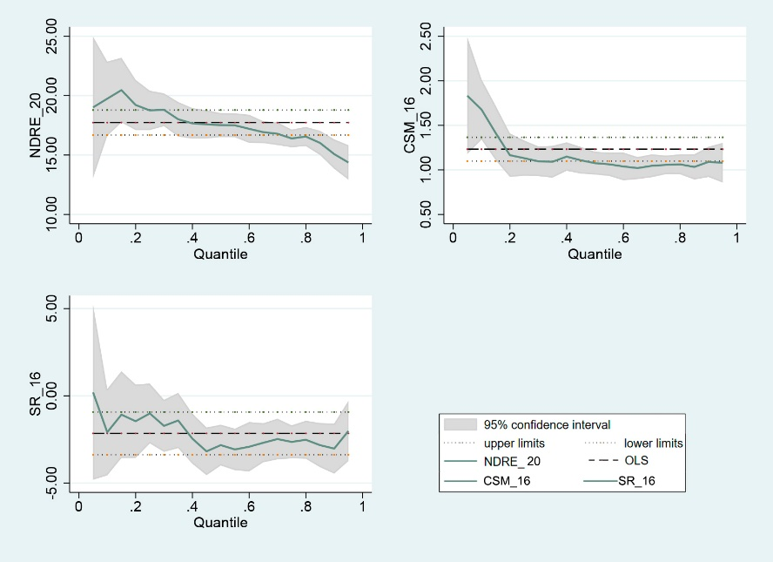 | 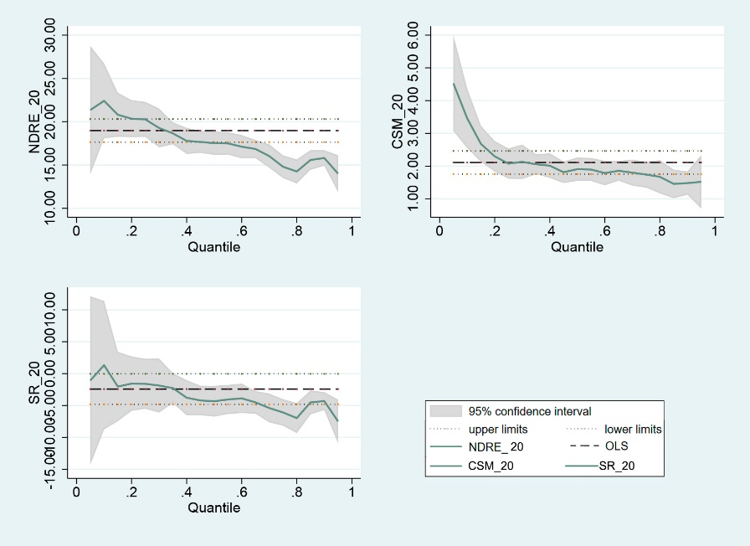
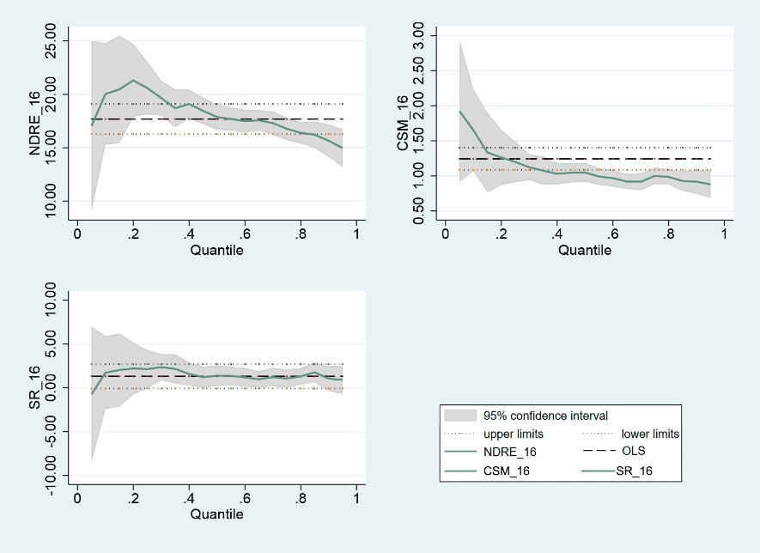 | 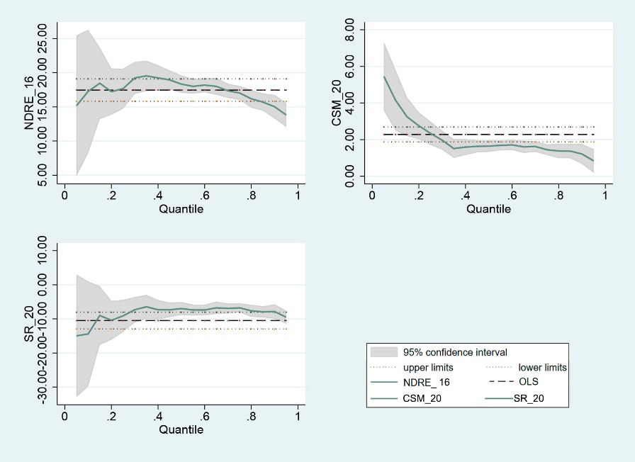
EVI2 index
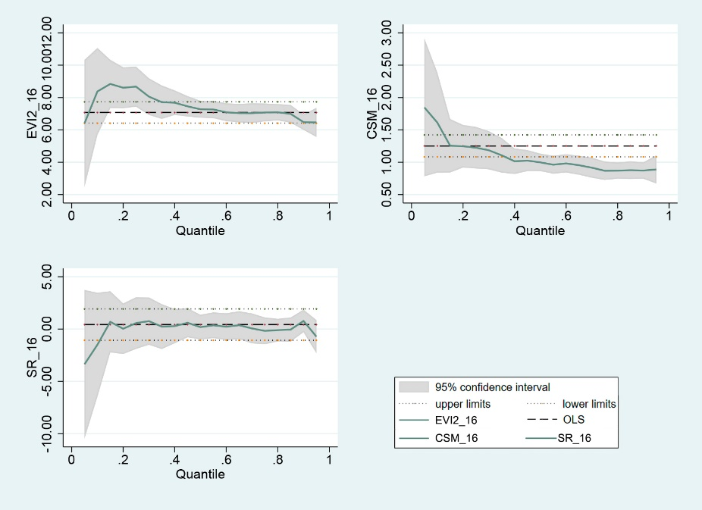 | 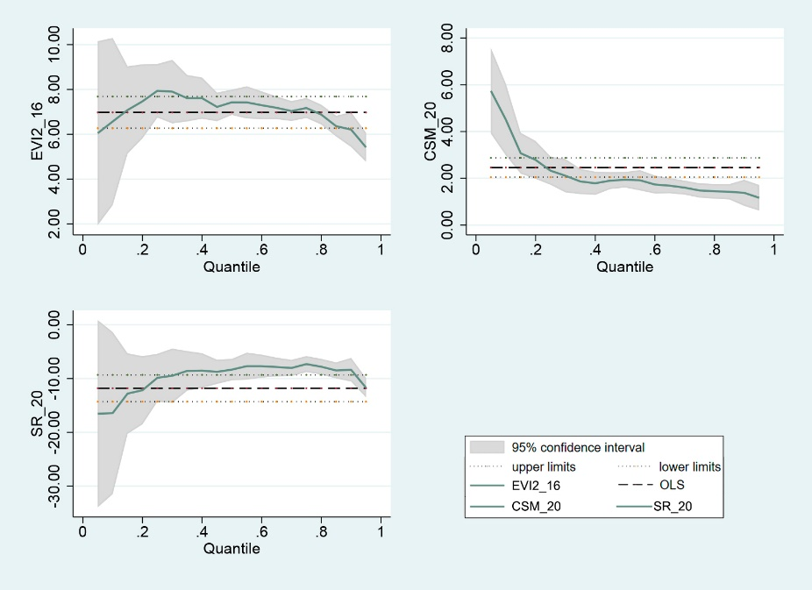
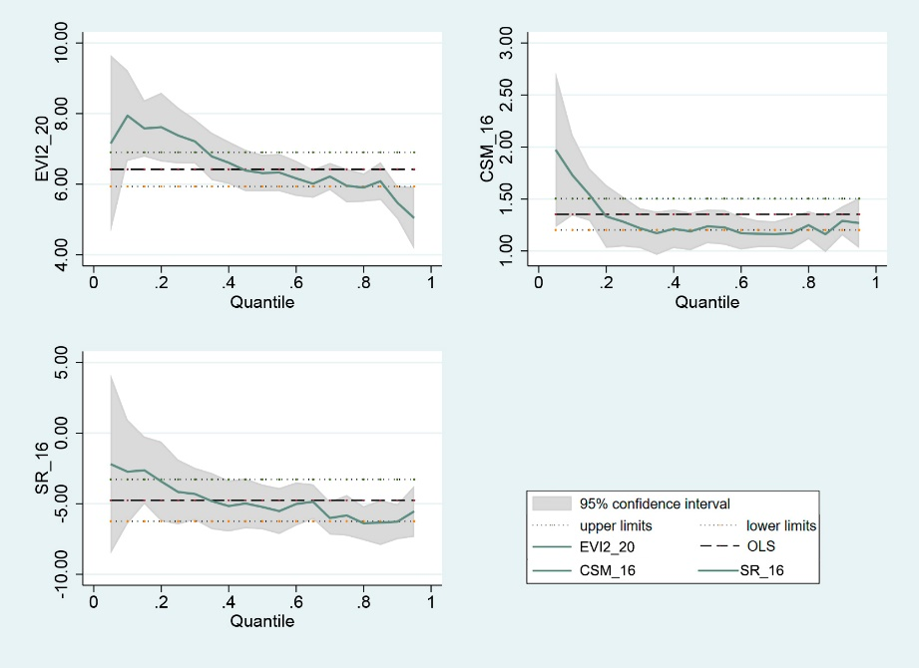 | 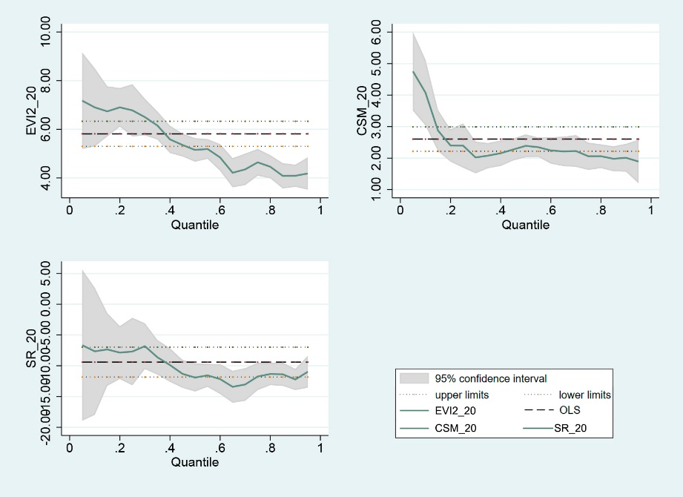
GCVI index
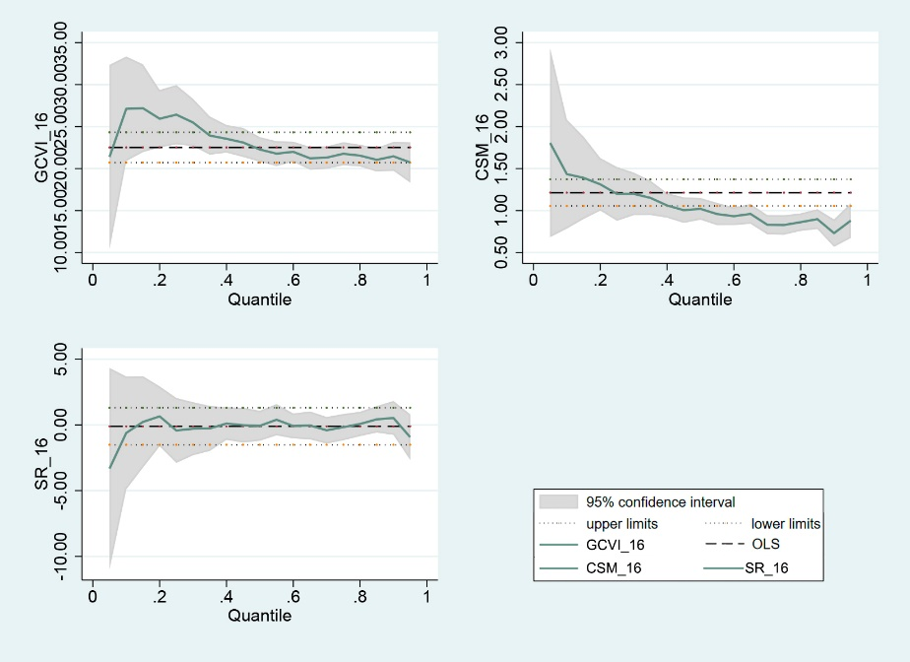 | 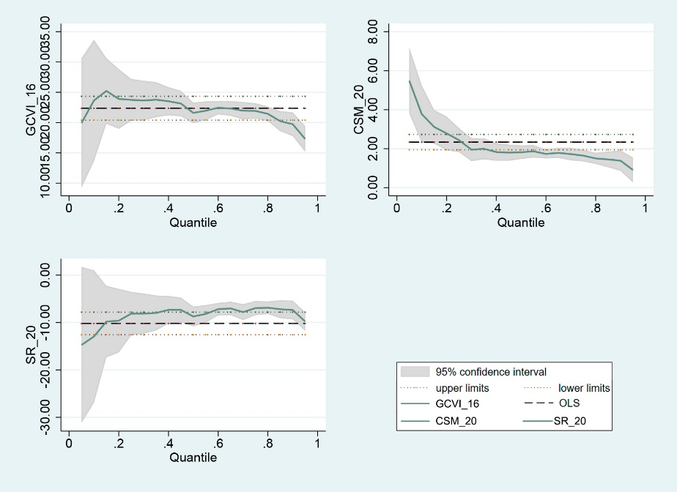
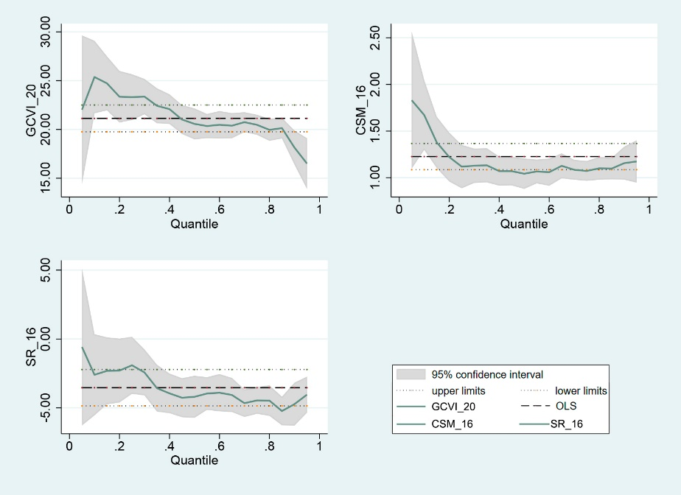 | 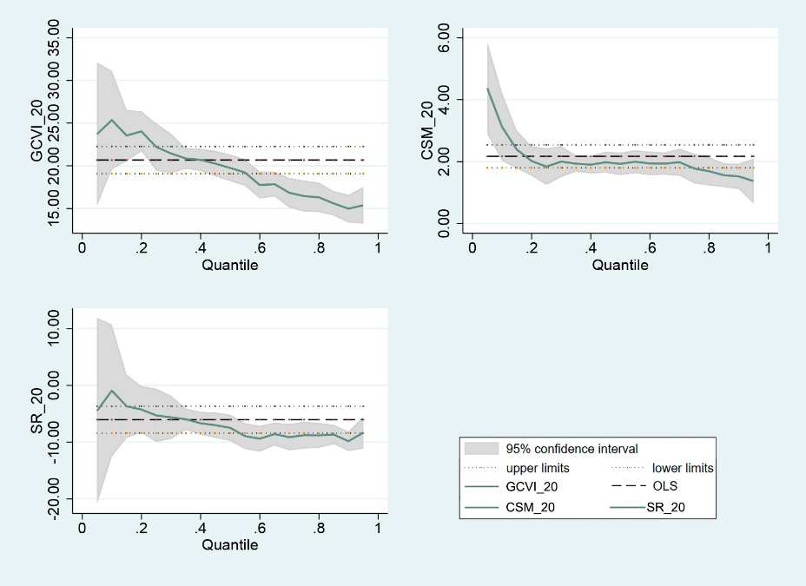
CIred index
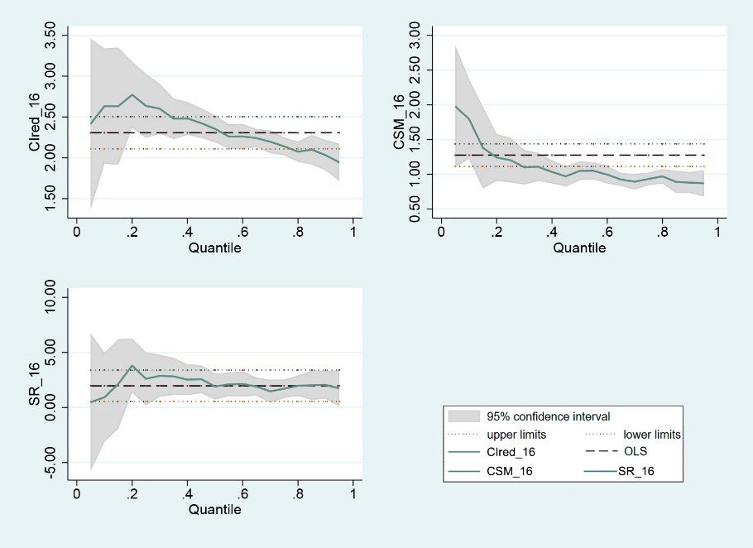 | 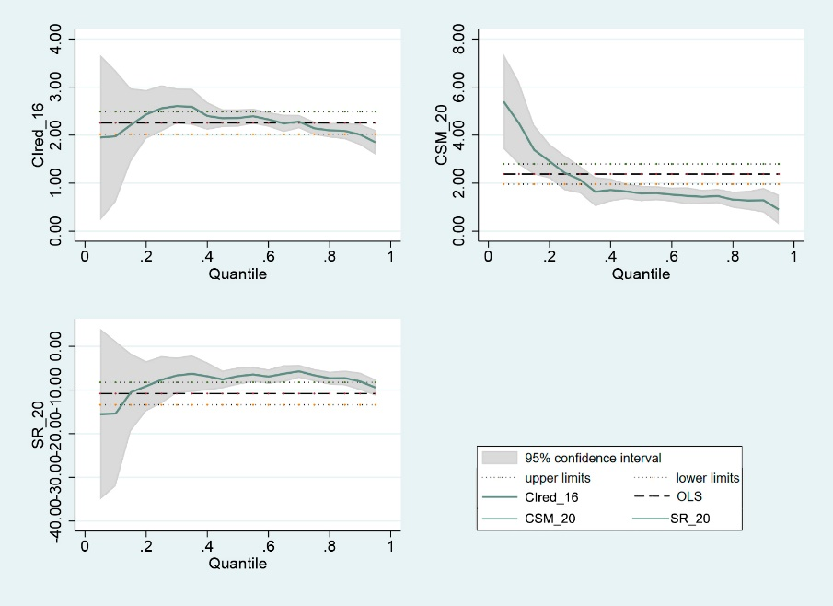
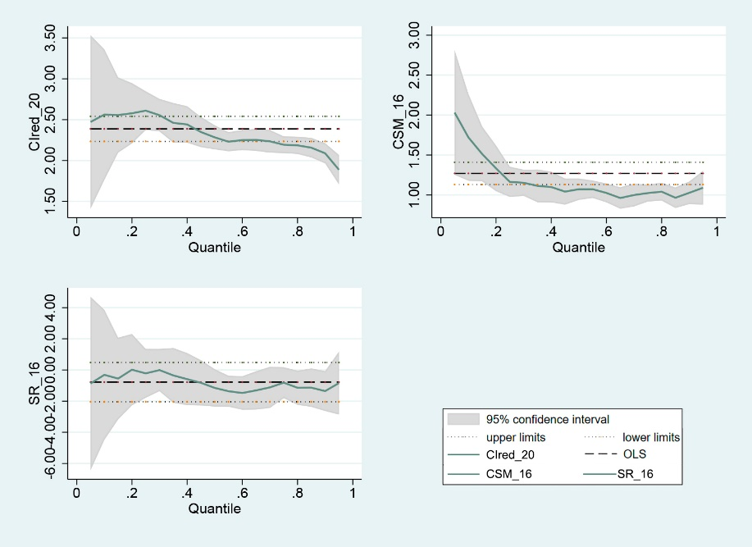 | 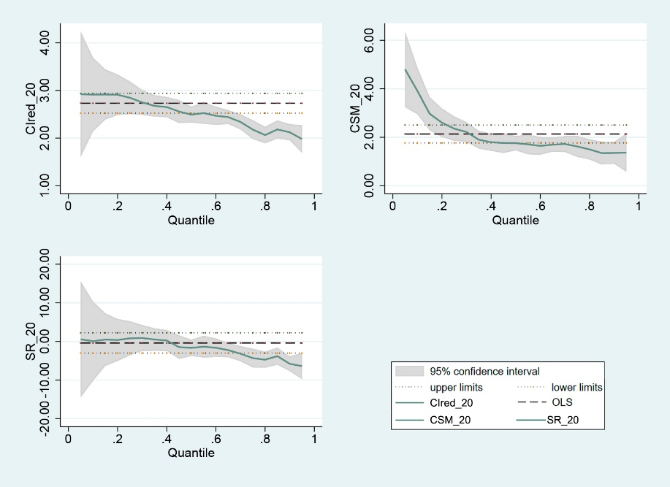
NDVI index
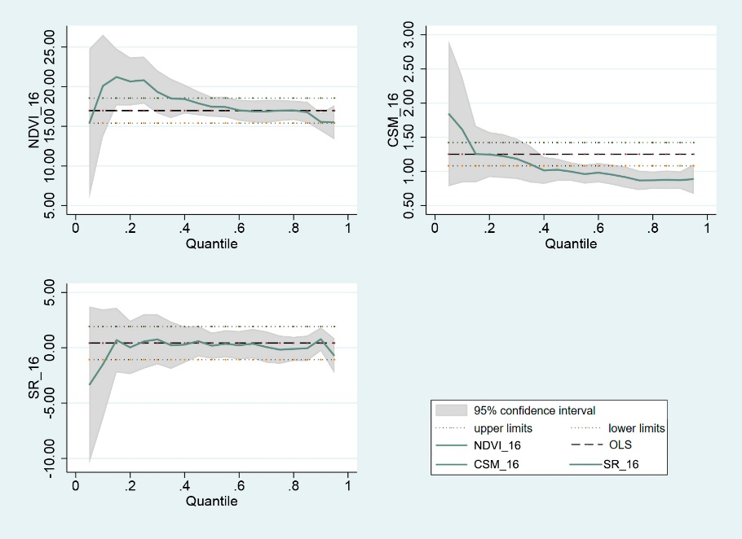 | 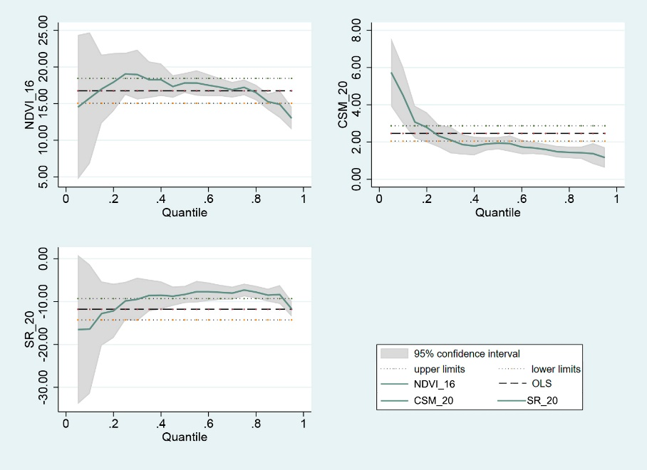
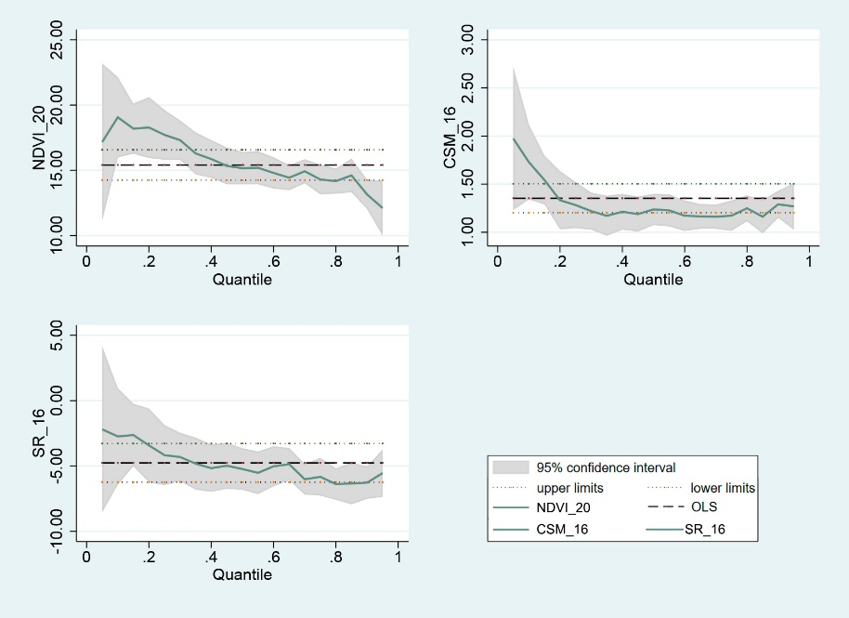 | 