**Comparing the performance of high-resolution global precipitation products across topographic and climatic gradients of Central Asia**

Peña-Guerrero, M. D.1,2,3,4*, Umirbekov, A.1,2,3 , Tarasova, L.4, Müller, D.1,2,5

1 Leibniz Institute of Agricultural Development in Transition Economies (IAMO), Halle (Saale), Germany

2 Geography Department, Humboldt-Universität zu Berlin, Berlin, Germany

3 **Tashkent Institute of Irrigation and Agricultural Mechanization Engineers,** Tashkent, Uzbekistan

4 Department of Catchment Hydrology, Helmholtz Centre for Environmental Research, Halle (Saale), Germany

5 Integrative Research Institute on Transformations of Human-Environment System (IRI THESys), Humboldt-Universität zu Berlin, Berlin, Germany

Correspondence to Mayra Daniela Peña-Guerrero ([pena-guerrero@iamo.de](mailto:pena-guerrero@iamo.de))

Umirbekov, A. ([Umirbekov@iamo.de](mailto:Umirbekov@iamo.de))

Tarasova, L. ([larisa.tarasova@ufz.de](mailto:larisa.tarasova@ufz.de))

Müller, D. ([Mueller@iamo.de](mailto:Mueller@iamo.de))

## **Supporting information**

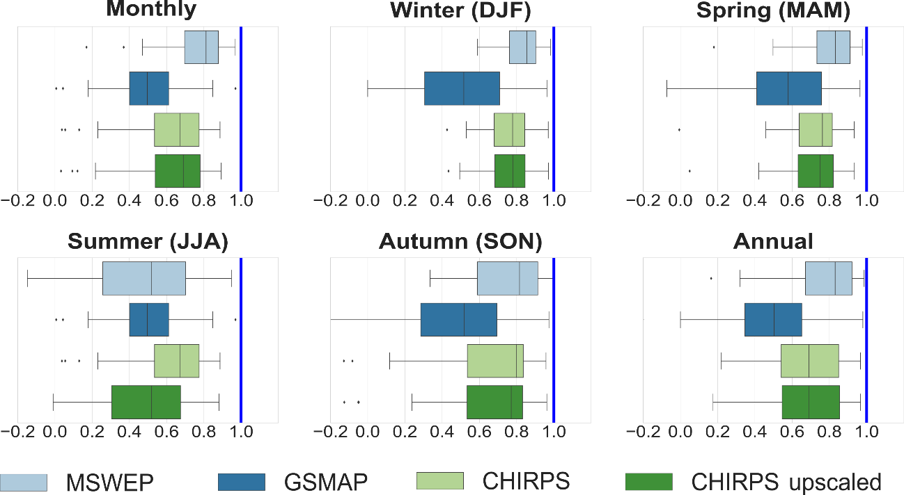

**Figure S1.** Pearson correlation coefficient (r) between different satellite estimations and precipitation gauge data at the corresponding grid cell for six temporal scales. The vertical blue line shows the optimum value for r.

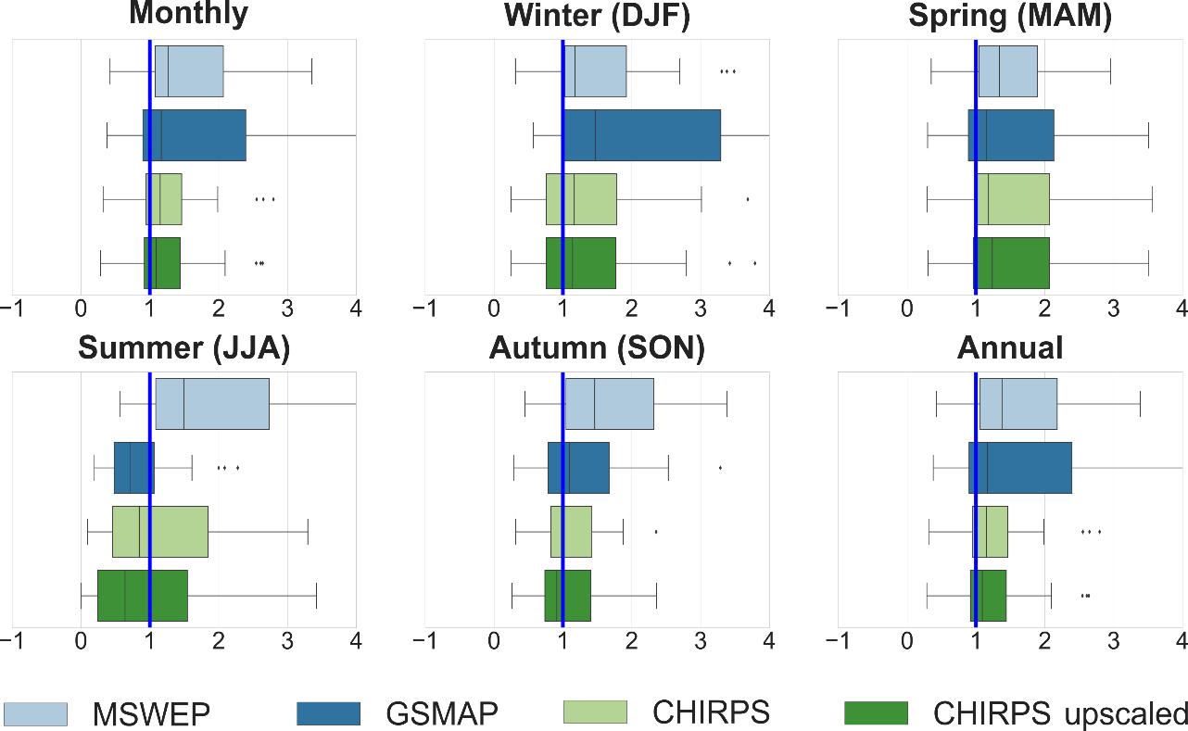

**Figure S2.** Bias ratio (β) of different satellite estimations and precipitation gauge data at the corresponding grid cell for six temporal scales. The vertical blue line shows the optimum value for β.

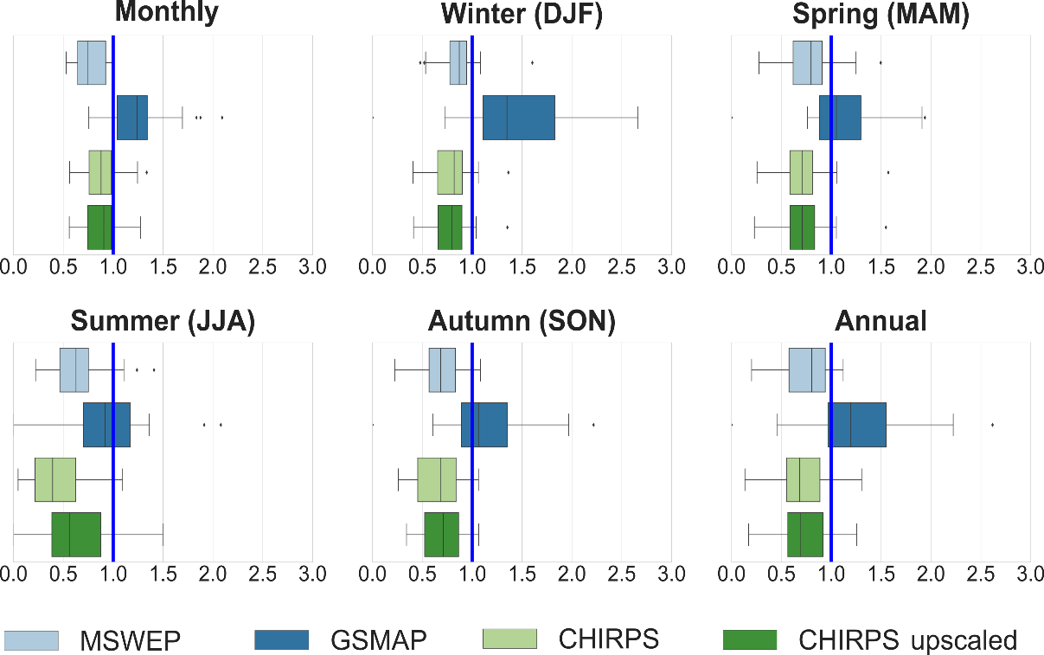

**Figure S3.** Variability ratio (γ) between different satellite estimations and precipitation gauge data at the corresponding grid cell for six temporal scales. The vertical blue line shows the optimum value for γ.

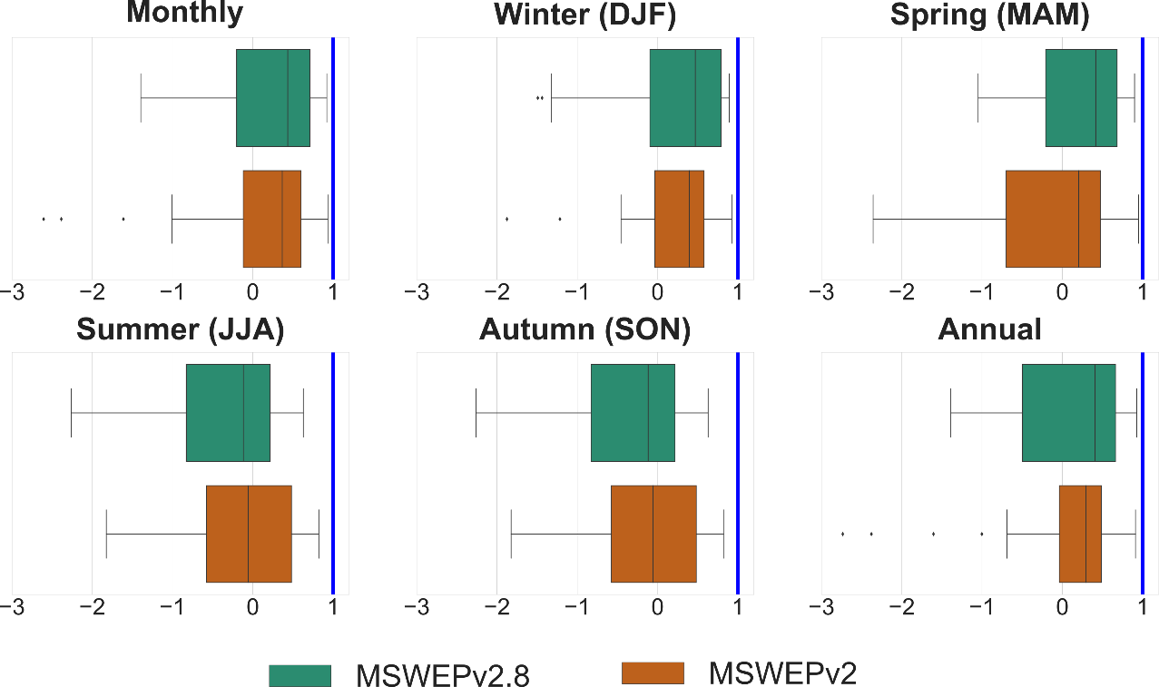

**Figure S4.** KGE' for both MSWEP versions and precipitation gauge data at the corresponding grid cell for six temporal scales. The vertical blue line shows the optimum value for KGE'.

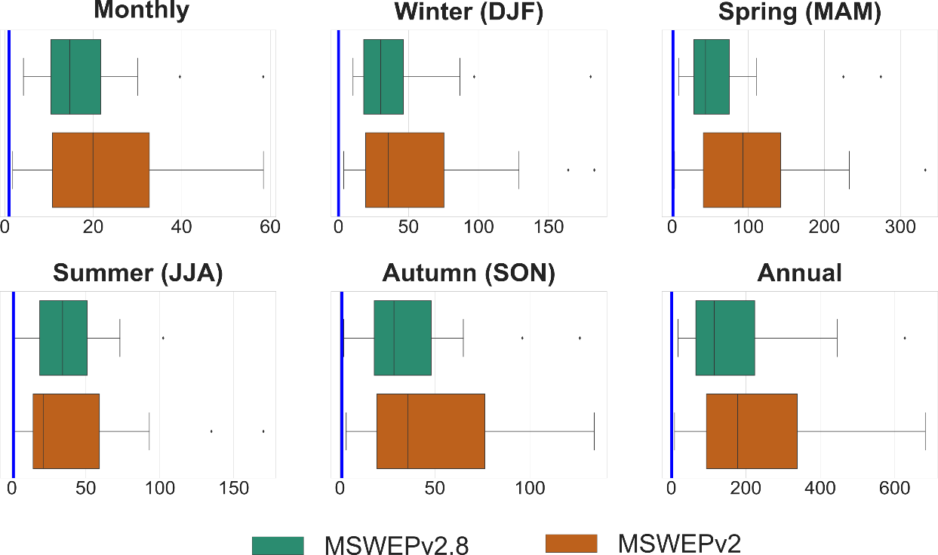

**Figure S5.**MAE for both MSWEP versions and precipitation gauge data at the corresponding grid cell for six temporal scales. The vertical blue line shows the optimum value for MAE.

**Table S1.** Precipitation products evaluated over Central Asia. NP: Near present.

| **Study** | **Evaluated datasets** | **Evaluated period** | **Evaluated temporal resolution** | **Product spatial resolution** | **Product temporal coverage** | **Product data sources** | **Region** | **Reference dataset** | **Source** |
| --- | --- | --- | --- | --- | --- | --- | --- | --- | --- |
| Zandler et al. (2019) | GPCC Full data (2018) | 1980–1994; 1998–2012 | Monthly | 0.25° x 0.25° | 1891–2016 | Gauge | Pamir Mountains, Tajikistan | 5 gauging stations | Schneider et al. (2018a) |
| GPCC Monitoring v.6 | 1° x 1° | 1982–NP | Gauge | Schneider et al. (2018b) |
| CRU TS 4.03 | 0.5° x 0.5° | 1901–2018 | Gauge | Harris et al. (2014) |
| GPCP V2.3 | 2.5° x 2.5° | 1979–NP | Satellite- Gauge | Huffman et al. (1997), Adler et al. (2018) |
| PERSIANN-CDR | 0.25° x 0.25° | 1983–NP | Satellite | Ashouri et al. (2015) |
| MERRA-2 | 0.5° x 0.625° | 1980–NP | Reanalysis | Reichle et al. (2017) |
| MERRA-2 Bias Corrected | 0.5° x 0.625° | 1980–NP | Reanalysis- Gauge |
| ERA-interim | 0.7° x 0.7° | 1979–NP | Reanalysis | Dee et al. (2011) |
| ERA5 | 0.25° x 0.25° | 1979–NP | Reanalysis | European Centre for Medium-range Weather Forecast (2019) |
| TRMM 3B43 version 7 | 1998–2012 | 0.25° x 0.25° | 1998–2014 | Satellite | Huffman and Bolvin (2018) |
| Hu et al. (2018) | GPCC v 7 | 1901–2010 | Monthly, seasonal, Annual | 0.5° x 0.5° | 1901–NP | Gauge | Kazakhstan, Uzbekistan, Turkmenistan, Kyrgyzstan, Tajikistan, and Xinjiang, China | 586 meteorological stations: 438 CGP V1.0 (China Meteorological Administration, Global Precipitation V1.0) and 148 from NSIDC (U.S. National Snow and Ice Data Center) | Schneider et al. (2015) |
| CRU TS 3.22 | 0.5° x 0.5° | 1901–NP | Gauge | Harris et al. (2014) |
| WM | 0.5° x 0.5° | 1901–NP | Gauge | Willmott and Matsuura (2012) |
| Guo et al. (2015); | TMPA 3B42V7 | 2004–2006 | Daily, seasonal, monthly | 0.25° x 0.25° | 1998-2019 | Satellite/ Satellite-Gauge | Kazakhstan, Uzbekistan, Turkmenistan, Kyrgyzstan and, Tajikistan | Asian Precipitation-Highly Resolved Observation Data integration Towards Evaluation of Water Resources (APHRODITE - 0.25° x 0.25°) Yatagai et al. (2012) | Huffman et al. (2007) |
| CMORPH | 0.25° x 0.25° | 1998–NP | Satellite/ Satellite-Gauge | Joyce et al. (2004), Xie et al. (2014) |
| GSMaP (MVK) | 0.1° x 0.1° | 2000-NP | Satellite/ Satellite-Gauge | Okamoto et al. (2005), Kubota et al. (2007), Mega et al. (2014) |
| PERSIANN | 0.25° x 0.25° | 1983–NP | Satellite/ Satellite-Gauge | Sorooshian et al. (2000), Hsu et al. (1997), Ashouri et al. (2015) |
| Guo et al. (2017) | TMPA 3B42V7 | 2001–2006 | Daily, seasonal | 0.25° x 0.25° | 1998-2019 | Satellite/ Satellite-Gauge | Kazakhstan, Uzbekistan, Turkmenistan, Kyrgyzstan and, Tajikistan | APHRODITE - 0.25° x 0.25° Yatagai et al. (2012) | Huffman et al. (2007) |
| CMORPH | 0.25° x 0.25° | 1998–NP | Satellite/ Satellite-Gauge | Joyce et al. (2004), Xie et al. (2014) |
| GSMaP (RNL) | 0.1° x 0.1° | 2000-2014 | Satellite-Reanalysis/ Satellite-Reanalysis-Gauge | Okamoto et al. (2005), Kubota et al. (2007), Mega et al. (2014) |
| PERSIANN | 0.25° x 0.25° | 1983–NP | Satellite/ Satellite-Gauge | Sorooshian et al. (2000), Hsu et al. (1997), Ashouri et al. (2015) |
| Salehie et al. (2021) | APRHODITE | 1979–2019 | Monthly | 0.25° x 0.25° | 1951-NP | Gauge | Amu Darya Basin | 55 meteorological stations | Yatagai et al. (2012) |
| CHIRPS | 0.05° x 0.05° | 1981–NP | Satellite-Gauge-Reanalysis | Funk et al. (2015) |
| CPC | 0.5° x 0.5° | 2002-NP | Gauge | <https://psl.noaa.gov/data/gridded/data.cpc.globalprecip.html> |
| CRU TS V4.03 | 0.5° x 0.5° | 1901–2018 | Gauge | Harris et al. (2014) |
| GPCC | 0.5° x 0.5° | 1901-NP | Gauge | Schneider et al. (2018b) |
| PGF | 0.25° x 0.25° | 1948-2016 | Gauge-Reanalysis | http://hydrology.princeton.edu/data/pgf/v3/0.25deg/daily/ |
| Udel V5.01 | 0.5° x 0.5° | 1900-2017 | Gauge | Willmott and Matsuura (2012) |
| Schär et al. (2004) | ERA-15 | 1979–1993 | Monthly, Seasonal | 2.5° x 2.5° | 1979–1993 | Reanalysis | Syr Darya and Amu Darya basins | 4 meteorological stations | Gibson et al. (1999) |
| Hu et al. (2016) | MERRA | 1979–2010 | Monthly, Seasonal, Annual | 0.5° x 0.67° | 1979–NP | Reanalysis | Kazakhstan, Uzbekistan, Turkmenistan, Kyrgyzstan, Tajikistan, and Xinjiang, China | 199 meteorological stations | Rienecker et al. (2011) |
|  | ERA-Interim | 0.75° x 0.75° | 1979–NP | Reanalysis | Dee et al. (2011) |
|  | CFSR | 0.31° x 0.31° | 1979–NP | Reanalysis | Saha et al. (2010) |
|  | TRMM 3B32 | 0.25° x 0.25° | 1998–NP | Satellite | Huffman et al. (2007) |
|  | MW | 0.5° x 0.5° | 1900–2010 | Gauge | Willmott and Matsuura (2012) |
| Malsy et al. (2014) | CRU TS 3.2 | 1971–2000 | Mean monthly precipitation | 0.5° x 0.5° | 1901–2011 | Gauge | Rivers Ob, Irtysh, Tobol, Ural, Amu  Darya, Syr Darya, Tarim and the lakes Balkhash, Issyk  Kul, and Aral Sea | 142 hydrological stations | Harris et al. (2014) |
| GPCC v 6 | 0.5° x 0.5° | 1901–2010 | Reanalysis | Schneider et al. (2011) |
| WATCH forcing data (WFD) | 0.5° x 0.5° | 1958–2001/1979–2009 (ERA Interim) | Reanalysis | Weedon et al. (2014) |
| APRHODITE | 0.25° x 0.25° | 1951–2007 | Gauge | Yatagai et al. (2012) |
| Schiemann et al. (2008) | CRU TS 2.1 | 1960–1990 | Monthly, seasonal, annual | 0.5° x 0.5° | 1901–2002 | Gauge | Kazakhstan, Uzbekistan, Turkmenistan, Kyrgyzstan, and Tajikistan | CRU, GPCC, and UDEL | Mitchell and Jones (2005) |
| GPCC | 0.5° x 0.5° | 1950–2000 | Gauge | http://www.dwd.de/en/FundE/Klima/KLIS/  int/GPCC/Projects/VASClimO |
| UDEL 1.02 | 0.5° x 0.5° | 1950–1999 | Gauge | Legates and Willmott (1990) |
| CAMS-OPI | 0.5° x 0.5° | 1979–2008 | Gauge- Satellite | http://www.cpc.ncep.noaa.gov/products/  global precip/html/wpage.camsopi.html |
| ERA-40 | ~125 km | 1958–2002 | Reanalysis | (Uppala et al., 2005) |
| NCEP | ~210 km | 1948–2008 | Reanalysis | Kalnay et al. (1996) |
| ECOP | (changing) | 1985–2008 | Reanalysis | http://www.ecmwf.int/products/data/  operational system/ |
| CHRM | 0.5° x 0.5° | 1958–2001 | Reanalysis | Vidale et al. (2003) |
| CHRM-ECOP | 0.5° x 0.5° | 1997–2006 | Gauge- Satellite |
| Lu et al. (2021) | SM2RAIN | 2007–2019 |  | 0.125° x 0.125° | 2007–NP | Satellite- Reanalysis | Kazakhstan, Uzbekistan, Turkmenistan, Kyrgyzstan, Tajikistan, and Xinjiang, China | SM2RAIN and ERA5 | Brocca et al. (2019) |
|  | ERA5 | 0.29° x 0.29° | 1979–NP | Reanalysis | Hersbach et al. (2019) |
|  | 3B42 | 0.25° x 0.25° | 1997–NP | Satellite | Huffman et al. (2017) |
|  | CHIRPS | 0.05° x 0.05° | 1981–NP | Satellite-Gauge-Reanalysis | Funk et al. (2015) |
|  | CMORPH_CRT | 0.0727° x 0.0727° | 1998–NP | Reanalysis | Joyce et al. (2004) |
|  | GSMAP-Gauge | 0.1° x 0.1° | 2000–NP | Satellite- Gauge | Kubota et al. (2007) |
|  | IMERG_FR | 0.1° x 0.1° | 2000–NP | Reanalysis | http://storm-pps.gsfc.nasa. gov/storm |
|  | PERSIANN_CDR | 0.25° x 0.25° | 1983–NP | Satellite | Sorooshian et al. (2000) |
| Zhang et al. (2018) | GPM IMERG | 2014-2015 |  | 0.1° x 0.1° | 2014-NP | Satellite | Tien Shan Mountain Area | 46 stations | https://pmm.nasa.gov/data-access/downloads/GPM |
|  | CMORPH |  | 0.07° x 0.07° | 2002-NP | Reanalysis | https://rda.ucar.edu/datasets/ds502.0/ |
|  | TRMM 3B42V7 |  | 0.25° x 0.25° | 1998-2015 | Satellite | https://pmm.nasa.gov/data-access/downloads/TRMM |

**Table S2.** Local gauging stations used in the validation*.* KG: Kyrgyzstan; KZ: Kazakhstan; TM: TJ: Tajikistan; Turkmenistan; UZ: Uzbekistan. (–) Not available. (––) Not used. * Based on information provided byftp://chg-ftpout.geog.ucsb.edu/pub/org/chg/products/CHIRPS-2.0/list_of_stations_used/monthlyftp://chg-ftpout.geog.ucsb.edu/pub/org/chg/products/CHIRPS-2.0/list_of_stations_used/monthly ftp://chg-ftpout.geog.ucsb.edu/pub/org/chg/products/CHIRPS-2.0/list_of_stations_used/monthlyftp://chg-ftpout.geog.ucsb.edu/pub/org/chg/products/CHIRPS-2.0/list_of_stations_used/monthly. These stations are also considered independent for MSWEP. ftp://chg-ftpout.geog.ucsb.edu/pub/org/chg/products/CHIRPS-2.0/list_of_stations_used/monthly

| **Station** | **Country** | **Altitude**  **(m)** | **Lat** | **Lon** | **Annual precipitation (mm/year)** | **Available period (monthly)** | **Available period (daily)** | **Period used in CHIRPS\*** | **Validation period** |
| --- | --- | --- | --- | --- | --- | --- | --- | --- | --- |
| **Ak-Terek** | KG | 1,190 | 40.37 | 74.22 | 1085 | 2000–2015 | – | –– | 2000–2015 |
| **Baytyk** | KG | 1,579 | 42.67 | 74.63 | 559 | 2000–2015 | – | 1981 –2000 | 2001–2015 |
| **Buhara** | UZ | 219 | 39.72 | 64.62 | 126 | – | 1988–2012 | 1981–1995/ 2000–2020 | 1995–1999 |
| **Bulunkul** | TJ | 3,744 | 37.70 | 72.95 | 88 | 1981–1990/1999–2013 | 1936–1967/1975–1989 | 1981–1991 | 1999–2013 |
| **Chatkal** | KG | 2,300 | 41.82 | 71.10 | 500 | 2000–2015 | – | 1981–1995 | 2000–2015 |
| **Gulcha** | KG | 1,575 | 40.30 | 73.47 | 678 | 2000–2015 | – | 1981–1997 | 2000–2015 |
| **Guzar** | UZ | 527 | 38.62 | 66.27 | 200 | – | 1988–2001/2005–2012/2015–2016 | 1981–1999 | 2005–2012 |
| **Humragi** | TJ | 1,737 | 38.28 | 71.33 | 169 | 1958–1994/2001–2008 | 1936–1970/1976–1984 | –– | 1981–1994/2001–2008 |
| **Irkht** | TJ | 3,276 | 38.13 | 72.62 | 120 | 1981–1991/1998–2009 | 1939–1967/1974~1985 | 1981 – 1997 / 2014–2020 | 1998–2009 |
| **Ishkashim** | TJ | 2,510 | 36.72 | 71.61 | 134 | 1981–1991/1998–2009 | 1939–1967/1974–1985 | 1981–1991 / 2014–2020 | 2001–2009 |
| **Javshangoz** | TJ | 3,438 | 37.36 | 72.44 | 87 | 1981–1995/2001–2006/2009–2013 | 1936–1989 | 1981–1991 | 1992–1994/2001–2006/2009–2013 |
| **Kala-i-Khumb** | TJ | 1,231 | 38.51 | 70.94 | 485 | 1997–2005 | 1936–1981 | 1981–1991 / 2013–2020 | 1997–2005 |
| **Kara Kuzhur** | KG | 855 | 41.93 | 76.30 | 264 | 2000–2015 | – | 1981–1991 | 2000–2015 |
| **Karshi** | UZ | 363 | 38.75 | 65.72 | 255 | – | 1988–1999/2007/2014–2018 | 1981–1992/2000–2020 | 1993–1999 |
| **Khorog** | TJ | 2,077 | 37.48 | 71.54 | 272 | 1936–2001–2013 | 1939–1989/2001–2013 | 1991–2020 | 1981–1990 |
| **Kyzyl-Adyr** | KG | 1,764 | 42.62 | 71.59 | 327 | 2000–2015 | – | 1981–1991 | 2000–2015 |
| **Lasi_Uzgen** | KG | 978 | 40.77 | 73.30 | 977 | 2000–2015 | – | 1981–1991 | 2000–2015 |
| **Minchukur** | UZ | 2,147 | 38.65 | 66.93 | 676 | – | 1988–1992/1994–2013/2015–2016 | 1981–1999 | 2000–2013 |
| **Murghab** | TJ | 3,576 | 38.15 | 73.96 | 80 | 1936–1991–1993/1998–2009 | 1936–1970/1974–1985 | 1981–1993 / 2013–2020 | 1998–2009 |
| **Navabad** | TJ | 2,576 | 37.67 | 71.83 | 392 | 1981–2013 | 1956–1989 | –– | 1981–2013 |
| **Navoi** | UZ | 339 | 40.13 | 65.20 | 176 | – | 1988–2017 | 1981–1995/2009–2019 | 1996–2008 |
| **Oygaing** | UZ | 1,620 | 42.00 | 70.63 | 733 | 2000–2015 | – | 1981–1999 | 2000–2015 |
| **Rushan** | TJ | 1,980 | 37.95 | 71.57 | 289 | 1960–2001–2008 | 1936–1984/2001–2008 | 1981–1991/2013–2020 | 2001–2008 |
| **Savnob** | TJ | 2,955 | 38.40 | 72.60 | 153 | 1986–1999–2001–2005 | 1962–1981 | –– | 1986–2005 |
| **Shahrisabz** | UZ | 1,026 | 39.25 | 67.07 | 499 | – | 1988–2018 | 1985–1999 | 2000–2018 |
| **Shaymak** | TJ | 3,840 | 37.54 | 74.82 | 151 | 1981–1991/1999–2009 | 1936–1970/ 1975–1985 | 1981–1991 | 1999–2009 |
| **Shelek** | KZ | 600 | 43.60 | 78.25 | 274 | 2000–2015 | – | 1981–1991/ 2018–2020 | 2000–2015 |
| **Tahtamish** | TJ | 3,729 | 37.83 | 74.64 | 68 | 1968–1987 | 1944–1964 | –– | 1981–1987 |
| **Takhta Bazar** | TM | 354 | 35.97 | 62.91 | 216 | 2000–2015 | – | 1981–1991 | 2000–2015 |
| **Zhalanash** | KZ | 1,690 | 43.04 | 78.64 | 507 | 2000–2015 | – | –– | 2000–2015 |

Eq. S1

$KGE^{'}=1-\sqrt{{\left(r-1\right)}^{2}+{\left(β-1\right)}^{2}+{\left(γ-1\right)}^{2}}$

$$r= \frac{1}{n}\sum_{1}^{n}{\frac{\left(O_{n}-μ_{o}\right)*(S_{n}-μ_{s})}{σ_{o}*σ_{s}}}$$

$$β= \frac{μ_{s}}{μ_{o}}$$

$γ= \frac{{CV}_{s}}{{CV}_{o}}= \frac{σ_{s}/μ_{s}}{σ_{o}/μ_{o}}$,

where µ isthe distribution mean, *σ* is the standard deviation, and *o* and *s* are the observed values and the product estimates, respectively.

Eq. S2

$$MAE= \frac{1}{N}\sum_{i=1}^{N}{|s_{i}-o_{i}|}$$

Eq. S3

$$POD= \frac{hits}{hits+misses}$$

$$FAR= \frac{false alarms}{hits+false alarms}$$

$$fBIAS= \frac{hits+false alarms}{hits+misses}$$

Eq. S4

$PKi=\frac{Pi}{PA}$,

where *PKi* is the Pardé coefficient of month *i*, *Pi* is the mean monthly precipitation (averaged over the study period) in month *i*, and *PA* is the mean annual precipitation (averaged over the same years) (Parajka et al., 2008, Weingartner et al., 2013).