**Online Appendix**

**Section A1. Frame dictionary creation and document annotation**

The four frame dictionaries contain English keywords and were employed to classify the English (translated) document versions. All keywords are intended to be unambiguous in the English language and represent the concepts defined in Table A1.

The dictionary creation process included several steps. Many of the terms were initially selected from available dictionaries on similar topics as well as extracted from annotated Manifesto sentences (Volkens et al., 2015) for the respective cases (= countries) . This way, the instruments should be equipped with case-specific vocabulary. All non-English keywords were machine-translated into English. Case experts reviewed the keyword lists per frame to evaluate their usefulness for the measurement per case. To uncover additional relevant keywords a sample of *n* = 2,000 documents, randomly selected from, were manually annotated by the researcher who created the dictionary. Coding followed the instructions as displayed in Table A1. The 2,000 documents included all involved languages (i.e., Germany, Polish, Spanish, Swedish, and English). The machine-translated English versions of all non-UK articles and the English UK documents were used in an iterative refinement process involving the classification of wrongly classified documents resulting in the addition, removing, or refinement of keywords in the dictionary. These steps were repeated until recall and precision for all four dictionaries reached satisfactory levels.

The validity of the final versions of the four dictionaries, furthermore, was evaluated based on a fresh subsample of *n* = 2,100 migration-related sentences. These sentences were randomly selected, included at least one migration word from the English search string and were not part of the articles used for the dictionary refinement. A researcher, who was not involved in the dictionary creation, annotated the sentences manually, following the instructions as displayed in Table A1. A shared understanding of the concepts between the researcher who created the dictionary and the researcher who manually annotated this validation data set was assessed via an intercoder reliability test. Both coded 100 migration-related sentences, Krippendorff's alpha values (Economy: .85, Labor market: .93, Security: 1, Welfare: 1) were deemed satisfactory. This validation procedure yielded following scores: Economy: Precision = .85 / Recall = .82 / F1 = .83; Labour market: .84 / .88 / .86; Security: .86 / .81 / .83; Welfare: .87 / .77 / .82.

For the application of the final dictionaries, eventually, keywords were compiled as regular expressions in R. Before the dictionaries were used to annotate the texts, the textual data was preprocessed. All words were lowercased and lemmatized and each documentsegmented into sentences. Dictionaries then detected the number of matches between the text under investigation and the respective frame-dictionary keywords.

**Section A2. Machine Translation**

We randomly selected sets of 50 tweets and posts for each language and asked bilingual coders to compare the original language version of the tweets/posts with the machine-translated version. For each pair, the coders answered three questions: 1) Do you perceive the translation as adequateoverall? Adequate means that the same or a very similar meaning is communicated in both versions? (Koby et al., 2014): 1 = yes, adequate, 0 = no, not adequate; 2) Comparing individual words more closely (e.g., nouns and verbs in the original language and in the translated version), do you perceive problems? 1 = yes, 0 = no; What problems occur? Please name specific errors/problems that you noted? (open answer). Over 90% of the 200 translation pairs were perceived as adequate. The issues identified concerned mainly the translation of abbreviations, named entities, and hashtags, which hardly affected the analyses as the respective terms were (mostly) not part of the dictionaries. Almost 70% of the pairs were labelled as unproblematic related to the verbs and nouns. Inspecting the remaining 30% text pairs that were labelled as problematic, we argue that they hardly affected the analyses. The identified issues mainly concerned the translation of abbreviations (e.g., “Groko”), named entities (e.g. “Essen” was not recognized as city name but translated with food), and hashtags consisting of multiple words (e.g., the "#TrabajoConDerecho" should have been translated to "#WorkWithRights"), terms that are (mostly) not part of our dictionaries. In sum, we concluded that the manual check of the machine translation quality confirmed that our analysis is largely unaffected by machine translation errors.

**Table A1. Frame Definitions**

|  |  |
| --- | --- |
| Frame | Definition |
| Security | The **security-**related aspects of migration (fr_sec) include references to...  … security and crime issues when those held responsible are migrants  … law and order, border security, border control, border protection actions (e.g., fence enforcement, tear gas), and also to the deportation of migrants  … human trafficking/smuggling, subjective security feeling, police dealings with migrants, (fear of) terror connected to migration  … the “fear of foreigners” ONLY if it is clear from the context that the fear is related to crime/security-related aspects (e.g., the fear of immigrants committing crimes)  … illegal immigration  It is important that the aspects may be addressed not only against migration or migrants (e.g., migration threatens the security of our country) but also in a favourable context (e.g., illegal migration should be legalized, protest against the deportation of migrants, three refugees are deported despite their remarkable integration efforts in British society). |
| Economy | The **economy-**related aspects of migration (fr_eco) include references to...  … so-called “economic migrants”, i.e., people referred to as being economically motivated to migrate  … migration as being related to the economic development of the country of destination (e.g., individual migrants’ hope for higher economic standard) or of the country of origin (e.g., emigration because of an economic crisis)  … explicit economic (i.e., financial) consequences for the migrants’ country of origin due to emigration (e.g., remittances)  … explicit economic (i.e., financial) consequences for the migrants’ country of transit or destination (host country) due to immigration (e.g., taxes)  … any sort of costs for a country that arise from migration, e.g., direct payments for migrants, the handling of migration  All these aspects may be linked to the EU/country/county/municipal level. |
| Labor market | The **labor market**-related aspects of migration (fr_lab) include references to...  … migrants’ participation in the labor market, this includes also actions/laws/plans to prevent/limit migrants’ active participation in the labor market, and mentions of non-active/passive participation or unemployment  … labor market-related consequences for the migrants’ country of origin due to emigration  … labor market-related consequences for the migrants’ country of transit or destination (host country) due to immigration  … legal and illegal forms of labor when related to migration  … the “fear of foreigners” ONLY if it is clear from the context that the fear is related to labor market-related aspects (e.g., the fear of immigrants taking away jobs)  … stories of individual migrants mentioning their working situation are also coded here (e.g., an artist with migration background, a soccer player playing abroad)  All these aspects may be linked to the EU/country/county/municipal level. An important specification is that politicians/professionals (e.g., social workers) dealing with aspects of migration are only part of the concept if the migration background of a politician/professional is explicitly mentioned. References to “economic migrant/migration” or “migrants contribute to the economy” are defined as being too implicit a reference to working/labor to be part of the labor market concept and are instead to be seen as part of the “Economy Frame”. |
| Welfare | The **welfare-**related aspects of migration (fr_wel) include references to…  … welfare, public or social assistance, social benefits, social care, or social services  … the following sub dimensions of welfare: (public) education, child and family support, work related support, pension/retirement, public healthcare, state subsidies food/clothing, public housing, and housing/accommodation organization for refugees/migrants  … EU support/aid payments for countries to handle migration *if* the previously mentioned welfare aspects are specifically addressed, thus general mentions of “humanitarian aid”, “european union aid” are not included  Welfare aspects to be included refer to services by countries of destination/transit or supranational institutions/organizations. Not included are monetary compensation/travel funding to leave a country. The mere mention of a reception center or refugee camp is not sufficient to code the “Welfare Frame” if it is only mentioned as mere place of events (e.g., a fire at a refugee camp, an attack on a public housing project or a meeting in a refugee accommodation); the article has to refer to handling/organization of accommodation of migrants (e.g., set up/create/manage/run a center/camp/accommodation). |

*Note.* We defined the concepts of the migration frames jointly, based on migration literature and including feedback rounds from experts with expertise for the countries and languages. This way, we tried to establish concept definitions which are located on a level that seek to include all cases and may take into account both transnational discourses as well as country-specific sub discourses. For additional information see AUTHORS (2020).

**Table A2. Survey Information**

|  |  |  |  |  |  |  |
| --- | --- | --- | --- | --- | --- | --- |
| Country | Party | Respondents | Attitude: Economy | Attitude: Labour Market | Attitude: Security | Attitude: Welfare |
| Germany | Alliance‘90 / Greens | 556 | 6.86 | 6.33 | 3.8 | 5.28 |
| Germany | Alternative for Germany | 410 | 3.26 | 3.17 | 1.16 | 1.91 |
| Germany | Christian Democratic Union / Christian Social Union | 848 | 6.02 | 5.62 | 2.93 | 4.24 |
| Germany | Free Democratic Party | 442 | 5.66 | 5.36 | 2.65 | 4.1 |
| Germany | Social Democratic Party of Germany | 862 | 6.18 | 5.8 | 3.23 | 4.61 |
| Germany | The Left | 535 | 5.96 | 5.42 | 3.14 | 4.5 |
| Poland | Civic Platform | 801 | 7.17 | 6.28 | 4.32 | 6.1 |
| Poland | Democratic Left Alliance | 443 | 6.94 | 6.22 | 4.18 | 5.92 |
| Poland | Law and Justice | 653 | 5.5 | 4.75 | 4.11 | 4.82 |
| Poland | Polish Peasants’ Party | 263 | 6.77 | 6.06 | 4.07 | 6.13 |
| UK | Conservative Party | 938 | 5.45 | 4.63 | 2.84 | 4.18 |
| UK | Green Party of England and Wales | 321 | 6.7 | 6.26 | 3.83 | 6.28 |
| UK | Labour Party | 970 | 6.58 | 5.78 | 3.87 | 5.65 |
| UK | Liberal Democrats | 328 | 7.3 | 6.48 | 4.1 | 6.52 |
| UK | Plaid Cymru | 145 | 7.14 | 6.64 | 3.31 | 6.59 |
| UK | Scottish National Party | 210 | 6.89 | 6.46 | 3.75 | 6.72 |
| UK | We Ourselves | 115 | 7.45 | 7.24 | 3.27 | 6.86 |
| Spain | Catalan Republican Left | 256 | 6.27 | 5.88 | 3.7 | 5.25 |
| Spain | Citizens | 795 | 5.8 | 5.08 | 3.34 | 3.92 |
| Spain | Democratic Convergence of Catalonia | 195 | 5.95 | 5.78 | 3.38 | 5.02 |
| Spain | People’s Party | 523 | 5.59 | 4.85 | 3.32 | 3.84 |
| Spain | Spanish Socialist Workers’ Party | 563 | 6.48 | 5.9 | 3.86 | 5.04 |
| Spain | United We Can | 418 | 6.93 | 6.48 | 4.2 | 5.68 |
| Sweden | Centre Party | 337 | 6.42 | 6.72 | 3.41 | 5.41 |
| Sweden | Christian Democrats | 212 | 5.22 | 6.05 | 2.7 | 4.5 |
| Sweden | Green Ecology Party | 273 | 6.7 | 6.99 | 4.1 | 6.26 |
| Sweden | Left Party | 391 | 6.65 | 6.81 | 3.94 | 5.98 |
| Sweden | Liberal People’s Party | 303 | 6 | 6.49 | 3.24 | 5.16 |
| Sweden | Moderate Coalition Party | 715 | 5.04 | 5.71 | 2.75 | 3.88 |
| Sweden | Social Democratic Labour Party | 835 | 6.18 | 6.43 | 3.72 | 5.38 |
| Sweden | Sweden Democrats | 682 | 2.59 | 3.76 | 1.46 | 1.98 |

**Table A3. Estimated Fixed Effects Parameters**

|  |  |  |  |  |
| --- | --- | --- | --- | --- |
|  | Facebook  [95% Credibility Interval] | | Twitter  [95% Credibility Interval] | |
|  | Model 1 | Model 2 | Model 3 | Model 4 |
| Intercept | 3.02 [2.39, 3.66] | 2.82 [2.14, 3.43] | -.47 [-1.48, .55] | -.86 [-1.79, 0.08] |
| *Hypothesis 2* |  |  |  |  |
| Security Frame | .17 [.12, .22] | .03 [-.11, .16] | .25 [.14, .37] | -.17 [-.42, .07] |
| Economic Frame | -.07 [-.11, -.02] | -.05 [-.09, -.0] | .12 [.01, .23] | .14 [.03, .25] |
| Labour Market Frame | -.01 [-.06, .03] | -.01 [-.06, .03] | -.05 [-.16, .06] | -.06 [-.17, .05] |
| Welfare Frame | -.08 [-.13, -.04] | -.14 [-.2, -.08] | .13 [.02, .23] | -.02 [-.15, .11] |
| *Hypothesis 3* |  |  |  |  |
| Negative Support  Base Valence |  | .73 [.19, 1.26] |  | 1.75 [.87, 2.66] |
| Extreme Support  Base Valence |  | -.09 [-.43, .24] |  | .27 [-.23, .75] |
| *Actor lvl Controls* |  |  |  |  |
| Leader (vs. Others) | 3.39 [2.74, 4.06] | 3.41 [2.75, 4.06] | 2.64 [1.84, 3.43] | 2.63 [1.86, 3.45] |
| Populist (vs. non-Populist) | .44 [0, .89] | .46 [-.0, .93] | 1.18 [.74, 1.62] | 1.08 [.63, 1.52] |
| Ideology | -.65 [-1.13, -.16] | -.85 [-1.41, -.29] | -.56 [-1.08, -.03] | -1.1 [-1.71, -.5] |
| Ideological Extremism | .01 [-.75, .75] | -.15 [-.94, .62] | 1.29 [.51, 2.09] | 1 [.17, 1.82] |
| *Message lvl Controls* |  |  |  |  |
| Photo (vs. Text Only) | -.13 [-.19, -.06] | -.13 [-.19, -.06] | .16 [.02, .31] | .16 [.02, .3] |
| Video (vs. Text Only) | .15 [.06, .25] | .16 [.06, .26] | 1.2 [.55, 1.92] | 1.22 [.6, 1.95] |
| Link (vs. Text Only) | -.41 [-.48, -.34] | -.41 [-.48, -.34] | -.44 [-.52, -.36] | -.44 [-.52, -.35] |
| Event (vs. Text Only) | -1.45 [-1.64, -1.26] | -1.45 [-1.65, -1.25] |  |  |
| Length (log) | .21 [.18, .23] | .21 [.18, .24] | .91 [.79, 1.01] | .9 [.79, 1] |
| *Group Effects* |  |  |  |  |
| Country Level (SD) | 0.53 [.14, 1.55] | .7 [.25, 1.89] | .84 [.33, 2.23] | .8 [.32, 2.06] |
| Account Level (SD) | 1.27 [1.21, 1.34] | 1.28 [1.21, 1.35] | 1.28 [1.2, 1.36] | 1.28 [1.2, 1.37] |
| NB shape parameter (φ) | 1.06 [1.04, 1.09] | 1.06 [1.04, 1.09] | .55 [.53, .56] | .55 [.53, .56] |
| N | 11,755 | | 9,085 | |

*Note: All parameters are estimated based on 4,000 MCMC posterior draws. Modes of parameter distributions and 95% CIs are reposted. Flat priors are used throughout, therefore parameter estimates are equivalent to MLE parameters.*

**Table A4. Estimated posterior fixed-effects parameters for Facebook and Twitter: Including *Sentiment* (H2).**

|  |  |  |
| --- | --- | --- |
|  | Facebook  [95% Credibility Interval] | Twitter  [95% Credibility Interval] |
| Intercept | 3.05 [2.45, 3.63] | -.58 [-1.48, .22] |
| *Hypothesis 2* |  |  |
| Security Frame | .12 [.08, .17] | .17 [.06, .29] |
| Economic Frame | -.05 [-.1, -.01] | .12 [.01, .23] |
| Labour Market Frame | 0 [-.04, .05] | -.06 [-.16, .05] |
| Welfare Frame | -.07 [-.11, -.03] | .12 [.01, .23] |
| *Actor lvl Controls* |  |  |
| Leader (vs. Others) | 3.37 [2.73, 4.01] | 2.61 [1.8, 3.39] |
| Populist (vs. non-Populist) | .43 [-.01, .85] | 1.15 [.7, 1.59] |
| Ideology | -.62 [-1.12, -.11] | -.52 [-1.03, .02] |
| Ideological Extremism | -.09 [-.82, .65] | 1.29 [.52, 2.11] |
| *Message lvl Controls* |  |  |
| Sentiment | -2.31 [-2.74, -1.89] | -1.25 [-1.65, -.85] |
| Photo (vs. Text Only) | -.1 [-.17, -.04] | .17 [.03, .31] |
| Video (vs. Text Only) | .16 [.06, .26] | 1.23 [.59, 1.9] |
| Link (vs. Text Only) | -.4 [-.47, -.33] | -.45 [-.54, -.37] |
| Event (vs. Text Only) | -1.44 [-1.64, -1.24] |  |
| Length (log) | .2 [.18, .23] | .93 [.83, 1.04] |
| *Group Effects* |  |  |
| Country Level (SD) | .5 [.14, 1.33] | .76 [.33, 1.78] |
| Account Level (SD) | 1.26 [1.2, 1.33] | 1.27 [1.18, 1.35] |
| NB shape parameter (φ) | 1.07 [1.04, 1.1] | .55 [.53, .56] |
| N | 11,755 | 9,085 |

*Note: All parameters are estimated based on 4,000 MCMC posterior draws. Modes of parameter distributions and 95% CIs are reposted. Flat priors are used throughout, therefore parameter estimates are equivalent to MLE parameters.*

**Table A5. Estimated posterior fixed-effects parameters for Facebook and Twitter: Including all Posts and Tweets (H2).**

|  |  |  |
| --- | --- | --- |
|  | Facebook  [95% Credibility Interval] | Twitter  [95% Credibility Interval] |
| Intercept | 3.03 [2.29, 3.71] | -.2 [-1.13, .78] |
| *Hypothesis 2* |  |  |
| Security Frame | .16 [.12, .2] | .24 [.19, .3] |
| Economic Frame | -.05 [-.09, -.01] | .11 [.04, .18] |
| Labour Market Frame | -.03 [-.07, .01] | -.11 [-.18, -.05] |
| Welfare Frame | -.1 [-.14, -.06] | .12 [.05, .18] |
| *Actor lvl Controls* |  |  |
| Leader (vs. Others) | 3.43 [2.82, 4.07] | 3.02 [2.24, 3.75] |
| Populist (vs. non-Populist) | .44 [.04, .87] | .88 [.52, 1.22] |
| Ideology | -.53 [-1.01, -.05] | -.42 [-.85, .01] |
| Ideological Extremism | .07 [-.71, .76] | 1.28 [.59, 2.03] |
| *Message lvl Controls* |  |  |
| Photo (vs. Text Only) | -.05 [-.1, -.0] | .37 [.31, .44] |
| Video (vs. Text Only) | .16 [.09, .23] | .93 [.68, 1.2] |
| Link (vs. Text Only) | -.36 [-.41, -.31] | -.4 [-.44, -.36] |
| Event (vs. Text Only) | -1.45 [-1.59, -1.32] |  |
| Length (log) | .17 [.15, .19] | .78 [.73, .83] |
| *Group Effects* |  |  |
| Country Level (SD) | .63 [.21, 1.69] | .91 [.37, 2.28] |
| Account Level (SD) | 1.28 [1.22, 1.34] | 1.33 [1.27, 1.4] |
| NB shape parameter (φ) | 1.03 [1.01, 1.05] | .51 [.5, .52] |
| N | 22,295 | 36,551 |

*Note: All parameters are estimated based on 4,000 MCMC posterior draws. Modes of parameter distributions and 95% CIs are reposted. Flat priors are used throughout, therefore parameter estimates are equivalent to MLE parameters.*

**Table A6. Estimated Fixed Effects Parameters with additional Culture Frame.**

|  |  |  |
| --- | --- | --- |
|  | Facebook  [95% Credibility Interval] | Twitter  [95% Credibility Interval] |
| Intercept | 3.01 [2.36, 3.67] | -.2 [-1.13, .78] |
| *Hypothesis 2* |  |  |
| Security Frame | .16 [.12, .21] | .24 [.19, .3] |
| Culture Frame | -.03 [-.07, .01] | .11 [-.02, .23] |
| Economic Frame | -.07 [-.11, -.02] | .12 [.01, .23] |
| Labour Market Frame | -.01 [-.06, .03] | -.05 [-.16, .05] |
| Welfare Frame | -.08 [-.13, -.04] | .13 [.03, .24] |
| *Actor lvl Controls* |  |  |
| Leader (vs. Others) | 3.4 [2.76, 4.02] | 2.64 [1.83, 3.44] |
| Populist (vs. non-Populist) | .44 [-.01, .9] | 1.17 [.73, 1.63] |
| Ideology | -.66 [-1.17, -.15] | -.55 [-1.06, .01] |
| Ideological Extremism | -.03 [-.83, .74] | 1.3 [.53, 2.1] |
| *Message lvl Controls* |  |  |
| Photo (vs. Text Only) | -.13 [-.19, -.06] | .15 [.01, .3] |
| Video (vs. Text Only) | .15 [.05, .25] | 1.19 [.55, 1.89] |
| Link (vs. Text Only) | -.41 [-.48, -.34] | -.44 [-.52, -.36] |
| Event (vs. Text Only) | -1.45 [-1.64, -1.25] |  |
| Length (log) | .21 [.18, .24] | .9 [.79, 1.01] |
| *Group Effects* |  |  |
| Country Level (SD) | .51 [.13, 1.38] | .78 [.33, 1.87] |
| Account Level (SD) | 1.27 [1.21, 1.34] | 1.28 [1.2, 1.36] |
| NB shape parameter (φ) | 1.06 [1.03, 1.09] | .55 [.53, .56] |
| N | 11,755 | 36,551 |

*Note: All parameters are estimated based on 4,000 MCMC posterior draws. Modes of parameter distributions and 95% CIs are reposted. Flat priors are used throughout, therefore parameter estimates are equivalent to MLE parameters.*

**Table A7. Estimated Fixed Effects Parameters for different Types of Facebook Interactions.**

|  |  |  |  |  |
| --- | --- | --- | --- | --- |
|  | Likes  [95% Credibility Interval] | Angrys  [95% Credibility Interval] | Loves  [95% Credibility Interval] | Shares  [95% Credibility Interval] |
| Intercept | 3.24 [2.39, 3.66] | -1.55 [-2.85, -.3] | -1.65 [-3.29, -.2] | .05 [-.98, 1] |
| Security Frame | .02 [-.11, .15] | -.23 [-.67, .2] | .13 [-.2, .47] | .04 [-.17, .24] |
| Economic Frame | -.06 [-.1, -.01] | .22 [.07, .37] | -.06 [-.18, .07] | .01 [-.06, .09] |
| Labour Market Frame | -.01 [-.05, .03] | -.33 [-.48, -.17] | .05 [-.07, .17] | -.02 [-.09, .06] |
| Welfare Frame | -.11 [-.16, -.05] | -.43 [-.62, -.24] | .14 [0, .28] | -.27 [-.36, -.18] |
| *Hypothesis 3* |  |  |  |  |
| Negative Support  Base Valence | .31 [.05, .57] | 1.74 [.81, 2.69] | -.14 [-.88, .61] | .45 [.03, .87] |
| Extreme Support  Base Valence | .03 [-.29, .34] | .13 [-.85, 1.07] | -.41 [-1.14, .31] | -.06 [-.58, .46] |
| *Actor lvl Controls* |  |  |  |  |
| Leader (vs. Others) | 3.46 [2.83, 4.1] | 4.01 [2.86, 5.18] | 4.36 [3.33, 5.35] | 3.37 [2.57, 4.18] |
| Populist (vs. non-Populist) | .42 [0, .84] | -.04 [-1.06, .97] | .71 [-.09, 1.51] | .71 [.14, 1.29] |
| Ideology | -.88 [-1.42, -.34] | -1.57 [-2.89, -.27] | -1.39 [-2.42, -.34] | -1.1 [-1.71, -.5] |
| Ideological Extremism | -.69 [-1.45, .05] | 3.33 [1.54, 5.16] | .47 [-.99, 1.93] | 1.42 [.46, 2.36] |
| *Message lvl Controls* |  |  |  |  |
| Photo (vs. Text Only) | -.2 [-.26, -.13] | -.66 [-.91, -.41] | -.04 [-.23, .14] | -.13 [-.23, -.02] |
| Video (vs. Text Only) | -.01 [-.1, .09] | .02 [-.33, .38] | .62 [.37, .88] | .63 [.48, .79] |
| Link (vs. Text Only) | -.51 [-.57, -.44] | .28 [.01, .54] | -.59 [-.79, -.39] | -.19 [-.3, -.09] |
| Event (vs. Text Only) | -1.34 [-1.52, -1.15] | -3.3 [-4.46, -2.19] | -1.54 [-2.21, -.89] | -9.83 [-13.15, -7.56] |
| Length (log) | .18 [.15, .21] | .2 [.09, .3] | .33 [.25, .4] | .37 [.33, .42] |
| *Group Effects* |  |  |  |  |
| Country Level (SD) | 0.49 [.11, 1.57] | .84 [.26, 2.14] | 1.42 [.64, 3.07] | .83 [.29, 2.35] |
| Account Level (SD) | 1.26 [1.19, 1.32] | 2.27 [2.07, 2.48] | 1.92 [1.77, 2.09] | 1.5 [1.41, 1.59] |
| NB shape parameter (φ) | 1.14 [1.12, 1.17] | .24 [.22, .25] | .43 [.41, .46] | .49 [.47, .5] |
| N | 11,755 | 7,503 | 7,503 | 11,755 |

*Note: All parameters are estimated based on 4,000 MCMC posterior draws. Modes of parameter distributions and 95% CIs are reposted. Flat priors are used throughout, therefore parameter estimates are equivalent to MLE parameters. For “Angry” and “Love” reactions, a subset was chosen, since those reactions were first introduced by Facebook in January 2016.*

**Table A8. Estimated Fixed Effects Parameters for different Types of Twitter Interactions.**

|  |  |  |
| --- | --- | --- |
|  | Favourites  [95% Credibility Interval] | Retweets  [95% Credibility Interval] |
| Intercept | -.89 [-1.73, -.04] | -.57 [-1.89, .76] |
| Security Frame | -.18 [-.45, .08] | -.16 [-.42, .1] |
| Economic Frame | .09 [-.02, .21] | .23 [.11, .34] |
| Labour Market Frame | -.06 [-.17, .06] | -.05 [-.16, .06] |
| Welfare Frame | -.01 [-.15, .12] | -.04 [-.17, .1] |
| *Hypothesis 3* |  |  |
| Negative Support  Base Valence | .85 [.38, 1.32] | .89 [.42, 1.36] |
| Extreme Support  Base Valence | .34 [-.17, .84] | .25 [-.26, .75] |
| *Actor lvl Controls* |  |  |
| Leader (vs. Others) | 2.76 [1.95, 3.56] | 2.45 [1.68, 3.23] |
| Populist (vs. non-Populist) | 1.09 [.63, 1.54] | 1.03 [.56, 1.49] |
| Ideology | -.88 [-1.51, -.25] | -1.29 [-1.92, -.67] |
| Ideological Extremism | .78 [-.06, 1.61] | 1.41 [.59, 2.24] |
| *Message lvl Controls* |  |  |
| Photo (vs. Text Only) | .17 [.01, .32] | .15 [0, .3] |
| Video (vs. Text Only) | 1.31 [.66, 2.03] | 1.19 [.54, 1.93] |
| Link (vs. Text Only) | -.55 [-.64, -.47] | -.3 [-.39, -.22] |
| Length (log) | 1 [.89, 1.11] | .79 [.67, .91] |
| *Group Effects* |  |  |
| Country Level (SD) | .66 [.26, 1.85] | 1.08 [.43, 2.89] |
| Account Level (SD) | 1.31 [1.22, 1.4] | 1.26 [1.17, 1.34] |
| NB shape parameter (φ) | .52 [.51, .54] | .51 [.5, .53] |
| N | 9,085 | |

*Note: All parameters are estimated based on 4,000 MCMC posterior draws. Modes of parameter distributions and 95% CIs are reposted. Flat priors are used throughout, therefore parameter estimates are equivalent to MLE parameters.*

**Figure A1. MCMC Trace plots and Posterior Parameter Densities (Model 1 & 3).**

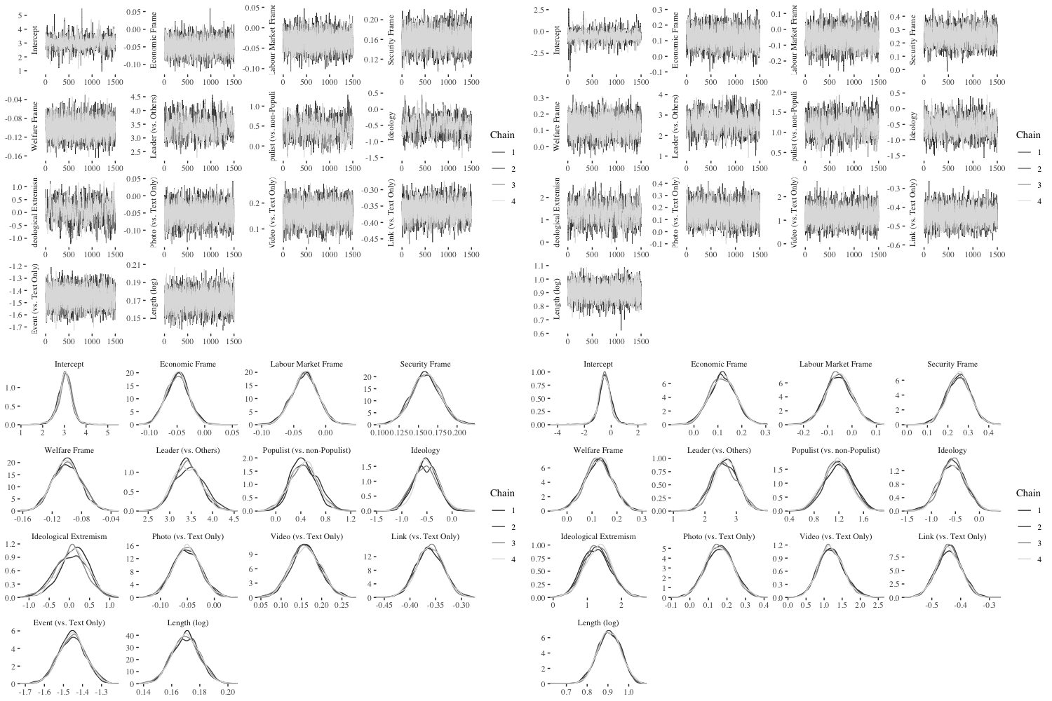

*Notes: Trace plots indicate a good mixture of the 4 Markov Chains. Posterior densities show that parameters are distributed roughly normally.*

**Figure A2. MCMC Trace plots and Posterior Parameter Densities (Model 2 & 4)**

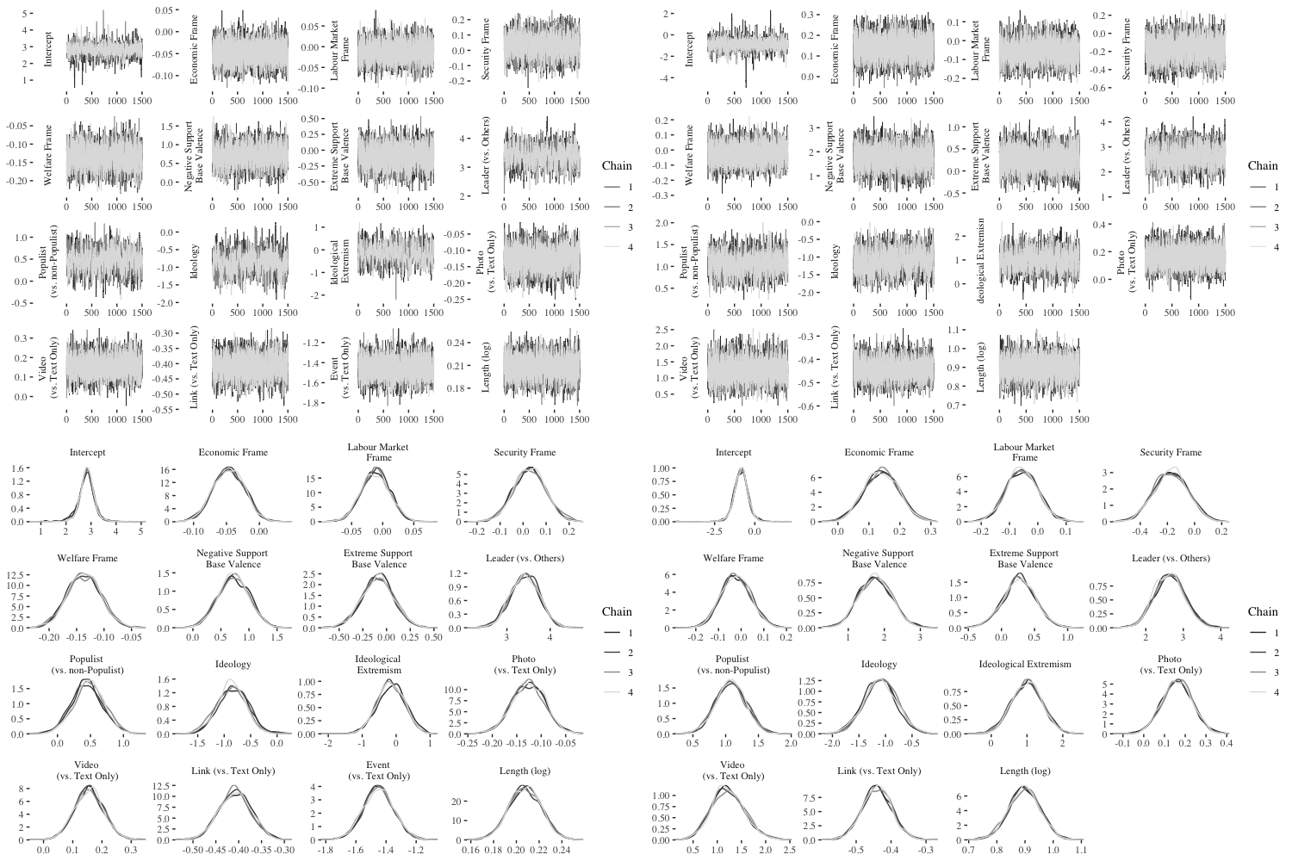

*Notes: Trace plots indicate a good mixture of the 4 Markov Chains. Posterior densities show that parameters are distributed roughly normally*

**References Appendix**

Koby, G. S., Fields, P., Hague, D. R., Lommel, A., & Melby, A. (2014). Defining translation quality. *Revista tradumàtica: traducció i tecnologies de la informació i la comunicació, (12)*, 413-420.

Volkens, A., Lehmann, P., Matthieß, T., Merz, N., Regel, S., & Werner, A. (2015). The manifesto data collection: Manifesto project (MRG/CMP/MARPOR, Version 2015a) [Computer software]. Berlin, Germany: Wissenschaftszentrum Berlin für Sozialforschung.