Supplementary Materials 3
Interacting thresholds per case study and synthesized results for all case studies.

BE-Dairy
Below, we show a representation of interacting thresholds when farm income is trespassing a tipping point on a majority of individual dairy farms. If the milk price is low for a considerable period of time, farm income will drop. As a result, fewer young farmers will take over the farm. However, this will make land available for remaining farmers, which allows scale enlargement on these farms. Depending on the extent to which this increase in scale also results in an increase in the number of cows and hence more environmental pressure at the farming system level, it may become difficult for instance to meet the target to reduce greenhouse gas emissions. More environmental pressure may lead to a damaged public image of the dairy sector. Nevertheless, these interactions are also influenced by many cross-compliance conditions, which are not shown in the figure below for reasons of simplification. If, for example, the land of stoppers does not remain in the farming system, scale enlargement at individual farms and also at sector level will not occur.

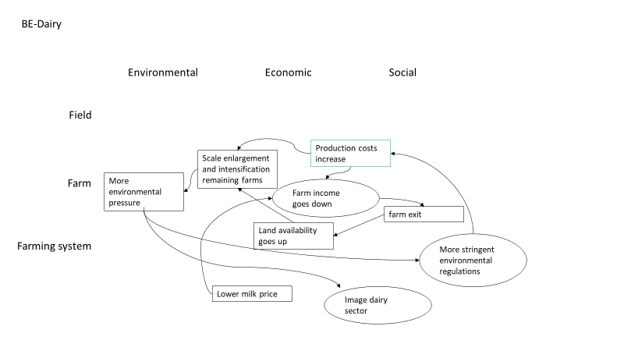
Figure SM3.1. Interacting thresholds across domains and levels of integration in BE-Dairy.

BG-Arable
Essential for the level of grains’ productivity are weather conditions and in the case of North East Bulgaria drought is very relevant as a consequence of global climate changes. At field level it reduces the yields, respectively the overall harvest at farm level. Having in mind that the irrigation system in the region is compromised, farmers do not have many buffers to overcome negative effects when productivity drops with more than 20%. There is still the possibility for farmers to decrease the negative consequences if the farm fields are spread on a territory large enough to have different weather conditions. Also implementing innovations could help. Following that farmer’s net income decreases and if the overall net farm income decreases by 50% (price volatility may accelerate the negative results), the farmers are expected to adapt or transform the farm. If the climate changes continue to deepen for a longer period of more than 5 years, it will become impossible for the system to preserve its current levels of production and the result will encourage farmers to quit their farming activities. Simultaneously, the farm sector attractiveness will decrease as well as willingness of new generation to continue running farm which at farming system level lead to decrease in farm population and rural population as well. Rural depopulation is a major factor in destroying different services’ systems, e.g. school closure, temporary health services offered several days in a week, infrastructure deterioration etc. which aggravates the labor force availability and quality.

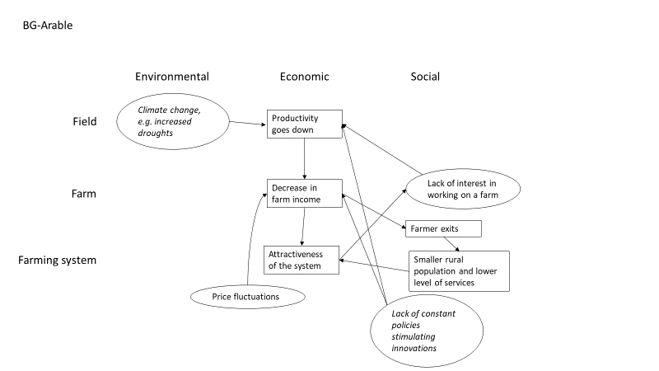
Figure SM3.2. Interacting thresholds across domains and levels of integration in BG-Arable.

DE-Arable&Mixed
One of the most likely major challenges for the future of the farming system in the Altmark is an increase in extreme weather events, particularly droughts due to climate change. An exceedance of the threshold for climate change would most likely drastically increase the water stress for cereal production in the region and might result in considerable harvest losses. The resulting reduction in yield would directly negatively impact the economic viability of farms. In this scenario of exceedance of the threshold for water availability, highly specialized crop farms might show less ability to adapt to the stress than mixed farms which also gain their income from other income sources. Hence, crop farms with a low share of farm-owned production factors (family labor, owned land) and/or no other income sources such as livestock production, tourism, direct marketing or other branches, might be less resilient (robust) towards extreme weather events because they would be hidden too strongly by the economic shock of harvest loss. The already existing challenge of low prices and high costs would be reinforced by the negative economic effects of climate change. If the farms’ financial situation deteriorates further, their ability of response diversity and farm investment also reduces. Since these are important resilience attributes, their overall resilience would be further negatively affected and their capacities to adapt undermined.
High costs in combination with a poorly developed infrastructure reduce the economic viability and response diversity of farms. This has a negative effect on the attractiveness of the area. Attractiveness of the area is also directly impacted by the poorly developed infrastructure. Reduced attractiveness of farming might show effects on the availability of workers in the farming system. Finally, the anticipated dropout of the less robust and adaptive farms might be accompanied with a reduction in farm employment possibilities in the region.
The frequent changes in policies and regulations (a challenge not represented in the figure below) have been a source of insecurity towards future perspectives in the sector and hence posed a challenge in the past years. Due to these insecurities on what to count for in future, workshop participants stated to be more reluctant to undertake important investments in the modernization of their farms that could help to improve economic viability.
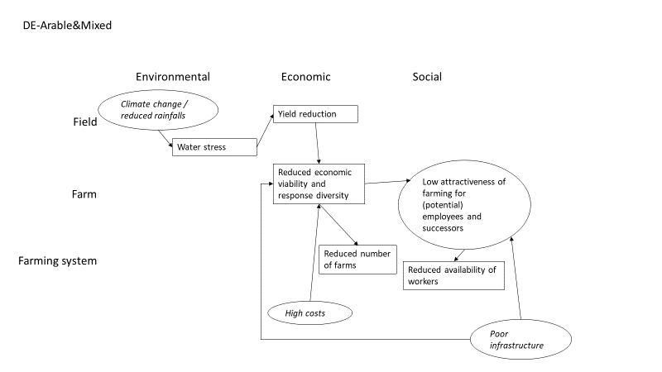
Figure SM3.3. Interacting thresholds across domains and levels of integration in DE-Arable&Mixed.

ES-Sheep
In ES-Sheep, interaction of thresholds across domains and scales results in a vicious circle, which explains the expected decline in system functioning when critical thresholds are approached and exceeded. Gross margin, the main indicator of the system, plays a pivotal role in the interaction of thresholds. The gross margin affects the number of farms and, consequently, the number of sheep in the area. The reducing number of sheep in the region negatively affects the function indicator “food production” and the resilience attribute “Coupled with local and natural capital”, related to the maintenance of landscape structure through sheep grazing. The decreasing number of sheep leads to shrub encroachment, biodiversity loss and increased risk of fires.
Three main challenges impact on gross margins: i) The reducing lamb meat consumption: The profitability depends of incomes from lamb meat sales, which have drastically decreased in the last years; ii) The reducing public aids. The profitability of ES-Sheep farming system also depends on CAP payments, which have shown a downward trend in the last years; and iii) The increasing feeding costs, mainly explained by the limited access and availability of pastures that force farmers to stable the animals and feed them with fodders and grains instead of pastures as free input. The limited access to pasturelands also reduces the environmental contribution of the extensive farming, and thus, hinders the “Coupled with local and natural capital” resilience attribute.
Reduced gross margins diminishes the attractiveness of the sector and leads to a lack of workers that in turn encourages the closure of the remaining farms. Furthermore, the lack of workers and families in the region reduce the attractiveness of the rural area and hence its population.

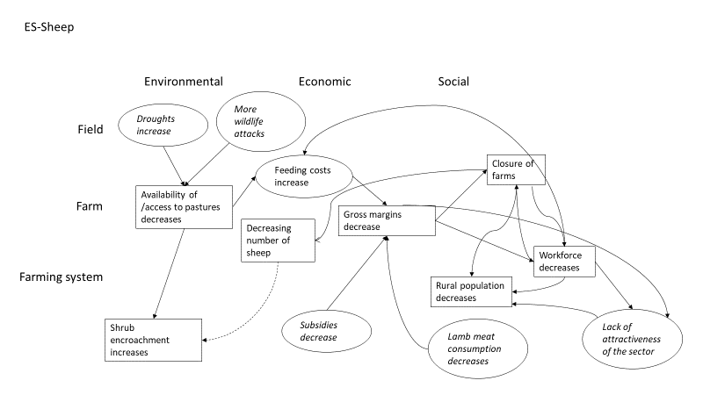
Figure SM3.4. Interacting thresholds across domains and levels of integration in ES-Sheep.

FR-Beef
The most important interaction between thresholds in the system is between decreasing willingness of consumers to pay and high expectations of farmers’ practices, which has a strong impact on the economic viability of farms. The low willingness to pay of the consumers lowers the economic viability of the system. For this reason, many farmers will likely quit, lowering the population of farmers at the farming system level. The maintenance of the landscape will be lowered because of the reduced budget of farmers and a decrease in the rural population. At its turn, the low level of landscape maintenance will exacerbate the negative impression of the consumer who will have its expectation deluded and will lower their willingness to pay. Increased frequencies of droughts are expected to increase costs for purchasing feed, which further reduce the economic viability.

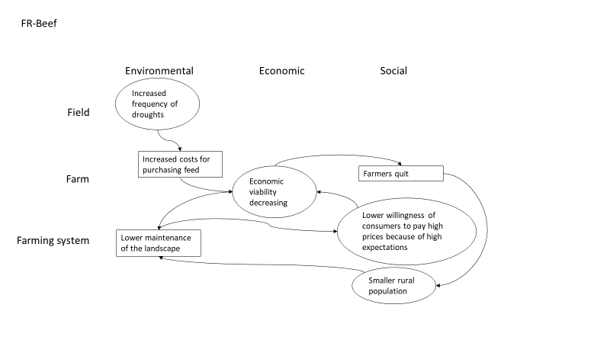
Figure SM3.5. Interacting thresholds across domains and levels of integration in FR-Beef.

IT-Hazelnut
Figure 1 reports the cascading scales effects starting from four challenges (in circle boxes): greater eco-friendly requirements, extreme weather events such as drought, phytopathology and the power of the confectionery industry.
If phytopathology and extreme weather events, such as droughts, exceed a critical threshold, the yields of the hazelnut crop will decline, and production costs will increase. This leads to the system's profitability decline and the economic viability consequently decreases. This is because hazelnut is the “engine” of the FS and it is the only crop currently capable to support adequately rural life, for lack of profitable alternatives. Decreasing profitability may lead young people to exit from the system. Furthermore, this will increase the instability of economic performances. Both challenges potentially have negative consequences on the environment because this may require an increase in the use of chemical inputs and irrigation water. Both are expected to have negative consequences on natural resources.
The growing power of the confectionary industry is often seen as a threat because of the high degree of negotiating power it holds. This results in defining parameters in the marketing of the product (prices and quality standards). Note that the growing quality standards (i.e. limited share of nuts affected by insects and large size of the kernel) are reinforcing the potential effects of the previous two mentioned challenges. Indeed, to fulfil these standards, farmers have to better control insects and to avoid the effects of drought. Because of this, the growing quality standards are perceived as preventing the use of more environmental-friendly practices, including organic production. Thus, the provision of environmental public goods is potentially threatened especially because of the reinforcing effects of the three mentioned challenges.
Furthermore, the concentration of the confectionery industry is the result of positive market development. This has ensured a stable and growing demand for raw hazelnut from the downstream industry. While this is positive for the system, it also makes the system prompt to satisfy the requests and needs of the buyers. And the local downstream operators, especially POs, have been very capable to do so ensuring relatively positive results for the associated farmers. However, by adapting to its protocols, the FS reduces its autonomy making it less stable in case of sudden changes in the strategies of the industries. The stakeholders are now considering whether shifting to a local valorization of the product could be needed to increase the autonomy of the system and enlarge the portfolio of buyers.
The relevant growth in the last decades of hazelnut production, both in terms of quantity and quality, brought the FS near to a crucial point: whether to continue on the path of intensification, following the demand of the multinational confectionery industry or to be more sustainable environmentally by intensifying the connection with local natural resources. In this regard, the perceived negative effects of the previous challenges on the environment and natural capital in general, many stakeholders – especially environmental groups and some municipalities - are taking action in demanding eco-friendly requirements from the FS. The greater eco-friendly requirement is a new challenge for the system. On the one hand, it could lead the system to incur higher production costs due to the adoption of eco-friendly practices (e.g., pest integrated management or ground cover to replace the use of chemicals) which somehow could limit yields and reduce profitability (with effects on the economic viability of the FS). Furthermore, this limits the expansion of the crop that is occurring. On the other hand, some stakeholders believe that the shift to more eco-friendly production patterns could be managed in a way to benefit the system. This will be the case if the shift to environmentally friendly production techniques is promoted, consumers are informed, and they are willing to pay a higher price. This strategy, if correctly implemented, could have a twofold positive effect: it allows increasing the economic viability of the system, its autonomy and the provision of public goods provided by the FS (Figure 1).
However, the confectionery industry is not pursuing any strategy in this direction and most hazelnuts are not processed locally. Hence, this valorisation strategy could be implemented only with the active participation of the confectionery industry, or according to the ability of the FS to develop a successful marketing strategy.

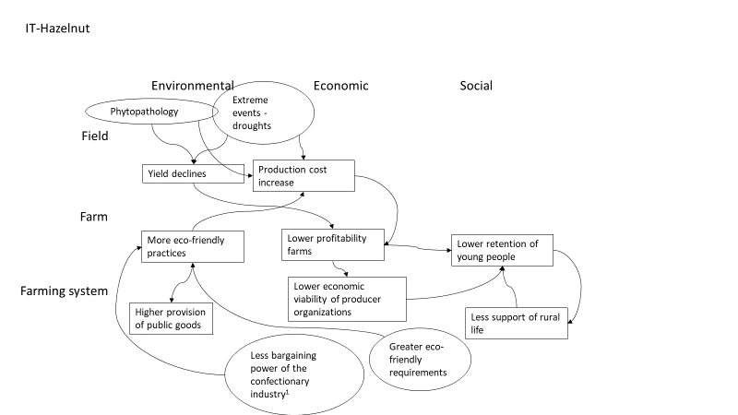
Figure SM3.6. Interacting thresholds across domains and levels of integration in IT-Hazelnut.¹Actually, the power of the confectionary industry is increasing and thus impeding the implementation of eco-friendly practices.

NL-Arable
In NL-Arable, a narrow crop rotation, which is essential for the profitability of the starch processing cooperative, increases nematode pressure. When pressure becomes higher, yields will reduce. Without further interventions, yields can go below the critical threshold of around 40 ton per hectare. This will reduce the revenue of farmers directly (less tons), and indirectly via a lower price when profitability of the cooperative goes down. When economic viability goes below a certain threshold (e.g. expressed in net profit per ha), farmers will grow less starch potatoes, provided there are good alternatives, thus further reducing the supply of starch potatoes to the cooperative. In case there are no good alternative crops, availability of successors will decline and more farmers will quit the farming system. At the farming system level this leads to a smaller rural population. When profitability is going down, the starch potato processing cooperative will have to re-organize and reduce in size at some point. This was also indicated as a possible option by de Bont et al. (2007) after the changing CAP legislation in 2013, provided that remaining starch products would be sold for a higher price. Kinzig et al. (2006) found a similar interaction for one out of three dairy processing plants in a region in Australia that closed when volume at regional level went below a critical threshold. The re-organization of the starch processing cooperative would reduce the need for the large share of starch potato area in the region, which would widen the rotation. Reducing the starch potato processing facilities would reduce the number of jobs in the region, leading to a further decline of the already shrinking rural population (Kuhlman et al., 2012). Smit, working for Wageningen Economic Research and over the past involved in multiple studies in the Veenkoloniën and Avebe, (2019; personal communication) estimated that re-organization of the cooperative would be necessary when the area with starch potatoes becomes less than 30,000 ha, in case of a rotation of around 1:3 or land being taken out of production, resulting in a supply reduction of 25% compared to the current level. This level corresponds more or less with the thresholds mentioned in the workshop.
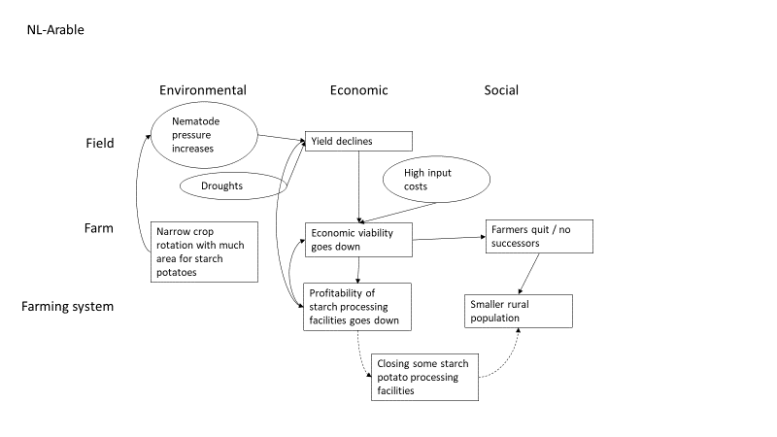
Figure SM3.7. Interacting thresholds across domains and levels of integration in NL-Arable.

PL-Horticulture
Key factors influencing the production processes are the extreme weather conditions and purchase prices for agricultural products. In case of the weather conditions, the extreme events impact the yield and harvested output, therefore influencing the farm income, which was constantly emphasized upon by the participants. On the economic side, the fluctuations and frequent drops in purchase prices for agricultural products affect economic viability, as harvested outputs may be lower due to two reasons: 1) expecting lower prices farmers tend to cultivate less, thus not supplying the demanded product volumes (there’s a substantial time lag in agriculture which limits possibility of quick farmers’ responses to demand changes), 2) understanding the potential losses, farmers might not harvest the cultivated crops in order to avoid additional labor expenses (in such cases the harvest is just left on the field to rot, thus not enabling the farmers to make expected profits). Lower yields in combination with price drops lead to a decreased income at farm level. Low income at farm level results in lower remuneration of laborers. This directly affects labor shortage and decrease in attractiveness of farming in general. The lower remuneration level in the countryside, also leads to further reduction of the rural population, which further impacts the availability of labor at the farm level (and in perspective increasing production obstacles for farmers). Attractiveness of farming is further reduced by bureaucracy and variability of regulations.
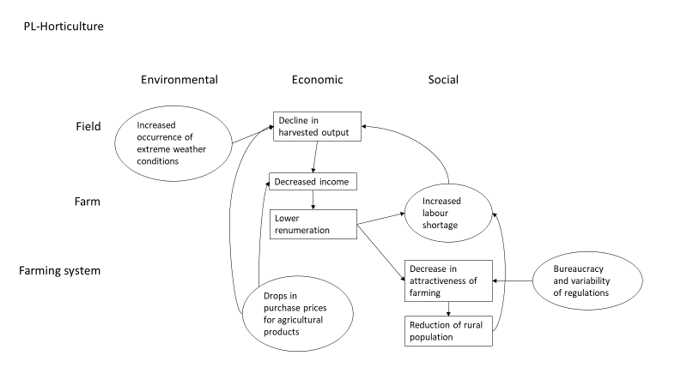
Figure SM3.8. Interacting thresholds across domains and levels of integration in PL-Horticulture.

RO-Mixed
Climate changes, particularly drought, result in significantly lower agricultural yields. A reduced level of output diminishes even more the volume of sales, since in most small farms part of the output is consumed on farm. Moreover, the participants emphasized that drought increased in frequency lately, generating additional costs with inputs needed to combat its effects (such as irrigation, drought-resistant crop varieties). The result is a lower economic viability at farm level.
The reluctance to cooperation (characteristic for the farming system in the region) results in a low level of supply concentration, leading to poor integration of the small mixed farms in agri-food chains. Also, prices for domestic agricultural products have decreased as competition from cheaper EU-imported agri-food products has intensified. Thus, lower sales and prices also contribute to the decrease of economic viability of the farms.
The low profitability of small-scale agriculture makes this activity unattractive for potential successors, which are looking for better occupational alternatives in urban areas or abroad. The migration of the young rural population (which, in general, has a higher level of education) generates a deficit in the labor market that, implicitly, translates into an increase of labor costs in the farm system.
Higher prices of agricultural inputs and labor result in a declining trend of input quantities used in the farms, and possibly also to declining yields. These combined trends have a negative influence on the profitability of small-mixed farms.
The participants pointed out that the rules and regulations (European and national) are changing too often, and also that the legislation is oriented mostly to the needs of large farms, and not of the small farms which are the vast majority, thus contributing to the low attractiveness of the rural area and the lack of successors in farms.

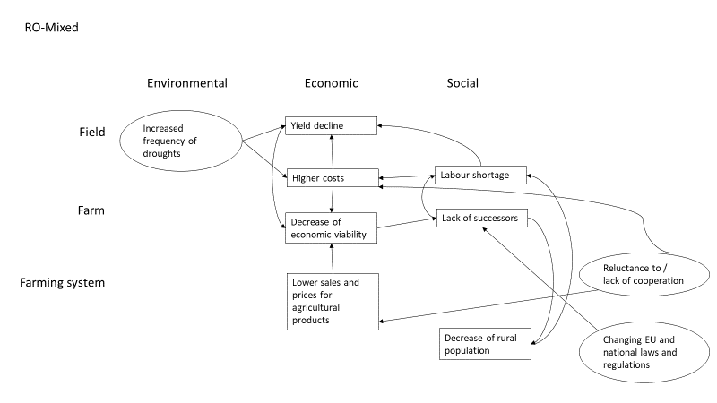
Figure SM3.9. Interacting thresholds across domains and levels of integration in RO-Mixed.

SE-Poultry
Figure A5.10 shows the interacting thresholds across domains (environmental, economic and social) and levels of integrations (field, farm, and farming system) in the Swedish egg and broiler sector. Findings show that the economic performance is central, linked to environmental and social failures, at all levels.
Failing to maintain the economic performance (e.g. profitability, viability) disables the farms and the farming system to adapt to new technologies and regulations. That undesirable state affects the supply of high quality poultry products and technology adaptations to satisfy animal welfare, -health and environmental requirements for maintaining the natural resources in good conditions, experimentation in innovative approaches. Low economic performance might initiate farming system transformation, and provision of alternative goods.
Low economic performance also decreases the interest in farming, and consequently availability of labour. Being a farmer it is not seen as an attractive decision for the successors, nor as an attractive employment for the potential employees.
Swedish has high national standards and regulations on animal welfare, health, and environment, leading to high production costs. Differences in the regulations for product quality across the EU decreases the price competitiveness of the Swedish production, thus prevent the Swedish producers to grow and export. Given the price constraints both the egg and the broilers productions are oriented for the domestic market. Higher production costs and thereby market prices make the products less affordable for the consumers. Exceedance of thresholds have lower impact on the domestic demand, thus the expectation is that the farming system will not change significantly. Yet, the domestic demand seemed to be more affected for the broiler sector, as cheaper imported chicken produced under weaker regulation can enter the market. Swedish egg producers benefit from the requirement that eggs imported to Sweden need to be salmonella-certified (Regulation NR 1688/2005). Overall, exceedance of these thresholds is perceived to have moderate negative effect on the farming system performance, predominantly with low price competitiveness at the EU market (egg and broilers production), and constraints in price competitiveness for the broilers production for the domestic market.
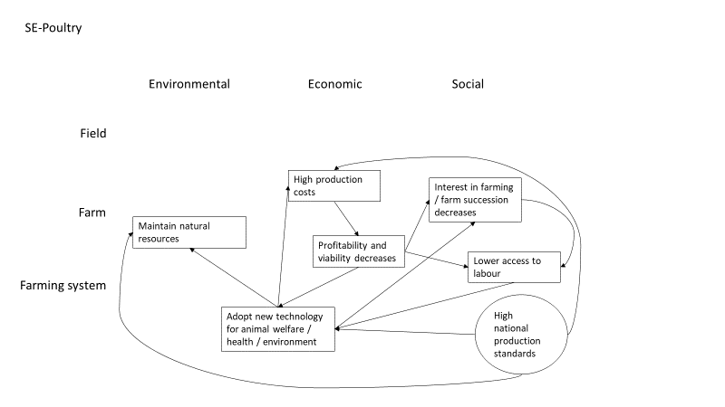
Figure SM3.10. Interacting thresholds across domains and levels of integration in SE-Poultry.

UK-Arable
Increased pressure from challenges is expected to lead to decline and system failure through greater social isolation, farmers dropping out of farming, degraded natural capital, loss in profitability and poor political support in UK-Arable (Figure A5.11). This could eventually lead to a decline in arable farming or much more intense systems with very few farmers. The strain on the natural capital and isolated farmers could then cause system collapse.
The current system is dominated by both environmental and political challenges. A lack of political support across the indicators could lead to the described system decline, including the environmental challenges. In this way, it is the most important challenge currently facing UK arable farmers. Lack of political support is seen through uncertainty in Brexit negotiations in respect to agricultural product trade deals, lack of overarching independent advisory systems and low environmental stewardship payments, making it unworthwhile for farmers to transition to more sustainable practices. Environmental challenges including climate change are more difficult to predict the timing of, although we are already experiencing great pressure from this. For example, spring droughts and wet autumns have been an issue for crop establishment and harvesting / cover crop or winter wheat planting, respectively. However, this could lead to system collapse eventually if farmers are not supported to better protect and to enhance natural capital.
A compounding issue is the archaic land owenrship system, which allows little access to land for new entrant farmers, whilst tenant farmers are locked in to short-term contracts by lnad owners, disincentivising long-term thinking or management.
The indicators / variables used were enough to highlight the challenges encompassing the whole farming system as it currently stands.
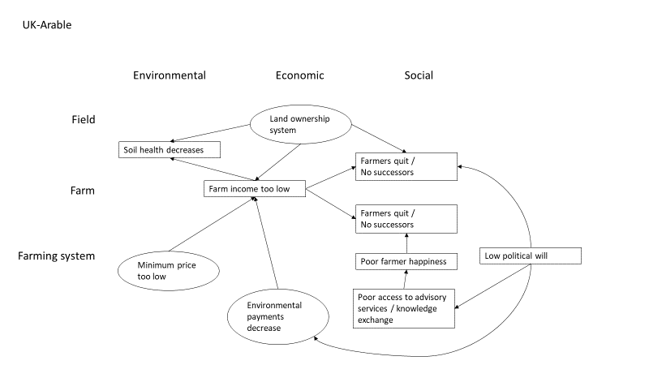
Figure SM3.11. Interacting thresholds across domains and levels of integration in UK-Arable.

