Supplementary materials

Annex 1. Sampling
Surveyed households and farms were selected through a two-stage sampling process, with first sub-district (selskii okrug (SO)), and then farmers and households sampled at random using different methods. Firstly, lists of registered individual farms (kristianskoe khozaistvo) covering the districts of interest were obtained. Fifteen clusters of 13-14 farms were selected over the list of SO using probability according to size based on farm numbers from the list. Two SO were very large and were represented by two clusters – i.e. 26 farms, reducing the final number of selected SOs to 13. The 13-14 farms in each cluster were selected at random from the lists, to bring the total to 200, each with an equal probability of selection. Concerning households, lists were not available so these were selected by visiting three or four houses at random in each cluster to bring the total number of sampled households to 50. In the field, the sample had to be adjusted in order to find enough available livestock-owning farms in Enbekshikazakh district. To this end, more than the original selected sample of two SO had to be sampled in that district, giving a total of 16 SO in the final sample: five in Enbekshikazkah and eleven in (former) Raiymbek district, which was in the process of division into two districts named Kegen and Raiymbek. Because households and farms are taken from two different sampling frames, all data for households is presented separately from those of farms.

Annex 2. Results of PCA
Five components with eigenvalues above one were obtained explaining around 85% of the total variance (Table A2.1). These factors corresponded to (i) scale – livestock and pasture ownership; (ii) Purchase of concentrate (iii) Self production of roughage (iv) Use of remote pasture and (v) access to cropland and self-production of concentrate (Table A2.2). Figure A2.1 presents plots of the PCA component scores against each other, with the farm production strategy clusters highlighted in different colours. Figure A2.2 presents equivalent examples of the use of (standardised) raw variables instead of PCA component scores, highlighting the improved discriminatory power of the PCA components.

Table A2.1. First five components after varimax rotation

Component | Variance | Difference | Proportion | Cumulative
1 | 2.251 | 0.693 | 0.250 | 0.250
2 | 1.558 | 0.012 | 0.173 | 0.423
3 | 1.546 | 0.371 | 0.172 | 0.595
4 | 1.175 | 0.024 | 0.131 | 0.726
5 | 1.151 | . | 0.128 | 0.853

Table A2.2 Contribution of variables to main principal components analysis factors (only contributions of over +/-0.3 are shown)

Meaning of component | Livestock & pasture ownership/use | Purchase (& non-production) of concentrate | Self production (& non-purchase) of roughage | Use of remote pasture | Cropland area & self production concentrate | Unexpl-ained
Component number | 1 | 2 | 3 | 4 | 5
Cattle | 0.666 |  |  |  |  | 0.098
Livestock Unit | 0.641 |  |  |  |  | 0.082
Pasture | 0.358 |  |  | 0.365 |  | 0.315
Cropland |  |  |  |  | 0.910 | 0.054
Concentrate purchased /head |  | 0.798 |  |  |  | 0.112
Concentrate self produced / head |  | -0.585 |  |  | 0.332 | 0.162
Roughage purchased / head |  |  | -0.685 |  |  | 0.217
Roughage self produced /head |  |  | 0.702 |  |  | 0.211
Months spent on remote pasture |  |  |  | 0.921 |  | 0.068
Rotation: Varimax normalized. Kaiser–Meyer–Olkin=0.67; lowest value 0.57; Bartlett χ2 732 (P:0.000).

Figure A2.1 PCA score plots: component 1 on y axis and other components on x axis, with production strategy clusters (generated from PCA scores) indicated in different colours
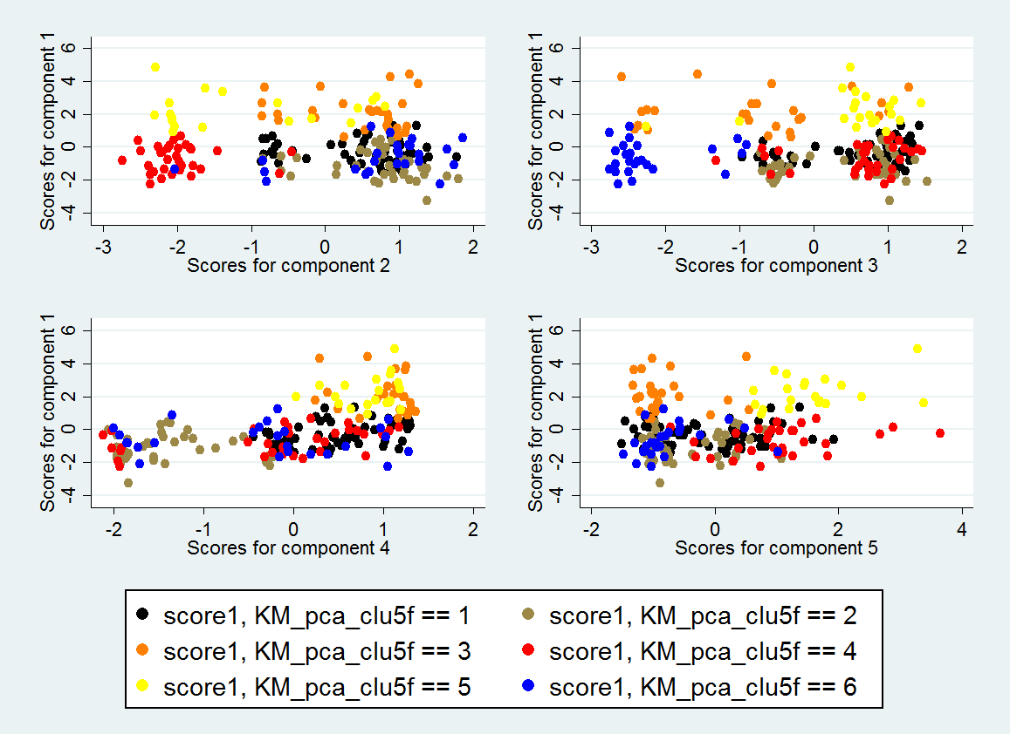

Figure A2.2 Raw logged and standardised variables plotted against cattle ownership with production strategy clusters (generated from these raw variables) indicated in different colours
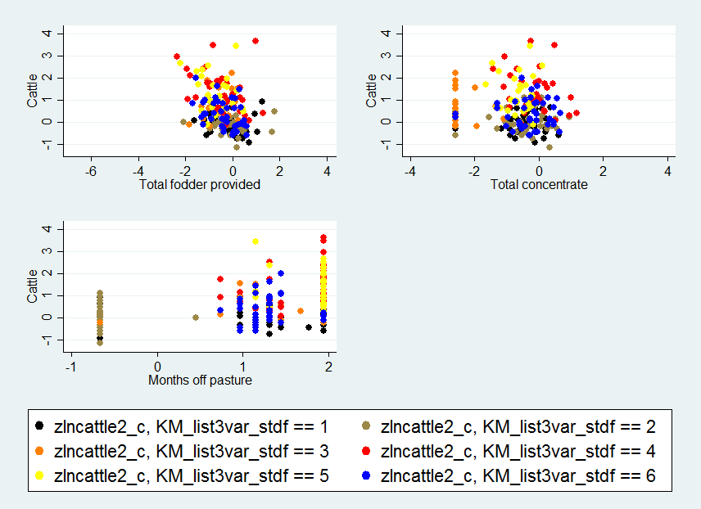

Annex 3. Results tables not shown in the main body
Table A3.1. Farm characteristics by household and farm quartile (sample means including zero observations unless specified in notes)
Variable |  | Household or farm (cattle ownership) quartile |  |  |  |  |  | Relation to herd size^{α}
 |  | HH | Q1 | Q2 | Q3 | Q4 | Farms
 | N | 50 | 56 | 49 | 45 | 50 | 200 | βlncattle
Livestock | Cattle (head) † | 9 | 8 | 14 | 24 | 85 | 33 | 1.000***
 | Cattle (head, range) | 1-39 | 3-10 | 11-18 | 19-30 | 31-395 | 3-395
 | Sheep & goats (head) | 20 | 36 | 51 | 82 | 363 | 132 | 1.007***
 | Livestock units†† | 66 | 89 | 133 | 223 | 891 | 330 | 0.987***
 | Proportion of cattle in LU | 0.60 | 0.47 | 0.48 | 0.52 | 0.48 | 0.49 | -0.003
Land | Cropland (ha) | 1.2 | 3.5 | 12.3 | 5.9 | 21.4 | 11 | 0.276***
 | Hayland (ha) | 4.2 | 3.8 | 12.6 | 13 | 29.3 | 14 | 0.466***
 | Cropland/ head cattle (ha) | 0.28 | 0.42 | 0.82 | 0.24 | 0.34 | 0.46 | -0.055*
 | Hayland+cropland /head (ha) | 0.99 | 0.92 | 1.64 | 0.76 | 0.71 | 1.01 | -0.091**
 | Crop/hayland lease (1/0) | 0.40 | 0.57 | 0.78 | 0.67 | 0.82 | 0.70 | 0.447**
 | Pasture (ha) | 6.4 | 21.3 | 52.5 | 85.2 | 259.9 | 103 | 1.350***
 | Pasture contract (1/0) | 0.10 | 0.50 | 0.61 | 0.71 | 0.84 | 0.66 | 0.847***
 | Pasture area per LU (ha) ¤ | 0.52 | 0.53 | 0.60 | 0.49 | 0.42 | 0.5 | -0.082
Fodder (kg/head/year) | Total fodder | 2121 | 2155 | 1807 | 1378 | 1165 | 1742 | -0.206***
 | Roughage, total | 1709 | 1990 | 1572 | 1260 | 1005 | 1477 | -0.215***
 | Concentrate, total | 412 | 164 | 236 | 118 | 160 | 170 | -0.114
 | Concentrate, purchased | 369 | 111 | 85 | 86 | 92 | 94 | -0.216
 | Concentrate, self-produced | 43 | 53 | 151 | 32 | 68 | 76 | 0.013
 | Roughage, purchased | 701 | 559 | 339 | 463 | 440 | 454 | 0.008
 | Roughage, self-produced | 1008 | 1432 | 1232 | 797 | 565 | 1023 | -0.466***
 | Quality (protein/kg fodder) | 90 | 110 | 100 | 110 | 110 | 107 | 0.0012
Mobility | Months on remote pasture | 2 | 4 | 5 | 7 | 9 | 6 | 0.37***
 | Remote pasture winter (1/0) | 0.04 | 0.13 | 0.16 | 0.40 | 0.64 | 33 | 1.14***
 | Remote pasture summer (1/0) | 0.28 | 0.57 | 0.63 | 0.84 | 0.92 | 73 | 1.13***
 | Any mobile stock (1/0) | 0.28 | 0.57 | 0.61 | 0.84 | 0.88 | 72 | 0.951***
Sales | Cattle (1/0) | 0.44 | 0.27 | 0.51 | 0.71 | 0.64 | 0.52 | 0.767***
 | Milk (1/0) | 0.10 | 0.04 | 0.12 | 0.16 | 0.06 | 0.09 | 0.089
 | Milk products (1/0) | 0.04 | 0.04 | 0.08 | 0.11 | 0.14 | 0.09 | 0.616**
 | Beef (1/0) | 0.10 | 0.05 | 0.08 | 0.13 | 0.18 | 0.11 | 0.614***
 | Carcass weight  at sale bullocks (kg)¤¤ | 139 | 146 | 138 | 166 | 192 | 166 | 28.8***
*** p<0.01, ** p<0.05, * p<0.1 . All data skewed and over-dispersed except proportion of cattle in LU and bullock weight.
^{α}Slope coefficients of regressions of log of cattle ownership against outcome variables. For carcass weight, cattle as proportion of LU and land variables (the last of which were log transformed), OLS regression was employed; for counts of livestock numbers, months on pasture and kg fodder, negative binomial regressions were used. For binary outcomes, logistic regression was employed.
† Variable used to create quartile.
†† Livestock units based on Kazakh sheep equivalents (sheep & goat = 1 LU, horse = 6 LU; cattle = 5 LU). Cattle coefficient adjusted for age using coefficients from Eurostat.
¤ Those with titles or contracts for pastureland indicating area only, n=132, no zeros are included.
¤¤ Sellers only, N=48, no zeros.

Table A3.2. Binary indicators (0/1) of land access and feeding intensity by production strategy cluster and scale
 |  |  | HH | 1: Small sedentary | 2: Medium mobile | 3: Medium fodder purchaser | 4: Medium fodder producer | 5: Large mobile fodder purchaser | 6: Large mobile fodder producer | Farms | Pearson’s  chi2# | Βlncattle^{α}
 |  | N | 50 | 40 | 56 | 25 | 32 | 27 | 20 | 200 | χ2 | β
Fodder provision | Concentrate | Any | 0.84 | 0.84 | 0.84 | 0.88 | 1 | 0.81 | 0.95 | 0.89 | 7.8 | -0.009
 |  | Purchased | 0.76 | 0.76 | 0.84^{+cv} | 0.84 | 0.06^{-cv} | 0.81 | 0.35^{-cv} | 0.68 | 86.0*** | -0.193
 |  | Self-produced | 0.1 | 0.1 | 0.04^{-cv} | 0.04 | 1^{+cv} | 0%^{-cv} | 0.7^{+cv} | 0.25 | 157.0*** | 0.202
 | Roughage | Any | 1 | 1 | 1 | 1 | 0.97 | 1 | 1 | 1 | 5.28 | 0.213
 |  | purchased | 0.72 | 0.72 | 0.27 | 1^{+cv} | 1^{-cv} | 0.81^{+cv} | 0.1^{-cv} | 0.42 | 74.5*** | 0.029
 |  | self-produced | 0.56 | 0.56 | 1^{+cv} | 0.2^{-cv} | 0.97 | 0.7^{-cv} | 0.95 | 0.85 | 109.4*** | -0.039
 | Cultivated hay | Any | 0.32 | 0.32 | 0.61 | 0.48 | 0.75 | 0.41 | 0.85 | 0.59 | 15.35*** | 0.054
 |  | purchased | 0.16 | 0.16 | 0.07 | 0.48^{+cv} | 0%^{-cv} | 0.33-^{cv} | 0.05 | 0.14 | 41.26*** | 0.221
 |  | self-produced | 0.2 | 0.2 | 0.57 | 0.08^{-cv} | 0.75^{+cv} | 0.26 | 0.8^{+cv} | 0.5 | 40.34*** | 0.07
 | Natural hay | Any | 0.88 | 0.88 | 0.79 | 0.76 | 0.66 | 0.93 | 0.8 | 0.8 | 7.58 | 0.144
 |  | purchased | 0.58 | 0.58 | 0.2 | 0.68^{+cv} | 0.16 | 0.7^{+cv} | 0.05^{-cv} | 0.34 | 46.58*** | -0.016
 |  | self-produced | 0.44 | 0.44 | 0.68 | 0.12^{-cv} | 0.63 | 0.52 | 0.75 | 0.6 | 31.9*** | 0.083
 | Silage | Any | 0.06 | 0.05 | 0.05 | 0 | 0 | 0.15 | 0 | 0.04 | 0.54 | 0.54
Land access | Cropland | Any access | 0.8 | 0.85 | 0.88 | 0.84 | 0.97 | 0.67 | 1 | 0.86 | -0.262 | -0.262
 |  | Any lease/sublease | 0.2 | 0.33 | 0.55 | 0.16^{-cv} | 0.88^{+cv} | 0.19^{-cv} | 0.95^{+cv} | 0.5 | 62.0*** | 0.15
 |  | State lease† | 0.12 | 0.3 | 0.41 | 0.16^{-cv} | 0.78 ^{cv} | 0.19^{-cv} | 0.9 ^{cv} | 0.44 | 50*** | 0.18
 |  | Sublease †† | 0.08 | 0.03 | 0.14 | 0 | 0.09 | 0 | 0.1 | 0.07 | 10.3* | 0.18
 | Hayland | Any access | 0.52 | 0.85 | 0.75 | 0.32^{-cv} | 0.81 | 0.67 | 0.75 | 0.71 | 0.179 | 0.179
 |  | Any lease/sublease | 0.26 | 0.38 | 0.36 | 0.12 | 0.34 | 0.41 | 0.2 | 0.32 | 7.9 | 0.23
 |  | State lease† | 0.2 | 0.33 | 0.3 | 0.04 | 0.31 | 0.3 | 0.2 | 0.27 | 8.6 | 0.11
 |  | Sublease †† | 0.06 | 0.05 | 0.05 | 0.08 | 0.03 | 0.15 | 0 | 0.06 | 5.7 | 0.64**
 | Crop /hayland | Any lease/sublease | 0.40 | 0.63 | 0.79 | 0.28-^{cv} | 0.91 | 0.59 | 1^{+cv} | 0.70 | 40.9*** | 0.45**
 |  | Sublease†† | 0.12 | 0.05 | 0.2 | 0.08 | 0.09 | 0.15 | 0.1 | 0.12 | 5.8 | 0.54**
 | Pasture | Any formal contract† | 0.10 | 0.40^{-cv} | 0.75 | 0.44 | 0.50 | 100^{+cv} | 1^{+cv} | 0.66 | 47.3*** | 0.84***
 |  | Sublease†† | 0.12 | 0.03 | 0.18 | 0.16 | 0.09 | 0.07 | 0.00 | 0.1 | 9.8* | -0.68**
#Pearson’s Chi2 test.: *** p<0.01, ** p<0.05, * p<0.1 Superscript +/-cv for binary variables indicates those cells which have Pearson’s residuals greater than critical value with Bonferroni correction (+ or - 2.86), indicating significant contribution to χ2
^{α}Logistic regression against log of cattle ownership, coefficient of ln cattle and significance *** p<0.01, ** p<0.05, * p<0.1
† 49 year leases from the state, or shorter contracts with Forest Department (in the case of pastures and hay)
††Mostly subleasing from other farmers or using land of relatives. In the case of pastures, these figures refer to pasture access in summer only.

Table A3.3. Farm output and animal performance by production strategy†
Cluster |  | Households | 1: Small sedentary | 2: Medium mobile | 3: Medium fodder purchaser | 4: Medium fodder producer | 5: Large mobile fodder purchaser | 6: Large mobile fodder producer | Total  (farms) | Test for overall  difference between groups# | Βlncattle^{α} | N
N |  | 50 | 40 | 56 | 25 | 32 | 27 | 20 | 200 | LR χ2/F
Mean sales (head) | Cattle sold  (including zeros) | 1 | 1⁵⁶ | 3⁵ | 4⁵ | 2⁵⁶ | 17¹²³⁴ | 10¹⁴ | 5 | 47.8*** | 1.1*** | 200
 | Cattle sold (sellers only) | 2 | 3⁵⁶ | 5⁵⁶ | 6⁵⁶ | 5⁵⁶ | 24¹²³⁴ | 16¹²³⁴ | 10 | 53.9*** | 0.86*** | 104
Mean age at sale (months) | Cattle | 16 | 20 | 22 | 23 | 22 | 28 | 22 | 23 | 0.91 | 1.9 | 101
 | Bullocks | 16 | 17 | 17 | 16 | 17 | 17 | 16 | 17 | 0.1 | 0.42 | 48
Mean weight at sale (kg) | Cattle | 130 | 155 | 181 | 183 | 205 | 202 | 206 | 188 | 1.14 | 19.1** | 101
 | Bullocks | 139 | 130 | 150 | 180 | 183 | 157 | 207 | 166 | 2.5** | 28.8*** | 48
Milk yield per cow |  | 707 | 791 | 818 | 897 | 798 | 955 | 942 | 847 | 0.53 | 74.8 | 176
Insufficient fodder (0/1) |  | 0.58 | 0.48 | 0.57 | 0.64 | 0.31 | 0.30 | 0.50 | 47% | 11.96** | -0.39** | 200
# Test for differences between groups as follows: head sold = negative binomial regression on categorical variable cluster, test statistics for likelihood ratio χ2; ages, weights = ANOVA F statistic. Superscripts indicate cluster numbers of significant pairwise comparisons, p<0.05 or below. *** p<0.01, ** p<0.05, * p<0.1.
αCoefficients for regressions with cattle ownership as follows: head sold = negative binomial regressions; age, weights and milk yields = OLS regressions; fodder sufficiency = logistic regressions. *** p<0.01, ** p<0.05, * p<0.1
†Note to Table: Ages and weights were requested as averages for each of the age/sex classes listed in this table. For average age/weight calculations, data were excluded as follows: bullocks >24 months and >300kg; bulls & steers <23 months and >400kg; cows>400kg; calves >200kg. According to these criteria, both bulls and bullocks can both be 24 months old – but these are not the same animals counted twice - some respondents counted animals of 24 months as bulls, others as bullocks. For groups containing multiple age classes (all cattle, males, females) weighted group means were calculated by multiplying the mean weight in each class given by respondents, by the number of animals sold in each class; summing the result across all age/sex in classes to be included in the result (e.g. all male classes) and then dividing by all cattle sold across those classes. This gives average weights weighted by number of animals sold in each age class. The same was done for age in each age/sex class.

Table A3.4. Principal marketing channels for live animals by farm scale (%)
 | HH | Q1 | Q2 | Q3 | Q4 | Farms
N (all) | 50 | 56 | 49 | 45 | 50 | 200
N (sellers) | 22 | 15 | 25 | 32 | 32 | 104
At market/bazaar | 45% | 33% | 36% | 41% | 31% | 36%
To neighbours/friends | 5% | 7% | 0% | 3% | 3% | 3%
Wholesalers, traders | 50% | 60% | 64% | 53% | 53% | 57%
Fattening enterprise | 0% | 0% | 0% | 0% | 3% | 1%
More than one principle destination | 0% | 0% | 0% | 3% | 9% | 4%
Total | 45% | 33% | 36% | 41% | 31% | 36%

Table A3.5. Principal marketing channels by production strategy
 | 1: Small sedentary | 2: Medium mobile | 3: Medium fodder purchaser | 4: Medium fodder producer | 5: Large mobile fodder purchaser | 6: Large mobile fodder producer | Total
N | 40 | 56 | 25 | 32 | 27 | 20 | 200
N (sellers) | 13 | 31 | 16 | 12 | 20 | 12 | 104
At market/bazaar | 31% | 35% | 56% | 25% | 40% | 17% | 13%
To neighbours/friends | 0% | 6% | 0% | 0% | 0% | 8% | 3%
Wholesalers, traders | 69% | 55% | 44% | 75% | 50% | 58% | 57%
Stock fattening enterprise | 0% | 0% | 0% | 0% | 5% | 0% | 1%
More than one principle destination | 0% | 3% | 0% | 0% | 5% | 17% | 4%
Total | 100% | 100% | 100% | 100% | 100% | 100% | 100%

Table A3.6. Frequency of product sales by district and distance from Almaty (farms only)
 | Enbekshikazakh | Kegen | Raiymbek | Total | Pearson’s chi² test# | Logit of sales frequency with km from Almaty βkm
N | 41 | 40 | 119 | 200 | χ2
Sold cattle | 44% | 55% | 54% | 52% | 1.37 | 0.003
Sold milk | 22%^{+cv} | 7%^{-cv} | 5% | 9% | 10.78*** | -.099**
Sold beef | 5% | 15% | 12% | 11% | 2.29 | .0018
Sold milk products | 5% | 10% | 10% | 9% | 1.07 | .005
#Superscript cv indicts adjusted residuals greater than critical value with Bonferroni correction

Table A3.7. Sales channels by geographical location for live cattle
 | HH | Farms |  |  | Total farms
 |  | Enbekshikazakh | Kegen | Raiymbek
N (sample) | 50 | 41 | 40 | 119 | 200
N (sellers) | 22 | 18 | 22 | 64 | 104
Market/bazaar | 46% | 44% | 50% | 28% | 36%
To neighbours/friends | 5% | 0% | 0% | 5% | 3%
Wholesalers, traders | 50% | 50% | 45% | 63% | 57%
Stock fattening enterprise | 0% | 6% | 0% | 0% | 1%
More than one principle destination | 0% | 0% | 5% | 5% | 4%

Figure A3.1. Proportion of farms investing
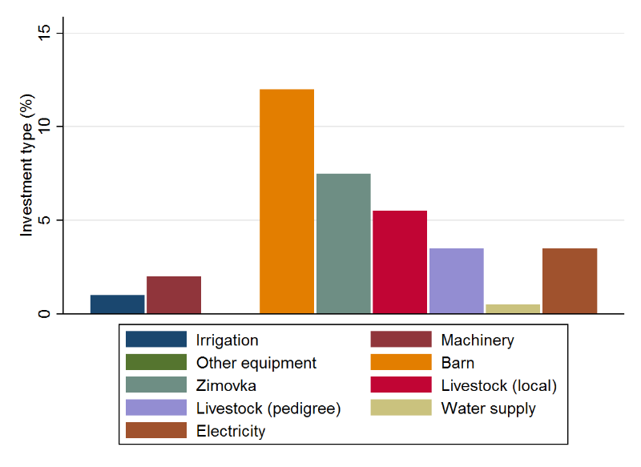
Table A3.8. Selected feeding and grazing indicators by district (means include zeros), farms only
 | District | Enbekshikazakh | Kegen | Raiymbek | Total | Difference between groups#
 | N | 41 | 40 | 119 | 200 | LR χ2, χ2
Livestock | Cattle (head) | 42^{R} | 50^{R} | 23^{EK} | 33 | 27.73***
 | Sheep & goats | 122^{K} | 311 ER | 75^{K} | 132 | 34.04***
 | Livestock units† | 356^{KR} | 630ER | 221ER | 330 | 37.00***
Land (ha) | Arable land | 21^{R} | 10 | 7E | 11 | 12.19***
 | Hayland | 14 | 25^{R} | 11^{K} | 14 | 7.80**
 | Pasture | 56^{K} | 225ER | 78^{K} | 103 | 11.05***
 | Cropland / head cattle | 0.78^{KR} | 0.29E | 0.40E | 0.46 | 7.61**
 | Crop+hayland / head cattle | 1.37 | 0.86 | 0.93 | 1.01 | 3.82
 | Pasture per LU¤ | 0.25 | 0.67 | 0.52 | 0.33 | 4.74**
Fodder  (kg/head/  year) | Concentrate, total | 311^{KR} | 125E | 137E | 170 | 14.15***
 | Roughage, total | 1342 | 1716 | 1443 | 1477 | 2.04
 | Mobility (0/1) | 0.66 | 0.68 | 0.76 | 0.72 | 1.9
*** p<0.01, ** p<0.05, * p<0.1
†Based on standard Kazakh sheep units (sheep & goat = 1 LU, horse = 6 LU; cattle = 5 LU).
#Negative binomial regression against categorical predictor district. Statistics represent LR χ2 test that all model coefficients are zero. Superscripts represent first letter of district name with which pairwise comparisons are significant to P<0.05 or lower. For binary variables (0/1), the figure represents Pearson’s χ2 statistic.
¤ Those with titles indicating area only, n=132

Table A3.9. Self-reported barriers to farm development by farm scale
Farm scale | HH | Q1 | Q2 | Q3 | Q4 | Total (farms) | Logit
 | 50 | 56 | 49 | 45 | 50 | 200 | βlncattle
Pasture | 36% | 30% | 29% | 36% | 40% | 34% | 0.30**
Pasture infrastructure | 2% | 4% | 4% | 0% | 8% | 4% | 0.43
Pasture water | 10% | 7% | 6% | 22% | 6% | 10% | 0.01
Land for growing fodder | 36% | 14% | 14% | 22% | 24% | 19% | 0.30
Other fodder issues | 12% | 11% | 14% | 16% | 14% | 14% | -0.05
Labour | 6% | 9% | 6% | 13% | 8% | 9% | 0.06
Financial | 28% | 21% | 27% | 40% | 22% | 27% | 0.06
Marketing | 6% | 4% | 16% | 13% | 14% | 12% | 0.32
Health | 4% | 2% | 2% | 2% | 0% | 1% | -0.75
Processing | 4% | 4% | 10% | 9% | 2% | 6% | -0.16

