*Supporting Information B: Additional Results and Discussion*

**Fading opportunities for mitigating agriculture-environment trade-offs in a South American deforestation hotspot**

Law, E., Macchi, L., Baumann, M., Decarre, J., Gavier-Pizarro, G., Levers, C., Mastrangelo, M.E., Murray, F., Müller, D., Piquer-Rodríguez, M., Torres, R., Wilson, K., Kuemmerle, T., 2021. *Biological Conservation.*

**CONTENTS:**

Data and code availability: 1

APPENDIX B: ADDITIONAL RESULTS AND DISCUSSION 2

B 1. Alternative visualization of 3D frontiers 2

B 2. Species level results 5

B 3. Past land system configurations, trends and benefits in the study region 8

B 4. Future point scenario allocations and achievements 8

B 5. Sensitivity of results to assumed forest smallholder area of influence 13

Forest smallholder areas of influence: assumptions and uncertainty 13

Forest smallholder transitions: spatial dependencies 23

Implications for the current problem formulation results 25

B 6. Additional land system planning considerations 26

REFERENCES 31

# Data and code availability:

Code and selected data are archived in OSF (DOI 10.17605/OSF.IO/5EJCQ). Further data can be provided at reasonable request.

# APPENDIX B: ADDITIONAL RESULTS AND DISCUSSION

## B 1. Alternative visualization of 3D frontiers

Additional details of the 3D frontier shown in Fig. 3 (main manuscript) can be shown via visualizing the individual 2D frontiers for all scenarios (Figure B1; agricultural profit vs. carbon, agricultural profit vs. biodiversity, and carbon vs. biodiversity). These further emphasize the negative relationships between agricultural profits and biodiversity, and the positive relationships between carbon and biodiversity. Together, these result in a fairly ‘narrow’ three dimensional frontier.

Further insight can be gained by comparing our most flexible scenario (S0) to the more constrained transition scenarios (i.e., more restrictions in terms of allowed transitions between land systems and/or where such transitions can take place) based on the forgone benefits at different agricultural profit and carbon stock target combinations (Figure B2).

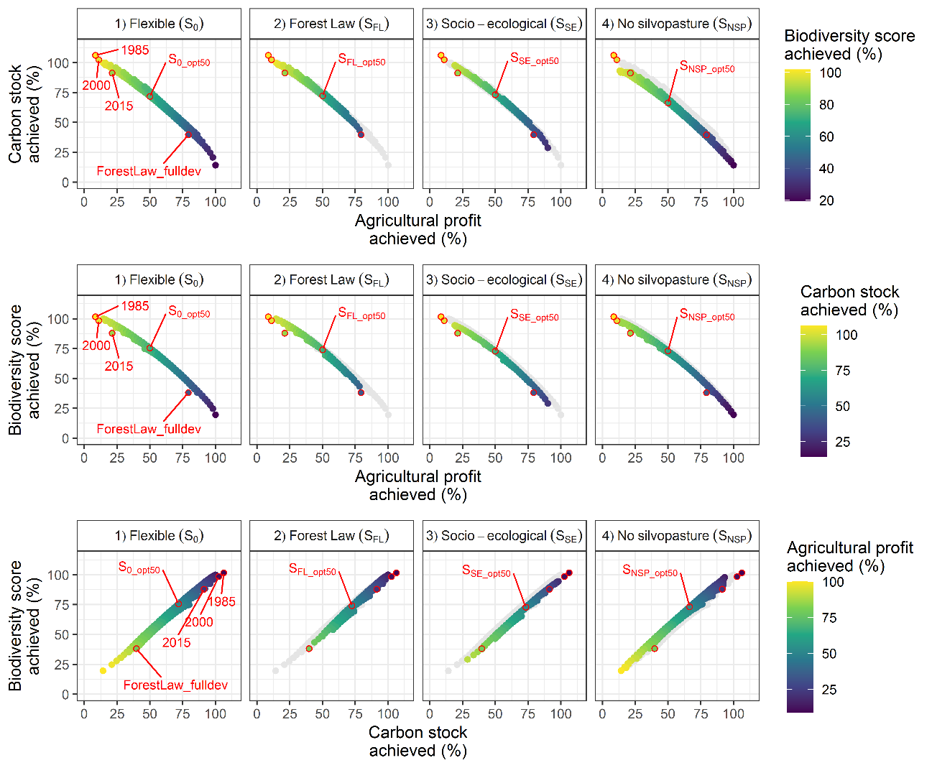

Figure B1: Additional perspectives of 2D perspectives on the full 3D possibility frontier, for all transition scenarios (columns). Axes are scaled as 100% of the maximum possible for each feature in the S0 frontier, and grey ‘shadows’ of this frontier are shown on columns 2:4 for ease of comparison. Past, current, and future land-use allocation point scenarios are visualized as points with red outlined points on these frontiers (optimal points shown with respect to their respective frontier, and past/SFL_fulldev point labelled in the first panel only as they remain in identical positions in all cases). Past point solutions may exceed current constraints (i.e. achieve scores greater than 100%) given that past land use change has resulted in forest loss, which we assumed is irreversible in this instance.

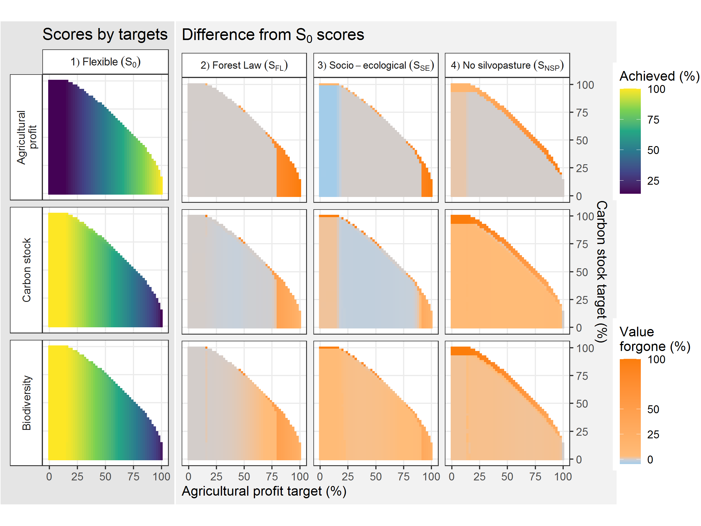

Figure B2: Value forgone or gained across scenarios. Each panel compares the possibility frontier – mapped on to the target combinations used to generate them – from the transition scenarios (columns) for one of the frontier features (i.e. achieved agricultural profit, biodiversity, carbon; rows). For reference, the S0 column shows the achieved values, whereas the other columns show the value forgone under the increased constraint scenario. In the latter, colours indicate where the value achieved under these target combinations is reduced (red tones) the same (grey) or increased (blue tones) in the more constrained scenarios, relative to the S0 scenario.

## B 2. Species level results

As we use a composite biodiversity metric, it is important to evaluate how this metric performs across each species of interest. In Figure B3 we provide additional information on species representation in Pareto optimal point solutions across the possibility frontier for S0, for the point solutions denoted by the letters A:E in Figure 3 (main manuscript). Differences in the species preferences as well as the methodology are likely to contribute to some mammals appearing to maintain populations under maximum agriculture. However, it is unlikely that many of these species could persist solely in such highly intensified agricultural landscapes (Newbold et al., 2015, 2016; Romero‐Muñoz et al., 2020). In addition, we show species representation compared across the multifunctional optimized point solutions (i.e. maximum biodiversity while achieving a 50% agricultural profit target; Figure B4). This highlights that while these alternative solutions return remarkably similar benefits for aggregate biodiversity, benefits for individual species differ.

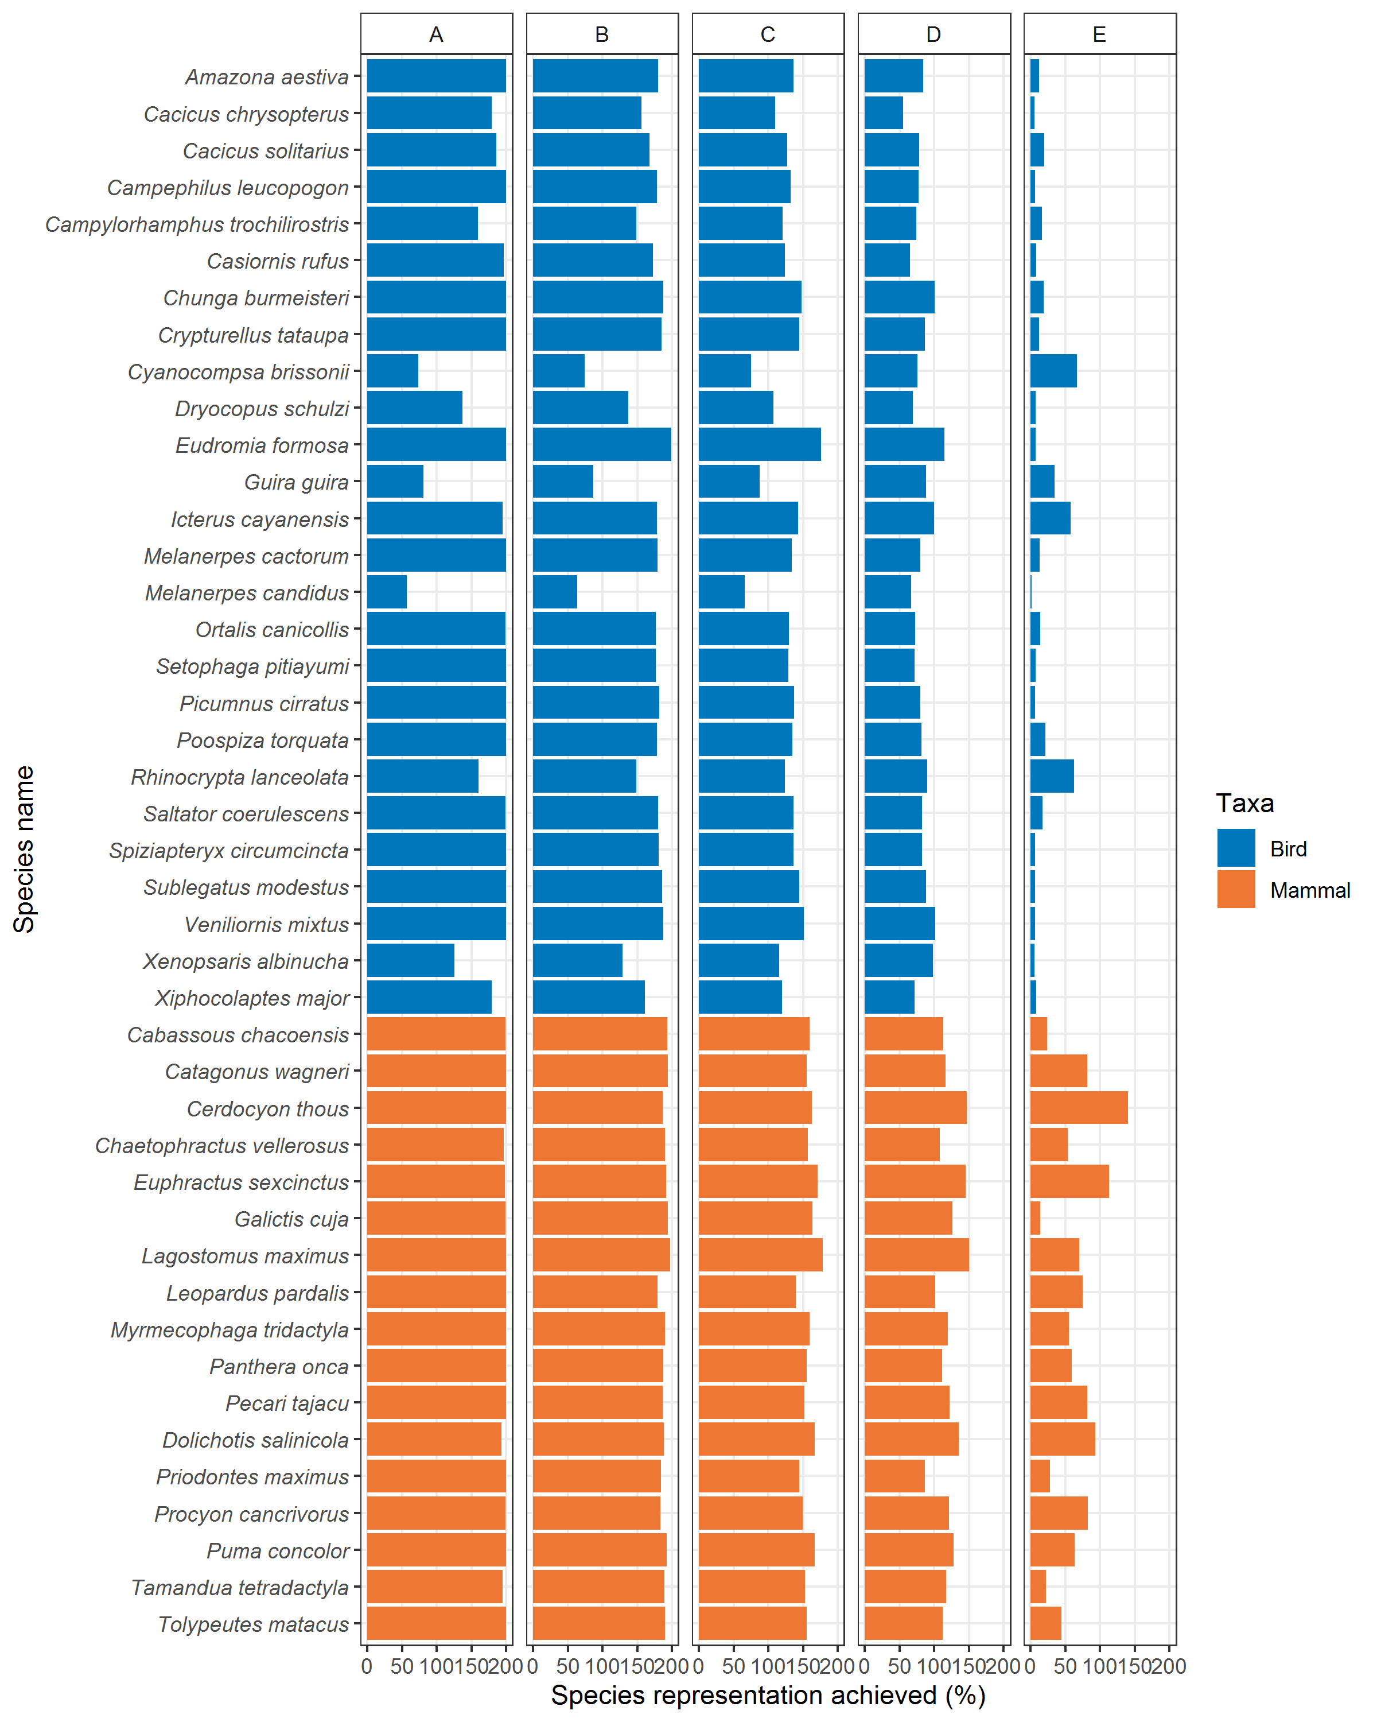

Figure B3: Species representation in Pareto optimal solutions for S0. These solutions are located at points A:E (as indicated in Figure 3 in the main manuscript), ranging from maximum biodiversity to maximum agriculture.

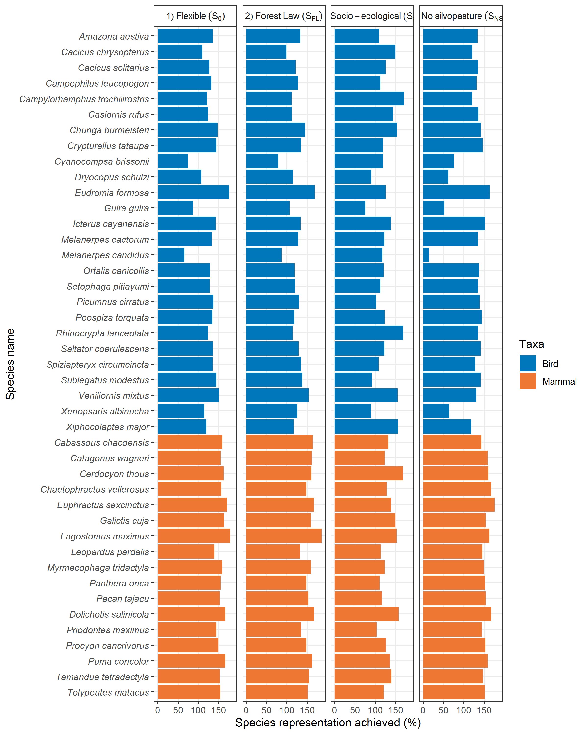

Figure B4: Species representation in the multifunctional point solutions (i.e. at maximum biodiversity for a 50% agricultural profit target).

## B 3. Past land system configurations, trends and benefits in the study region

Comparing land configurations from 1985 to 2015 show that while the region is still dominated by woodland, this is changing rapidly (Table B1). Rates of change show a large recent increase in the rate of cropland development, a reduction in the rate of pasture and silvopasture development (expanding more in 1985-2000 than in 2000-2015), an increasing rate of loss of forest smallholder area, and a strong increase in forest loss in 2000-2015, compared with 1985-2000.

These land system changes have resulted in relatively proportionate differences in achieved agricultural profit, carbon stock, and biodiversity, when these differences are viewed as a percent of the maximum possible under the S0 possibility frontier (Table B2).

## B 4. Future point scenario allocations and achievements

Future (i.e optimized and full development) point scenarios show major changes relative to the current (2015) land system configurations, allowing for continued agricultural development and encroachments on forest cover (Table B3). These have consequent substantial changes in the outcomes for agricultural profit, carbon stock, and biodiversity (Table B4).

Table B1: Land system configurations: past and present areas and change in area between 1985 and 2015 across the study region. Forest smallholders are here represented by a 2km radius in forest around their mapped point locations (note that their spatial footprint for some activities, such as hunting, can be larger – this scenario is explored in Appendix B5). Differences in the static area relate to differences in mapped natural grasslands and other excluded land covers. The sum of agriculture includes areas cleared for agriculture, i.e., cropland, pasture, and silvopasture, whereas forest cover includes forest smallholders, forest, and woodland in protected areas

|  |  |  |  |  |  |  |  |  |  |  |  |
| --- | --- | --- | --- | --- | --- | --- | --- | --- | --- | --- | --- |
| Land system | Area (km2) | | |  | Percent area (%) | | |  | Rate of change (as % of initial cover) | | |
| 1985 | 2000 | 2015 |  | 1985 | 2000 | 2015 |  | 1985 - 2000 | 2000 - 2015 | 1985 - 2015 |
| Cropland | 6,621 | 8,967 | 19,549 |  | 3.80 | 5.15 | 11.22 |  | 35.43 | 118.01 | 195.26 |
| Pasture | 503 | 2,775 | 10,005 |  | 0.29 | 1.59 | 5.74 |  | 451.69 | 260.54 | 1889.07 |
| Silvopasture | 3 | 389 | 3,464 |  | 0.00 | 0.22 | 1.99 |  | 12,866.67 | 790.49 | 115,366.67 |
| Forest Smallholders | 23,257 | 23,096 | 21,587 |  | 13.35 | 13.26 | 12.39 |  | -0.69 | -6.53 | -7.18 |
| Forest | 129,962 | 123,629 | 104,496 |  | 74.61 | 70.97 | 59.99 |  | -4.87 | -15.48 | -19.59 |
| Static | 13,851 | 15,341 | 15,096 |  | 7.95 | 8.81 | 8.67 |  | 10.76 | -1.60 | 8.99 |
| - of which, forest cover in PA | 5,012 | 4,865 | 4,710 |  | 2.88 | 2.79 | 2.70 |  | -2.93 | -3.19 | -6.03 |
| *Sum agriculture* (excl. PA, Forest smallholders) | 7,127 | 12,131 | 33,018 |  | 4.09 | 6.96 | 18.95 |  | 70.21 | 172.18 | 363.28 |
| *Sum forest cover* (incl. PA, Forest smallholders) | 158,231 | 151,590 | 130,793 |  | 90.83 | 87.02 | 75.08 |  | -4.20 | -13.72 | -17.34 |

*Table B2 Change in achievements on the frontier axes due to past land system change.*

|  |  |  |  |  |  |  |  |
| --- | --- | --- | --- | --- | --- | --- | --- |
| Axis feature | Achievement as % of maximum possible in S0 frontier | | | | | | |
| Year | | | Difference to 2015 | | Percent difference (of 2015 achievement) | |
| 1985 | 2000 | 2015 | 1985 | 2000 | 1985 | 2000 |
| Agricultural profit | 8.53 | 10.98 | 21.20 | 12.67 | 10.22 | 59.76 | 281.87 |
| Carbon stock | 101.67 | 98.41 | 87.84 | -13.84 | -10.58 | -15.75 | -17.94 |
| Biodiversity score | 106.28 | 102.62 | 91.31 | -14.97 | -11.31 | -16.39 | -17.96 |

Table B3: Future point scenario allocations, and change from 2015 configuration. Point scenarios represent solutions from optimizations (including solutions that exist on the frontier, i.e., those that maximize biodiversity at a 50% agricultural target for each of the transition scenarios; “opt50”), and an allocation representing full development of the SFL scenario (in accordance with zone expectations; “fulldev”).

|  |  |  |  |  |  |  |  |  |  |  |  |
| --- | --- | --- | --- | --- | --- | --- | --- | --- | --- | --- | --- |
|  |  |  | Land system | | | | | | Forest cover in PA | *Sum agriculture (excl. PA, forest smallholders)* | *Sum forest cover*  *(incl. PA, forest smallholders)* |
|  |  |  | Cropland | Pasture | Silvo-pasture | Forest small-holders | Forest | Static |
| Area within study region (% area) | 2015 |  | 11.22 | 5.74 | 1.99 | 12.39 | 59.99 | 8.67 | 2.70 | 18.95 | 75.08 |
| SFL | *fulldev* | 41.41 | 0.00 | 44.68 | 0.00 | 5.25 | 8.67 | 2.70 | 86.09 | 7.95 |
| S0 | *opt50* | 22.41 | 0.02 | 24.54 | 0.07 | 44.29 | 8.67 | 2.70 | 46.97 | 47.07 |
| SFL | 14.97 | 0.01 | 36.31 | 0.18 | 39.85 | 8.67 | 2.70 | 51.30 | 42.74 |
| SSE | 20.16 | 0.02 | 23.36 | 12.39 | 35.40 | 8.67 | 2.70 | 43.54 | 50.50 |
| SNSP | 34.36 | 6.75 | 1.50 | 0.08 | 48.64 | 8.67 | 2.70 | 42.61 | 51.43 |
| Difference to 2015 (% area) | SFL | *fulldev* | 30.19 | -5.74 | 42.69 | -12.39 | -54.74 | 0.00 | 0.00 | 67.13 | -67.13 |
| S0 | *opt50* | 11.19 | -5.73 | 22.55 | -12.32 | -15.69 | 0.00 | 0.00 | 28.02 | -28.02 |
| SFL | 3.75 | -5.73 | 34.33 | -12.21 | -20.13 | 0.00 | 0.00 | 32.34 | -32.34 |
| SSE | 8.94 | -5.73 | 21.37 | 0.00 | -24.59 | 0.00 | 0.00 | 24.59 | -24.59 |
| SNSP | 23.13 | 1.01 | -0.49 | -12.31 | -11.34 | 0.00 | 0.00 | 23.66 | -23.66 |
| Percent change (as % of 2015 percent area) | SFL | *fulldev* | 269.02 | -100.00 | 2146.62 | -100.00 | -91.25 | 0.00 | 0.00 | 354.18 | -89.41 |
| S0 | *opt50* | 99.70 | -99.70 | 1134.19 | -99.43 | -26.16 | 0.00 | 0.00 | 147.81 | -37.31 |
| SFL | 33.43 | -99.84 | 1726.19 | -98.52 | -33.56 | 0.00 | 0.00 | 170.64 | -43.08 |
| SSE | 79.65 | -99.70 | 1074.83 | 0.00 | -40.98 | 0.00 | 0.00 | 129.71 | -32.74 |
| SNSP | 206.14 | 17.58 | -24.51 | -99.34 | -18.91 | 0.00 | 0.00 | 124.81 | -31.51 |

*Table B4 Change in achievements on the frontier axes given future point scenario land system configurations.*

|  |  |  |  |  |
| --- | --- | --- | --- | --- |
|  | Point scenario | Agricultural profit | Carbon stock | Biodiversity score |
| Achievement as % of maximum possible in S0 frontier | 2015 | 21.20 | 87.84 | 91.31 |
| SFL_fulldev | 79.28 | 38.17 | 39.72 |
| S0_opt50 | 50.00 | 75.56 | 71.85 |
| SFL_opt50 | 50.00 | 74.15 | 72.31 |
| SSE_opt50 | 50.00 | 72.80 | 73.20 |
| SNSP_opt50 | 50.00 | 73.17 | 66.39 |
| Difference to 2015 | SFL_fulldev | 58.08 | -49.66 | -51.58 |
| S0_opt50 | 28.80 | -12.27 | -19.46 |
| SFL_opt50 | 28.80 | -13.68 | -18.99 |
| SSE_opt50 | 28.80 | -15.04 | -18.10 |
| SNSP_opt50 | 28.80 | -14.67 | -24.91 |
| Percent difference (of 2015 achievement) | SFL_fulldev | 273.94 | -56.54 | -56.50 |
| S0_opt50 | 135.83 | -13.97 | -21.31 |
| SFL_opt50 | 135.83 | -15.58 | -20.80 |
| SSE_opt50 | 135.83 | -17.12 | -19.82 |
| SNSP_opt50 | 135.83 | -16.70 | -27.29 |

## B 5. Sensitivity of results to assumed forest smallholder area of influence

Forest smallholders represented an interesting modelling challenge in that their area of influence is likely to be quite variable, particularly for different species. Here we summarise the major assumptions that we made, the uncertainty around these, and the potential implications of alternative parameterisation.

### Forest smallholder areas of influence: assumptions and uncertainty

As detailed in Appendix A1, we identified 2,196 forest smallholder point locations within a 5km buffer of the study region. This translated to 2144 cells in the study region containing a homestead point, and all of these were allocated to the forest smallholder land system, except for 4 cells that mapped into ‘uncategorised’. However, forest smallholders utilize the area around their homestead points, and one of our major points of uncertainty regarded how large we should make this ‘footprint’ of forest smallholder influence. In all cases, the footprint is defined as a buffer zone from the homestead point with a specified radius, but we assumed only ‘forest’ within this buffer area to be allowed to be allocated to the respective forest smallholder footprint.

The area of influence for carbon was modelled at a 1km radius from the homestead point. This was based on both satellite and field observations (Baumann et al., 2018; Macchi et al., 2019). This represents an average level of impact, but we did not check to see if this might vary spatially. For example, we might expect some regions to have increased production of wood and charcoal, which may impact carbon values more heavily or over a larger area, and thus affect trade-offs more locally within the region.

The area of influence for agriculture and biodiversity was more uncertain. In the version presented in the main manuscript, we chose the area of influence of forest smallholders on agriculture and biodiversity to be a 2km radius from the homestead point, aligned with the observable effects on vegetation and bird abundances (Macchi and Grau, 2012). However, we acknowledge that grazing may be more extensive, for example ca. 5km from the homestead point (Grau et al. 2008). As extensive grazing may be extremely spatially and temporally variable over this greater expanse, we chose to represent the agricultural area by the 2km radius of observable impact on the environment in the main results. For biodiversity, this distance represents an approximate average area of influence for multiple features, based on field-assessed distances of smallholder impact on the surrounding vegetation (Macchi and Grau, 2012). However, this may not be applicable for all species. In particular, species that are considered to conflict or compete with production may be affected by smallholder presence at much larger distances (e.g. 5km), for example large carnivores such as jaguar that might prey on livestock (Romero‐Muñoz et al., 2020). Hunting by indigenous villages (e.g. for bushmeat) are measured to occur at up to 14km surrounding villages (Vallejos et al., 2020), and although we might not expect forest smallholders to regularly engage in in hunting at such distances from their homesteads, this is an example of the distances that may be impacted for some species. However, other species may be principally affected only at much smaller distances, via concentrated grazing and trampling effects (e.g. Adamoli et al., 1990).

Given the impact of smallholder systems on biodiversity and carbon values is contentious, and that it is common to want to be precautionary in this regard, we focused on a sensitivity analysis where forest smallholder areas of influence for biodiversity and grazing were identified as a 5km radius, within forest cover, from their homestead points. This increased the forest smallholder area in current and past configurations (Table B5), for example in 2015 this increased smallholder area from 12.3% to 41.3% of the study region. In turn, this increases the total agricultural profit in the region at these points (by 33.4% to 31.8% of the maximum) due to this increase in assumed livestock grazing, and decreased the biodiversity achieved (down 18.6% to 74.0% of maximum; Table B6; note these values are relative for biodiversity, see following paragraph). Carbon values were not impacted in these past point solutions, as carbon impacts remain mapped at the same 1km radius from homestead locations.

As maximum agricultural profit for the optimized landscapes is seen when the majority of the allocable landscape is within cropping (and none in forest smallholder), and similarly the maximum carbon values are achieved when all the forest smallholder area is restored to forest (and more degraded areas forced into silvopastures due to the assumed inability to restore these areas to forest) the maximum ends of these axes remain the same (and therefore scores for these axis are equivalent when expressed as a % of maximum possible). For biodiversity, the increased area of forest smallholder influence in protected areas results in a small drop in the maximum endpoint for this axis, from 92.57% of the theoretical maximum biodiversity score (i.e. 43 species x 10000 = 430,000) in the 2km radius scenario, to 91.24% of the theoretical maximum in the 5km radius scenario. Therefore the biodiversity scores when expressed as a percent of the respective maximum possible are only marginally smaller for the 5km radius scenario compared to the 2km radius scenario, and should only be considered as indicative rather than directly comparable.

While the increase in assumed forest smallholder area did not substantially change the maximum possible for any of the frontier axes, it did result in broader frontier (Figure B5, B6). This was particularly visible along the carbon axis, where, for the same level of carbon stock, there were a greater range of solutions between maximum biodiversity and maximum agriculture for all bar the SSE scenario (bottom row, Figure B6). This is because in both area of forest smallholder influence scenarios, we assume that forest smallholders cannot expand outside of their current area. However, the greater current area under the 5km assumption means that more of this area can be optionally retained by the optimization. This greater area does not change the carbon impact estimates of forest smallholders, but does increase the agricultural value while (generally) decreasing the biodiversity value (although increasing it markedly for some species). The SSE scenario, in contrast, was more severely constrained by the increased forest smallholder radius, due to the transition constraint that this increased area must be retained. Relative to the 2km radius assumption, this reduced biodiversity along the possibility frontier (on average by 10.3, and up to 14.1 percentage points across equivalent targets) and further truncated the agricultural profit axis (to 68%). Further, this scenario was more markedly divergent from the most flexible scenario (S0).

Consequently, the future multifunctional point scenarios drawn from these frontiers are substantially unchanged with regard to their land system allocations or achievements (Tables B8, B9), with the exception of the point drawn from the SSE frontier, in which the increase in forest smallholder area (from 12.4% to 41.3% of the study region) was balanced by a large reduction in the forest land system (cf. forest cover; from 35.4% to 14.49% of the study region), as well as smaller reductions in cropland (from 20.2% to 14.3% of the study region) and silvopasture (from 23.4% to 21.2% of the study region). Total forest cover, however, remained the highest out of all of the multifunctional point scenarios (Figure B7).Despite the large difference in forest smallholder area, however, there is less than 8% change in axis outcomes (an increase in carbon, and a decrease in biodiversity) at this point, likely because forest smallholder are a ‘multifunctional’ land use in themselves.

*Figure B5: Possibility frontier for the most flexible S0 scenario under the assumption of a 5km forest smallholder area of influence. While the majority of the axes are not impacted substantially by this increased potential forest smallholder area, and the maximum biodiversity points along the agricultural axis (shown by maps A:E) also remain similar, the overall frontier is broader, indicating a greater difference between maximum biodiversity and maximum carbon options along the agricultural axis, and particularly a greater difference between maximum biodiversity and maximum agricultural profit options along the carbon axis, due to this greater availability of forest smallholder area available.*

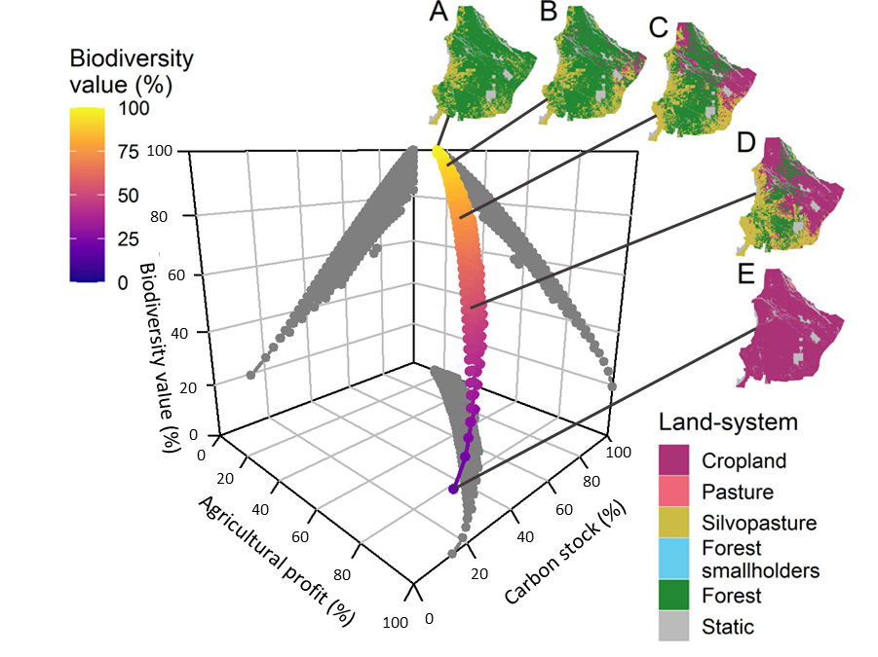

*Table B5 current and past land system areas calculated under a 5km radius area of smallholder influence. For past points, the increase in forest smallholder area comes at a direct cost to forest area. Only areas outside the static zone are shown; differences within static areas are proportionate to these.*

|  |  |  |  |  |  |
| --- | --- | --- | --- | --- | --- |
|  |  | Area of forest smallholders with | | Difference in % area | Percent difference from 2km radius |
| Year | Land system | 2km buffer | 5km buffer |
| 1985 | Forest smallholders | 13.35 | 46.53 | 33.18 | 248.54 |
|  | Forest | 74.61 | 41.42 | -33.18 | -44.48 |
| 2000 | Forest smallholders | 13.26 | 45.85 | 32.59 | 245.78 |
|  | Forest | 70.97 | 38.38 | -32.59 | -45.92 |
| 2015 | Forest smallholders | 12.39 | 41.26 | 28.87 | 232.94 |
|  | Forest | 59.99 | 31.12 | -28.87 | -48.12 |

*Table B6 current and past land system areas calculated under a 5km radius area of smallholder influence.*

|  |  |  |  |  |  |
| --- | --- | --- | --- | --- | --- |
| Year | Feature | Achieved under 2km radius  (% of max) | Achieved under 5km radius  (% of max) | Difference (% of max) | Difference relative to 2km scenario (%) |
| 1985 | Agriculture | 8.53 | 20.77 | 12.24 | 143.52 |
|  | Carbon | 106.28 | 106.28 | 0.00 | 0.00 |
|  | Biodiversity* | 101.67 | 85.84 | -15.83 | -15.57 |
| 2000 | Agriculture | 10.98 | 23.00 | 12.02 | 109.42 |
|  | Carbon | 102.62 | 102.62 | 0.00 | 0.00 |
|  | Biodiversity* | 98.41 | 82.86 | -15.56 | -15.81 |
| 2015 | Agriculture | 21.20 | 31.84 | 10.64 | 50.18 |
|  | Carbon | 91.31 | 91.31 | 0.00 | 0.00 |
|  | Biodiversity* | 87.84 | 74.03 | -13.81 | -15.72 |

* Biodiversity scores expressed as a % of maximum possible are not directly comparable as there is a 1.4% decrease in the maximum possible biodiversity score, and many some more substantial differences in individual species (Table B7). However they are being directly compared here as a rough comparison of the overall differences.

*Table B7 (next page): Differences in individual species metrics when forest smallholder areas of influence are increased from a 2km radius to a 5km radius. Differences are scaled relative to the 2km radius score.*

|  |  |  |
| --- | --- | --- |
| Taxa | Species | Percent difference in biodiversity score |
| Bird | *Amazona aestiva* | -0.46 |
|  | *Cacicus chrysopterus* | 12.61 |
|  | *Cacicus solitarius* | -0.19 |
|  | *Campephilus leucopogon* | -0.38 |
|  | *Campylorhamphus trochilirostris* | 26.23 |
|  | *Casiornis rufus* | 0.00 |
|  | *Chunga burmeisteri* | -0.08 |
|  | *Crypturellus tataupa* | -0.40 |
|  | *Cyanocompsa brissonii* | 5.52 |
|  | *Dryocopus schulzi* | -0.45 |
|  | *Eudromia formosa* | -0.54 |
|  | *Guira guira* | -0.09 |
|  | *Icterus cayanensis* | -0.19 |
|  | *Melanerpes cactorum* | -0.30 |
|  | *Melanerpes candidus* | 3.40 |
|  | *Ortalis canicollis* | -0.29 |
|  | *Setophaga pitiayumi* | -0.37 |
|  | *Picumnus cirratus* | -0.53 |
|  | *Poospiza torquata* | -0.44 |
|  | *Rhinocrypta lanceolata* | 22.89 |
|  | *Saltator coerulescens* | -0.32 |
|  | *Spiziapteryx circumcincta* | -0.46 |
|  | *Sublegatus modestus* | -0.72 |
|  | *Veniliornis mixtus* | -0.08 |
|  | *Xenopsaris albinucha* | -0.34 |
|  | *Xiphocolaptes major* | 12.54 |
| Mammal | *Cabassous chacoensis* | -0.73 |
|  | *Catagonus wagneri* | -0.37 |
|  | *Cerdocyon thous* | 0.03 |
|  | *Chaetophractus vellerosus* | -0.52 |
|  | *Euphractus sexcinctus* | -0.42 |
|  | *Galictis cuja* | -0.26 |
|  | *Lagostomus maximus* | -0.52 |
|  | *Leopardus pardalis* | -0.61 |
|  | *Myrmecophaga tridactyla* | -0.46 |
|  | *Panthera onca* | -0.86 |
|  | *Pecari tajacu* | -0.37 |
|  | *Dolichotis salinicola* | -0.19 |
|  | *Priodontes maximus* | -0.92 |
|  | *Procyon cancrivorus* | -0.32 |
|  | *Puma concolor* | -0.32 |
|  | *Tamandua tetradactyla* | -0.27 |
|  | *Tolypeutes matacus* | -0.68 |
| Bird | Average | 2.94 |
| Mammal | Average | -0.46 |

*Figure B6: 2D representations of the possibility frontier for all transition frontier scenarios, and the relative location of past, current, and future point scenarios, under the assumption of a 5km forest smallholder area of influence.*

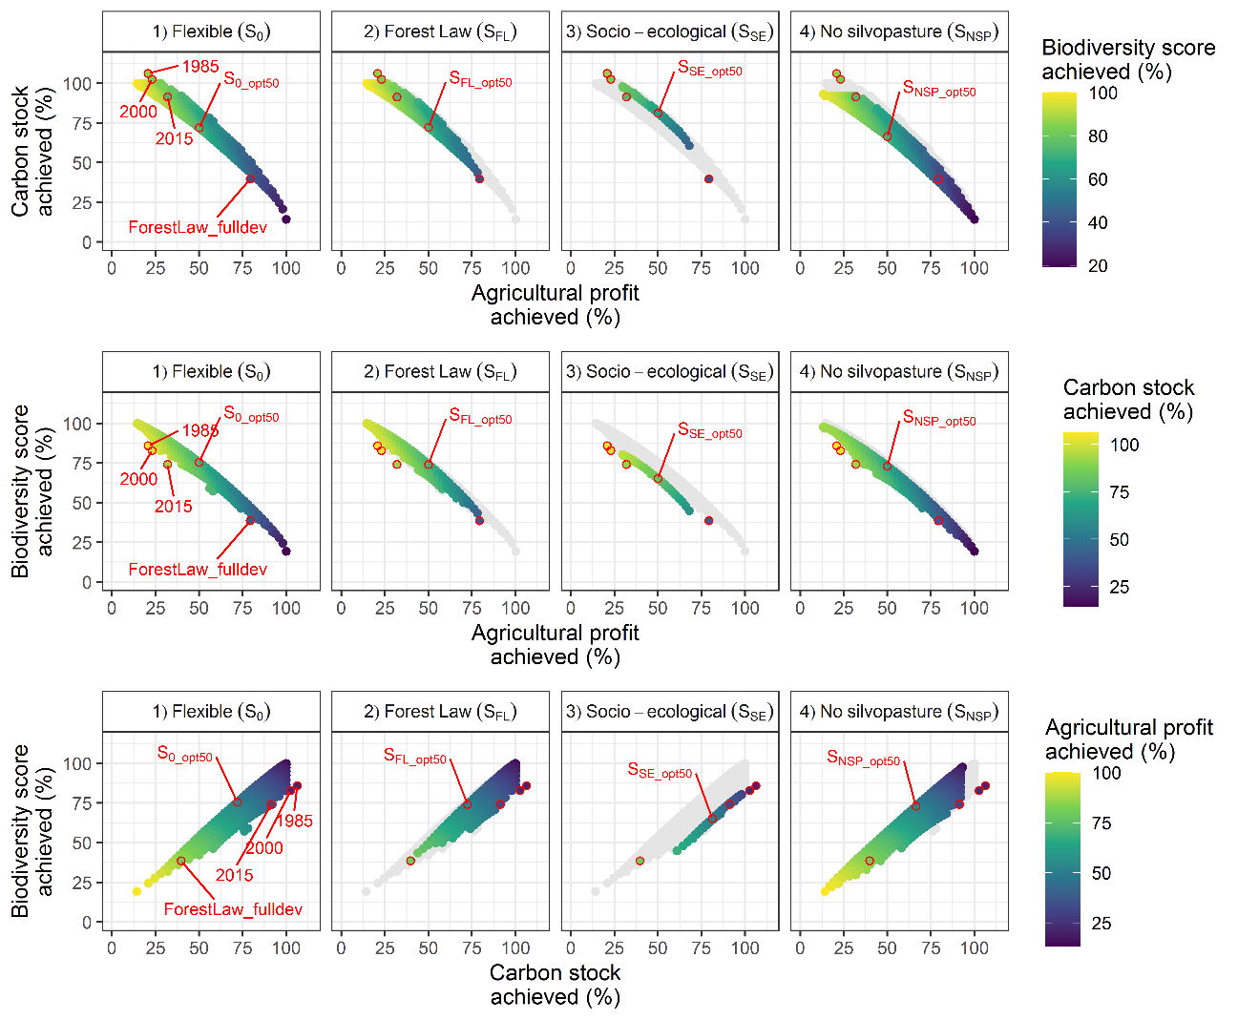

*Table B8: Differences in allocated areas for the point scenarios when forest smallholder areas of influence are compared. As the majority of the multifunctional optimal solutions (i.e. maximum biodiversity for 50% agriculture) allocate very little forest smallholder area, this results in only small differences in these from the original 2km radius assumption.*

|  |  |  |  |  |  |
| --- | --- | --- | --- | --- | --- |
|  | | Area allocated, with the initial area of forest smallholders given | | Difference in % area | Percent difference from 2km radius |
| Future point scenario | Land system | 2km radius | 5km radius |
| SFL_fulldev | Cropland | 41.41 | 41.41 | 0.00 | 0.00 |
|  | Pasture | 0.00 | 0.00 | 0.00 | 0.00 |
|  | Silvopasture | 44.68 | 44.68 | 0.00 | 0.00 |
|  | Forest smallholders | 0.00 | 0.00 | 0.00 | 0.00 |
|  | Forest | 5.25 | 5.25 | 0.00 | 0.00 |
|  | Static | 8.67 | 8.67 | 0.00 | 0.00 |
| S0_opt50 | Cropland | 22.41 | 22.17 | -0.24 | -1.08 |
|  | Pasture | 0.02 | 0.02 | 0.00 | 0.00 |
|  | Silvopasture | 24.54 | 24.92 | 0.37 | 1.52 |
|  | Forest smallholders | 0.07 | 0.10 | 0.03 | 46.34 |
|  | Forest | 44.29 | 44.13 | -0.16 | -0.37 |
|  | Static | 8.67 | 8.67 | 0.00 | 0.00 |
| SFL_opt50 | Cropland | 14.97 | 14.78 | -0.19 | -1.28 |
|  | Pasture | 0.01 | 0.01 | 0.00 | 0.00 |
|  | Silvopasture | 36.31 | 36.67 | 0.35 | 0.97 |
|  | Forest smallholders | 0.18 | 0.11 | -0.08 | -42.81 |
|  | Forest | 39.85 | 39.77 | -0.08 | -0.21 |
|  | Static | 8.67 | 8.67 | 0.00 | 0.00 |
| SSE_opt50 | Cropland | 20.16 | 14.34 | -5.82 | -28.87 |
|  | Pasture | 0.02 | 0.02 | 0.00 | 0.00 |
|  | Silvopasture | 23.36 | 21.23 | -2.13 | -9.14 |
|  | Forest smallholders | 12.39 | 41.26 | 28.87 | 232.94 |
|  | Forest | 35.40 | 14.49 | -20.91 | -59.07 |
|  | Static | 8.67 | 8.67 | 0.00 | 0.00 |
| SNSP_opt50 | Cropland | 34.36 | 34.28 | -0.07 | -0.22 |
|  | Pasture | 6.75 | 6.85 | 0.10 | 1.43 |
|  | Silvopasture | 1.50 | 1.51 | 0.01 | 0.50 |
|  | Forest smallholders | 0.08 | 0.10 | 0.02 | 19.72 |
|  | Forest | 48.64 | 48.60 | -0.05 | -0.09 |
|  | Static | 8.67 | 8.67 | 0.00 | 0.00 |

*Figure B7. Allocation of land systems and achievement of axis features A) across maximum-biodiversity frontier solutions (locations of A:E in Figure B6), and B) for past, current, and future point scenarios, under a 5km radius of forest smallholder influence.*

|  |  |
| --- | --- |
| *A.* |  |
| *B.* |  |

*Table B8: Differences in achievement over the frontier axes for the point scenarios when forest smallholder areas of influence are compared.*

|  |  |  |  |  |  |  |
| --- | --- | --- | --- | --- | --- | --- |
|  | | Achievement as % of maximum possible, with forest smallholders given | | Difference in % achievement | Percent difference from 2km radius | |
| Future point scenario | Feature | 2km radius | 5km radius |
| SFL_fulldev | Agriculture | 79.28 | 79.28 | 0.00 | | 0.00 |
|  | Carbon | 39.72 | 39.72 | 0.00 | | 0.00 |
|  | Biodiversity | 38.17 | 38.51 | 0.34 | | 0.89 |
| S0_opt50 | Agriculture | 50.00 | 50.00 | 0.00 | | 0.00 |
|  | Carbon | 71.85 | 71.87 | 0.03 | | 0.04 |
|  | Biodiversity | 75.56 | 75.52 | -0.04 | | -0.06 |
| SFL_opt50 | Agriculture | 50.00 | 50.00 | 0.00 | | 0.00 |
|  | Carbon | 72.31 | 72.33 | 0.01 | | 0.02 |
|  | Biodiversity | 74.15 | 74.15 | -0.01 | | -0.01 |
| SSE_opt50 | Agriculture | 50.00 | 50.00 | 0.00 | | 0.00 |
|  | Carbon | 73.20 | 81.20 | 7.99 | | 10.92 |
|  | Biodiversity | 72.80 | 65.18 | -7.62 | | -10.46 |
| SNSP_opt50 | Agriculture | 50.00 | 50.00 | 0.00 | | 0.00 |
|  | Carbon | 66.39 | 66.37 | -0.02 | | -0.03 |
|  | Biodiversity | 73.17 | 73.06 | -0.11 | | -0.15 |

### Forest smallholder transitions: spatial dependencies

In our problem formulation we allowed forest smallholder areas to partially convert (i.e. a single forest area containing multiple cells – including a more degraded homestead/core area, surrounded by a ring of extensive grazing – could transition to multiple other land system types; see Appendix A 3). While this simplification is reasonable if the entirety of each individual homestead’s respective forest smallholder area is converted to alternative land systems (as is the majority case in our frontiers and focal points above), it is not realistic in the case of some but not all of the area remaining as forest smallholder. This is because a) forest smallholder areas may not be viable if too small, and b) it allows the more extensively used ‘ring’ (with biodiversity and agricultural values of forest smallholder, but no carbon impact) to be selected, without the concurrent selection of the respective homestead cell (with its associated carbon impact). We chose this formulation because it reduced the problem size and complexity, and therefore was a pragmatic approach in the first instance. Further, these cases of unrealistic incomplete conversion are identifiable in the results and represent interesting cases for discussion.

To add this spatial dependency to the problem definition, we would need to include a constraint for each forest smallholder entity, all constituent cells needs to be selected (or not selected) as a group (i.e. including the core degraded area). There are a few ways we could specify this. First, we could amalgamate cells so that each smallholder forest location is one planning unit. However, this approach would result in an inability to convert a smallholder forest area partially into multiple alternative non-forest-smallholder land uses, and is therefore unacceptable. Second, we can add the transition constraints linearly using a “big M” indicator constraint. This adds to the problem an additional binary variable for every forest smallholder entity, along with two constraints. For example, given a smallholder forest area (y) that covers a hypothetical 3 cells (with x1, x2, and x3 representing the variables indicating an allocation of this to forest smallholder), the additional constraints will be:

x1 + x2 + x3 – My = 0 (where M is the number of cells in smallholder, in this case, =3)

- x1 – x2 – x3 + y <= 0 (i.e. y has be 1 if any x is 1, or 0 otherwise)

Together, these would enforce smallholder forest areas to be selected as a group, but would allow them to convert to multiple different other land systems. However, by adding additional variables, the results would need further processing to be interpretable using prioritizr functions.

An alternative method which conserves the same number of decision variables, would need to add many more constraints. For every forest smallholder entity (given the same example as above, where the smallholder covers 3 cells and the variable representing the allocation of this cell to smallholder forest is represented by x1,x2, and x3), the number of constraints would need to be equal to the number of cells in the respective forest smallholder smallholder entity, for example:

Mx1 – x2 – x3 = 0

– x1 + Mx2 – x3 = 0

– x1 – x2 + Mx3 = 0

where M is the number of cells in the forest smallholder -1, in this case = 2.

While the latter formulation might be easier in terms of post-processing of optimization results, the optimization speed may differ and would need to be tested. Further, both of these approaches needs a method to allocate forest smallholder cells to individual smallholder identities. For example, smallholder cells could be allocated to their nearest point (using all points, even those falling outside the study region boundary) using Euclidean allocation. This will split any potential areas of overlap, but would not check that forest area is contiguous within each smallholder entity, nor check if the area allocated to each entity point is of a viable size. These latter points are also caveats of our current analysis.

### Implications for the current problem formulation results

In the frontier analyses, we could check for issues of partial selection of smallholder forest areas by calculating the area of ‘core’ smallholder area (i.e. the 1km radius defining the most heavily impacted area surrounding the homestead, gaining agricultural and biodiversity values of forest smallholders, with reduced carbon value) with respect to the ring areas selected (i.e. the 2km or 5km buffer zones gaining agricultural and biodiversity values of smallholders, but a carbon value equivalent to nearby forest). If only the carbon-agriculture trade-off is considered, this is essentially ‘free’ agricultural profit, and it would likely always be selected. In our case, it is only the reduced biodiversity value (for the majority of species, but not all, Table B7) that prevents this from happening.

In this respect, it is somewhat surprising that the maximum biodiversity parts of the frontiers that we focus on do not include more of this forest smallholder buffer zone (see maps in Figure B5, allocations in Figure B7, Table B8, and in the main text Figures 3,4,5). While forest smallholders remain in SSE (socio-ecological scenario) solutions, this is mandated so all of the individual forest smallholder entities are selected together, and partial allocation problems are irrelevant.

We do note that in previous ‘draft’ versions of this analysis (with the principle difference being resolution of the target matrix for developing the frontier, which was in deciles rather than 2% intervals), the SNSP (no silvopasture) scenario included a much greater amount of allocated forest smallholder. This formulation resulted in a much ‘narrower’ frontier, where maximum biodiversity and maximum carbon options for each agricultural target were identical over much of the frontier. Likely, forest smallholder was selected to compensate for the lack of silvopasture – however, on closer inspection, the areas selected were only the ring, and no core area, i.e. only the area that maintains carbon value of surrounding forest. Given 6.1% of the region was selected for (ring) forest smallholder, we estimated another ca. 2.3 % should have been selected as the associated (core) forest smallholder. These areas were instead being allocated to crop (34%) or forest (65%). If all the core forest smallholder not in static (3.4% of study region in this case – practically all of which was converted by the optimization) was converted back into forest smallholder, then this could in a <1% drop in both agricultural profit and carbon stock (and we can assume loss in biodiversity is similar to the loss in carbon). Given that only ca. 2/3 of this is likely needing to be reconverted, this is likely to be closer to 0.5% difference if the core was constrained to be retained with the ring. These estimates should translate into the current analysis, where we suspect that more forest smallholder area is retained along the maximum carbon edge of the frontier.

This suggests that the lack of spatial dependencies regarding forest smallholder selection in our problem formulation likely has a minor, if not negligible effect. However, we recommend that further analysis exploring these different assumptions regarding smallholder forests be combined with further exploration of the value of other low intensity land systems, such as silvopasture, for improved ability to comment specifically on these approaches to land use planning in the study region.

## B 6. Additional land system planning considerations

Additional considerations regarding land-system allocations may include 1) ethical considerations of local use of land by indigenous/traditional communities, 2) areas identified as potentially valuable for biodiversity in other studies, and 3) costs of land use transitions, including restoration costs where applicable. We do not consider the latter here, but note they could be included in a diversity of ways in the problem formulation (as optimization objectives, costs, or constraints). In Figures B8-10, we map these over the Forest Law zoning. Indigenous area use has been identified as extending to 8, 14, or 18 km around villages, depending on the resource types being extracted (Vallejos et al., 2020). Figures 8-10a shows 14 km buffers around known indigenous villages in the region. Prior biodiversity priority mapping from Nori et al. (2016) identified ‘additive benefit’ priorities, and ‘core area’ priorities, here mapped in Figures 8-10b and Figures 8-10c, respectively. In terms of proportions, these additional areas of interest are typically poorly addressed in the current Forest Law policy, with their areas allocated to the development zone (and thus likely lost to these objectives) at equal or higher rates that the general distribution of the study region (Figures 8-10d). Optimized solutions (e.g. main text, Figure 3) also do not provide much additional protection, particularly for indigenous and important biodiversity areas in the Formosa, and therefore we would recommend these constraints be explicitly considered within future planning.

Figure B8: Other potential considerations of a) indigenous areas (14 km areas of use around known villages), and areas previously identified as biodiversity priorities from Nori et al. (2016) for b) ‘additive benefit’ priorities, and c) ‘core area’ priorities, mapped onto current (2015) land systems using a 2km forest smallholder radius of influence assumption. Proportions, in terms of percentage of the study region are shown in (d).

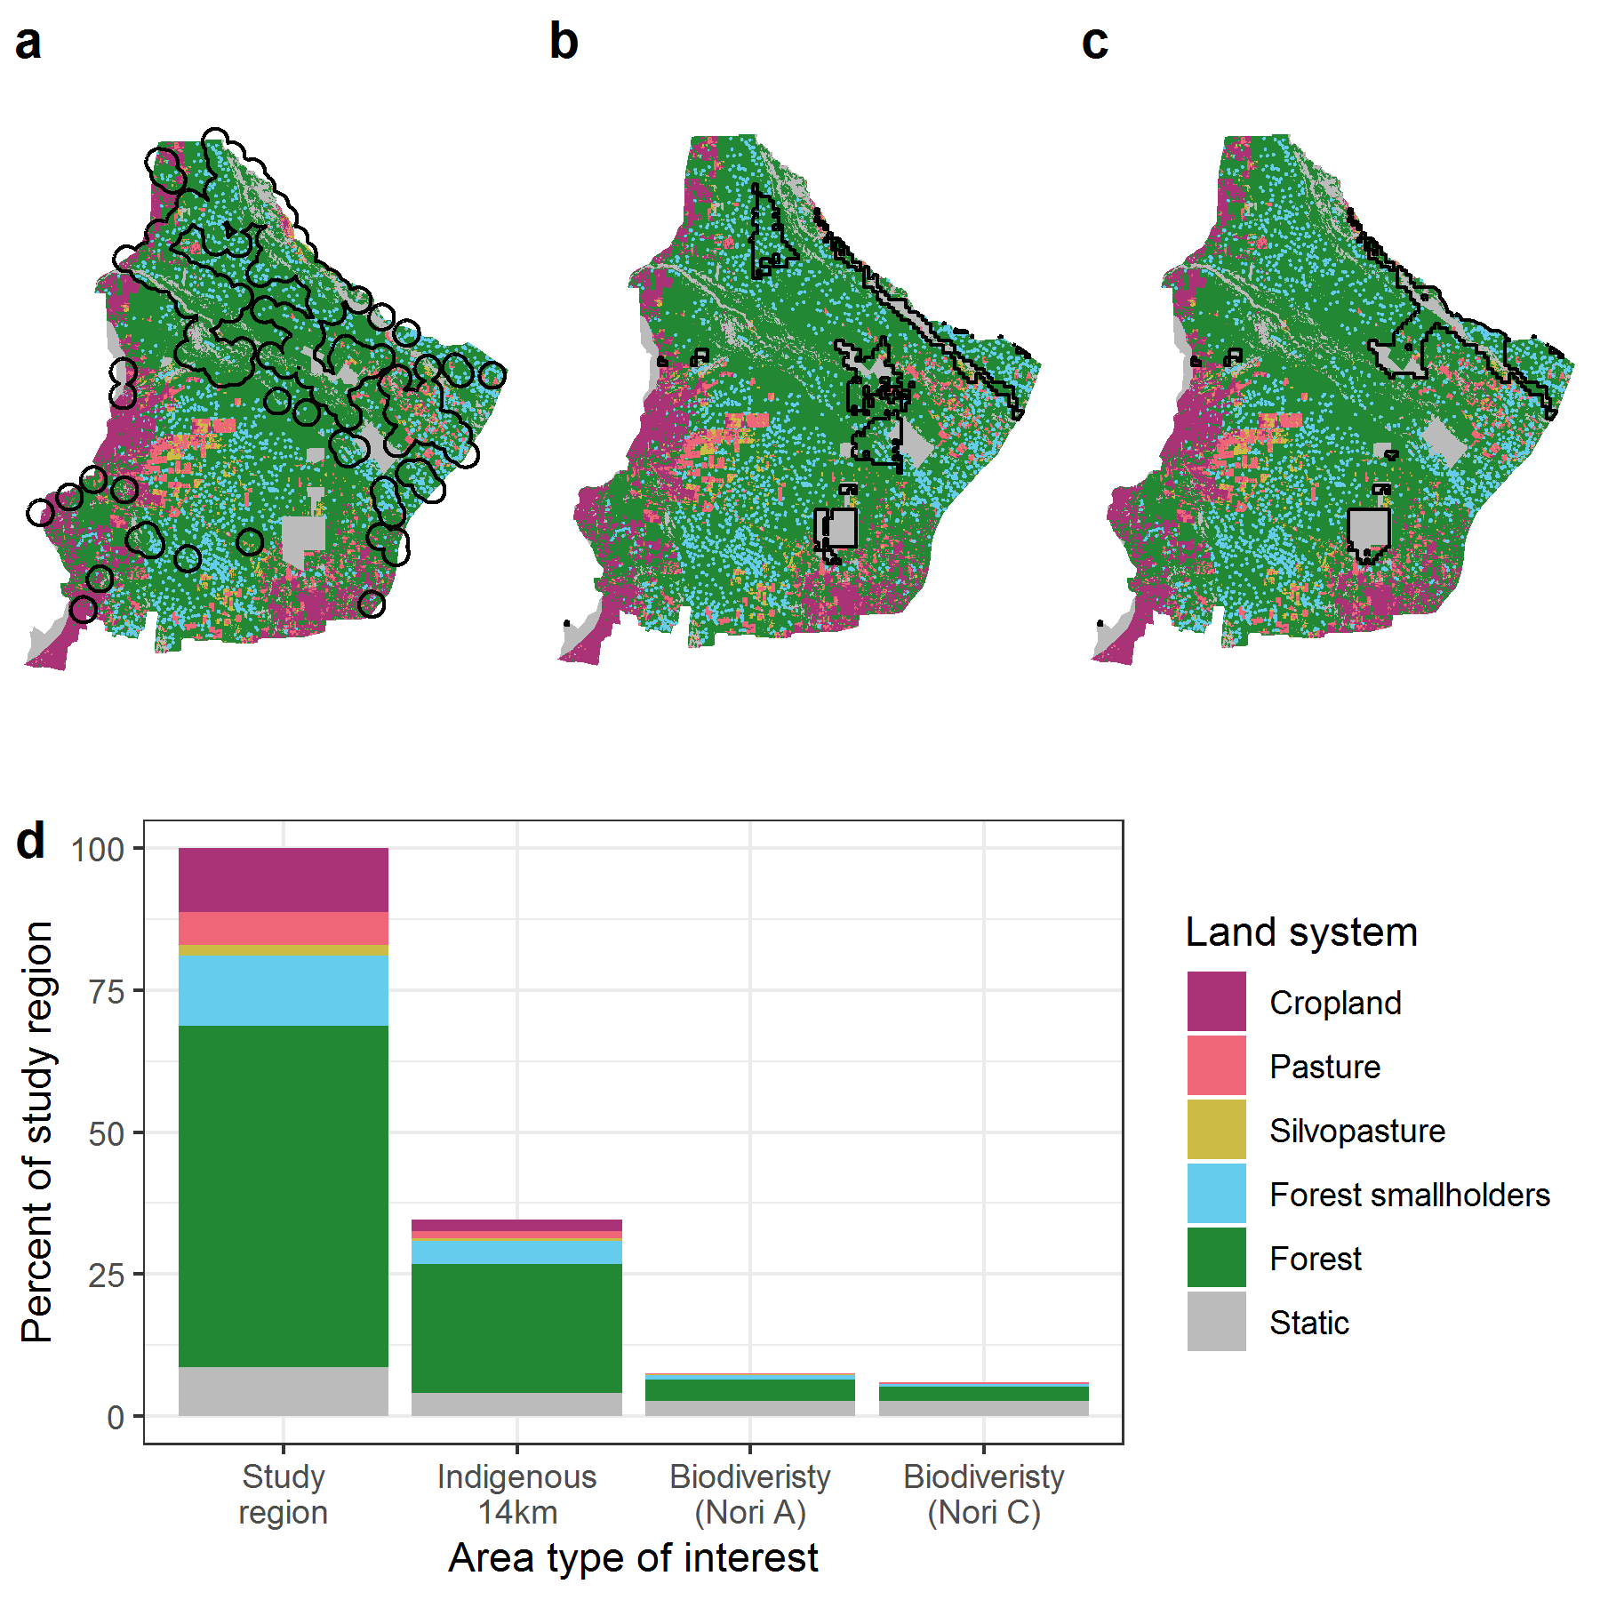

Figure B9: Other potential considerations of a) indigenous areas (14 km areas of use around known villages), and areas previously identified as biodiversity priorities from Nori et al. (2016) for b) ‘additive benefit’ priorities, and c) ‘core area’ priorities, mapped onto current (2015) land systems using a 2km forest smallholder radius of influence assumption. Proportions, in terms of percentage of the study region are shown in (d). 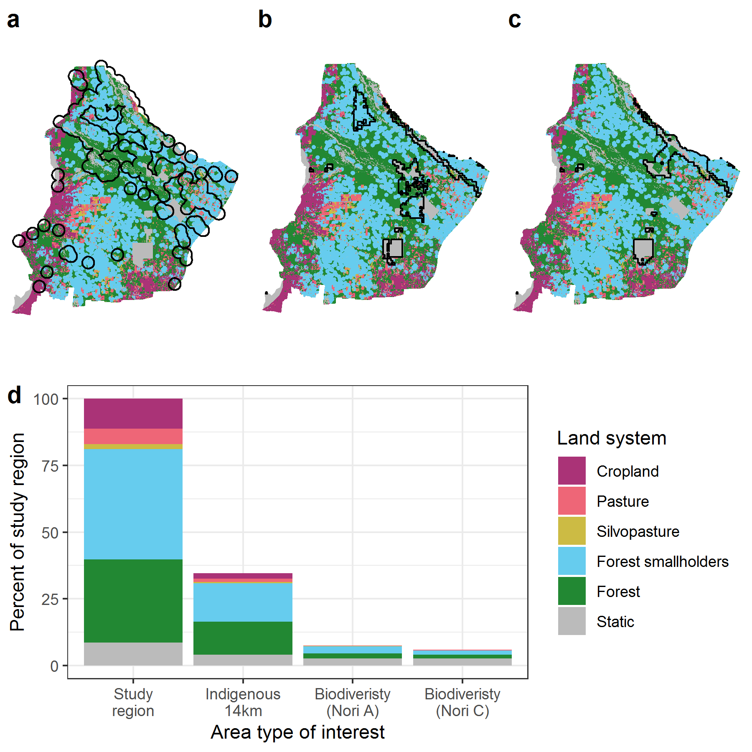

Figure B10: Other potential considerations of a) indigenous areas (14 km areas of use around known villages), and areas previously identified as biodiversity priorities from Nori et al. (2016) for b) ‘additive benefit’ priorities, and c) ‘core area’ priorities, mapped onto the current Forest Law zoning regulation. Proportions, in terms of percentage of the study region are shown in (d). 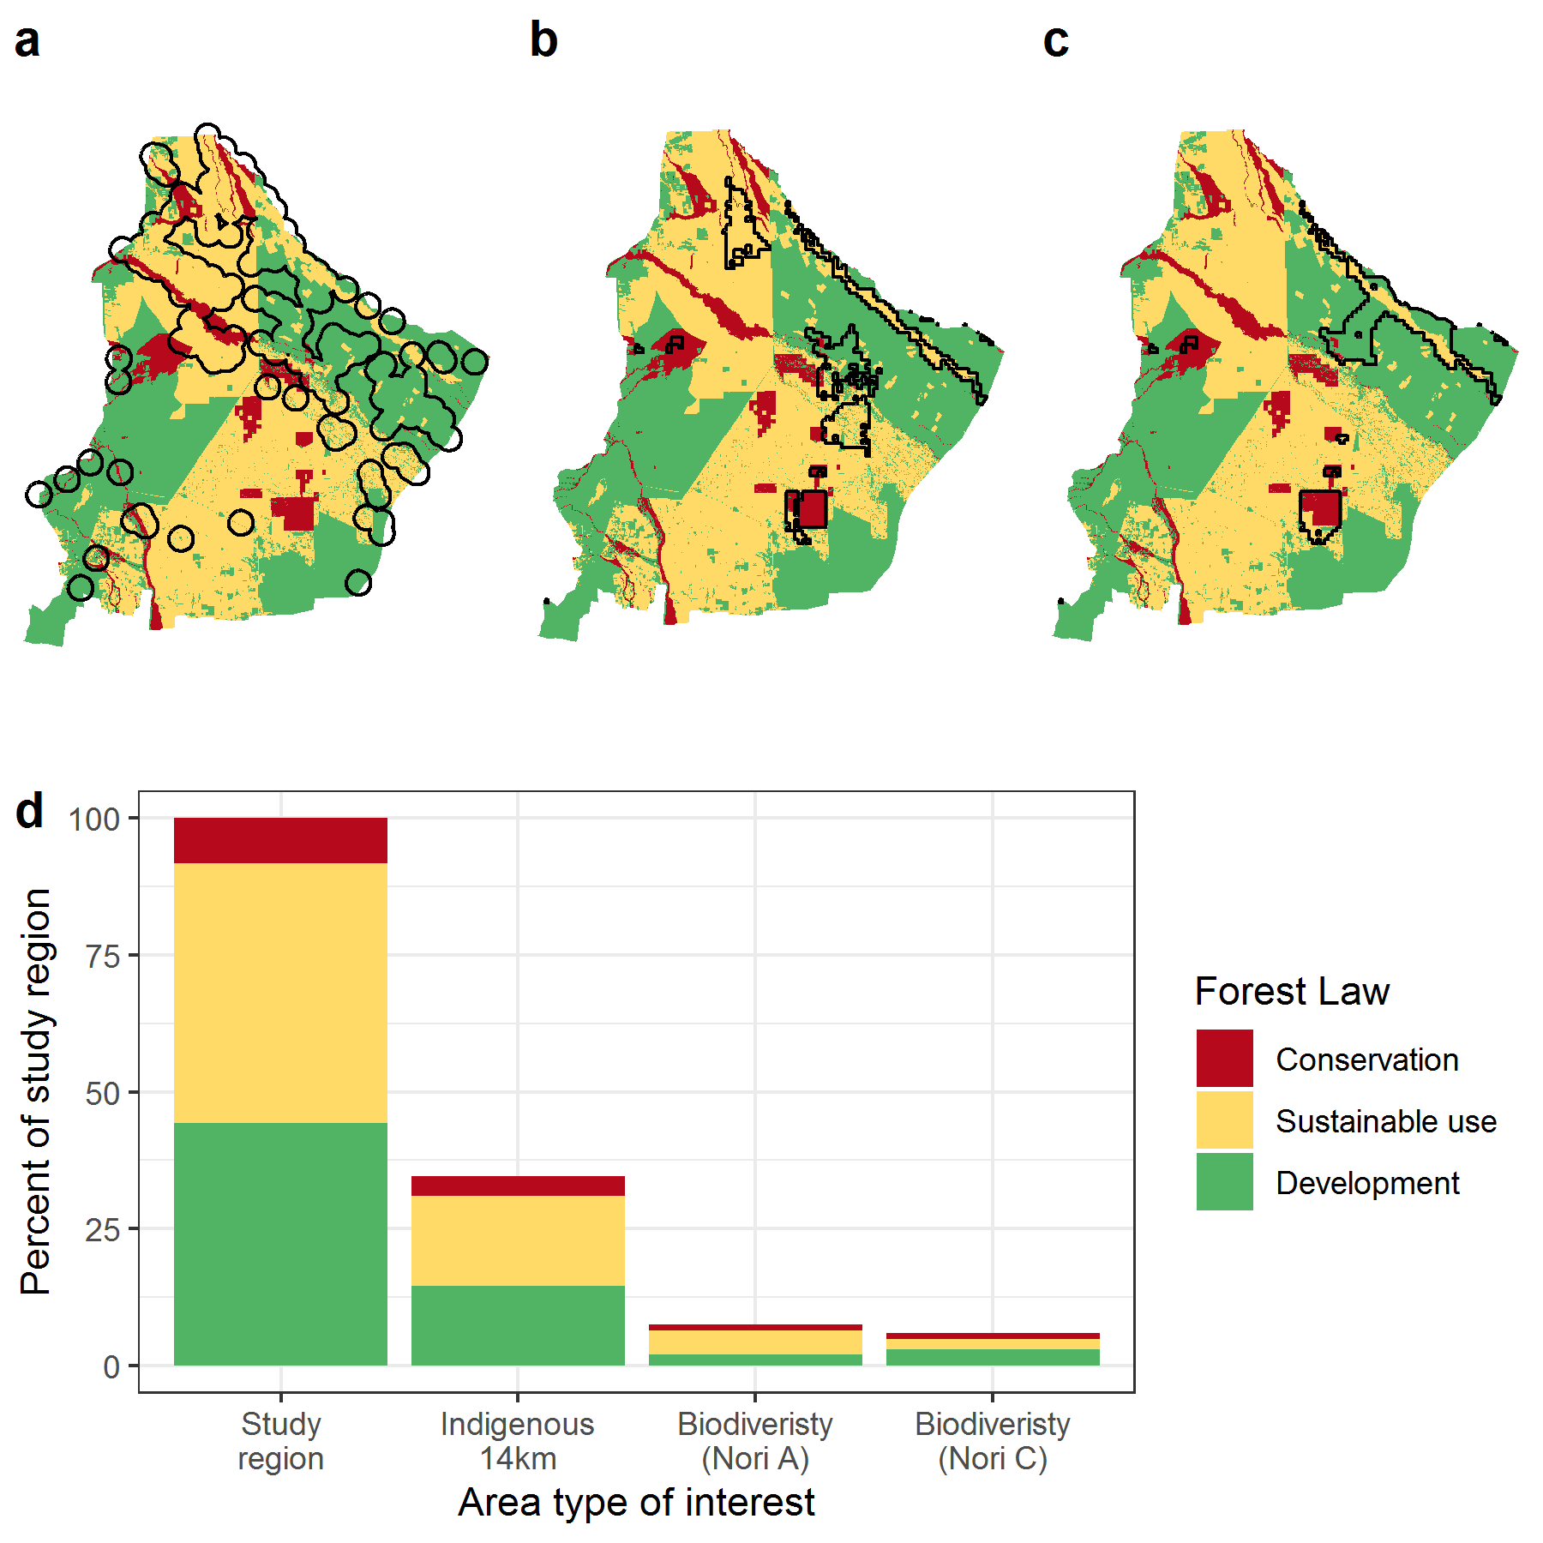

# REFERENCES

Adamoli, J., Sennhauser, E., Acero, J.M., Rescia, A., 1990. Stress and Disturbance: Vegetation Dynamics in the Dry Chaco Region of Argentina. *Journal of Biogeography* 17, 491–500. https://doi.org/10.2307/2845381.

Baumann, M., Levers, C., Macchi, L., Bluhm, H., Waske, B., Gasparri, N.I., Kuemmerle, T., 2018. Mapping continuous fields of tree and shrub cover across the Gran Chaco using Landsat 8 and Sentinel-1 data. *Remote Sensing of Environment* 216, 201–211. <https://doi.org/10.1016/j.rse.2018.06.044>.

Grau, H.R., Gasparri, N.I., Aide, T.M., 2008. Balancing food production and nature conservation in the Neotropical dry forests of northern Argentina. *Global Change Biology* 14, 985–997. https://doi.org/10.1111/j.1365-2486.2008.01554.x.

Macchi, L., Baumann, M., Bluhm, H., Baker, M., Levers, C., Grau, H.R., Kuemmerle, T., 2019. Thresholds in forest bird communities along woody vegetation gradients in the South American Dry Chaco. *Journal of Applied Ecology* 56, 629–639. https://doi.org/10.1111/1365-2664.13342.

Macchi, L., Grau, H.R., 2012. Piospheres in the dry Chaco. Contrasting effects of livestock puestos on forest vegetation and bird communities. *Journal of Arid Environments* 87, 176–187. https://doi.org/10.1016/j.jaridenv.2012.06.003.

Morgan-Wall, T., 2020. rayshader: Create Maps and Visualize Data in 2D and 3D. https://CRAN.R-project.org/package=rayshader.

Mukherjee, N., Hugé, J., Sutherland, W.J., McNeill, J., Opstal, M.V., Dahdouh‐Guebas, F., Koedam, N., 2015. The Delphi technique in ecology and biological conservation: applications and guidelines. *Methods in Ecology and Evolution* 6, 1097–1109. https://doi.org/10.1111/2041-210X.12387.

Murray, F., Baldi, G., von Bernard, T., Viglizzo, E.F., Jobbágy, E.G., 2016. Productive performance of alternative land covers along aridity gradients: Ecological, agronomic and economic perspectives. *Agricultural Systems* 149, 20–29. https://doi.org/10.1016/j.agsy.2016.08.004.

Newbold, T., Hudson, L.N., Hill, S.L.L., Contu, S., Gray, C.L., Scharlemann, J.P.W., Börger, L., Phillips, H.R.P., Sheil, D., Lysenko, I., Purvis, A., 2016. Global patterns of terrestrial assemblage turnover within and among land uses. *Ecography* 39, 1151–1163. https://doi.org/10.1111/ecog.01932.

Newbold, T., Hudson, L.N., Hill, S.L.L., Contu, S., Lysenko, I., Senior, R.A., Börger, L., Bennett, D.J., Choimes, A., Collen, B., Day, J., De Palma, A., Díaz, S., Echeverria-Londoño, S., Edgar, M.J., Feldman, A., Garon, M., Harrison, M.L.K., Alhusseini, T., Ingram, D.J., Itescu, Y., Kattge, J., Kemp, V., Kirkpatrick, L., Kleyer, M., Correia, D.L.P., Martin, C.D., Meiri, S., Novosolov, M., Pan, Y., Phillips, H.R.P., Purves, D.W., Robinson, A., Simpson, J., Tuck, S.L., Weiher, E., White, H.J., Ewers, R.M., Mace, G.M., Scharlemann, J.P.W., Purvis, A., 2015. Global effects of land use on local terrestrial biodiversity. *Nature* 520, 45–50. https://doi.org/10.1038/nature14324.

Nori, J., Torres, R., Lescano, J.N., Cordier, J.M., Periago, M.E., Baldo, D., 2016. Protected areas and spatial conservation priorities for endemic vertebrates of the Gran Chaco, one of the most threatened ecoregions of the world. *Diversity and Distributions* 22, 1212–1219. https://doi.org/10.1111/ddi.12497.

Romero‐Muñoz, A., Benítez‐López, A., Zurell, D., Baumann, M., Camino, M., Decarre, J., Castillo, H., Giordano, A.J., Gómez‐Valencia, B., Levers, C., Noss, A.J., Quiroga, V., Thompson, J.J., Torres, R., Velilla, M., Weiler, A., Kuemmerle, T., 2020. Increasing synergistic effects of habitat destruction and hunting on mammals over three decades in the Gran Chaco. *Ecography* 43, 954–966. https://doi.org/10.1111/ecog.05053.

Vallejos, M., Álvarez, A.L., Paruelo, J.M., 2020. How are indigenous communities being affected by deforestation and degradation in northern Argentina? *Preprints* 2020110568. https://doi.org/10.20944/preprints202011.0568.v1.