Supporting Information A: Additional Methods
Fading opportunities for mitigating agriculture-environment trade-offs in a South American deforestation hotspot
Law, E., Macchi, L., Baumann, M., Decarre, J., Gavier-Pizarro, G., Levers, C., Mastrangelo, M.E., Murray, F., Müller, D., Piquer-Rodríguez, M., Torres, R., Wilson, K., Kuemmerle, T., 2021. Biological Conservation.
CONTENTS:
Data and code availability: 2
APPENDIX A: ADDITIONAL METHODS 3
A 1. LAND SYSTEMS MAPPING 3
A 1.2 Land systems definition 3
A 1.3 Land system mapping 5
A 2. LAND SYSTEMS PROPERTIES 9
A 2.1 Potential agricultural profits per land system 9
A 2.2 Potential biodiversity benefits per land system 13
A 2.3 Potential carbon stock per land system 20
A 3. POLICY (TRANSITION) AND POINT SCENARIOS 22
A 3.1 POLICY (TRANSITION) SCENARIOS 22
A 3.2 POINT SCENARIOS 27
A 4. OPTIMIZATION PROCEDURE 29
A 4.1 OPTIMIZATION PROCEEDURE 29
A 4.2 ALTERNATIVE SOLUTIONS AND APPROACHES 32
REFERENCES 34

Data and code availability:
Code and selected data are archived in OSF (DOI 10.17605/OSF.IO/5EJCQ). Further data can be provided at reasonable request.

APPENDIX A: ADDITIONAL METHODS

A 1. LAND SYSTEMS MAPPING

A 1.2 Land systems definition
Our study region was the northern Argentinean Dry Chaco (174,197 km²), as delineated in Torres et al. (2014), which is part of the wider Argentinean Chaco, itself a subregion of the 1.1 million km² Gran Chaco Americano. Several of the input data we used here were generated for either the entire Argentinean Chaco or the Gran Chaco scales. We used a baseline grid of 1x1 km² based on a South American Albers Equal Area Conic projection (https://spatialreference.org/ref/esri/south-america-albers-equal-area-conic). All spatial inputs were linked to this grid.
Our land-system maps provided a spatial basis for mapping current, past, and future land-system properties and the transitions allowed under alternative policy scenarios. The current land system map also provided the spatial template (i.e., the starting condition) for the optimization. In this respect, we defined land systems with the following conditions in mind: (1) Land systems needed to capture major land-based impacts for our feature objectives (agricultural profit, carbon stock, and biodiversity); (2) Spatial data was available to map the systems and provide meaningful disaggregation of values for the three dimensions (agricultural profit, carbon stock, biodiversity) per system; (3) Systems needed to represent the dominant land-use actors and policy directions in the study region; and (4) the number of systems needed to be manageable for the optimization (i.e., not too many). We decided on the following classes (Table A1).

Table A1: Land systems used in our study and rational for inclusion
Land system | Description
Cropland | Several crops are grown in the region (including soy, wheat, cotton, corn, and other grains), and these are collectively mapped as current areas of ‘cropland’. However, soybean production drives the agri-business cropping mode that this land system presents, and is by far the most important cropping activity in the region.
Pasture | This land system represents agribusiness ranching, based on highly intensive pastures with no or low tree cover and typically with exotic, highly productive grasses. It is the typical agribusiness model of livestock production in the study area.
Silvopasture | This land system has a higher level of woody plant cover (12-30%) remaining on grazing land than the pasture systems (above). In the study region current silvopasture is mainly based on intensively managed grazing areas sown with exotic grasses but can also include areas with natural grasses. However, ideally silvopasture manages both livestock and timber, and this multifunctional land system is of regional and international interest for managing environment-development trade-offs.
Forest smallholders | Forest smallholder systems, locally known as puestos, represent subsistence ranchers living inside woodlands and producing mainly for themselves. Livestock roams freely around homesteads. This is an historical and culturally important multifunctional land system, with an extensive area of influence, and of interest in regional land-use policy.
Forest | This land system includes the various forms of naturally occurring woodlands and shrubland in the region, including xeric woodlands, subtropical and tropical deciduous forests, and riverine gallery forests. Forests can be closed or partly open.
Other (designated as ‘static’ in the analysis) | This category comprised areas that we designated as constant (‘static’) throughout the analysis – contributing to benefits, but not reallocated during optimization. These included:  (1) Protected areas, typically represented by their constituent land cover (mainly forest and/or grassland). We assumed no agricultural profit and a higher abundance of mammals given an assumed lower hunting pressure (see below).  (2) Natural grasslands outside protected areas, as these represent relatively small areas of generally high conservation value. These areas can be distinguished from pastures via their location (along rivers or surrounded by forest matrix) and shape (natural edges).  (3) Areas that would provide no value for our feature objectives (e.g. urban, bare, water, and unclassified cells).

A 1.3 Land system mapping
To map land systems, we used methods from Baumann et al. (2017) to derive a 30-m resolution land-cover map for 2015 using the entire Landsat ETM+/OLI image archive for that year. For this, we derived Landsat-spectral-temporal metrics and additionally added a set of Sentinel-2 backscatter coefficient metrics, which improve land-cover discrimination (Baumann et al., 2017). We updated the original reference dataset collected for 2013 (Baumann et al., 2017) by cross-checking them with Landsat imagery to ensure that land cover remained stable between 2013 and 2015 (and updated original class labels if needed) and by collecting additional training data. We then used random forests to map the following classes: forest, croplands, pastures, natural grasslands, palm savanna, bare areas, water, wetlands. We validated this map following best practices (Olofsson, 2018). The map had an overall accuracy of 85.71% with average user’s and producer’s accuracies of ~81.1% and 80.9%, respectively. Finally, we separated tree-less pastures from pastures with trees (i.e. silvopastures) using a map of fractional woody cover (%) generated for the same region (Baumann et al., 2018), using thresholds of woody cover: pastures below 12% were allocated as pasture, and from 12-30% were allocated to silvopasture (above 30% were classified as forest).
We aggregated the 30-m land-cover map to the 1x1km scale by calculating shares of land-cover classes per 1km cell. We used a decision tree (Figure A1) to assign the dominating land system to each 1km cell (Kehoe et al., 2017; van Asselen and Verburg, 2012). To simplify these categories, we grouped all cells allocated to natural grassland, savannah, or wetlands into the class ‘natural grasslands’, and all areas that do not contribute value for any of our objectives into an ‘excluded’ category (including water, bare, built, and unclassified). Both the ‘natural grassland’ group and the ‘excluded’ group were allocated to the land system ‘static’ for the optimization.
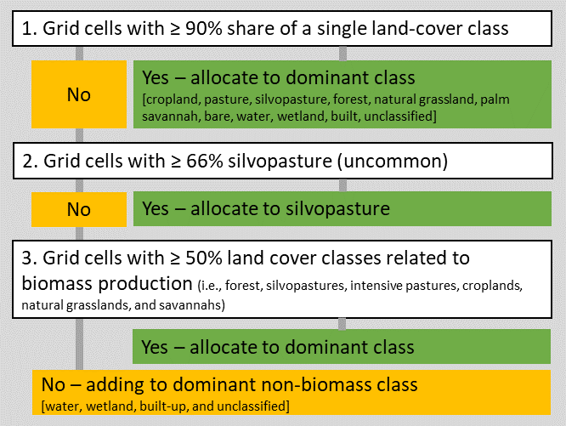
Figure A1: Ruleset for defining land systems.
We used visually digitized locations of forest smallholder systems within forest areas based on high-resolution imagery available in Google Earth (Romero‐Muñoz et al., 2020). We searched for three characteristics of forest smallholder homesteads: (1) the radial increase in forest cover around their homesteads due to forest degradation close to homesteads, (2) the presence of at least one building, and (3) the presence of a stable, corral, and/or water hole or well. This yielded 2,196 forest smallholder points within a 5km buffer of the study region, which rarefied to 2,182 grid cells, 2,144 of which were within the study region. Most fell within majority forest cells (n=1,916). The remainder (n=266) were individually checked for reallocation to a forest smallholder cell. The areas around homesteads are often grassy or bare, with some tree cover, and typically include several buildings. We found that the 266 cells with forest smallholder points that were not classified as majority forest were often categorized by our satellite derived land-system map as areas of silvopasture (n=23), grassy (n=67), pasture (n=60), crop (n=28), bare (n=24), and urban (n=26), usually within a forest matrix or mosaic at the 1km or local (~10km) level. This highlights the challenge of consistently classifying this land system with automated methods. We determined that all cells underlying forest smallholder points – except for 4 ‘unclassified’ that were masked from the Chaco region – were suitable for reallocation to the forest smallholder land system.
We then assigned all cells dominated by woodland within a 2km radius around homestead cells also to the forest smallholder land-system. This distance represents an approximate average area of influence for multiple features, based on field-assessed distances of smallholder impact on the surrounding vegetation, which they use for forest grazing, fuelwood collection, etc. (Macchi and Grau, 2012). For carbon stocks, we restrict the major influence to this 1km radius (see below) but for species biodiversity, agricultural production (livestock grazing), and the area of influence influencing transition constraints, we selected a 2km radius as the average over many features (e.g. Adamoli et al., 1990; Macchi and Grau, 2012). However, we acknowledge that grazing is often more extensive, and some species, for example large carnivores such as jaguar that might prey on livestock, may be substantially affected by smallholder presence at much larger distances (e.g. 5km; Romero‐Muñoz et al., 2020). We therefore developed a sensitivity scenario based on a forest smallholder footprint with a 5 km radius from homestead points (again within majority woodland). This footprint area expanded the influence of smallholders on biodiversity, increased the area utilized and profits generated from livestock grazing, and increased the area of impact for transition rules regarding forest smallholders. Presentation of the results from, and a discussion of the implications of this assumption regarding forest smallholder footprint is given in Appendix B 1.5.
Finally, we assigned all cells within protected areas to this land system and designated these as ‘static’ for the optimization. Protected areas were delineated according to the World Database of Protected Areas (UNEP-WCMC and IUCN, 2016). Protected areas retained the values of their constituent underlying land systems, except for (1) increased values for mammals due to expectations of lower hunting pressure, and (2) no value to agriculture from agricultural land uses or forest smallholders.
Table A2 Area coverage and share of the major land systems in our study area for the year 2015 (our baseline year). Forest smallholder areas are based on 2km radius in woodland from their point locations, representing an average area of influence over multiple features. Areas of influence for specific species or features may differ (section A1.3, discussed further with respect to smallholders in Appendix B1.5).
Class |  | Area (km²) | Share of region
Cropland |  | 19,549 | 11.22%
Pasture |  | 10,005 | 5.74%
Silvopasture |  | 3,464 | 1.99%
Forest smallholder |  | 21,587 | 12.39%
Forest |  | 104,496 | 59.99%
Static | (all static) | 15,096 | 8.67%
 | Natural grassland (total) | 5,544 | 3.18%
 | Natural grassland (outside protected areas) | 5,380 | 3.09%
 | Excluded (total) | 4,505 | 2.59%
 | Excluded (outside protected areas) | 4,467 | 2.56%
 | Protected areas (PA; total) | 5,249 | 3.01%
 | PA/Crop | 28 | 0.02%
 | PA/Pasture | 281 | 0.16%
 | PA/Silvopasture | 27 | 0.02%
 | PA/Forest Smallholder | 282 | 0.16%
 | PA/Forest | 4,428 | 2.54%
 | PA/Natural grassland | 164 | 0.09%
 | PA/Excluded | 38 | 0.02%
TOTAL |  | 174,197 | 100%

A 2. LAND SYSTEMS PROPERTIES
Our problem formulation required us to estimate for each cell the potential value for each dimension (agricultural profits, carbon stock, biodiversity) should it be allocated to each land system. Note that the ‘static’ system is represented by the underlying land systems (and thus the values of these systems, with the exceptions noted above).

A 2.1 Potential agricultural profits per land system
For cropland, we estimated potential profits from soybean production, the most important, widespread and profitable crop in the region. For beef production, we estimated profits for pastures, silvopastoral systems and forest smallholder systems. For all other land systems, we assumed no benefit to agricultural production (including current agricultural or forest smallholder areas inside protected areas). We estimated gross profits by expanding the equations given in Murray et al. (2016) for yield and profit of each of our land systems. For soybean, these equations include gross income estimates (i.e., market prices by the quantity of commodities produced), various cost (i.e., local costs for labour, inputs and services, maintenance and repair costs, production costs in relation to seeds and agrochemicals, fixed transportation costs and administrative costs), using average market values. For beef production, the Murray et al. (2016) equations considered farm-level profits calculated as production (i.e., weight average of sold animals) times average price, minus recurring costs (i.e., labour, reseeding pastures, shrub removal, bull replacement, veterinary services, infrastructure maintenance), trade costs and fixed cost (e.g. commissions and transport). All data for parameterizing came from regional sources (Murray et al., 2016). Murray et al. (2016) also provide a description of profits as a function of precipitation, per land system (Table A3). For details, we refer to (Murray et al., 2016).

Table A3: Agricultural profit functions (USD ha⁻¹yr⁻¹), assuming fixed-distance travel costs, as a function of annual precipitation (mm yr⁻¹). Source: Murray et al. (2016).
Agricultural production type | Profit (fixed-distance) for cell i, as a function of precipitation (p)
Cropland (soy) | 0.4528 $p_{i}$ – 135.9
Forest smallholder (beef) | 0.00007 $p_{i}^{2}$ + 0.0664 $p_{i}$ – 28.557
Silvopasture (beef) | 0.0001 $p_{i}^{2}$+ 0.1331 $p_{i}$ - 34.982
Pasture (beef) | 0.00006 $p_{i}^{2}$+ 0.1344 $p_{i}$ - 25.306
To map profits for our cropping and ranching land systems across the study region, we adjusted the original equations from Murray et al. (2016) to account for spatially variable transport costs. We substituted fixed-distance travel costs by re-estimating yields from the yield equations (Table A4), removing these fixed distance costs, and adding in variable distance costs. Specifically, we used the general function:
$$a_{ijf}= β_{fj1}p_{i}^{2}+β_{fj2}p_{i}+c_{fj1}+\left(β_{fj3}p_{i}+c_{fj2}\right)*(d_{if}m_{f}-w_{f})$$
where a_{ijf} is the profit for feature f (i.e., soy or beef) in cell i when allocated to zone j, and determined as a combination of linear functions, with beta coefficients, βij, and constants, c_{fj}, specific to each feature and zone. Precipitation occurring in each cell, p_{i}, and the distance, d_{if}, being specific to the cell (the start location for transport) and the feature (the end location of transport), were spatially variable.
The first part of the function $(β_{fj1}p_{i}^{2}+β_{fj2}p_{i}+c_{fj1})$ is given directly by the Murray et al. (2016) fixed-distance profit functions (Table A4). This needed to be adjusted to remove the fixed-distance (but variable yield) travel costs for each feature, w_{f}. We did this by 1) estimating yield at each cell, based on functions relating precipitation to yield in the study region, 2) based on the yield calculated from (1), we calculated the estimated fixed-distance travel costs for each cell, 3) removed these travel costs calculated in (2) from calculated profit, 4) then added in variable travel costs, estimated as a product of the yield, distance, d_{if}, and the cost km⁻¹ Mg⁻¹, m_{f}. We estimated the yield component of the equations $\left(β_{fj3}p_{i}+c_{fj2}\right)$ given min/max values (Table A4). For example, Murray et al. (2016) estimated fixed distance travel costs (w_{f}) for soy as USD 44 for 500 km of travel, which we translated to a USD 0.088 km⁻¹Mg⁻¹ equivalent (44/500). Similarly, Murray et al. (2016) estimated fixed distance travel costs for beef as USD 31 for 200km of travel, which we translated to a USD 0.155 km⁻¹Mg⁻¹ equivalent. We based these variable distance costs on the travel distance from each cell (i.e. Euclidean distance from each cell to the nearest road, then travel along these roads) to the nearest port (for soy) or agricultural center (for beef; including provincial capital cities, and known livestock refrigeration and slaughterhouse facilities) (Piquer-Rodríguez et al., 2018). As precipitation layer, we used the 1981-2000 average annual precipitation generated with the ClimateSA v1.0 software package (available at http://tinyurl.com/ClimateSA, based on methodology described by Hamann et al. 2013), clipped to a maximum of 900mm yr⁻¹. The final range of profits for each of the land systems is given below (Figure A2; Table A5)
Table A4: Line endpoints of functions relating yield to precipitation, from Murray et al. (2016), used to estimate slope and intercepts to derive linear functions for yields.
Feature and zone | Endpoints of lines
Precipitation (mm yr⁻¹) | 500, 900
Soy (Mg ha⁻¹yr⁻¹) | 1.364, 2.384
Forest smallholder beef (Mg ha⁻¹yr⁻¹) | 0.020, 0.048
Silvopasture beef (Mg ha⁻¹yr⁻¹) | 0.067, 0.160
Pasture beef (Mg ha⁻¹yr⁻¹) | 0.067, 0.160

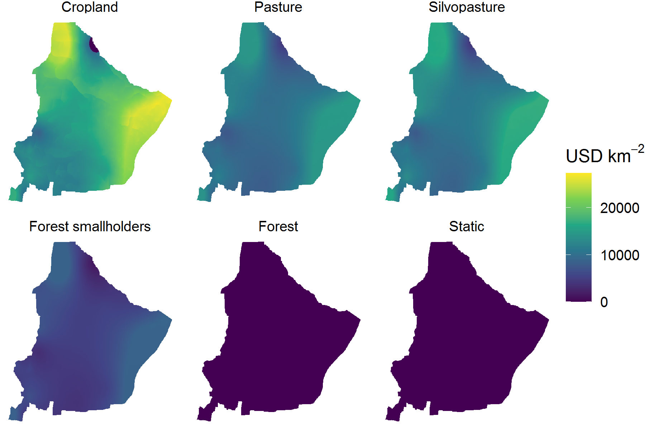
Figure A2: Agricultural profit estimates by land system, showing potential profit of each cell under each land system in our study (USD km⁻²yr⁻¹).
Table A5: Range of profits from agricultural activities as mapped for the land systems in our study region (USD km⁻²yr⁻¹).
Croplands | Pasture | Silvopasture | Forest smallholders | Forest | Other
0 –  27,278 | 4,470 – 15,062 | 4,188 – 17,217 | 1,246 –  8,801 | 0 | 0

A 2.2 Potential biodiversity benefits per land system
To represent biodiversity, we used an index representing the aggregate relative abundance of a set of focal species (i.e., 26 birds and 17 mammals), representative of natural woodlands and grassland in the Chaco. We chose species to represent a range of habitats and ecologies, including species of conservation concern, while considering data availability regarding their distribution and abundance. We estimated our biodiversity index for all species across all land systems.
To map the potential relative abundance of each of our focal species per land system across the study region, we combined the spatial information on potential presence across the study region, with thematic information on relative abundance in each land system. Potential presence distributions were derived using species distribution modelling based on climate and soil predictors, for the entire Argentinian Chaco ecoregion at a 1-km resolution (Torres et al., 2014)(Figure A3).
To estimate relative abundances for birds, we used data from our own field surveys carried out across the northern Argentinean Dry Chaco between 2009 and 2013 (Macchi et al., 2013) and covering all land systems considered. Our surveys (n=167) used repeated 10-minute point counts in randomly chosen, locally homogenous locations with a 20-meter fixed radius. A detailed description of the sampling protocol is provided in (Macchi et al., 2013, 2019). We averaged the abundance per species and land system and converted them into relative abundance measures (10 = highest) to ensure comparability across species, with a score of 10 representing the highest abundance seen across the land systems for each species. Finally, we selected the 26 bird species (Table A6) for which sufficient data was available (>10 occurrence points used in the distribution modelling, and >10 frequency observations in the field) and for which distribution model fits were robust (AUC values > 0.65) (Torres et al., 2014).
For mammals, we considered 17 species common and/or of conservation concern in the Chaco (Table A7). As no standardized abundance estimates for these species existed, we used an expert-elicitation process to assign abundance scores per species and land systems. We consulted 12 experts with substantial field experience and knowledge of Chaco wildlife and followed a Delphi technique with two rounds (Mukherjee et al., 2015). In the first round, experts were asked to assign a relative abundance score for each species and land system (10 = maximum possible abundance). Based on the outcomes of this elicitation, we calculated average abundance ranks per species and land system. In the second round, experts were presented the results from the first round, along with their own initial response, and asked to assess whether or not they agreed with the average score using a Likert scale from 1 (strongly disagree) to five (strongly agree). We then averaged these ranks (i.e., number of experts agreeing). Based on this, we calculated a final abundance score per species and land system by weighting the abundance score of each species by the consensus level (Table A7):
new abundance score = expert value + (expert value - average group)*p(consensus)
The aggregate relative abundance biodiversity metric then summed, for each land system, the scaled relative abundances over all species with potential presence in each cell. To give each species equal representation in the aggregate biodiversity index used in the optimization, we rescaled the relative abundance score for each cell for each species by the maximum sum possible for that species (i.e. if land systems are optimized for that species only), given the S₀ transition constraints. This was scaled to an arbitrary large number (10⁴) to minimise numerical issues when solving the optimization. This gives a scale to the aggregate biodiversity metric of 43x10⁴ if all species could achieve their optimized allocations, and a cell-wise theoretical average score of 2.47 if all species had potential presence across the entire 174,197km² study region. However, note this is a theoretical maximum, not the maximum possible within our landscape, as different species have conflicting habitat requirements. Our final aggregate biodiversity metric ranged from 0 to a maximum of 4.07 km⁻² cell (Figure A4, Table A8)
Taxonomic assignments were reviewed with the Encyclopaedia of Life (as of 25th Jan 2021) via the R package ‘taxize’ (Chamberlain and Szocs 2013; Chamberlain et al. 2020).
Figure A3: Potential distributions for the bird (blue) and mammal (orange) species considered in this study. Potential distributions represent bioclimatic suitability per species, given a suitable land system (Torres et al., 2014), but do not necessarily correspond with current species presence, which is typically additionally conditional on current and past land use practices.
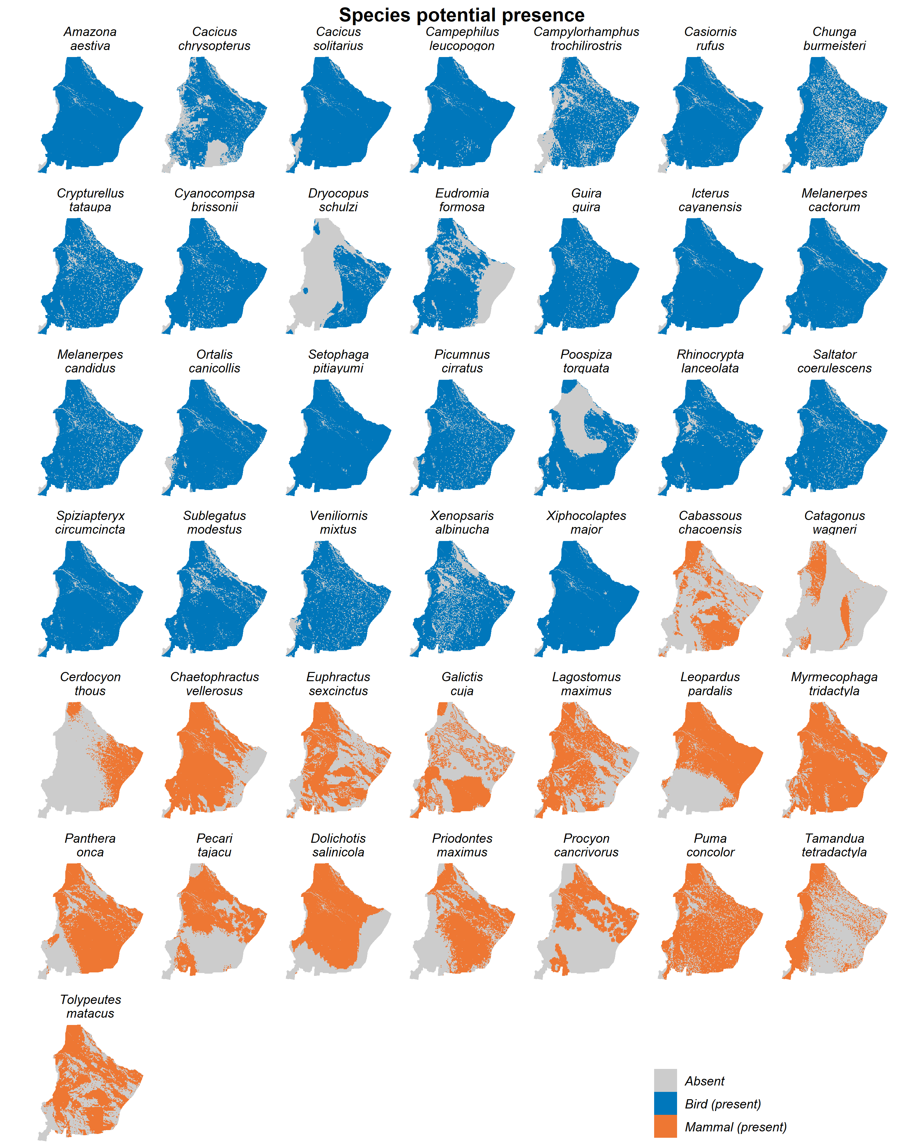

Table A6: Relative abundance (average abundance scaled to the maximum average abundance found in across the region) for the 26 bird species for which sufficient data were available.
Species name | Forest | Natural grasslands | Forest smallholders | Silvo-pastures | Pastures | Cropland
Amazona aestiva | 1.00 | 0.09 | 0.34 | 0.30 | 0.19 | 0.02
Cacicus chrysopterus | 0.75 | 0.00 | 1.00 | 0.00 | 0.00 | 0.00
Cacicus solitarius | 1.00 | 0.17 | 0.72 | 0.22 | 0.56 | 0.06
Campephilus leucopogon | 1.00 | 0.07 | 0.45 | 0.21 | 0.05 | 0.00
Campylorhamphus trochilirostris | 0.57 | 0.11 | 1.00 | 0.11 | 0.03 | 0.03
Casiornis rufus | 1.00 | 0.04 | 1.00 | 0.00 | 0.08 | 0.00
Chunga burmeisteri | 1.00 | 0.44 | 0.88 | 0.36 | 0.24 | 0.04
Crypturellus tataupa | 1.00 | 0.14 | 0.43 | 0.20 | 0.13 | 0.02
Cyanocompsa brissonii | 0.29 | 0.14 | 1.00 | 0.43 | 0.86 | 0.29
Dryocopus schulzi | 0.60 | 0.00 | 0.20 | 1.00 | 0.00 | 0.00
Eudromia formosa | 1.00 | 0.20 | 0.20 | 0.40 | 0.00 | 0.00
Guira guira | 0.00 | 0.00 | 0.00 | 0.00 | 0.00 | 1.00
Icterus cayanensis | 0.23 | 0.35 | 0.08 | 1.00 | 0.65 | 0.15
Melanerpes cactorum | 1.00 | 0.17 | 0.72 | 0.22 | 0.33 | 0.22
Melanerpes candidus | 0.00 | 0.33 | 0.00 | 0.00 | 1.00 | 0.00
Ortalis canicollis | 1.00 | 0.00 | 0.58 | 0.21 | 0.11 | 0.03
Setophaga pitiayumi | 0.08 | 0.00 | 1.00 | 0.92 | 0.00 | 0.00
Picumnus cirratus | 1.00 | 0.04 | 0.61 | 0.06 | 0.08 | 0.03
Piranga flava | 1.00 | 0.00 | 0.00 | 0.00 | 0.00 | 0.00
Poospiza torquata | 1.00 | 0.10 | 0.50 | 0.10 | 0.00 | 0.00
Rhinocrypta lanceolata | 1.00 | 0.00 | 0.25 | 0.19 | 0.13 | 0.00
Saltator coerulescens | 0.33 | 1.00 | 0.22 | 0.33 | 0.67 | 0.00
Spiziapteryx circumcincta | 1.00 | 0.07 | 0.58 | 0.07 | 0.04 | 0.04
Sublegatus modestus | 0.59 | 0.06 | 1.00 | 0.12 | 0.18 | 0.18
Veniliornis mixtus | 1.00 | 0.02 | 0.56 | 0.19 | 0.21 | 0.05
Xenopsaris albinucha | 1.00 | 0.00 | 0.33 | 0.33 | 0.00 | 0.00
Xiphocolaptes major | 0.12 | 0.73 | 1.00 | 0.18 | 0.03 | 0.00

Table A7: Relative abundance score for the 17 mammal species considered across the land systems.
Species name | Forest | Natural  grassland | Forest smallholders | Silvo-pastures | Pasture | Cropland
Cabassous chacoensis | 1.00 | 0.18 | 0.32 | 0.46 | 0.48 | 0.05
Catagonus wagneri | 0.90 | 0.21 | 0.26 | 0.40 | 0.30 | 0.29
Cerdocyon thous | 0.48 | 0.5 | 0.50 | 0.44 | 0.41 | 0.37
Chaetophractus vellerosus | 0.92 | 0.55 | 0.33 | 0.16 | 0.21 | 0.14
Euphractus sexcinctus | 0.73 | 0.70 | 0.27 | 0.34 | 0.37 | 0.36
Galictis cuja | 0.79 | 0.535 | 0.52 | 0.39 | 0.41 | 0.00
Lagostomus maximus | 0.80 | 0.16 | 0.26 | 0.56 | 0.52 | 0.17
Leopardus pardalis | 0.98 | 0.11 | 0.25 | 0.24 | 0.24 | 0.23
Myrmecophaga tridactyla | 0.88 | 0.38 | 0.22 | 0.52 | 0.42 | 0.18
Panthera onca | 0.94 | 0.61 | 0.09 | 0.35 | 0.23 | 0.18
Pecari tajacu | 0.94 | 0.20 | 0.21 | 0.43 | 0.36 | 0.32
Dolichotis salinicola | 0.51 | 0.17 | 0.37 | 0.31 | 0.42 | 0.20
Priodontes maximus | 1.00 | 0.39 | 0.14 | 0.22 | 0.22 | 0.06
Procyon cancrivorus | 0.74 | 0.63 | 0.33 | 0.30 | 0.34 | 0.28
Puma concolor | 0.77 | 0.64 | 0.33 | 0.53 | 0.38 | 0.23
Tamandua tetradactyla | 0.74 | 0.32 | 0.36 | 0.35 | 0.40 | 0.04
Tolypeutes matacus | 0.91 | 0.41 | 0.22 | 0.38 | 0.36 | 0.14

Figure A4: Aggregate biodiversity index for each land system (km⁻² cell). As these are constrained by land system transitions pertaining to the most flexible transition scenario (S₀), value in the forest smallholder layer is restricted to the extant forest smallholder areas, value in ‘static’ areas is removed from the other layers, and values outside of static areas is removed from the ‘static’ layer. Further, these estimates pertain only to the main scenario where forest smallholder footprint extends over a radius of 2km. The 5km forest smallholder footprint version is given in Appendix B5.
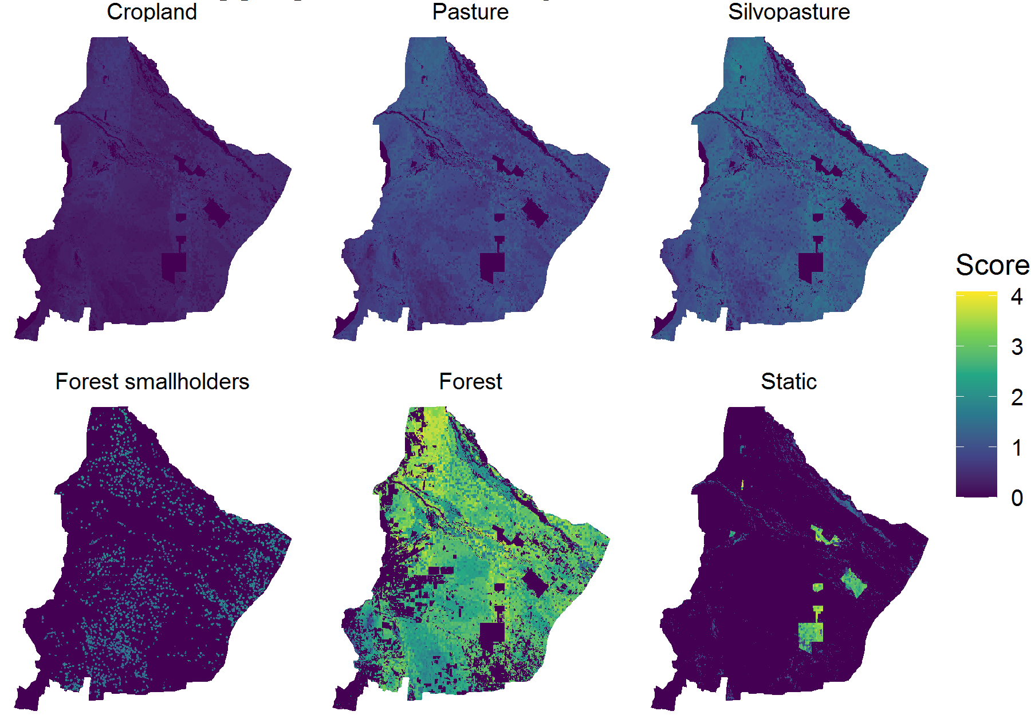
Table A8: Range of the aggregate biodiversity index for each land system (km⁻² cell), for the forest smallholder 2km footprint scenario.
Croplands | Pasture | Silvopasture | Forest smallholders | Forest | Other
0 – 0.737 | 0 – 1.464 | 0 – 1.818 | 0 – 2.320 | 0 – 4.073 | - 3.900

A 2.3 Potential carbon stock per land system
To map potential carbon stock of forest, we used existing relationships between biomass and average annual precipitation, which are based on inventory plots and satellite imagery and were used to estimate above-ground biomass for the study region (Gasparri and Baldi, 2013). Annual precipitation, was the strongest predictor of AGB in the study region at a regional scale, suggesting that annual precipitation can be used to map potential AGB for forest/woodland across the study region. We projected the function given in Gasparri and Baldi (2013) using the same precipitation layer as used for the agricultural profit estimation and converted mapped AGB to carbon stocks a conversion factor of 0.5 (Baumann et al., 2017). The resulting values ranged from about 32.3 – 54.8 MgC ha⁻¹ and were consistent with estimates from Baumann et al. (2017). The carbon stock for crop and pasture (Table A9) was derived from biomass values given in Baumann et al. (2017). For silvopastoral systems, we used the average value of actual (mapped) biomass for areas where this system occurs (Gasparri and Baldi, 2013). This resulted in a value of 22.8 Mg in AGB C ha⁻¹, which is well within the range of carbon stocks assessed in the field for these systems (max = 34.9, min = 2.42, mean = 16.26, median =15.91 MgC in AGB ha⁻¹ (Fernández et al., 2020). Forest smallholder systems reduce tree density and cover surrounding their homesteads due to firewood collection, charcoal production, and cattle foraging on woody vegetation. To estimate carbon stocks for these systems we assumed an average sphere of influence of 1-km around homesteads, which has been found both in the field (Macchi and Grau, 2012) and in remote sensing imagery (Baumann et al., 2018). We estimated average values for these spheres of influence based on Gasparri and Baldi (2013). Finally, the value of carbon stocks of all land systems was clipped to the maximum of forest in the same location, and converted from a per hectare metric to MgC km⁻² (Figure A5).

Table A9: Carbon stock estimators per land system (above ground MgC km⁻²).
Land system | Carbon stock (MgC km⁻²) | Source
Crop | 500 | Baumann et al. (2017)
Grassland/Pasture | 650 | Baumann et al. (2017)
Silvopasture | 2280 | Average from Gasparri & Baldi (2013) for the current silvopasture area
Forest smallholders (1 km radius from point locations, the remainder to 2 km receiving the same value as the underlying forest) | 2615 | Average from Gasparri & Baldi (2013) for the current sphere of carbon influence (1 km radius).
Forest | 3233 – 5484 | Gasparri and Baldi (2013) AGB biomass estimate * 0.5.

Figure A5: Carbon stock estimations per land system (above ground MgC km⁻²).
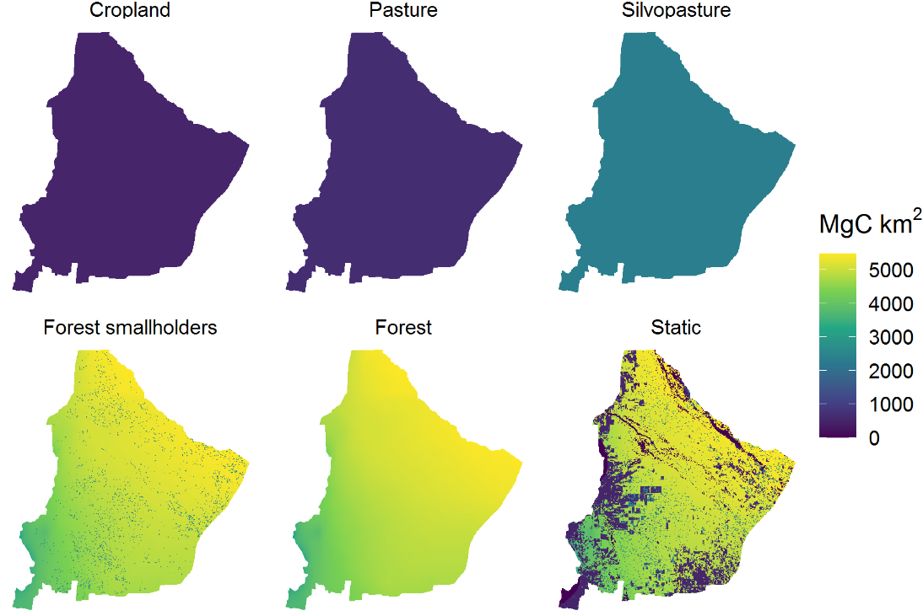

A 3. POLICY (TRANSITION) AND POINT SCENARIOS

A 3.1 POLICY (TRANSITION) SCENARIOS
We defined four policy scenarios with regards to allowed transitions between land systems (Table 1 in the main manuscript). Transitions were defined as the allowed land system in a solution, given the starting condition of 2015. Our scenario S₀ was developed as the most flexible scenario – based on biophysical and socioeconomic constraints, without further zoning restrictions – thus defining the ‘fundamental’ frontier. Under this policy scenario, three rules were applied (Figure A6):
- Static remains as static, identical in the constituent land systems represented.
- No land systems were allowed to transition into forest smallholder (i.e. only forest smallholders could remain as such), considering that the trend in the last decades for the region has been the reduction in the number of forest smallholders (Grau et al., 2008).
- No land system could restore to forest if not already in a forest-containing land system (forest smallholder, forest). We considered the time required for restoration of full forest values (i.e. carbon, biodiversity, and other omitted ecosystem service values) to be longer than the policy window we considered (approximately 30 years). Further, transitions from cleared land systems to forest are unlikely given the contemporary socio-economic trajectory in the region. Based on the underlying land-cover mapping, observed transitions from cropland, pasture, or silvopasture to woodland (i.e. either from 1985 – 2000 and remaining forest in 2015, or 2000 – 2015) were rare, occurring in only 33 cells for ‘pure’ land systems, or 52 cells if ‘mix’ options were also included (< 0.03% of the study region). These carried into our ‘detailed’ land system mapping, where we note all of them occurred outside protected areas, and all but 3 cells were to ‘forest’ rather than forest cover within forest smallholders.
Otherwise, all land system could transition into all others. This included cropland and pasture conversions to silvopasture, despite the latter being practically difficult or uncertain, and rare in the study system as of 2015 (1.99% cover and only four cells transitioning from silvopasture in 1985 or 2000 to forest in 2015). We also assume that forest smallholders could be restored to forest (despite this not being observed in land system changes previously). Indeed we assume all currently degraded forest land covers (i.e., identified as forest or forest smallholder systems), if allocated to the forest land system, will restore to full carbon and biodiversity values. Further, we allowed forest smallholder areas to partially convert, i.e. a single forest smallholder containing multiple cells – including a more degraded homestead/core area, surrounded by a ring of extensive grazing – could transition to multiple other land system types. While this simplification is reasonable if the entirety of the forest smallholder is converted to alternative land systems, it is not realistic in the case of some but not all of the area remaining as forest smallholder. However, it reduces the problem size and complexity, and therefore was a pragmatic approach in the first instance. Further, these cases of incomplete conversion are identifiable in the results and represent interesting cases for discussion. We discuss this and other forest smallholder considerations in Appendix B5.
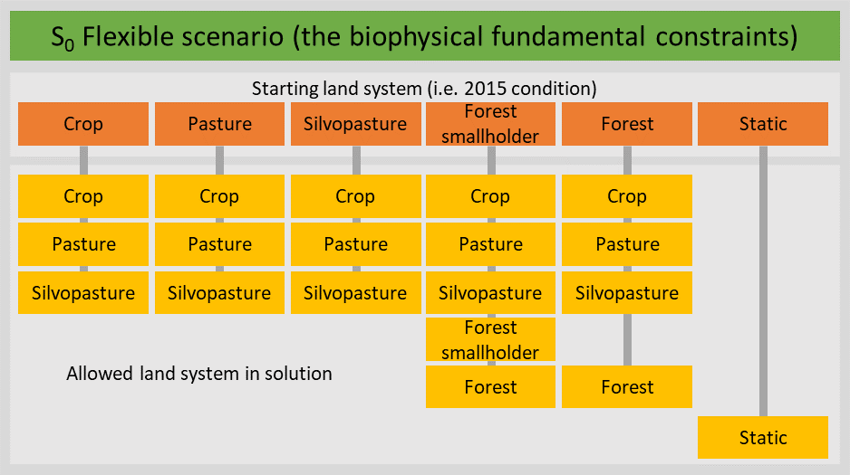
Figure A6: Land system transitions allowed in the base scenario S₀
All other scenarios included further constraints from these S₀ rules. The S_{FL} Forest Law scenario interprets the current zoning law (i.e., the Argentinean ‘Forest Law’ #26331), with simplifications. We interpreted the Forest Law zones as follows: The ‘green’ development zone (26.0% of the study region) allows transitions among all zones as in S₀. As such, it follows the Forest Law by excluding rather than mandating the allowed uses. The ‘yellow’ sustainable-use zone (47.5% of the study region) allows transition to silvopastures (but not to cropland or pasture) and supports but does not mandate persistence of forest smallholders. The ‘red’ conservation zone (8.2% of the study region) maintains or restores forest where this is possible (i.e. restored from forest smallholders, or maintained as woodland); where this was not possible, the ´red´ conservation zone allowed transitions to more biodiversity-friendly land systems (e.g. crop or pasture to silvopasture; Figure A ). We allocated all areas not covered under the Forest Law zoning (26.4% of the study region) to the ‘green’ development zone, expanding this zone to 52.4% of the study region. These additional non-zoned areas consisted of 40% cropland, 13% pasture, 2% silvopasture, 7% forest smallholder, 29% forest, and 10% static in our 2015 land system configuration. Major simplifications involved in this interpretation include that, in reality, both the development and sustainable-use zones include further provisions on permitting and percentages of conversion allowed. Further, other uses not considered in this analyses, such as eco-tourism and sustainable forestry, are also advocated for the sustainable-use zone.

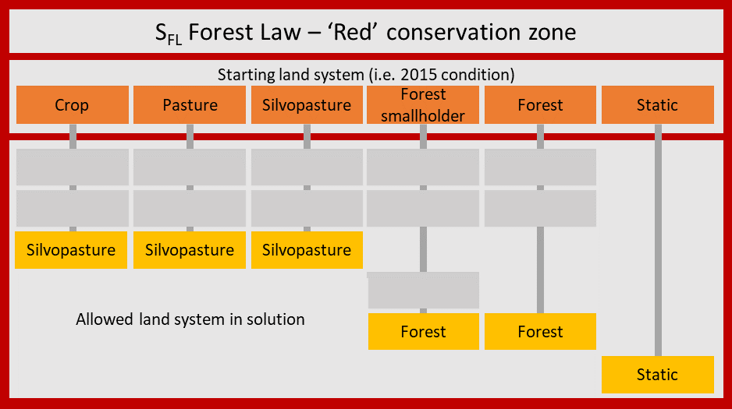
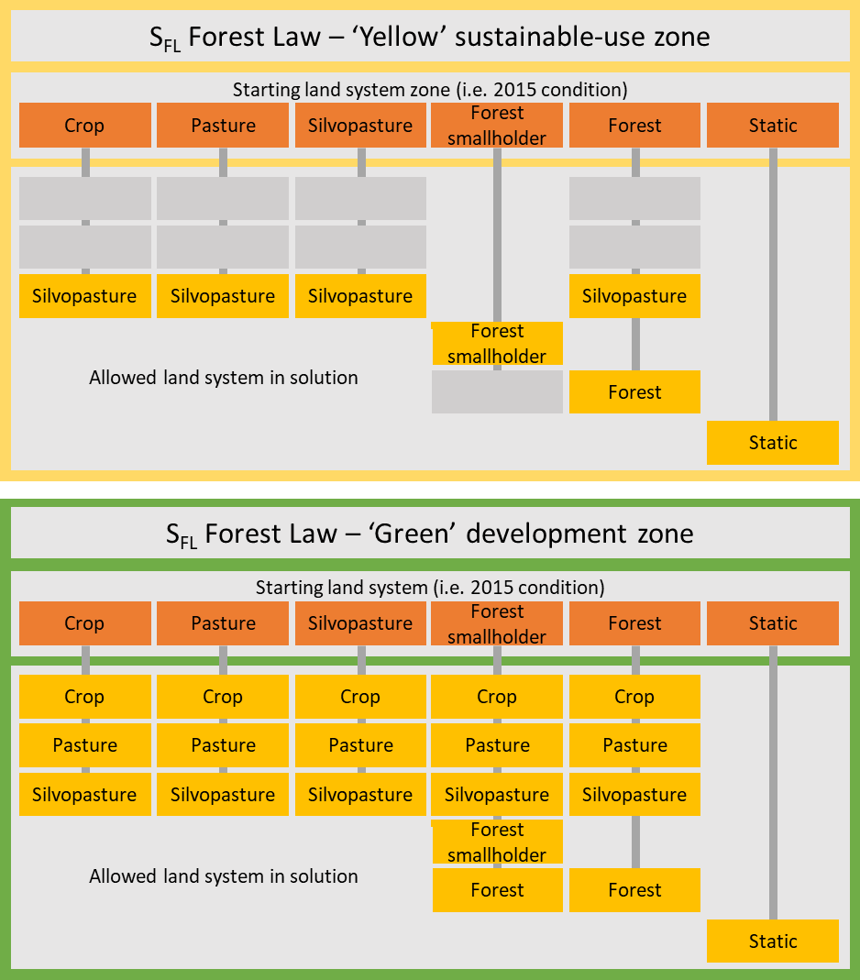
Figure A 7: Land system transition rules for our Forest Law scenario S_{FL.}
Our third scenario, the social-ecological scenario S_{SE}, tests the influence of forest smallholders. Forest smallholders are an historical and culturally important can provide a multifunctional land system potentially useful at landscape scales. In this scenario, forest smallholders were therefore assumed to persist (i.e., will be constant) in the optimized landscape. All other transitions were the same as in scenario S₀ (Figure A).
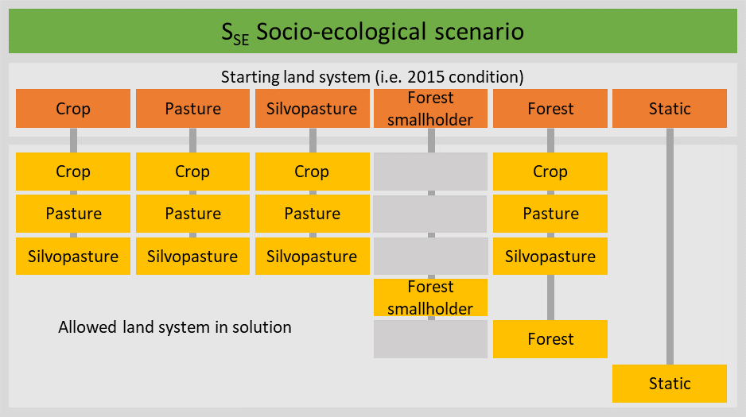
Figure A8: Transition rules for our social-ecological scenario S_{SE}.
Finally, our S_{NSP} scenario was developed to test for the importance of the silvopasture land system. While underdeveloped in the study system, this land system is receiving attention both regionally and internationally as a potential multifunctional land system useful for mitigating environment-development trade-offs. To test the influence of this land system, the S_{NSP} scenario specifies that silvopastures are not allowed to expand further from 2015 levels (2% of the study region). All other transitions were the same as in our baseline scenario S₀ (Figure A).
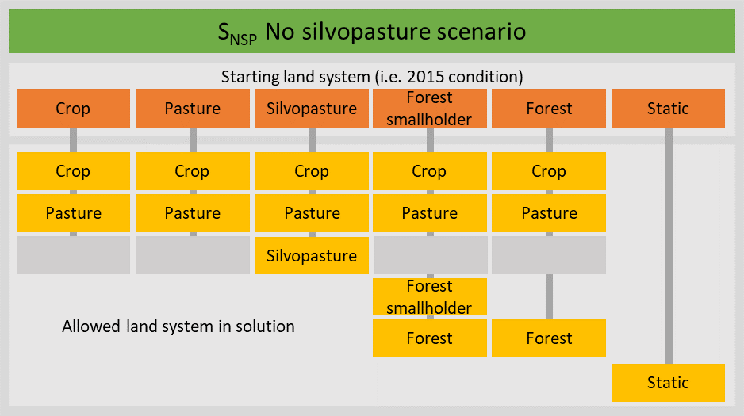
Figure A9: Transition rules for our scenario S_{NSP}.

A 3.2 POINT SCENARIOS
We developed eight ‘point scenarios’ representing past and future land-allocations for which to compare land system allocations and benefits. These included past, optimized, and future point solutions.
Past point scenarios used the actual land-system configurations from 1985, 2000, and 2015. The 2015 land system map construction is detailed above in section A1.3. The 1985 and 2000 land systems maps were constructed similarly. This included modification of the static zone to reflect the contemporary areas of natural grasslands and excluded land systems, and differences in the land systems mapped under protected areas (which itself was not changed). The area of forest smallholders was recalculated to reflect increased forest cover surrounding their homestead locations. The homestead locations were again identified from the same points as in A1.3, as no prior information is available. Forest cover (in forest and forest smallholders, i.e. excluding that in static) in past land system points exceeds that extant in 2015 (81.0% of the study region), including an additional 13.2% of the study region in 1985, and 4.2% of the study region in 2000.
Optimized point solutions were defined by land-system allocations from selected points from each transition scenario’s possibility frontier. These represent efficient land use configurations that gave ‘multifunctional’ outcomes at the landscape scale. Because the co-benefits of biodiversity conservation for carbon conservation are typically higher than the co-benefits of carbon conservation for biodiversity, we focused on optimal points defined hierarchically, first by maximum biodiversity score, then maximum carbon score, while achieving at least 50% of the maximum agricultural production possible for the study region, a point arbitrarily chosen because it lies on the middle of our frontiers and reflects a ‘balance’ of future agricultural development possibility and environmental concerns.
We also developed a future point scenario projected future land-system allocations as if the Forest Law zoning would be fully developed (i.e. all of the development zone transitions to cropland, all of the sustainable-use zone transitions to silvopasture, and all of the conservation zone transitions to the land system providing the highest biodiversity score possible at a given location). We stress that this explores the hypothetical endpoint of full development for a pragmatic interpretation of the current zoning. Some provinces currently specify maximum conversion proportions, so our scenario explores the situation should these restrictions be adjusted (e.g. in case land for expansion becomes scarcer) or relaxed (e.g. due to weak enforcement). In addition, we assumed the static area to remain constant (i.e. reflecting the 2015 benefits) for this point scenario.
Resulting land system shares and trends are provided in appendix B3.

A 4. OPTIMIZATION PROCEDURE

A 4.1 OPTIMIZATION PROCEEDURE
We defined the frontier as a spatial multi-objective optimization problem, solved through mixed integer linear programming (similar to Bryan et al., 2016; Law et al., 2017). This optimizes a set of decision variables (in our case: which alternative land-systems are allocated to each planning unit across the landscape), given an objective function (in our case: to maximize a biodiversity metric), subject to target, transition, and fundamental constraints.
We define the objective function to maximize the aggregate biodiversity metric, subject to the constraints, with the general form:
Maximize $\sum_{j=1}^{J}{\sum_{i=1}^{I}{B_{ij}x_{ij}}}$ (1)
Subject to: $\sum_{j=1}^{J}{\sum_{i=1}^{I}{a_{ijf}x_{ij}}}≥A_{f}, f ∈F$
$B_{ij}= \sum_{s=1}^{S}{b_{ijs}x_{ij}}$
$\sum_{j=1}^{J}{x_{ij}=1 }$
$x_{ij}=0, i ∈I_{T0}, j ∈J_{T0}$
$x_{ij}=1, i ∈I_{T1}, j ∈J_{T1}$
$x_{ij} ∈\{0,1\}$
where x_{ij} is the binary decision variable for cell i being allocated to zone j, B is the biodiversity metric (defined, cell-wise, as the sum of the species abundance indices, s, from the set of species, S), a_{ijf} is the value of an axis feature (i.e. one axis of the possibility frontier) for cell i in zone j, which must sum to be above the target for this axis feature, A_{f}, for all axis features, f, in the set of axis features F. All cells must be allocated to one zone, and one zone only. Additional constraints apply to specific cells in specific zones, given as a ‘lock out’ matrix, T0, and the ‘lock in’ matrix, T1, which are themselves subsets of the full set of cells, I, and zones, J.
In our case, we selected axis features as the agricultural profit and carbon stock objectives, as these are more conceptually tractable metrics than biodiversity, and it allowed multiple biodiversity formulations to be trialled. The target constraints trace the possibility frontier across a gradient of agricultural profit and carbon stock values that must be achieved for the solution to be accepted. Agriculture and carbon targets increased from 0 to 100% of their respective maxima, by intervals of 2%, resulting in 51 targets across each axis, and 2,601 target combinations across the frontier. Transition constrains were defined by our different policy scenarios as defined above.
To implement the optimization, we first prepared all the data as conformant rasters using R v3.1.2 (R Core Team, 2020), including the use of packages for programming ‘tidyverse’ (Wickham et al., 2019), and spatial processing ‘raster’ (Hijmans et al., 2020) and ‘rgdal’ (Bivand et al., 2020). We then used the package ‘prioritizr’ (Hanson et al., 2020) to define the problem as a mixed integer linear problem. Prioritizr offers a useful toolbox of functions for both efficient development of models (which can involve large, sparse matrices for this type of problem) and summarizing model outputs. It offers several alternative optimization objectives. However, as none of these were adequate as an off-the-shelf solution, we found it was easiest to modify the compiled problem from the minimization objective with the following specifications:
prioritizr::problem(x = biodiversity_score, features = sbenefits) %>%
add_manual_targets(targets = mtargets) %>%
add_manual_locked_constraints(data = locked_dataframe) %>%
add_mandatory_allocation_constraints() %>%
add_min_set_objective() %>%
add_binary_decisions() %>%
add_gurobi_solver(gap = 0.01, presolve = 2, time_limit = 1000)
This collates the problem as a minimization objective, minimizing the biodiversity_score (a single-layer raster representing B_{ij}), and the other features specified as the ‘zones’ object, sbenefits (created using prioritizer::zones() from raster stacks giving the benefits for each feature in each zone, along with the zone and feature names). In our case, we included both the axis target features (agricultural profit and carbon stock) as well as all the individual species. While we specified the targets for all the individual species to be always zero (using a custom dataframe, mtargets), this formulation allowed us to easily track the species representation outcomes using summary functions of prioritizr and from gurobi outputs (i.e. the ‘slack’), especially as we scaled all input benefits to a maximum of 1000. Transition constraints were specified manually via a dataframe, locked_dataframe, that details for each planning unit, which zones must not be selected.
We then compiled the problem (prioritizr::compile()),converted it using custom code to a maximization objective, and added a starting solution (the land systems as of 2015), to improve solving time. We then created 2,601 versions of this problem for each transition scenario, based on an 51 x 51 target matrix for the agricultural profit and carbon stock axes, by iteratively modifying the target constraints. This conversion and versioning used the R packages ‘rlist’ (Ren, 2016) and ‘Matrix’ (Bates and Maechler, 2019). We parallelized this problem formulation and solving using the R package ‘snowfall’ (Knaus, 2015), in which we passed the compiled and converted problem to be solved by the Gurobi optimization software v6.0 (Gurobi Optimization LLC, 2020) via the R package ‘gurobi’ (Gurobi Optimization LLC, 2020) with the following parameters used for solving: Presolve = -1, Timelimit = 3000, MIPGap = 0.01, IntFeasTol = 0.0001. This MIP gap specifies that solutions need to be within 1% of the true frontier to be accepted (and often they are optimal). Gurobi offers one of the most powerful solvers for mixed integer problems. Mixed integer problems are very flexible, and can be used for many alternative problem formulations, several of which are directly available via priortitzr functions. Gurobi uses a number of pre-solving algorithms to reduce the problem prior to solving. This means that our somewhat inflated problem formulation (containing excess features for all the species) is automatically rapidly reduced for processing.
Solutions derived from Gurobi were then further processed, including using prioritizr to map solutions and determine feature representation (for both axis features and all species). We utilized ‘snowfall’ (Knaus, 2015) to parallelize summarization of the results, ‘sf’ (Pebesma 2018), ‘rgdal’ (Bivand et al. 2021), and ‘raster’ (Hijmans 2020), for spatial processing, and plotting packages ‘ggplot2’ (Wickham, 2016), ‘plot3d’ (Soetaert 2019), ‘magik’ (Ooms, 2020), ‘ggthemes’ (Arnold, 2019), ‘cowplot’ (Wilke, 2019), ‘scatterpie’ (Yu, 2020), ‘scales’ (Wickham et al., 2020), ‘ggrepel’ (Slowikowski 2021) to develop the figures.

A 4.2 ALTERNATIVE SOLUTIONS AND APPROACHES
Solutions from the optimization (a mixed integer program, implemented via Gurobi) may be exact or within the tolerance specified. This depends on the problem formulation, and the parameters used for solving. We used a tolerance gap parameter of 0.01, meaning that solutions must be within 1% of optimal to be selected (as discussed in section A4.1). Given the large number of potential solutions involved in landscape planning with multiple alternative land system options, multiple alternative solutions may indeed satisfy this near-optimal or optimal solution criteria. In some cases, these alternative solutions may be relatively minor – a change location of a few cells, for example. This is more likely to occur with more homogenous value layers in the problem. In other cases, alternative solutions may result in major changes, particularly, for example, if two different decision alternatives provide the same or very similar values.
As Gurobi uses heuristics to facilitate solving of these large problems, it will give the same answer every time when presented with the same problem, and different presentations of the same problem may present slightly different answers. To address this, Gurobi output includes some alternative solutions, and suggests further analysis of this can involve random permutations of the input problem. Unfortunately, there is no easy way (and often it is simply not feasible) to identify all the potential alternative solutions for any particular problem in cases such as ours, due to the complexity of the optimization problem. Even an exploration of a range of solutions would require many iterations of each optimization and subsequent processing of the results, and there is no guaranteed way of sampling all feasible options representatively.
In our study, we use detailed spatial models to identify benefits across many objectives. We made every effort to develop spatially varying models as this actually facilitates the solving process, and is more likely to result in good solutions in a faster time, and the algorithm can more easily select priories from a set of cells. This is also more likely to give exact optima, and reduce the number of alternative solutions with minor changes. Our analysis of different policy outcomes essentially stands in for an analysis of alternative solutions that include major changes in land allocations. Our results show that all of the policies we explore can deliver very similar outcomes (at least for relevant sections of the possibility frontiers), despite very different allocations of land systems. Of course, further analysis of alternative solutions could have been pursued, but we feel that this is out of the scope and focus of the current analysis, and result in unnecessary complexity in an already complex analysis.
Other approaches for solving these problems include either Genetic Algorithms or the related Simulated Annealing algorithms, which are fundamentally stochastic. The benefit of these algorithms are that they can deal with complex non-linear problem formulations (or are at least easier to utilise for these), and in their typical basic implementation are more likely (but not guaranteed) to sample a range of similarly performing alternative solutions. The challenges with these approaches are that, under these algorithms, optimality is not guaranteed and is unquantifiable, the range of alternative solutions is not guaranteed to be representatively sampled, they are difficult to parameterize to ensure quality results, and there is no potential to leverage solutions from similar problems to speed the processing time. As such, we feel that mixed integer programming is superior for our analysis of possibility frontiers, although a joint approach (where mixed integer programming is used to map a frontier, and genetic algorithm solutions are evaluated with respect to this) might leverage the benefits of both methods, albeit with additional analytical and processing burdens.

REFERENCES
Adamoli, J., Sennhauser, E., Acero, J.M., Rescia, A., 1990. Stress and Disturbance: Vegetation Dynamics in the Dry Chaco Region of Argentina. Journal of Biogeography 17, 491–500. https://doi.org/10.2307/2845381.
Arnold, J.B., 2019. ggthemes: Extra Themes, Scales and Geoms for “ggplot2.” https://CRAN.R-project.org/package=ggthemes.
Bates, D., Maechler, M., 2019. Matrix: Sparse and Dense Matrix Classes and Methods. https://CRAN.R-project.org/package=Matrix.
Baumann, M., Gasparri, I., Piquer‐Rodríguez, M., Pizarro, G.G., Griffiths, P., Hostert, P., Kuemmerle, T., 2017. Carbon emissions from agricultural expansion and intensification in the Chaco. Global Change Biology 23, 1902–1916. https://doi.org/10.1111/gcb.13521.
Baumann, M., Levers, C., Macchi, L., Bluhm, H., Waske, B., Gasparri, N.I., Kuemmerle, T., 2018. Mapping continuous fields of tree and shrub cover across the Gran Chaco using Landsat 8 and Sentinel-1 data. Remote Sensing of Environment 216, 201–211. https://doi.org/10.1016/j.rse.2018.06.044.
Bivand, R., Keitt, T., Rowlingson, B. 2021. rgdal: Bindings for the 'Geospatial' Data Abstraction Library. R package version 1.5-19. https://CRAN.R-project.org/package=rgdal
Bivand, R., Keitt, T., Rowlingson, B., Pebesma, E., Sumner, M., Hijmans, R., Rouault, E., Warmerdam, F., Ooms, J., Rundel, C., 2020. rgdal: Bindings for the “Geospatial” Data Abstraction Library. https://CRAN.R-project.org/package=rgdal.
Bryan, B.A., Runting, R.K., Capon, T., Perring, M.P., Cunningham, S.C., Kragt, M.E., Nolan, M., Law, E.A., Renwick, A.R., Eber, S., Christian, R., Wilson, K.A., 2016. Designer policy for carbon and biodiversity co-benefits under global change. Nature Climate Change 6, 301–305. https://doi.org/10.1038/nclimate2874.
Chamberlain, S., Szocs E. 2013. taxize - taxonomic search and retrieval in R. F1000Research, 2:191. URL:https://f1000research.com/articles/2-191/v2
Chamberlain, S., Szoecs, E., Foster, Z., Arendsee, Z., Boettiger, C., Ram, K., Bartomeus, I., Baumgartner, J., O’Donnell, J., Oksanen, J., Greshake Tzovaras, B., Marchand, P., Tran, V., Salmon, M., Li, G., Grenié, M. 2020. taxize: Taxonomic information from around the web. R package version 0.9.98. https://github.com/ropensci/taxize
Fernández, P.D., de Waroux, Y. le P., Jobbágy, E.G., Loto, D.E., Gasparri, N.I., 2020. A hard-to-keep promise: Vegetation use and aboveground carbon storage in silvopastures of the Dry Chaco. Agriculture, Ecosystems & Environment 303, 107117. https://doi.org/10.1016/j.agee.2020.107117.
Gasparri, N.I., Baldi, G., 2013. Regional patterns and controls of biomass in semiarid woodlands: lessons from the Northern Argentina Dry Chaco. Reg Environ Change 13, 1131–1144. https://doi.org/10.1007/s10113-013-0422-x.
Grau, H.R., Gasparri, N.I., Aide, T.M., 2008. Balancing food production and nature conservation in the Neotropical dry forests of northern Argentina. Global Change Biology 14, 985–997. https://doi.org/10.1111/j.1365-2486.2008.01554.x.
Gurobi Optimization LLC, 2020. Gurobi Optimizer Reference Manual. http://www.gurobi.com.
Hamann, A., Wang, T., Spittlehouse, D.L., Murdock, T.Q., 2013. A Comprehensive, High-Resolution Database of Historical and Projected Climate Surfaces for Western North America. Bull. Amer. Meteor. Soc. 94, 1307–1309. https://doi.org/10.1175/BAMS-D-12-00145.1.
Hanson, J.O., Schuster, R., Morrell, N., Strimas-Mackey, M., Watts, M.E., Arcese, P., Bennett, J., Possingham, H.P., 2020. prioritizr: Systematic Conservation Prioritization in R. https://CRAN.R-project.org/package=prioritizr.
Hijmans, R.J. 2020. raster: Geographic Data Analysis and Modeling. R package version 3.4-5. https://CRAN.R-project.org/package=raster
Hijmans, R.J., Etten, J. van, Sumner, M., Cheng, J., Baston, D., Bevan, A., Bivand, R., Busetto, L., Canty, M., Fasoli, B., Forrest, D., Ghosh, A., Golicher, D., Gray, J., Greenberg, J.A., Hiemstra, P., Hingee, K., Geosciences, I. for M.A., Karney, C., Mattiuzzi, M., Mosher, S., Nowosad, J., Pebesma, E., Lamigueiro, O.P., Racine, E.B., Rowlingson, B., Shortridge, A., Venables, B., Wueest, R., 2020. raster: Geographic Data Analysis and Modeling. https://CRAN.R-project.org/package=raster.
Kehoe, L., Romero-Muñoz, A., Polaina, E., Estes, L., Kreft, H., Kuemmerle, T., 2017. Biodiversity at risk under future cropland expansion and intensification. Nature Ecology & Evolution 1, 1129–1135. https://doi.org/10.1038/s41559-017-0234-3.
Knaus, J., 2015. snowfall: Easier cluster computing (based on snow). https://CRAN.R-project.org/package=snowfall.
Law, E.A., Bryan, B.A., Meijaard, E., Mallawaarachchi, T., Struebig, M.J., Watts, M.E., Wilson, K.A., 2017. Mixed policies give more options in multifunctional tropical forest landscapes. Journal of Applied Ecology 54, 51–60. https://doi.org/10.1111/1365-2664.12666.
Macchi, L., Grau, H.R., 2012. Piospheres in the dry Chaco. Contrasting effects of livestock puestos on forest vegetation and bird communities. Journal of Arid Environments 87, 176–187. https://doi.org/10.1016/j.jaridenv.2012.06.003.
Morgan-Wall, T., 2020. rayshader: Create Maps and Visualize Data in 2D and 3D. https://CRAN.R-project.org/package=rayshader.
Mukherjee, N., Hugé, J., Sutherland, W.J., McNeill, J., Opstal, M.V., Dahdouh‐Guebas, F., Koedam, N., 2015. The Delphi technique in ecology and biological conservation: applications and guidelines. Methods in Ecology and Evolution 6, 1097–1109. https://doi.org/10.1111/2041-210X.12387.
Murray, F., Baldi, G., von Bernard, T., Viglizzo, E.F., Jobbágy, E.G., 2016. Productive performance of alternative land covers along aridity gradients: Ecological, agronomic and economic perspectives. Agricultural Systems 149, 20–29. https://doi.org/10.1016/j.agsy.2016.08.004.
Olofsson, P., 2018. 6.08 - Accuracy and Area Estimation, in: Liang, S. (Ed.), Comprehensive Remote Sensing. https://doi.org/10.1016/B978-0-12-409548-9.10382-3.
Ooms, J., 2020. magick: Advanced Graphics and Image-Processing in R. https://CRAN.R-project.org/package=magick.
Pebesma, E., 2018. Simple Features for R: Standardized Support for Spatial Vector Data. The R Journal 10 (1), 439-446, https://doi.org/10.32614/RJ-2018-009
Piquer-Rodríguez, M., Baumann, M., Butsic, V., Gasparri, H.I., Gavier-Pizarro, G., Volante, J.N., Müller, D., Kuemmerle, T., 2018. The potential impact of economic policies on future land-use conversions in Argentina. Land Use Policy 79, 57–67. https://doi.org/10.1016/j.landusepol.2018.07.039.
R Core Team, 2020. R: A Language and Environment for Statistical Computing. R Foundation for Statistical Computing, Vienna, Austria, https://www.R-project.org/.
Ren, K., 2016. rlist: A Toolbox for Non-Tabular Data Manipulation. https://CRAN.R-project.org/package=rlist.
Romero‐Muñoz, A., Benítez‐López, A., Zurell, D., Baumann, M., Camino, M., Decarre, J., Castillo, H., Giordano, A.J., Gómez‐Valencia, B., Levers, C., Noss, A.J., Quiroga, V., Thompson, J.J., Torres, R., Velilla, M., Weiler, A., Kuemmerle, T., 2020. Increasing synergistic effects of habitat destruction and hunting on mammals over three decades in the Gran Chaco. Ecography 43, 954–966. https://doi.org/10.1111/ecog.05053.
Slowikowski, K. 2021. ggrepel: Automatically Position Non-Overlapping Text Labels with 'ggplot2'. R package version 0.9.1. https://CRAN.R-project.org/package=ggrepel
Soetaert, K. 2019. plot3D: Plotting Multi-Dimensional Data. R package version 1.3. https://CRAN.R-project.org/package=plot3D
Torres, R., Gasparri, N.I., Blendinger, P.G., Grau, H.R., 2014. Land-use and land-cover effects on regional biodiversity distribution in a subtropical dry forest: a hierarchical integrative multi-taxa study. Reg Environ Change 14, 1549–1561. https://doi.org/10.1007/s10113-014-0604-1.
UNEP-WCMC, IUCN, 2016. Protected Planet: The World Database on Protected Areas (WDPA). Online, accessed 2016. UNEP-WCMC and IUCN, Cambridge, UK, www.protectedplanet.net.
van Asselen, S., Verburg, P.H., 2012. A Land System representation for global assessments and land-use modeling. Global Change Biology 18, 3125–3148. https://doi.org/10.1111/j.1365-2486.2012.02759.x.
Wallig, M., Corporation, M., Weston, S., 2020. doSNOW: Foreach Parallel Adaptor for the “snow” Package. https://CRAN.R-project.org/package=doSNOW.
Wickham, H., 2016. ggplot2: Elegant Graphics for Data Analysis. Springer-Verlag, New York, https://ggplot2-book.org/.
Wickham, H., Averick, M., Bryan, J., Chang, W., McGowan, L., François, R., Grolemund, G., Hayes, A., Henry, L., Hester, J., Kuhn, M., Pedersen, T., Miller, E., Bache, S., Müller, K., Ooms, J., Robinson, D., Seidel, D., Spinu, V., Takahashi, K., Vaughan, D., Wilke, C., Woo, K., Yutani, H., 2019. Welcome to the Tidyverse. Journal of Open Source Software 4, 1686. https://doi.org/10.21105/joss.01686.
Wickham, H., Seidel, D., RStudio, 2020. scales: Scale Functions for Visualization. https://CRAN.R-project.org/package=scales.
Wilke, C.O., 2019. cowplot: Streamlined Plot Theme and Plot Annotations for “ggplot2.” https://CRAN.R-project.org/package=cowplot.
Yu, G., 2020. scatterpie: Scatter Pie Plot. https://CRAN.R-project.org/package=scatterpie.

