Supplementary material (SM)
SM 1: Distance from meteorological station to crop fields
The figure also demonstrates the distance from the cropland to the station where non-active stations were removed from the dataset. There are 252 active stations with various historical records in Central Asia, and the majority of the active stations are located in croplands. Nevertheless, as it is demonstrated in Figure SM 1.1, the diversity of stations is very low: only 0.4% of croplands are located within a 5-kilometer distance to a station, 1.1% of croplands are located within a 5- to 10-kilometre distance, 1.7% of croplands are located within a 1- to 15-kilometre distance, and 2.2% of croplands are located within a 15-to 20-kilometre distance to stations.
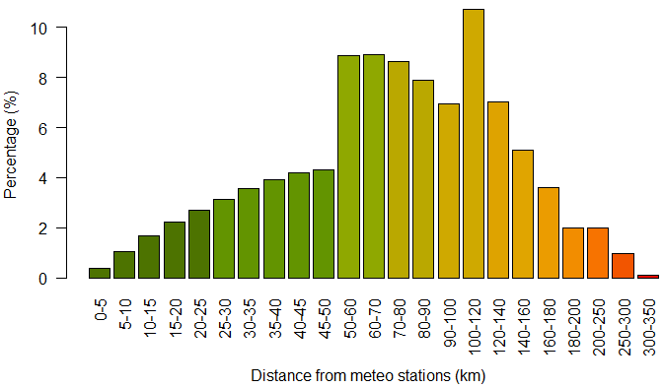
Figure SM 1.1. Percentage of cropland located at different distances from meteorological stations. Source: author’s calculation

SM 2: Literature review on application of satellite-based land cover data
Hochrainer-Stigler et al. (2014) have explored the applicability and usefulness of index insurance for smallholder farmers in North Shewa, Ethiopia. They found a satisfactory relationship between NOAA Advanced Very High Resolution Radiometer (NOAA AVHRR)-based Vegetation Health Index (VHI) and crop yield that allows for the identification of trigger points for claim payments and premium calculation on a promotion and protection-level. Bokusheva et al. (2016) have analyzed the applicability of NOAA AVHRR-based Vegetation Condition Index (VCI) and Temperature Condition Index (TCI) to insure yield losses of wheat-producing farms in Kazakhstan; they employed different capula approaches and concluded that VH indices can be a solid basis for detecting drought-related yield losses and implementing index insurance on a district scale. Sinha & Tripathi (2016) have investigated the usefulness of hybrid satellite agriculture drought indices to improve rice index insurance in Thailand; they combined LANDSAT-based Normalized Difference Vegetation Index (NDVI), Land Surface Temperature (LST) and Temperature Vegetation Index (TVI) to produce a unique hybrid index and identified significant potential to assess drought impact on a district scale when there is a shortage of long-term historical data. Flatnes & Carter (2016) have used plot-level rice yields in Tanzania to analyze the efficiency contract, by using a Moderate Resolution Imaging Spectroradiometer (MODIS)-based NDVI-based index insurance as a primary index which also contains the possibility for famers to request an audit if the primary index fails to predict yields; according to the results, by using this method it is possible to eliminate design risk at a very modest cost, which is useful for the future of index-based insurance in developing countries. Coleman et al. (2018) have used village-scale groundnut, millet and maize yield data in Senegal to review and examine the applicability and ways of using European Remote Sensing (ERS)-based Soil Moisture, METOP Advanced Scatterometer (ASCAT)-based Soil Water Index (SWI), MODIS-based Actual Evapotranspiration (ETa), METEOSAT-based Relative Evapotranspiration (ETr), SPOT/PROBA-based NDVI and SPOT/PROBA-based Fraction of Absorbed Photosynthetically Active Radiation (fAPAR) in designing index insurance; they concluded that satellites are operationally feasible for agricultural index insurance and developed several recommendations to deal with challenges and improve the quality of the index insurance. Osgood et al. (2018) have tested the cross-consistency of community-level farmers-reported drought years in Ethiopia against independent satellite data sources such as MODIS-NDVI, MODIS-based Enhanced Vegetation Index (EVI), The Atmosphere Land Exchange Inverse (ALEXI)-based Evapotranspiration (ET), and European Space Agency (ESA)-based Soil Moisture; they found evidence that events reported by farmer are independently reflected in satellite datasets. Eze et al. (2020) have examined MODIS-NDVI to design area-specific yield index insurance in Ethiopia; their results demonstrated that designed indexes performed very well when payout conditions were evaluated in recent drought years.

SM 3: Need for satellite weather data usage
Introducing low-cost insurance schemes like index insurance or other types of agricultural index-based insurances in the region would help to make small farmers more resilient to climate variabilities and uncertainties. A variable and unpredictable climate significantly restricts the options of farmers and so limits their development (Rao, 2011). As farmers avoid taking risks, there is a possibility of weather shocks. Moreover, creditors are also uneasy to lend if droughts or floods could cause widespread defaults, and when farmers are not insured. For farmers, not having access to credits critically limits their use of agricultural inputs and technologies. Even if a drought or flood happens only once in five or six years, the threat of the phenomenon is sufficient to slow down the economic development and wealth growth in all those years. Therefore, based on our study, we recommend the implementation of satellite-based index insurance in the regions, which might solve some of the existing issues for farmers regarding credits and investment into improved seeds and fertilizers. Using satellite products for design and implementation will significantly lower the price of the insurance and decrease the issues related to weather data, as weather data is an essential component of index insurance design and its sustainability. Moreover, satellite-based index insurance will improve the information asymmetry between the insurance company and the insured farmer, as none of them can influence the pre-defined index. This minimizes adverse selection and problems of moral peril frequently encountered in traditional agricultural insurances (Fisher et al., 2019; World Bank, 2015). In addition, there is a great basis risk when the density of stations is very low, as is the case in Central Asia. Using satellite-based weather data for index insurance design will minimize the basis risk. Employing satellite-based weather data will also significantly reduce product and administrative costs, which offers the potential for lower premiums, as satellite-based weather data is free of charge, and index insurance does not require field visits to assess losses reported by farmers.

SM 4: Location of selected meteo stations
The agro-climatic class of the locations was identified according to De Pauw (2008); accordingly, stations are located either in arid or semi-arid agro-climatic zones. All data has been received in paper form and manually digitized.
Table SM 4.1
List and details of meteorological stations
Name | Province | Country | Latitude | Longitude | Elevation | Agro-climatic Zone
Djizzakh | Djizzakh | Uzbekistan | 40.117 | 67.833 | 345 | SA-C-W
Gallaral | Djizzakh | Uzbekistan | 40 | 67.6 | 571 | SA-K-W
Lalmikor | Djizzakh | Uzbekistan | 39.9 | 67.5 | 744 | SA-K-W²
Samarkand | Samarkand | Uzbekistan | 39.57 | 66.95 | 485 | SA-C-W¹
Karshi | Kashkadarya | Uzbekistan | 38.8 | 65.717 | 376 | A-K-VW
Takhtakupir | Karakalpakstan Republic | Uzbekistan | 43.01 | 60.27 | 59 | A-K-W

SM 5: Review of existing globally available precipitation data
Every satellite-based precipitation estimate (SPE) product has its own advantages and disadvantages in terms of accuracy, near-real time data availability, spatial resolution, temporal resolution, historical time coverage, land surface coverage, complexity of acquisition and processing of the satellite data. For the most part, weather data from satellite products is freely available in 5 to 50 kilometre spatial resolution and in daily, decadal, monthly, seasonal and annual scales. For example, the Tropical Application of Meteorology Using Satellite Data (TAMSAT) produces daily rainfall estimates for the entire African continent at 4 km spatial resolution, and its archive spans a period from 1983 to the delayed present (Maidment et al., 2014; Tarnavsky et al., 2014). The NOAA-based African Rainfall Climatology Version 2 (ARC2) consist of daily rainfall estimates from 1983 to nearly real time at 0.1º spatial resolution for the whole African continent (Novella and Thiaw, 2012). The Historical Database for Gridded Daily Precipitation Dataset over Latin America (LatAmPrec) provides daily rainfall estimates for the entire South American continent at 0.25º spatial resolution, and has a temporal coverage from 2000 to the near present (Vila et al., 2009). The Tropical Rainfall Measuring Mission (TRMM) generates 3-hourly rainfall estimates from 2000 to the near present at 0.25º spatial resolution for the latitudes 60S - 60N (Kummerow et al., 2000). The Precipitation Estimation from Remotely Sensed Information using Artificial Neural Networks - Cloud Classification System (PERSIANN-CCS) contains daily rainfall estimates from 1983 until the near present at 0.25º spatial resolution for the latitudes 60S - 60N (Ashouri et al., 2014; Sorooshian et al., 2000). The NOAA CDR Climate Prediction Center morphing technique (CMORPH) produces daily rainfall estimates for the latitudes 60S - 60N from 2002 to the present at a 30-minute temporal resolution and 0.07º spatial resolution. The Global Precipitation Climatology Project (GPCP) provides monthly rainfall estimates from 1979 to the delayed present for the whole world, at 2.5º spatial resolution (Huffman et al., 1997). The CPC Merged Analysis of Precipitation (CMAP) produces monthly and pentadal rainfall estimates at 2.5º spatial resolution from 1978 to the delayed present for the whole world (Xie and Arkin, 1997) . The Climate Hazards Group InfraRed Precipitation with Station (CHIRPS) provides semi-global daily, pentadal, decadal and monthly rainfall estimates, covering the 50°S-50°N latitudes at 0.05º spatial resolution from 1981 to the near present (Funk et al., 2015). The Global Satellite Mapping of Precipitation (GSMaP) generates global 1-hourly precipitation estimates at 0.1º spatial resolution from 2000 to near real time (Ushio et al., 2009).

SM 6: Satellite Remote Sensing data acquisition, online free platform
One of the main disadvantages of using satellite products in index insurance is the fact that acquisition and processing of satellite products require special technical skills that are highly problematic for the insurance market. In this study, we therefore aimed to develop a user-friendly web platform which allows obtaining data from satellite products for everyone who has an access to the internet. In order to obtain CHIRPS, GSMaP and GLDAS data on a daily scale, we developed an algorithm and programmed one unique automatic web platform using the Google Earth Engine (GEE). GEE is an open source platform for satellite imagery analysis and geospatial datasets on a planetary scale. GEE aims to increase quality and time efficiency of spatial analyses for research, business and government users (Gorelick et al., 2017). This platform allows for satellite image analysis in the cloud system of the server, which in turn allows for the minimalization of several steps in satellite image analyses and the production of final outputs.
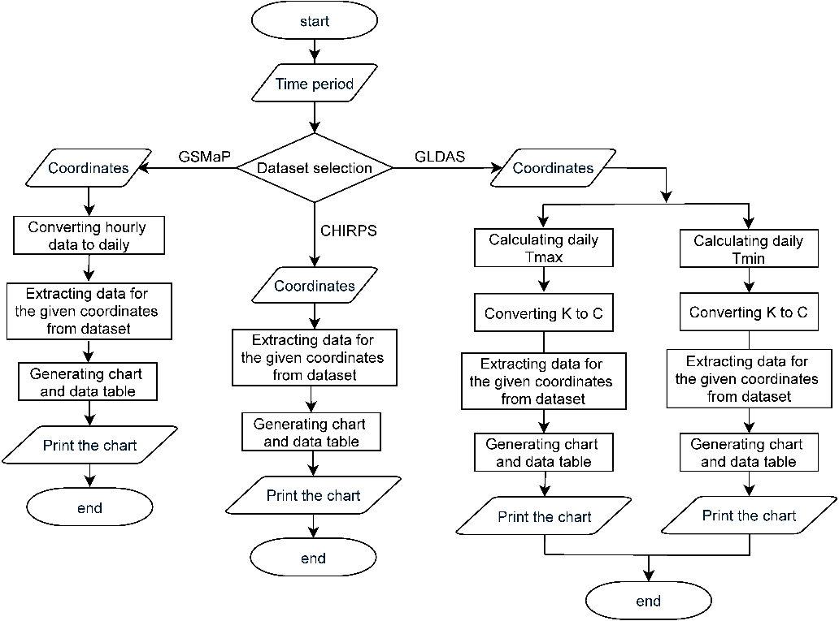
Figure SM 6.1. Flowchart of the developed automatic web platforms for extracting daily remote sensing data from (a) CHIRPS, (b) GSMaP and (c) GLDAS. Source: Authors’ own presentations
Figure demonstrates the algorithm for how data is obtained from existing daily GSMaP precipitation data from original hourly data, daily GLDAS maximum temperature (Tmax) and minimum temperature (Tmin) data from original 3-hourly data, and CHIRPS data originally in daily scale.
A web platform was developed for an automatic point scale daily data acquisition process and to be made available for interested parties in open access, as it does not require any knowledge of remote sensing data acquisition and processing. The web platform requires the user to enter a time period and the desired coordinates. The coordinates can be inserted by entering them manually or by clicking the area of interest on the map. The web platform produces the daily GSMaP precipitation data from the original hourly data, daily GLDAS maximum temperature (Tmax) and minimum temperature (Tmin) data from the original 3-hourly data, and CHIRPS data originally in daily scale. The GLDAS air temperature data are originally in Kelvin units. The unit was converted to Celsius to be in line with the meteorological data. Decadal and monthly data were produced from daily data.
SM 7: Visualization of monthly precipitation and temperature data for remaining 5 stations.
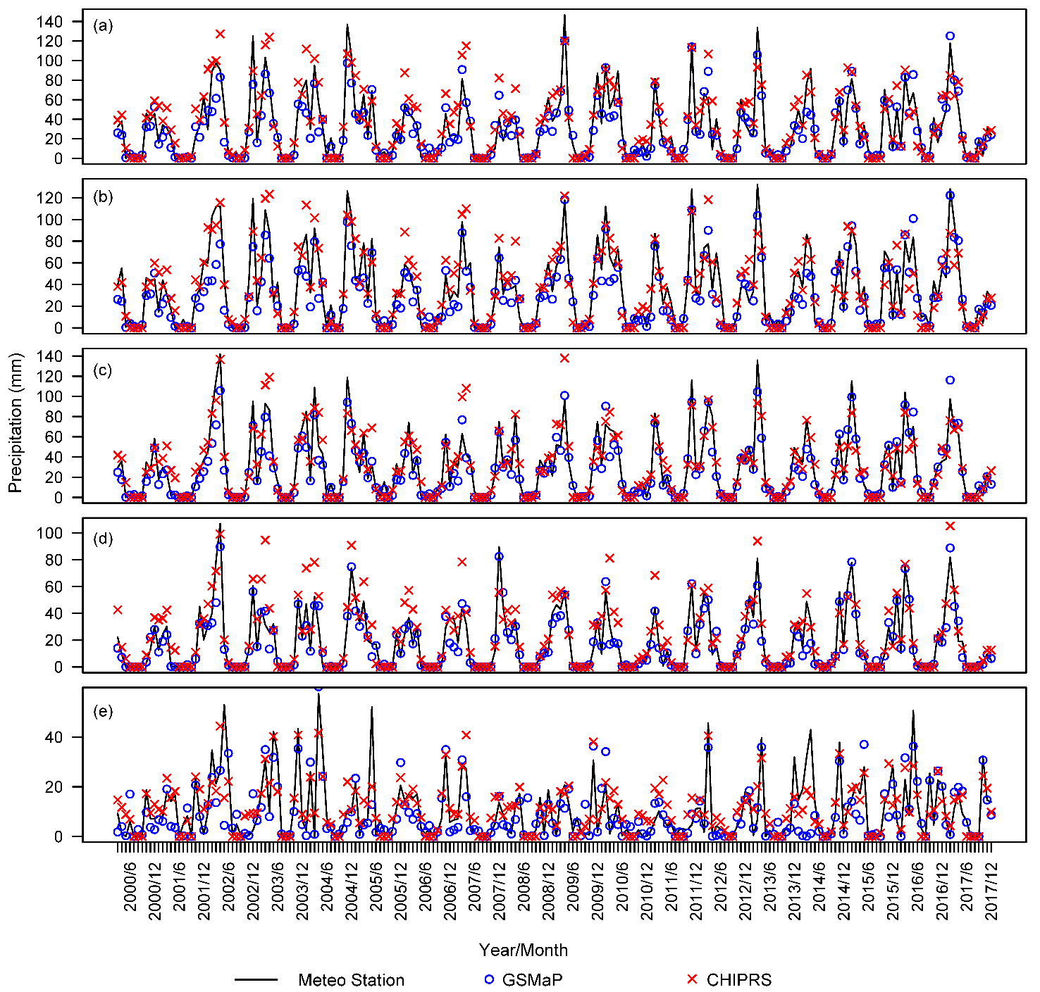
Figure SM 7.1. Monthly precipitation by stations, GSMaP and CHIRPS in selected locations (a) Gallaral, (b) Lalmikor, (c) Samarkand, (d) Karshi and (e) Takhtakupir

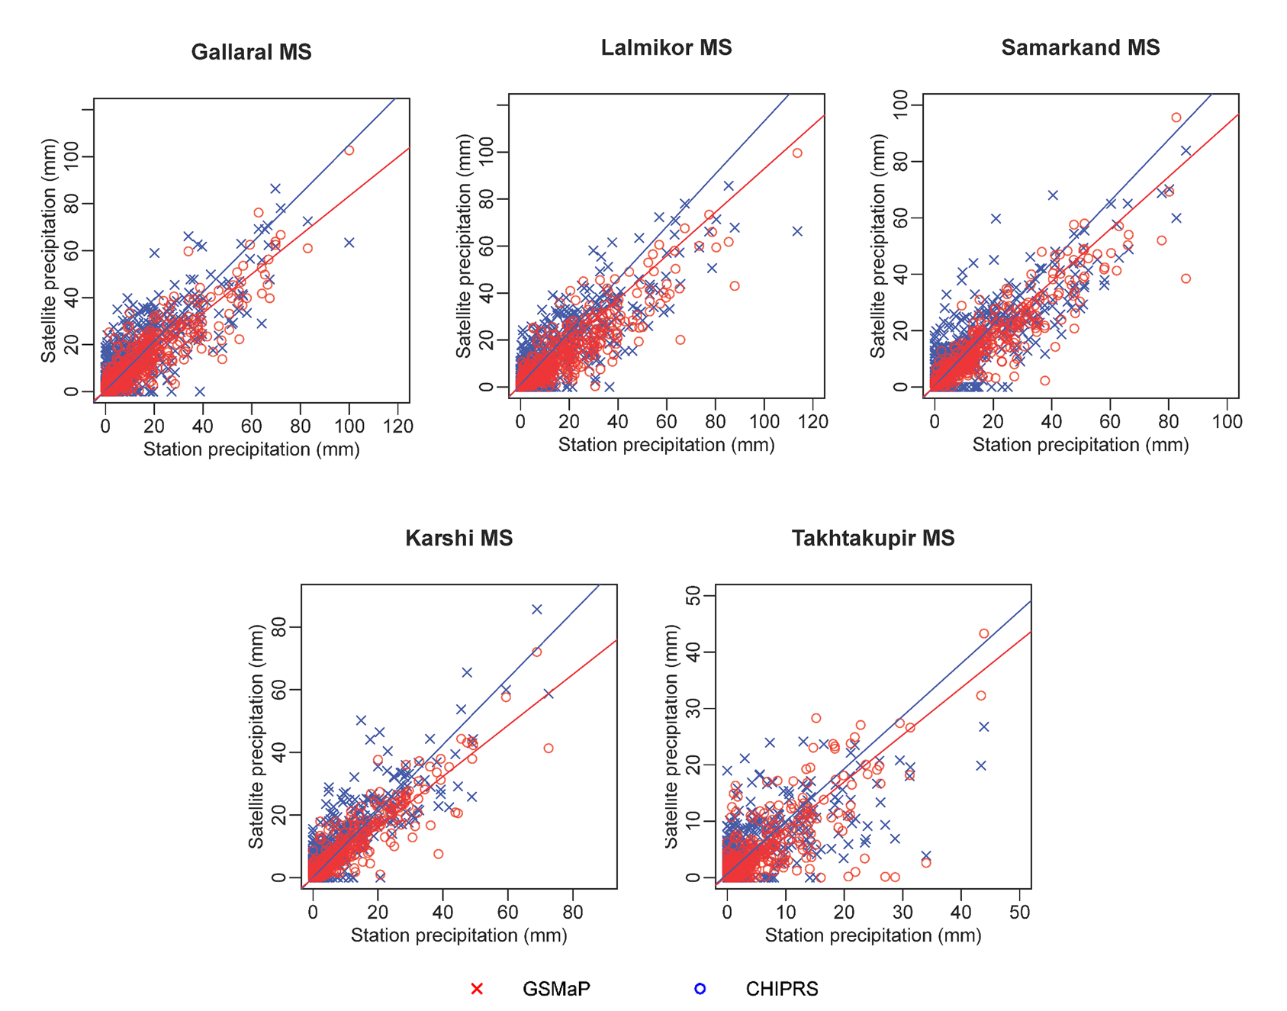
Figure SM 7.2. Decadal precipitation by stations vs GSMaP and CHIRPS in selected locations

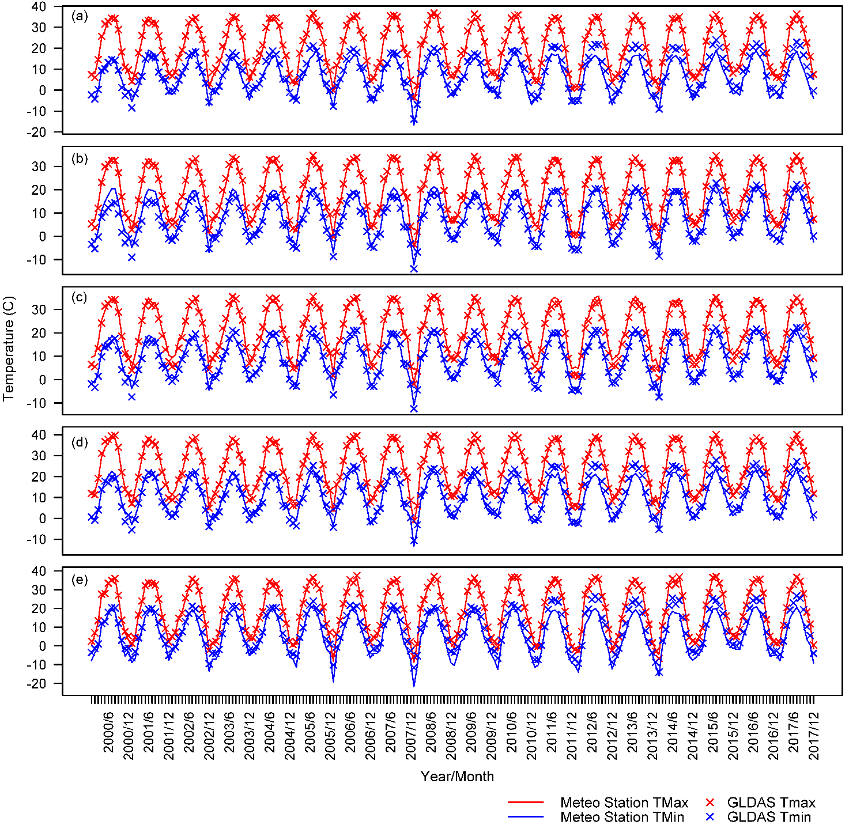
Figure SM 7.3. Monthly average Tmax and Tmin by stations and GLDAS in selected locations (a) Gallaral, (b) Lalmikor, (c) Samarkand, (d) Karshi and (e) Takhtakupir

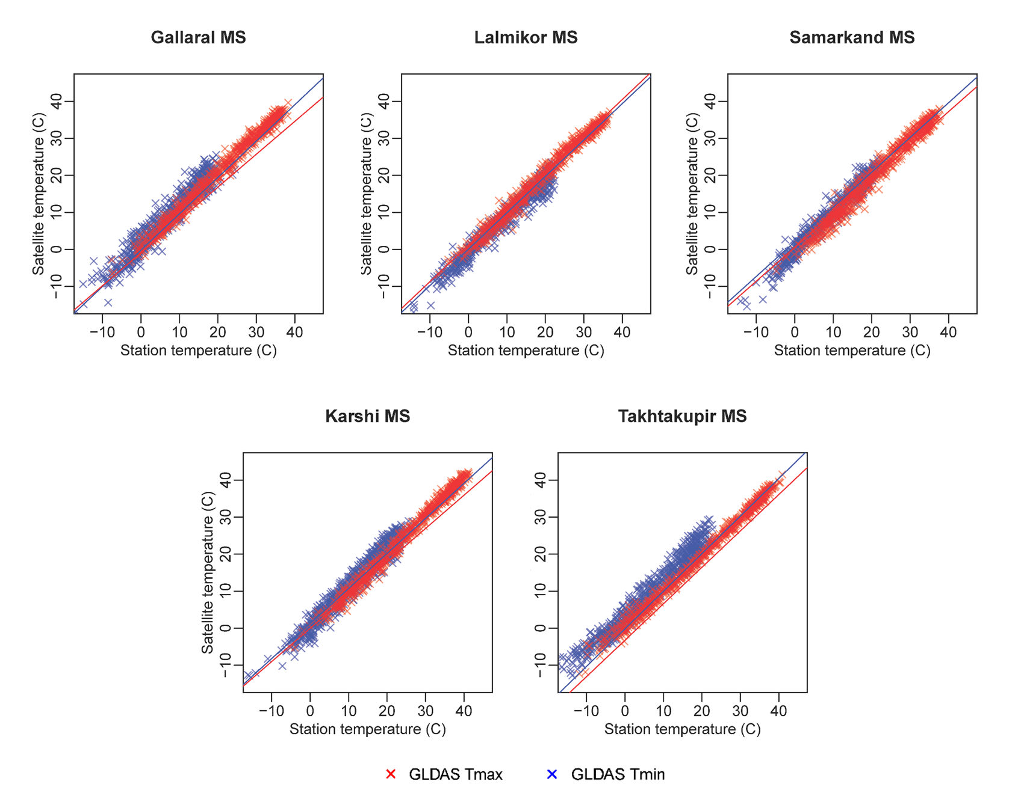
Figure SM 7.4. Decadal precipitation by stations vs GLDAS Tmax and Tmin in selected locations

SM 8: Results of accuracy assessment for decadal precipitation measurements
Table SM 8.1
Accuracy assessment of continuous decadal precipitation in selected locations (March 2000-December 2017)
 | Djizzakh |  |  | Gallaral |  |  | Lalmikor |  |  | Samarkand |  |  | Karshi |  |  | Takhtakupir |  |  | Average
 | GSMaP | CHIPRS |  | GSMaP | CHIPRS |  | GSMaP | CHIPRS |  | GSMaP | CHIRPS |  | GSMaP | CHIPRS |  | GSMaP | CHIPRS |  | GSMaP | CHIRPS
BIAS | 1.17 | 0.89 |  | 1.19 | 0.90 |  | 1.16 | 0.88 |  | 1.24 | 0.87 |  | 1.40 | 1.02 |  | 1.26 | 0.91 |  | 1.24 | 0.91
CSI | 0.84 | 0.89 |  | 0.83 | 0.86 |  | 0.86 | 0.86 |  | 0.81 | 0.86 |  | 0.71 | 0.91 |  | 0.72 | 0.82 |  | 0.80 | 0.87
POD | 1.00 | 0.89 |  | 1.00 | 0.88 |  | 1.00 | 0.87 |  | 1.00 | 0.87 |  | 1.00 | 0.97 |  | 0.95 | 0.86 |  | 0.99 | 0.89
FAR | 0.15 | 0.00 |  | 0.16 | 0.02 |  | 0.14 | 0.01 |  | 0.19 | 0.01 |  | 0.29 | 0.05 |  | 0.25 | 0.05 |  | 0.20 | 0.02
PBIAS | -14.20 | 10.60 |  | -9.10 | 18.00 |  | -18.90 | 4.00 |  | -12.90 | 4.90 |  | -6.80 | 28.50 |  | -13.90 | 9.50 |  | -12.63 | 12.58
MBE | -4.68 | 3.50 |  | -2.79 | 5.52 |  | -6.48 | 1.37 |  | -3.81 | 1.46 |  | -1.22 | 5.11 |  | -1.41 | 0.96 |  | -3.40 | 2.99
MAE | 6.45 | 10.37 |  | 7.77 | 11.74 |  | 9.25 | 10.93 |  | 6.27 | 8.33 |  | 3.69 | 6.97 |  | 4.15 | 4.86 |  | 6.26 | 8.87
RMSE | 11.13 | 15.76 |  | 12.37 | 16.98 |  | 14.11 | 15.71 |  | 10.64 | 12.77 |  | 6.59 | 11.57 |  | 7.58 | 7.26 |  | 10.41 | 13.34
SC | 0.97 | 0.92 |  | 0.94 | 0.91 |  | 0.95 | 0.91 |  | 0.98 | 0.94 |  | 0.96 | 0.95 |  | 0.84 | 0.84 |  | 0.94 | 0.91
PC | 0.96 | 0.90 |  | 0.93 | 0.88 |  | 0.93 | 0.89 |  | 0.95 | 0.92 |  | 0.96 | 0.91 |  | 0.79 | 0.80 |  | 0.92 | 0.88
R² | 0.93 | 0.81 |  | 0.86 | 0.78 |  | 0.87 | 0.79 |  | 0.91 | 0.84 |  | 0.92 | 0.84 |  | 0.63 | 0.65 |  | 0.85 | 0.78
p | 0.00 | 0.00 |  | 0.00 | 0.00 |  | 0.00 | 0.00 |  | 0.00 | 0.00 |  | 0.00 | 0.00 |  | 0.00 | 0.00 |  | 0.00 | 0.00
d | 0.97 | 0.94 |  | 0.96 | 0.93 |  | 0.95 | 0.94 |  | 0.97 | 0.96 |  | 0.97 | 0.94 |  | 0.88 | 0.88 |  | 0.95 | 0.93
LEPS | 0.05 | 0.08 |  | 0.06 | 0.09 |  | 0.07 | 0.09 |  | 0.04 | 0.07 |  | 0.04 | 0.06 |  | 0.10 | 0.13 |  | 0.06 | 0.09

Table SM 8.2
Accuracy assessment of continues decadal average temperature in selected locations (January 2000 – December 2017)
 | Djizzakh |  |  | Gallaral |  |  | Lalmikor |  |  | Samarkand |  |  | Karshi |  |  | Takhtakupir |  |  | Average
 | Tmax | Tmin |  | Tmax | Tmin |  | Tmax | Tmin |  | Tmax | Tmin |  | Tmax | Tmin |  | Tmax | Tmin |  | Tmax | Tmin
BIAS | 1.00 | 1.00 |  | 1.00 | 1.00 |  | 1.00 | 1.00 |  | 1.00 | 1.00 |  | 1.00 | 1.00 |  | 1.00 | 1.00 |  | 1.00 | 1.00
CSI | 1.00 | 1.00 |  | 1.00 | 1.00 |  | 1.00 | 1.00 |  | 1.00 | 1.00 |  | 1.00 | 1.00 |  | 1.00 | 1.00 |  | 1.00 | 1.00
POD | 1.00 | 1.00 |  | 1.00 | 1.00 |  | 1.00 | 1.00 |  | 1.00 | 1.00 |  | 1.00 | 1.00 |  | 1.00 | 1.00 |  | 1.00 | 1.00
FAR | 0.00 | 0.00 |  | 0.00 | 0.00 |  | 0.00 | 0.00 |  | 0.00 | 0.00 |  | 0.00 | 0.00 |  | 0.00 | 0.00 |  | 0.00 | 0.00
PBIAS | 3.40 | 4.60 |  | 2.80 | 28.60 |  | 1.30 | -11.60 |  | -3.70 | 2.20 |  | 0.20 | 11.60 |  | -0.70 | 58.70 |  | 0.55 | 15.68
MBE | 0.73 | 0.43 |  | 0.58 | 1.86 |  | 0.26 | -1.03 |  | -0.81 | 0.20 |  | 0.04 | 1.21 |  | -0.13 | 3.39 |  | 0.11 | 1.01
MAE | 1.26 | 1.41 |  | 1.12 | 2.40 |  | 1.09 | 1.53 |  | 1.46 | 1.18 |  | 1.02 | 2.07 |  | 0.92 | 3.44 |  | 1.14 | 2.00
RMSE | 1.57 | 1.76 |  | 1.43 | 3.03 |  | 1.41 | 2.02 |  | 1.89 | 1.58 |  | 1.31 | 2.46 |  | 1.22 | 4.02 |  | 1.47 | 2.48
SC | 0.99 | 0.98 |  | 0.99 | 0.96 |  | 0.99 | 0.98 |  | 0.99 | 0.98 |  | 0.99 | 0.97 |  | 1.00 | 0.98 |  | 0.99 | 0.98
PC | 0.99 | 0.98 |  | 0.99 | 0.96 |  | 0.99 | 0.98 |  | 0.99 | 0.98 |  | 0.99 | 0.97 |  | 1.00 | 0.98 |  | 0.99 | 0.98
R2 | 0.99 | 0.97 |  | 0.99 | 0.93 |  | 0.98 | 0.96 |  | 0.98 | 0.97 |  | 0.99 | 0.95 |  | 0.99 | 0.96 |  | 0.99 | 0.95
p | 0.00 | 0.00 |  | 0.00 | 0.00 |  | 0.00 | 0.00 |  | 0.00 | 0.00 |  | 0.00 | 0.00 |  | 0.00 | 0.00 |  | 0.00 | 0.00
d | 1.00 | 0.99 |  | 1.00 | 0.97 |  | 1.00 | 0.99 |  | 0.99 | 0.99 |  | 1.00 | 0.98 |  | 1.00 | 0.96 |  | 1.00 | 0.98
LEPS | 0.04 | 0.05 |  | 0.03 | 0.08 |  | 0.03 | 0.05 |  | 0.04 | 0.04 |  | 0.03 | 0.07 |  | 0.02 | 0.09 |  | 0.03 | 0.06
NSE | 0.98 | 0.95 |  | 0.98 | 0.86 |  | 0.98 | 0.94 |  | 0.97 | 0.96 |  | 0.99 | 0.92 |  | 0.99 | 0.86 |  | 0.98 | 0.91

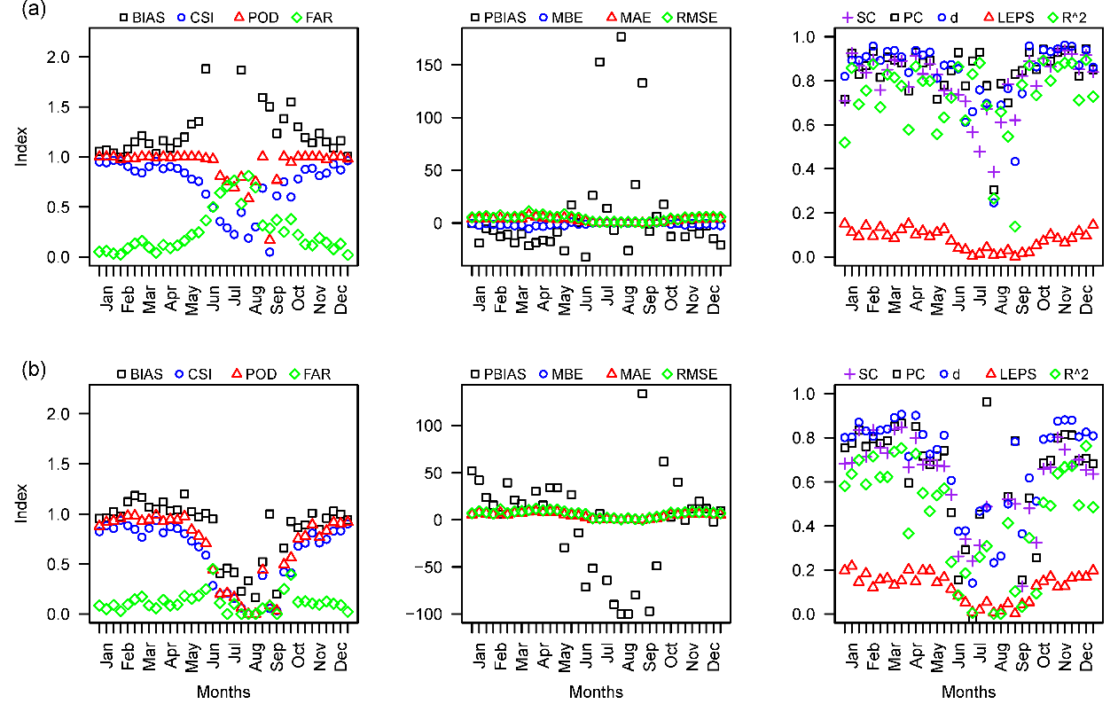
Figure SM 8.3. Average results of classification, quantitative and agreement accuracy metrics of decadal precipitation for all stations, by (a) GSMaP and (b) CHIRPS

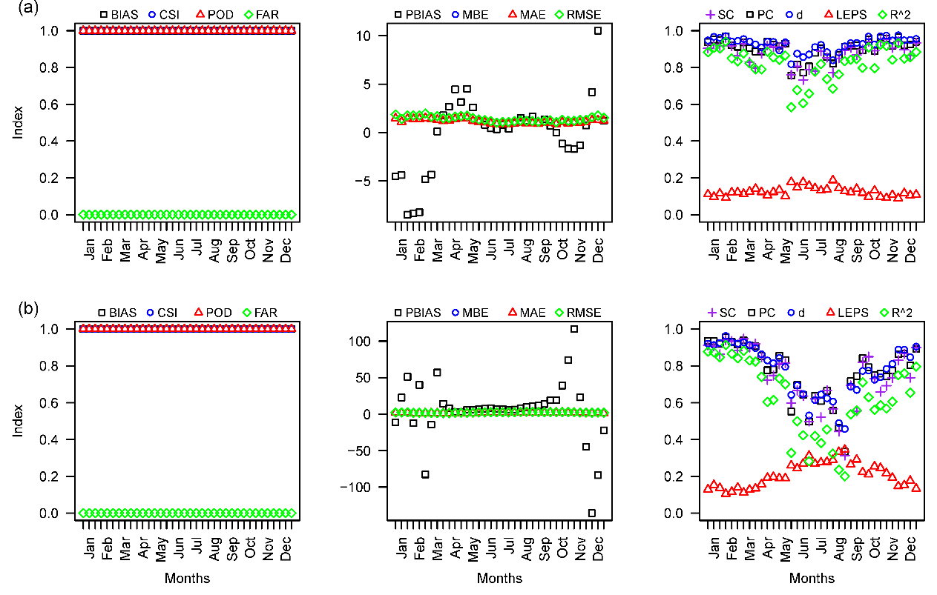
Figure SM 8.4. Average results of classification, quantitative and agreement accuracy metrics of decadal temperature for all stations, for (a) GLDAS Tmax and (b) GLDAS Tmin

SM 9: Visualization of quantile regressions results for GSMaP, CHIRPS and GLDAS in selected locations
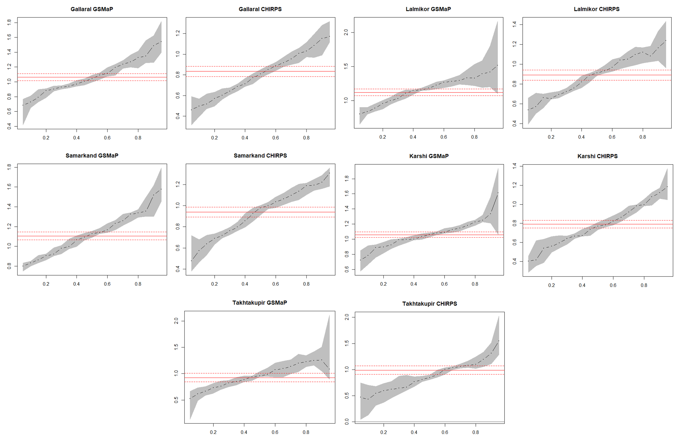
Figure SM 9.1. Estimated results of quantile regressions for GSMaP and CHIRPS for remaining 5 stations (monthly scale)
Table 9.2
Quantile regression results of satellite-based precipitation estimates for remaining 5 stations (monthly scale) (n = 214)
 |  | OLS | 0.5 | 0.1 | 0.25 | 0.5 | 0.75 | 0.9 | 0.95
Gallaral-GSMaP | Coef. | 1.063*** | 0.684*** | 0.728*** | 0.902*** | 1.044*** | 1.268*** | 1.488*** | 1.541***
 | SE | -0.029 | -0.077 | -0.037 | -0.024 | -0.029 | -0.041 | -0.053 | -0.088
 | R2/pR2 | 0.861 | 0.359 | 0.474 | 0.621 | 0.690 | 0.702 | 0.712 | 0.713
Gallaral-CHIRPS | Coef. | 0.833*** | 0.461*** | 0.499*** | 0.602*** | 0.808*** | 1.007*** | 1.153*** | 1.171***
 | SE | -0.03 | -0.043 | -0.03 | -0.03 | -0.03 | -0.046 | -0.071 | -0.072
 | R2/pR2 | 0.779 | 0.280 | 0.371 | 0.507 | 0.594 | 0.615 | 0.634 | 0.651
Lalmikor-GSMaP | Coef. | 1.120*** | 0.805*** | 0.839*** | 0.998*** | 1.181*** | 1.333*** | 1.420*** | 1.516***
 | SE | -0.030 | -0.048 | -0.045 | -0.035 | -0.025 | -0.037 | -0.073 | -0.159
 | R2/pR2 | 0.871 | 0.436 | 0.528 | 0.646 | 0.711 | 0.701 | 0.666 | 0.641
Lalmikor-CHIRPS | Coef. | 0.891*** | 0.539*** | 0.570*** | 0.695*** | 0.912*** | 1.098*** | 1.166*** | 1.237***
 | SE | -0.031 | -0.042 | -0.043 | -0.025 | -0.034 | -0.046 | -0.1 | -0.103
 | R2/pR2 | 0.795 | 0.350 | 0.410 | 0.548 | 0.611 | 0.607 | 0.590 | 0.584
Samarkand-GSMaP | Coef. | 1.105*** | 0.801*** | 0.831*** | 0.920*** | 1.127*** | 1.327*** | 1.519*** | 1.579***
 | SE | -0.024 | -0.033 | -0.018 | -0.022 | -0.023 | -0.022 | -0.066 | -0.06
 | R2/pR2 | 0.909 | 0.607 | 0.647 | 0.711 | 0.766 | 0.785 | 0.776 | 0.777
Samarkand-CHIRPS | Coef. | 0.940*** | 0.478*** | 0.573*** | 0.718*** | 0.979*** | 1.137*** | 1.220*** | 1.307***
 | SE | -0.028 | -0.047 | -0.042 | -0.029 | -0.031 | -0.03 | -0.041 | -0.061
 | R2/pR2 | 0.842 | 0.306 | 0.392 | 0.555 | 0.660 | 0.718 | 0.746 | 0.749
Karshi-GSMaP | Coef. | 1.059*** | 0.723*** | 0.785*** | 0.924*** | 1.062*** | 1.181*** | 1.335*** | 1.614***
 | SE | -0.022 | -0.038 | -0.043 | -0.025 | -0.014 | -0.019 | -0.085 | -0.122
 | R2/pR2 | 0.916 | 0.459 | 0.532 | 0.674 | 0.786 | 0.799 | 0.755 | 0.720
Karshi-CHIRPS | Coef. | 0.792*** | 0.404*** | 0.416*** | 0.594*** | 0.771*** | 0.984*** | 1.122*** | 1.186***
 | SE | -0.024 | -0.031 | -0.038 | -0.026 | -0.021 | -0.026 | -0.041 | -0.054
 | R2/pR2 | 0.835 | 0.287 | 0.356 | 0.530 | 0.682 | 0.727 | 0.733 | 0.729
Takhtakupir-GSMaP | Coef. | 0.926*** | 0.524*** | 0.614*** | 0.761*** | 0.956*** | 1.197*** | 1.260*** | 1.088
 | SE | -0.049 | -0.074 | -0.042 | -0.03 | -0.033 | -0.056 | -0.126 | -0.553
 | R2/pR2 | 0.626 | 0.166 | 0.288 | 0.435 | 0.521 | 0.522 | 0.460 | 0.358
Takhtakupir-CHIRPS | Coef. | 0.990*** | 0.470*** | 0.431*** | 0.621*** | 0.849*** | 1.083*** | 1.312*** | 1.550***
 | SE | -0.05 | -0.047 | -0.048 | -0.062 | -0.046 | -0.054 | -0.157 | -0.296
 | R2/pR2 | 0.647 | 0.079 | 0.154 | 0.301 | 0.458 | 0.523 | 0.502 | 0.468
Coef. = Coefficient; SE = standard error; R2 = R-square for OLS; pR2 = pseudo R-square for quantiles; * p<0.05, ** p<0.01, *** p<0.001

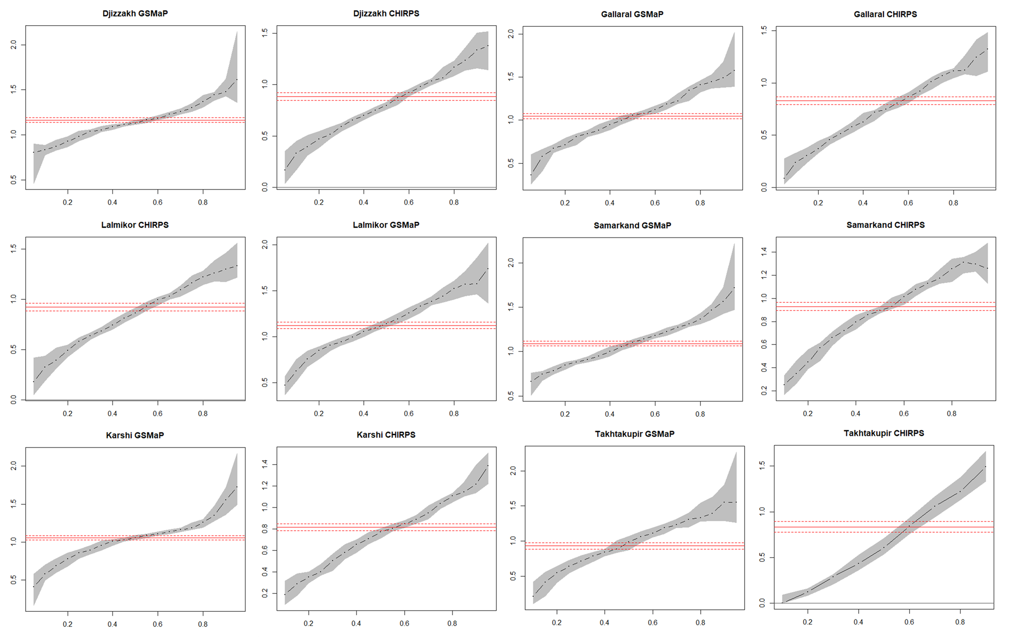
Figure SM 9.3. Estimated results of quantile regressions for GSMaP and CHIRPS in selected locations (decadal scale)
Table SM 9.4
Quantile regression results of satellite-based precipitation estimates for the selected stations (decadal scale) (n = 642)
 |  | OLS | 0.5 | 0.1 | 0.25 | 0.5 | 0.75 | 0.9 | 0.95
Djizzakh-GSMaP | Coef. | 1.165*** | 0.805*** | 0.835*** | 0.980*** | 1.13*** | 1.299*** | 1.478*** | 1.612***
 | SE | 0.014 | 0.064 | 0.028 | 0.040 | 0.026 | 0.029 | 0.035 | 0.189
 | R2/pR2 | 0.906 | 0.335 | 0.467 | 0.627 | 0.761 | 0.799 | 0.787 | 0.760
Djizzakh-CHIRPS | Coef. | 0.885*** | 0.166** | 0.333*** | 0.515*** | 0.798*** | 1.065*** | 1.335*** | 1.376***
 | SE | 0.023 | 0.060 | 0.069 | 0.039 | 0.028 | 0.046 | 0.128 | 0.115
 | R2/pR2 | 0.693 | 0.043 | 0.111 | 0.305 | 0.504 | 0.568 | 0.542 | 0.539
Gallaral-GSMaP | Coef. | 1.0458*** | 0.365*** | 0.578*** | 0.807*** | 1.054*** | 1.343*** | 1.489*** | 1.577***
 | SE | 0.019 | 0.083 | 0.056 | 0.045 | 0.036 | 0.043 | 0.071 | 0.124
 | R2/pR2 | 0.827 | 0.175 | 0.282 | 0.474 | 0.638 | 0.694 | 0.705 | 0.700
Gallaral-CHIRPS | Coef. | 0.831*** | 0.088* | 0.241*** | 0.458*** | 0.747*** | 1.068*** | 1.246*** | 1.322***
 | SE | 0.022 | 0.052 | 0.056 | 0.037 | 0.031 | 0.033 | 0.076 | 0.125
 | R2/pR2 | 0.682 | 0.026 | 0.092 | 0.272 | 0.473 | 0.547 | 0.550 | 0.554
Lalmikor-GSMaP | Coef. | 1.122*** | 0.47*** | 0.624*** | 0.906*** | 1.14*** | 1.439*** | 1.572*** | 1.738***
 | SE | 0.02 | 0.059 | 0.075 | 0.041 | 0.032 | 0.049 | 0.118 | 0.184
 | R2/pR2 | 0.826 | 0.218 | 0.309 | 0.494 | 0.643 | 0.687 | 0.680 | 0.674
Lalmikor-CHIRPS | Coef. | 0.925*** | 0.182*** | 0.324*** | 0.581*** | ***0.864 | 1.164*** | 1.300*** | 1.334***
 | SE | 0.023 | 0.050 | 0.043 | 0.039 | 0.034 | 0.052 | 0.099 | 0.127
 | R2/pR2 | 0.719 | 0.056 | 0.133 | 0.319 | 0.511 | 0.569 | 0.553 | 0.573
Samarkand-GSMaP | Coef. | 1.092*** | 0.661*** | 0.746*** | 0.881*** | 1.104*** | 1.311*** | 1.564*** | 1.719***
 | SE | 0.017 | 0.075 | 0.035 | 0.025 | 0.033 | 0.022 | 0.063 | 0.088
 | R2/pR2 | 0.868 | 0.338 | 0.447 | 0.593 | 0.712 | 0.763 | 0.752 | 0.722
Samarkand-CHIRPS | Coef. | 0.930*** | 0.135** | 0.253*** | 0.573*** | 0.894*** | 1.174*** | 1.297*** | 1.259***
 | SE | 0.022 | 0.052 | 0.038 | 0.054 | 0.031 | 0.038 | 0.050 | 0.091
 | R2/pR2 | 0.738 | 0.028 | 0.097 | 0.288 | 0.522 | 0.608 | 0.620 | 0.617
Karshi-GSMaP | Coef. | 1.059*** | 0.413*** | 0.58*** | 0.857*** | 1.058*** | 1.186*** | 1.554*** | 1.726***
 | SE | 0.017 | 0.117 | 0.057 | 0.048 | 0.019 | 0.024 | 0.094 | 0.168
 | R2/pR2 | 0.857 | 0.143 | 0.286 | 0.503 | 0.701 | 0.772 | 0.757 | 0.730
Karshi-CHIRPS | Coef. | 0.815*** | 0.085* | 0.187*** | 0.399*** | 0.771*** | 1.034*** | 1.216*** | 1.387***
 | SE | 0.018 | 0.042 | 0.048 | 0.040 | 0.038 | 0.036 | 0.093 | 0.088
 | R2/pR2 | 0.752 | 0.003 | 0.064 | 0.252 | 0.515 | 0.651 | 0.674 | 0.672
Takhtakupir-GSMaP | Coef. | 0.933*** | 0.077* | 0.215* | 0.64*** | 0.987*** | 1.309*** | 1.554*** | 1.551***
 | SE | 0.029 | 0.034 | 0.090 | 0.057 | 0.070 | 0.058 | 0.077 | 0.078
 | R2/pR2 | 0.624 | 0.023 | 0.064 | 0.260 | 0.470 | 0.573 | 0.551 | 0.489
Takhtakupir-CHIRPS | Coef. | 0.834*** |  |  | 0.18*** | 0.608*** | 1.175*** | 1.49*** | 1.678***
 | SE | 0.036 |  |  | 0.043 | 0.076 | 0.067 | 0.084 | 0.180
 | R2/pR2 | 0.451 |  |  | 0.056 | 0.234 | 0.383 | 0.426 | 0.425
Coef. = Coefficient; SE = standard error; R2 = R-square for OLS; pR2 = pseudo R-square for quantiles; * p<0.05, ** p<0.01, *** p<0.001
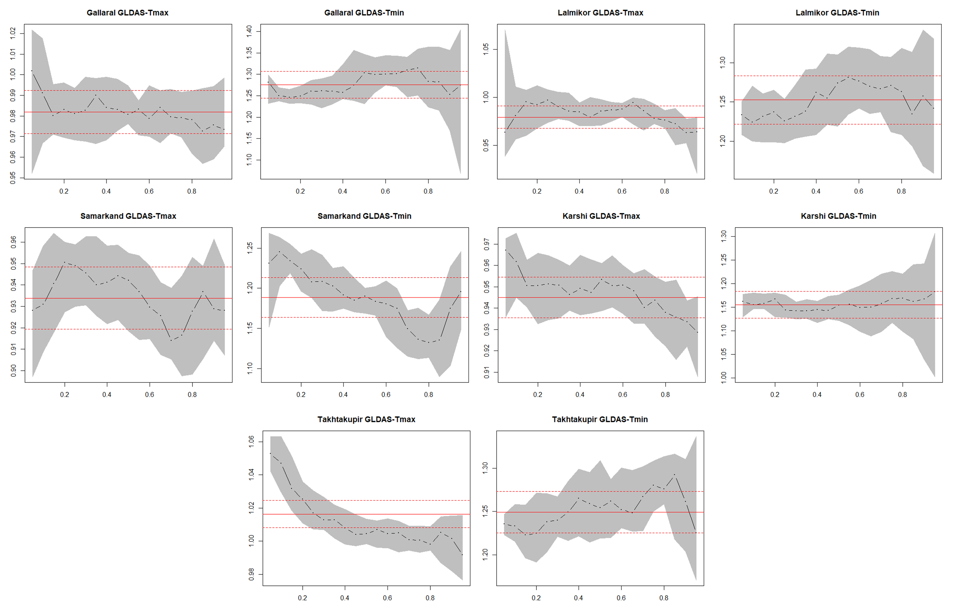
Figure SM 9.5. Estimated results of quantile regressions for GLDAS Tmax and Tmin in selected locations (monthly scale)
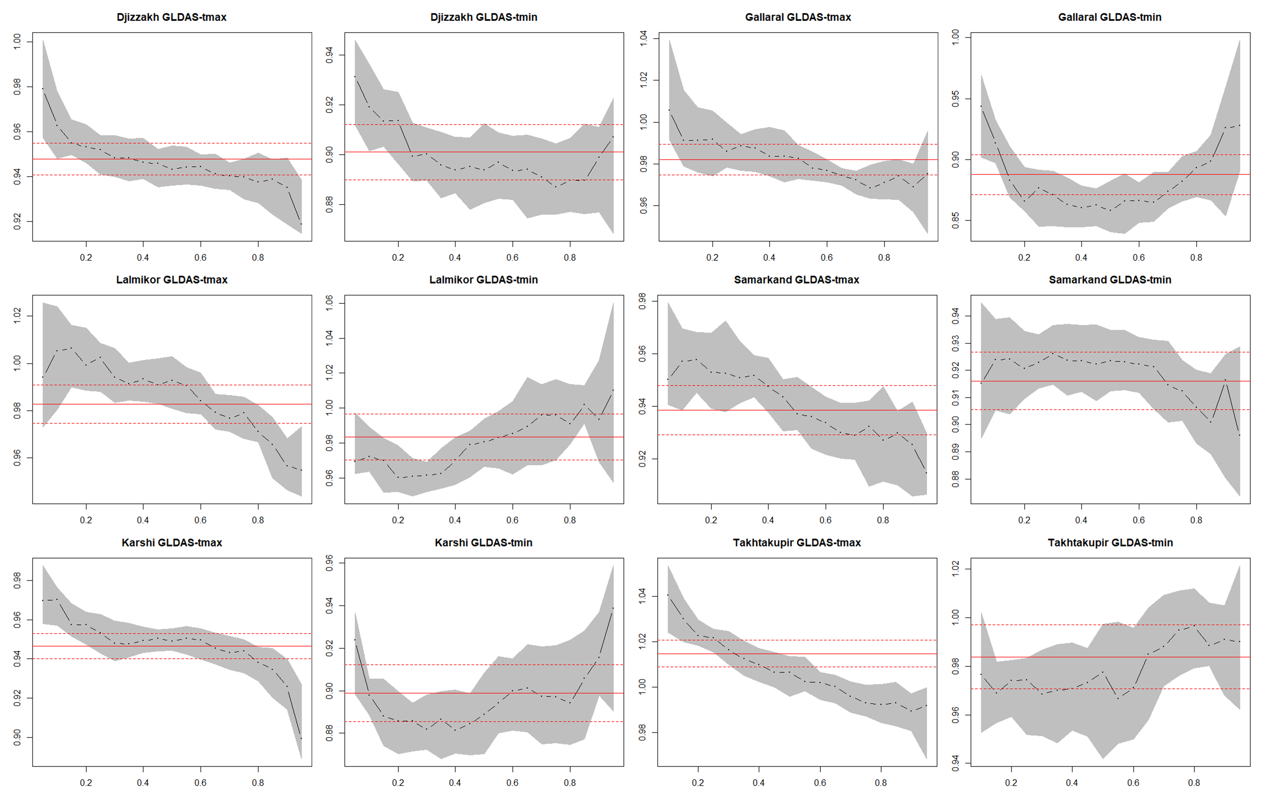
Figure SM 9.6. Estimated results of quantile regressions for GLDAS Tmax and Tmin in selected locations (decadal scale)
Table SM 9.7
Estimated results of OLS regressions for GLDAS Tmax and GLDAS Tmin in all locations (decadal scale)
 | Djizzakh |  | Gallaral |  | Lalmikor |  | Samarkand |  | Karshi |  | Takhtakupir
 | GLDAS Tmax | GLDAS Tmin | GLDAS Tmax | GLDAS Tmin | GLDAS Tmax | GLDAS Tmin | GLDAS Tmax | GLDAS Tmin | GLDAS Tmax | GLDAS Tmin | GLDAS Tmax | GLDAS Tmin
Coef. | 0.948*** | 0.901*** | 0.982*** | 0.888*** | 0.983*** | 0.983*** | 0.938*** | 0.916*** | 0.946*** | 0.898*** | 1.015*** | 0.984***
SE | 0.004 | 0.007 | 0.004 | 0.009 | 0.005 | 0.008 | 0.006 | 0.006 | 0.004 | 0.008 | 0.004 | 0.008
R-sq | 0.987 | 0.965 | 0.987 | 0.926 | 0.984 | 0.959 | 0.977 | 0.969 | 0.989 | 0.95 | 0.992 | 0.959
Coef. = Coefficient; SE = standard error; R2 = R-square for OLS; pR2 = pseudo R-square for quantiles; * p<0.05, ** p<0.01, *** p<0.001

SM 10: Results of accuracy assessment for seasonal precipitation measurements
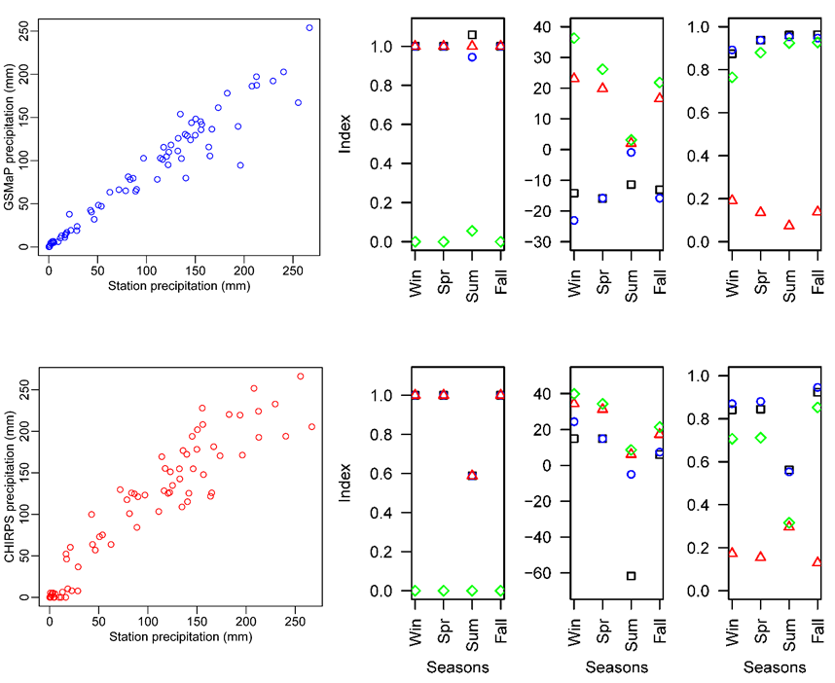
Figure SM 10.1. Results of classification, quantitative and agreement accuracy metrics of seasonal precipitation for the Djizzakh station, first row is GSMaP and second row is CHIRPS (legends are same as in above Figure SM 7.1)
Table SM 10.2
Accuracy assessment of continuous decadal and seasonal precipitation at the Djizzakh station
 | BIAS | CSI | POD | FAR | PBIAS | MBE | MAE | RMSE | SC | PC | R2 | p | d | LEPS
GSMaP | 1.01 | 0.99 | 1 | 0.01 | -14.2 | -13.91 | 622.1 | 24.94 | 0.98 | 0.97 | 0.93 | 0.000 | 0.97 | 0.07
CHIRPS | 0.9 | 0.9 | 0.9 | 0 | 10.6 | 10.41 | 822.1 | 28.67 | 0.96 | 0.94 | 0.88 | 0.000 | 0.96 | 0.09
SM 11: Visualization of MDIs and classification accuracy assessment of anomaly detection for remaining 5 stations
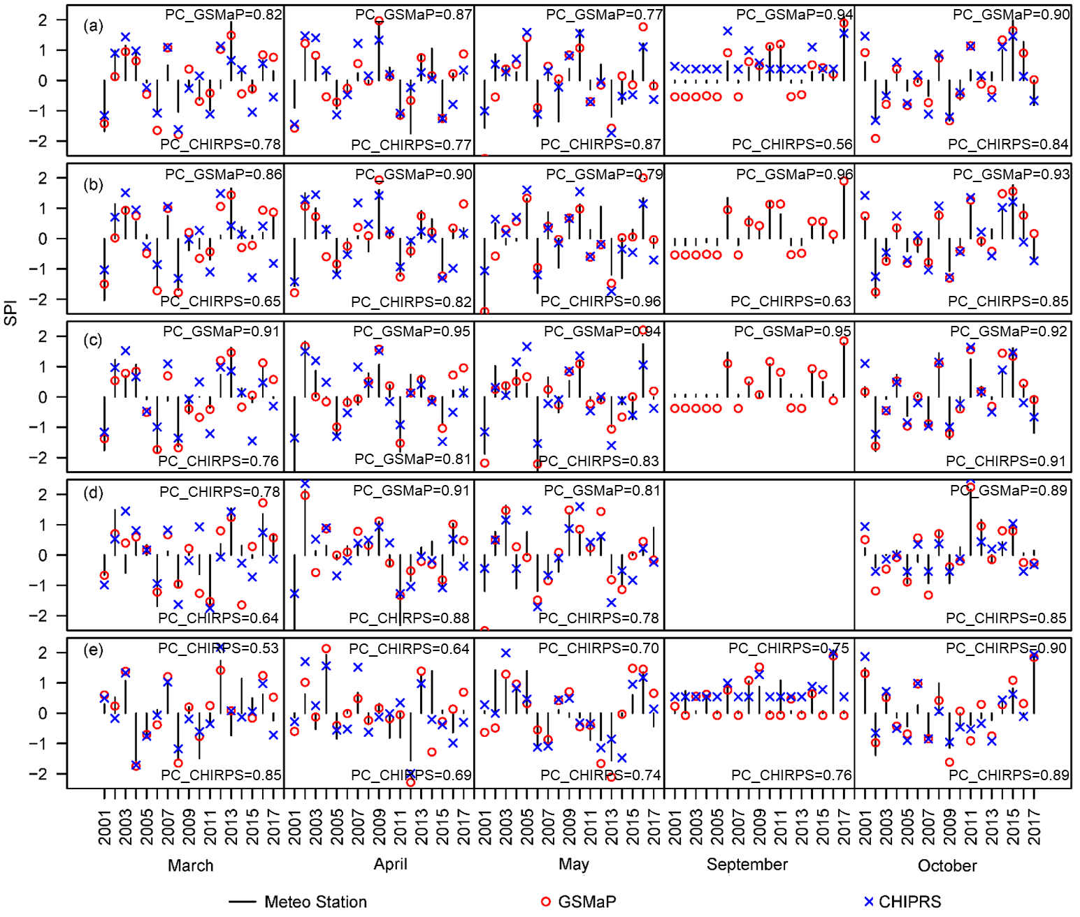
Figure SM 11.1. Monthly values of Standardized Precipitation Index by stations, GSMaP and CHIRPS in selected locations (a) Gallaral, (b) Lalmikor, (c) Samarkand, (d) Karshi and (e) Takhtakupir

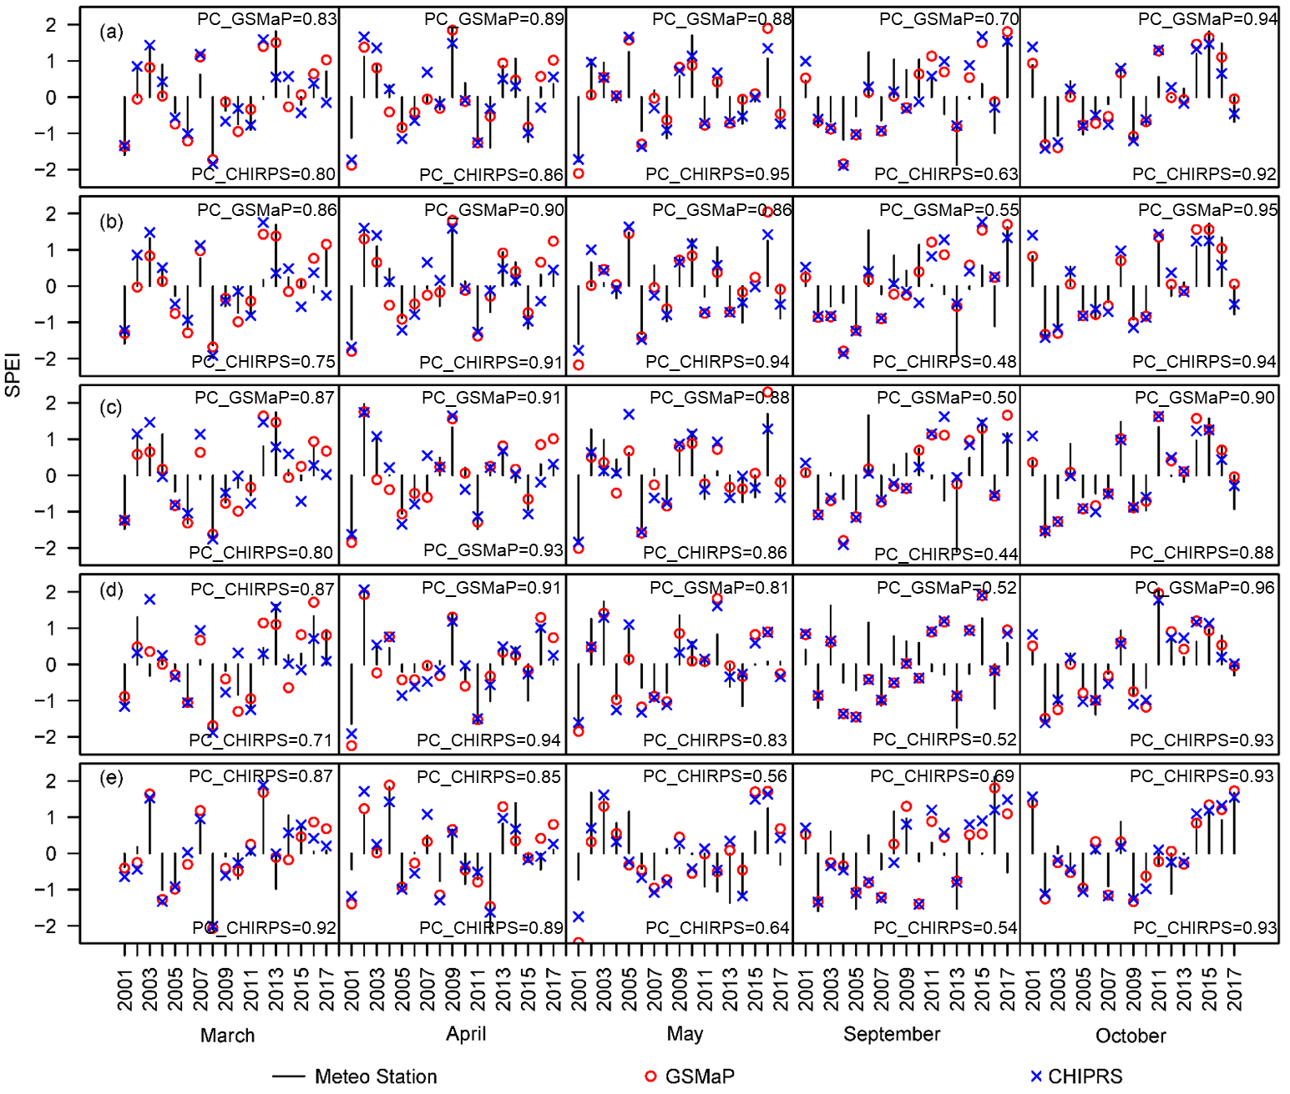
Figure SM 11.2. Monthly values of Standardized Precipitation-Evapotranspiration Index by the combinations of MS & MS, GSMaP & GLDAS and CHIRPS & GLDAS in selected locations (a) Gallaral, (b) Lalmikor, (c) Samarkand, (d) Karshi and (e) Takhtakupir

Table SM 11.3
Detailed classification accuracy assessment of anomaly detection at <10th and <20th (March, April and May) percentiles for drought and >80th and >90th (May, September, October) percentiles for flood by GSMaP and CHIRPS at the Djizzakh station.
Percentile: |  | <10th |  |  |  |  |  |  |  | <20th |  |  |  |  |  |  |  | >80th |  |  |  |  |  |  |  | >90th
 | Metrics | GSMaP-Overall | CHIRPS-Overall | GSMaP-March | CHIRPS-March | GSMaP-April | CHIRPS-April | GSMaP-May | CHIRPS-May | GSMaP-Overall | CHIRPS-Overall | GSMaP-March | CHIRPS-March | GSMaP-April | CHIRPS-April | GSMaP-May | CHIRPS-May | GSMaP-Overall | CHIRPS-Overall | GSMaP-May | CHIRPS-May | GSMaP-September | CHIRPS-September | GSMaP-October | CHIRPS-October | GSMaP-Overall | CHIRPS-Overall | GSMaP-May | CHIRPS-May | GSMaP-September | CHIRPS-September | GSMaP-October | CHIRPS-October
Monthly | BIAS | 1.2 | 0.8 | 1.3 | 0.7 | 1.7 | 1.3 | 0.8 | 0.5 | 1 | 0.8 | 0.8 | 0.6 | 1.3 | 0.9 | 0.9 | 0.9 | 1.3 | 2.7 | 2 | 3 | 1 | 2 | 1 | 3 | 1.3 | 1.7 | 2 | 2 | 1 | 2 | 1 | 1
 | CSI | 0.7 | 0.5 | 0.8 | 0.7 | 0.6 | 0.4 | 0.8 | 0.5 | 0.7 | 0.6 | 0.8 | 0.3 | 0.6 | 0.6 | 0.6 | 0.9 | 0.8 | 0.4 | 0.5 | 0.3 | 1 | 0.5 | 1 | 0.3 | 0.8 | 0.6 | 0.5 | 0.5 | 1 | 0.5 | 1 | 1
 | POD | 0.9 | 0.6 | 1 | 0.7 | 1 | 0.7 | 0.8 | 0.5 | 0.8 | 0.7 | 0.8 | 0.4 | 0.9 | 0.7 | 0.7 | 0.9 | 1 | 1 | 1 | 1 | 1 | 1 | 1 | 1 | 1 | 1 | 1 | 1 | 1 | 1 | 1 | 1
 | FAR | 0.3 | 0.3 | 0.3 | 0 | 0.4 | 0.5 | 0 | 0 | 0.2 | 0.1 | 0 | 0.3 | 0.3 | 0.2 | 0.2 | 0 | 0.3 | 0.6 | 0.5 | 0.7 | 0 | 0.5 | 0 | 0.7 | 0.3 | 0.4 | 0.5 | 0.5 | 0 | 0.5 | 0 | 0
Decadal | BIAS | 0.9 | 0.6 | 1.2 | 0.5 | 0.9 | 0.6 | 0.9 | 0.5 | 1 | 0.7 | 1.1 | 0.7 | 0.9 | 0.7 | 0.9 | 0.6 | 0.8 | 0.9 | 0.6 | 0.6 | 0.7 | 1 | 1 | 1.2 | 0.8 | 0.8 | 0.7 | 0.7 | 1 | 1.5 | 1 | 0.8
 | CSI | 0.8 | 0.4 | 0.9 | 0.3 | 0.8 | 0.5 | 0.8 | 0.4 | 0.8 | 0.6 | 0.8 | 0.5 | 0.8 | 0.5 | 0.8 | 0.6 | 0.6 | 0.3 | 0.4 | 0.2 | 0.7 | 0.2 | 0.7 | 0.3 | 0.6 | 0.2 | 0.4 | 0.3 | 1 | 0.3 | 0.6 | 0.2
 | POD | 0.9 | 0.4 | 1 | 0.3 | 0.8 | 0.5 | 0.8 | 0.4 | 0.9 | 0.6 | 0.9 | 0.6 | 0.8 | 0.6 | 0.9 | 0.6 | 0.6 | 0.4 | 0.4 | 0.3 | 0.7 | 0.3 | 0.8 | 0.5 | 0.7 | 0.3 | 0.5 | 0.3 | 1 | 0.5 | 0.8 | 0.3
 | FAR | 0.1 | 0.3 | 0.1 | 0.4 | 0.1 | 0.2 | 0 | 0.2 | 0.1 | 0.1 | 0.2 | 0.1 | 0.1 | 0.2 | 0 | 0 | 0.2 | 0.6 | 0.3 | 0.5 | 0 | 0.7 | 0.2 | 0.6 | 0.2 | 0.6 | 0.3 | 0.5 | 0 | 0.7 | 0.3 | 0.7

Table SM 11.4
Overall classification accuracy assessment of anomaly detection at <10th and <20th (March, April and May) percentiles for drought and >80th and >90th (May, September, October) percentiles for flood by GSMaP and CHIRPS for remaining 5 stations
 | Monthly |  |  |  |  |  |  |  |  | Decadal
 | <10 |  | <20 |  | <80 |  | <90 |  |  | <10 |  | <20 |  | >80 |  | >90
 | GSMaP | CHIRPS | GSMaP | CHIRPS | GSMaP | CHIRPS | GSMaP | CHIRPS |  | GSMaP | CHIRPS | GSMaP | CHIRPS | GSMaP | CHIRPS | GSMaP | CHIRPS
Gallaral | 0.8 | 0.6 | 0.9 | 0.9 | 1.3 | 2.7 | 1.0 | 2.0 |  | 1.0 | 0.6 | 1.0 | 0.7 | 1.2 | 1.4 | 1.1 | 1.0
 | 0.6 | 0.5 | 0.6 | 0.6 | 0.4 | 0.4 | 0.5 | 0.5 |  | 0.6 | 0.4 | 0.7 | 0.6 | 0.6 | 0.3 | 0.5 | 0.3
 | 0.7 | 0.5 | 0.7 | 0.7 | 0.7 | 1.0 | 0.7 | 1.0 |  | 0.8 | 0.4 | 0.9 | 0.6 | 0.8 | 0.5 | 0.7 | 0.4
 | 0.1 | 0.1 | 0.2 | 0.2 | 0.5 | 0.6 | 0.3 | 0.5 |  | 0.2 | 0.3 | 0.2 | 0.1 | 0.3 | 0.6 | 0.4 | 0.6
Lalmikor | 0.8 | 0.6 | 1.1 | 1.0 | 0.7 | 1.5 | 1.0 | 1.3 |  | 1.2 | 0.5 | 1.1 | 0.7 | 0.8 | 1.0 | 0.8 | 0.8
 | 0.8 | 0.5 | 0.7 | 0.5 | 0.4 | 0.4 | 0.6 | 0.1 |  | 0.6 | 0.4 | 0.7 | 0.6 | 0.5 | 0.4 | 0.5 | 0.3
 | 0.8 | 0.5 | 0.8 | 0.7 | 0.5 | 0.7 | 0.8 | 0.3 |  | 0.8 | 0.4 | 0.9 | 0.6 | 0.6 | 0.5 | 0.6 | 0.4
 | 0.0 | 0.1 | 0.2 | 0.3 | 0.3 | 0.6 | 0.3 | 0.8 |  | 0.3 | 0.2 | 0.2 | 0.1 | 0.2 | 0.5 | 0.3 | 0.5
Samarkand | 1.0 | 1.1 | 1.1 | 1.2 | 1.0 | 1.0 | 1.3 | - |  | 1.0 | 0.5 | 1.0 | 0.7 | 1.0 | 1.0 | 1.3 | 1.1
 | 1.0 | 0.5 | 0.8 | 0.8 | 0.4 | 0.1 | 0.4 | - |  | 0.8 | 0.4 | 0.8 | 0.5 | 0.5 | 0.2 | 0.4 | 0.1
 | 1.0 | 0.7 | 0.9 | 0.9 | 0.6 | 0.2 | 0.5 | - |  | 0.9 | 0.4 | 0.9 | 0.5 | 0.6 | 0.3 | 0.6 | 0.3
 | 0.0 | 0.4 | 0.1 | 0.2 | 0.4 | 0.8 | 0.7 | - |  | 0.1 | 0.2 | 0.1 | 0.2 | 0.4 | 0.7 | 0.5 | 0.8
Karshi | 0.9 | 0.8 | 1.1 | 1.0 | 1.3 | 1.0 | 1.7 | 1.3 |  | 0.9 | 0.6 | 1.0 | 0.6 | 1.5 | 1.5 | 1.4 | 1.3
 | 0.6 | 0.5 | 0.6 | 0.6 | 0.8 | 0.3 | 0.6 | 0.4 |  | 0.8 | 0.4 | 0.8 | 0.6 | 0.7 | 0.4 | 0.7 | 0.3
 | 0.7 | 0.6 | 0.8 | 0.8 | 1.0 | 0.5 | 1.0 | 0.7 |  | 0.8 | 0.5 | 0.9 | 0.6 | 1.0 | 0.8 | 1.0 | 0.6
 | 0.2 | 0.3 | 0.2 | 0.2 | 0.2 | 0.5 | 0.4 | 0.5 |  | 0.1 | 0.2 | 0.1 | 0.0 | 0.3 | 0.5 | 0.3 | 0.6
Takhtakupir | 1.3 | 0.8 | 1.5 | 0.8 | 1.0 | 0.8 | 0.8 | 0.8 |  | 1.1 | 0.4 | 1.1 | 0.7 | 1.0 | 0.9 | 0.9 | 1.1
 | 0.5 | 0.7 | 0.5 | 0.6 | 0.4 | 0.3 | 0.5 | 0.3 |  | 0.8 | 0.4 | 0.8 | 0.6 | 0.3 | 0.2 | 0.3 | 0.2
 | 0.7 | 0.7 | 0.9 | 0.7 | 0.6 | 0.4 | 0.6 | 0.4 |  | 0.9 | 0.4 | 0.9 | 0.6 | 0.5 | 0.3 | 0.4 | 0.4
 | 0.4 | 0.1 | 0.4 | 0.2 | 0.4 | 0.5 | 0.3 | 0.5 |  | 0.2 | 0.1 | 0.2 | 0.1 | 0.5 | 0.7 | 0.6 | 0.6

References
Ashouri, H., Hsu, K.-L., Sorooshian, S., Braithwaite, D.K., Knapp, K.R., Cecil, L.D., Nelson, B.R., Prat, O.P., 2014. PERSIANN-CDR: Daily Precipitation Climate Data Record from Multisatellite Observations for Hydrological and Climate Studies. Bull. Am. Meteorol. Soc. 96, 69–83. https://doi.org/10.1175/BAMS-D-13-00068.1
Bokusheva, R., Kogan, F., Vitkovskaya, I., Conradt, S., Batyrbayeva, M., 2016. Satellite-based vegetation health indices as a criteria for insuring against drought-related yield losses. Agric. For. Meteorol. 220, 200–206. https://doi.org/10.1016/J.AGRFORMET.2015.12.066
Coleman, E., Dick, W., Gilliams, S., Piccard, I., Rispoli, F., Stoppa, A., 2018. Remote sensing for index insurance: Findings and lessons learned for smallholder agriculture.
De Pauw, E., 2008. ICARDA regional GIS datasets for Central Asia: Explanatory notes. GIS unit technical bulletin. Int. Cent. Agric. Res. Dry Areas.
Eze, E., Girma, A., Zenebe, A.A., Zenebe, G., 2020. Feasible crop insurance indexes for drought risk management in Northern Ethiopia. Int. J. Disaster Risk Reduct. 47, 101544. https://doi.org/10.1016/J.IJDRR.2020.101544
Flatnes, J.E., Carter, M.R., 2016. Fail-safe index insurance without the cost: a satellite based conditional audit approach. Department of Agricultural and Resource Economics, University of California.
Gorelick, N., Hancher, M., Dixon, M., Ilyushchenko, S., Thau, D., Moore, R., 2017. Google Earth Engine: Planetary-scale geospatial analysis for everyone. Remote Sens. Environ. 202, 18–27. https://doi.org/https://doi.org/10.1016/j.rse.2017.06.031
Hochrainer-Stigler, S., van der Velde, M., Fritz, S., Pflug, G., 2014. Remote sensing data for managing climate risks: Index-based insurance and growth related applications for smallhold-farmers in Ethiopia. Clim. Risk Manag. 6, 27–38. https://doi.org/https://doi.org/10.1016/j.crm.2014.09.002
Huffman, G.J., Adler, R.F., Arkin, P., Chang, A., Ferraro, R., Gruber, A., Janowiak, J., McNab, A., Rudolf, B., Schneider, U., 1997. The Global Precipitation Climatology Project (GPCP) Combined Precipitation Dataset. Bull. Am. Meteorol. Soc. 78, 5–20. https://doi.org/10.1175/1520-0477(1997)078<0005:TGPCPG>2.0.CO;2
Kummerow, C., Simpson, J., Thiele, O., Barnes, W., Chang, A.T.C., Stocker, E., Adler, R.F., Hou, A., Kakar, R., Wentz, F., Ashcroft, P., Kozu, T., Hong, Y., Okamoto, K., Iguchi, T., Kuroiwa, H., Im, E., Haddad, Z., Huffman, G., Ferrier, B., Olson, W.S., Zipser, E., Smith, E.A., Wilheit, T.T., North, G., Krishnamurti, T., Nakamura, K., 2000. The Status of the Tropical Rainfall Measuring Mission (TRMM) after Two Years in Orbit. J. Appl. Meteorol. 39, 1965–1982. https://doi.org/10.1175/1520-0450(2001)040<1965:TSOTTR>2.0.CO;2
Maidment, R.I., Grimes, D., Allan, R.P., Tarnavsky, E., Stringer, M., Hewison, T., Roebeling, R., Black, E., 2014. The 30 year TAMSAT African Rainfall Climatology And Time series (TARCAT) data set. J. Geophys. Res. Atmos. 119, 10,610-619,644. https://doi.org/10.1002/2014JD021927
Novella, N.S., Thiaw, W.M., 2012. African Rainfall Climatology Version 2 for Famine Early Warning Systems. J. Appl. Meteorol. Climatol. 52, 588–606. https://doi.org/10.1175/JAMC-D-11-0238.1
Osgood, D., Powell, B., Diro, R., Farah, C., Enenkel, M., Brown, M., Husak, G., Blakeley, S., Hoffman, L., McCarty, J., 2018. Farmer Perception, Recollection, and Remote Sensing in Weather Index Insurance: An Ethiopia Case Study. Remote Sens. 10, 1887. https://doi.org/10.3390/rs10121887
Rao, G.P., 2011. Climate Change Adaptation Strategies in Agriculture and Allied Sectors. Scientific Publishers, Valencia, CA, USA.
Sinha, S., Tripathi, N.K., 2016. Hybrid satellite agriculture drought indices: A multi criteria approach to improve crop insurance, in: 2016 Fifth International Conference on Agro-Geoinformatics (Agro-Geoinformatics). pp. 1–5. https://doi.org/10.1109/Agro-Geoinformatics.2016.7577664
Sorooshian, S., Hsu, K.-L., Gao, X., Gupta, H. V, Imam, B., Braithwaite, D., 2000. Evaluation of PERSIANN System Satellite-Based Estimates of Tropical Rainfall. Bull. Am. Meteorol. Soc. 81, 2035–2046. https://doi.org/10.1175/1520-0477(2000)081<2035:EOPSSE>2.3.CO;2
Tarnavsky, E., Grimes, D., Maidment, R., Black, E., Allan, R.P., Stringer, M., Chadwick, R., Kayitakire, F., 2014. Extension of the TAMSAT Satellite-Based Rainfall Monitoring over Africa and from 1983 to Present. J. Appl. Meteorol. Climatol. 53, 2805–2822. https://doi.org/10.1175/JAMC-D-14-0016.1
Vila, D.A., de Goncalves, L.G.G., Toll, D.L., Rozante, J.R., 2009. Statistical Evaluation of Combined Daily Gauge Observations and Rainfall Satellite Estimates over Continental South America. J. Hydrometeorol. 10, 533–543. https://doi.org/10.1175/2008JHM1048.1
Xie, P., Arkin, P.A., 1997. Global Precipitation: A 17-Year Monthly Analysis Based on Gauge Observations, Satellite Estimates, and Numerical Model Outputs. Bull. Am. Meteorol. Soc. 78, 2539–2558. https://doi.org/10.1175/1520-0477(1997)078<2539:GPAYMA>2.0.CO;2

SA-C-W: Semi-arid, cool winter, warm summer
SA-K-W: Semi-arid, cold winter, warm summer
A-K-VW: Arid, cool winter, very warm summer
A-K-W: Arid, cool winter, warm summer

