Supplementary Material
Table S1: Annual number of images (N Img), average number of clear observations (N Obs), area-adjusted overall (OA) and class-wise user´s (UA) and producer´s accuracies (PA) (%) with corresponding 95% confidence intervals (95% CI).
 |  |  |  |  | Summer crop |  |  |  | Others
Year | N Img | N Obs | OA | 95% CI | PA | 95% CI | UA | 95% CI | PA | 95% CI | UA | 95% CI
1990 | 68 | 8.4 | 99.83% | 0.25% | 88.32% | 16.47% | 97.14% | 9.52% | 99.97% | 0.10% | 99.86% | 0.23%
1991 | 74 | 8.3 | 99.79% | 0.28% | 84.24% | 18.74% | 96.60% | 10.85% | 99.97% | 0.11% | 99.82% | 0.25%
1992 | 71 | 8.3 | 99.67% | 0.34% | 82.64% | 17.88% | 91.64% | 15.02% | 99.90% | 0.18% | 99.76% | 0.29%
1993 | 57 | 5.9 | 99.33% | 0.43% | 88.63% | 16.38% | 67.31% | 21.96% | 99.46% | 0.36% | 99.86% | 0.23%
1994 | 71 | 7.1 | 99.61% | 0.37% | 73.03% | 21.23% | 92.26% | 16.60% | 99.93% | 0.15% | 99.68% | 0.34%
1995 | 73 | 7.4 | 98.40% | 0.75% | 47.89% | 13.08% | 88.85% | 15.42% | 99.83% | 0.23% | 98.55% | 0.72%
1996 | 69 | 6.6 | 99.46% | 0.44% | 79.07% | 15.24% | 93.40% | 11.29% | 99.88% | 0.20% | 99.57% | 0.39%
1997 | 74 | 7.7 | 99.35% | 0.48% | 74.71% | 15.07% | 95.13% | 9.69% | 99.91% | 0.17% | 99.43% | 0.45%
1998 | 66 | 7.3 | 98.41% | 0.75% | 62.00% | 11.80% | 94.20% | 8.80% | 99.85% | 0.23% | 98.52% | 0.73%
1999 | 107 | 11.8 | 99.24% | 0.52% | 75.94% | 13.18% | 96.55% | 7.26% | 99.92% | 0.17% | 99.30% | 0.50%
2000 | 107 | 10.9 | 99.11% | 0.56% | 73.87% | 13.90% | 91.29% | 11.40% | 99.81% | 0.25% | 99.28% | 0.51%
2001 | 91 | 8.6 | 99.28% | 0.50% | 83.12% | 11.12% | 94.82% | 7.69% | 99.84% | 0.23% | 99.41% | 0.46%
2002 | 96 | 9.9 | 99.26% | 0.51% | 86.57% | 10.23% | 91.57% | 9.18% | 99.72% | 0.31% | 99.52% | 0.42%
2003 | 73 | 7.4 | 98.63% | 0.69% | 70.05% | 12.05% | 90.90% | 10.16% | 99.73% | 0.30% | 98.86% | 0.64%
2004 | 113 | 11.2 | 99.27% | 0.51% | 88.46% | 8.96% | 92.89% | 7.84% | 99.72% | 0.31% | 99.52% | 0.42%
2005 | 101 | 9.2 | 98.89% | 0.62% | 74.03% | 11.86% | 94.20% | 8.25% | 99.83% | 0.24% | 99.03% | 0.59%
2006 | 126 | 12.8 | 99.24% | 0.52% | 86.09% | 9.51% | 94.70% | 6.95% | 99.80% | 0.27% | 99.41% | 0.46%
2007 | 116 | 11.4 | 98.92% | 0.61% | 79.97% | 11.14% | 89.95% | 9.84% | 99.65% | 0.34% | 99.23% | 0.53%
2008 | 89 | 7.7 | 98.65% | 0.64% | 84.72% | 11.09% | 76.71% | 13.22% | 99.13% | 0.49% | 99.48% | 0.44%
2009 | 120 | 11.7 | 98.09% | 0.80% | 72.11% | 11.11% | 82.25% | 11.59% | 99.28% | 0.46% | 98.72% | 0.68%
2010 | 92 | 9.2 | 99.24% | 0.52% | 89.90% | 7.78% | 93.89% | 6.66% | 99.71% | 0.32% | 99.49% | 0.43%
2011 | 121 | 11.8 | 99.11% | 0.55% | 94.87% | 5.24% | 90.70% | 6.93% | 99.38% | 0.46% | 99.67% | 0.35%
2012 | 66 | 6.1 | 98.39% | 0.74% | 80.43% | 8.96% | 90.10% | 7.91% | 99.47% | 0.42% | 98.83% | 0.66%
2013 | 134 | 13.1 | 99.19% | 0.52% | 95.22% | 4.99% | 92.04% | 6.37% | 99.46% | 0.43% | 99.68% | 0.35%
2014 | 145 | 12.9 | 99.19% | 0.53% | 95.14% | 4.83% | 92.90% | 5.85% | 99.48% | 0.43% | 99.65% | 0.36%
2015 | 148 | 12.9 | 98.99% | 0.57% | 97.48% | 3.66% | 87.97% | 7.29% | 99.09% | 0.55% | 99.83% | 0.26%
2016 | 143 | 13.0 | 99.24% | 0.51% | 96.19% | 4.36% | 92.52% | 5.99% | 99.45% | 0.44% | 99.73% | 0.32%
2017 | 149 | 14.4 | 98.96% | 0.59% | 95.71% | 4.44% | 90.17% | 6.48% | 99.21% | 0.52% | 99.67% | 0.35%
2018 | 146 | 13.7 | 98.92% | 0.61% | 90.15% | 6.20% | 94.97% | 4.92% | 99.62% | 0.37% | 99.22% | 0.54%

Table S2: Linear regression analyses between accuracy measures (response) and the mean number of observations (predictor) in each year. intercept, β_{nobs}, standard error of β_{nobs} given in %.
Accuracy | Class | Intercept | β_{nobs} | SE(β_{nobs}) | R² | p-value
Producer´s | Dry season crops | 58.526 | 2.420 | 0.709 | 0.302 | 0.002
 | Others | 100.083 | -0.043 | 0.018 | 0.180 | 0.022
User´s | Dry season crops | 88.580 | 0.544 | 0.452 | 0.051 | 0.239
 | Others | 99.065 | 0.034 | 0.029 | 0.049 | 0.247

Table S3: Map-based summer-cropped area by provinces. Total area, post-1995 area, as well as the largest annual expansion in ha and the according year.
Province | Cumulative activated area (ha) | Initial year after 1995 (ha) | Activated post-1995 (%) | Largest annual expansion after 1995 (ha) | Largest expansion year
Adıyaman | 36,351 | 24,438 | 67.23% | 2,143 | 1996
Batman | 20,515 | 11,685 | 56.96% | 1,919 | 1998
Diyarbakır | 144,809 | 96,744 | 66.81% | 9,242 | 2004
Gaziantep | 63,267 | 38,339 | 60.60% | 4,010 | 1996
Kilis | 5,135 | 4,409 | 85.85% | 678 | 2013
Mardin | 152,521 | 138,977 | 91.12% | 1,226 | 2004
Şanlıurfa | 460,483 | 384,058 | 83.40% | 26,824 | 1998
Siirt | 11,582 | 7,398 | 63.88% | 1,219 | 2000
Şırnak | 42,379 | 25,070 | 59.16% | 3,706 | 1995
Total | 937,044 | 731,118 | 78.02% | 48,383 | 2011

Figure S1: Climate diagrams for measurement station in Sanliurfa comparing measured temperature and precipitation for every year relative to the normal climate based on 1961 - 1990. Data from Harris et al. (2020).

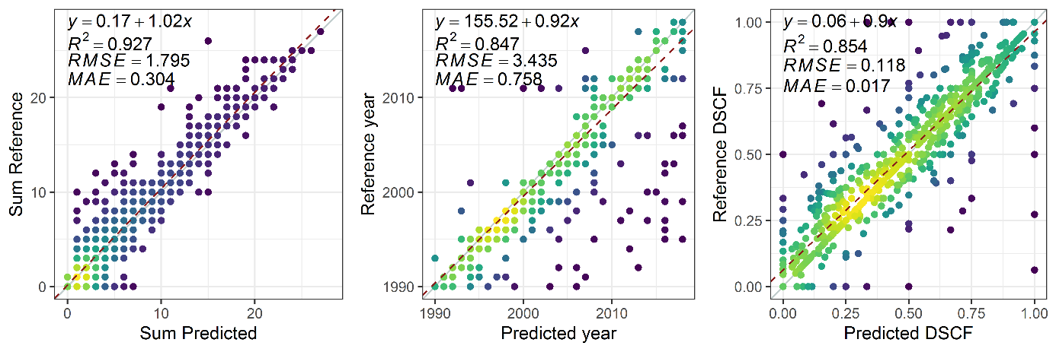
Figure S2: Scatterplots of mapped against reference data values (n = 1,081) for three variables derived in post-classification analysis: the number of years under summer cultivation (left), the earliest year where summer cultivation occurred (middle), and dry season cropping frequency (right). Point density displayed in colors from low (purple) to high (yellow).

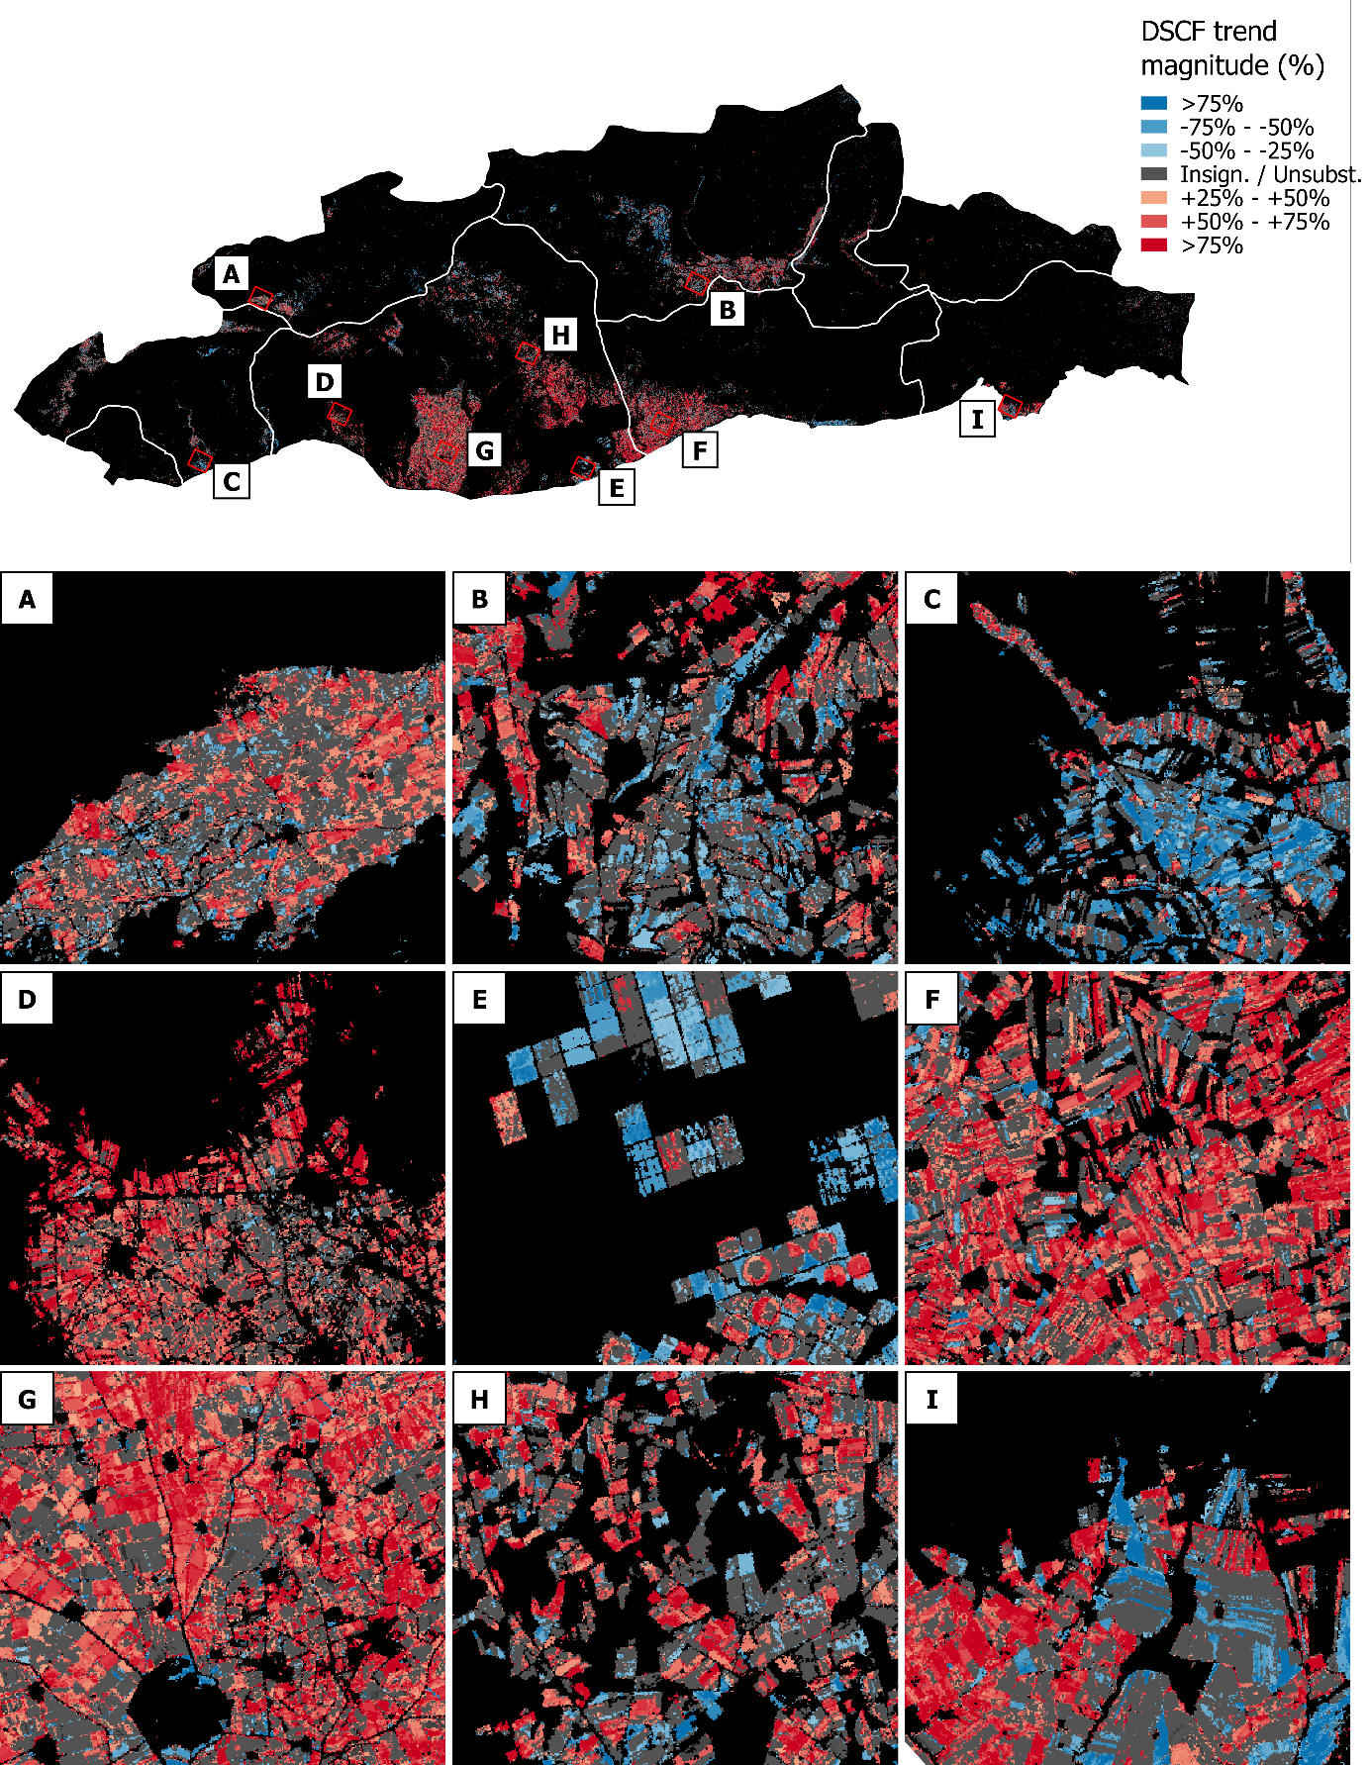
Figure S3: DSCF trend magnitudes, showing varying magnitudes of increasing (red) and decreasing 5-year DSCF (blue). For significance levels please see Figure S4.
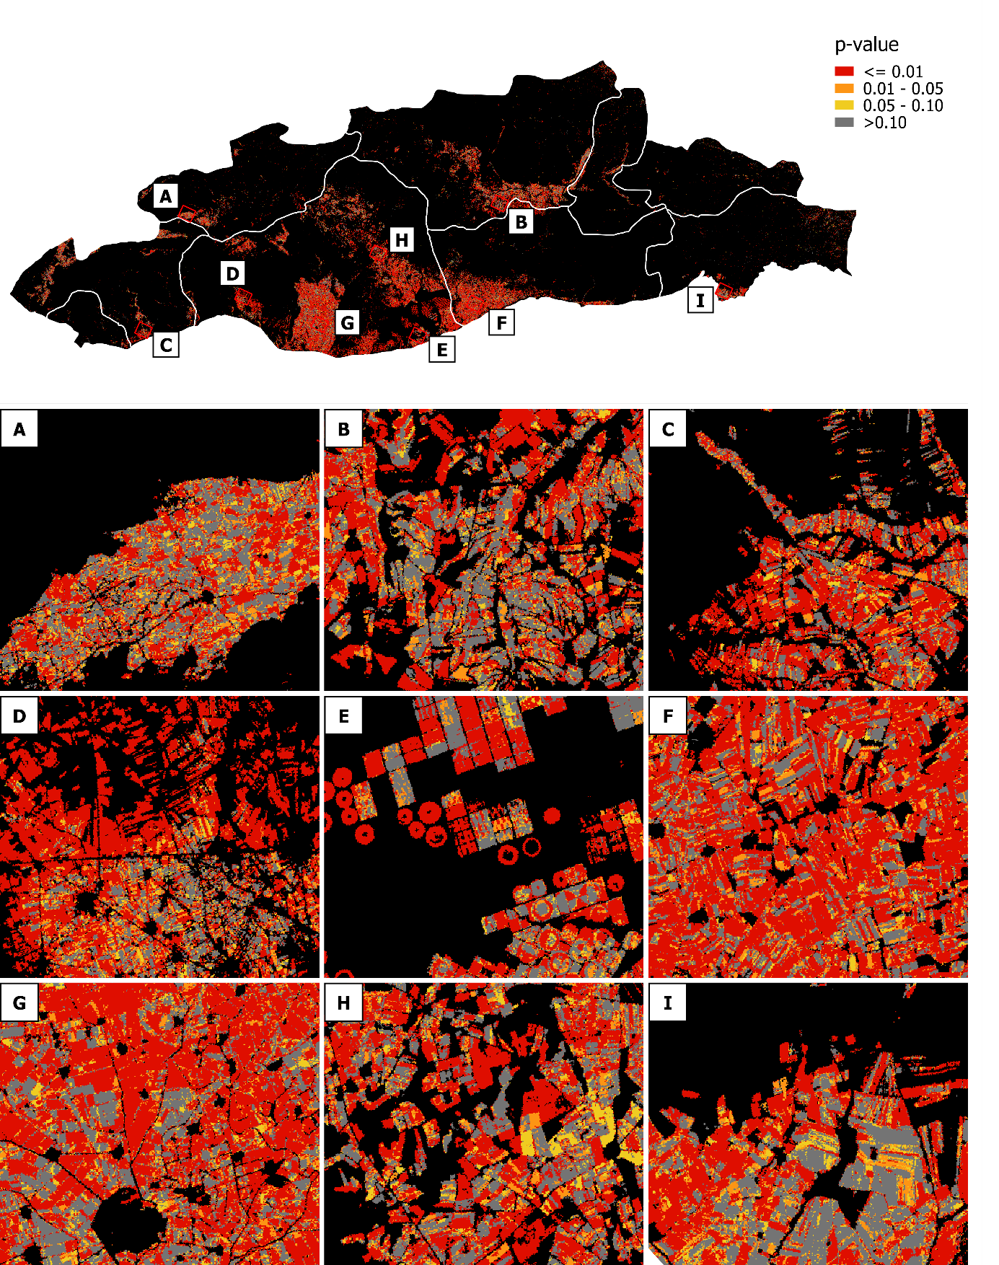
Figure S4: Significance level of SCF trend parameter expressed by varying p-values. Numbers in the main text body include all pixels with trends significant at p<0.05.
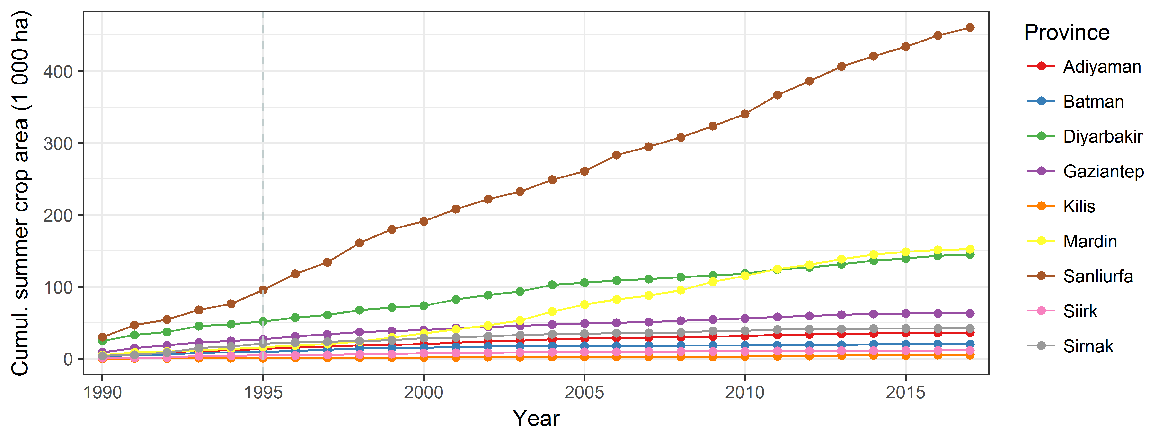
Figure S5: Map-based cumulative summer-cropped area in thousand hectares between 1990 and 2015. These estimates consider all areas, which were under summer cultivation at least twice between 1990 and 2018.

References
Harris, I., Osborn, T.J., Jones, P., & Lister, D. (2020). Version 4 of the CRU TS monthly high-resolution gridded multivariate climate dataset. Scientific data, 7, 109. DOI: 10.1038/s41597-020-0453-3

