Supplementary materials

Appendix 1 Results of the SWIM model calibration and validation in three river catchments under study: comparison of the observed and simulated river discharges for the long-term mean daily dynamics
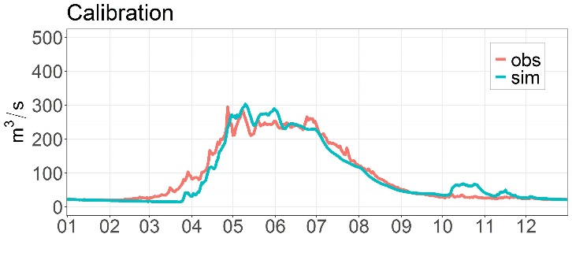
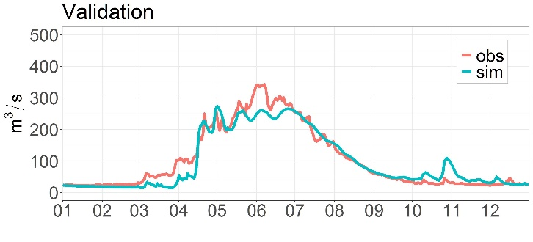
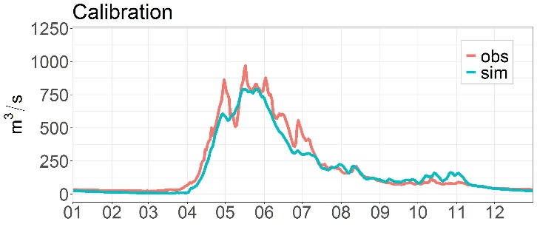
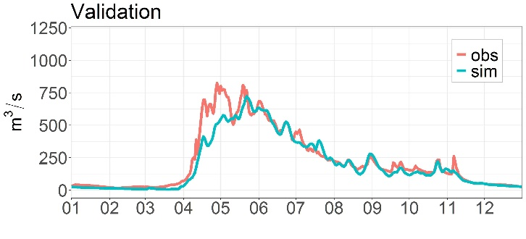
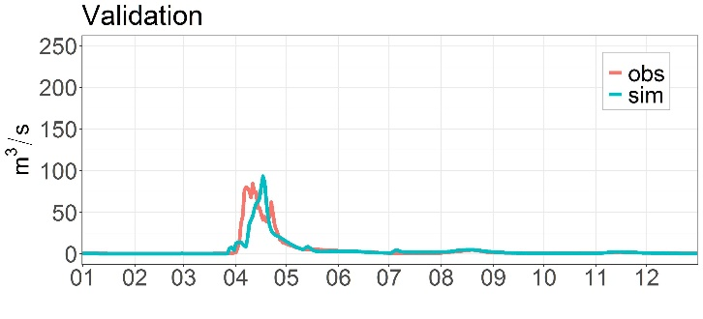
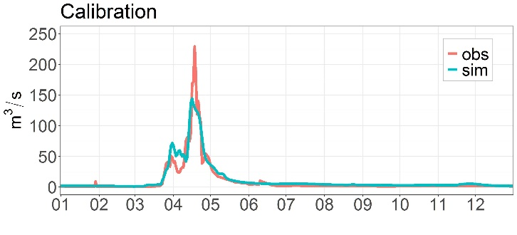
a) Zhabay b) Bukhtarma c) Kafirnigan

Appendix 2 SWIM model parameters used during calibration in seven river catchments under study

Group name | Parameter | Range
Basin baseflow factor | bff | 0.16 – 0.6
Saturated conductivity correction factor | sccor | 0.8 – 1.4
Routing coefficients | roc2 | 2 – 25
 | roc4 | 3 – 30
Snow fall & melt, glacier parameters | tsnfall | -3.5 – 3.7
 | tmelt | -3.2 – 4
 | smrate | 0.07 – 0.19
 | gmrate | 0.3-10

Appendix 3 The multi-model medians of annual mean temperature under RCP 4.5 and RCP 8.5 scenarios in the 21st century.
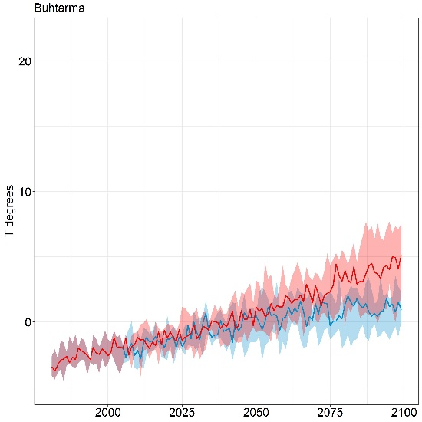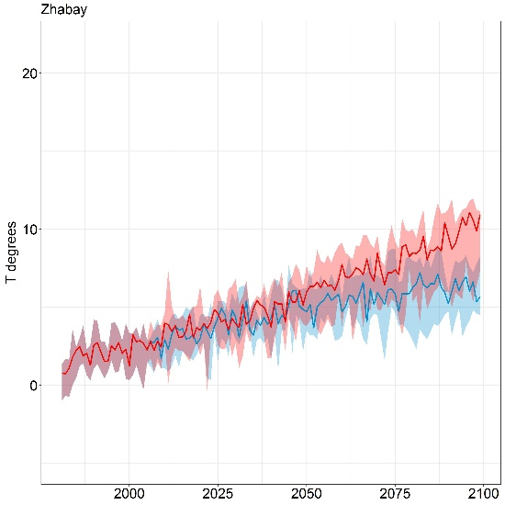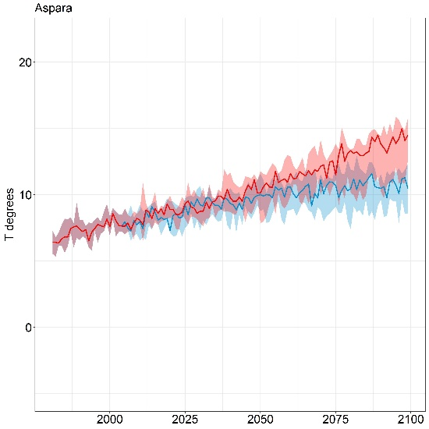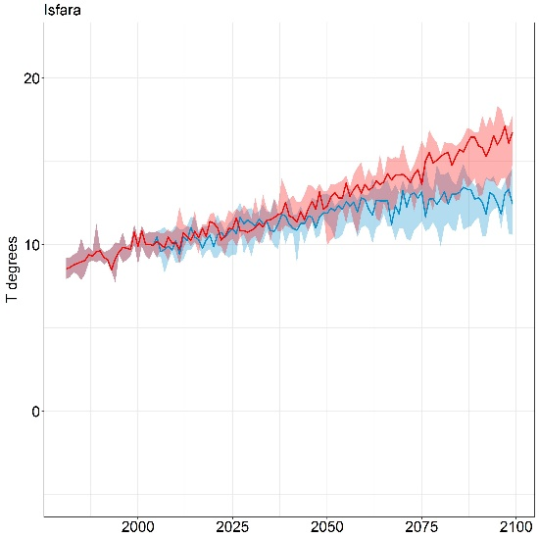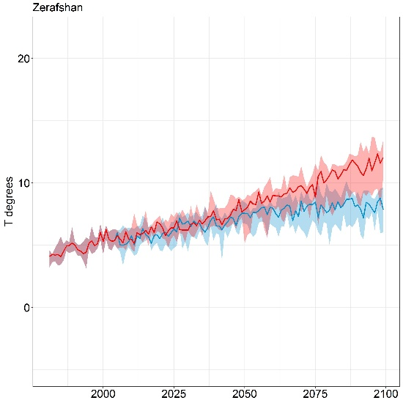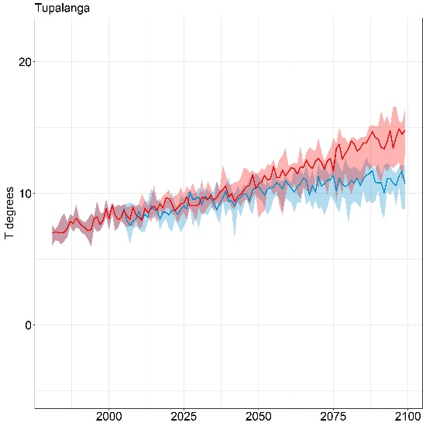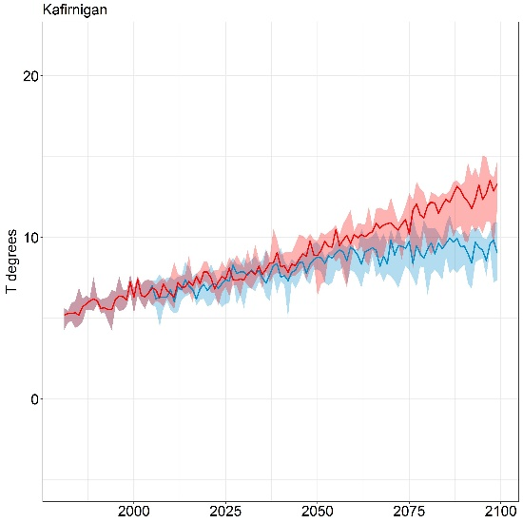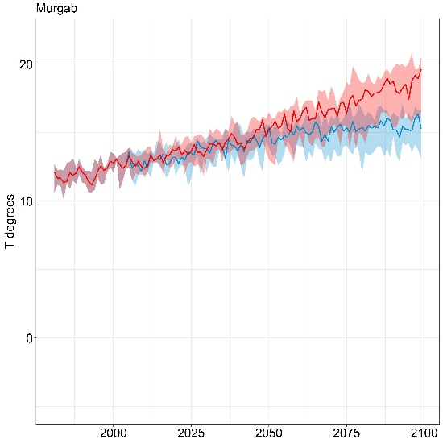

Appendix 4 Changes in multi-model medians of monthly river discharge for three future periods compared to the reference period under RCP 4.5 and RCP 8.5
Month | Scenario | Zhabay |  |  | Bukhtarma |  |  | Aspara |  |  | Isfara |  |  | Zeravshan |  |  | Tupalang |  |  | Kafirnigan |  |  | Murghab
 |  | near | mid | far | near | mid | far | near | mid | far | near | mid | far | near | mid | far | near | mid | far | near | mid | far | near | mid | far
Jan | RCP 4.5 | -21 | 58 | 138 | 5 | 19 | 26 | -11 | -2 | -5 | -10 | -27 | -25 | -2 | -10 | -13 | 54 | 45 | 66 | 1 | -9 | -4 | -1 | -12 | -38
Feb |  | -11 | 59 | 113 | 5 | 19 | 25 | -11 | -2 | -5 | -7 | -16 | -22 | -1 | -9 | -14 | 55 | 113 | 185 | 3 | -1 | 11 | -11 | -12 | -45
Mar |  | -8 | 57 | 143 | 7 | 27 | 36 | -10 | 2 | 5 | 28 | 57 | 95 | 3 | -1 | 4 | 64 | 98 | 178 | 57 | 112 | 207 | -1 | -26 | -28
Apr |  | 53 | 97 | 119 | 44 | 142 | 132 | 5 | 10 | 35 | 11 | 9 | 10 | 24 | 73 | 93 | 11 | 16 | 17 | 14 | 55 | 59 | -18 | -35 | -48
May |  | -17 | -12 | 9 | -7 | -23 | -15 | 22 | 49 | 60 | 1 | -6 | -9 | 31 | 58 | 57 | -10 | -17 | -33 | 9 | 1 | -6 | -15 | -37 | -38
Jun |  | -5 | 43 | 89 | -7 | -20 | -14 | -2 | -10 | -19 | -9 | -38 | -46 | 6 | 0 | -5 | -30 | -51 | -64 | -12 | -35 | -45 | -8 | -31 | -32
Jul |  | -1 | 69 | 108 | -4 | -7 | -13 | -2 | -15 | -26 | -42 | -60 | -60 | -5 | -20 | -35 | -29 | -47 | -60 | -13 | -54 | -65 | -9 | -30 | -31
Aug |  | -5 | 68 | 103 | -6 | -13 | -24 | -7 | -7 | -12 | -10 | -26 | -25 | -16 | -38 | -51 | -28 | -47 | -60 | -23 | -44 | -49 | -9 | -30 | -31
Sep |  | -7 | 64 | 107 | -16 | -22 | -14 | -6 | -2 | -8 | -10 | -26 | -25 | -21 | -36 | -45 | -28 | -47 | -60 | -12 | -27 | -32 | -9 | -30 | -31
Oct |  | -8 | 52 | 99 | 10 | -3 | 13 | -4 | -1 | -7 | -10 | -24 | -26 | -12 | -23 | -28 | -20 | -40 | -56 | -6 | -14 | -19 | -9 | -30 | -31
Nov |  | 4 | 61 | 116 | 6 | 29 | 47 | -1 | 5 | -1 | -10 | -25 | -28 | 5 | -3 | -3 | 0 | -6 | -28 | 7 | 14 | 14 | -9 | -28 | -30
Dec |  | -5 | 60 | 138 | 3 | 19 | 25 | -4 | -1 | -5 | -9 | -24 | -28 | -1 | -5 | -2 | 40 | 68 | 44 | 4 | 7 | 6 | -2 | -27 | -38
Jan | RCP 8.5 | 36 | 99 | 171 | 19 | 1 | 18 | -7 | -16 | -17 | -8 | -18 | -39 | -9 | -7 | -14 | 31 | 89 | 111 | -9 | -3 | 9 | -27 | -18 | -52
Feb |  | 36 | 99 | 175 | 19 | 1 | 17 | -7 | -16 | -15 | 0 | -7 | -27 | -7 | -8 | -8 | 71 | 225 | 325 | -1 | 20 | 73 | -22 | 0 | -51
Mar |  | 81 | 252 | 403 | 20 | 20 | 39 | -6 | -14 | 12 | 49 | 102 | 99 | 4 | 11 | 29 | 59 | 210 | 217 | 60 | 241 | 430 | -21 | -17 | -55
Apr |  | 84 | 94 | 13 | 19 | 99 | 141 | 14 | 11 | 79 | 3 | 4 | 12 | 24 | 104 | 218 | 7 | 4 | -1 | 14 | 43 | 46 | -48 | -33 | -67
May |  | 20 | -10 | -7 | 1 | -20 | -44 | 2 | 19 | 56 | -8 | -10 | -37 | 28 | 44 | 59 | -17 | -25 | -55 | -4 | -13 | -39 | -55 | -39 | -71
Jun |  | 66 | 74 | 121 | -7 | -17 | -28 | -11 | -30 | -47 | -18 | -41 | -80 | -5 | -4 | -17 | -43 | -56 | -75 | -23 | -31 | -65 | -46 | -29 | -65
Jul |  | 71 | 100 | 128 | 1 | -17 | -24 | -11 | -27 | -44 | -48 | -57 | -70 | -16 | -21 | -54 | -38 | -52 | -72 | -34 | -45 | -75 | -46 | -29 | -65
Aug |  | 90 | 96 | 121 | -13 | -11 | -35 | -12 | -23 | -31 | -15 | -24 | -43 | -27 | -34 | -63 | -38 | -51 | -72 | -35 | -41 | -55 | -46 | -29 | -65
Sep |  | 59 | 98 | 142 | -18 | -38 | -44 | -8 | -20 | -28 | -15 | -24 | -43 | -28 | -34 | -51 | -37 | -51 | -71 | -21 | -26 | -40 | -46 | -29 | -65
Oct |  | 51 | 95 | 124 | 23 | -4 | 5 | -8 | -19 | -23 | -14 | -25 | -44 | -19 | -25 | -42 | -40 | -57 | -74 | -16 | -25 | -40 | -46 | -29 | -65
Nov |  | 50 | 124 | 131 | 17 | 23 | 24 | -7 | -11 | -11 | -11 | -26 | -45 | -3 | -16 | -28 | 32 | -35 | -49 | 2 | -2 | -10 | -45 | -28 | -64
Dec |  | 64 | 161 | 224 | 14 | 2 | 11 | -7 | -15 | -10 | -6 | -21 | -40 | -5 | -4 | -2 | 23 | 36 | 41 | -4 | 12 | 29 | -36 | -17 | -52

