APPENDIX

Quantifying the Soil Erosion Legacy of the Soviet Union

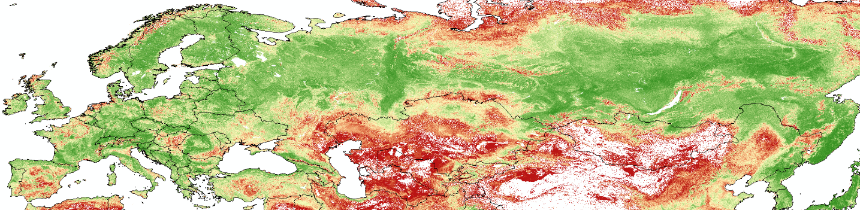

Fig S1. The Natural Vegetation Distribution in Europe and Asia.

Legend: Red = Bare Soil, Yellow = Grassland, Green = Forest

Data from Bastin et al. (2019)

