SUPPLEMENTAL INFORMATION

S1: Methods

Regression analysis of rubber market price
Ordinary Least Squares (OLS) regression analysis is conducted with annual average rubber prices calculated by the Luang Namtha Provincial Investment and Commerce Office (PICO) (Vongvisouk & Dwyer, 2017) as the dependent variable and annual average rubber prices from the SCE (Indexmundi 2018) as the independent variable. OLS regression with no intercept yields an almost-perfect correlation (coefficient = 0.42, SD = 0.03, p < 0.001, R_{adj}² = 0.92). The correlation coefficient is 0.826 (p < 0.001).
We run an additional OLS regression with detrended PICO and SCE annual price data to account for possible autocorrelation and non-stationarity in price time-series data (Podobnik & Stanley, 2008), yielding a coefficient of 0.46 (SD=0.09; p-value<0.001; R_{adj}=0.65). The correlation coefficient is very similar to the above, namely 0.820 (p < 0.001).

Consolidation of land-use categories in the land-use maps
Land-use types in the for the Oudomsin CSA include forest, fallow, shifting cultivation, rubber, paddy, banana, sugarcane, and unclassified. Land-use types in Prang include forest, old fallow, young fallow, shifting cultivation, old rubber, young rubber, cardamom, paddy, bamboo forest, shrub, bare soil, river, urban, road, pond, cloud cover, and unclassified. We defined equivalent land-use categories in both CSAs for the time-series CSA land-use maps. In the Prang area, we consolidated old and young fallow as fallow, old and young rubber as rubber, and assigned bare soil, river, urban, road, pond, cloud cover to the unclassified category. Cardamom, referring to the sun-exposed Paksong variety, only covers 0.5 hectares, indicating that cardamom was not mapped in the Prang area, given that it covered only an estimated 111 hectares.
The value of 111 ha, i.e. the area covered by Paksong cardamom in the Prang CSA in 2017 (cardamom_{CSA}), is estimated as cardamom_{CSA} = cardamom_{sample} * pop_{CSA} / pop_{sample}, where cardamom_{sample} = 20.0 hectares is the area planted with cardamom in 2017 by the population sampled in the household survey (pop_{sample} = 273), and pop_{CSA} = 1,509 is the estimated population in the Prang CSA in 2017.
We classified reported land uses as forest, old fallow, upland rice fallow, upland rice, sugarcane, rubber, cardamom (Paksong and Guangdung varieties), and oil crops. Fallows older than nine years or (based on Sovu et al., 2009), with a diameter larger than nine centimeters, are categorized as old fallow.
Upland crops in 2017 include rubber, cardamom, forest, fallow, upland rice, and bamboo. While some sugarcane was planted in upland plots in the late 1990s, in 2017 there were no upland sugarcane plots in either CSA.

S2: Tables
Table A 1. Description of variables used in the analysis. Variables are calculated separately for each CSA; O = Oudomsin CSA, P = Prang CSA.
Name | Description | Units / values | Mean (SD), min-max
Time-independent, pixel level

Slope | Slope | deg | O: 17.3 (10.8); 0.3-56.3  P: 19.1 (8.8); 0.2-44.3
CostDistance | Accumulated cost distance from the nearest village taking slope into consideration | Cost distance units | O: 25125 (20449); 506-93451  P: 32233 (19881); 281-84868
Distance | Distance to nearest village | m | O: 3064 (1548); 166-6855  P: 3216 (1651); 144-7873
Elevation | Elevation | masl | O: 1004 (212); 716-1647  P: 923 (162); 626-1492
ProtectionStatus | Protection status | O: 1=NPA, 2=HLPA,3=WSP, 4=WSP Joint, 5=Cons, 6=Use, 7=Cem, 8=Regen, 9=DAFO, 0=rest.  P: 1=NPA, 0=rest. | NA
Time-dependent, CSA level

Follow | Percent of the sampled population who planted rubber in year t and indicated that imitation was the main reason for rubber adoption | Fraction | O: 0.3 (0.2); 0-0.8  P: 0.2 (0.3); 0-0.8
KnowPrice | Fraction of the sampled population who plated rubber in year t and knew the market price of rubber | 1/0 | O: 0.5 (0.4); 0-1  P: 0.5 (0.4); 0-1
R_Converted | Rubber converted (planted) annually | ha | O: 222 (160.6); 34.7-646.9  P: 24.7 (28); 0-96.4
Price_R_CHN | Rubber market price in China (SEC rubber price as a proxy) | Chinese Yuan (CNY) | 13 (6.6); 4.8-31.2
Price_R_Local | Rubber price elicited in the household survey | CNY | 7.4 (2.5); 4.1-11.3
Rubber_Conversion_Signal | Local rubber conversion signal (calculated in BN as the factor of R_Converted and Follow and divided by its maximum) | 1/0 | O: 0.2 (0.2); 0-1  P: 0.2 (0.2); 0-1
Price_Signal | Price signal (calculated in BN as the factor of Price_R_CHN and KnowPrice and divided by its maximum) | 1/0 | O: 0.3 (0.2); 0-1  P: 0.3 (0.2); 0-1
CashFlow | Household income from cash crop sales (continuous variable) | Million Lao KIP (LAK)** | O: 3.5 (5.7); 0-16.1 (75% quantile=5.3)  P: 0.7 (1.3); 0-4.1 (75% quantile=0.34)
CashFlow (binary) | Household income from cash crop sales (binary variable) | 1/0 | O: 0.3 (0.5); 0-1  P: 0.2 (0.4); 0-1
* Fixed currency conversions corresponding to 2017 levels are used: LAK/US Dollars =8000; LAK/CNY=1255.
Table A 2: Regression results for Model 1. Dependent variable is conversion to rubber between 2000–2017 (1 = yes, 0 = no).
 | Model 1a |  | Model 1b |  | Model 1c
 | Oudomsin | Prang | Oudomsin | Prang | Oudomsin | Prang
NPA | -1.65***  (0.58) | -0.34  (0.63) | -1.70***  (0.59) | -0.16  (0.66) | -2.15***  (0.58) | -0.35  (0.66)
HLPA | 0.19  (0.52) | NA | 0.18  (0.52) | NA | 0.07  (0.55) | NA
WSP Joint Forest | -0.43  (0.68) | NA | -0.24  (0.70) | NA | -0.15  (0.70) | NA
WSP Forest | -1.18***  (0.44) | NA | -0.96**  (0.48) | NA | -0.82*  (0.46) | NA
Conservation Forest | -1.84**  (0.93) | NA | -1.71*  (0.94) | NA | -1.71*  (0.92) | NA
Use Forest | 0.84  (1.10) | NA | 1.08  (1.13) | NA | 1.35  (1.13) | NA
Regeneration Forest | 0.35  (0.85) | NA | 0.27  (0.84) | NA | -0.005  (0.80) | NA
DAFO Land | 12.48  (882.74) | NA | 12.65  (882.74) | NA | 12.87  (882.74) | NA
Cost Distance | -2.60***  (0.47) | -7.49*** (1.45) | -1.68*  (0.89) | -4.77*** (1.41)
Elevation |  |  | -2.62  (2.24) | -13.11*** (4.43) | -6.39***  (1.39) | -15.69*** (4.43)
Slope |  |  |  |  | 0.001  (0.34) | -0.84  (0.69)
Distance |  |  |  |  | -0.08  (0.52) | -2.81***  (0.87)
Observations | 330 | 451 | 330 | 451 | 330 | 451
Log likelihood | -138 | -65
AIC | 296 | 137 | 297 | 129 | 303 | 130
McFadden pseudo-R2 | 0.39 | 0.36 | 0.40 | 0.41 | 0.39 | 0.41
Moran’s I | 0.14 | 0.05 | 0.13 | 0.01 | 0.12 | 0.02
p-value: ^p < 0.10, *p < 0.05, **p < 0.01. ***p < 0.01. Also indicated for Moran’s I where significant.
Table A 3: Regression results for Model 2. The dependent variable is conversion to rubber in each year
(1 = yes, 0 = no).
 | Model 2a |  | Model 2b |  | Model 2c |  | Model 2d |  | Model 2e
 | Oudomsin | Prang | Oudomsin | Prang | Oudomsin | Prang | Oudomsin | Prang | Oudomsin | Prang
NPA | -1.2** (0.43) | -0.53 (0.77) | -1.21** (0.44) |  | -1.2** (0.44) | -0.60 (0.81) | -1.6** (0.50) | -0.78 (0.97) | -1.2** (0.44) | -0.55 (0.78)
Cost Distance | -1.2* (0.51) | -3.5** (1.3) | -1 .00* (0.51) | -3.9** (1.5) | -1.1* (0.51) | -3.9** (1.5) | -1.5* (0.64) | -4.8* (2.0) | -1.2* (0.51) | -3.6** (1.4)
Elevation | -1.7 (1.3) | -9.8* (3.9) | -2.0 (1.3) | -10.7* (4.4) | -2.0  (1.3) | -11* (4.5) | -2.4  (1.6) | -13* (5.7) | -1.8  (1.3)
Price rubber China | 0.70*** (0.17) | 0.32 (0.50) |  |  | 0.51* (0.21) | 0.09 (0.60) | 0.89  ** (0.28) | 0.64  (0.73) | 0.53** (0.19) | -0.14 (0.61)
Rubber converted CSA |  |  | -0.85*** (0.10) | 0.94*** (0.26) | 0.78*** (0.11) | 0.94*** (0.26) | 0.79*** (0.11) | 1.0*** (0.29)
Cash Flow |  |  |  |  |  |  | 0.88*** (0.16) | 0.66 (0.43)
Follow |  |  |  |  |  |  |  |  | 1.0* (0.48) | 1.3^ (0.84)
Free parameters | 13 | 6 | 13 | 6 | 14 | 7 | 15 | 8 | 14 | 7
Log likelihood | -648 | -115 | -626 | -109 | -623 | -109 | -598 | -108 | -646 | -114
AIC | 1322 | 243 | 1278 | 231 | 1275 | 233 | 1227 | 232 | 1319 | 242
p-value: ^p < 0.10, *p < 0.05, **p < 0.01. ***p < 0.01.
Table A 4: Regression results for Model 2 with interaction variables (signals). The dependent variable is conversion to rubber in each year (1 = yes, 0 = no).
 | Model 2f |  | Model 2g |  | Model 2h |  | Model 2i
 | Oudomsin | Prang | Oudomsin | Prang | Oudomsin | Prang | Oudomsin | Prang
NPA | -1.6** (0.50) | -0.70 (0.90) | -1.7** (0.51) | -0.72 (0.93) | -1.66** (0.51) | -0.73 (0.93) | -1.3** (0.44) | -0.56 (0.79)
Cost Distance | -1.4* (0.63) | -4.4*  (1.8) | -1.6* (0.66) | -4.5*  (1.8) | -1.5*  (0.65) | -4.6*  (1.8) | -1.1*  (0.52) | -3.7** (1.4)
Elevation | -2.5  (1.5) | -12*  (5.1) | -2.3  (1.6) | -12*  (5.3) | -2.5  (1.6) | -12*  (5.2) | -2.0  (1.3) | -10* (4.3)
Price Rubber China |  |  | 0.96*** (0.26) | 0.67  (0.70)
Price Rubber China x KnowPrice | 1.0** (0.33) | -0.07 (0.66) |  |  |  |  | 0.97*** (0.23) | -0.12 (0.51)
Price Rubber China x Told |  |  |  |  | 1.0*** (0.28) | 0.38  (0.58)
Rubber converted | 0.84*** (0.11) | 0.98*** (0.29) |  |  | 0.78*** (0.12) | 0.93*** (0.27)
Rubber converted x Follow |  |  | 1.7*** (0.35) | 1.2*  (0.48) |  |  | 1.9*** (0.31) | 1.1* (0.48)
Cash Flow | 0.70*** (0.14) | 0.45  (0.43) | 0.86*** (0.16) | 0.61^  (0.34) | 0.91*** (0.17) | 0.64  (0.44)
Free parameters | 15 | 8 | 15 | 8 | 15 | 8 | 14 | 7
Log likelihood | -599 | -108 | -608 | -111 | -597 | -108 | -623 | -113
AIC | 1229 | 233 | 1246 | 239 | 1225 | 233 | 1251 | 239
p-value: ^p < 0.10, *p < 0.05, **p < 0.01, ***p < 0.01.
Table A 5: Regression results for Model 3. The dependent variable is conversion to rubber in each year
(1 = yes, 0 = no).
 | Model3a |  | Model 3b
 | Oudomsin | Prang | Oudomsin | Prang
NPA | -1.9**  (0.58) | -0.71  (0.91) | -2.3***  (0.66) | -0.87  (1.1)
Cost Distance | -1.7*  (0.74) | -4.4*  (1.8) | -2.0*  (0.86) | -5.3*  (2.4)
Elevation | -2.7  (1.8) | -12*  (5.1) | -3.1  (2.1) | -13.91*  (6.70)
Cash Flow | 0.77***  (0.23) | 0.39  (0.44) | 1.2***  (0.32) | -0.85  (0.86)
Price Rubber China x Period 1 |  |  | -0.24  (1.2) | -41  (1848)
Price Rubber China x Period 2 |  |  | 1.6^  (0.82) | -2.2  (2.0)
Price Rubber China x Period 3 |  |  | 0.86^  (0.49) | -1.5  (1.3)
Price Rubber China x Period 4 |  |  | 1.3  (0.94) | 0.21  (2.6)
Rubber converted x Follow |  |  | 0.23  (0.51) | -0.12  (0.76)
Price Rubber China x Know Price | 0.49  (0.42) | 0.09  (0.75)
Rubber converted x Period 1 | -0.75  (0.66) | -153  (3734)
Rubber converted x Period 2 | 0.58***  (0.15) | 0.94  (0.60)
Rubber converted x Period 3 | 0.67^  (0.37) | 0.45  (0.79)
Rubber converted x Period 4 | 0.54^  (0.32) | 0.80**  (0.31)
Free parameters | 18 | 11 | 18 | 11
Log likelihood | -589 | -106 | -591 | -104
AIC | 1215 | 234 | 1218 | 230
p-value: ^p < 0.10, *p < 0.05, ** p < 0.01. *** p < 0.01

S3: Figures
Figure A 1: Annual hectares converted to rubber (positive values), and land use from which it was converted (negative values), per CSA.
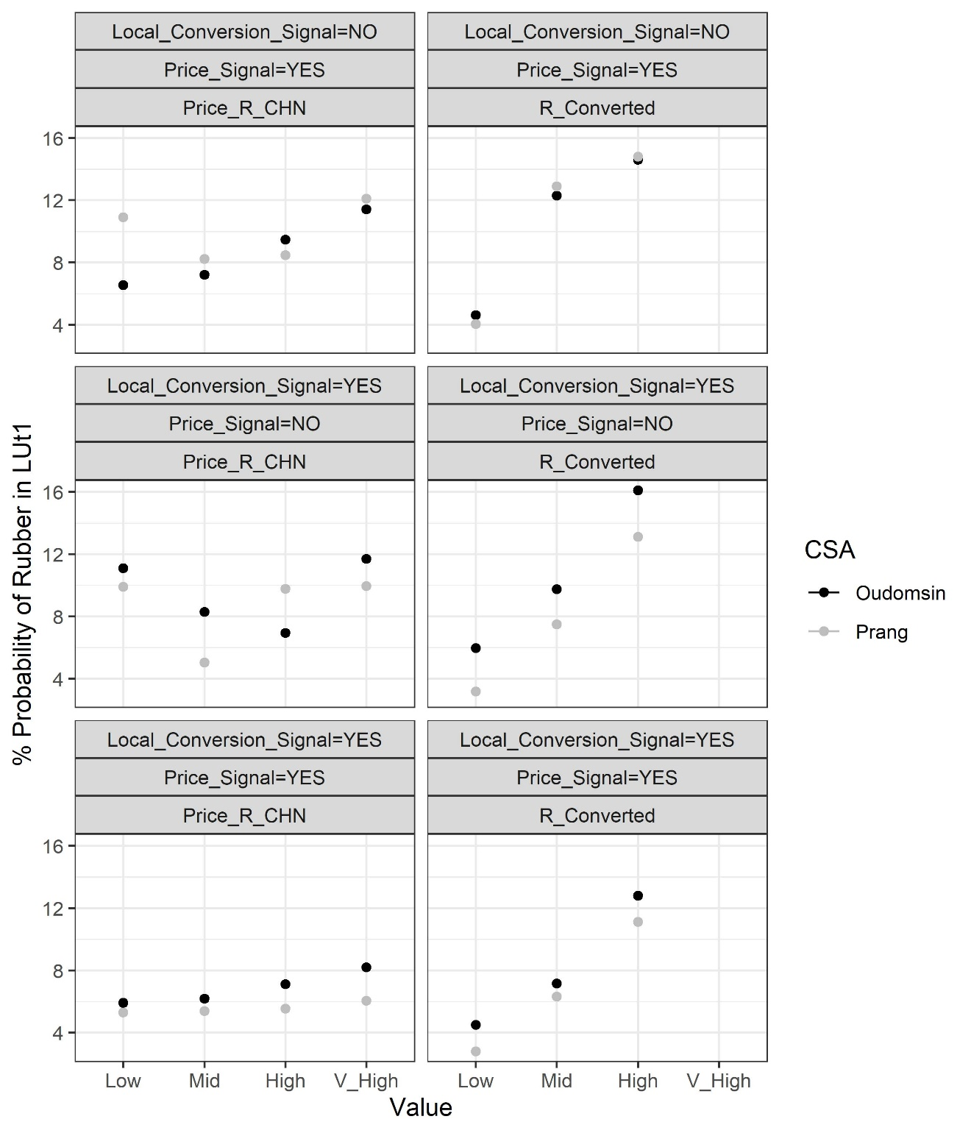
Figure A 2: Percent probability of rubber in output node LUt1 predicted by the BN in each CSA for different states of R_Converted (Low, Mid, or High) and different states of Price_R_CHN (Low, Mid, High, and Very High) when the BN model includes (YES) or does not include (NO) a Local_Conversion_Signal (in which the node Follow is associated with R_Converted) or a Price_Signal (in which the node KnowPrice is associated with Price_R_CHN). Where a signal is not implemented, the nodes R_Converted and/or Price_R_CHN are tied directly to the node LUt1.
Oudomsin  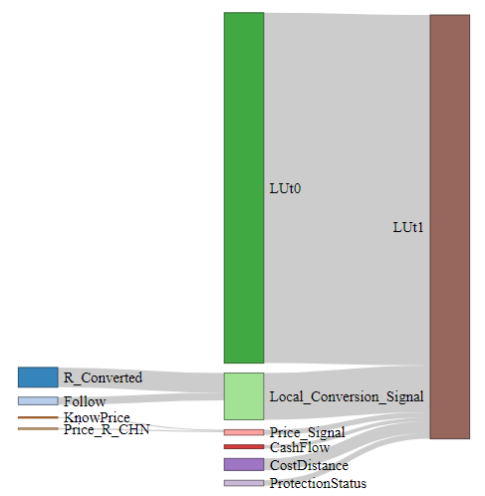  39% | Prang  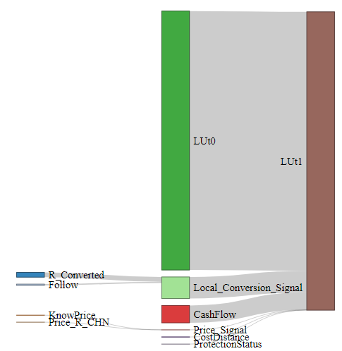  42%
Figure A 3: Results of the sensitivity analysis showing percent entropy reduction of the LUt1 variable when other variables are instantiated. The cumulative entropy reduction is 39 % for the Oudomsin BN and 42% for the Prang model, indicating that around 60% of variability in LUt1 is not explained by the variables included in the BN model.
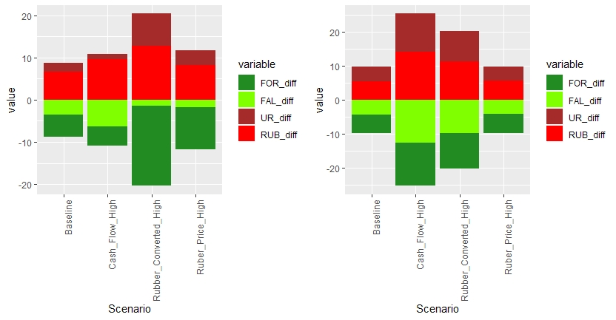
Figure A 4: Change (“diff”) in the probability of occurrence of a land-use category for difference scenarios in each CSA. Calculated as the probability of a given land use in LUt1 minus its probability in LUt0 (the probability of rubber in LUt0 is assumed as zero). Scenarios include: Baseline (shown in Figure 5), Cash Flow High, Rubber Converted High, and Price Rubber High (16-24 CNY/kg). FOR = Forest; FAL = Fallow; UR = Upland rice; RUB = Rubber.

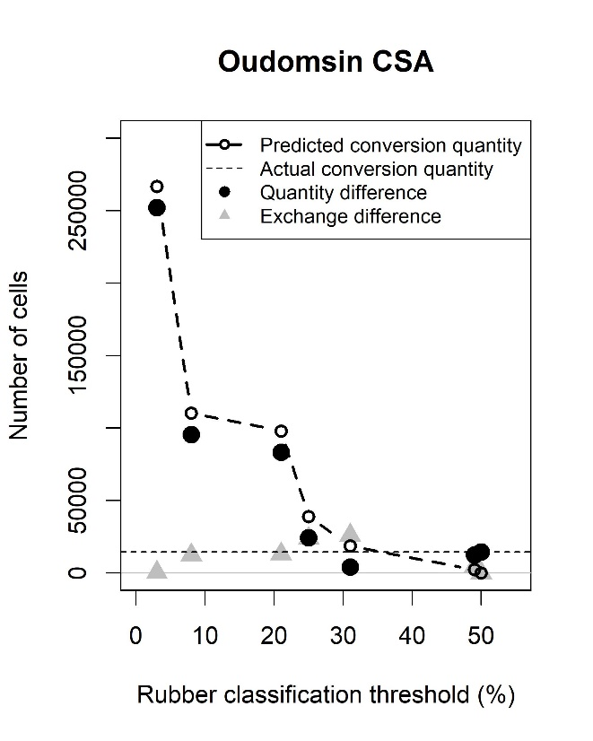 | 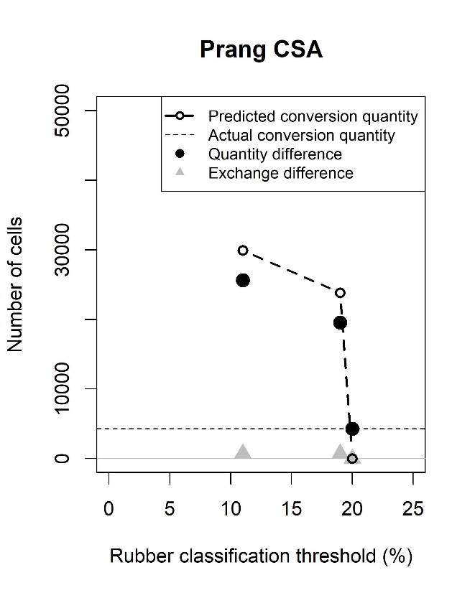
Figure A 5: Quantity and overall difference in rubber conversion between the model output and the LU maps, as well as predicted and “actual” (based on LU maps) conversion quantity for both CSAs. The rubber classification threshold refers to the probability of occurrence of rubber in LUt1 above which a pixel is assigned to the rubber category.

References
Indexmundi. 2018. Rubber (Asia, RSS3 grade), Monthly price (Yuan Renminbi per kilogram), Singapore Commodity Exchange Ltd (SICOM). https://www.indexmundi.com/commodities/?commodity=rubber&months=240&currency=cny.
Podobnik, B., and H. E. Stanley. 2008. Detrended cross-correlation analysis: A new method for analyzing two nonstationary time series. Physical Review Letters 100(8):1–4.
Sovu, M. Tigabu, P. Savadogo, P. C. Odén, and L. Xayvongsa. 2009. Recovery of secondary forests on swidden cultivation fallows in Laos. Forest Ecology and Management 258(12):2666–2675.
Vongvisouk, T., and M. Dwyer. 2017. After the boom: Responding to falling rubber prices in northern Laos. MRLG Thematic Study Series #4: MRLG and Forest Trends(May).

