Validation of the map of the proximate causes of deforestation (figure 3)
A quantitative validation of the final map was conducted for the area within the Department of Santa Cruz, where this map is based on Museo Noel Kempff and Prefectura de Santa Cruz (2008). The validation uses 18 scenes from the High Resolution Camera of the China-Brazil Earth Resource Satellite (CBERS HRC) with a spatial resolution of 2.5 meters distributed over the entire lowland area of the Department of Santa Cruz. For each proximate cause of deforestation identified on the final map, 150 pixels were randomly chosen within the area covered by the 18 satellite images. Proximate causes of deforestation were identified in the 450 selected pixels based on a visual interpretation of the satellite images, and the results were then compared with the final map. A coincidence of 88% was found (weighted average of the user's accuracy); the allocation disagreement was 6.5% and the quantity disagreement 5.5% (see Pontius and Millones 2011).

Deforestation patterns from small-scale agriculture typically consist of several small rectangular patches containing different degrees of vegetation removal, whereas clearings for pastures are generally larger, more uniform and often contain a few scattered remaining trees as well as drinking ponds. Mechanized agriculture is characterized by generally large, geometrically shaped clearings. These clearings often contain windbreaks and furrows and have highly varying reflectivities due to particular agricultural phases (e.g., sewing or harvesting).

Table 4: Confusion matrix of sample unadjusted for stratified sampling design (following Pontius and Millones 2011)

Map of proximate causes of deforestation
 |  | Mechanized agriculture | Small-scale agriculture | Cattle ranching | Total | Producer's accuracy | Producer's accuracy adjusted for class sizes
CBERS interpretation | Mechanized agriculture | 129 | 3 | 9 | 141 | 91% | 96%
CBERS interpretation | Small-scale agriculture | 3 | 139 | 8 | 150 | 93% | 87%
CBERS interpretation | Cattle ranching | 18 | 8 | 133 | 159 | 84% | 77%
 | Total | 150 | 150 | 150 | 450
 | User's accuracy | 86% | 93% | 89%

Table 5: Accuracy assessment (following Pontius and Millones 2011)

Results adjusted for class sizes
Weighted average of user’s accuracy (proportion agreement) | 88.0%
Allocation disagreement | 6.5%
Quantity disagreement | 5.5%

Figure 7: Examples of the identification of proximate causes of deforestation from CBERS HRC images (mechanized agriculture in red, small-scale agriculture in purple and cattle ranching in yellow)
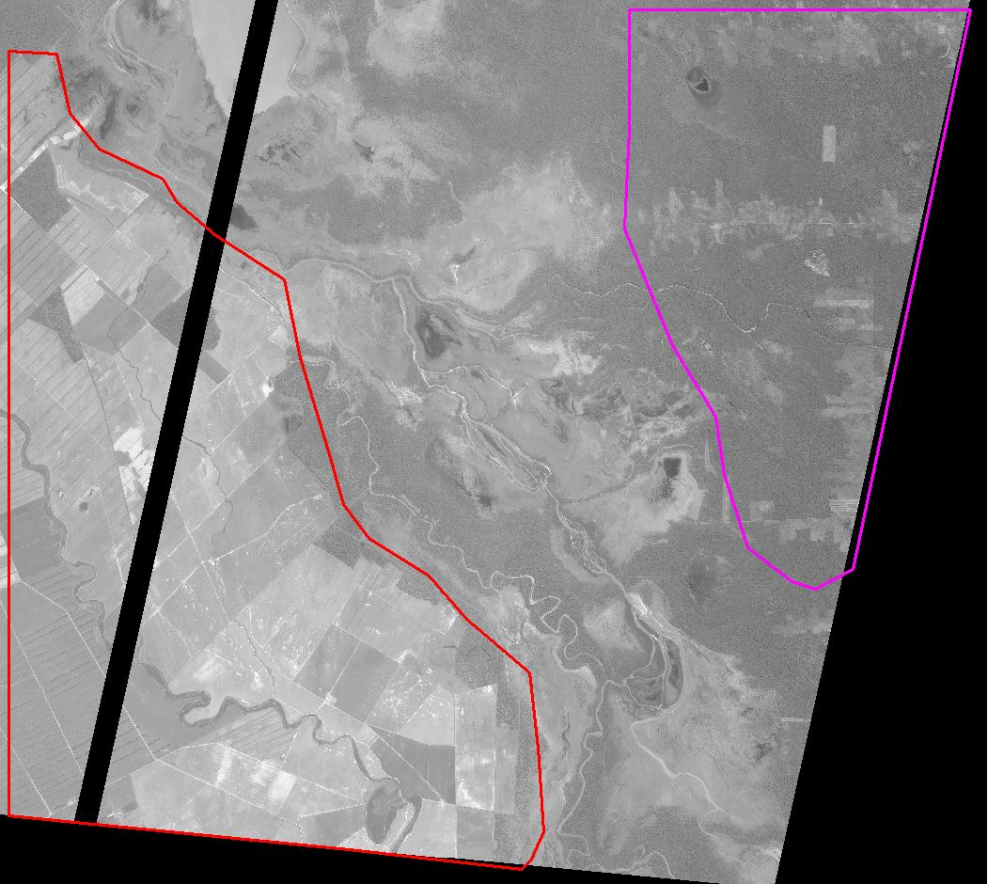
a) North of Santa Cruz
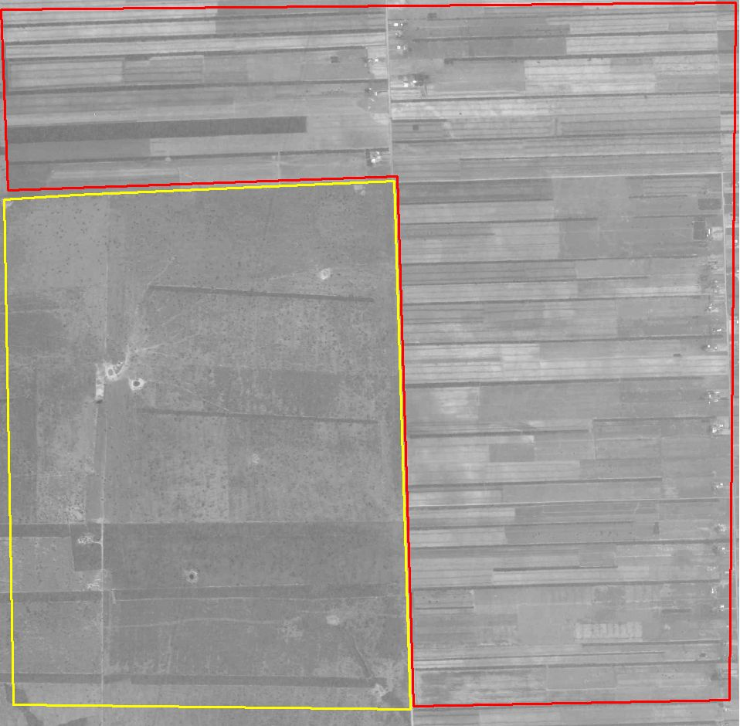
b) South of Santa Cruz

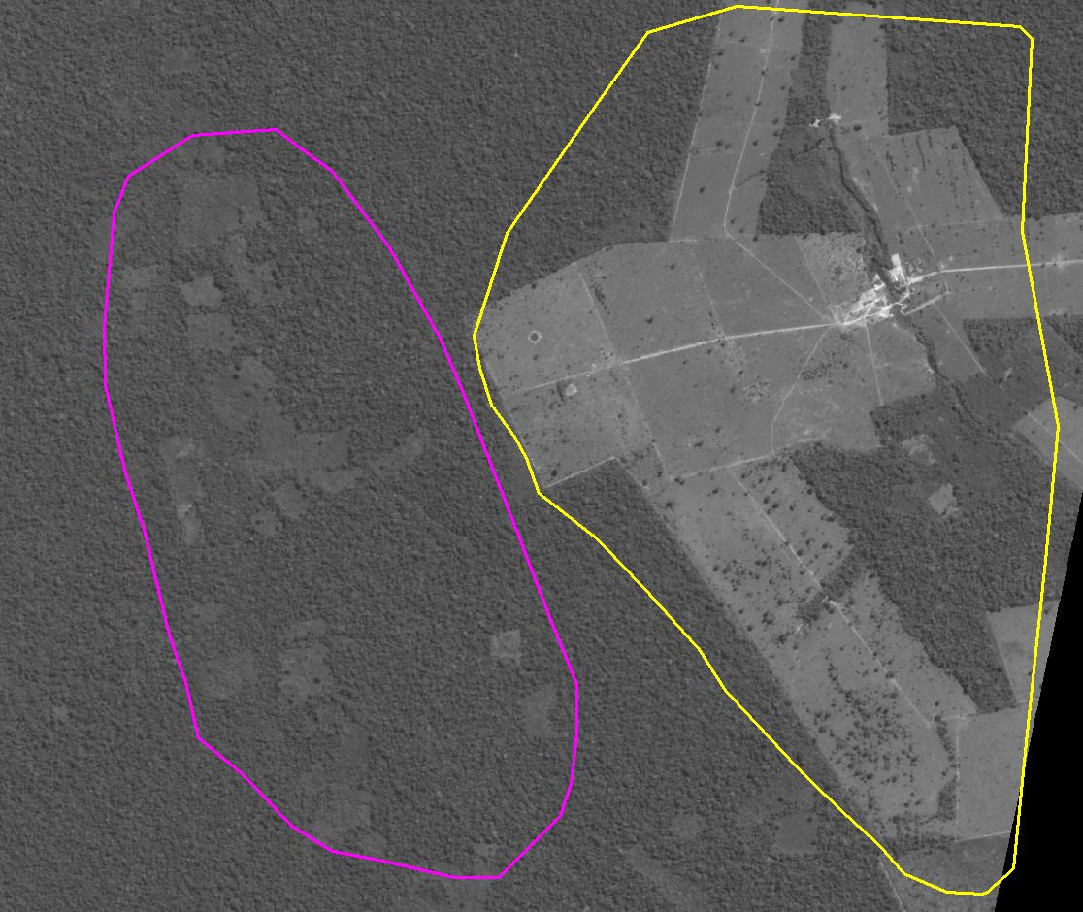
c) East of Riberalta
Visual representations of the ROC AUC to evaluate the goodness of fit of calibration for the three proximate causes of deforestation

8 a) Mechanized agriculture 8 b) Small-scale agriculture 8 c) Cattle ranching

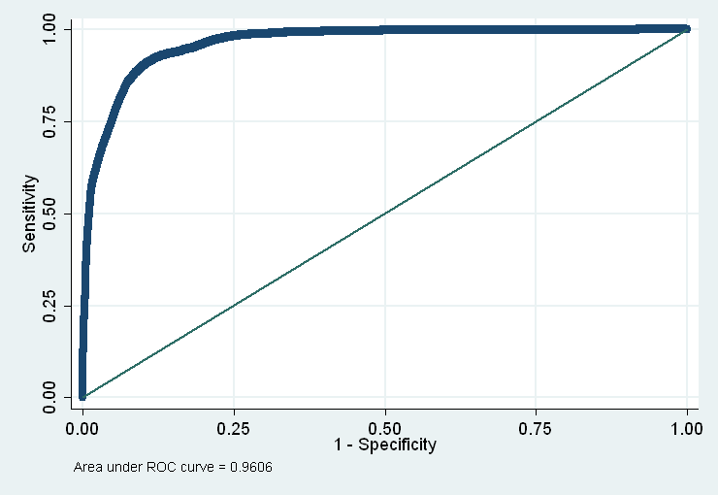
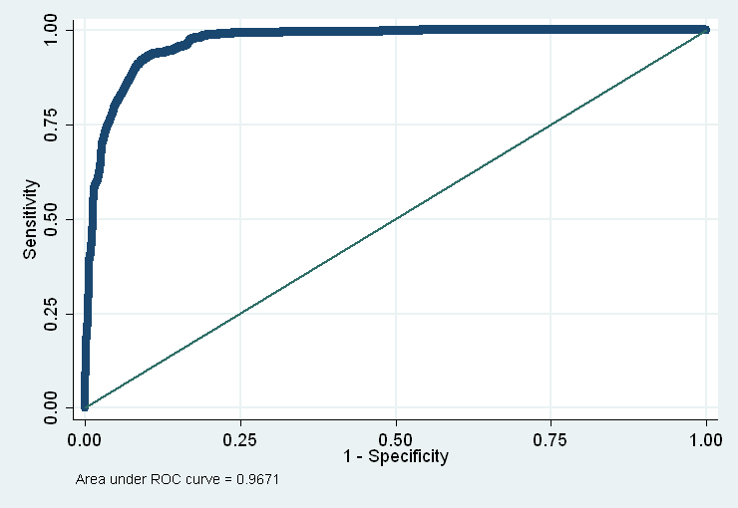
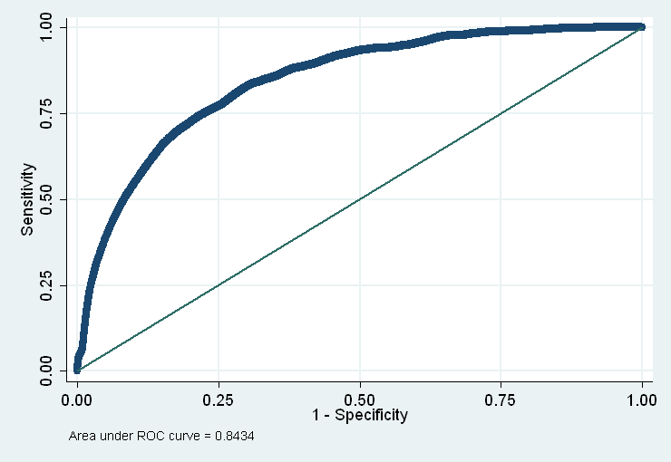
Figure 3 in higher resolution, raster format
