**Herd Growth, Farm Organisation and Subsidies in the Dairy Sector of Russia and Kazakhstan**

Martin Petrick and Linde Götz

# Online Appendix

# Appendix S1: Additional Figures and Tables

Figure S1. Dairy production and consumption, Russian Federation and Kazakhstan 1990–2016

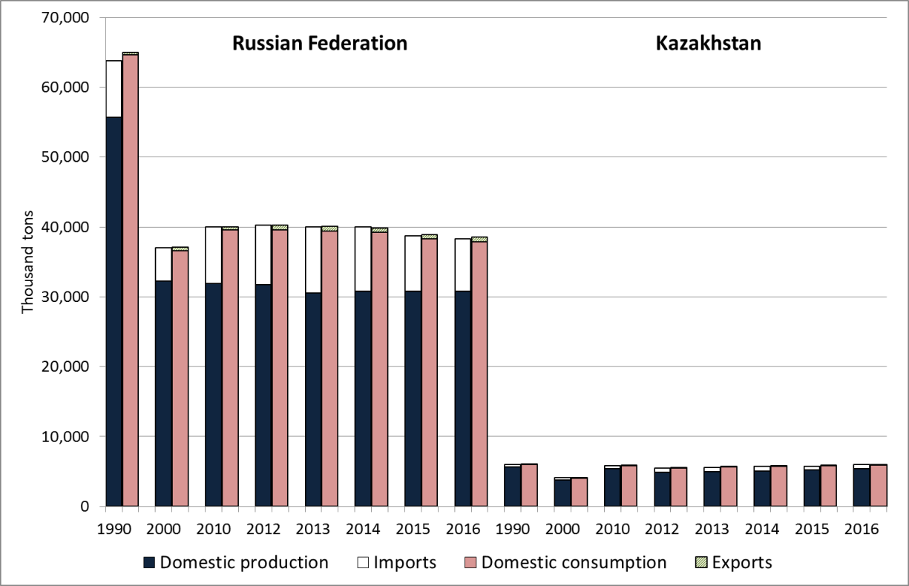

***Notes***: Domestic consumption includes industrial and private consumption plus losses. Difference in total bar height per year is equal to change in inventories.

***Source***: National Statistical Offices.

Figure S2. Size of the domestic dairy herd and milk yields by farm type, Russian Federation and Kazakhstan 1990–2016

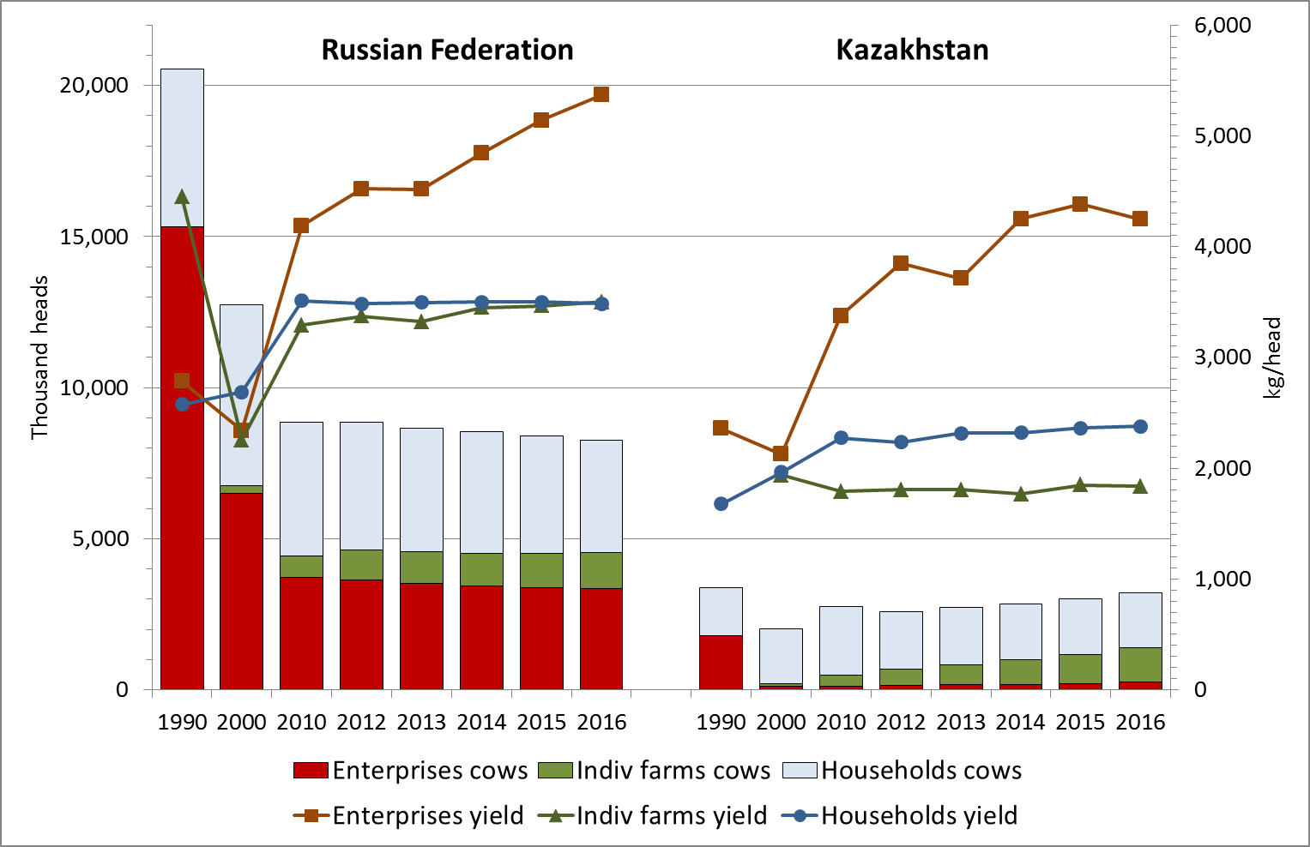

***Source***: Authors’ compilation based on data from National Statistical Offices.

Figure S3. Distribution of herd sizes in 2012 and 2015



***Note***: Includes farms for which cow number observations are available in only one of the two years (N=180).

***Source***: Authors’ compilation based on IAMO survey.

Figure S4. Milk yield vs. herd size in 2015



***Note***: Based on farms with non-zero and non-missing observations in 2015 (N=171).

***Source***: Authors, based on IAMO survey.

Table S1

**Number of sampled farms by dairy status in 2012 and 2015**

|  |  |  |  |
| --- | --- | --- | --- |
|  | Farms keeping dairy cows in 2015 | Farms not keeping dairy cows in 2015 | Total |
| Farms keeping dairy cows in 2012 | 147 | 3  (exiting farms) | 150 |
| Farms not keeping dairy cows in 2012 | 24  (entering farms) | 620 | 644 |
| Total | 171 | 623 | 794 |

***Note***: Based on farms for which cow number observations are available in both years (N=174).

***Source***: Authors, based on IAMO survey.

Table S2

**Number of sampled farms keeping cows by farm type and country in 2015**

|  |  |  |  |
| --- | --- | --- | --- |
|  | Russian Federation | Kazakhstan | Total |
| Individual farms | 75 | 19 | 93 |
| Agricultural enterprises | 74 | 3 | 78 |
| Total | 149 | 22 | 171 |

***Note***: Based on farms with non-zero and non-missing observations in 2015 (N=171).

***Source***: Authors.

Table S3

**Regression results of proportionate herd growth 2012–2015**

|  |  |  |  |  |  |  |  |  |  |  |  |
| --- | --- | --- | --- | --- | --- | --- | --- | --- | --- | --- | --- |
|  | **(Herd size 2015 – herd size 2012) / herd size 2012 (D)** | | |  | **Log dairy cows in 2012  (E)** | | |  | **Log livestock subsidies   (F)** | | |
|  | **Coeff.** |  | ***p*-val.** |  | **Coeff.** |  | ***p*-val.** |  | **Coeff.** |  | ***p*-val.** |
| Log dairy cows 2012 | -0.5 | * | 0.065 |  | – |  |  |  | 4.2 |  | 0.372 |
| Log dairy cows 2012 squared | <0.1 |  | 0.129 |  | – |  |  |  | – |  |  |
| Log milk price | -0.4 | ** | 0.013 |  | – |  |  |  | – |  |  |
| Log agricultural wage | 0.1 |  | 0.185 |  | – |  |  |  | – |  |  |
| Log concentrate price | <0.1 |  | 0.711 |  | – |  |  |  | – |  |  |
| Log livestock value | <0.1 | ** | 0.032 |  | – |  |  |  | – |  |  |
| Log livestock subsidies | 0.1 |  | 0.518 |  | – |  |  |  | – |  |  |
| Log fodder land | <0.1 |  | 0.268 |  | – |  |  |  | 0.6 |  | 0.399 |
| Log perm workers 2012 | >-0.1 |  | 0.499 |  | – |  |  |  | 2.1 |  | 0.370 |
| Age of manager | >-0.1 |  | 0.224 |  | – |  |  |  | 0.3 |  | 0.314 |
| Age of farm | <0.1 |  | 0.841 |  | – |  |  |  | -0.5 | *** | 0.006 |
| Share of hired workers | 0.8 | *** | 0.009 |  | – |  |  |  | 2.0 |  | 0.774 |
| Pregnancy tests (1/0) | 0.2 |  | 0.668 |  | – |  |  |  | -13.2 | ** | 0.027 |
| Artificial insemination (1/0) | 0.5 |  | 0.148 |  | – |  |  |  | 15.0 | *** | 0.001 |
| Agric education (1/0) | <0.1 |  | 0.939 |  | – |  |  |  | -1.7 |  | 0.724 |
| Agroholding (1/0) | -0.1 |  | 0.635 |  | – |  |  |  | 1.2 |  | 0.834 |
| Credit rationed (1/0) | 0.4 | * | 0.066 |  | – |  |  |  | 3.8 |  | 0.357 |
| Milk contract (1/0) | 0.2 |  | 0.427 |  | – |  |  |  | -11.8 | *** | 0.006 |
| Individual farm (1/0) | -0.2 |  | 0.412 |  | – |  |  |  | 11.5 | ** | 0.013 |
| New entrant (1/0) | – |  |  |  | – |  |  |  | 10.5 |  | 0.352 |
| Riazan (1/0) | 0.3 |  | 0.364 |  | 1.8 | *** | 0.001 |  | -1.2 |  | 0.891 |
| Stavropol (1/0) | -0.1 |  | 0.749 |  | -0.5 |  | 0.714 |  | 9.7 |  | 0.248 |
| Altai Krai (1/0) | 0.1 |  | 0.850 |  | -0.3 |  | 0.650 |  | 2.0 |  | 0.806 |
| Novosibirsk (1/0) | 0.2 |  | 0.472 |  | -0.9 | * | 0.051 |  | -6.5 |  | 0.362 |
| Akmola (KZ) (1/0) | 0.7 | ** | 0.031 |  | -0.9 |  | 0.219 |  | -9.6 |  | 0.297 |
| Constant | 0.1 |  | 0.860 |  | 1.0 | * | 0.058 |  | -54.5 | *** | 0.002 |
| Additional instruments : |  |  |  |  |  |  |  |  |  |  |  |
| Land owned when farm was established (LEST) | – |  |  |  | 0.2 | * | 0.068 |  | – |  |  |
| Land cultivated in 2004 (L04) | – |  |  |  | -0.6 |  | 0.109 |  | – |  |  |
| LEST * L04 | – |  |  |  | <0.1 |  | 0.760 |  | – |  |  |
| Land cultivated in 2009 (L09) | – |  |  |  | 0.7 | *** | 0.006 |  | – |  |  |
| LEST * L09 | – |  |  |  | >-0.1 |  | 0.868 |  | – |  |  |
| L04 * L09 | – |  |  |  | 0.2 | *** | 0.009 |  | – |  |  |
| LEST * L04 * L09 | – |  |  |  | >-0.1 |  | 0.282 |  | – |  |  |
| LEST2 | – |  |  |  | <0.1 |  | 0.132 |  | – |  |  |
| L042 | – |  |  |  | -0.1 | ** | 0.017 |  | – |  |  |
| L092 | – |  |  |  | -0.1 | * | 0.076 |  | – |  |  |
| N | 172 | | | | | | | | | | |

***Notes***: Equations D – F simultaneously estimated by Maximum Likelihood using the conditional mixed process estimator by Roodman (2011). * (**, ***): significantly different from zero at the 10 (5, 1) % level.

***Source***: Authors.

Table S4

Regression results of log herd size 2015 – log herd size 2012

|  |  |  |  |  |  |  |  |  |  |  |  |
| --- | --- | --- | --- | --- | --- | --- | --- | --- | --- | --- | --- |
|  | **Log herd size 2015 –  log herd size 2012  (G)** | | |  | **Log dairy cows in 2012  (H)** | | |  | **Log livestock subsidies   (I)** | | |
|  | **Coeff.** |  | ***p*-val.** |  | **Coeff.** |  | ***p*-val.** |  | **Coeff.** |  | ***p*-val.** |
| Log dairy cows 2012 | -0.4 | ** | 0.030 |  | – |  |  |  | 5.5 | * | 0.065 |
| Log dairy cows 2012 squared | >-0.1 |  | 0.990 |  | – |  |  |  | – |  |  |
| Log milk price | -0.5 | *** | 0.004 |  | – |  |  |  | – |  |  |
| Log agricultural wage | 0.1 | * | 0.057 |  | – |  |  |  | – |  |  |
| Log concentrate price | >-0.1 |  | 0.921 |  | – |  |  |  | – |  |  |
| Log livestock value | >-0.1 |  | 0.104 |  | – |  |  |  | – |  |  |
| Log livestock subsidies | 0.1 | ** | 0.017 |  | – |  |  |  | – |  |  |
| Log fodder land | <0.1 |  | 0.142 |  | – |  |  |  | 0.1 |  | 0.807 |
| Log perm workers 2012 | <0.1 |  | 0.975 |  | – |  |  |  | 2.4 | * | 0.090 |
| Age of manager | >-0.1 |  | 0.915 |  | – |  |  |  | 0.3 |  | 0.251 |
| Age of farm | <0.1 | * | 0.097 |  | – |  |  |  | -0.5 | ** | 0.025 |
| Share of hired workers | 0.5 | ** | 0.011 |  | – |  |  |  | -0.9 |  | 0.881 |
| Pregnancy tests (1/0) | 0.6 | ** | 0.048 |  | – |  |  |  | -16.4 | *** | 0.002 |
| Artificial insemination (1/0) | -0.1 |  | 0.599 |  | – |  |  |  | 15.6 | *** | 0.001 |
| Agric education (1/0) | >-0.1 |  | 0.927 |  | – |  |  |  | -1.4 |  | 0.782 |
| Agroholding (1/0) | >-0.1 |  | 0.930 |  | – |  |  |  | 1.5 |  | 0.776 |
| Credit rationed (1/0) | <0.1 |  | 0.990 |  | – |  |  |  | 2.9 |  | 0.547 |
| Milk contract (1/0) | 0.6 | *** | <0.001 |  | – |  |  |  | -14.0 | *** | 0.001 |
| Individual farm (1/0) | -0.4 |  | 0.153 |  | – |  |  |  | 17.8 | * | 0.071 |
| New entrant (1/0) | 1.6 | *** | <0.001 |  | – |  |  |  | 7.3 |  | 0.289 |
| Riazan (1/0) | 0.5 |  | 0.161 |  | 1.9 | *** | 0.001 |  | -3.7 |  | 0.580 |
| Stavropol (1/0) | -0.3 |  | 0.423 |  | -0.5 |  | 0.727 |  | 13.0 |  | 0.177 |
| Altai Krai (1/0) | 0.3 |  | 0.444 |  | -0.2 |  | 0.776 |  | 3.5 |  | 0.622 |
| Novosibirsk (1/0) | -0.1 |  | 0.705 |  | -0.9 | * | 0.061 |  | -8.6 |  | 0.161 |
| Akmola (KZ) (1/0) | 0.4 |  | 0.196 |  | -0.7 |  | 0.361 |  | -4.3 |  | 0.634 |
| Constant | -0.1 |  | 0.859 |  | 1.2 | ** | 0.015 |  | -53.8 | *** | <0.001 |
| Additional instruments : |  |  |  |  |  |  |  |  |  |  |  |
| Land owned when farm was established (LEST) | – |  |  |  | 0.2 |  | 0.296 |  | – |  |  |
| Land cultivated in 2004 (L04) | – |  |  |  | -0.3 |  | 0.413 |  | – |  |  |
| LEST * L04 | – |  |  |  | <0.1 |  | 0.861 |  | – |  |  |
| Land cultivated in 2009 (L09) | – |  |  |  | 0.5 |  | 0.111 |  | – |  |  |
| LEST * L09 | – |  |  |  | >-0.1 |  | 0.586 |  | – |  |  |
| L04 * L09 | – |  |  |  | 0.2 |  | 0.181 |  | – |  |  |
| LEST * L04 * L09 | – |  |  |  | >-0.1 |  | 0.613 |  | – |  |  |
| LEST2 | – |  |  |  | <0.1 | * | 0.059 |  | – |  |  |
| L042 | – |  |  |  | -0.1 |  | 0.100 |  | – |  |  |
| L092 | – |  |  |  | -0.1 |  | 0.308 |  | – |  |  |
| N | 172 | | | | | | | | | | |

***Note***: Equations G – I simultaneously estimated by Maximum Likelihood using the conditional mixed process estimator by Roodman (2011). * (**, ***): significantly different from zero at the 10 (5, 1) % level.

***Source***: Authors.

Table S5: Regression results of herd growth 2012–2015, single equation models

|  |  |  |  |  |  |  |  |  |  |  |  |  |  |  |  |  |  |  |  |
| --- | --- | --- | --- | --- | --- | --- | --- | --- | --- | --- | --- | --- | --- | --- | --- | --- | --- | --- | --- |
|  | **Dependent variable:  Log absolute herd size change eq. (1)** | | |  | **Dependent variable:   (Herd size 2015 – herd size 2012) / herd size 2012** | | |  | **Dependent variable:  Log herd size 2015 – log herd size 2012** | | | | | | | | | | |
|  | **Pooled sample (J)** | | |  | **Pooled sample (K)** | | |  | **Pooled sample (L)** | | |  | **Agric enterprises (M)** | | |  | **Individual farms (N)** | | |
|  | **Coeff.** |  | ***p*-val.** |  | **Coeff.** |  | ***p*-val.** |  | **Coeff.** |  | ***p*-val.** |  | **Coeff.** |  | ***p*-val.** |  | **Coeff.** |  | ***p*-val.** |
| Log dairy cows 2012 | -0.1 |  | 0.751 |  | -0.6 | ** | 0.015 |  | -0.7 | *** | 0.001 |  | -0.4 |  | 0.340 |  | -0.6 | ** | 0.011 |
| Log dairy cows 2012 * individual farm (1/0) | – |  |  |  | – |  |  |  | 0.2 | ** | 0.045 |  | – |  |  |  | – |  |  |
| Log dairy cows squared | – |  |  |  | <0.1 |  | 0.145 |  | <0.1 | * | 0.054 |  | <0.1 |  | 0.941 |  | 0.1 |  | 0.121 |
| Log milk price | -2.7 | *** | <0.001 |  | -0.4 | ** | 0.039 |  | -0.5 | *** | 0.009 |  | -0.5 | * | 0.095 |  | -0.5 | * | 0.034 |
| Log agricultural wage | 0.3 |  | 0.231 |  | 0.1 |  | 0.224 |  | 0.1 | * | 0.065 |  | 0.1 | ** | 0.030 |  | >-0.1 |  | 0.698 |
| Log concentrate price | -0.3 | ** | 0.051 |  | >-0.1 |  | 0.905 |  | >-0.1 |  | 0.807 |  | >-0.1 |  | 0.920 |  | >-0.1 |  | 0.612 |
| Log fodder land | 0.1 |  | 0.299 |  | <0.1 |  | 0.287 |  | <0.1 |  | 0.161 |  | <0.1 | * | 0.061 |  | <0.1 |  | 0.810 |
| Log perm workers 2012 | -0.2 |  | 0.219 |  | >-0.1 |  | 0.662 |  | >-0.1 |  | 0.998 |  | <0.1 |  | 0.803 |  | <0.1 |  | 0.623 |
| Log livestock value | <0.1 |  | 0.695 |  | <0.1 | * | 0.059 |  | >-0.1 |  | 0.227 |  | >-0.1 |  | 0.105 |  | <0.1 |  | 0.399 |
| Log livestock subsidies | 0.1 |  | 0.189 |  | 0.1 |  | 0.374 |  | 0.1 | ** | 0.020 |  | <0.1 |  | 0.158 |  | 0.1 |  | 0.118 |
| Age of manager | <0.1 |  | 0.491 |  | >-0.1 |  | 0.281 |  | >-0.1 |  | 0.776 |  | >-0.1 | * | 0.079 |  | <0.1 |  | 0.777 |
| Age of farm | 0.1 | *** | 0.002 |  | <0.1 |  | 0.685 |  | <0.1 |  | 0.200 |  | <0.1 |  | 0.119 |  | >-0.1 |  | 0.323 |
| Share of hired workers | 1.2 | * | 0.062 |  | 0.9 | ** | 0.020 |  | 0.5 | ** | 0.021 |  | 1.5 | *** | 0.009 |  | 0.3 |  | 0.205 |
| Pregnancy tests (1/0) | 1.3 |  | 0.152 |  | 0.2 |  | 0.660 |  | 0.5 | * | 0.089 |  | 0.7 | ** | 0.027 |  | 0.3 |  | 0.459 |
| Artificial insemination (1/0) | 0.7 |  | 0.321 |  | 0.5 |  | 0.173 |  | -0.1 |  | 0.780 |  | 0.2 |  | 0.364 |  | >-0.1 |  | 0.929 |
| Agric education (1/0) | 0.2 |  | 0.688 |  | <0.1 |  | 0.794 |  | >-0.1 |  | 0.708 |  | 0.3 |  | 0.181 |  | -0.1 |  | 0.669 |
| Agroholding (1/0) | -0.8 |  | 0.477 |  | -0.1 |  | 0.481 |  | 0.1 |  | 0.570 |  | -0.1 |  | 0.741 |  | 0.4 |  | 0.489 |
| Credit rationed (1/0) | 0.6 |  | 0.201 |  | 0.4 | * | 0.093 |  | <0.1 |  | 0.762 |  | >-0.1 |  | 0.890 |  | -0.1 |  | 0.689 |
| Milk contract (1/0) | 0.8 | ** | 0.065 |  | 0.2 |  | 0.455 |  | 0.5 | *** | <0.001 |  | 0.2 |  | 0.313 |  | 0.4 | ** | 0.019 |
| Individual farm (1/0) | 0.3 |  | 0.631 |  | -0.3 |  | 0.456 |  | -0.9 | * | 0.060 |  | – |  |  |  | – |  |  |
| New entrant (1/0) | 2.2 | ** | 0.011 |  | – |  |  |  | 1.3 | *** | 0.005 |  | 2.6 | ** | 0.019 |  | 1.0 | * | 0.057 |
| Riazan (1/0) | 1.6 |  | 0.123 |  | 0.4 |  | 0.357 |  | 0.3 |  | 0.297 |  | – |  |  |  | >-0.1 |  | 0.941 |
| Stavropol (1/0) | -1.7 |  | 0.094 |  | -0.2 |  | 0.625 |  | -0.1 |  | 0.815 |  | -0.9 | * | 0.062 |  | 0.2 |  | 0.701 |
| Altai Krai (1/0) | 0.2 |  | 0.845 |  | 0.2 |  | 0.580 |  | 0.2 |  | 0.502 |  | -0.6 | * | 0.051 |  | 0.3 |  | 0.489 |
| Novosibirsk (1/0) | 0.8 |  | 0.377 |  | 0.2 |  | 0.493 |  | -0.2 |  | 0.601 |  | -0.4 |  | 0.169 |  | -0.1 |  | 0.841 |
| Akmola (KZ) (1/0) | 1.4 |  | 0.167 |  | 0.8 | * | 0.050 |  | 0.2 |  | 0.475 |  | -1.5 | ** | 0.035 |  | 0.5 |  | 0.119 |
| Constant | -6.7 | *** | 0.001 |  | 0.2 |  | 0.801 |  | 0.7 |  | 0.395 |  | -0.1 |  | 0.946 |  | 0.4 |  | 0.604 |
| R2 | 0.340 | | |  | 0.323 | | |  | 0.778 | | |  | 0.897 | | |  | 0.748 | | |
| F-value (p-value) | 6.05 (<0.001) | | |  | 2.48 (<0.001) | | |  | 14.07 (<0.001) | | |  | 21.29 (<0.001) | | |  | 13.54 (<0.001) | | |
| N | 158 | | |  | 135 | | |  | 158 | | |  | 70 | | |  | 88 | | |

***Note***: All regressions estimated by OLS. * (**, ***): significantly different from zero at the 10 (5, 1) % level, based on robust standard errors.

***Source***: Authors.

Table S6

Regression of farm-gate milk price and descriptive statistics

|  |  |  |  |  |  |  |  |
| --- | --- | --- | --- | --- | --- | --- | --- |
|  | **Log milk price  (P)** | | |  | **Descriptive statistics of variables** | | |
|  | **Coeff.** |  | ***p*-val.** |  | Mean | Min | Max |
| Milk price (US cent/kg) | – |  |  |  | 0.33 | 0.15 | 0.83 |
| Dairy cows 2015 (heads) a | -0.1 | ** | 0.010 |  | 275.4 | 2 | 3,000 |
| Pregnancy tests (1/0) | 0.1 |  | 0.464 |  | 0.17 | 0 | 1 |
| Artificial insemination (1/0) | -0.1 |  | 0.174 |  | 0.38 | 0 | 1 |
| Age of manager (years) | 0.0 |  | 0.957 |  | 47.9 | 28 | 78 |
| Age of farm (years) | <0.1 |  | 0.245 |  | 18.5 | 0 | 86 |
| Agric education (1/0) | <0.1 |  | 0.738 |  | 0.42 | 0 | 1 |
| Agroholding (1/0) | >-0.1 |  | 0.895 |  | 0.10 | 0 | 1 |
| Livestock subsidies (USD) a | >-0.1 |  | 0.762 |  | 670 | 0 | 20,000 |
| Milk contract (1/0) | 0.1 |  | 0.124 |  | 0.65 | 0 | 1 |
| Marketing = directly to consumer (1/0) | 0.7 | *** | <0.001 |  | 0.22 | 0 | 1 |
| Marketing = independent trader (1/0) | 0.6 | *** | <0.001 |  | 0.33 | 0 | 1 |
| Marketing = dairy processor (1/0) | 0.5 | *** | <0.001 |  | 0.40 | 0 | 1 |
| Marketing = state procurement (1/0) | 0.5 | *** | <0.001 |  | 0.03 | 0 | 1 |
| Cooperates with other farmers (1/0) | <0.1 |  | 0.974 |  | 0.07 | 0 | 1 |
| Individual farm (1/0) | -0.1 | * | 0.094 |  | 0.14 | 0 | 1 |
| New entrant (1/0) | -0.1 | * | 0.088 |  | 0.50 | 0 | 1 |
| Riazan (1/0) | -0.3 | *** | 0.002 |  | 0.20 | 0 | 1 |
| Stavropol (1/0) | -0.2 |  | 0.104 |  | 0.10 | 0 | 1 |
| Altai Krai (1/0) | -0.3 | *** | 0.002 |  | 0.22 | 0 | 1 |
| Novosibirsk (1/0) | -0.5 | *** | <0.001 |  | 0.22 | 0 | 1 |
| Akmola (KZ) (1/0) | 0.2 | ** | 0.025 |  | 0.12 | 0 | 1 |
| Constant | -1.2 | *** | <0.001 |  | – |  |  |
| F-value (*p*-value) | 11.15 (<0.001) | | |  |  | | |
| R2 | 0.505 | | |  |  | | |
| N | 156 | | |  | 156 | | |

***Note***: Equation P estimated by OLS. * (**, ***): significantly different from zero at the 10 (5, 1) % level, based on robust standard errors. a variable enters regression in log form.

***Source***: Authors.

# Appendix S2: Plausibility Checks of the Survey Data in the Light of Official Livestock Statistics

Table S7 offers a plausibility check of the survey data in light of official estimates of regional cow herds and data from the Russian agricultural censuses conducted in 2006 and 2016. Specifically, we ask whether the growth of cow herds in the survey matches the growth in aggregate estimates provided by statistical offices. As dynamics differ between enterprises and individual farms, we analyse the two separately. The comparison shows that the survey data exceed the official growth rates for enterprises and understate the official rates for individual farms. However, the census data give hints why this should be expected.

According to Table S7, cow stocks in *enterprises* located in the five Russian provinces (RU5) covered by the survey grew by 23.9%, whereas aggregate cow stocks published by the statistical office shrank by about 13.6% (line 3). This apparent inconsistency can be explained by the ongoing decline of enterprise numbers due to closure or liquidation. According to the census data, 14.5% of all enterprises were liquidated on average during a three-year period (line 9). Enterprises dropping out between 2012 and 2015 were not covered by the survey. At the same time, the average herd size of enterprises in the survey matches the census data for 2016 quite well (line 14).

Cow stocks in *individual farms* in RU5 covered by the survey grew by 21%, whereas cow stocks in official statistics grew by almost 67.5% (line 6). The census data suggest that individual farms with fewer than 100 cattle grew most dynamically. In 2006, only 5% of individual farms kept herd sizes with more than 100 cattle, whereas in 2017 this fraction stood at 17% (Rosstat, 2008, 2017; no data specifically on cows have been published yet for 2016). At the same time, the number of cattle per farm on farms with more than 100 cattle went down. In the survey data, 20% of farms had cattle herds of 100 head or more in 2012 and average herd size was 152 (line 15). In other words, larger, less dynamically growing individual farms are over-represented in the sample, which is consistent with the lower overall growth rate among individual farms in the survey data compared to official aggregate estimates.

As there are no recent census data available for Kazakhstan, we can only compare the growth rates of the aggregate cow herd in the survey with official estimates of current cow stocks in Akmola province. While the growth of the cow herd in individual farms in the survey matches the official estimate fairly well (line 6), the numbers for agricultural enterprises differ considerably (line 3). However, the sample contains only two enterprises with dairy cows in Akmola in 2012 and three in 2015, so that the empirical basis is probably too small to draw conclusions for enterprises in Akmola as a whole.

# References

Rosstat *Itogi Vserossiiskoi selskokhoziaistvennoi perepisi 2006 goda (v 9 tomakh) Tom 5. Pogolovie selskokhoziaistvennykh zhivotnykh Kniga 2. Gruppirovki obiektov perepisi po pogoloviu selskokhoziaistvennykh zhivotnykh (Results of the All-Russia census of agriculture in 2006 (9 volumes), Volume 5: Number of livestock, Book 2. Subgroups of census units by livestock).* (Moscow: Rosstat, 2008).

Rosstat *Vserossiiskaia selskokhoziaistvennaia perepis 2016 goda: Tom 2. Predvaritelnye itogi Vserossiiskoi selskokhoziaistvennoi perepisi 2016 goda po subektam Rossiiskoi Federatsii (All-Russian agricultural census 2016, Volume 2: Preliminary results of the All-Russian Agricultural Census of 2016 for the subjects of the Russian Federation).* (Moscow: Rosstat 2017). Available online at: <http://www.vshp2016.ru/resume/>

Table S7: Key indicators from survey and official data compared

|  |  |  |  |  |  |  |  |
| --- | --- | --- | --- | --- | --- | --- | --- |
| Line |  | **Russian Federation** | | | **Kazakhstan** | | |
|  |  | National Statistical Office | | IAMO Survey | National Statistical Office | | IAMO Survey |
|  |  | **Russian Fed** | **RU5 provinces** | | **Kazakhstan** | **Akmola province** | |
|  | ***Aggregate cow stocks and growth*** |  |  |  |  |  |  |
| 1 | No. of cows in ag enterprises 2012 (thousand) | 3,640.10 | 492.18 | 30.94 | 141.80 | 27.10 | 0.76 |
| 2 | No. of cows in ag enterprises 2015 (thousand) | 3,387.40 | 425.20 | 38.32 | 200.70 | 48.90 | 0.55 |
| 3 | Herd growth in ag enterprises 2012-2015 (%) | -6.9 | -13.6 | 23.9 | 41.5 | 80.4 | -28.5 |
| 4 | No. of cows in individual farms 2012 (thousand) | 978.97 | 54.80 | 2.84 | 551.90 | 15.20 | 0.90 |
| 5 | No. of cows in individual farms 2015 (thousand) | 1,138.90 | 91.80 | 3.44 | 950.20 | 30.20 | 1.65 |
| 6 | Herd growth in individual farms 2012-2015 (%) | 16.3 | 67.5 | 21.0 | 72.2 | 98.7 | 82.8 |
|  | ***Dynamics of farm numbers from Russian census data*** |  |  |  |  |  |  |
| 7 | No. of active ag enterprises 2006 | 40,627 | 4,642 |  |  |  |  |
| 8 | No. of active ag enterprises 2016 | 27,508 | 2,770 |  |  |  |  |
| 9 | Av. tri-annual change in ag enterprises (%) | -11.1 | -14.5 |  |  |  |  |
| 10 | No. of active individual farms 2006 | 147,496 | 12,446 |  |  |  |  |
| 11 | No. of active individual farms 2016 | 115,600 | 11,601 |  |  |  |  |
| 12 | Av. tri-annual change in individual farms (%) | -7.1 | -2.1 |  |  |  |  |
|  | ***Cattle stocks per farm*** |  |  |  |  |  |  |
| 13 | No. of cattle per ag enterprise 2012 |  |  | 1,004 |  |  | 389 |
| 14 | No. of cattle per ag enterprise 2015/16 * | 785 | 1,156 | 1,106 |  |  | 319 |
| 15 | No. of cattle per individual farm 2012 |  |  | 152 |  |  | 105 |
| 16 | No. of cattle per individual farm 2015/16 * | 62 | 77 | 129 |  |  | 163 |

***Note***: * Official data from 2016 census; survey data from 2015. RU5 includes Belgorod, Riazan, Stavropol, Altai Krai and Novosibirsk provinces.

***Sources***: Official data on Russia: <https://www.fedstat.ru/>. Russian census data from Rosstat (2008, 2017). Kazakhstan data from Statistical Yearbooks.