Supplementary Material for:

Flexible electricity generation, grid exchange and storage for the transition to a 100% renewable energy system in Europe
Michael Child^{1∗}, Claudia Kemfert², Dmitrii Bogdanov¹, Christian Breyer¹
¹ Lappeenranta University of Technology, Skinnarilankatu 34, 53850 Lappeenranta, Finland
² German Institute for Economic Research (DIW) and Hertie School of Governance, Mohrenstrasse 58, 10117 Berlin, Germany
∗ Email: Michael.Child@lut.fi

Table A.1: Technical and financial assumptions of all energy system components used in the energy transition from 2015 to 2050. Assumptions are taken from [1] and European Commission [2] and further references are individually mentioned.

Name of component |  |  | 2015 | 2020 | 2025 | 2030 | 2035 | 2040 | 2045 | 2050 | Reference
PV optimally tilted | Capex | €/kW | 1000 | 680 | 560 | 480 | 420 | 370 | 330 | 300 | [3], [4]
 | Opex fix | €/(kW a) | 15 | 10.2 | 8.4 | 7.2 | 6.3 | 5.6 | 5 | 4.5
 | Opex var. |  | 0 | 0 | 0 | 0 | 0 | 0 | 0 | 0
 | Lifetime | years | 30 | 30 | 35 | 35 | 35 | 40 | 40 | 40
PV single-axis tracking | Capex | €/kW | 1150 | 750 | 620 | 530 | 465 | 410 | 365 | 330 | [3], [4]
 | Opex fix | €/(kW a) | 17.3 | 11.3 | 9.3 | 8 | 7 | 6.2 | 5.5 | 5
 | Opex var. |  | 0 | 0 | 0 | 0 | 0 | 0 | 0 | 0
 | Lifetime | years | 30 | 30 | 35 | 35 | 35 | 40 | 40 | 40
PV prosumers | Capex | €/kW | 1360 | 1090 | 890 | 760 | 680 | 610 | 550 | 500 | [3], [4]
 | Opex fix | €/(kW a) | 20 | 16 | 13 | 11 | 10 | 9 | 8 | 8
 | Opex var. |  | 0 | 0 | 0 | 0 | 0 | 0 | 0 | 0
 | Lifetime | years | 30 | 30 | 35 | 35 | 35 | 40 | 40 | 40
Wind onshore | Capex | €/kW | 1250 | 1150 | 1060 | 1000 | 965 | 940 | 915 | 900 | [5]
 | Opex fix | €/(kW a) | 25 | 23 | 21 | 20 | 19 | 19 | 18 | 18
 | Opex var. |  | 0 | 0 | 0 | 0 | 0 | 0 | 0 | 0
 | Lifetime | years | 25 | 25 | 25 | 25 | 25 | 25 | 25 | 25
CSP (solar field. parabolic trough) | Capex | €/m² | 270 | 240 | 220 | 200 | 180 | 170 | 150 | 140 | [6], [7]
 | Opex fix | % | 2.3 | 2.3 | 2.3 | 2.3 | 2.3 | 2.3 | 2.3 | 2.3
 | Opex var. |  | 0 | 0 | 0 | 0 | 0 | 0 | 0 | 0
 | Lifetime | years | 25 | 25 | 25 | 25 | 30 | 30 | 30 | 30
Geothermal power | Capex | €/kW | 5250 | 4970 | 4720 | 4470 | 4245 | 4020 | 3815 | 3610 | [2], [8]
 | Opex fix | €/(kW a) | 80.0 | 80.0 | 80.0 | 80.0 | 80.0 | 80.0 | 80.0 | 80.0
 | Opex var. |  | 0 | 0 | 0 | 0 | 0 | 0 | 0 | 0
 | Lifetime | years | 40 | 40 | 40 | 40 | 40 | 40 | 40 | 40
Water electrolysis | Capex | €/kW_{H2} | 800 | 685 | 500 | 363 | 325 | 296 | 267 | 248 | [9], [10]
 | Opex fix | €/(kW a) | 32 | 27 | 20 | 12.7 | 11.4 | 10.4 | 9.4 | 8.7
 | Opex var. | €/kWh | 0.0012 | 0.0012 | 0.0012 | 0.0012 | 0.0012 | 0.0012 | 0.0012 | 0.0012
 | Lifetime | years | 30 | 30 | 30 | 30 | 30 | 30 | 30 | 30
Methanation | Capex | €/kW_{CH4} | 492 | 421 | 310 | 278 | 247 | 226 | 204 | 190 | [9], [10]
 | Opex fix | €/(kW a) | 19.7 | 16.8 | 12.4 | 11.1 | 9.9 | 9 | 8.2 | 7.6
 | Opex var. | €/kWh | 0.0015 | 0.0015 | 0.0015 | 0.0015 | 0.0015 | 0.0015 | 0.0015 | 0.0015
 | Lifetime | years | 30 | 30 | 30 | 30 | 30 | 30 | 30 | 30
CO₂ direct air capture | Capex | €/tCO₂ | 480 | 411 | 301 | 228 | 201 | 183 | 165 | 154 | [9], [10]
 | Opex fix | €/(tCO₂ a) | 19.2 | 16.4 | 12 | 9.1 | 8 | 7.3 | 6.6 | 6.1
 | Opex var. | €/tCO₂ | 7.2 | 7.2 | 7.2 | 7.2 | 7.2 | 7.2 | 7.2 | 7.2
 | Lifetime | years | 30 | 30 | 30 | 30 | 30 | 30 | 30 | 30
CCGT | Capex | €/kW | 775 | 775 | 775 | 775 | 775 | 775 | 775 | 775 | [11]
 | Opex fix | €/(kW a) | 19.4 | 19.4 | 19.4 | 19.4 | 19.4 | 19.4 | 19.4 | 19.4
 | Opex var. |  | 0 | 0 | 0 | 0 | 0 | 0 | 0 | 0
 | Efficiency | % | 58 | 58 | 58 | 58 | 59 | 60 | 60 | 60
 | Lifetime | years | 35 | 35 | 35 | 35 | 35 | 35 | 35 | 35
OCGT | Capex | €/kW | 475 | 475 | 475 | 475 | 475 | 475 | 475 | 475 | [11]
 | Opex fix | €/(kW a) | 9.5 | 9.5 | 9.5 | 14.25 | 14.25 | 14.25 | 14.25 | 14.25
 | Opex var. | €/kWh | 0.004 | 0.004 | 0.004 | 0.004 | 0.004 | 0.004 | 0.004 | 0.004
 | Efficiency | % | 43 | 43 | 43 | 43 | 43 | 43 | 43 | 43
 | Lifetime | years | 35 | 35 | 35 | 35 | 35 | 35 | 35 | 35
Steam turbine (CSP) | Capex | €/kW | 760 | 740 | 720 | 700 | 670 | 640 | 615 | 600 | [10], [11]
 | Opex fix | €/(kW a) | 15.2 | 14.8 | 14.4 | 14 | 13.4 | 12.8 | 12.3 | 12
 | Opex var. |  | 0 | 0 | 0 | 0 | 0 | 0 | 0 | 0
 | Efficiency | % | 42 | 42 | 42 | 43 | 44 | 44 | 45 | 45
 | Lifetime | years | 25 | 25 | 25 | 25 | 30 | 30 | 30 | 30
Steam turbine (coal-fired PP) | Capex | €/kW | 1500 | 1500 | 1500 | 1500 | 1500 | 1500 | 1500 | 1500
 | Opex fix | €/(kW a) | 20 | 20 | 20 | 20 | 20 | 20 | 20 | 20
 | Opex var. |  | 0 | 0 | 0 | 0 | 0 | 0 | 0 | 0
 | Efficiency | % | 45 | 45 | 45 | 45 | 46 | 46 | 47 | 47
 | Lifetime | years | 40 | 40 | 40 | 40 | 40 | 40 | 40 | 40
Nuclear PP | Capex | €/kW | 6210 | 6003 | 6003 | 5658 | 5658 | 5244 | 5244 | 5157 | [2], [12]–[14]
 | Opex fix | €/(kW a) | 162 | 157 | 157 | 13 | 137 | 116 | 116 | 109
 | Opex var. | €/kWh | 0.0025 | 0.0025 | 0.0025 | 0.0025 | 0.0025 | 0.0025 | 0.0025 | 0.0025
 | Efficiency | % | 37 | 37 | 37 | 38 | 38 | 38 | 38 | 38
 | Lifetime | years | 40 | 40 | 40 | 40 | 40 | 40 | 40 | 40
Biomass PP | Capex | €/kW | 3400 | 2900 | 2700 | 2500 | 2300 | 2200 | 2100 | 2000
 | Opex fix | €/(kW a) | 238 | 203 | 189 | 175 | 161 | 154 | 147 | 140
 | Opex var. | €/kWh | 0.001 | 0.001 | 0.001 | 0.001 | 0.001 | 0.001 | 0.001 | 0.001
 | Efficiency | % | 36 | 37 | 40 | 43 | 45 | 47 | 48 | 48
 | Lifetime | years | 30 | 30 | 30 | 30 | 30 | 30 | 30 | 30
Biogas CHP | Capex | €/kW | 503 | 429 | 400 | 370 | 340 | 326 | 311 | 296
 | Opex fix | €/(kW a) | 20.1 | 17.2 | 16.0 | 14.8 | 13.6 | 13.0 | 12.4 | 11.8
 | Opex var. | €/(kWh) | 0.001 | 0.001 | 0.001 | 0.001 | 0.001 | 0.001 | 0.001 | 0.001
 | Efficiency | % | 35 | 36 | 39 | 42 | 44 | 46 | 46 | 47
 | Lifetime | years | 30 | 30 | 30 | 30 | 30 | 30 | 30 | 30
Waste incinerator | Capex | €/kW | 5940 | 5630 | 5440 | 5240 | 5030 | 4870 | 4690 | 4540
 | Opex fix | €/(kW a) | 267.3 | 253.35 | 244.8 | 235.8 | 226.35 | 219.15 | 211.05 | 204.3
 | Opex var. | €/kWh | 0.0069 | 0.0069 | 0.0069 | 0.0069 | 0.0069 | 0.0069 | 0.0069 | 0.0069
 | Efficiency | % | 27 | 31 | 32.5 | 34 | 35.5 | 37 | 29.5 | 42
 | Lifetime | years | 30 | 30 | 30 | 30 | 30 | 30 | 30 | 30
Biogas digester | Capex | €/kW | 771 | 731 | 706 | 680 | 653 | 632 | 609 | 589
 | Opex fix | €/(kW a) | 30.8 | 29.2 | 28.2 | 27.2 | 26.1 | 25.3 | 24.3 | 23.6
 | Opex var. |  | 0 | 0 | 0 | 0 | 0 | 0 | 0 | 0
 | Efficiency | % | 100 | 100 | 100 | 100 | 100 | 100 | 100 | 100
 | Lifetime | years | 20 | 20 | 20 | 20 | 25 | 25 | 25 | 25
Biogas upgrade | Capex | €/(kW a) | 340 | 290 | 270 | 250 | 230 | 220 | 210 | 200 | [11]
 | Opex fix | €/kW | 27.2 | 23.2 | 21.6 | 20 | 18.4 | 17.6 | 16.8 | 16
 | Opex var. |  | 0 | 0 | 0 | 0 | 0 | 0 | 0 | 0
 | Efficiency | % | 98 | 98 | 98 | 98 | 98 | 98 | 98 | 98
 | Lifetime | years | 20 | 20 | 20 | 20 | 25 | 25 | 25 | 25
Battery Li-ion | Capex | €/kWh | 600 | 300 | 200 | 150 | 120 | 100 | 85 | 75
 | Opex fix | €/(kWh a) | 24 | 9 | 5 | 3.75 | 3 | 2.5 | 2.125 | 1.875
 | Opex var. | €/kWh | 0.0002 | 0.0002 | 0.0002 | 0.0002 | 0.0002 | 0.0002 | 0.0002 | 0.0002
 | Efficiency | % | 96 | 96 | 96 | 96 | 96 | 96 | 96 | 96
 | Lifetime | years | 15 | 20 | 20 | 20 | 20 | 20 | 20 | 20
Adiabatic compressed air energy storage (A-CAES) | Capex | €/kWh | 35.0 | 35.0 | 33.0 | 31.1 | 30.4 | 29.8 | 28.0 | 26.3
 | Opex fix | €/(kWh a) | 0.46 | 0.46 | 0.43 | 0.40 | 0.40 | 0.39 | 0.36 | 0.34
 | Opex var. | €/kWh | 0.0012 | 0.0012 | 0.0012 | 0.0012 | 0.0012 | 0.0012 | 0.0012 | 0.0012
 | Efficiency | % | 84 | 84 | 84 | 84 | 84 | 84 | 84 | 84
 | Lifetime | years | 40 | 55 | 55 | 55 | 55 | 55 | 55 | 55
Gas storage | Capex | €/kWh | 0.05 | 0.05 | 0.05 | 0.05 | 0.05 | 0.05 | 0.05 | 0.05
 | Opex fix | €/(kWh a) | 0.001 | 0.001 | 0.001 | 0.001 | 0.001 | 0.001 | 0.001 | 0.001
 | Opex var. | €/kWh | 0 | 0 | 0 | 0 | 0 | 0 | 0 | 0
 | Lifetime | years | 50 | 50 | 50 | 50 | 50 | 50 | 50 | 50
HVDC Transmission (Underground or undersea cable) | Capex | €/(kW km) | 1.368 | 1.368 | 1.368 | 1.368 | 1.368 | 1.368 | 1.368 | 1.368 | [15]
 | Opex fix | €/(kW km) | 0.003 | 0.003 | 0.003 | 0.003 | 0.003 | 0.003 | 0.003 | 0.003
 | Opex var. | €/(kW km) | 0 | 0 | 0 | 0 | 0 | 0 | 0 | 0
 | Lifetime | years | 50 | 50 | 50 | 50 | 50 | 50 | 50 | 50
HVDC Transmission (Overhead) | Capex | €/(kW km) | 0.288 | 0.288 | 0.288 | 0.288 | 0.288 | 0.288 | 0.288 | 0.288
 | Opex fix | €/(kW km) | 0.003 | 0.003 | 0.003 | 0.003 | 0.003 | 0.003 | 0.003 | 0.003
 | Opex var. | €/(kW km) | 0 | 0 | 0 | 0 | 0 | 0 | 0 | 0
 | Lifetime | years | 50 | 50 | 50 | 50 | 50 | 50 | 50 | 50
HVAC Transmission | Capex | €/(kW km) | 0.458 | 0.458 | 0.458 | 0.458 | 0.458 | 0.458 | 0.458 | 0.458
 | Opex fix | €/(kW km) | 0.003 | 0.003 | 0.003 | 0.003 | 0.003 | 0.003 | 0.003 | 0.003
 | Opex var. | €/(kW km) | 0 | 0 | 0 | 0 | 0 | 0 | 0 | 0
 | Lifetime | years | 50 | 50 | 50 | 50 | 50 | 50 | 50 | 50
AC/DC Converter station | Capex | €/(kW) | 180 | 180 | 180 | 180 | 180 | 180 | 180 | 180
 | Opex fix | €/(kW a) | 1.8 | 1.8 | 1.8 | 1.8 | 1.8 | 1.8 | 1.8 | 1.8
 | Opex var. | €/(kW) | 0 | 0 | 0 | 0 | 0 | 0 | 0 | 0
 | Lifetime | years | 50 | 50 | 50 | 50 | 50 | 50 | 50 | 50

Table A.2: Energy to power ratio of the storage technologies. Assumptions based on [1].
Technology | Energy /Power Ratio (h) | Self-Discharge(%/h)
Battery | 6 | 0
A-CAES | 100 | 0.1
Gas storage | 80·24 | 0
TES | 8 | 0.2
PHES | 8 | 0

Table A.3: Annual electricity demand and cumulative annual growth rate (CAGR) for all regions from 2015 to 2050.
Region | 2015 | 2020 | 2025 | 2030 | 2035 | 2040 | 2045 | 2050
 | TWh | TWh | TWh | TWh | TWh | TWh | TWh | TWh | CAGR
Norway | 115 | 122 | 129 | 137 | 146 | 155 | 164 | 174 | 1.2%
Denmark | 32 | 30 | 31 | 32 | 34 | 36 | 39 | 42 | 0.8%
Sweden | 145 | 155 | 160 | 163 | 174 | 179 | 190 | 199 | 0.9%
Finland | 74 | 74 | 85 | 93 | 97 | 101 | 108 | 113 | 1.2%
Baltic | 26 | 26 | 28 | 33 | 33 | 35 | 36 | 38 | 1.1%
Poland | 152 | 173 | 181 | 186 | 193 | 202 | 216 | 221 | 1.1%
Iberia | 327 | 340 | 364 | 384 | 403 | 416 | 433 | 443 | 0.9%
France | 529 | 525 | 545 | 568 | 582 | 600 | 634 | 645 | 0.6%
Benelux | 206 | 205 | 195 | 197 | 203 | 216 | 225 | 231 | 0.3%
UK and Ireland | 356 | 340 | 351 | 365 | 383 | 414 | 438 | 448 | 0.7%
Germany | 544 | 533 | 531 | 540 | 544 | 557 | 563 | 580 | 0.2%
Czech Republic & Slovakia | 95 | 100 | 104 | 110 | 121 | 126 | 131 | 135 | 1.0%
Austria Hungary | 93 | 94 | 100 | 106 | 108 | 113 | 119 | 124 | 0.8%
Balkan West | 88 | 92 | 96 | 101 | 106 | 113 | 117 | 123 | 1.0%
Balkan East | 148 | 156 | 160 | 170 | 180 | 190 | 201 | 208 | 1.0%
Italy | 289 | 290 | 302 | 315 | 333 | 359 | 391 | 399 | 0.9%
Switzerland | 61 | 65 | 69 | 73 | 78 | 82 | 87 | 93 | 1.2%
Turkey, Cyprus | 274 | 382 | 425 | 469 | 520 | 573 | 611 | 649 | 2.5%
Ukraine, Moldova | 148 | 157 | 166 | 177 | 187 | 199 | 211 | 224 | 1.2%
Iceland | 17 | 18 | 19 | 20 | 22 | 23 | 24 | 26 | 1.2%
Europe total | 3718 | 3876 | 4041 | 4239 | 4445 | 4690 | 4941 | 5116 | 0.9%

Table A.4: Residential Electricity Price (€/kWh). Based on [16], [17]
Region | 2015 | 2020 | 2025 | 2030 | 2035 | 2040 | 2045 | 2050
Norway | 0.1590 | 0.1843 | 0.2137 | 0.2477 | 0.2655 | 0.2791 | 0.2791 | 0.2933
Denmark | 0.2640 | 0.2775 | 0.2916 | 0.3065 | 0.3221 | 0.3386 | 0.3386 | 0.3558
Sweden | 0.1670 | 0.1936 | 0.2244 | 0.2602 | 0.2735 | 0.2874 | 0.2874 | 0.3021
Finland | 0.1294 | 0.1501 | 0.1740 | 0.2017 | 0.2338 | 0.2606 | 0.2606 | 0.2739
Baltic | 0.1083 | 0.1338 | 0.1589 | 0.1874 | 0.2182 | 0.2511 | 0.2513 | 0.2699
Poland | 0.1420 | 0.1646 | 0.1908 | 0.2212 | 0.2565 | 0.2696 | 0.2696 | 0.2833
Iberia | 0.1655 | 0.1918 | 0.2224 | 0.2578 | 0.2716 | 0.2855 | 0.2855 | 0.3001
France | 0.1290 | 0.1495 | 0.1734 | 0.2010 | 0.2330 | 0.2649 | 0.2649 | 0.2784
Benelux | 0.1891 | 0.2192 | 0.2539 | 0.2703 | 0.2841 | 0.2986 | 0.2986 | 0.3138
UK and Ireland | 0.1511 | 0.1754 | 0.2036 | 0.2341 | 0.2643 | 0.2777 | 0.2778 | 0.2920
Germany | 0.2330 | 0.2649 | 0.2784 | 0.2926 | 0.3075 | 0.3232 | 0.3232 | 0.3397
Czech Republic & Slovakia | 0.1460 | 0.1696 | 0.1967 | 0.2281 | 0.2608 | 0.2740 | 0.2740 | 0.2879
Austria Hungary | 0.1901 | 0.2203 | 0.2551 | 0.2716 | 0.2855 | 0.3001 | 0.3000 | 0.3153
Balkan West | 0.0915 | 0.1107 | 0.1338 | 0.1598 | 0.1859 | 0.2103 | 0.2088 | 0.2318
Balkan East | 0.1146 | 0.1387 | 0.1626 | 0.1881 | 0.2182 | 0.2490 | 0.2491 | 0.2702
Italy | 0.2150 | 0.2492 | 0.2671 | 0.2808 | 0.2951 | 0.3101 | 0.3101 | 0.3260
Switzerland | 0.1320 | 0.1530 | 0.1774 | 0.2057 | 0.2384 | 0.2657 | 0.2657 | 0.2793
Turkey, Cyprus | 0.1443 | 0.1673 | 0.1939 | 0.2248 | 0.2602 | 0.2735 | 0.2735 | 0.2874
Ukraine, Moldova | 0.0215 | 0.0275 | 0.0351 | 0.0448 | 0.0571 | 0.0729 | 0.0729 | 0.0918
Iceland | 0.1070 | 0.1340 | 0.1553 | 0.1800 | 0.2087 | 0.2419 | 0.2419 | 0.2645

Table A.5: Commercial Electricity Price (€/kWh). Based on [16], [17]
Region | 2015 | 2020 | 2025 | 2030 | 2035 | 2040 | 2045 | 2050
Norway | 0.1180 | 0.1413 | 0.1696 | 0.1980 | 0.2187 | 0.2391 | 0.2621 | 0.2854
Denmark | 0.1890 | 0.2081 | 0.2263 | 0.2465 | 0.2692 | 0.2946 | 0.3122 | 0.3282
Sweden | 0.1180 | 0.1402 | 0.1676 | 0.1981 | 0.2156 | 0.2351 | 0.2570 | 0.2816
Finland | 0.0918 | 0.1096 | 0.1311 | 0.1571 | 0.1860 | 0.2104 | 0.2299 | 0.2516
Baltic | 0.0887 | 0.1126 | 0.1378 | 0.1661 | 0.1943 | 0.2249 | 0.2503 | 0.2689
Poland | 0.1190 | 0.1436 | 0.1678 | 0.1945 | 0.2255 | 0.2476 | 0.2724 | 0.2863
Iberia | 0.1332 | 0.1597 | 0.1856 | 0.2151 | 0.2358 | 0.2586 | 0.2821 | 0.2965
France | 0.1000 | 0.1201 | 0.1445 | 0.1702 | 0.1973 | 0.2260 | 0.2477 | 0.2721
Benelux | 0.1512 | 0.1794 | 0.2079 | 0.2290 | 0.2509 | 0.2754 | 0.2905 | 0.3054
UK and Ireland | 0.1270 | 0.1627 | 0.1887 | 0.2177 | 0.2488 | 0.2693 | 0.2833 | 0.2978
Germany | 0.1740 | 0.2031 | 0.2211 | 0.2412 | 0.2638 | 0.2891 | 0.3039 | 0.3194
Czech Republic & Slovakia | 0.1305 | 0.1556 | 0.1806 | 0.2095 | 0.2410 | 0.2614 | 0.2798 | 0.2940
Austria Hungary | 0.1572 | 0.1848 | 0.2144 | 0.2366 | 0.2595 | 0.2805 | 0.2948 | 0.3099
Balkan West | 0.0841 | 0.1039 | 0.1271 | 0.1529 | 0.1774 | 0.2031 | 0.2289 | 0.2546
Balkan East | 0.1004 | 0.1243 | 0.1484 | 0.1729 | 0.2006 | 0.2307 | 0.2572 | 0.2743
Italy | 0.1780 | 0.2064 | 0.2283 | 0.2502 | 0.2749 | 0.2915 | 0.3064 | 0.3221
Switzerland | 0.1080 | 0.1301 | 0.1558 | 0.1806 | 0.2094 | 0.2374 | 0.2609 | 0.2793
Turkey, Cyprus | 0.1373 | 0.1596 | 0.1850 | 0.2145 | 0.2485 | 0.2686 | 0.2823 | 0.2967
Ukraine, Moldova | 0.0215 | 0.0275 | 0.0351 | 0.0448 | 0.0571 | 0.0729 | 0.0918 | 0.1156
Iceland | 0.0530 | 0.0670 | 0.1044 | 0.0900 | 0.1044 | 0.1210 | 0.1322 | 0.1390

Table A.6: Industrial Electricity Price (€/kWh). Based on [16], [17]
Region | 2015 | 2020 | 2025 | 2030 | 2035 | 2040 | 2045 | 2050
Norway | 0.0770 | 0.0983 | 0.1254 | 0.1482 | 0.1718 | 0.1992 | 0.2309 | 0.2625
Denmark | 0.1130 | 0.1388 | 0.1609 | 0.1865 | 0.2162 | 0.2506 | 0.2687 | 0.2824
Sweden | 0.0680 | 0.0868 | 0.1108 | 0.1360 | 0.1577 | 0.1828 | 0.2119 | 0.2457
Finland | 0.0542 | 0.0691 | 0.0882 | 0.1126 | 0.1383 | 0.1603 | 0.1858 | 0.2154
Baltic | 0.0697 | 0.0914 | 0.1166 | 0.1449 | 0.1705 | 0.1987 | 0.2307 | 0.2529
Poland | 0.0960 | 0.1225 | 0.1448 | 0.1679 | 0.1946 | 0.2256 | 0.2615 | 0.2749
Iberia | 0.1000 | 0.1276 | 0.1488 | 0.1725 | 0.1999 | 0.2318 | 0.2642 | 0.2776
France | 0.0710 | 0.0906 | 0.1157 | 0.1393 | 0.1615 | 0.1872 | 0.2171 | 0.2516
Benelux | 0.1136 | 0.1395 | 0.1619 | 0.1877 | 0.2176 | 0.2522 | 0.2673 | 0.2809
UK and Ireland | 0.1291 | 0.1499 | 0.1737 | 0.2014 | 0.2334 | 0.2610 | 0.2747 | 0.2887
Germany | 0.1150 | 0.1412 | 0.1637 | 0.1898 | 0.2200 | 0.2551 | 0.2681 | 0.2818
Czech Republic & Slovakia | 0.1155 | 0.1416 | 0.1645 | 0.1909 | 0.2213 | 0.2488 | 0.2717 | 0.2854
Austria Hungary | 0.1240 | 0.1493 | 0.1736 | 0.2016 | 0.2335 | 0.2609 | 0.2744 | 0.2884
Balkan West | 0.0764 | 0.0971 | 0.1205 | 0.1459 | 0.1689 | 0.1959 | 0.2253 | 0.2532
Balkan East | 0.0860 | 0.1099 | 0.1341 | 0.1577 | 0.1829 | 0.2124 | 0.2442 | 0.2647
Italy | 0.1410 | 0.1635 | 0.1895 | 0.2197 | 0.2547 | 0.2730 | 0.2869 | 0.3015
Switzerland | 0.0840 | 0.1072 | 0.1342 | 0.1556 | 0.1804 | 0.2091 | 0.2424 | 0.2650
Turkey, Cyprus | 0.1312 | 0.1520 | 0.1762 | 0.2043 | 0.2368 | 0.2638 | 0.2773 | 0.2914
Ukraine, Moldova | 0.0215 | 0.0275 | 0.0351 | 0.0448 | 0.0571 | 0.0729 | 0.0918 | 0.1156
Iceland | 0.0000 | 0.0000 | 0.0000 | 0.0000 | 0.0000 | 0.0000 | 0.0000 | 0.0000

Table A.7: Installed capacities for 2015 in units of MW_{th} for CSP and MW_{el} for all other technologies. Based on [18]
Technology | PV optimal tilt | PV single-axis tracking | Wind Onshore | Wind Offshore | Run-of-River Hydro | Hydro Dam | CSP
Region / Unit | MW_{el} | MW_{el} | MW_{el} | MW_{el} | MW_{el} | MW_{el} | MW_{th}
Norway | 13 | 0 | 1280 | 2 | 9191 | 20116 | 0
Denmark | 655 | 0 | 3993 | 1271 | 9 | 0 | 0
Sweden | 72 | 0 | 7651 | 212 | 5336 | 11496 | 0
Finland | 19 | 0 | 1151 | 226 | 3434 | 0 | 0
Baltic | 76 | 0 | 613 | 0 | 1119 | 70 | 0
Poland | 28 | 0 | 4335 | 0 | 210 | 489 | 0
Iberia | 6098 | 0 | 27888 | 7 | 5061 | 17691 | 2355
France | 6149 | 0 | 9713 | 0 | 6077 | 12380 | 2
Benelux | 4614 | 0 | 4451 | 1688 | 136 | 25 | 0
UK and Ireland | 5808 | 0 | 14015 | 5238 | 796 | 1561 | 0
Germany | 38636 | 0 | 37386 | 3320 | 3281 | 2091 | 2
Czech Republic & Slovakia | 2900 | 0 | 289 | 0 | 899 | 2470 | 0
Austria Hungary | 809 | 0 | 2608 | 0 | 5577 | 4938 | 0
Balkan West | 385 | 0 | 1131 | 0 | 2536 | 5991 | 0
Balkan East | 5299 | 0 | 8632 | 0 | 3275 | 8466 | 0
Italy | 19251 | 0 | 9012 | 0 | 5367 | 9215 | 5
Switzerland | 1062 | 0 | 73 | 0 | 4141 | 8132 | 0
Turkey, Cyprus | 150 | 0 | 5046 | 0 | 7635 | 16457 | 0
Ukraine, Moldova | 856 | 0 | 1115 | 0 | 2641 | 1988 | 0
Iceland | 3 | 0 | 0 | 0 | 9 | 1943 | 0
Europe total | 92881 | 0 | 140380 | 11965 | 66729 | 125521 | 2364

Table A.8: Assumed upper limits of installed capacities for generation technologies in units of GW_{th} for CSP and GW_{el} for all other technologies. Calculated according to [19]
Technology | PV  optimal tilt | PV single-axis tracking | Wind  Onshore | Wind  Offshore | Hydro  Run-of-River | Hydro  Reservoir/ Dam | CSP
Region / Unit | GW_{el} | GW_{el} | GW_{el} | GW_{el} | GW_{el} | GW_{el} | GW_{th}
Norway | 1457 | 1457 | 109 | 100 | 14 | 30 | 2914
Denmark | 194 | 194 | 14 | 101 | 0 | 0 | 388
Sweden | 2026 | 2026 | 151 | 100 | 8 | 17 | 4053
Finland | 1522 | 1522 | 114 | 100 | 5 | 0 | 3043
Baltic | 788 | 788 | 59 | 100 | 2 | 0 | 1576
Poland | 1407 | 1407 | 105 | 100 | 0 | 1 | 2814
Iberia | 2689 | 2689 | 201 | 100 | 8 | 27 | 5377
France | 2484 | 2484 | 185 | 100 | 9 | 19 | 4968
Benelux | 336 | 336 | 25 | 102 | 0 | 0 | 672
UK and Ireland | 1416 | 1416 | 106 | 105 | 1 | 2 | 2832
Germany | 1607 | 1607 | 120 | 103 | 5 | 3 | 3213
Czech Republic & Slovakia | 576 | 576 | 43 | 0 | 1 | 4 | 1151
Austria Hungary | 796 | 796 | 59 | 0 | 8 | 7 | 1592
Balkan West | 1281 | 1281 | 96 | 0 | 4 | 9 | 2562
Balkan East | 2166 | 2166 | 162 | 100 | 5 | 13 | 4331
Italy | 1358 | 1358 | 101 | 100 | 8 | 14 | 2715
Switzerland | 186 | 186 | 14 | 0 | 6 | 12 | 371
Turkey, Cyprus | 3568 | 3568 | 266 | 100 | 11 | 25 | 7135
Ukraine, Moldova | 2868 | 2868 | 214 | 100 | 4 | 3 | 5737
Iceland | 464 | 464 | 35 | 100 | 0 | 3 | 927
Europe total | 29186 | 29186 | 2179 | 1612 | 100 | 188 | 58373

Table A.9: Estimation of bioenergy potential (TWh_{th}) for Europe from 2015 to 2050. Based on [20], [21]
Region | Solid waste - MSW | Solid waste - biomass | Solid residues | Biogas | Bioenergy total
Norway | 0.9 | 1.7 | 8.5 | 1.4 | 12.5
Denmark | 2.4 | 0.7 | 15.2 | 28.4 | 46.6
Sweden | 2.0 | 69.7 | 48.3 | 8.4 | 128.5
Finland | 2.5 | 58.1 | 36.5 | 14.8 | 112.0
Baltic | 2.0 | 20.6 | 24.5 | 6.4 | 53.5
Poland | 11.4 | 18.2 | 65.9 | 144.7 | 240.3
Iberia | 10.9 | 28.3 | 47.3 | 93.2 | 179.8
France | 11.9 | 25.8 | 148.0 | 149.5 | 335.2
Benelux | 9.3 | 7.1 | 8.3 | 80.1 | 104.8
UK and Ireland | 15.6 | 11.5 | 36.7 | 114.5 | 178.4
Germany | 17.2 | 58.6 | 122.1 | 77.8 | 275.7
Czech Republic & Slovakia | 2.9 | 23.1 | 37.0 | 35.5 | 98.5
Austria Hungary | 2.9 | 25.0 | 57.0 | 39.4 | 124.3
Balkan West | 2.3 | 0.6 | 21.4 | 5.4 | 29.8
Balkan East | 7.5 | 16.7 | 82.6 | 52.2 | 159.0
Italy | 14.4 | 7.5 | 38.6 | 85.0 | 145.6
Switzerland | 1.1 | 1.8 | 5.6 | 2.2 | 10.7
Turkey, Cyprus | 12.5 | 1.4 | 41.3 | 6.4 | 61.5
Ukraine, Moldova | 4.4 | 1.4 | 42.9 | 11.2 | 60.0
Iceland | 0.1 | 0.0 | 0.0 | 0.0 | 0.1
Europe total | 134.3 | 377.9 | 887.8 | 956.6 | 2356.6

Table A.10: Estimation of bioenergy gate fees and prices (€/MWh) for Europe from 2015 to 2050.
 | Solid waste – MSW gate fee |  |  |  |  |  |  |  | Solid waste – Biomass | Solid residues | Biogas
Region | 2015 | 2020 | 2025 | 2030 | 2035 | 2040 | 2045 | 2050 | All years | All years | All years
Norway | 20.3 | 20.3 | 20.3 | 20.3 | 20.3 | 20.3 | 20.3 | 20.3 | 0 | 15.2 | 0
Denmark | 20.3 | 20.3 | 20.3 | 20.3 | 20.3 | 20.3 | 20.3 | 20.3 | 0 | 6.2 | 0
Sweden | 20.3 | 20.3 | 20.3 | 20.3 | 20.3 | 20.3 | 20.3 | 20.3 | 0 | 15.0 | 0
Finland | 20.3 | 20.3 | 20.3 | 20.3 | 20.3 | 20.3 | 20.3 | 20.3 | 0 | 14.3 | 0
Baltic | 17.3 | 18.1 | 19.2 | 20.2 | 20.3 | 20.3 | 20.3 | 20.3 | 0 | 10.3 | 0
Poland | 17.5 | 19.7 | 20.3 | 20.3 | 20.3 | 20.3 | 20.3 | 20.3 | 0 | 7.7 | 0
Iberia | 19.2 | 19.6 | 20.0 | 20.3 | 20.3 | 20.3 | 20.3 | 20.3 | 0 | 8.6 | 0
France | 20.3 | 20.3 | 20.3 | 20.3 | 20.3 | 20.3 | 20.3 | 20.3 | 0 | 6.9 | 0
Benelux | 20.3 | 20.3 | 20.3 | 20.3 | 20.3 | 20.3 | 20.3 | 20.3 | 0 | 7.7 | 0
UK and Ireland | 20.3 | 20.3 | 20.3 | 20.3 | 20.3 | 20.3 | 20.3 | 20.3 | 0 | 6.8 | 0
Germany | 20.3 | 20.3 | 20.3 | 20.3 | 20.3 | 20.3 | 20.3 | 20.3 | 0 | 8.5 | 0
Czech Republic & Slovakia | 18.6 | 19.5 | 20.0 | 20.3 | 20.3 | 20.3 | 20.3 | 20.3 | 0 | 8.6 | 0
Austria Hungary | 19.2 | 20.1 | 20.3 | 20.3 | 20.3 | 20.3 | 20.3 | 20.3 | 0 | 7.7 | 0
Balkan West | 15.7 | 17.1 | 18.1 | 19.2 | 20.3 | 20.3 | 20.3 | 20.3 | 0 | 6.4 | 0
Balkan East | 15.7 | 17.1 | 19.1 | 20.2 | 20.3 | 20.3 | 20.3 | 20.3 | 0 | 7.0 | 0
Italy | 19.7 | 20.3 | 20.3 | 20.3 | 20.3 | 20.3 | 20.3 | 20.3 | 0 | 7.2 | 0
Switzerland | 20.3 | 20.3 | 20.3 | 20.3 | 20.3 | 20.3 | 20.3 | 20.3 | 0 | 14.7 | 0
Turkey, Cyprus | 17.5 | 18.8 | 19.5 | 20.3 | 20.3 | 20.3 | 20.3 | 20.3 | 0 | 5.3 | 0
Ukraine, Moldova | 10.7 | 11.5 | 12.9 | 14.9 | 17.5 | 19.2 | 20.3 | 20.3 | 0 | 5.3 | 0
Iceland | 20.3 | 20.3 | 20.3 | 20.3 | 20.3 | 20.3 | 20.3 | 20.3 | 0 | 0.0 | 0
Europe total | 20.3 | 20.3 | 20.3 | 20.3 | 20.3 | 20.3 | 20.3 | 20.3 | 0 | 15.2 | 0

Table A.11: Total European installed capacities of different electricity generation technologies from 2015 to 2050 [GW] for the Regions scenario.
Technology | 2015 | 2020 | 2025 | 2030 | 2035 | 2040 | 2045 | 2050
PV optimally tilted | 49 | 49 | 57 | 62 | 68 | 135 | 203 | 227
PV single-axis tracking | 0 | 104 | 190 | 252 | 360 | 414 | 449 | 480
PV prosumers | 54 | 127 | 355 | 584 | 781 | 974 | 1124 | 1268
CSP | 2 | 2 | 3 | 3 | 3 | 2 | 0 | 0
Wind onshore | 127 | 204 | 369 | 479 | 534 | 536 | 539 | 546
Wind offshore | 8 | 8 | 8 | 7 | 5 | 0 | 0 | 0
Geothermal power | 2 | 3 | 5 | 5 | 6 | 6 | 6 | 6
Hydro RoR | 67 | 67 | 67 | 67 | 67 | 67 | 67 | 67
Hydro Dam | 126 | 131 | 140 | 146 | 154 | 155 | 156 | 156
CCGT | 177 | 172 | 166 | 170 | 164 | 135 | 106 | 88
OCGT | 96 | 98 | 131 | 143 | 139 | 135 | 120 | 132
Steam turbine | 0 | 1 | 3 | 3 | 7 | 7 | 8 | 7
Biomass PP | 20 | 20 | 35 | 43 | 49 | 51 | 55 | 59
Waste incinerator | 8 | 8 | 7 | 7 | 6 | 6 | 5 | 6
Biogas PP | 9 | 12 | 22 | 39 | 48 | 62 | 64 | 74
Coal PP | 234 | 166 | 111 | 72 | 51 | 36 | 24 | 20
Internal combustion gen. | 55 | 33 | 7 | 3 | 1 | 0 | 0 | 0
Nuclear PP | 138 | 133 | 105 | 58 | 22 | 13 | 8 | 2

Table A.12: Total European installed capacities of different electricity generation technologies from 2015 to 2050 [GW] for the Area scenario.
Technology | 2015 | 2020 | 2025 | 2030 | 2035 | 2040 | 2045 | 2050
PV optimally tilted | 49 | 49 | 49 | 49 | 48 | 38 | 58 | 72
PV single-axis tracking | 0 | 105 | 224 | 231 | 245 | 288 | 337 | 369
PV prosumers | 54 | 127 | 355 | 584 | 781 | 974 | 1124 | 1268
CSP | 2 | 2 | 2 | 2 | 2 | 2 | 0 | 0
Wind onshore | 127 | 246 | 435 | 508 | 570 | 580 | 585 | 597
Wind offshore | 8 | 8 | 8 | 7 | 5 | 0 | 0 | 0
Geothermal power | 2 | 2 | 2 | 2 | 2 | 2 | 2 | 1
Hydro RoR | 67 | 67 | 67 | 67 | 67 | 67 | 67 | 67
Hydro Dam | 126 | 126 | 139 | 141 | 143 | 145 | 145 | 146
CCGT | 177 | 165 | 159 | 158 | 147 | 119 | 82 | 47
OCGT | 96 | 101 | 105 | 102 | 101 | 91 | 72 | 77
Steam turbine | 0 | 0 | 0 | 0 | 1 | 1 | 0 | 0
Biomass PP | 20 | 20 | 25 | 27 | 27 | 26 | 24 | 25
Waste incinerator | 8 | 7 | 7 | 7 | 6 | 5 | 5 | 5
Biogas PP | 9 | 11 | 13 | 19 | 22 | 24 | 37 | 62
Coal PP | 234 | 166 | 111 | 72 | 51 | 36 | 24 | 20
Internal combustion gen. | 55 | 33 | 7 | 3 | 1 | 0 | 0 | 0
Nuclear PP | 138 | 133 | 105 | 58 | 22 | 13 | 8 | 2

Table A.13: Full Load Hours of generation and storage technologies from 2015 to 2050 (h) in the Regions scenario.
Technology | 2015 | 2020 | 2025 | 2030 | 2035 | 2040 | 2045 | 2050
PV optimally tilted | 1236 | 1236 | 1238 | 1241 | 1241 | 1340 | 1350 | 1375
PV single-axis tracking | 1432 | 1931 | 1814 | 1727 | 1710 | 1693 | 1688 | 1668
PV prosumers
CSP | 2069 | 2048 | 1999 | 1999 | 1998 | 1977 | 1310 | 1244
Wind onshore | 2546 | 3091 | 3042 | 2993 | 3078 | 3153 | 3187 | 3178
Wind offshore | 3960 | 3961 | 3963 | 3960 | 3968 | 3988 | 3146 | 3144
Hydro ROR | 2907 | 2878 | 2878 | 2878 | 2878 | 2878 | 2878 | 2878
Hydro dams | 2932 | 2936 | 2971 | 2988 | 2954 | 2960 | 2972 | 2977
Geothermal | 5827 | 6257 | 6411 | 6256 | 6109 | 6018 | 6250 | 6497
Battery prosumers (Residential) | 0 | 1560 | 1501 | 1446 | 1399 | 1357 | 1330 | 1307
Battery prosumers (Commercial) | 0 | 1601 | 1530 | 1502 | 1458 | 1420 | 1379 | 1353
Battery prosumers (Industrial) | 0 | 1664 | 1578 | 1548 | 1494 | 1444 | 1403 | 1371
Battery prosumers (total) | 0 | 1581 | 1535 | 1499 | 1452 | 1408 | 1373 | 1345
Battery system | 0 | 2087 | 2776 | 1856 | 1731 | 1677 | 1698 | 1657
PHES | 571 | 1227 | 1527 | 1557 | 1558 | 1472 | 1534 | 1466
TES | 8279 | 5067 | 5092 | 4169 | 5551 | 5506 | 4928 | 4402
A-CAES | 0 | 1463 | 1518 | 1655 | 1956 | 1993 | 1910 | 2112
Power-to-gas | 0 | 513 | 1346 | 42 | 2136 | 2699 | 3039 | 3012
CCGT | 2377 | 2334 | 1327 | 1624 | 1833 | 2100 | 2503 | 2926
OCGT | 2085 | 61 | 97 | 213 | 198 | 237 | 331 | 309
Steam turbine | 5912 | 2953 | 2315 | 2538 | 2487 | 2475 | 2586 | 2607
Biomass PP | 4865 | 7032 | 6953 | 6441 | 5811 | 5545 | 5353 | 5083
Waste incinerator | 2775 | 3609 | 4744 | 5633 | 6545 | 7315 | 8216 | 8018
Biogas CHP | 5255 | 4157 | 3935 | 2900 | 2318 | 1945 | 2095 | 1926
Biogas upgrade | 0 | 8154 | 8112 | 8260 | 8147 | 7984 | 7921 | 7898
Biogas digester | 8322 | 8322 | 8322 | 8322 | 8322 | 8322 | 8322 | 8322
Coal PP | 4881 | 5424 | 3366 | 1977 | 1140 | 567 | 298 | 0
Internal combustion gen. | 1147 | 4 | 138 | 1 | 26 | 0 | 0 | 0
Nuclear PP | 7104 | 7446 | 7446 | 7446 | 7446 | 7446 | 7446 | 7446

Table A.14: Full Load Hours of generation and storage technologies from 2015 to 2050 (h) in the Area scenario.
Technology | 2015 | 2020 | 2025 | 2030 | 2035 | 2040 | 2045 | 2050
PV optimally tilted | 1236 | 1236 | 1236 | 1236 | 1238 | 1237 | 1359 | 1538
PV single-axis tracking | 1432 | 1944 | 1855 | 1849 | 1848 | 1852 | 1849 | 1847
PV prosumers | 1198 | 1239 | 1237 | 1232 | 1232 | 1227 | 1224 | 1219
CSP | 2069 | 2068 | 2066 | 2066 | 2066 | 2067 | 1450 | 1281
Wind onshore | 2553 | 3195 | 3365 | 3308 | 3431 | 3481 | 3502 | 3494
Wind offshore | 3960 | 3960 | 3961 | 3959 | 3966 | 2847 | 2847 | 3253
Hydro ROR | 2878 | 2878 | 2878 | 2878 | 2878 | 2878 | 2878 | 2878
Hydro dams | 2902 | 2906 | 2974 | 2983 | 2995 | 3005 | 3012 | 3017
Geothermal | 5612 | 5887 | 5905 | 6024 | 6044 | 5944 | 5694 | 5240
Battery prosumers (Residential) | 0 | 1560 | 1501 | 1446 | 1399 | 1357 | 1330 | 1307
Battery prosumers (Commercial) | 0 | 1601 | 1530 | 1502 | 1458 | 1420 | 1379 | 1353
Battery prosumers (Industrial) | 0 | 1664 | 1578 | 1548 | 1494 | 1444 | 1403 | 1371
Battery prosumers (total) | 0 | 1581 | 1535 | 1499 | 1452 | 1408 | 1373 | 1345
Battery system | 0 | 7593 | 3007 | 2227 | 2020 | 2037 | 1970 | 1938
PHES | 94 | 921 | 1731 | 1935 | 1990 | 1933 | 1729 | 1715
TES | 8292 | 8032 | 8128 | 8419 | 8784 | 7186 | 5562 | 5767
A-CAES | 0 | 1647 | 1680 | 1839 | 2135 | 2371 | 2569 | 2433
Power-to-gas | 0 | 613 | 549 | 25 | 65 | 290 | 2285 | 2826
CCGT | 2174 | 1537 | 1330 | 1613 | 1810 | 2256 | 2947 | 3705
OCGT | 2085 | 38 | 95 | 314 | 366 | 412 | 419 | 529
Steam turbine | 5916 | 5897 | 5116 | 4573 | 3938 | 3497 | 3085 | 3176
Biomass PP | 4909 | 6984 | 7205 | 6725 | 7060 | 7115 | 7068 | 6811
Waste incinerator | 2720 | 3584 | 4737 | 5625 | 6595 | 7382 | 8309 | 8219
Biogas CHP | 5248 | 4185 | 5292 | 5277 | 4649 | 4400 | 3739 | 3074
Biogas upgrade | 0 | 8322 | 8321 | 8322 | 8320 | 8306 | 8233 | 7675
Biogas digester | 8322 | 8322 | 8322 | 8322 | 8322 | 8322 | 8322 | 8322
Coal PP | 4953 | 5466 | 497 | 119 | 72 | 51 | 77 | 0
Internal combustion gen. | 1147 | 1 | 1 | 1 | 2 | 0 | 0 | 0
Nuclear PP | 7104 | 7446 | 7446 | 7446 | 7446 | 7446 | 7446 | 7446

Table A.15: Installed capacities of storage systems from 2015 to 2050 for the Regions scenario.
Technology | Units | 2015 | 2020 | 2025 | 2030 | 2035 | 2040 | 2045 | 2050
A-CAES storage | [GWh] | 0 | 25 | 143 | 149 | 149 | 149 | 213 | 214
Battery RES | [GWh] | 0 | 63 | 195 | 311 | 403 | 482 | 535 | 581
Battery COM | [GWh] | 0 | 28 | 165 | 281 | 372 | 446 | 509 | 555
Battery IND | [GWh] | 0 | 9 | 169 | 328 | 449 | 558 | 651 | 718
Battery System | [GWh] | 0 | 4 | 33 | 78 | 354 | 794 | 1189 | 1465
Battery total | [GWh] | 0 | 103 | 561 | 999 | 1578 | 2280 | 2883 | 3320
PHES storage | [GWh] | 388 | 388 | 392 | 392 | 392 | 392 | 396 | 396
TES storage | [GWh] | 22 | 41 | 149 | 157 | 309 | 326 | 394 | 395
A-CAES storage | [GWh] | 0 | 25 | 143 | 149 | 149 | 149 | 213 | 214
PtSNG el. input | [GW] | 0 | 1 | 5 | 3 | 9 | 17 | 37 | 37
Gas storage | [GWh] | 0 | 5570 | 16954 | 66564 | 96651 | 145504 | 193080 | 218042

Table A.16: Output of storage systems from 2015 to 2050 for the Regions scenario.
Technology | Units | 2015 | 2020 | 2025 | 2030 | 2035 | 2040 | 2045 | 2050
Battery SC output | [TWh] | 0 | 26 | 135 | 230 | 296 | 349 | 388 | 416
Battery system output | [TWh] | 0 | 1 | 15 | 24 | 102 | 222 | 336 | 405
Battery total output | [TWh] | 0 | 28 | 150 | 254 | 398 | 571 | 724 | 820
PHES output | [TWh] | 28 | 60 | 75 | 76 | 76 | 72 | 76 | 73
TES output | [TWh] | 4 | 5 | 18 | 16 | 41 | 43 | 46 | 41
A-CAES output | [TWh] | 0 | 0 | 2 | 2 | 3 | 3 | 4 | 5
Gas output | [TWh] | 0 | 217 | 348 | 521 | 548 | 548 | 547 | 537

Table A.17: Installed capacities of storage systems from 2015 to 2050 for the Area scenario.
Technology | Units | 2015 | 2020 | 2025 | 2030 | 2035 | 2040 | 2045 | 2050
A-CAES storage | [GWh] | 0 | 1 | 2 | 5 | 6 | 11 | 14 | 16
Battery RES | [GWh] | 0 | 63 | 195 | 311 | 403 | 482 | 535 | 581
Battery COM | [GWh] | 0 | 28 | 165 | 281 | 372 | 446 | 509 | 555
Battery IND | [GWh] | 0 | 9 | 169 | 328 | 449 | 558 | 651 | 718
Battery System | [GWh] | 0 | 0 | 0 | 10 | 103 | 376 | 798 | 1023
Battery total | [GWh] | 0 | 100 | 529 | 930 | 1327 | 1862 | 2492 | 2878
PHES storage | [GWh] | 388 | 388 | 388 | 388 | 388 | 388 | 388 | 388
TES storage | [GWh] | 22 | 23 | 23 | 26 | 29 | 41 | 22 | 23
A-CAES storage | [GWh] | 0 | 1 | 2 | 5 | 6 | 11 | 14 | 16
PtSNG el. input | [GW] | 0 | 0 | 0 | 0 | 0 | 0 | 2 | 4
Gas storage | [GWh] | 0 | 4594 | 47389 | 72122 | 99400 | 109887 | 141260 | 170638

Table A.18: Output of storage systems from 2015 to 2050 for the Area scenario.
Technology | Units | 2015 | 2020 | 2025 | 2030 | 2035 | 2040 | 2045 | 2050
Battery SC output | [TWh] | 0 | 26 | 135 | 230 | 296 | 349 | 388 | 416
Battery system output | [TWh] | 0 | 0 | 0 | 4 | 35 | 128 | 262 | 331
Battery total output | [TWh] | 0 | 26 | 135 | 234 | 331 | 476 | 650 | 746
PHES output | [TWh] | 5 | 45 | 84 | 94 | 97 | 94 | 84 | 83
TES output | [TWh] | 4 | 4 | 5 | 5 | 6 | 7 | 3 | 3
A-CAES output | [TWh] | 0 | 0 | 0 | 0 | 0 | 0 | 0 | 0
Gas output | [TWh] | 0 | 235 | 393 | 545 | 554 | 553 | 485 | 392

Table A.19: Amounts of renewable energy, storage discharge and curtailment. Shares are shown as percentage of total generation.
Storage technology | Unit | Scenario | 2015 | 2020 | 2025 | 2030 | 2035 | 2040 | 2045 | 2050
Share of RE | % | Regions | 30.4 | 48.1 | 72.9 | 87.3 | 95.2 | 97.6 | 98.9 | 99.8
 |  | Area | 30.5 | 51.6 | 80.8 | 90.4 | 96.6 | 98.1 | 98.9 | 99.8
Storage discharge | TWh_{e} | Regions | 29 | 90 | 237 | 340 | 500 | 675 | 848 | 940
 |  | Area | 6 | 73 | 221 | 330 | 430 | 574 | 736 | 833
Share of storage discharge | % | Regions | 0.7 | 2.2 | 5.5 | 7.6 | 10.8 | 13.8 | 16.5 | 17.7
 |  | Area | 0.2 | 1.8 | 5.2 | 7.4 | 9.3 | 11.7 | 14.3 | 15.7
PtG storage discharge | TWh_{e} | Regions | 0 | 0 | 2 | 0 | 5 | 11 | 24 | 24
 |  | Area | 0 | 0 | 0 | 0 | 0 | 0 | 1 | 2
Curtailment | TWh_{e} | Regions | 26 | 34 | 74 | 167 | 257 | 335 | 367 | 422
 |  | Area | 1 | 2 | 19 | 62 | 149 | 183 | 213 | 278
Share of curtailment | % | Regions | 0.6 | 0.8 | 1.7 | 3.6 | 5.1 | 6.3 | 6.5 | 7.2
 |  | Area | 0 | 0.1 | 0.4 | 1.3 | 3.2 | 3.6 | 3.9 | 4.9
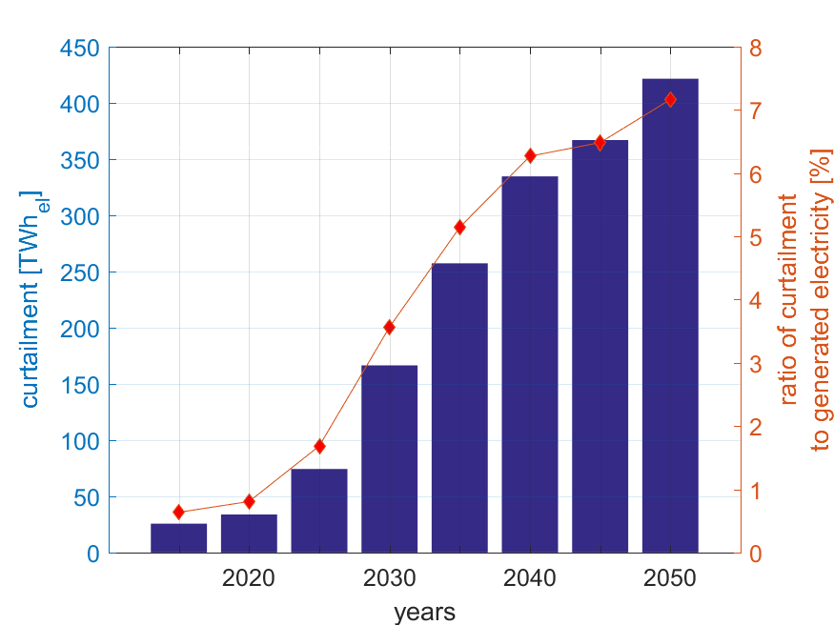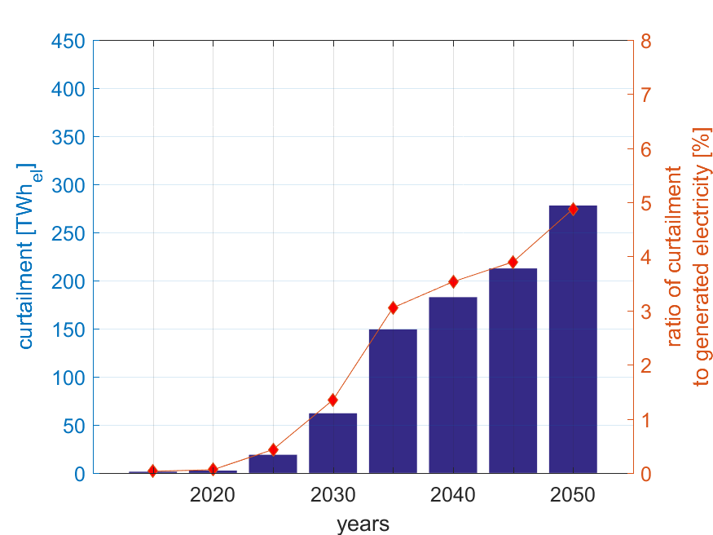
Figure A.1. Curtailed electricity from 2015 to 2050 for Europe for the Regions (left) and Area (right) scenarios.

Table A.20: Financial results from 2015 to 2050 for the Regions scenario.
 | LCOE  [€/MWh] | LCOE primary  [€/MWh] | LCOC  [€/MWh] | LCOS  [€/MWh] | LCOT  [€/MWh] | Total annualized cost  [b€]
2015 | 68.4 | 66.3 | 0.4 | 1.6 | 0 | 274
2020 | 65.8 | 58.9 | 0.5 | 6.4 | 0 | 276
2025 | 67.8 | 56.2 | 0.9 | 10.7 | 0 | 295
2030 | 66.3 | 51.2 | 1.8 | 13.3 | 0 | 302
2035 | 62.9 | 45.5 | 2.3 | 15.0 | 0 | 299
2040 | 59.9 | 41.5 | 2.6 | 15.8 | 0 | 299
2045 | 57.8 | 39.2 | 2.5 | 16.1 | 0 | 303
2050 | 55.8 | 37.3 | 2.5 | 16.0 | 0 | 302

Table A.21: Financial results from 2015 to 2050 for the Area scenario.
 | LCOE  [€/MWh] | LCOE primary  [€/MWh] | LCOC  [€/MWh] | LCOS  [€/MWh] | LCOT  [€/MWh] | Total annualized cost  [b€]
2015 | 68.5 | 66.4 | 0.0 | 1.5 | 0.5 | 274
2020 | 65.3 | 57.2 | 0.0 | 7.3 | 0.8 | 274
2025 | 64.3 | 51.1 | 0.2 | 10.5 | 2.5 | 280
2030 | 63.1 | 47.6 | 0.6 | 12.3 | 2.5 | 288
2035 | 58.9 | 41.7 | 1.2 | 13.2 | 2.8 | 281
2040 | 55.7 | 38.4 | 1.3 | 13.3 | 2.7 | 279
2045 | 53.4 | 36.6 | 1.3 | 13.0 | 2.5 | 280
2050 | 51.1 | 34.7 | 1.5 | 12.5 | 2.5 | 276

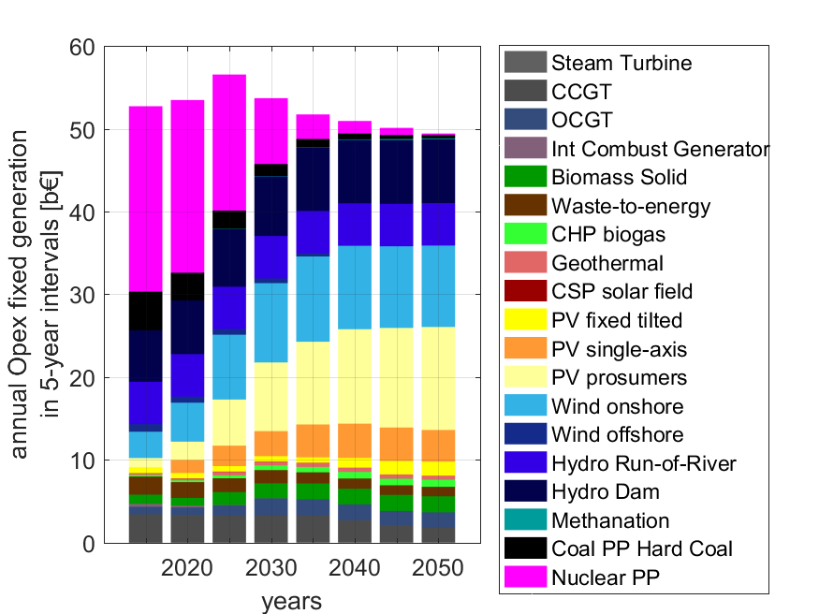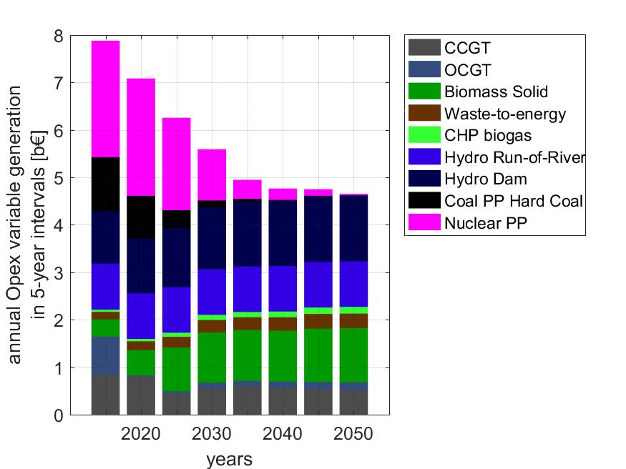
Figure A.2: Annual fixed (left) and variable (right) operations and maintenance costs from 2015 to 2050 for the Regions scenario.
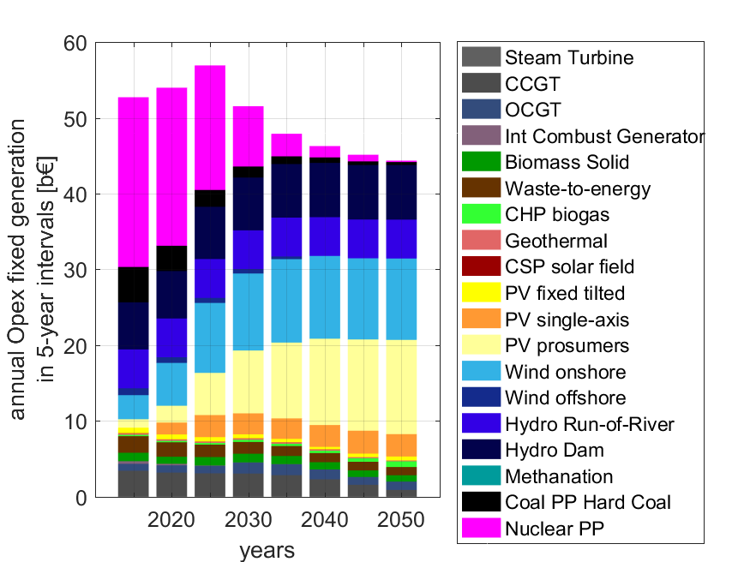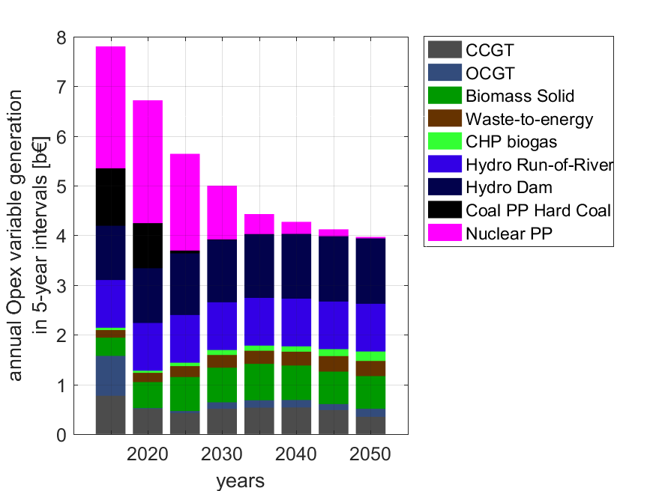
Figure A.3: Annual fixed (left) and variable (right) operations and maintenance costs from 2015 to 2050 for the Area scenario.
10
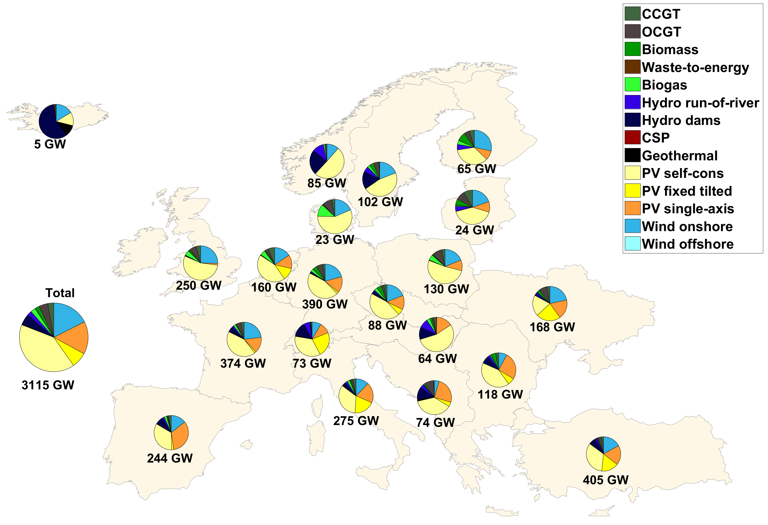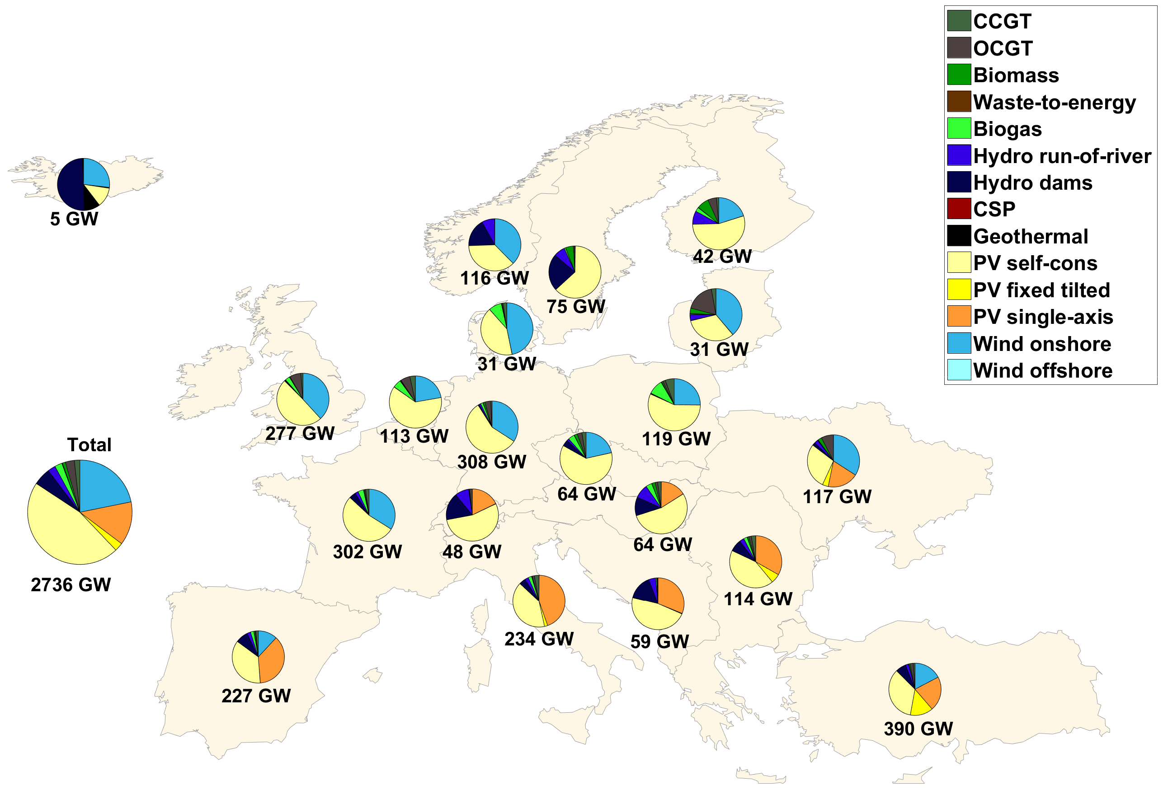
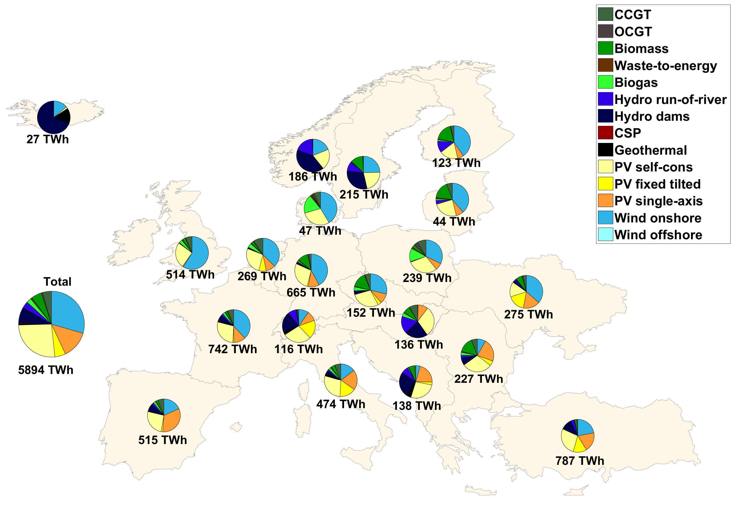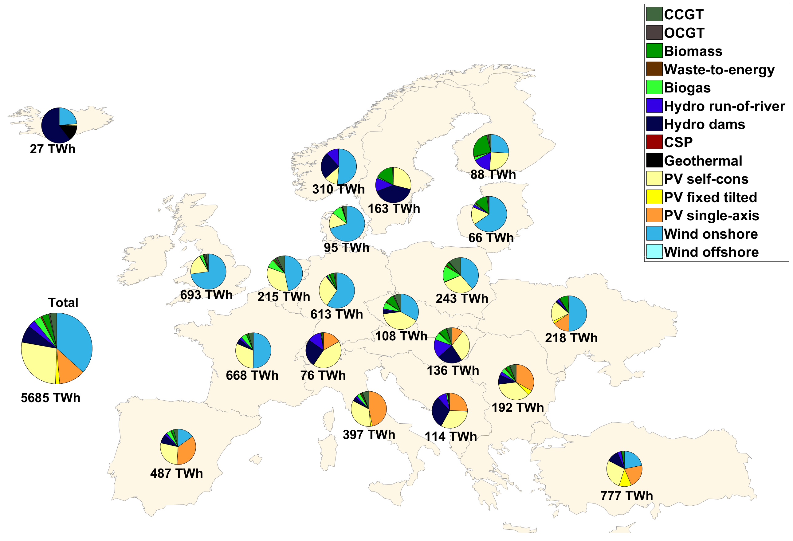
Figure A.4: Installed capacities (upper) and total generation (lower) for the Regions (left) and Area (right) scenarios for 2050.

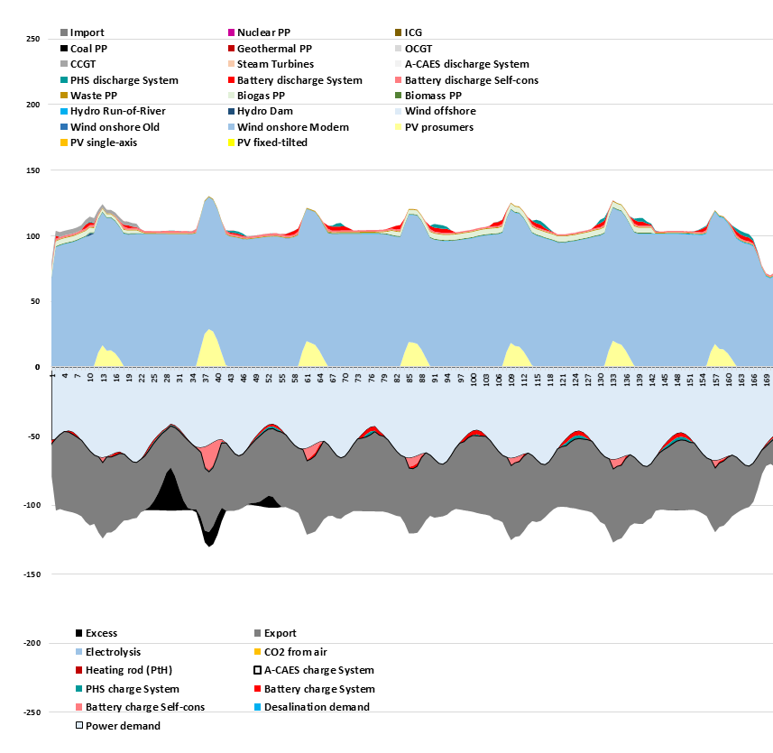
Figure A.5: Hourly profile of a representative winter period in the UK and Ireland in 2050. An example of a region with a high net export of wind power.
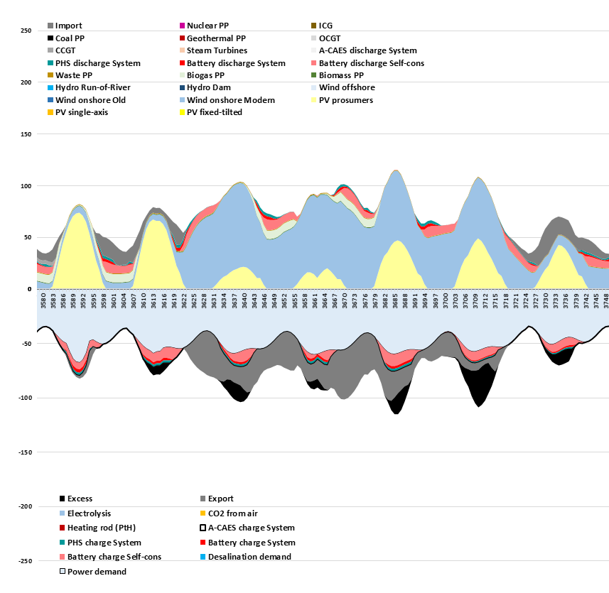
Figure A.6: Hourly profile of a representative summer period in Britain and Ireland in 2050. An example of a region with a high net export of wind power.

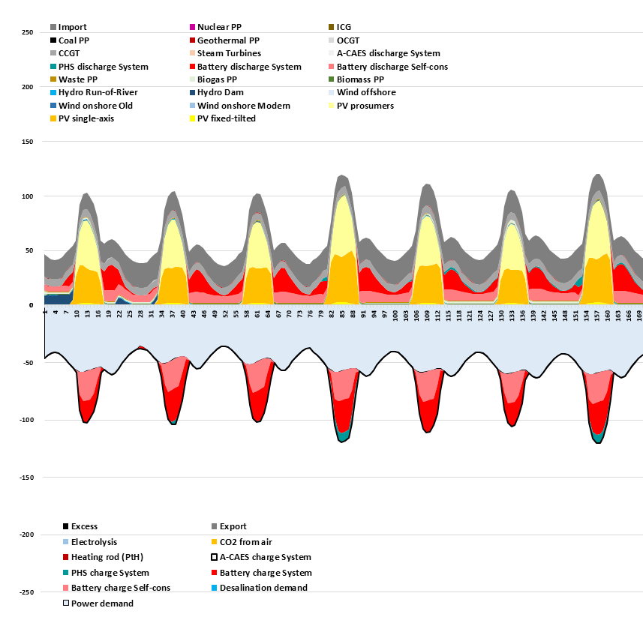
Figure A.7: Hourly profile of a representative winter period in Italy in 2050. An example of a region with a high net export of solar power.

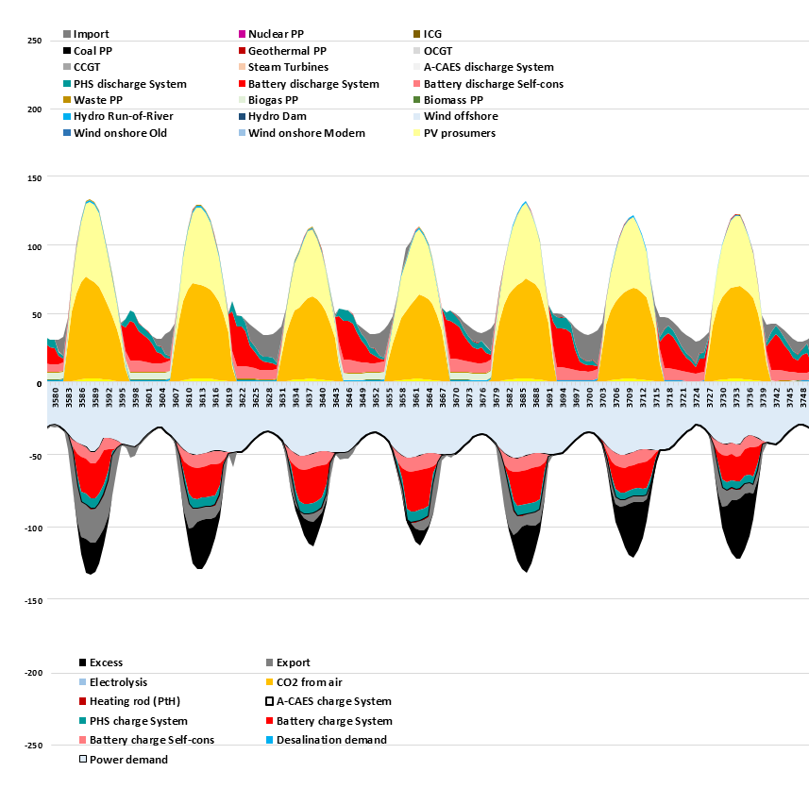
Figure A.8: Hourly profile of a representative summer period in the Italy in 2050. An example of a region with a high net export of solar power.
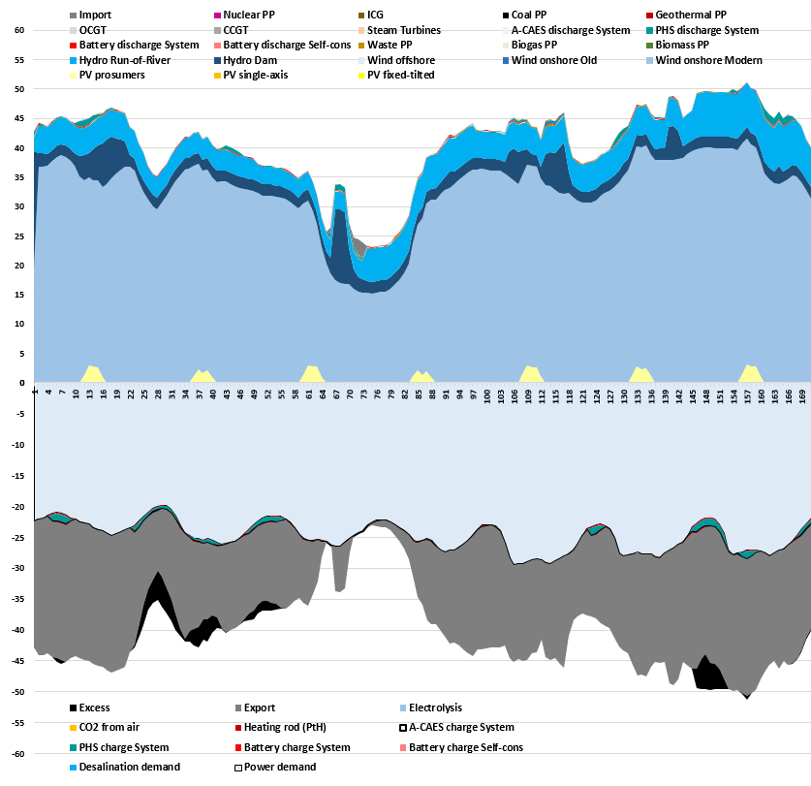
Figure A.9: Hourly profile of a representative winter period in Norway in 2050. An example of a region with a high net export of wind and hydropower.
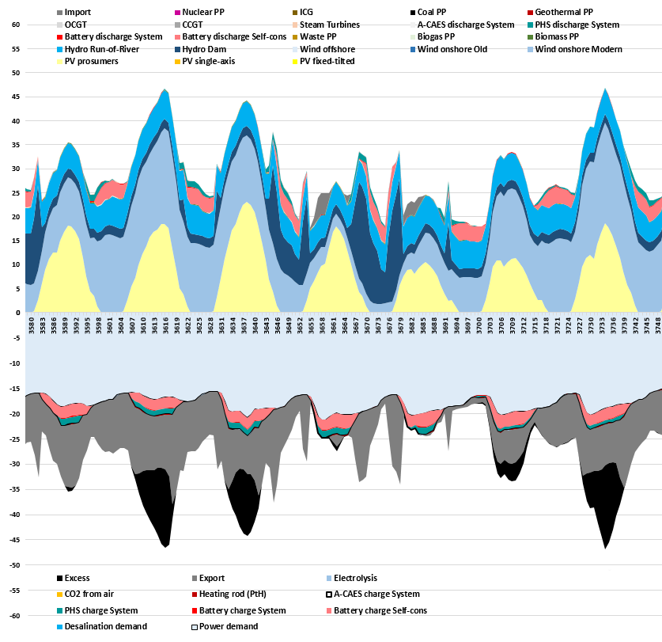
Figure A.10: Hourly profile of a representative summer period in Norway in 2050. An example of a region with a high net export of wind and hydropower.
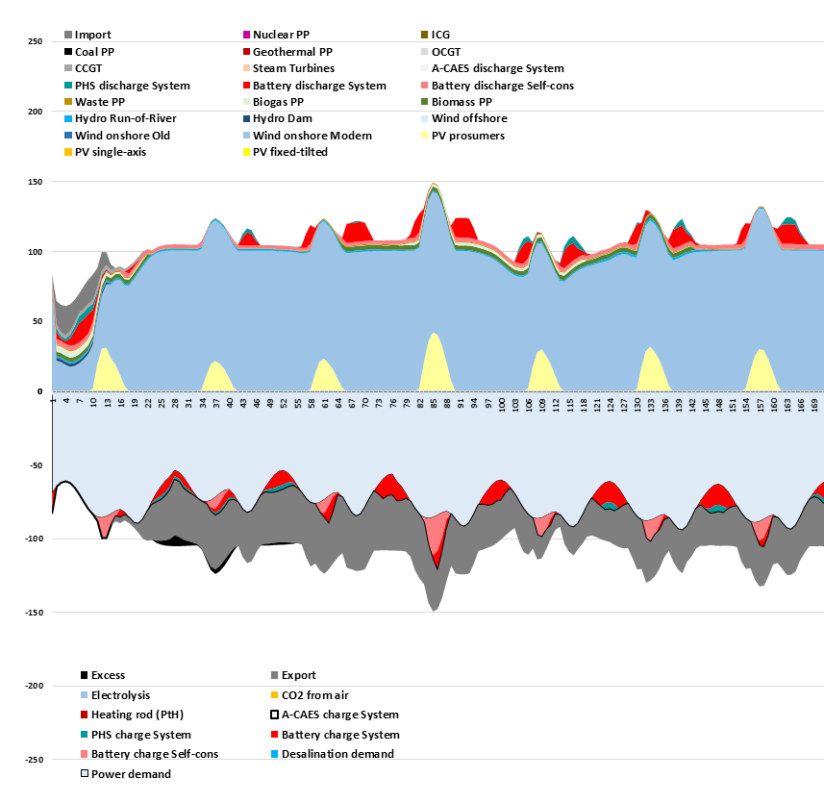
Figure A.11: Hourly profile of a representative winter period in Germany in 2050. An example of a large balancing region with a mix of several renewable resources.

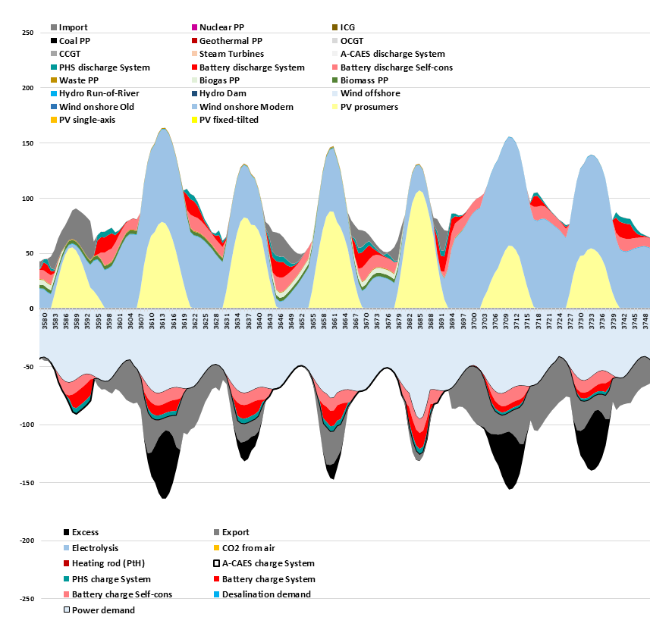
Figure A.12: Hourly profile of a representative summer period in Germany in 2050. An example of a large balancing region with a mix of several renewable resources.

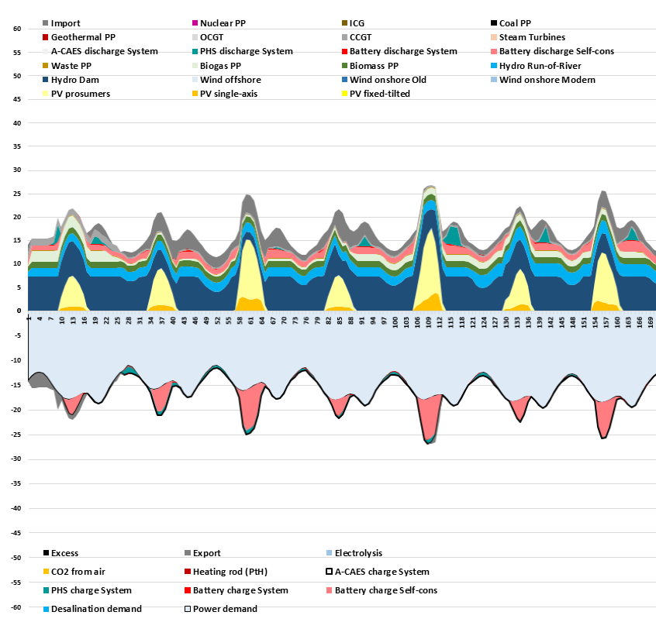
Figure A.13: Hourly profile of a representative winter period in Austria and Hungary in 2050. An example of a small balancing region.

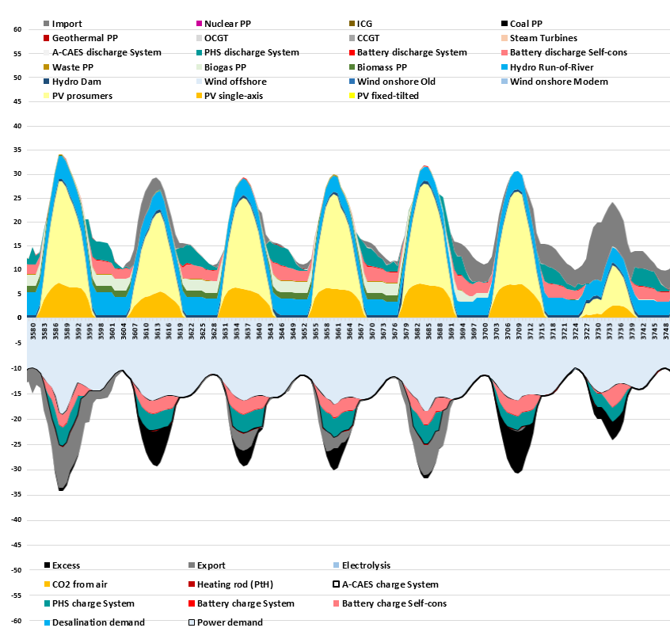
Figure A.14: Hourly profile of a representative summer period in Austria and Hungary in 2050. An example of a small balancing region.

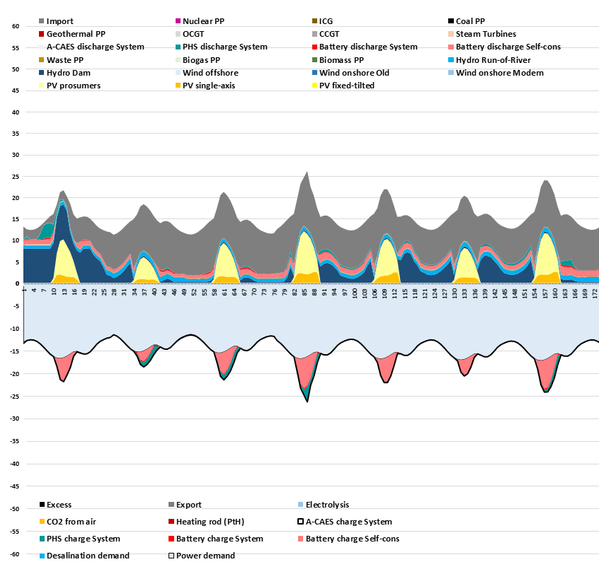
Figure A.15: Hourly profile of a representative winter period in Switzerland in 2050. An example of a net importing country.
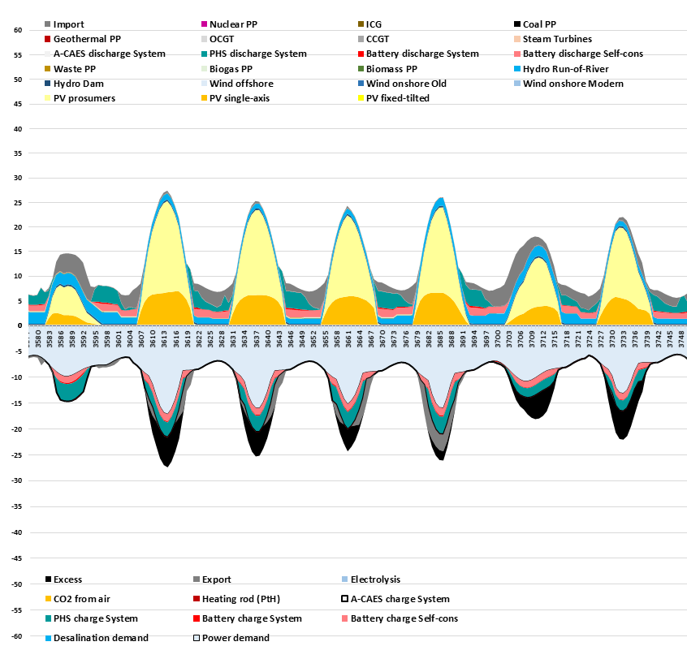Figure A.16: Hourly profile of a representative summer period in Switzerland in 2050. An example of a net importing country.

  - Table A22. Transmission line distances (km) and interconnections (MW) between regional electricity demand centers. Future HVDC interconnection capacities have no restrictions, but are determined be the model.
 | Land distance (km) | Sea distance (km) | Total (km) | A  Current Connection (MW) | B*  Future Potential (MW) | C**  Current HVDC (MW) | A-C***  Current HVAC (MW)
Oslo - Copenhagen | 546 | 5 | 550 | 950 | 1640 | 1700 | 0
Oslo - London | 866 | 529 | 1395 | 0 | 1400 | 0 | 0
Oslo -Amsterdam | 518 | 484 | 1002 | 0 | 700 | 700 | 0
Oslo - Stockholm | 468 | 0 | 468 | 3895 | 3995 | 0 | 3895
Stockholm - Helsinki | 234 | 184 | 419 | 2050 | 3200 | 1300 | 750
Stockholm - Riga | 209 | 246 | 455 | 0 | 700 | 700 | 0
Stockholm - Warsaw | 840 | 167 | 1008 | 600 | 600 | 600 | 0
Stockholm - Copenhagen | 578 | 5 | 582 | 2450 | 2440 | 550 | 1900
Helsinki - Riga | 330 | 66 | 396 | 350 | 1016 | 1000 | 0
Riga - Warsaw | 622 | 0 | 622 | 0 | 1000 | 500 | 0
Warsaw - Frankfurt | 981 | 0 | 981 | 1200 | 3000 | 0 | 1200
Warsaw - Prague | 569 | 0 | 569 | 2400 | 2400 | 0 | 2400
Warsaw - Kiev | 770 | 0 | 770 | 0 | 0 | 0 | 0
Copenhagen - Frankfurt | 706 | 29 | 735 | 2085 | 4000 | 600 | 1485
Frankfurt - Prague | 453 | 0 | 453 | 2300 | 2600 | 600 | 1700
Frankfurt - Amsterdam | 399 | 0 | 399 | 4830 | 8300 | 0 | 4830
Frankfurt - Zurich | 334 | 0 | 334 | 3500 | 4700 | 0 | 3500
Frankfurt - Paris | 529 | 0 | 529 | 3200 | 4800 | 0 | 3200
Amsterdam - London | 361 | 81 | 442 | 0 | 2000 | 1000 | 0
Amsterdam - Paris | 473 | 0 | 473 | 3400 | 4680 | 0 | 3400
London - Paris | 369 | 35 | 404 | 0 | 6100 | 2000 | 0
London - Reykjavik | 1159 | 838 | 1997 | 0 | 0 | 0 | 0
Paris - Madrid | 1161 | 0 | 1161 | 500 | 8000 | 2000 | 0
Paris - Zurich | 538 | 0 | 538 | 3200 | 3700 | 0 | 3200
Zurich - Rome | 752 | 0 | 752 | 1810 | 3860 | 0 | 1810
Zurich - Vienna | 670 | 0 | 670 | 1200 | 1700 | 0 | 1200
Prague - Vienna | 277 | 0 | 277 |  |  |  | 0
Vienna - Belgrade | 541 | 0 | 541 | 2200 | 7500 | 0 | 2200
Vienna - Kiev | 1164 | 0 | 1164 | 3400 | 5800 | 0 | 3400
Rome - Sofia | 1114 | 139 | 1253 | 0 | 0 | 0 | 0
Rome - Belgrade | 664 | 170 | 834 | 500 | 500 | 500 | 0
Sofia - Belgrade | 360 | 0 | 360 | 580 | 2730 | 0 | 580
Sofia - Kiev | 1123 | 0 | 1123 | 2100 | 3180 | 0 | 2100
Sofia - Istanbul | 556 | 0 | 556 | 0 | 0 | 0 | 0
Oslo-Frankfurt | 219 | 402 | 621 | 0 | 0 | 0 | 0
Stockholm-Frankfurt | 341 | 348 | 689 | 0 | 1400 | 0 | 0
Copenhagen-Amsterdam | 153 | 207 | 360 | 600 | 1315 | 600 | 0
Copenhagen-London | 267 | 271 | 538 | 0 | 700 | 0 | 0
Frankfurt-Vienna | 364 | 0 | 364 | 0 | 1400 | 0 | 0
Paris-Rome | 660 | 0 | 660 | 2200 | 7500 | 0 | 2200
Prague-Kiev | 733 | 0 | 733 | 2575 | 4350 | 0 | 2575
Vienna-Rome | 535 | 0 | 535 | 0 | 0 | 0 | 0
Vienna-Sofia | 519 | 0 | 519 | 285 | 1655 | 0 | 285
* The future potential of the Warsaw-Prague interconnection was reported as 1590 MW, a value below the current interconnection. For this reason, the current level of 2400 MW is maintained.
** Current HVDC interconnections are taken from the following sources: [22]–[24]
*** Values of 0 are assigned when calculated values are negative, or if the interconnection is known to be an undersea cable.

  - Equations used for levelised cost of electricity calculations (Adapted from [19]):
The total annualized cost of the system is calculated as the sum of all sectors costs Eq. (A1), which includes annualized capital cost and operational costs of all system elements Eq. (A2):

$${totalCost}_{sys}=elSysCost+elProsCost+heatSysCost+heatIndCost+transpSysCost+industrSysCost$$ | (A1)
$${totalCost}_{sys}=\sum_{t=1}^{tech}{\left({CAPEX}_{t}{∙crf}_{t}+{OPEXfix}_{t}\right)∙{Cap}_{t}+{OPEXvar}_{t}∙E_{gen,t}}$$ | (A2)
$${crf}_{t}= \frac{WACC∙{\left(1+WACC\right)}^{N_{t}}}{{\left(1+WACC\right)}^{N_{t}}-1}$$ | (A3)

Abbreviations: total annualized cost of the system (𝑡otalCost_{sys}), annualized cost of the centralized Power sector (elSysCost), annualized cost of the electricity prosumers sector (elProsCost), annualized cost of the centralized heat sector (heatSysCost), annualized cost of the individual heat sector (heatIndCost), annualized cost of the transportation sector (transpSysCost), annualized cost of the industrial sector (industrSysCost), all technologies (tech), technology (t), capital expenditures (CAPEX), capital recovery factor for technology t (crf_{t}) Eq. (30), annual fixed operational expenditures (OPEXfix), variable operational expenditures (OPEXvar), installed capacity of the technology t (Cap_{t}), annual output for the technology t (E_{gen,t}), weighted average cost of capital (WACC), lifetime for technology t (N_{t}).

Total levelized cost of electricity in the system (LCOEtotal) is calculated as the electricity demand weighted average of the centralized power system LCOE (LCOEsys) and prosumer sector LCOE (LCOEpros); the formula is presented in Eq. (A4). Centralized power system LCOE is comprised of levelized cost of consumed electricity (LCOEprim), levelized cost of storage (LCOS), levelized cost of curtailed electricity (LCOC), levelized cost of electricity transition (LCOT) and levelized cost of prosumer feed-in reimbursement (LCOFS), Eq. (A5). For the prosumer sector total LCOE is comprised of the levelized cost of consumed electricity (LCOEprim), levelized cost of storage (LCOS), and levelized cost of prosumer feed-in reimbursement (LCOFS), Eq. (A6). Levelized cost of generated electricity is calculated as the total annualized cost of the electricity generation system divided by total annual generation Eq. (A7). In this calculation, operational costs include costs of fuel and GHG emission cost per unit of generated electricity. The electricity generation systems also include part of the fuel production facilities, which are used for fuel production for power system generators. Levelized cost of consumed electricity is calculated based on the cost of the generated electricity (LCOEgen), excluding electricity lost due to curtailment, storage and transmission system losses Eq. (A8). Levelized cost of storage is calculated as the annualized cost of storage system equipment and annual cost of electricity losses divided by total electricity consumption Eq. (A9). Storage systems also include part of the fuel production facilities, which are used for fuel production for the storage system generators (e.g. for Power-to-Gas – Gas-to-Power). Levelized cost of curtailment is calculated as the annual cost of curtailed electricity divided by total electricity consumption Eq. (A10). Levelized cost of transmission is the calculated area total annualized cost of power grid equipment and annual cost of electricity losses divided by total electricity consumption, and multiplied by regional grid utilisation weights Eq. (A11), where regional grid utilisation weights are the average of regional shares of total export and import of energy Eq. (A12).

$${LCOEtotal}_{r}={(LCOEsys}_{r}∙{{El}_{consSys}}_{r}+{LCOEpros}_{r}∙{{El}_{consPros}}_{r})/({{El}_{consSys}}_{r}+{{El}_{consPros}}_{r})$$ | (A4)
$${LCOEsys}_{r}={LCOEprim}_{r}+{LCOS}_{r}+{LCOC}_{r}+{LCOT}_{r}+{LCOFS}_{r}$$ | (A5)
$${LCOEpros}_{r}={LCOEprim}_{r}+{LCOS}_{r}-{LCOFS}_{r}$$ | (A6)
$${LCOEgen}_{r}= \frac{\sum_{t=1}^{Gen}{\left({CAPEX}_{t}{∙crf}_{t}+{OPEXfix}_{t}\right)∙{Cap}_{t,r}+{OPEXvar}_{t}∙{El}_{gen,t,r}}}{{El}_{gen,r}}$$ | (A7)
$${LCOEprim}_{r}= \frac{{LCOEgen}_{r} ∙({El}_{gen,r}- {El}_{curt,r}-{El}_{storLoss,r}- {El}_{transLoss,r})}{{El}_{cons,r}}$$ | (A8)
$${LCOS}_{r}=(\sum_{t=1}^{Stor}{\left({CAPEX}_{t}{∙crf}_{t}+{OPEXfix}_{t}\right)∙{Cap}_{t,r}+{OPEXvar}_{t}∙E_{out,t,r}+ {LCOEgen}_{r}∙{El}_{storLoss,r}})/{El}_{cons,r}$$ | (A9)
$${LCOC}_{r}= \frac{{LCOEgen}_{r}∙{El}_{curt,r}}{{El}_{cons,r}}$$ | (A10)
$${LCOT}_{r}= {RegShare }_{r}∙(\sum_{r}^{Reg}{\sum_{t=1}^{trans}{\left({CAPEX}_{t}{∙crf}_{t}+{OPEXfix}_{t}\right)∙{Cap}_{t,r}+{OPEXvar}_{t}∙{El}_{out,t,r}+ {LCOEgen}_{r}∙{El}_{transLoss,r}}})/{El}_{cons,r}$$ | (A11)
$${RegShare }_{r}=0.5∙\frac{{Import}_{r}}{\sum_{r}{{Import}_{r}}}+0.5∙\frac{{Export}_{r}}{\sum_{r}{{Export}_{r}}}$$ | (A12)
$${LCOFS}_{r}= \frac{{feedInTarif}_{r}∙{El}_{prosTogrid,r}}{{El}_{cons,r}}$$ | (A13)

Abbreviations: region (r), total levelized cost of electricity in the system (LCOEtotal), centralized system levelized cost of electricity (LCOEsys), prosumer sector levelized cost of electricity (LCOEpros), centralized system electricity consumption (El_{consSys}), prosumer sector electricity consumption (El_{consPros}), consumed electricity LCOE (LCOEprim), levelized cost of stored electricity (LCOS), levelized cost of curtailed electricity (LCOC), levelized cost of prosumer feed-in reimbursement (LCOFS), generated electricity LCOE (LCOEgen), power generation technologies (Gen), storage technologies (Stor), power transmission technologies (trans), technology (t), capital expenditures (CAPEX), capital recovery factor for technology t (crf_{t}) , annual fixed operational expenditures (OPEXfix), variable operational expenditures (OPEXvar), installed capacity of the technology t (Cap_{t}), annual output for the technology t (El_{gen,t}), annual electricity generation (El_{gen}), annual electricity curtailment (El_{curt}), annual storage loss (El_{storLoss}), annual grid loss (El_{transLoss}), annual electricity consumption (El_{cons}), annual output of storage t (E_{out,t}), annual export of grid technology t (El_{out,t}), electricity exported by region r (Export), electricity imported by region r (Import), feed-in reimbursement (feedInTarif), electricity sold by prosumers to the grid (EL_{prosTogrid}).

  - References

[1] G. Pleßmann, M. Erdmann, M. Hlusiak, and C. Breyer, “Global energy storage demand for a 100% renewable electricity supply,” Energy Procedia, vol. 46, pp. 22–31, 2014.
[2] J. Carlsson, Energy Technology Reference Indicator 2014. LE Petten: European Commission Joint Research Centre, 2014. Available: https://setis.ec.europa.eu/system/files/ETRI 2014.pdf
[3] E. Vartiainen, G. Masson, and C. Breyer, “PV LCOE in Europe 2015 - 2050,” in 31st European Photovoltaic Solar Energy Conference, Hamburg, September 14-18, 2015. Available: https://www.researchgate.net/publication/281939918_PV_LCOE_in_Europe_2015-2050
[4] Fraunhofer ISE, “Current and Future Cost of Photovoltaics. Long-term Scenarios for Market Development, System Prices and LCOE of Utility-Scale PV systems,” Berlin, 2015. [Online]. Available: http://www.fvee.de/fileadmin/publikationen/weitere_publikationen/15_AgoraEnergiewende-ISE_Current_and_Future_Cost_of_PV.pdf. [Accessed: 12-Oct-2016].
[5] L. Neij, “Cost development of future technologies for power generation-A study based on experience curves and complementary bottom-up assessments,” Energy Policy, vol. 36, no. 6, pp. 2200–2211, 2008.
[6] J. E. Haysom, O. Jafarieh, H. Anis, K. Hinzer, and D. Wright, “Learning curve analysis of concentrated photovoltaic systems,” Prog. Photovoltaics Res. Appl., vol. 23, no. 11, pp. 1678–1686, 2015.
[7] C. Kutscher, M. Mehos, C. Turchi, G. Glatzmaier, and T. Moss, “Line-Focus Solar Power Plant Cost Reduction Plan,” Golden, 2010.
[8] B. Sigfusson and A. Uihlein, 2014 JRC Geothermal Energy Status Report. 2015.
[9] Agora Energiewende, “Stromspeicher in der Energiewende,” Berlin, 2014.
[10] C. Breyer, E. Tsupari, V. Tikka, and P. Vainikka, “Power-to-gas as an emerging profitable business through creating an integrated value chain,” Energy Procedia, vol. 73, pp. 182–189, 2015.
[11] International Energy Agency, “World Energy Investment Outlook,” Paris, 2014.
[12] J. Koomey and N. E. Hultman, “A reactor-level analysis of busbar costs for US nuclear plants, 1970-2005,” Energy Policy, vol. 35, no. 11, pp. 5630–5642, 2007.
[13] International Energy Agency, “World Energy Outlook,” International Energy Agency, Paris, 2015.
[14] International Energy Agency and Nuclear Energy Agency, “Projected costs of generating electricity,” Paris, 2015. Available: https://www.oecd-nea.org/ndd/pubs/2015/7057-proj-costs-electricity-2015.pdf
[15] F. Zickfeld and A. Wieland, “Perspectives on a Sustainable Power System for EUMENA. Desert Power 2050,” Munich, 2012.
[16] C. Breyer and A. Gerlach, “Global overview on grid-parity,” Progress in Photovoltaics: Research and Applications, vol. 21, no. 1. pp. 121–136, 2013.
[17] A. Gerlach, C. Breyer, and C. Werner, “Impact of financing cost on global grid-parity dynamics till 2030,” in 29th European Photovoltaic Solar Energy Conference, Amsterdam, September 22-26, 2014.DOI: 10.4229/29thEUPVSEC2014-7DO.15..
[18] J. Farfan and C. Breyer, “Structural changes of global power generation capacity towards sustainability and the risk of stranded investments supported by a sustainability indicator,” J. Clean. Prod., vol. 141, pp. 370–384, 2016.
[19] D. Bogdanov and C. Breyer, “North-East Asian Super Grid for 100% renewable energy supply: Optimal mix of energy technologies for electricity, gas and heat supply options,” Energy Convers. Manag., vol. 112, pp. 176–190, 2016.
[20] B. Elbersen, I. Startisky, G. Hengeveld, M.-J. Schelhaas, and H. Naeff, “Atlas of EU biomass potentials,” 2012. Available: https://ec.europa.eu/energy/intelligent/projects/sites/iee-projects/files/projects/documents/biomass_futures_atlas_of_technical_and_economic_biomass_potential_en.pdf
[21] K. Bunzel, V. Zeller, M. Buchhorn, F. Griem, and D. Thrän, “Regionale und globale räumliche Verteilung von Biomassepotenzialen,” German Biomass Research Center, Leipzig, 2009. Available: https://www.uni-hohenheim.de/organisation/projekt/regionale-und-globale-raeumliche-verteilung-von-biomassepotenzialen-status-quo-und-moeglichkeiten-der-praezisierung
[22] ABB, “HVDC References,” 2018. [Online]. Available: https://new.abb.com/systems/hvdc/references. [Accessed: 12-Jan-2018].
[23] Siemens AG, “High-voltage direct current transmission,” 2017. [Online]. Available: https://www.energy.siemens.com/co/pool/hq/power-transmission/HVDC/HVDC-Classic/HVDC-Classic_Transmission_References_en.pdf. [Accessed: 12-Jan-2018].
[24] Interconnexion France-Angleterre, “Assets,” 2018. [Online]. Available: http://ifa1interconnector.com/about-us/assets/. [Accessed: 12-Jan-2018].

