**Supplementary materials**

# Using crop data from crop simulation models

The yield functions in the bio-economic model are taken from the simulations of CropSyst and DSSAT models. These models were calibrated with the data on crop experiments conducted by national research institutes in Central Asia was obtained in order to calibrate the crop simulation models (Kato and Nkonya, 2012; Sommer *et al.*, 2012). The location of the calibration sites is provided in Figure SM1.

The low input use management option in the case of wheat may indicate fertilizer usage with the range of 0-80 kg and irrigation water use in range of 0-120 mm depending on the farming system. For example, farmers in northern Kazakhstan do not irrigate crops (rainfed based) and use very limited nitrogen fertilizer. In contrast farmers in western Uzbekistan use very high amounts of irrigation water and fertilizer. This information was obtained from farm survey results as well as secondary data sources and expert interviews and was considered in crop simulation models. The crop simulation models were calibrated based on the field level experimental data as well as with the input use data from the household surveys.

Table SM1

Crop management options

|  |  |  |
| --- | --- | --- |
| Management options | crop | Description |
| Low input levels | wheat | 0-80 kg ha-1 of fertilizer, 0-120 mm of irrigation water depending on AEZ (without irrigation under rainfed conditions) |
|  | cotton | 100-120 kg ha-1 fertilizer depending on AEZ |
|  | potato | 100-120 kg ha-1 fertilizer depending on AEZ |
| Average input levels | wheat | 25-30% more fertilizer (depending on the country), 30-50% more water than low input level management option |
|  | cotton | 5 tons ha-1of organic fertilizer |
|  | potato | 5 tons ha-1of organic fertilizer |
| High input levels | wheat | 40-50% more fertilizer (depending on a country), 60-70% more water than low input management option |
|  | cotton | 50% more fertilizer than low input level management option |

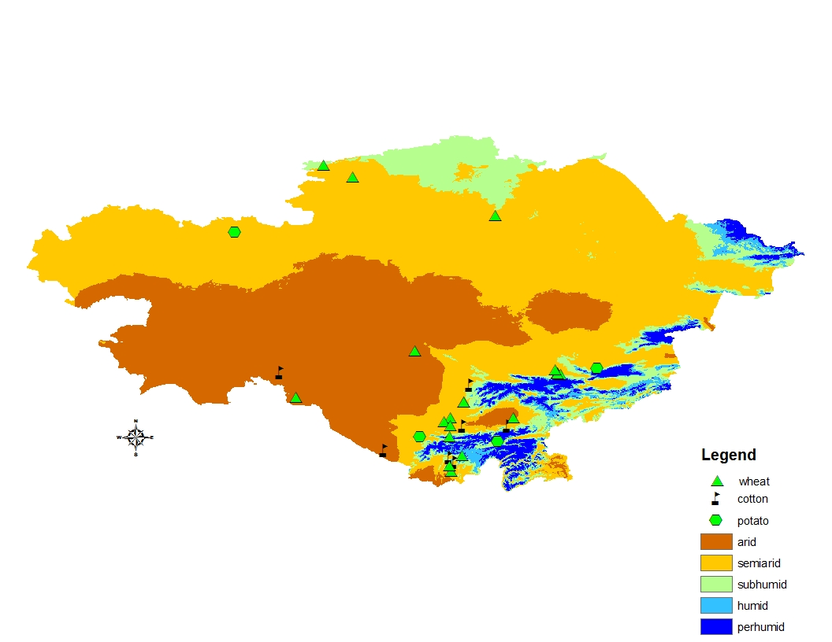

**Fig. SM1.** The location of the crop experimental stations

*Source: Illustrated based on* *Sommer et al. (2012**),* *Kato and Nkonya (2012**)*

**Fig. SM2.** Fertilizer (N) application rates in all farming systems

# Consideration of yield and price risk in the objective function

The stochastic variables in the model are crop yields and output prices and the expected income of the farm *E(Y)* in equation 1 can be written as (Anderson et al., 1977):

 (3)

Where,

 is expected price of commodity *i*

 is the expected yield from *ith* activity

 is the input level (e.g. water application, fertilizer use),

 is the variable cost of production (fertilizer, labor, fuel and machinery)

 is the fixed costs

 is the crop area expressed in hectares.

The variance of the income ( in the equation 1 can be approximated according to Anderson et al. (1977) as:

 (4)

The expected yields () and standard deviation of yields are often estimated from the historical observations. However, historical yields cannot be considered as representative for the future under climate change scenarios when precipitation and temperature is expected to be different than that observed in the past (Hardaker and Lien, 2010). Therefore, the expected yields and standard deviation of yields are obtained from the results of the crop simulation models for each crop under different crop management options discussed in the previous section. Only there points in the production function  is considered in the simulations: low, average and high input use intensities as mentioned in the previous section and Fig. 3.

Several constraints considered in the optimization process are availability of fertilizer (), water () and minimal crop area (e.g. state procurement) for cotton () and wheat () in Uzbekistan:

 (5)

 (6)

 (7)

 (8)

where,  is the input use coefficient for crop *i* under management level k (low, average and high),  is the area of crop i under management level k,  the area under cotton in Uzbekistan and  is the area under wheat in Uzbekistan.

Long-term price and country level production data in equations 3 and 4 are compiled from international (FAO) (<http://faostat.fao.org/>) and national statistical committees ([www.stat.uz](http://www.stat.uz), [www.stat.kz](http://www.stat.kz), [www.stat.tj](http://www.stat.tj), [www.stat.kg](http://www.stat.kg)) to estimate the variability of commodity prices and price-yield covariance in the model. The price-yield correlations in the model are in the range of -0.2 and -0.4. Variable costs of production under present conditions were estimated from the household survey data.

# Model calibration and sensitivity tests

The optimization model is calibrated by adjusting the risk aversion parameter  in equation 1 (Howitt, 1995; Heckelei, 2002). The model is calibrated to the observed crop allocation in each of the agro-ecological zones considered. Moreover, policies such as state procurement for cotton and wheat in Uzbekistan are incorporated in the model as constraints in the face of which the optimization should take place. The main reason for introducing the state order constraint is to capture allocation of crops with lower income (or higher risk) due to certain policy restrictions which will not be planted otherwise (Bobojonov *et al.*, 2010; Djanibekov *et al.*, 2012).

The tables below provide sensitivity of the model results to the varying levels of the risk aversion parameter. Wide range of values for the risk aversion tested and only 3 levels presented below. The selected risk aversion parameter indicates the value of the risk aversion found as “optimal” to produce observed cropping patterns.

**Table SM2**

Risk aversion parameter range considered in the simulations

|  |  |  |  |  |  |  |  |  |  |  |
| --- | --- | --- | --- | --- | --- | --- | --- | --- | --- | --- |
|  | Kazakhstan | | | Kyrgyzstan | | Tajikistan | | | Uzbekistan | |
|  | Arid | Semiarid | Subhumid | semiarid | subhumid | Arid | Semiarid | Humid | Arid | Semiarid |
| Lower risk aversion | 3,5E-05 | 0,00003 | 3,5E-07 | 0,0005 | 0,0001 | 0,00005 | 0,0005 | 0,0005 | 0,00005 | 0,00005 |
| Current level | 0,00007 | 0,00006 | 7E-07 | 0,001 | 0,0002 | 0,0001 | 0,001 | 0,001 | 0,0001 | 0,0001 |
| Higher risk aversion | 0,0001 | 8,9E-05 | 1E-06 | 0,00148 | 0,0003 | 0,00015 | 0,00148 | 0,00148 | 0,00015 | 0,00015 |

**Table SM3**

Total cropped area under different risk aversion levels, ha

|  |  |  |  |  |  |  |  |  |  |  |
| --- | --- | --- | --- | --- | --- | --- | --- | --- | --- | --- |
|  | Kazakhstan | | | Kyrgyzstan | | Tajikistan | | | Uzbekistan | |
|  | Arid | Semiarid | Subhumid | semiarid | subhumid | Arid | Semiarid | Humid | Arid | Semiarid |
| Lower risk aversion | 28 | 77 | 773 | 5,1 | 5,1 | 4,1 | 4,6 | 2,1 | 27,1 | 34,1 |
| Current level | 28 | 77 | 773 | 5,1 | 5,1 | 4,1 | 4,6 | 2,0923 | 27,1 | 34,1 |
| Higher risk aversion | 28 | 77 | 773 | 5,1 | 5,1 | 4,1 | 4,6 | 1,9863 | 27,1 | 34,1 |

*Note: see table SM3 for the values of risk aversion parameter*

**Table SM4**

CE under different risk aversion parameters, thousand USD per farm

|  |  |  |  |  |  |  |  |  |  |  |
| --- | --- | --- | --- | --- | --- | --- | --- | --- | --- | --- |
|  | Kazakhstan | | | Kyrgyzstan | | Tajikistan | | | Uzbekistan | |
|  | Arid | Semiarid | Subhumid | semiarid | subhumid | Arid | Semiarid | Humid | Arid | Semiarid |
| Lower risk aversion | 11,50 | 52,63 | 101,12 | 3,06 | 3,71 | 2,29 | 0,65 | 0,93 | 12,77 | 25,03 |
| Current level | 10,23 | 42,63 | 99,87 | 2,61 | 3,38 | 2,19 | 0,51 | 0,78 | 11,33 | 16,13 |
| Higher risk aversion | 9,08 | 36,85 | 98,68 | 2,31 | 3,07 | 2,10 | 0,41 | 0,66 | 10,05 | 12,21 |

*Note: see table SM3 for the values of risk aversion parameter*

The simulation results show that the selected risk aversion levels could be considered as “average” levels in all considered farming systems.

# Output and input costs differences: market liberation scenario

CIS countries have established several regional cooperation organizations in order to develop economic cooperation between these states. There is a very long list of regional organizations and several ones are expected to be established in the future (Pomfret, 2005; UNDP, 2005; ADB, 2006). The regional cooperation organizations could play an important role in improving economic cooperation and trade between the states. Furthermore, the regional cooperation could also facilitate the cumbersome transit bureaucracy between the countries, which could also increase the trade between non-CIS countries. However, the impacts of these organizations have been minimal in the past two decades and challenges associated with transportation remains unsolved (ADB, 2006). The fear that these organizations could become more political was one of the reasons for the failure of a wide number of regional agreements and cooperations (UNDP, 2005).

Furthermore, ethnic disputes and political problems between the states have negative impacts on trade of agricultural commodities between the countries. For example, ethnic violence against Uzbeks living in southern Kyrgyzstan that happened in June 2010 had negative impacts not only on food security in the country but also damaged trade relations of the country. The violence has displaced more than 350 thousand people in the country and more than 100 thousand crossed the border to Uzbekistan. The violence which continued for several weeks showed its negative impact on food security for several months (FAO and WFP, 2010 ). Closing the borders of Kazakhstan and Uzbekistan during this violent period reduced the flour and wheat imports to incredibly low levels and caused extremely high prices in Kyrgyzstan (Barrows and Gusev, 2010). The large scale mills and bakeries stopped operations due to the lack of wheat and flour associated with damage to the import infrastructure during the violence. The negative effect continued for several years also due to complications associated with the trade activities transiting Uzbekistan.

In addition to the ethnic disputes, resource related political disagreements also put much pressure on the function of agricultural commodity exchange between the countries. One of the examples could be given in case of Uzbek and Tajik political disputes over construction of the Rogun dam in Tajikistan. Uzbekistan is opposing the construction of the dam since the Uzbek government argues that it will reduce water availability in downstream regions especially during the summer periods (Eshchanov et al., 2011). The blockage of construction material transiting though Uzbekistan to Tajikistan has occurred some years which also resulted in negative impacts on trade of agricultural goods. This political dispute reduced the trade potential between these two countries. For example, Uzbekistan exports grain to Azerbaijan and could also export grain to Tajikistan in years when RUK countries have production shortfall or export restrictions if political disputes did not hinder this option. This could also function as risk minimization policy for Tajikistan since production risks are not correlated between Uzbekistan and RUK. USAID (2011) discusses complaints of the traders from Tajikistan about the complications of buying grain from Uzbekistan which gives disincentives to the traders.

Trade limitation cause substantial differences in input prices between the regions. Highest input prices are found in Tajikistan. One of the main reasons for this problem could be explained by landlocked location of Tajikistan and transportation problems caused by transboundary water use disputes with Uzbekistan. Cheapest input costs are found in Kazakhstan.

**Fig. SM4.** Input price differences between the regions

**Fig. SM5.** Farm gate output price differences between the regions

# Model results

This section provides more detailed information about the farm level crop allocation and management intensity levels for all considered agro-ecological zones and scenarios.

**Table SM5**

Change in crop areas under different scenarios, ha

|  |  |  |  |  |  |  |  |  |  |
| --- | --- | --- | --- | --- | --- | --- | --- | --- | --- |
|  |  | Normal water availability | | | | 30% water reduction | | | |
|  | base | A1b | A1b | A2 | A2 | A1b | A1b | A2 | A2 |
|  | 2010-2040 | 2070-2100 | 2010-2040 | 2070-2100 | 2010-2040 | 2070-2100 | 2010-2040 | 2070-2100 |
| Kazakhstan arid | | |  |  |  |  |  |  |  |
| wheat low |  |  |  |  |  |  |  |  | 0,01 |
| wheat average | 6,07 | 6,07 | 6,07 | 6,07 | 6,07 | 17,58 | 17,72 | 19,18 | 19,39 |
| wheat high | 21,94 | 21,94 | 21,94 | 21,94 | 21,94 | 9,4 | 9,34 | 8,69 | 8,59 |
| total | 28 | 28 | 28 | 28 | 28 | 26,99 | 27,06 | 27,87 | 28 |
| Kazakhstan semiarid | | |  |  |  |  |  |  |  |
| cotton low | 8,88 | 4,85 | 3,62 | 5,74 | 3,71 | 2,26 | 1,39 | 3,62 | 1,42 |
| wheat low | 20,3 | 19,93 | 22,52 | 20,04 | 24,92 | 21,84 | 24,4 | 22 | 26,76 |
| potato low | 6,44 | 7,54 | 7,88 | 5,93 | 7,84 | 6,85 | 7,27 | 5,48 | 7,21 |
| wheat average | 24,08 | 23,57 | 22,86 | 23,19 | 21,95 | 25,1 | 24,42 | 24,73 | 23,51 |
| potato average | | 0,87 | 1,15 | 1,09 | 1,19 | 0,83 | 1,11 | 1,07 | 1,15 |
| cotton high |  | 1,58 | 2,04 | 2,41 | 1,94 |  |  | 0,05 |  |
| wheat high | 17,3 | 18,67 | 16,94 | 18,59 | 15,46 | 20,12 | 18,41 | 20,05 | 16,95 |
| total | 77 | 77 | 77 | 77 | 77 | 77 | 77 | 77 | 77 |
| Kazakstan subhumid | | |  |  |  |  |  |  |  |
| wheat low | 422,44 | 422,44 | 422,44 | 422,44 | 422,44 | 422,44 | 422,44 | 422,44 | 422,44 |
| wheat average | 350,56 | 350,56 | 350,56 | 350,56 | 350,56 | 350,56 | 350,56 | 350,56 | 350,56 |
| total | 773 | 773 | 773 | 773 | 773 | 773 | 773 | 773 | 773 |
| Kyrgyzstan semiarid | | |  |  |  |  |  |  |  |
| cotton low |  | 0,45 |  | 0,15 |  |  |  |  |  |
| wheat low | 0,68 | 0,64 | 0,9 | 0,67 | 0,97 | 2,05 | 1,77 | 2,06 | 1,82 |
| wheat average | 2,23 | 1,99 | 2,07 | 2,02 | 2,04 | 1,52 | 1,42 | 1,52 | 1,4 |
| cotton high |  | 0,04 |  | 0,26 |  |  |  |  |  |
| wheat high | 2,2 | 1,98 | 2,13 | 2 | 2,09 | 0,99 | 1,22 | 0,98 | 1,2 |
| total | 5,1 | 5,1 | 5,1 | 5,1 | 5,1 | 4,55 | 4,4 | 4,56 | 4,43 |
| Kyrgyzstan subhumid | | |  |  |  |  |  |  |  |
| wheat low | 4 | 4 | 4 | 4 | 4 | 2,05 | 2,05 | 2,05 | 2,05 |
| potato low | 1,1 | 0,84 | 0,77 | 0,76 | 0,79 | 0,84 | 0,77 | 0,76 | 0,79 |
| potato average | | 0,27 | 0,33 | 0,35 | 0,32 | 0,27 | 0,33 | 0,35 | 0,32 |
| total | 5,1 | 5,1 | 5,1 | 5,1 | 5,1 | 3,16 | 3,16 | 3,16 | 3,16 |
| Tajikistan arid | | |  |  |  |  |  |  |  |
| cotton low | 3,15 | 1,32 |  | 1,07 |  | 0,47 |  | 0,45 |  |
| potato low |  |  | 0,02 |  | 0,02 |  |  |  |  |
| cotton average | | 1,58 |  | 1,82 |  | 0,83 |  | 1,28 |  |
| potato average | |  | 0,02 |  | 0,02 |  |  |  |  |
| cotton high |  | 0,56 | 2,72 | 0,56 | 2,12 | 0,54 | 2,17 |  | 2,12 |
| wheat high | 0,95 | 0,65 | 0,46 | 0,65 | 0,95 | 1,56 | 0,91 | 1,77 | 0,95 |
| potato high | 4,1 | 4,1 | 3,21 | 4,1 | 3,11 | 3,39 | 3,09 | 3,49 | 3,08 |
| Tajikistan semiarid | | |  |  |  |  |  |  |  |
| cotton low | 0,33 |  |  |  |  |  |  |  |  |
| wheat low | 0,79 | 1,22 | 1,03 | 1,26 | 1,1 | 0,93 | 0,96 | 0,96 | 1,1 |
| wheat average | 1,72 | 1,6 | 1,64 | 1,53 | 1,68 | 1,74 | 1,67 | 1,67 | 1,68 |
| potato average | |  |  |  |  |  |  |  |  |
| cotton high |  | 0,4 | 0,31 | 0,4 | 0,1 | 0,28 | 0,28 | 0,28 | 0,1 |
| wheat high | 1,76 | 1,37 | 1,63 | 1,41 | 1,72 | 1,65 | 1,69 | 1,68 | 1,72 |
| total | 4,6 | 4,6 | 4,6 | 4,6 | 4,6 | 4,6 | 4,6 | 4,6 | 4,6 |
| Tajikistan humid | | |  |  |  |  |  |  |  |
| potato low | 1,42 | 1,44 | 1,42 | 1,42 | 1,38 | 0,97 | 0,93 | 0,94 | 0,88 |
| wheat average | |  |  |  | 0,02 |  |  |  | 0,14 |
| wheat high | 0,67 | 0,62 | 0,68 | 0,68 | 0,7 | 0,53 | 0,64 | 0,63 | 0,69 |
| total | 2,09 | 2,06 | 2,1 | 2,1 | 2,1 | 1,51 | 1,58 | 1,57 | 1,71 |
| Uzbekistan arid | | |  |  |  |  |  |  |  |
| cotton low | 14,91 | 8,19 | 9,33 | 10,16 | 13,32 | 7,09 | 7,59 | 8,81 | 10,35 |
| cotton average | | 3,67 | 2,56 | 1,39 |  | 2,67 | 0,81 | 0,04 |  |
| wheat average | 2,33 | 5,22 | 5,2 | 5,6 | 3,51 |  |  |  |  |
| cotton high |  | 3,04 | 3,02 | 3,36 | 1,59 | 7,15 | 6,5 | 8,06 | 4,56 |
| wheat high | 9,86 | 6,97 | 6,99 | 6,6 | 8,69 | 5,42 | 6,44 | 5,42 | 6,44 |
| total | 27,1 | 27,1 | 27,1 | 27,1 | 27,1 | 22,33 | 21,34 | 22,33 | 21,34 |
| Uzbekistan semiarid | | |  |  |  |  |  |  |  |
| cotton low | 18,76 | 9,03 | 17,34 | 7,83 | 17,82 | 5,89 | 11,11 | 4,74 | 16,79 |
| wheat low |  |  |  |  |  |  |  |  | 3,08 |
| potato low | 4,76 | 4,91 | 5,17 | 4,9 | 4,87 | 3,2 | 3,18 | 3,19 | 2,76 |
| cotton average | | 7,5 |  | 8,57 |  | 4,93 |  | 6,22 |  |
| wheat average | | 1,15 | 0,3 | 1,41 |  |  |  |  | 0,42 |
| cotton high |  | 2,23 | 1,42 | 2,36 | 0,93 | 7,93 | 7,65 | 7,8 | 1,96 |
| wheat high | 10,58 | 9,01 | 9,88 | 8,76 | 10,48 | 8,42 | 8,55 | 8,48 | 9,08 |
| total | 34,1 | 33,82 | 34,1 | 33,82 | 34,1 | 30,38 | 30,48 | 30,43 | 34,1 |

# Scenario simulation with water availability levels

Sensitivity of the considered farms to different water availability level is simulated. X axes indicate the water availability levels in figures below. Some farms (e.g. located in the subhumid zones of Kazakhstan, the semiarid zones of Tajikistan) show less reduction of their revenues under reduction of water availability levels to high contribution of rainfall to the water requirement of crops. In contrast farms located in the arid and semiarid zones in Uzbekistan show very high reduction of their revenues under declining water availability levels. Similar decline is also seen in case of semiarid regions of Kyrgyzstan.

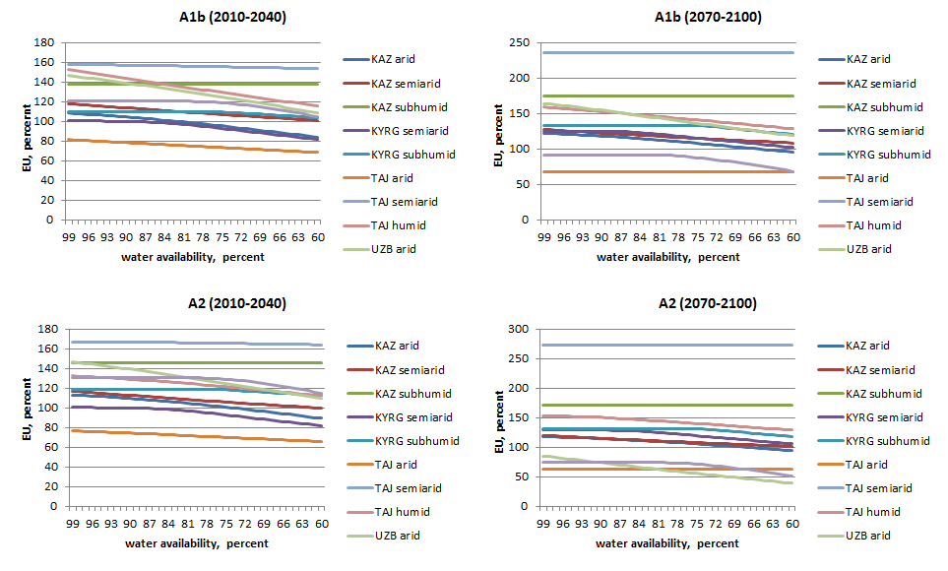**Fig SM6.** Sensitivity test to water availability levels.

**References**

ADB, 2006. Central Asia. Increasing Gains from Trade Through Regional Cooperation in Trade Policy, Transport, and Customs Transit. Asian Development Bank, Philippines.

Barrows, B., Gusev, E., 2010. Emergency Market Mapping and Analysis (EMMA). Wheat Flour Market System, Kyrgyzstan. International Rescue Committee.

Bobojonov, I., Franz, J., Berg, E., Lamers, J.P.A., Martius, C., 2010. Improved Policy Making for Sustainable Farming: A Case Study on Irrigated Dryland Agriculture in Western Uzbekistan. Journal of Sustainable Agriculture 34, 800 – 817.

Djanibekov, N., Assche, K.v., Bobojonov, I., Lamers, J.P.A., 2012. Farm Restructuring and Land Consolidation in Uzbekistan: New Farms with Old Barriers. Europe-Asia Studies 64, 1101-1126.

Eshchanov, B.R., Stultjes, M.G.P., Salaev, S.K., Eshchanov, R.A., 2011. Rogun Dam—Path to Energy Independence or Security Threat? . Sustainability 3, 1573-1592.

FAO, WFP, 2010 FAO/WFP crop and food security assessment mission to Kyrgyzstan. Food and Agriculture Organization of the United Nations World Food Programme.

Hardaker, J.B., Lien, G., 2010. Probabilities for decision analysis in agriculture and rural resource economics: The need for a paradigm change. Agricultural Systems 103, 345-350.

Heckelei, T., 2002. Calibration and estimation of programming models for agricultural supply analysis. Universität Bonn, Bonn.

Howitt, R.E., 1995. Positive Mathematical Programming. American Journal of Agricultural Economics 77, 329-342

Kato, E., Nkonya, E., 2012. DSSAT model for cotton and potato ICARDA, Aleppo.

Pomfret, R., 2005. Trade policies in Central Asia after EU enlargement and before Russian WTO accession: Regionalism and integration into the world economy. Economic Systems 29, 32-58.

Sommer, R., Glazirina, M., Yuldashev, T., 2012. Impact of Climate Change on rural livelihood in Central Asia – Component 1: “Assessing the vulnerability of selected agro-ecosystems in Central Asia to threats resulting from climate change – production and productivity of wheat. . Adaptation to Climate Change in Central Asia and People’s Republic of China. ICARDA, Aleppo.

UNDP, 2005. Central Asia human development report. Bringing down barriers: Regional cooperation for human development and human security. The UNDP Regional Bureau for Europe and the Commonwealth of Independent States, Bratislava, Slovak Republic.

USAID, 2011. A regional view of wheat markets and food security in Central Asia. With a focus on Afghanistan and Tajikistan. USAID, EWSNET, WFP.